Untitled

Guilherme Oliveira Casagrande

2023-12-04

## Regressão linear

## Preparação dos dados

## Etapa descritiva

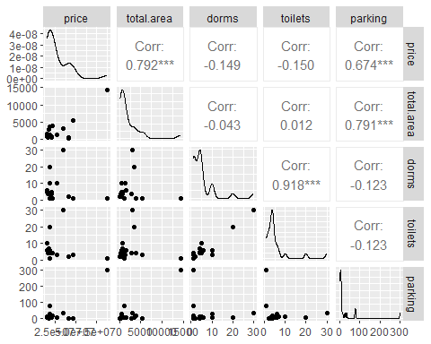

VIF com todas as variáveis

|  | x |
| --- | --- |
| total.area | 2.87 |
| dorms | 6.58 |
| parking | 2.86 |
| toilets | 6.75 |

VIF sem toilets

|  | x |
| --- | --- |
| total.area | 2.70 |
| dorms | 1.02 |
| parking | 2.73 |

## StepAIC

## Start: AIC=811.19  
## price ~ total.area + dorms + parking  
##   
## Df Sum of Sq RSS AIC  
## - parking 1 2.2773e+13 2.2652e+15 809.44  
## - dorms 1 7.0208e+13 2.3126e+15 809.96  
## <none> 2.2424e+15 811.19  
## - total.area 1 1.1781e+15 3.4206e+15 819.74  
##   
## Step: AIC=809.44  
## price ~ total.area + dorms  
##   
## Df Sum of Sq RSS AIC  
## - dorms 1 8.4180e+13 2.3494e+15 808.35  
## <none> 2.2652e+15 809.44  
## - total.area 1 3.9068e+15 6.1720e+15 832.50  
##   
## Step: AIC=808.35  
## price ~ total.area  
##   
## Df Sum of Sq RSS AIC  
## <none> 2.3494e+15 808.35  
## - total.area 1 3.9635e+15 6.3129e+15 831.06

## Modelo

Resultados finais

|  | Estimate | Std. Error | t value | Pr(>|t|) |
| --- | --- | --- | --- | --- |
| (Intercept) | 18894426.70 | 2460225.74 | 7.68 | 0 |
| total.area | 4297.17 | 689.85 | 6.23 | 0 |

## Gráfico de dispersão

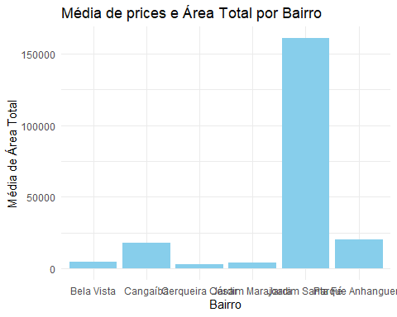

## Clusterização

