**Project Report - DMV Blockchain**

Alex Gaggiotti, Ryan Hiltabrand

Professor Ravi Mukkamala

CS 764 - Blockchains and Cryptocurrencies

02 May 2022

**Table of Contents**

1 Abstract 3

2 Key Decisions Made 3

3 Implementation 5

3.1 Home Page 6

3.2 Account Page 7

3.3 Practice Test Page 8

3.4 Online Services 9

3.5 Vehicle Services 12

4 Lessons Learned 14

# **1 Abstract**

This project aims to emulate the services that are typically provided by the Department of Motor Vehicles (DMV). These services include, but are not limited to: registering vehicles, renewing driver's licenses, and hosting knowledge-based driving practice exams. Normally, these services would require a human agent; however, this project makes use of blockchain technology, so authentication and transactions are able to take place purely online without the need for these agents.

# **2 Key Decisions Made**

Decisions were made throughout as the whole process of a DMV can not exactly convert to a decentralized application. The first thing you need to have in a case of the DMV is records. However, as we made this application from scratch we had to make many assumptions. The instructions said to assume that the authentication is handled outside of our portion of the app. We took this to understand that basically a key and public address from Metamask is assumed to be given after authentication from an outside service. This key therefore is a user's whole life on our application as without it you will lose access to all records associated with the DMV. Since this is a fact we can assume that an outside service provides users with keys which are stored on some server somewhere.   
 Going back to the problem of not having any records on a user we employed a smart contract that someone will assign themselves on the first time using the dmv app. In a real world application of the DMV this would be assumed to be imputed by the government already but since we do not have records we went with the approach to have the user input it themselves only for simplicity.

Another key decision we made was how this project would be developed. This is the first thing as a team we had to figure out. We decided for the project to use a local blockchain server using Truffle and Ganache. Hosting the blockchain ourselves allows for complete control as well as unlimited funds when deploying and using smart contracts as if we had used a test net we would need to collect their currency which would take time to collect. We are also using React JS to write our front end as it offers many web3 tools which are necessary to execute smart contracts.

The creation of smart contracts was left up to the interpretation of students. We decided that smart contracts should be owned by the dmv so they can access any funds that have been deployed to the smart contracts for services. We also split our contracts up so we have contracts to do the following:

* Create and link Personal information such as name and date of birth to a public key
* Create and link your address to a public key
  + Change your address
* Create and link your license information to your public key
  + Renew License
* Create and link your vital records to your public key
* Title a vehicle and associated it with your public key
* Transfer a vehicle using a person's public address
* Register your vehicle after every year
* Take a practice test with ether

These were our core contracts and only a new deployment of a map on the contract can be made by the users who own that instance of the map.

# **3 Implementation**

This project incorporates many features found on a typical DMV website. The front-end layout of the project is as follows:

* Home
* Account
  + Initial user account creation – First & Last name, DOB, Address, State, ZIP Code
* Practice Test
  + Contains a 5-question knowledge-based practice test
* Online Services
  + My Information – View information entered in the “Account” page
  + Driver’s License Renewal
  + Change Address
  + Obtain Vital Record (i.e. birth, marriage, death certificates)
  + Real ID
* Vehicle Services
  + VIN Lookup – Search for owned vehicles by VIN
  + Transfer Ownership
  + Title a Vehicle – Register a vehicle with the DMV

[This space is intentionally left blank.]

## **3.1 Home Page**

Upon starting the application and navigating to <https://localhost:3000>, the user is greeted with the home page. When this page is accessed for the first time, a Metamask window will appear and ask the user to sign into their account. This will allow transactions made by the user to be linked and shown in Ganache.

For purposes of this project, a message is displayed on the home page, letting the user know that they should have linked their wallet created in Ganache to Metamask beforehand.

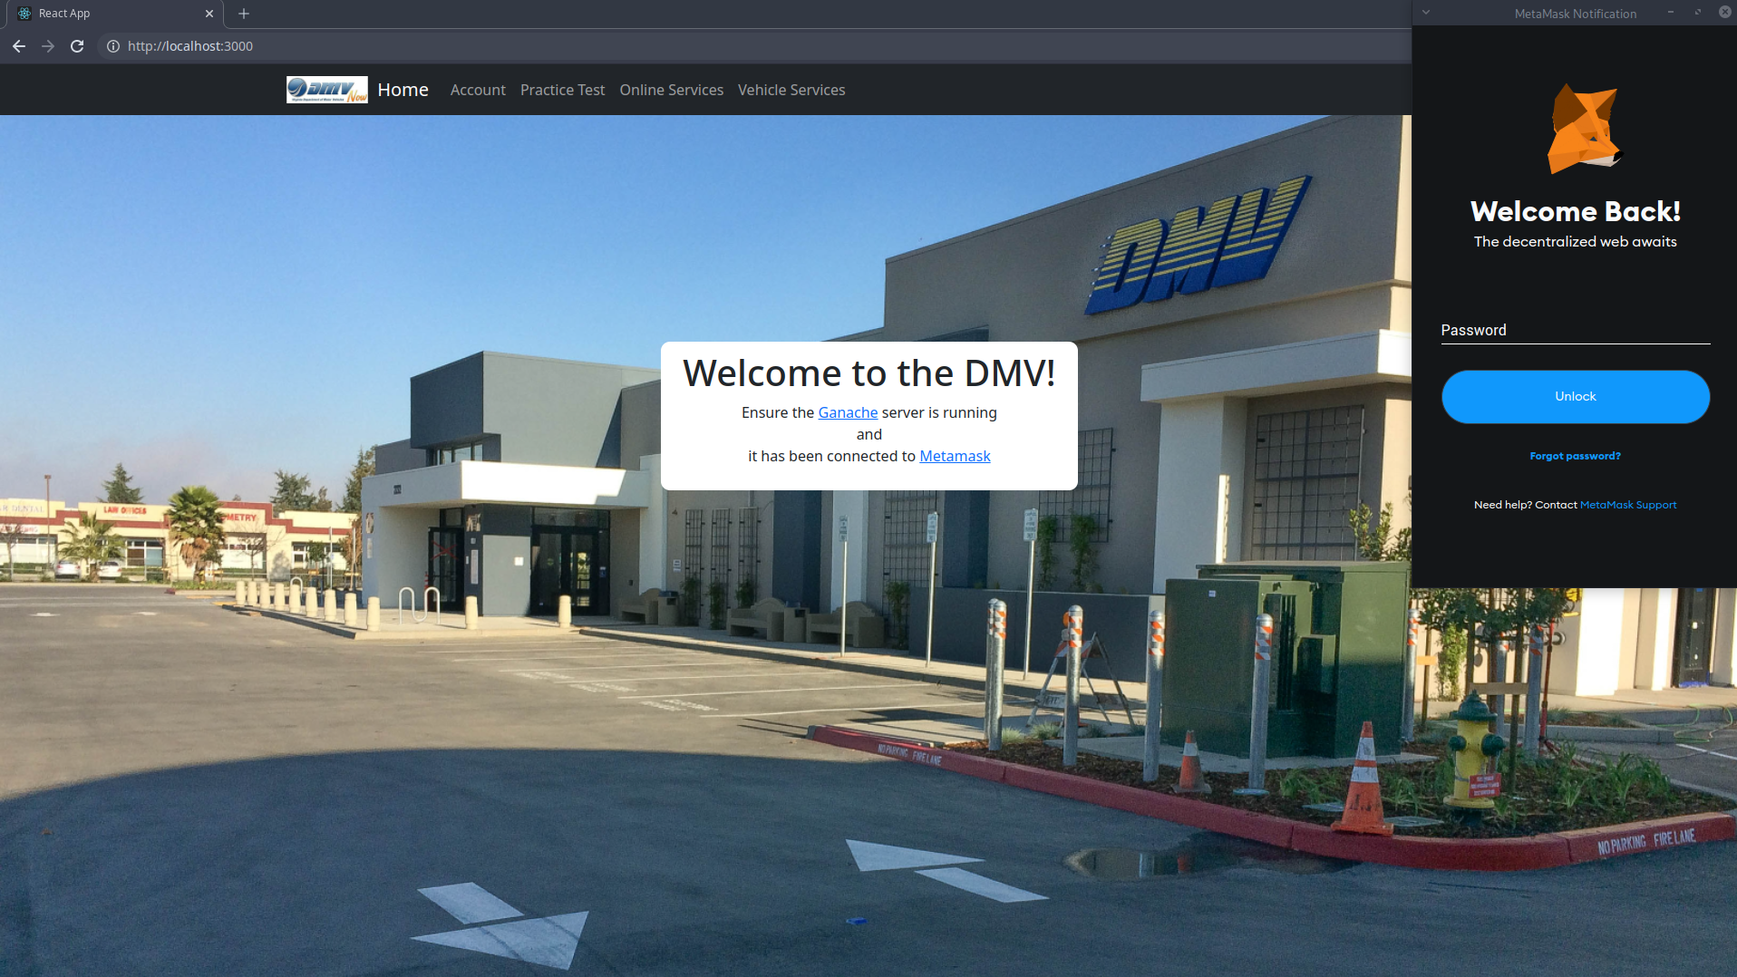

[This space is intentionally left blank.]

## **3.2 Account Page**

The “Account” page allows the user to enter their information; this information is stored on the blockchain. This information is associated with the public key of the account they signed in with initially.

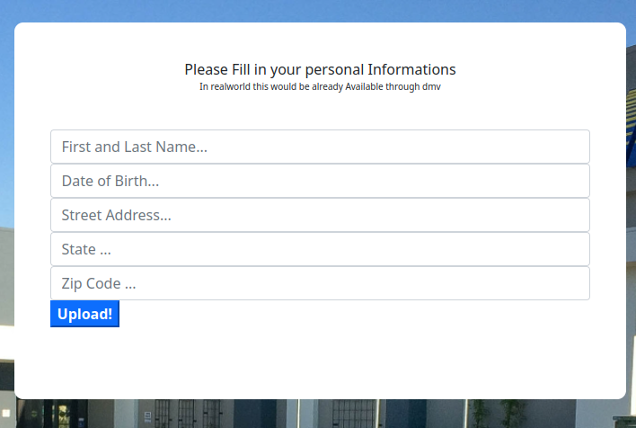

If a user has already provided their information, the page will display the following:

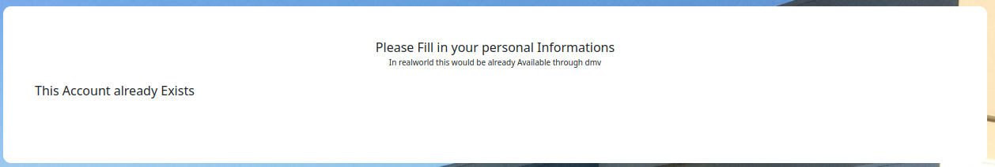

[This space is intentionally left blank.]

## **3.3 Practice Test Page**

On this page, users are able to take a 5-question knowledge-based practice exam. When a user submits, they are prompted by Metamask to pay a fee; after paying, users are notified of their score.

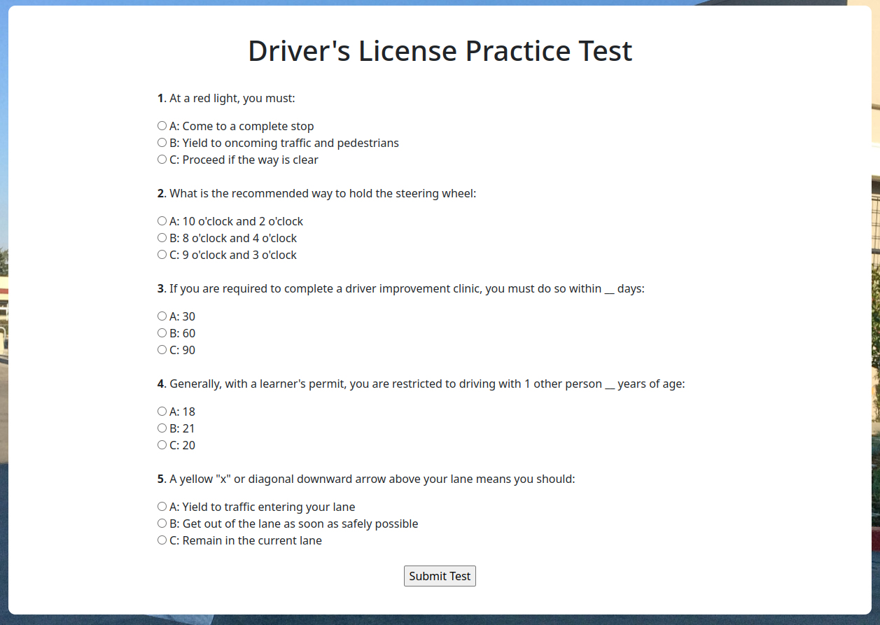

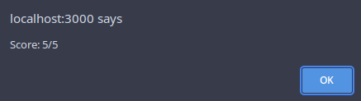

[This space is intentionally left blank.]

## **3.4 Online Services**

This page contains many account-based services. Users can view their information and perform various actions such as renewing their driver’s license and obtaining their vital records.



In the “My Information” section, customers can view the information they entered in the “Account” page along with additional information such as when their license expires and their license ID.

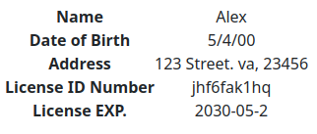

In the “Driver’s License Renewal” page, users can see their license information and request to renew their license if needed. Users will be asked to provide a reason why they need to renew.

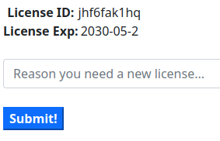

[This space is intentionally left blank.]

The “Change Address” page shows the user’s current address information and allows them to make any updates. If we go back to the “My Information” page, the updates will appear once the transaction is approved.

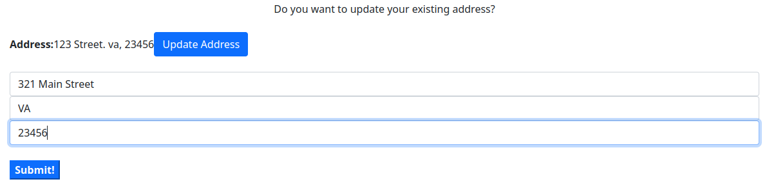

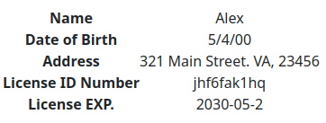

Users can also request their vital information in the “Obtain vital record” section. Upon clicking “request vital records”, the user is prompted with a Metamask transaction:

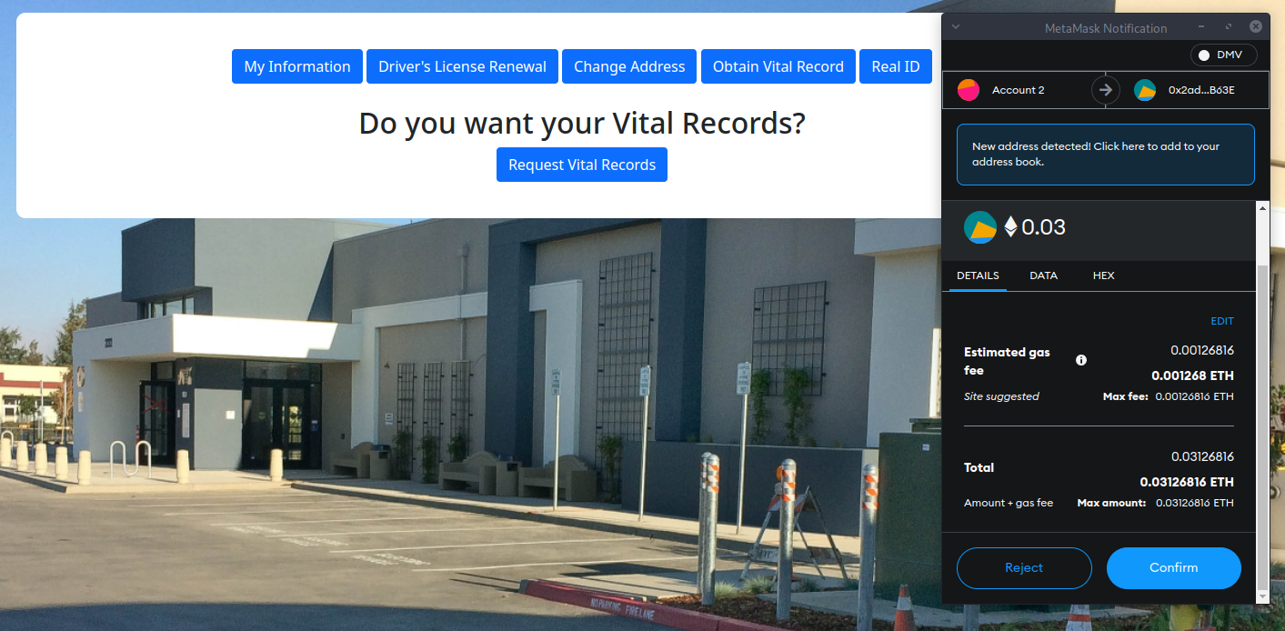

Then users can see and open their available records:

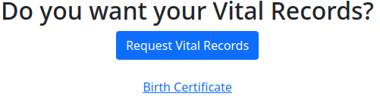



Because real IDs will be required, users can update their driver’s licenses to be real ID compliant in the “Real ID” section.

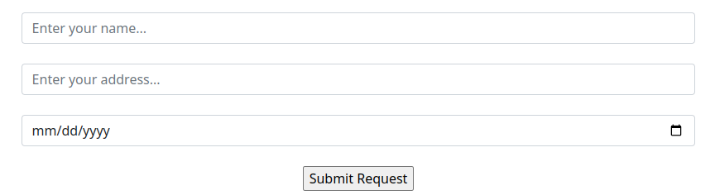

[This space is intentionally left blank.]

## **3.5 Vehicle Services**

The last page of the application involves “Vehicle Services”. This page allows users to perform operations such as searching the VINs of the vehicles they own, transfer ownership of a vehicle, and title vehicles.

As stated previously, the first page, “VIN Lookup”, allows users to search for vehicles based on their VINs. If the provided VIN matches any VINs of vehicles the owner owns, it will appear after the user hits “Submit!”.

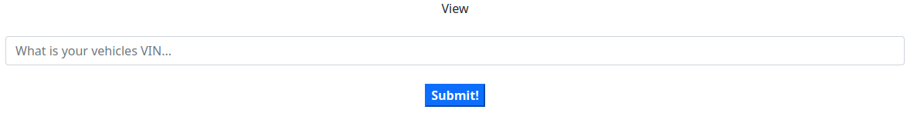

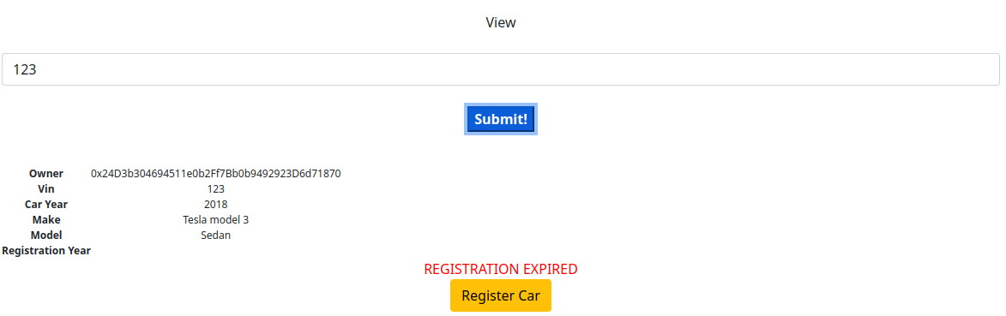

It should be noted that initially, new vehicles are not registered, so the user will need to click “Register Car” in order to do so. This prompts them with a transaction and upon completion their car will be registered.

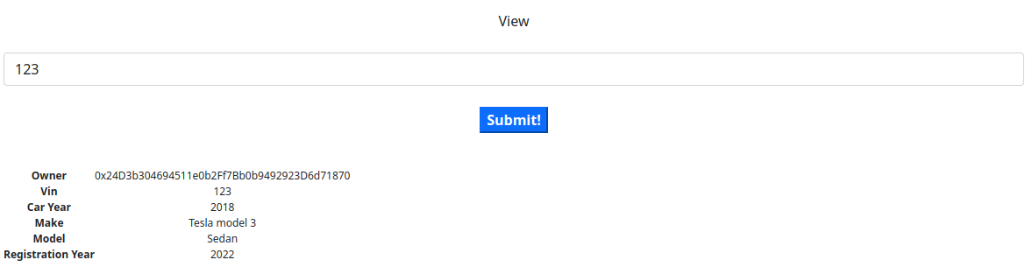

The next page, “Transfer Ownership”, allows the user to transfer ownership of their vehicle to another user, provided they know the receiver’s public key address. After hitting “Submit!” and paying the transaction fee, the user will no longer own the vehicle.

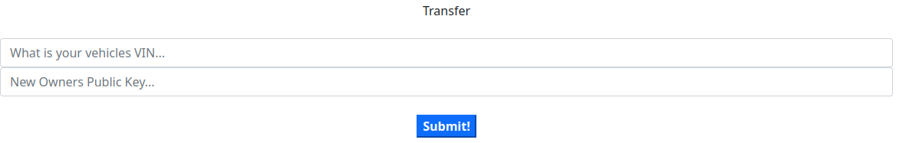

The final page, “Title a Vehicle”, allows the user to add a vehicle to the blockchain. Users will be required to fill out all of the fields. Upon doing so, they will be able to view their vehicle in the “VIN Lookup” page and transfer ownership in the “Transfer Ownership” page.

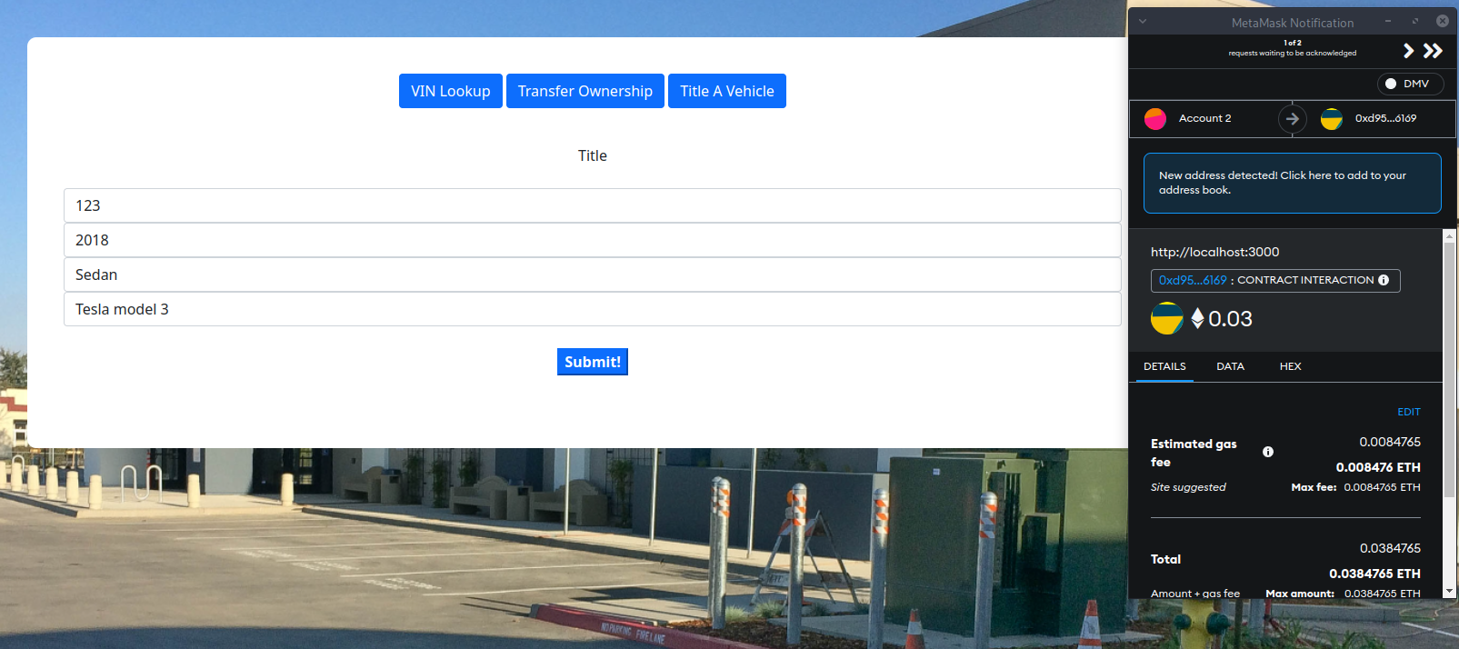

[This space is intentionally left blank.]

# **4 Lessons Learned**

This project taught us many things associated with smart contracts and front end development relating to web3 frameworks. The biggest lesson learned is how much harder it is to handle all information on a blockchain rather than on a centralized database. This comes by understanding that once you post a contract to the ethereum network it becomes immutable so any information changed needs to become a new instance. This was interesting to work with when deploying contracts as whenever there was a single change to the contract we need to reset the whole contract losing any data previously stored as we are working on a local instance which gets wiped when you reset your contract. In the real world you would have to get all users to migrate to a new contract which would be quite hard as not everyone is tech savvy.

As a group we had very little experience working with the solidity language meaning that we had a slow start to the project as well as learning as we went. This led to many errors and broken contracts when trying to execute them on the front end. Eventually we gained an understanding of the actual programming portion of smart contracts but it was definitely something we believe would have been beneficial to learn before starting this project.

A final concept that really stood out to us was how expensive it is to run code on the ethereum blockchain. A large portion of the price for this project is coming from the storage of information. Understanding that if this was a real world application it would run on a government blockchain all transactions would be mined by a central government which would be a lot cheaper than that of the gas price of the ethereum blockchain, however it would be something that the government would have to account for if this integration would happen.