AppDR Clinical Decision-Support System Brief
  - Traditional retinal image processing, handcrafted features, shallow ML, and clinician-reviewed workflow
Item | Details
Project | AppDR / DRAppFix undergraduate thesis prototype.
System role | Semi-automated clinical decision-support tool for retinal screening review.
Important boundary | The system does not provide an autonomous diagnosis or treatment recommendation.
Clinical workflow | A qualified eye-care professional reviews image quality, lesion overlays, stage estimate, confidence, and manual override before saving the report.
Deep learning status | No CNNs, PyTorch, TensorFlow, or learned pixel embeddings are used.

Executive Summary
AppDR is framed as a semi-automated clinical decision-support system using traditional retinal image processing. The backend extracts explicit retinal measurements from a fundus image, then uses a shallow scikit-learn tabular model as an internal statistical decision engine. The output is a screening-support stage estimate for clinician review, not a medical diagnosis.
The current trained model is a HistGradientBoostingClassifier selected by cross-validated macro F1 over 30 handcrafted features. Stages 0-1 are mapped to Non-Referable screening support and stages 2-4 are mapped to Referable screening support. Because severe and proliferative recall remains limited, the frontend includes a mandatory specialist manual review step.

Thesis Constraint Compliance
- Uses OpenCV and classical image processing for image normalization, vessel segmentation, lesion candidate extraction, and texture measurement.
- Uses scikit-learn models only on handcrafted scalar features, not directly on image pixels.
- Avoids CNNs, deep learning frameworks, learned embeddings, and autonomous diagnostic language.
- Frames the product as decision support for a human clinician, with manual stage override and audit-style confirmation.

Backend Workflow
- Ingest a retinal image through FastAPI.
- Assess quality: blur, brightness, contrast, retinal field shape, and vessel visibility.
- Preprocess with fundus cropping, green-channel enhancement, illumination correction, CLAHE, and denoising.
- Segment vessels with classical vesselness and morphology.
- Detect microaneurysm-like candidates using black-hat filtering, vessel suppression, color gating, and component shape filters.
- Detect exudate-like candidates using L*a*b* color space, b-channel support, local bright-lesion gating, Otsu/percentile thresholds, and optic-disc exclusion.
- Extract 30 handcrafted measurements covering lesion burden, vessel morphology, color statistics, and multi-angle GLCM texture.
- Estimate a five-stage DR support level using the trained shallow tabular model.
- Map stage 0-1 to Non-Referable support and stage 2-4 to Referable support.
- Return processed images, lesion overlays, confidence values, and lesion coordinates for visual verification.

Feature Vector
Feature group | Measurements
Microaneurysm features | ma_count, ma_area, ma_density, ma_mean_area
Exudate features | exudate_count, exudate_area, exudate_density, exudate_mean_area
Vessel morphology | vessel_density, vessel_skeleton_length, endpoints, branchpoints, tortuosity mean/max/std
L*a*b* color features | lab_b_mean, lab_b_std, lab_b_exudate_mean, lab_b_exudate_std
Texture features | GLCM contrast, homogeneity, energy, and 0/45/90/135 degree contrast/energy values

Total active handcrafted feature count: 30.

Training Summary
Item | Details
Training table | backend/features.csv rebuilt from 3,662 APTOS-style labeled training images.
Failed samples | 0 failed samples during expanded feature extraction.
Class labels | 0 No DR, 1 Mild NPDR, 2 Moderate NPDR, 3 Severe NPDR, 4 Proliferative DR.
Best model | HistGradientBoostingClassifier
Best parameters | {'classifier__learning_rate': 0.1, 'classifier__max_iter': 100, 'classifier__max_leaf_nodes': 15}
Cross-validation | 5-fold StratifiedKFold, macro F1 scoring.
Imbalance handling | RandomForest/SVC use balanced class weights; HistGradientBoosting uses SMOTE inside the cross-validation pipeline.

Model Comparison
Model | Best CV macro F1 | Holdout macro F1 | Best parameters
RandomForestClassifier | 0.5026 | 0.4879 | {'classifier__max_depth': 10, 'classifier__min_samples_split': 5, 'classifier__n_estimators': 50}
SVC | 0.5032 | 0.4603 | {'classifier__C': 10, 'classifier__kernel': 'rbf'}
HistGradientBoostingClassifier | 0.5117 | 0.4874 | {'classifier__learning_rate': 0.1, 'classifier__max_iter': 100, 'classifier__max_leaf_nodes': 15}

Evaluation Results
Item | Details
Accuracy | 0.7026
Macro precision | 0.4877
Macro recall / balanced accuracy | 0.4875
Macro F1 | 0.4874
Cohen's kappa | 0.5514

Stage | Sensitivity / TPR | Specificity / TNR | Clinical interpretation
0: No DR | 93.07% | 93.28% | Use as evidence for screening-support performance, not as proof of diagnostic validity.
1: Mild NPDR | 41.89% | 93.02% | Use as evidence for screening-support performance, not as proof of diagnostic validity.
2: Moderate NPDR | 62.00% | 85.55% | Use as evidence for screening-support performance, not as proof of diagnostic validity.
3: Severe NPDR | 17.95% | 95.97% | Use as evidence for screening-support performance, not as proof of diagnostic validity.
4: Proliferative DR | 28.81% | 93.77% | Use as evidence for screening-support performance, not as proof of diagnostic validity.

Known Limitation and Required Framing
The current model performs best on no-DR and moderate cases but has weak recall for severe and proliferative DR. In the latest holdout evaluation, severe NPDR sensitivity is 17.95% and proliferative DR sensitivity is 28.81%. This limitation must be disclosed in the thesis, user interface, and API language.
- Use the phrase screening-support estimate instead of diagnosis.
- Use clinician review or specialist manual review instead of autonomous decision.
- Show confidence as model support, not certainty.
- Keep the lesion overlay visible so the clinician can verify the evidence.
- Require the clinician to confirm the estimate or manually select a different stage before saving a report.

Frontend Workflow
- Tier 1 banner: Referable or Non-Referable screening-support status.
- Tier 2 detail: Stage estimate 0-4 and estimated-stage confidence.
- Lesion overlay toggle: displays backend-generated vessel, microaneurysm, and exudate masks.
- Specialist manual review: clinician confirms the estimate or selects another stage.
- Advanced calibration: clinician can adjust selected classical CV thresholds and reprocess the image.

Recommended Defense Wording
This project is a non-deep-learning diabetic retinopathy screening-support prototype. It uses traditional retinal image processing to extract handcrafted lesion, vessel, color, and texture features. A shallow scikit-learn model then estimates a screening stage from those tabular features. The system is not autonomous and is not clinically validated; its output must be reviewed by a qualified eye-care professional.

Artifacts
Item | Details
Trained model | backend/results/best_model.pkl
Model metadata | backend/results/best_model_metadata.json
Expanded feature table | backend/features.csv
API routes | GET /health, POST /analyze, GET /status/{task_id}, POST /analyze-sync
Frontend file | App.tsx

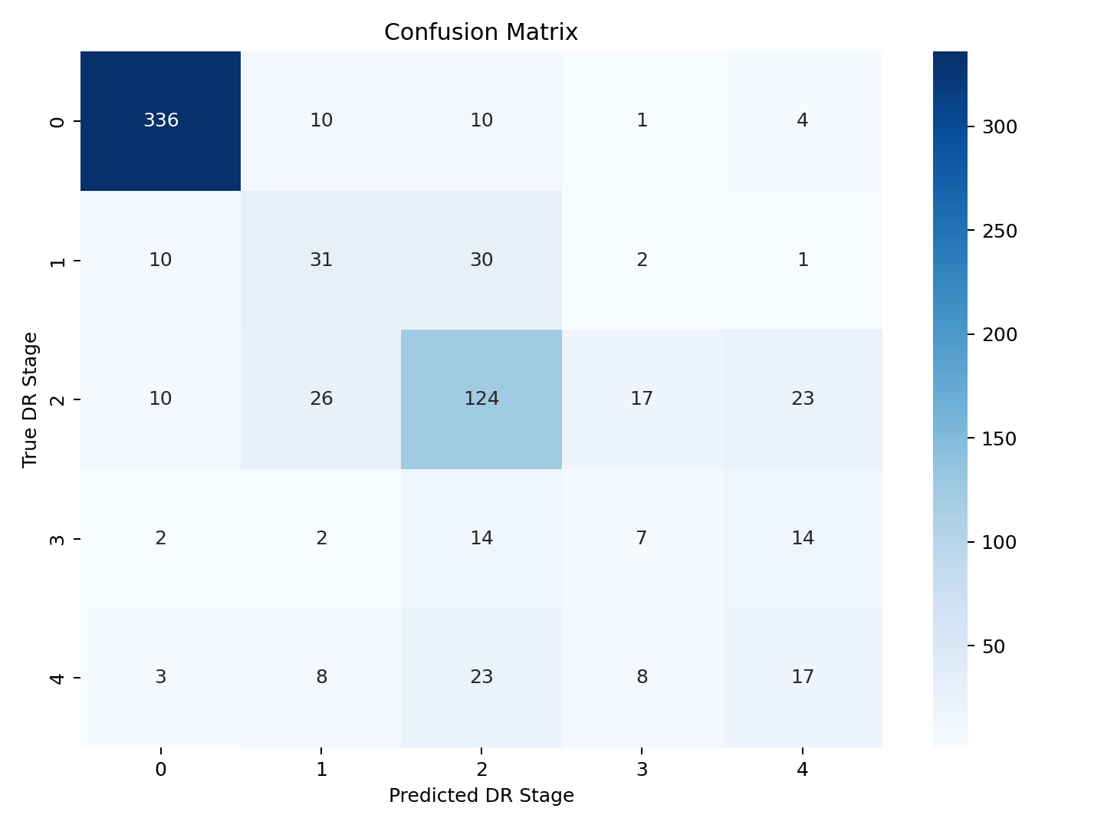
Figure 1. Holdout confusion matrix for the selected shallow tabular model.
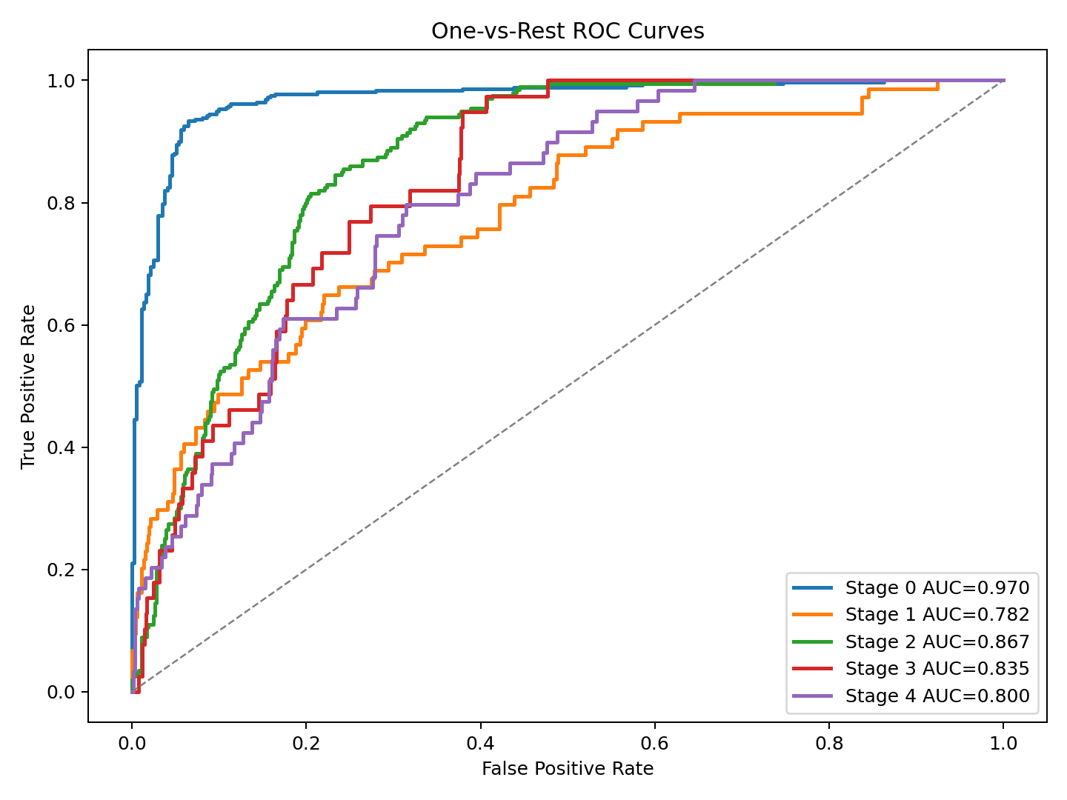
Figure 2. One-vs-rest ROC curves for stage estimates.

