***Home Appliances & Entertainment (HAE) Service Framework***

***F2F Meeting in Seoul – April 20 ~ 24, 2015***

***Attendees***

|  |  |
| --- | --- |
| ***Name*** | ***Company*** |
| Inhwan Choi | LGE |
| Wonchul Choi | LGE |
| Seungchul Han | LGE |
| Stefano Toppan | Electrolux |
| Mauro Taiariol | Electrolux |
| Fabrizio Dolce (April 20 ~ 23) | Electrolux |
| Milton Wang | Haier |
| Lu Xiaoqiang | Haier |
| Yoshinori Nagai | Sharp |
| Tomoki Ogawa | Panasonic |
| Hiroo Ishikawa | Panasonic |
| Shigeki Nakamura | Sony |
| Takeshi Oishi | Sony |
| Jonathan Han (April 20 ~ 21) | First Build |

***Day 1 (April 20th) Meeting Notes***

1. Open Points : Part 1 (https://jira.allseenalliance.org/browse/ASAHAE-13)
   1. [ID 1] Check the availability of Time Service for use by HAE devices. (Closed)
      1. Jeff Drake volunteered to take over the Time Service and he is expected to be a committer and project maintainer of Common Framework working group.
      2. At a reasonable time, let’s invite him to our technical meeting and ask about the Time Service progress.
   2. [ID 2] Check the reusability of the Control.Volume interface for use by HAE devices (Closed)
      1. We will define our own Volume Control interface.
   3. [ID 3] Supporting a subset of data type enumeration (Still Open)
      1. Mauro asked how can we manage the changing enumeration subset dynamically?
      2. If the supported subset of enumeration is implemented as (read-only) property, then the dynamically changing subset can be annotated automatically.
      3. LGE will provide a proposed change to its solution and revisit this open point some time later during our F2F meeting.
   4. [ID 4] Returning an appropriate error when a consumer application tries to set AllJoyn Property with invalid value (Closed)
   5. Another open point was raised.
      1. When setting or changing a property value, the behavior or call flow between a controller, AllJoyn interface of a controllee and the controllee's internal module should be clearly described from the very beginning of the AllJoyn command to set the property value to the emission of PropertyChangedSignal.
      2. This will be added as a new open point to ASAHAE-13 by the project maintainer.
   6. [ID 5] Method call vs SetProperty (Closed)
      1. Using method call has a slight advantage in terms of returning an error message.
      2. Use a pair of read-only property and method call instead of a writable property.
      3. Apply this rule retroactively to our previous interface definitions.
2. Open Points : Part 2 (Allseen-HAE-Open Points-r0-20150417.pptx)
   1. Define a standard Unit for temperature properties
      1. All members agreed with using the Celsius as a temperature unit.
      2. All members agreed with removing the unit property of the Target Temperature.
   2. Define UI Unit
      1. The UI unit is the unit used to represent temperature in the local UI and it is just for remote application’s information to be used for its presented unit synchronization.
      2. Electrolux will provide an additional comment and their proposed change to TargetTemperature interface definition.
   3. Add StepValue properties
      1. Electrolux team will provide a more detailed description of the StepValue for our comment & resolution.
      2. Error handling mechanism will be similar to that of Humidity.
   4. Change FilterStatus
      1. It seems to violate one of IRB guideline. “Units are non-negotiable”. But in the sense that the StatusType conversion is not quite straightforward, it can not be compared to the Celsius vs Fahrenheit.
      2. It was determined to keep the current interface definition and get an official feedback from IRB.

***Day 2 (April 21th) Meeting Notes***

1. Review minutes from yesterday’s meeting
   1. Discussion on error code and error message
      1. We will use the predefined error codes as much as possible, but if error codes defined by the Core WG are not enough to express all error cases of our HAE Service Framework, we should define our own error messages for those error cases.  
         The error messages we defined will be delivered by the generic error message delivery mechanism which use the error code, ER_BUS_REPLY_ERROR_MESSAGE(0x9032).
   2. Discussion on a behavior or a call flow between a controller, the AllJoyn interface of a controllee and the controllee's internal module.
      1. Three possible behaviors are discussed.  
         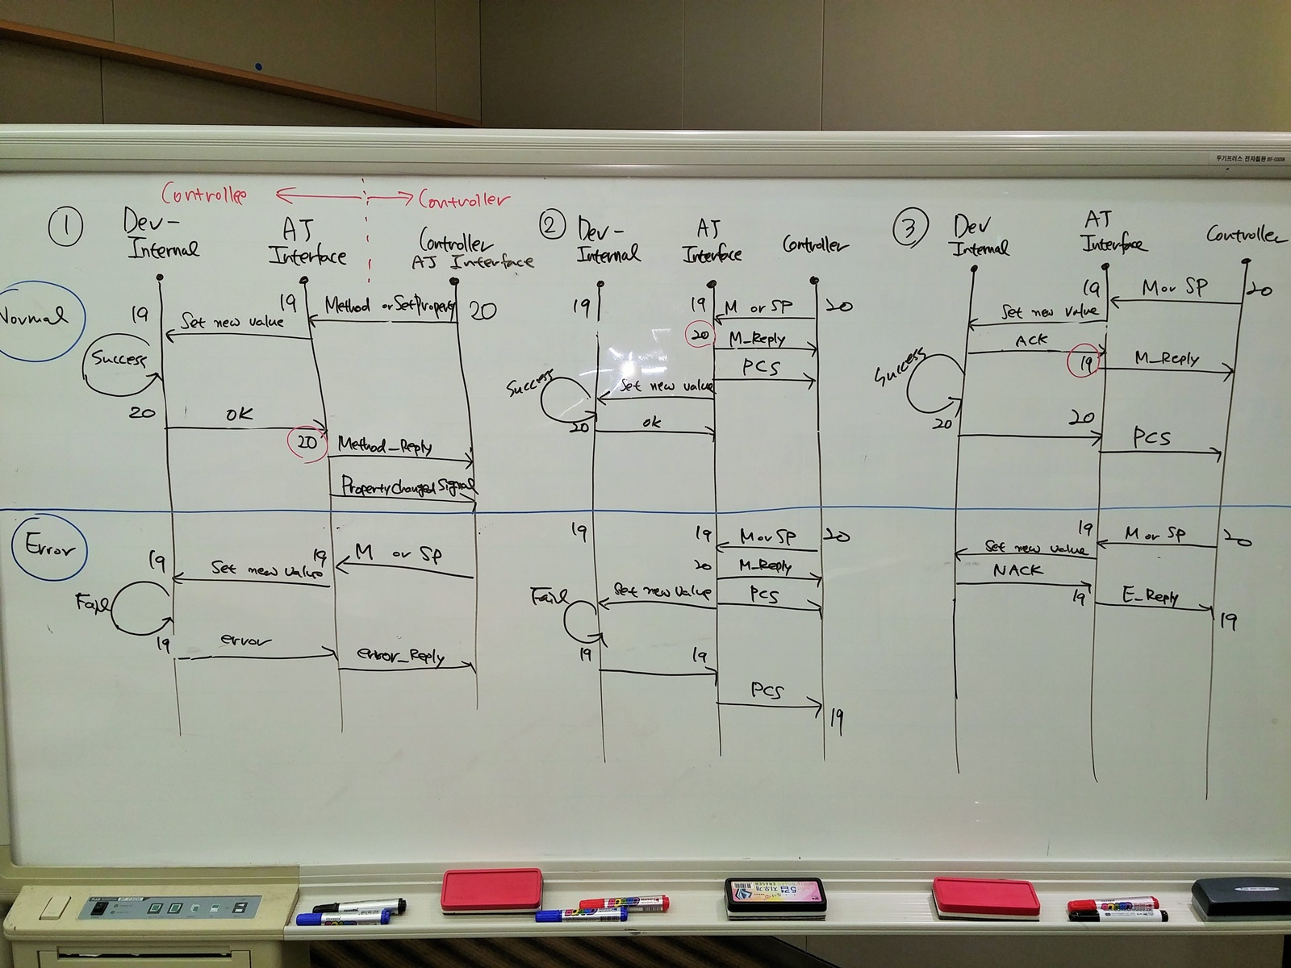
      2. The behavior between the AJ interface of a controllee device and its internal logic is out of scope of AllJoyn standardization. The important thing we should be aware of is if it is legal to reply to a method call or SetProperty before applying a setpoint value to the AllJoyn property or not. Responding to the method call or SetProperty includes both the normal reply (no error) and the error reply. This should be checked by asking Core WG or IRB.
   3. All members approved yesterday’s meeting minutes.
2. Review HAE device model structure
   1. Electrolux team suggested to rename the “shared” terminology. This is TBD item.
   2. All members approved to remove the component “Shared” from the name of the Shared interface.
      1. org.allseen.Hae.Shared.Xxx → org.alljoyn.Hae.Xxx
   3. Discussion on multiple instances
      1. Difficulties in associating semantic meaning with multiples instances of the same interface was discussed.
      2. Inhwan Choi suggested to leave this issue as an open point with two candidate solutions.
         * standardizing the enumeration of the positions, for example  
           Vertical : {Top, Middle, Bottom}, Horizontal : {Left, Center, Right}
         * adding a string-type property having human readable description to each interface.
3. Approve the proposed list of standard HAE device types
   1. Electrolux team suggested adding the Cooker Hood and the Cooktop to the proposed list of standard HAE device types.
   2. All members approved the extended list of standard device types.
   3. Refer to “AllSeen-HAE-HAE Device Model and Operation Control-r2-20150421”
4. Review operation control
   1. Mauro Taiariol suggested the followings.
      1. Remove the OnOffControl interface and add the On and Off to the enumeration of the operation command.
      2. Add additional states including “Off” into “OperationState” property.
   2. Inhwan Choi and Mauro Taiariol drafted for the OperationControl interface.
   3. Refer to “AllSeen-HAE-HAE Device Model and Operation Control-r2-20150421”
   4. Electrolux team will provide additional detailed description about the dependency between OperationState and OperationCommand.  
      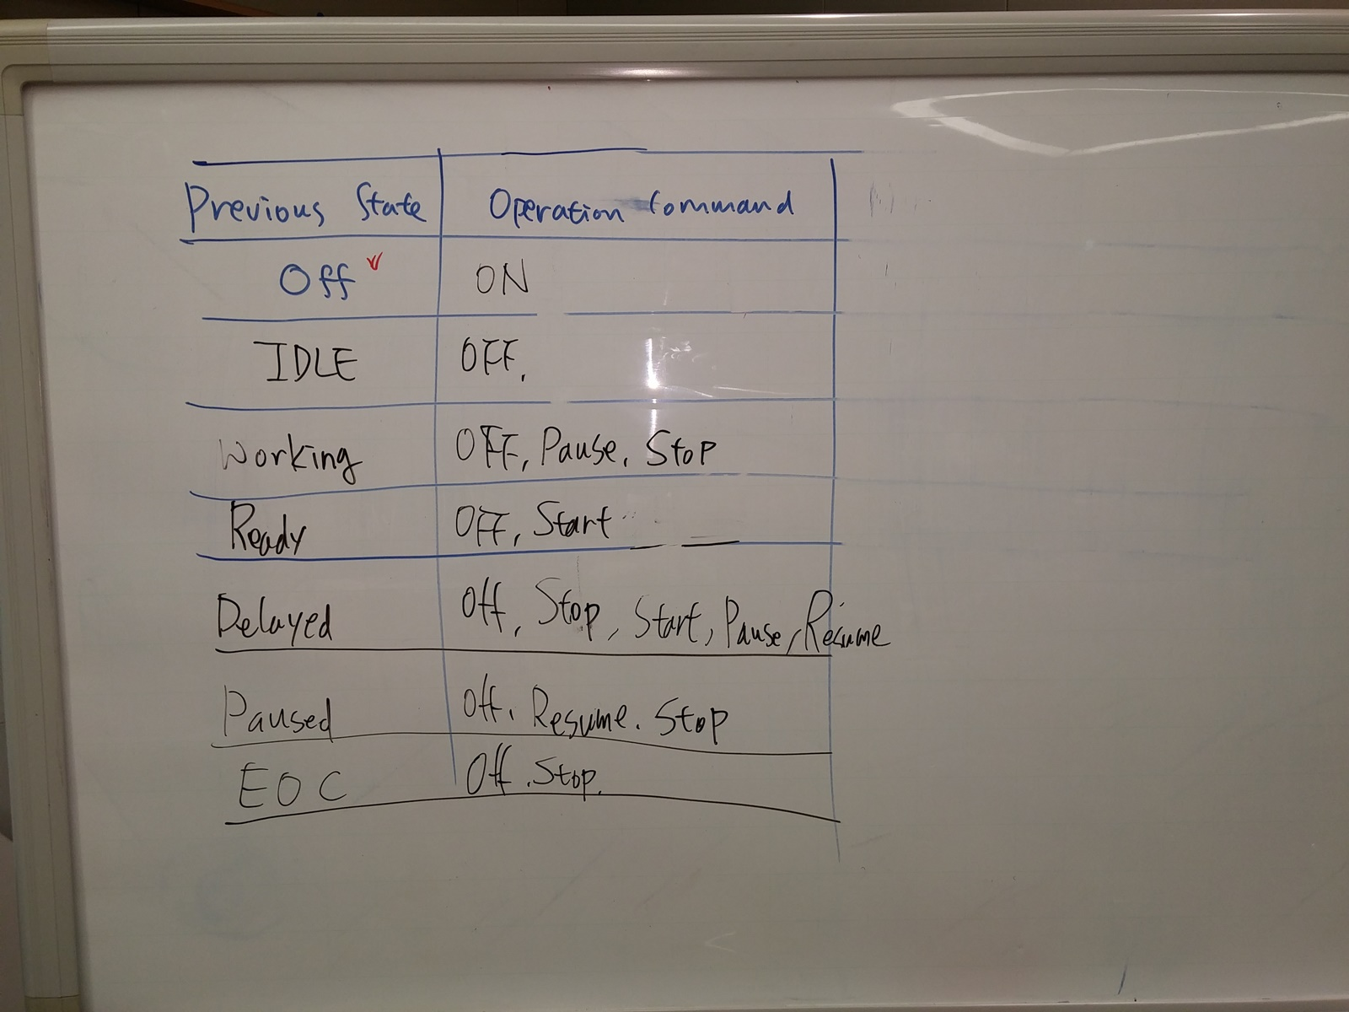
5. Develop shared interfaces - Fan
   1. r5 and r4 versions are compared.
   2. r4 was favored because it gives us additional information of dynamically changing value of the wind strength or wind direction when the auto mode is turned on.
   3. Two open points raised.
      1. When the auto mode is turned off, at which value the wind strength or wind direction should remain ? Possible solutions are discussed.
         * Define one default value.
         * Remain at the value when the auto mode is turned off.
         * Leave it to be determined by a controllee device
      2. DirectionType is duplicated and it looks strange.
         * While defining AutoWindDirection, to use this interface as stand-alone (not together with WindDirection), the same property was duplicated.
6. Developing shared interfaces – Target Humidity, Represented Humidity
   1. All members agreed with the proposed change by Panasonic to the description of TargetVaue.
   2. All members approved the Target Humidity and the Represented Humidity device model.
7. Developing shared interfaces – Energy
   1. Electrolux explained their contribution on EnergyUsage
   2. The name of interface was renamed to EnergyUsage
   3. A special value for <base> was reserved for “unknown” or “undefined”
   4. Refer to Allseen-HAE-Shared Part-r6-20150421

***Day 3 (April 22th) Meeting Notes***

1. Review minutes from yesterday’s meeting
   1. Regarding to the dependency between OperationState and OperationCommand, Fabrizio Dolce commented that we can provide example state transition matrix to help developer’s understanding, but we cannot force a certain transition from one state to the next for all devices. The important thing is the OperationCommand itself.
2. Develop shared interfaces – Energy
   1. Discussion on the frequency of event notification
      1. Inhwan Choi commented that a frequency of event notification is a general issue; we had discussed a similar issue on the discussion for the Represented Temperature.
      2. Fabrizio Dolce commented adding a timestamp attribute could be helpful when reconstructing a precise energy usage graph.
      3. Inhwan Choi suggested adding this issue as a general open point to the JIRA. (<https://jira.allseenalliance.org/i#browse/ASAHAE-13>)
      4. Hiroo Ishikawa will add this open point to the JIRA ticket for general open points.
      5. Fabrizio Dolce recommended to get consultation from IRB or Core WG while we are finding our solution.
3. Develop shared interfaces – Air Quality
   1. Discussion on a necessity of the MinValue and MaxValue from the Haier’s proposal
      1. Milton Wang explained that we need the MinValue and MaxValue to support graphical UI of air quality monitor where the sensing value is greater than the represented MaxValue.
      2. Members voted on 3 items for the MinValue and MaxValue.
         * Add PM10 to the Air Quality and allow the MinValue, MaxValue to only PM2.5 and PM10. (Approved)
         * Define two special values which mean that MinValue or MaxValue is not available from the controllee device. (Approved)
         * Define two special values which indicate “above MaxValue” and “below MinValue”, respectively. (Approved)
   2. Discussion on the qualitative representation of Air Quality from the Sharp’s proposal
      1. All members agreed to add qualitative representation interface for each CO2, CO, CH2O, VOC, PM2.5, PM10 and Humidity.
4. Mauro Taiariol suggested removing the mandatory column in our Shared Part excel sheets.
   1. All members approved to remove the mandatory column.
5. Develop shared interfaces – VolumeControl
   1. Mauro Taiariol suggested changing the data type from uint16 to byte.
   2. Inhwan Choi agreed with Mauro Taiariol and changed the data type to byte.
   3. Sony team suggested adding StepValue.
   4. Mauro Taiariol suggested adding UpVolume and DownVolume as method calls.
   5. Inhwan Choi modified VolumeControl and VolumeMute interfaces reflecting member’s suggestions.
   6. All members approved the VolumeControl and VolumeMute interfaces definition.
6. Develop shared interfaces – AVInput
   1. Regarding to ConnectedInputSource, a concern raised. Some TV sets can’t detect if their input source is connected or not.
   2. Inhwan choi suggested to change the word from ‘ConnectedInputSource’ to “SupportedInputSource” and Takeshi Oishi suggested to add ‘detectedState’ to the InputSource structure.
   3. Inhwan Choi added the detectedState and it has an enumeration of {‘detected’, ‘not detected’ and ‘unknown’}.
   4. All members agreed their suggestions.
   5. There was a request to add ‘SCART’, ‘External Storage’ and ‘Network’ to the sourceType.  
      But there raised a concern that ‘Network’ is too broad and ambiguous.
   6. Regarding to InputSource, Inhwan Choi will check if there is any similar work from Smart TV Alliance.

***Day 4 (April 23th) Meeting Notes***

1. Review minutes from yesterday’s meeting
   1. All members approved yesterday’s meeting minutes.
2. Develop shared interfaces – Channel
   1. Mauro Taiariol and Takeshi Oishi commented that a controller should know total number of scanned channels.
   2. Inhwan Choi added the TotalNumberOfChannels attribute.
   3. Takeshi Oishi asked how to handle the case where the channel list changes, but the total number of channel remains the same.
   4. Inhwan Choi suggested adding a dedicated signal to notify the channel list update event and LG will draft the signal definition.
3. Develop shared interfaces – Mouse
   1. Takeshi Oishi commented that a controller should know maximum size of the screen.
   2. Inhwan Choi added the MaxPosition attribute to inform the screen resolution, but at the end of discussion, both the MousePosition and its MaxPosition were removed from the interface because in principle, mouse doesn’t have to know its absolute position in the screen. The important thing between mouse and screen is the relative movement.
   3. All members agreed and renamed the interface as “MouseMovement”.
   4. Mauro Taiariol commented that we should consider a sensitivity or speed control of mouse movement.
4. Develop shared interfaces – KeyInput
   1. Sony team and LGE team agreed to change a word “Mandatory Key List” to “Sample Key List” in definition because typical TV ignores a received input code which is not supported.
   2. Inhwan Choi clarified that our interface follows the existing key code definition from "CEA-2014-A - CE-HTML Annex F".
   3. All members approved the KeyInput interface definition.
5. Develop shared interfaces – Part1 of AirQuality (proposed by Haier)
   1. Inhwan Choi suggested changing the terminologies used in floating point value representation like below and all members agreed.
      1. <base> 10^ <factor> => <significand> 10^ <exponent>.
   2. Members modified the special values for “above MaxValue” and “below MinValue” (<significand>, <exponent>).
      1. above MaxValue : (0xFFFF, 0x7FFF)
      2. below MinValue : (0x0, 0x8000)
   3. Members updated the descriptions of MinValue and MaxValue and reserved the following special values.
      1. MaxValue is not available : (0xFFFF, 0x7FFF)
      2. MinValue is not available : (0x0, 0x8000)
   4. All members approved the updated Part1 of the AirQualilty interfaces definition.
6. Develop shared interfaces – Part2 of AirQuality (proposed by Sharp)
   1. Members changed the expression “The represented value” to “The qualitative representation” in description sections to make their meaning clear.
   2. All members approved the updated Part2 of the AirQualilty interfaces definition.
7. Develop shared interfaces – Represented Humidity Level
   1. All members approved the Represented Humidity Level interface definition.
8. All members confirmed to change the name of operation “SetVolume” to “ChangeVolume” in the VolumeControl interface.
9. Develop shared interfaces – AVInput
   1. Inhwan Choi told that he found no similar work from Smart TV Alliance regarding to Input Source Type.
   2. All members approved the AVInput interface definition as it was.
10. Develop shared interfaces – EnergyUsage
    1. All members agreed to keep the “Notifiable” as True and deal with the frequency of event notification issue as a general open point.
    2. Stefano Toppan updated the special value (0x80000000, 0x7FFF) that indicates “unknown” or “undefined”.
       1. The special value applies to both RepresentedPower and UsedEnergy.
    3. All members approved the updated EnergyUsage interface definition.
11. Develop shared interfaces – Fan

Resolutions for two open points were made.

* 1. Open Point 1: When the auto mode is turned off, at which value the wind strength or wind direction should remain?
     1. Leave it to be determined by a controllee device
  2. Open Point 2: DirectionType is duplicated and it looks strange.
     1. Remove DirectionType from both WindDirection and AutoWindDirection
     2. Split the WindDirection into the HorizontalWindDirection and VerticalWindDirection
     3. Split the AutoWindDirection into the AutoHorizontalWindDirection and AutoVerticalWindDirection
  3. All members approved the Fan device model including 6 interfaces.
     1. WindStrength, AutoWindStrength, HorizontalWindDirection, AutoHorizontalWindDirection, VerticalWindDirection, AutoVerticalWindDirection

1. Discussion on the OperationalStateCommandTransitionMatrix.

(AllSeen-HAE-OperationalState&CommandTransitionMatrix-r0-20150423)

* 1. Electrolux team commented that the table of matrix should be considered as a best practice.
  2. After lengthy discussion on this issue, vote was taken to approve OperationControl interface definition.
     1. In favor : 3 (Electrolux, LGE, Haier), Opposed : 3 (Panasonic, Sharp, Sony)
     2. Not approved.
  3. Tomoki Ogawa and Yoshinori Nagai opposed because the controller cannot know clearly how to make a state transition from Idle state to another state.

1. Discussion on Tomorrow’s meeting agenda
   1. Inhwan Choi suggested that we develop Washer device interface definition in the morning, and then have a discussion on the general open points, wrap-up and our roadmap update in the afternoon on Friday.
   2. Electrolux suggested discussing the general open points first in the morning.

***Day 5 (April 24th) Meeting Notes***

Part 1 : Comments&Resolutions and Device Interface

1. Review minutes from yesterday’s meeting
   1. All members approved yesterday’s meeting minutes.
2. Discussion on general open points (https://jira.allseenalliance.org/browse/ASAHAE-13)
   1. [ID 3] Develop mechanism for supporting a subset of data type enumeration (Closed)
   2. Inhwan Choi suggested adding an owner column in the comments & resolution table and members agreed.
   3. [ID 6] Stefano Toppan volunteered to make a resolution for this issue. He will make other JIRA ticket and make a link on the Link/Reference column.
   4. [ID 7] Stefano Toppan volunteered to be an owner for this issue and he will draft “UserInterfaceSetting” interface definition for members’ review.
   5. [ID 8] Milton Wang volunteered to be an owner for this issue.
   6. Wonchul Choi requested to revisit the Part2 of the AirQuality interfaces definition.
      1. Wonchul Choi commented that the level of the RepresentedValue should be expressed as a human understandable language, not an integer value.
      2. Inhwan Choi suggested that Wonchul Choi add a new comment and his proposed change and Yoshinori Nagai volunteered to be an owner for this issue.
3. The issue of using JIRA when defining AllJoyn interfaces is raised.
   1. Stefano Toppan expressed difficulties in using Jira when developing AllJoyn interfaces definition and suggested converting the AllJoyn-syntax independent Device Model to the markdown format file directly to avoid two conversions.
   2. Stefano Toppan will provide his proposed change by taking an example and members will discuss about that on next weekly call.
4. Comments&Resolutions on the org.alljoyn.Hae

(<https://jira.allseenalliance.org/i#browse/ASAHAE-3>)

* 1. [ID 1] Change from “InterfaceVersion" to "Version” (Accepted and Resolved)
  2. [ID 2] Remove “HaeVersion” Property (Accepted and Resolved)
  3. [ID 3] Remove “DeviceModelName” Property (Not Accepted and still Open)
     1. Mauro Taiariol commented that the DeviceModelName should allow an empty string and it should be clarified if it is safe to set an empty or other meaning less strings such as “Not Available”, “-“, “Unknown”, etc. Especially from the certification point of view.
     2. Electrolux will add an open point about this issue to ASAHAE-13 and LGE volunteered to be an owner for this open point.
  4. [ID 4] Remove “DeviceManufacturer” Property (Not Accepted and still Open)
     1. Same reason with ID3
  5. [ID 5] Remove “FriendlyName” Property (Accepted and Resolved)
  6. [ID 6] Remove “DeviceId” Property (Not Accepted and still Open)
     1. Same reason with ID3
  7. [ID 7] Remove “ProductionDate” Property (Accepted and Resolved)
  8. [ID 8]Data Typesshould be subject to review (Still Open)
     1. Inhwan Choi suggested that members revisit this comment once we defined all required interfaces.

1. Comments&Resolutions on the org.alljoyn.Hae.TargetTemperature (<https://jira.allseenalliance.org/i#browse/ASAHAE-6>)
   1. [ID 3] Add the StepValue Property (Accepted along with Stefano’s proposal and Resolved)
2. Comments&Resolutions on the org.alljoyn.Hae.Alerts (<https://jira.allseenalliance.org/i#browse/ASAHAE-7>)
   1. [ID 1] Add a severity type descriptions (Accepted and Resolved)
3. Comments&Resolutions on the org.alljoyn.Hae.DoorStatus (<https://jira.allseenalliance.org/i#browse/ASAHAE-8>)
   1. [ID 1] DoorStatus - Open : False, Closed : True (Accepted along with Inhwan Choi’s additional suggestions and Resolved)
4. Discussion on org.alljoyn.Hae.Device.AirConditioner interface

(<https://jira.allseenalliance.org/i#browse/ASAHAE-12>)

* 1. Yoshinori Nagai commented that ‘Economy’, one of operation modes can be controlled independently.
  2. Inhwan Choi explained that in that case, the economy mode is not included in supported operation modes and you can support your independent economy mode on/off by using another interface, for example, EnergySaving interface.
  3. Yoshinori Nagai asked about difference between operation mode and phase and Inhwan Choi answered that operation mode is a mode of device operation which doesn’t change over time unless a controller change the operation mode, while the running phase is a phase of cycle which changes over time.
  4. While discussing about washing machine case, Mauro Taiariol pointed out that the operation modes LG provided for washing machine is not a mode and it should be called a cycle. For washing machine, there is only one operation mode, ‘Washing’ mode, and thus there is no need to have OperationMode property in its device interface.
  5. The discussion continued to the Operation Control and members expressed a concern on ‘Idle’ mode.
     1. Mauro Taiariol clarified that ‘Idle’ is only available from devices having cyclic operations and members requested to add clarification on the description of ‘Idle’ mode.
     2. Members asked Electrolux team to provide more clear description for the ‘Idle’ mode, for example, what are cyclic operation device, what are non-cyclic operation device and ‘Idle’ mode is only available from cyclic operation devices.
     3. Members agreed that this clarification could be very helpful for controller application developers’ understanding and member’s approval.

Part 2 : Wrap-up & Next Step

1. Review minutes from Day 5 Part 1.
   1. All members reviewed the minutes from Day 5 Part meeting and approved.
2. Inhwan Choi summarized briefly what we achieved during this F2F meeting and what are still remaining for our interfaces definition. The followings are the remaining work items.
   1. Shared Interfaces
      1. Operation Control (Electrolux) : Provide an additional clarification on ‘Idle’ state.
      2. Mouse (LGE) : Propose a resolution on mouse speed control issue.
      3. Channel (LGE) : Add a dedicated signal to notify a change of the channel list
      4. Energy Saving (Panasonic) : Draft an initial version.
      5. Display (Sony) : Draft an initial version if needed.
   2. Device Interfaces
      1. Inhwan Choi asked members to volunteer for drafting device interfaces and made assignments like below.

|  |  |
| --- | --- |
| Company | Devices |
| Electrolux | Refrigerator, Fridge, Freezer, Ice Maker, Washer, Dryer, Washer Dryer, Dish Washer, Oven, Cooker Hood, Cooktop |
| Haier | Air Quality Monitor |
| Honeywell | Thermostat |
| LGE | Air Conditioner, Humidifier, Dehumidifier, Robot Cleaner |
| Panasonic | Electric Fan |
| Sharp | Air Purifier |
| Sony | TV |

1. Third F2F meeting
   1. Members agreed the necessity of another F2F meeting to finalize interfaces definition. The main topic of the third F2F meeting will be the development of ‘Device’ interfaces.
   2. The week of June 8th was discussed as a candidate timing.
   3. Inhwan Choi asked members to volunteer for hosting the next F2F meeting before the next weekly call.
   4. The time and place will be discussed at the next weekly call.
2. Next weekly call schedule
   1. There will be no call next week (the week of April 27th).
   2. The next technical meeting will be held on May 7th with Sequence T1.
3. Members updated project milestones.

|  |  |
| --- | --- |
| **Milestone** | **Date** |
| Draft AllJoyn Interface specifications | June 2015 |
| IRB Approval of Interfaces Definition | July 2015 |
| High-level design (HLD) documents | August 2015 |
| Foundational component implementations for Linux | October 2015 |
| Certification test suite | December 2015 |
| Reference controller applications for Android & iOS | December 2015 |