A Study on the Impact of Consumer Buying Behaviours on Lakme Cosmetic Products Among Women

# Abstract

This study investigates consumer buying behaviours regarding Lakme cosmetic products among women. Using data collected from 50 respondents via an online questionnaire, the report analyses demographic factors, brand preferences, purchase frequency, spending habits, importance of product attributes, and consumer perception of the Lakme brand. The findings provide insights into factors influencing purchasing decisions and suggest areas for improvement.

# Introduction

The cosmetic industry is highly competitive, with numerous brands vying for consumer attention. Lakme, a prominent player in the Indian market, has a diverse range of products appealing to various segments of the population. This study aims to understand how consumer demographics, preferences, and perceptions influence their buying decisions related to Lakme products.

# Methodology

Data was collected through an online Google Form, answered by 50 women. The questionnaire covered demographic details, brand preferences, reasons for choosing Lakme, spending patterns, media influence, and perceptions of the brand. Both qualitative and quantitative data were analyzed to derive meaningful insights.

# Demographics Analysis

## 2.Age

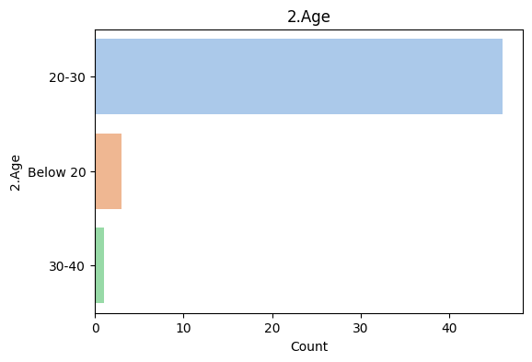

## 3.Marital status

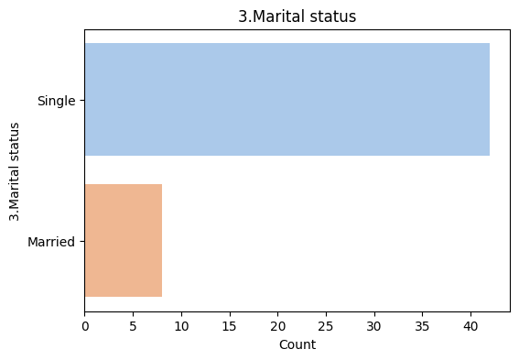

## 4. Educational qualifications

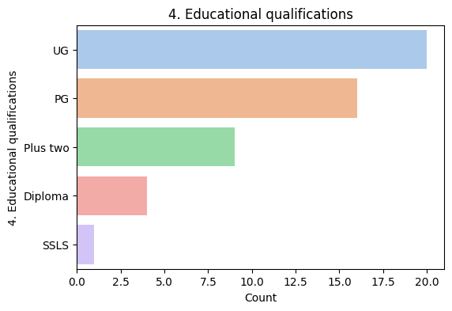

# Brand Preferences

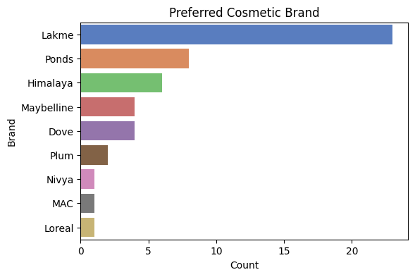

# Frequency of Lakme Product Purchase

