David Wang

Lab1 02: Digital Media

1. Five misleading history photos with explanation
2. Five items manipulated in the video
3. Screen shot of TinEye results
4. Photo properties displayed (a – e, indicate if no information provided)
   1. Date taken
   2. Date modified
   3. Camera brand and model
   4. Photographer
   5. Place taken
5. Results of research paper

1.)

The lighting is different for the water in the altered photo. I think that this is to cover for the after-effects of removing the person on the right from the original photo.

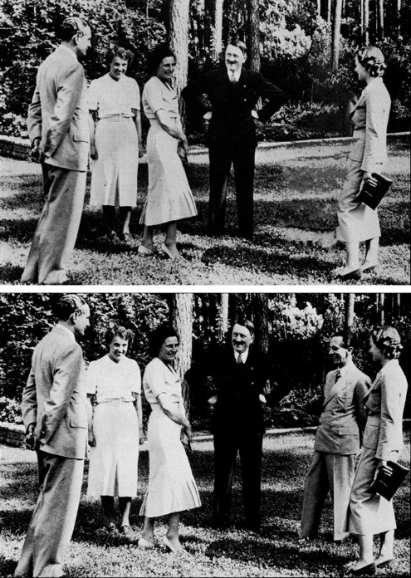 The original photo has a person standing next to the lady on the right. Similar to the Stalin photo, the shadows look subtly lighter around the area where the person used to be.

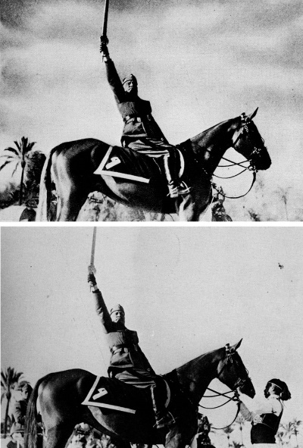The edit in this photo is harder to see, since they added clouds to the altered version to probably cover for any discrepancies from removing the original person.

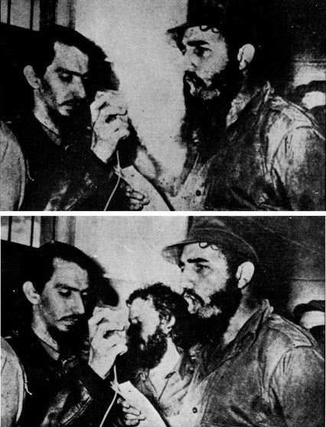The edit is subtle in this photo as well. There are no blurs on the wall showing that an edit occurred, but looking closely at the hand of the person on the left shows a little bit of shadow remaining from the person removed from the original photo.

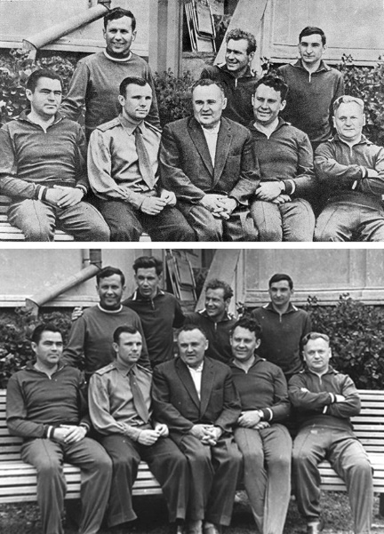The only way to tell that the person was removed from this photo is by looking at the bush where the person originally was. The lighting on the photoshopped bush is darker than the surrounding bushes.

2.)

From the video, I noticed that:

* The tree on the left side was removed
* The road is gone
* They added foliage and sky to make up for the gap
* The fence is missing its poles
* Some of the light from the sun is lessened

3.)



4.)







5.)

They were not able to conclude whether the film was real or not. However, they found that the shadow cast by the head was physically possible.