CSE 005

Summer 2020

Lassen Group

**Lab 2 03: Research Project Milestone 5 – Visual Layout and Design**

Group Topic: Malware

Aldo Alvarez, Cesar Cardenas, David Wang, Matthew Guzman, Yilinda Li

Screenshots of our webpages:

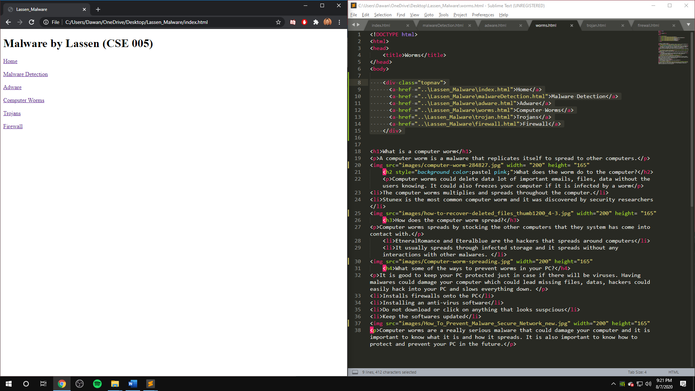

This is the home page, written in the file index.html. David wrote this page and provided the links to the other pages.

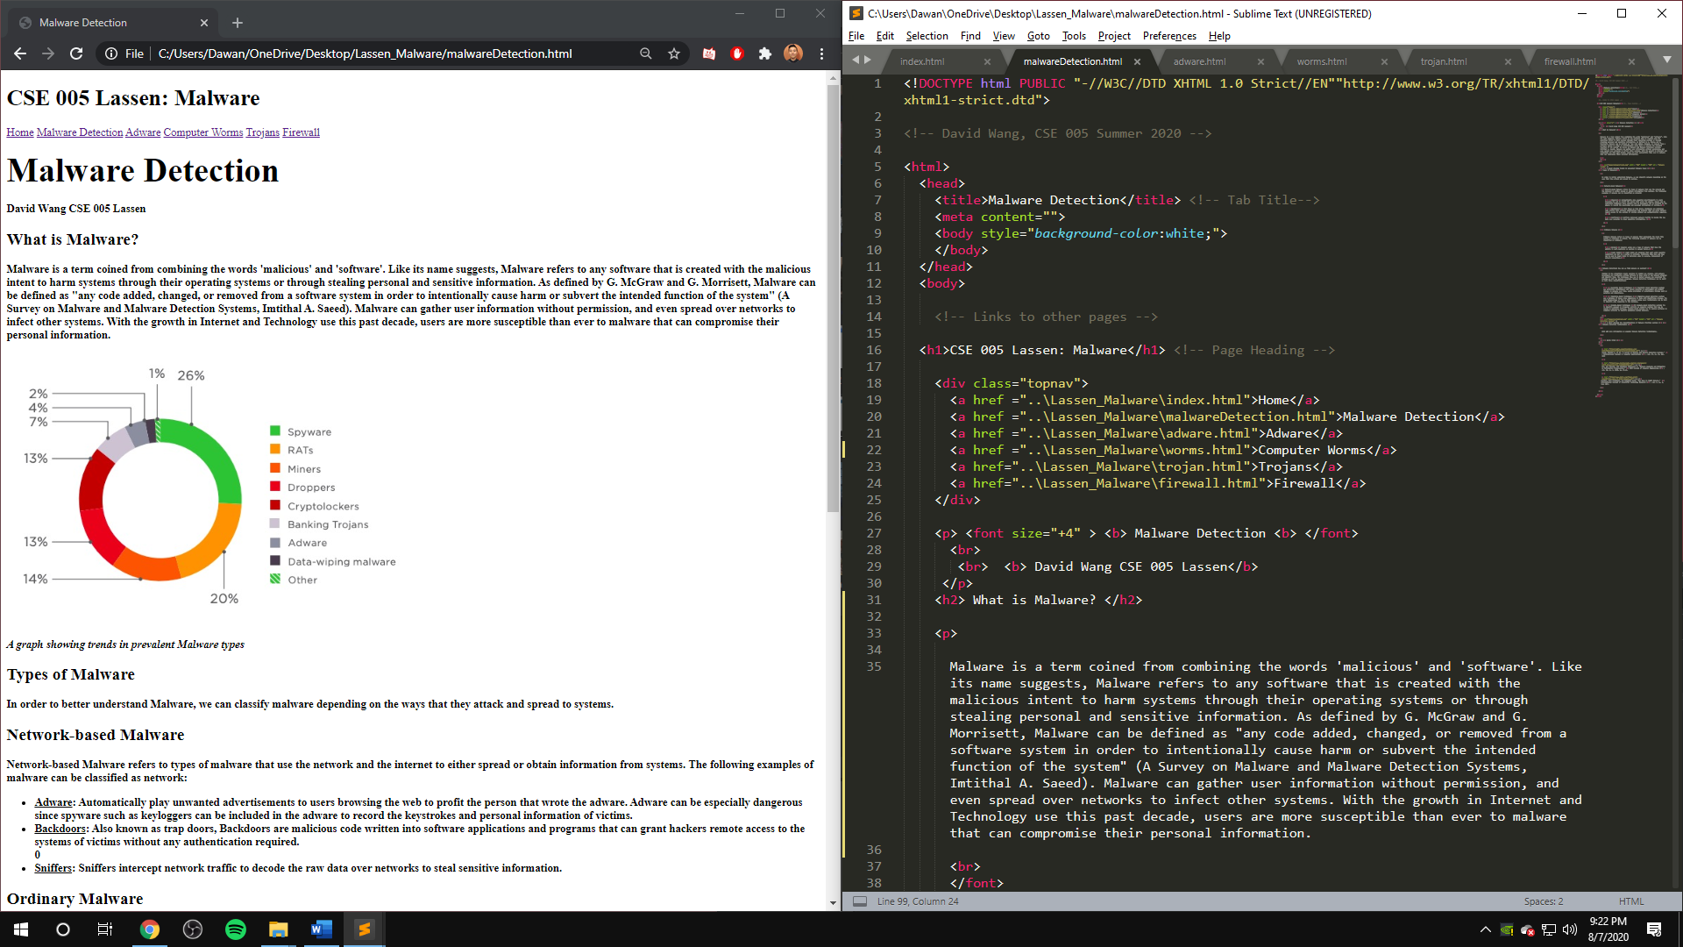

This is the Malware Detection page, written by David. The links at the top of the page help navigate to the other pages on the site.

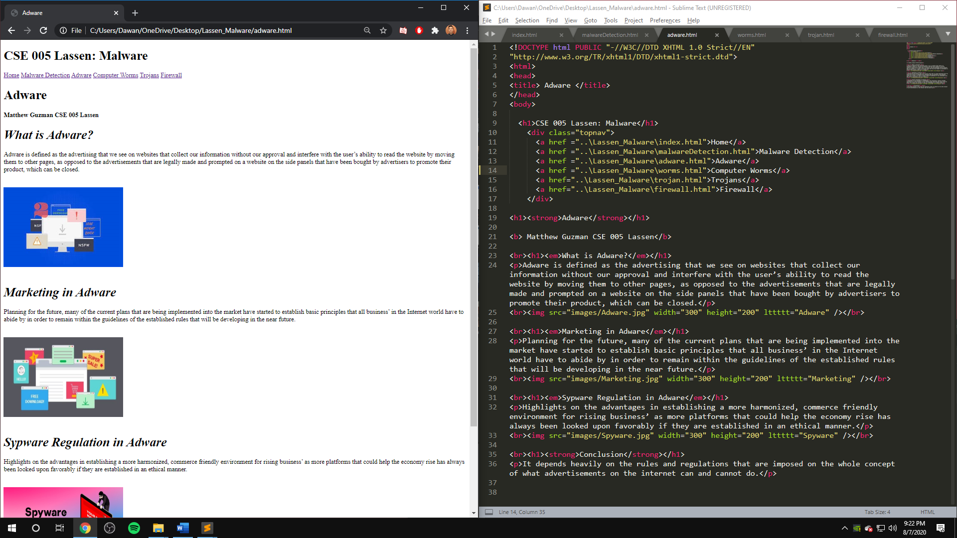

This is the Adware page, written by Matthew. The links at the top are for navigating between the other web pages.

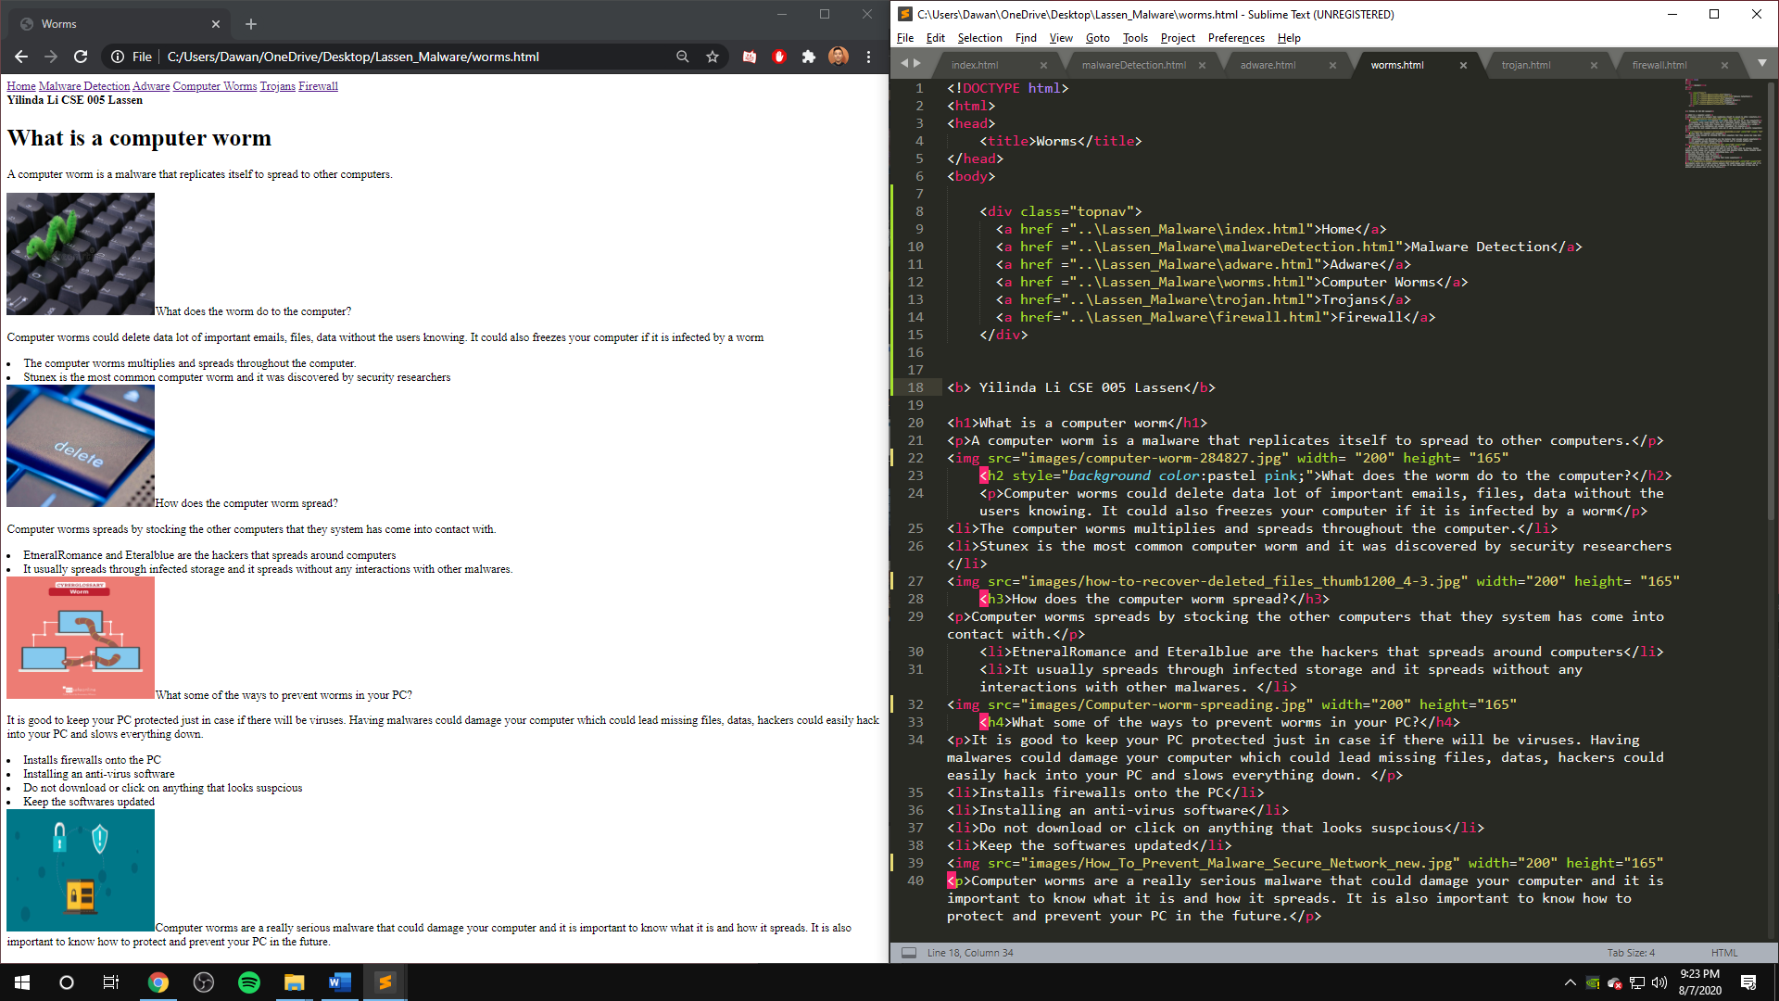

This is the Computer Worm page, written by Yilinda. The links at the top of the page are for navigating between the other pages.

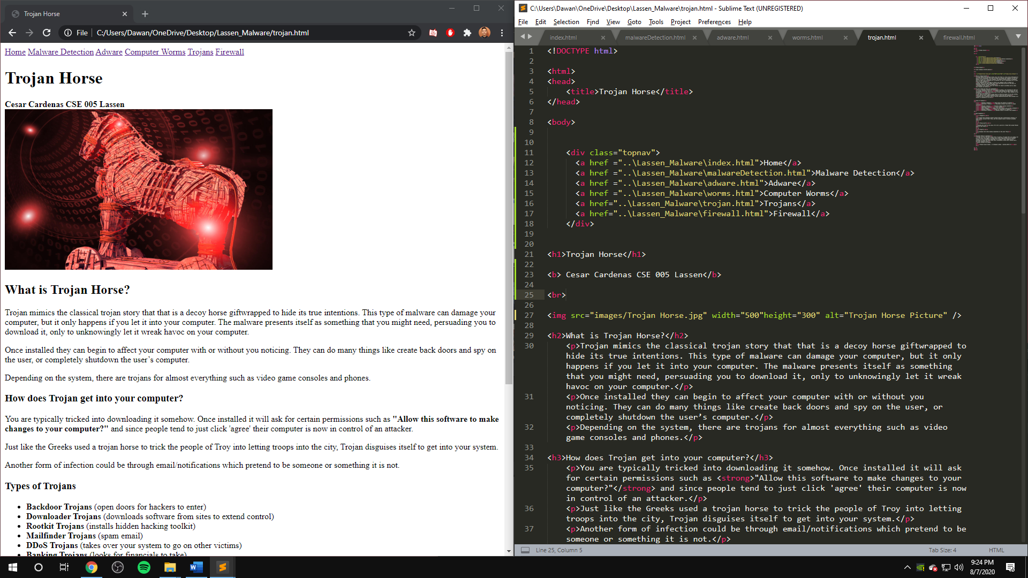

This is the Trojan Horse page, written by Cesar. The links at the top are for navigating between the other pages.

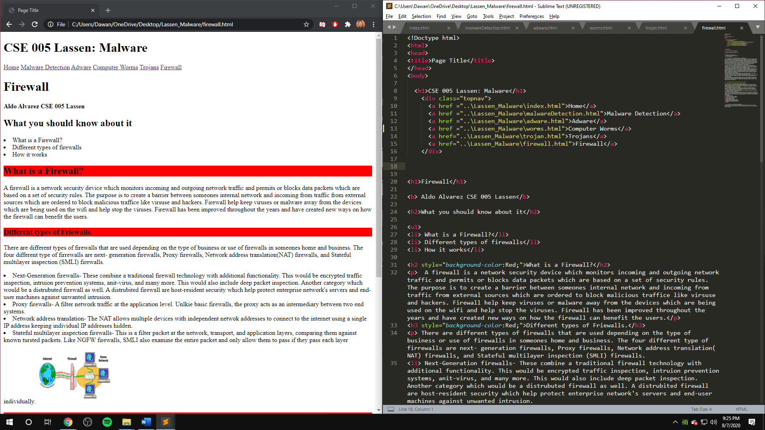

This is the Firewall page, written by Aldo. The links at the top are for navigating between the other pages on the site.

Images of full pages (Had to be shrunk to fit on screen completely)

