CSE185 Midterm exam 2 Name: David Wang

Academic integrity is the foundation of an academic community and without it none of the educational or research goals of the university can be achieved. Academic integrity applies to research as well as undergraduate and graduate coursework/exams. Existing policies forbid cheating on examinations, plagiarism and other forms of academic dishonesty. UC Merced students are held to high standards of personal and professional conduct in compliance with the UC Merced Academic Honesty Policy and the UCM Code of Student Conduct.

**UCM Code of Student Conduct can be found here:** [**http://studentconduct.ucmerced.edu**](http://studentconduct.ucmerced.edu/)

By completing this exam, I acknowledge and confirm that I will not give or receive any unauthorized assistance on this examination. I will conduct myself within the guidelines of the university academic integrity guidelines.

You must sign this form before taking the exam. You will not receive any credit if your signature (handwritten or digital) is not on this paper.

Name: David Wang

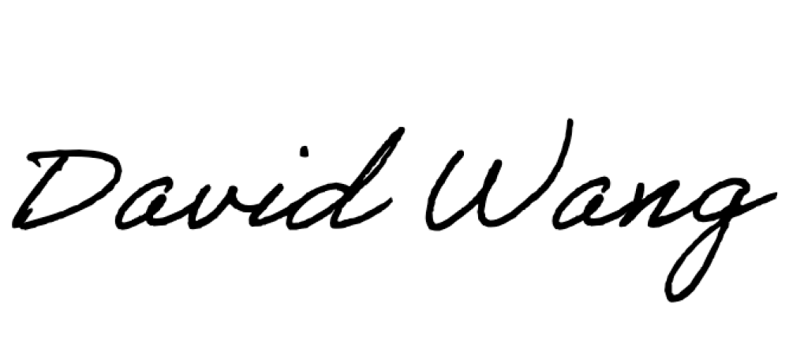Signature:

Note: 14 questions on both sides, maximum 100 points.

1. [5 points] Let 𝑓 be an image and 𝑔 be a Gaussian filter. When we compute 𝑥 image gradient, why do we want to apply Gaussian filter first, i.e., ! (𝑓 ∗ 𝑔)?

!"

Applying a Gaussian filter first allows us to smooth the image, reducing noise and removing unwanted details and textures.

1. [5 points] Let 𝑓 be an image and 𝑔 be a Gaussian filter. When we compute 𝑥 gradient, why can we first compute ! 𝑔 and then convolve an image f with ! 𝑔 ? What are the

!" !"

advantages?

1. [5 points] Let 𝑓 be an image and 𝑔 be a Gaussian filter. When we find the zero crossing on the 𝑥 image gradient, why can we convolve an image f with !! 𝑔 directly? What are the

!"!

advantages?

1. [5 points] Canny edge detector. Which of the following statement is true? Explain your answers for full credits.
   1. Non-maximum suppression is used to select a pixel that is close to the true edge
   2. The edges found by a Canny edge detector are determined by the Gaussian kernel scale
   3. In hysteresis process, we start with low thresholds and then high thresholds
   4. a, b and c are correct
   5. a and b are correct

The answer is **e:** a and b are correct. c is false since with the hysteresis process we start with high then low thresholds, thus d is false as well since it assumes c is true. a and b are both true, therefore the answer is **e.**

1. [10 points] For Harris point detector, the second moment matrix at a pixel 𝑝 is computed by

𝐼# 𝐼 𝐼

𝑀 = + " " $- where 𝐼", 𝐼$ are 𝑥 and 𝑦 image gradients. Let the first and second eigenvalues

𝐼$𝐼" 𝐼#

$

of 𝑀 be 𝜆%, 𝜆#, 𝜆% ≥ 𝜆#. Explain why the eigenvalues can tell us the whether we find an edge, corner, or flat region at pixel 𝑝?

1. [10 points] For Harris point detector, the corner response 𝑅 = det(𝑀) − 0.04 𝑡𝑟(𝑀) where det

𝐼# 𝐼 𝐼

and tr are the determinant and trace of a matrix. For a point where 𝑀 = + "

" $- =

𝐼$𝐼" 𝐼#

$

<0.8 0.2@ where 𝐼", 𝐼$ are 𝑥 and 𝑦 image gradients, is this point on an edge? a corner? or a flat region?

0.2 0.9

1. [5 points] Hough transform. Given one points (x, y) = (2, 6) in the image plane, write down the corresponding line in the Hough parameter space (describe a line in terms of m and b, your answer should be m= ).

Haugh Space: m = (-1/x)b + (y/x)

Plugging in the point (2, 6) should give m =

1. [5 points] Which of the following statements regarding line fitting is true?
   1. Line fitting with least squares minimization gives a closed form solution.
   2. Line fitting with least squares minimization is not sensitive to outliers.
   3. Hough transform can be efficiently applied to model fitting with a large number of parameters.
   4. Model fitting with RANSAC does not the same answer every time.
   5. a and d are correct
2. [5 points] Which of the following statements is true when we use RANSAC to fit data points with an objective function?
   1. Applicable to an objective function with more parameters than the Hough transform
   2. Optimization parameters are easier to choose than Hough transform
   3. Computational time grows quickly with fraction of outliers
   4. Not good for getting multiple fits
   5. a, b, and d are correct
3. [5 points] Which of the following statements regarding 2D transformation are correct?

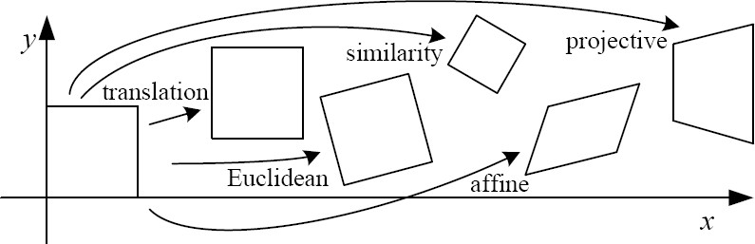

* 1. Euclidean transformation has 3 parameters
  2. Similarity transformation has 4 parameters
  3. Affine transformation has 6 parameters
  4. a, b, and c are true
  5. a and c are true

1. [10 points] Given a pair of stereo images. Show every step on how to compute depth 𝑍 =

𝑓 &

""'"#

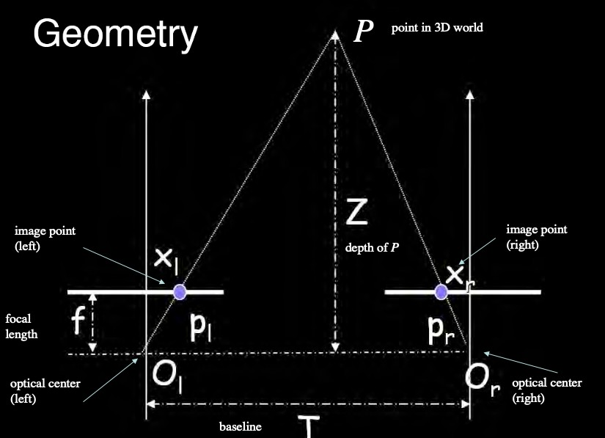

1. [10 points] Which of the following statements are true? Explain your answers.
   1. Given a pair of images from a calibrated stereo camera, for each pixel in one image, we can use the essential matrix to compute the corresponding epipolar line in the other image
   2. Give a pair of images from an uncalibrated stereo camera, for each pixel in one image, we can use the essential matrix to compute the corresponding epipolar line in the other image.
   3. Epipolar lines are always horizontal lines on an image
   4. When we use larger window for search correspondence, we can capture more details
   5. a and c are correct
2. [10 points] Given a pair of left and right images for a calibrated stereo camera, which of the following statements for the calibrated stereo camera are true? Explain your answers.
   1. Given one point in one image, the corresponding point in the second image of a stereo par is on a line passing through its epipole.
   2. We can use the essential matrix to map a point in the left image to a line in the right image.
   3. Depth is inversely proportional to disparity
   4. a and c are correct
   5. a, b and c are correct
3. [10 points] Epipolar geometry. Given a point P in the world coordinate with two mapped points p and p’ on two image planes with two optical centers O and O’. Derive the following equations.

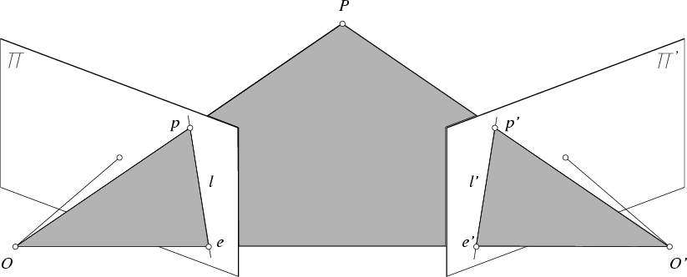

Explain every step (what does the cross product of two vectors do and what does the inner product of two vectors do?) to earn full credit.