Lab2 05: Research Project Milestone 4 – Website Coding

Lassen Group: Aldo Alvarez, Cesar Cardenas, David Wang, Matthew Guzman, Yilinda Li

**Summary of website progress:**

As of this week, we are starting on the implementation phase of our project. Last week we planned out the overall structure of our website from homepage to subtopic pages and individual page content. Currently, we are working on taking our research from previous weeks and using it to create an HTML page for each subtopic. After all the subtopic pages are finished, we can use the <a href = > tag to link the home page, index.html, to the subtopic pages.

Listed below are each of our group’s members, and their respective tasks for this milestone:

**Aldo:**

-Set up the homepage with tags which can be clicked to have subtopics. I am currently working on the page for the subtopic what a firewall does.

-created html for each subtopic but haven't done anything else for them yet. Need to work a little more on the subtopics.

I'm going to start separating the section of the main subtopic page which is the firewall.

I separated the subtopic pages and need to add a little more content.

**Cesar:**

* My subtopic portion is mainly focused on the trojan horse section. I will be finishing up a html web on this, adding details, data, graphs, images, etc.
* I’m mainly planning to follow the same format of what I did when creating our practice webpage.
* I’ve planned out how I’m going to format everything throughout this week.

**David:**

* Set up the homepage, index.html, with <a href> tags to provide clickable links to the subtopic pages. Currently working on design for the homepage
* Created an html document for my subtopic page on Malware Detection
  + Split page into sections about History of Malware, Malware Detection Techniques, and Malware Propagation and Attack Techniques
  + Adding images to supplement information

**Matthew:**

-Wrote a short excerpt for each of my 3 subcategories in Adware

-Wrote a html code for what I wanted it to look like

-Added Pictures to add a “wow” factor

-Made a conclusion for my html page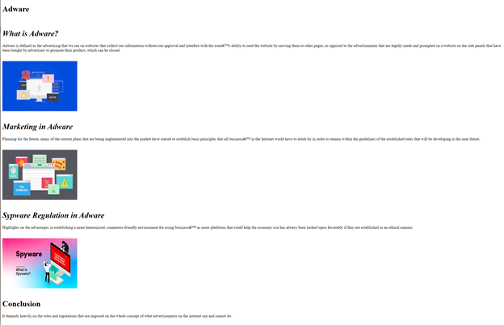

**Yilinda:**

-wrote short paragraphs for my subtopics

-set up the homepage with the necessary tags to lead to the subtopics such as worms and ways to prevent malwares

-still have not yet added datas, graphs, or the softwares to prevent it

-wrote html code for the website