Roderick Buo

CSE 005-05L

2/4/2020

Lab 1-2 Digital Media

**1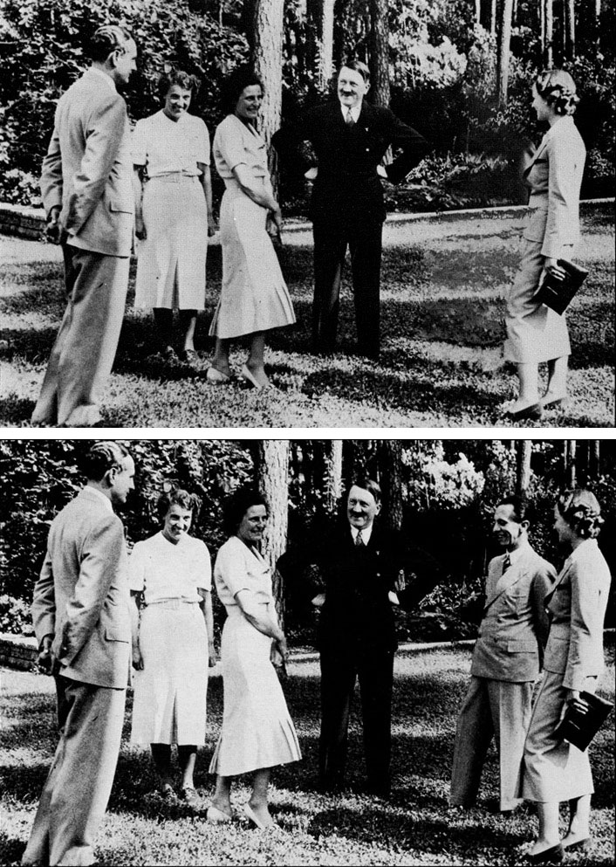)** I think that this photo is misleading due to it just being an empty space between the people in the cneter and the right. Upon closer observation, you can notice the shadow becoming lighter. I probably would have not notice, if I did not know it was photoshopped or take my time looking at the photo.

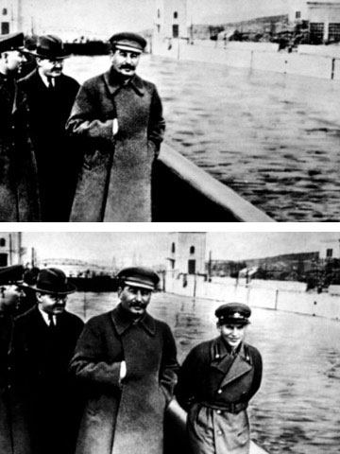

This photo is more difficult to notice than the previous photo because they changed more than the area of the person removed. I noticed that the whole body of water was lighter. The body of water becoming lighting made the blurred area of the removed person harder to see.

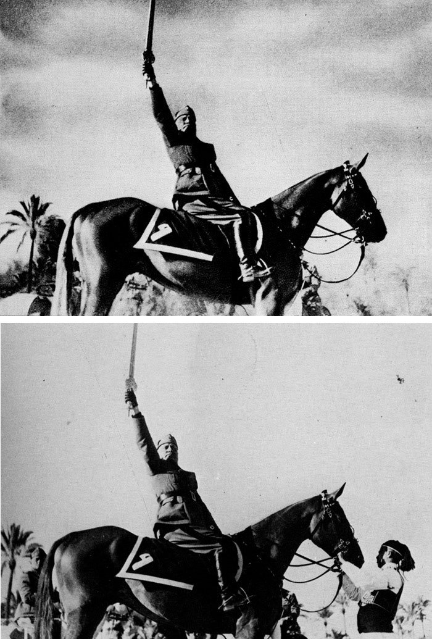 This photo was photoshopped quite well. The background was already out of focus, so it was easy to remove the horse handler without disturbing the background. They also added clouds which was easy to add to the background without disrupting the center piece’s focus.

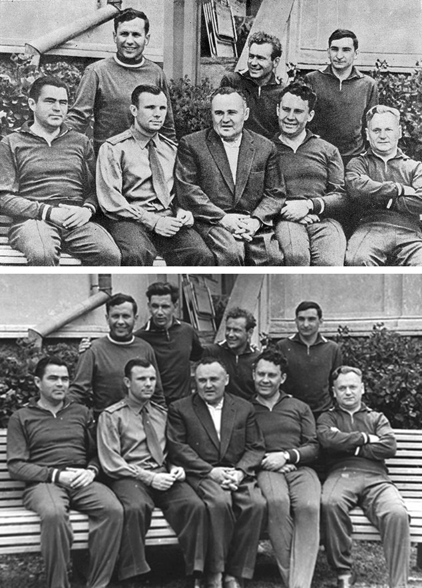

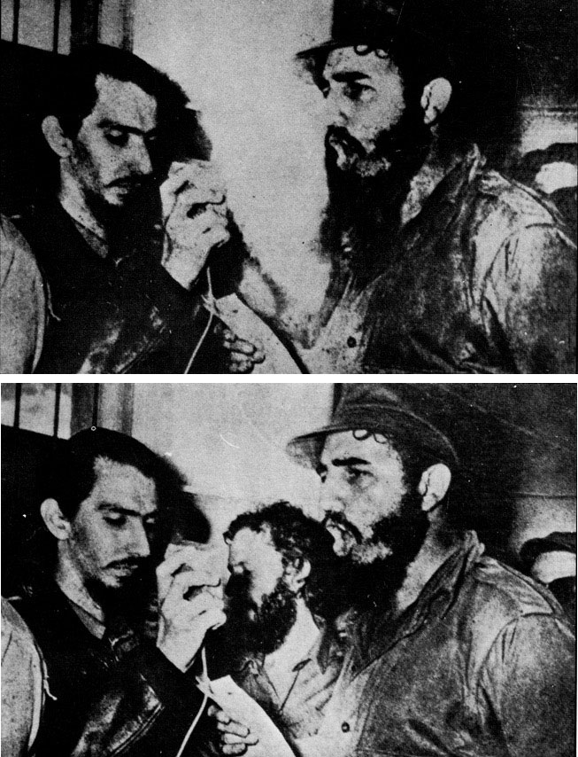 The photoshopped area was hard to notice because the bush that replaced the person wasn’t blurry.

The person who was photoshopped out became a blank white wall. It would be hard to notice that its photoshopped because there was little effects to add to the blank wall. The biggest flaw was shadow of the left person’s hand.

**2)**

* The poles of the fence were removed.
* The tree on the left was removed
* The lens flare from the sun was reduced.
* The road was removed
* The sky and bushes were added to fill the gap.

**3)**

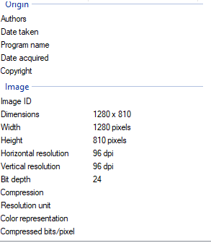

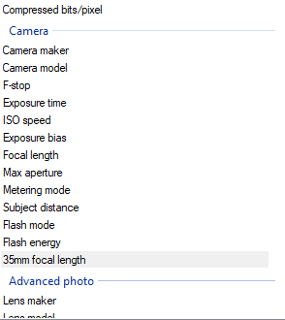**4)**

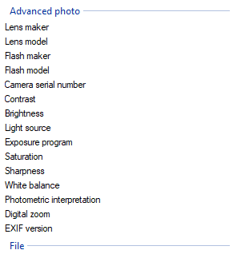

**5)**

Research Paper: A 3-D Lighting and Shadow Analysis of the JFK Zapruder Film (Frame 317) by Hany Farid

They concluded that the shadow of the head was physically possible, but they cannot confirm if the film was altered or not.