ENCM 511 Assignment2

Preamble

The above definitions have been added at the start of the code to improve readability. Their corresponding pin mapping may be referenced in the image above. LED2 is unused in this lab and is commented out for that reason. Global ISR priority and debounce time variables have also been created to allow for easy adjustment.

Peripherals

Above is the IO_init, timer_init, and delay_init functions to be called at the beginning of main to configure IO pins and timers on the microcontroller. Line functions are elucidated by their comments.

Datatypes and Initialization

The state variable will be in the range of 0 to 3 and thus is an unsigned 8bit integer.

The pb_event variable will hold 1 or 0 and thus is an unsigned 8 bit integer.

The bp2_last variable will hold 1 or 0 and thus is an unsigned 8 bit integer.

The LED0_last variable will hold 1 or 0 and thus is an unsigned 8 bit integer.

The LED1_last variable will hold 1 or 0 and thus is an unsigned 8 bit integer.

Operation

The code begins by calling all three initialization functions before entering its while loop and going into idle.

Assuming this is the first run of the program, i.e. no timers are going, the microcontroller will remain in idle until one of the push buttons triggers an IOC interrupt.

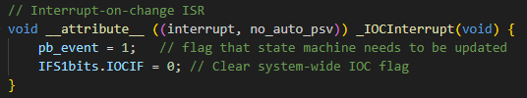

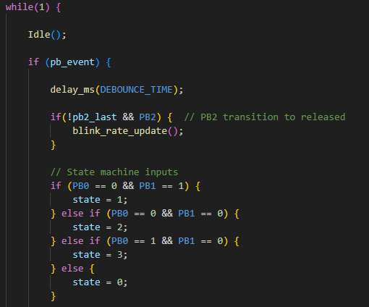The IOC ISR will then cause the pb_event variable to be set. The flag is then cleared, and the program returns to main.

After getting out of idle, the programs checks to see if the pb_event flag was asserted. This is to verify that the reason for exiting idle was a pb event rather than a timer before doing any logic.

After verifying a pb event occurred, a debounce delay is incurred using the delay_ms function, this helps to avoid multiple high and low transitions on a button press.

After the debounce the program reevaluates which state it should be in based on the buttons, this is illustrated in the state diagram below.

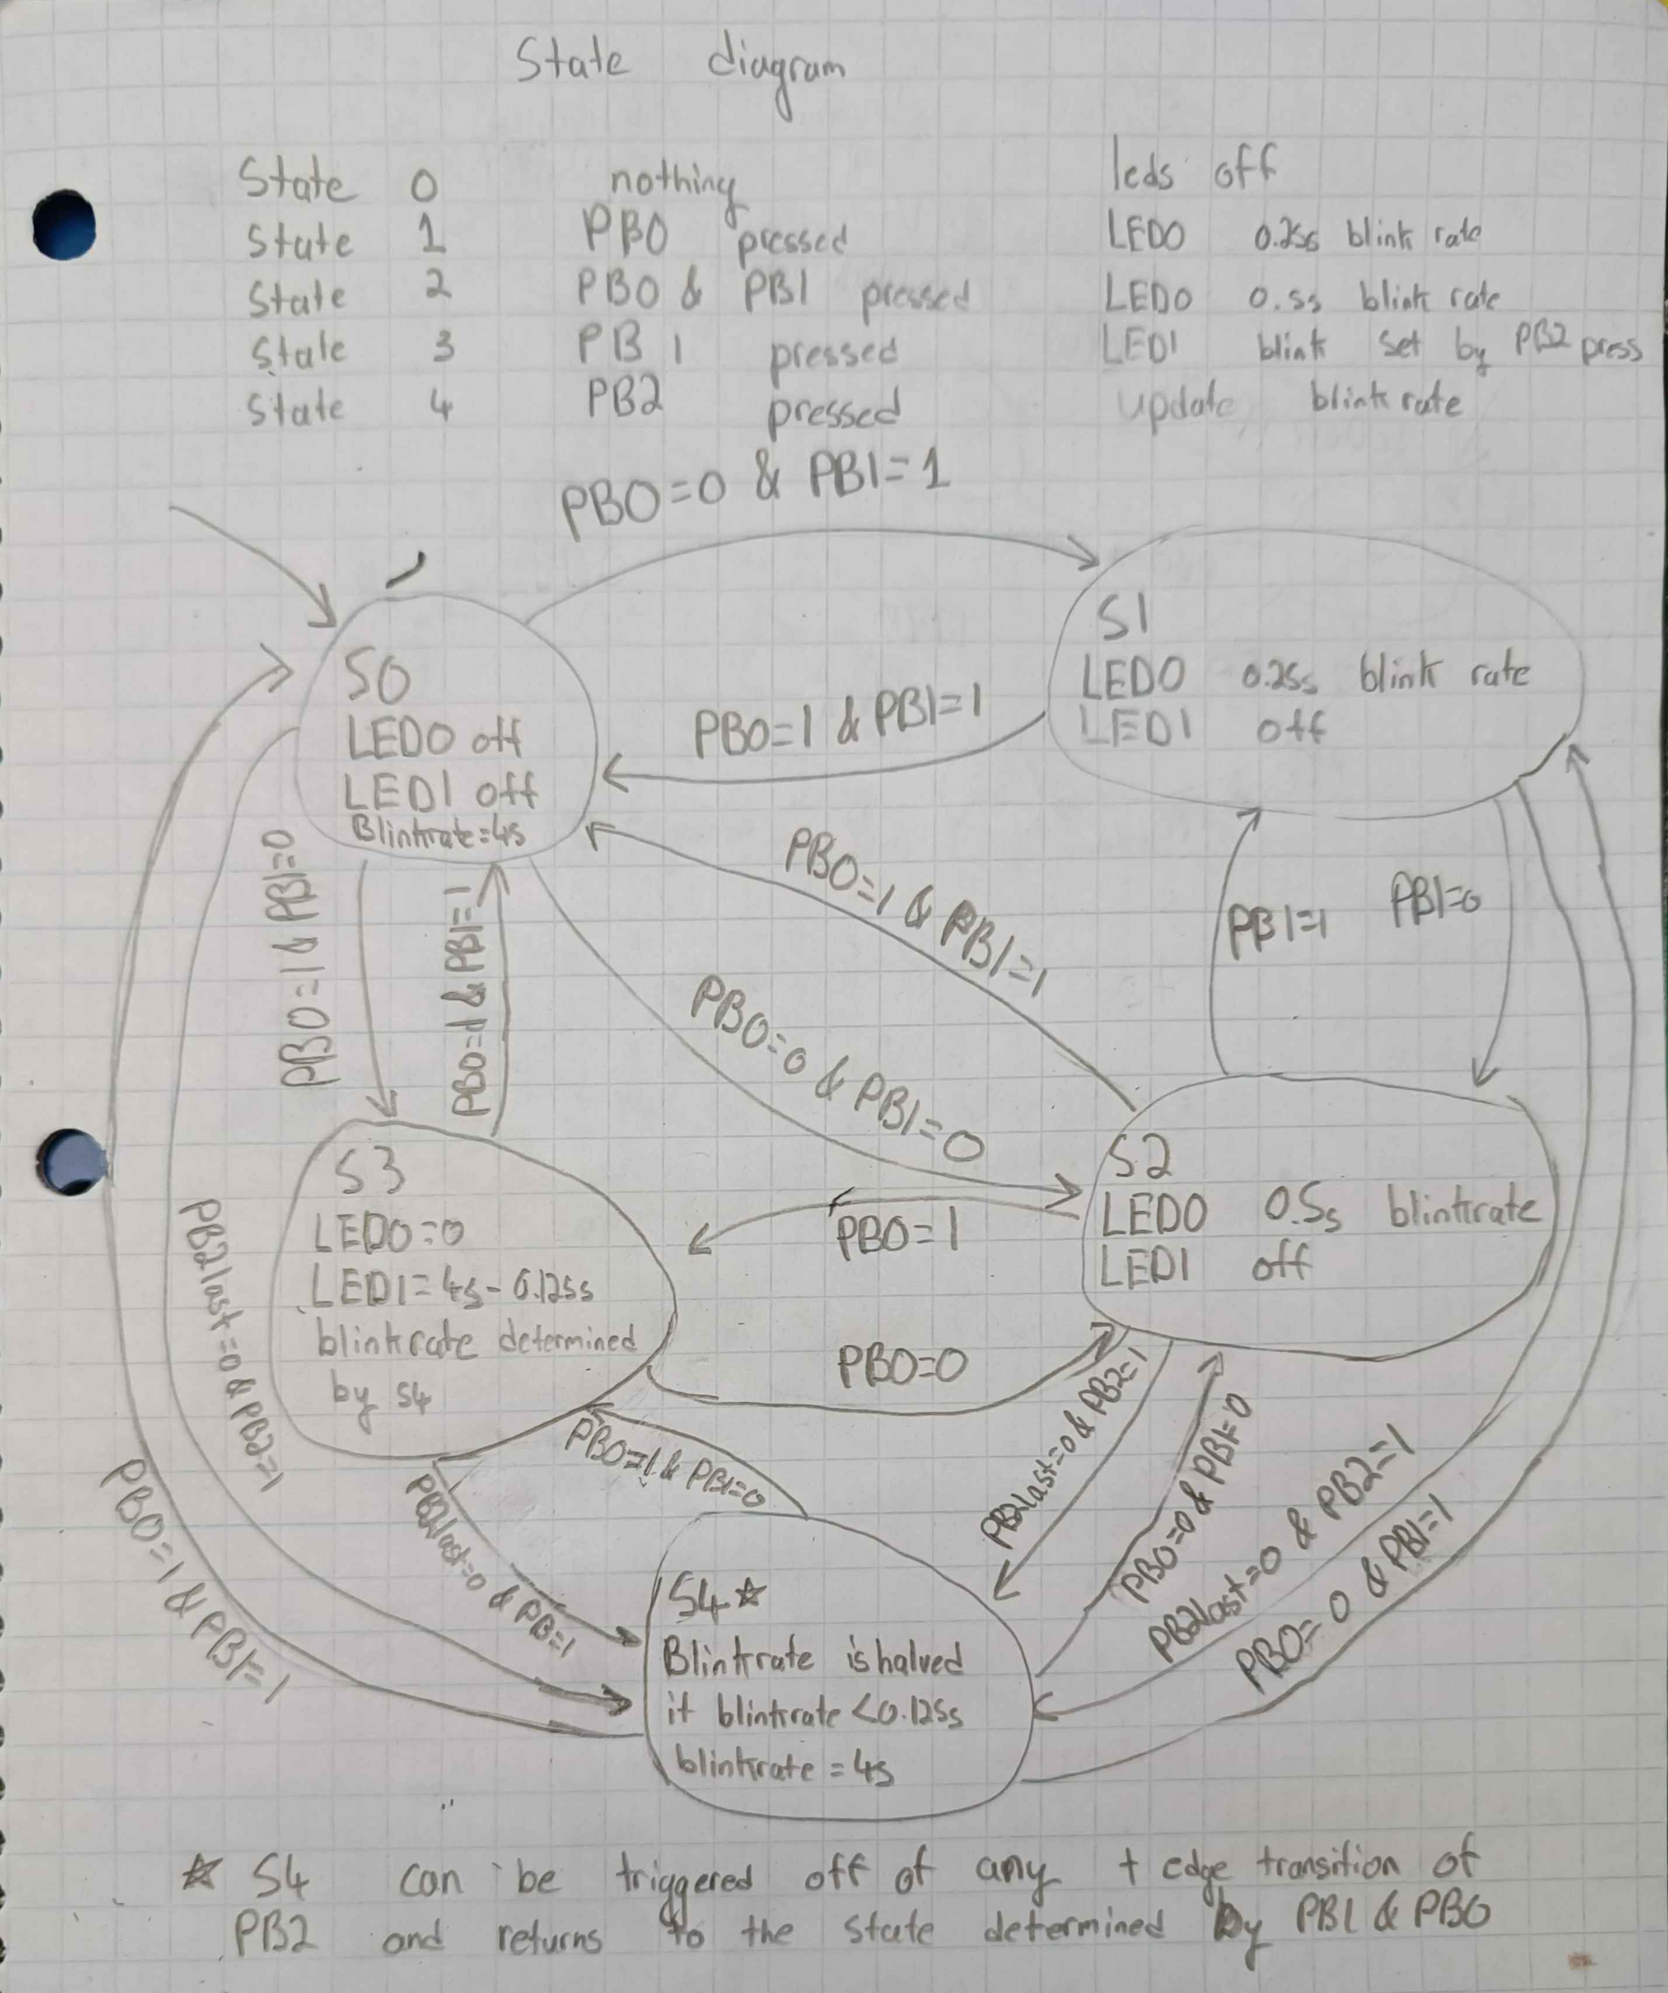\

In the case that the program detects that PB2 has been released, it enters the blink_rate_update function which updates the period of timer 3 which is the blink rate of LED1. First it checks to see if the blink rate is less than or equal to the lowest blink rate of 0.125s, if that’s true it resets the blink rate to 4s. Otherwise it simply divides the blink rate by 2. TMR3 is also check to catch the case of it exceeding the value of PR3, if PR3 ends up above the value of TMR3 the timer does not trigger an interrupt until PR3 reaches its makes value and resets before counting to TMR3 again.

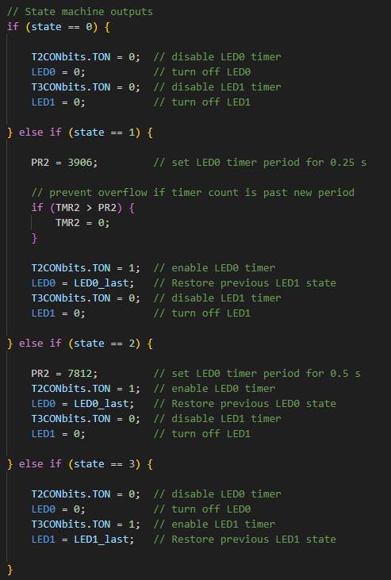

The program then updates the appropriate timers and LEDs as per the assignment specifications. See state diagram for more details.



Finally, the pb_event is reset so it can wait for the next button input and the state of PB2 is saved in pb2_last so it can be compared in the future to determine in a press-and-release has occurred. The microcontroller then returns to idle.

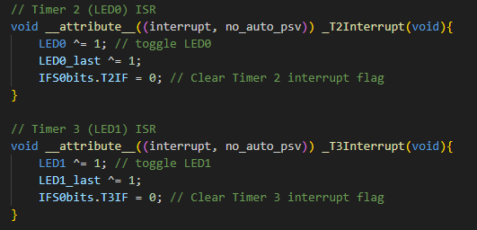

Idle may now be exited by one of Timer 2 or Timer 3 (depending on the current state) as well as by a button input. Upon a timer interrupt the ISR toggles one of LED0 or LED1 and saves its state in LEDx_last before clearing its interrupt flag and returning to main.

Answers to Lab Questions

*In the original provided program, why does the LED appear to “flash” every time you “click” a button (quickly)?*

Because multiple interrupts are occurring as the button “bounces” which causes multiple high-low and low-high transitions.

*If you press a button and hold it there, does the IOC interrupt service routine keep executing repeatedly? If so, why? If not, why not?*

No, the IOC does not repeatedly trigger on a button being held down as it only interrupts on a change (i.e. low to high or high to low transition).

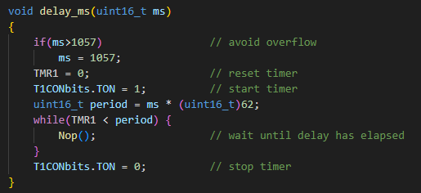*Explain your implementation of void delay_ms(uint16_t ms). How do you guarantee that the delay works across the range of possible input values? What combination of clock/prescaler/PRx values do you use? What is the maximum delay you can use for the FOSC and timer prescaler setting?*

The maximum delay for the delay_ms function is 1057ms as any number larger will cause in overflow in the calculation. A prescaler of 64 was used to maximize resolution while still allowing up to 1 sec of delay.

*How many timers do you use? What do you use each timer for?*

Three timers are used, Timer 1 is used for the delay_ms function (which is used to debounce), Timer 2 and Timer 3 are used for blinking LEDs and specified rates.

*Explain your implementation of the IOC interrupt service routine, and your choice of IOC settings. How do you distinguish between a button press and a release? How about the different buttons?*

The IOC register is configured to trigger on high and low going transitions on all three buttons, this allows the detection of any change of state in the pressed buttons. To detect a press and release on push button 2 the previous state is stored. Iif the button was pressed in the previous state and is now high it is considered a press and release.