ENCM 511 Assignment 4

  - Preamble
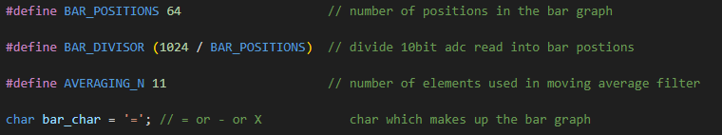
The above definitions have been added at the start of the code to improve readability. BAR_POSITIONS is the maximum number of positions in the bar graph. BAR_DIVISOR is used to divide the count of the ADC (1024 for the 10-bit ADC) to determine the correct number of bar graph characters. AVERAGING_N is the size of the moving average filter used to smooth out the ADC values. The bar_char is updated during runtime and dictates which characters compose the bar graph.
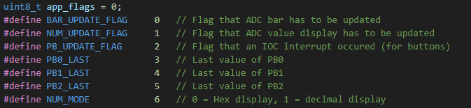
The app_flags bit field is used to keep track of flags to control program flow.
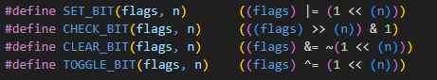
It is used in conjunctions with these helper macros to allow reading/writing of the bitfield.
Example above.

  - Peripherals
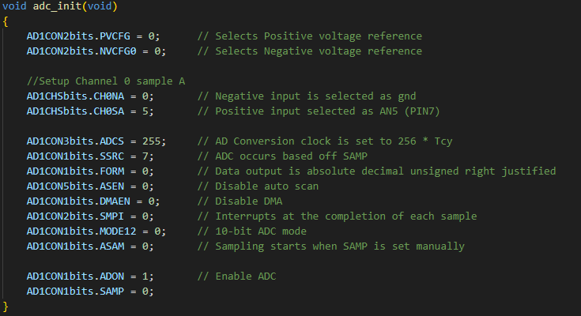
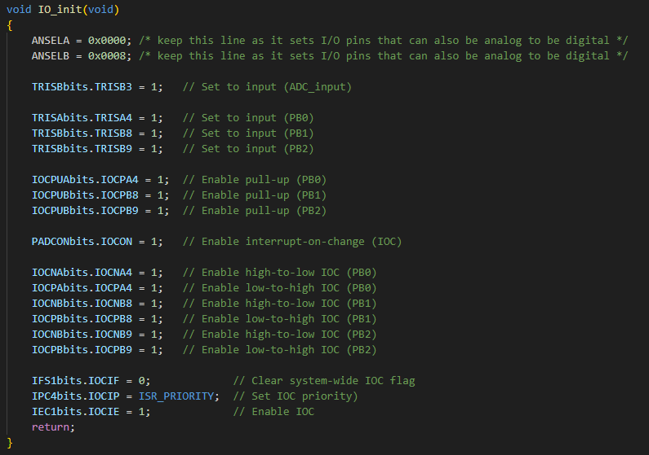
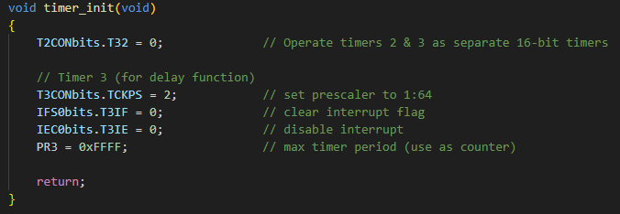
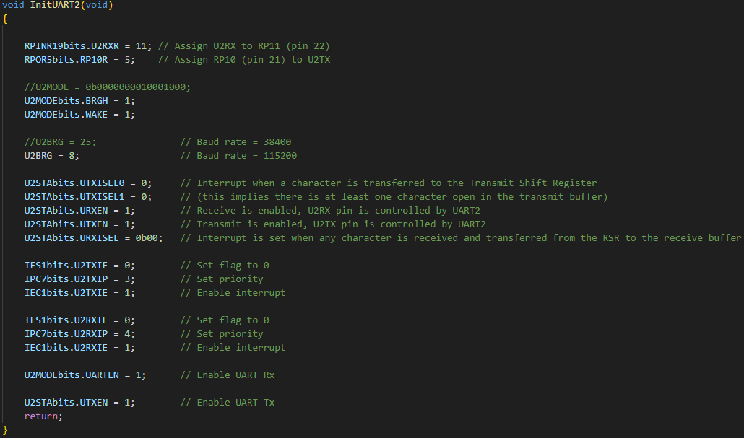
Above are the initialization functions to be called at the beginning of main. Line functions are elucidated by their comments.

  - Datatypes and Initialization
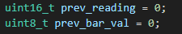
These two variables store the previous reading of the ADC and the previous value of the bar graph. The ADC reading is selected as uint16_t as we are using the ADC in 10-bit mode, and the previous bar value is selected to be uint8_t as we have 64 graphical elements for the graph. These are both used to compare the previous value with the new value to determine if the UART display must be updated (as opposed to constantly updating the UART display with the current value).
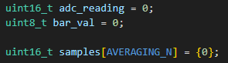
These are used to hold the new value from the ADC and the current bar graph value. The samples variable is part of the aforementioned moving average filter.

  - Operation
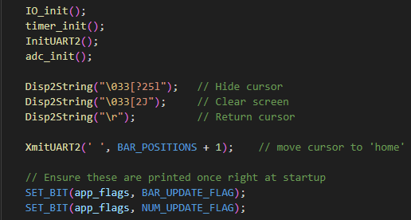
The code begins by calling all four initialization functions and then sending some ASCII commands to clean up the terminal and set the cursor to the ‘home’ position. It then sets the BAR_UPDATE_FLAG and NUM_UPDATE_FLAG to ensure that the graph is printed on startup.
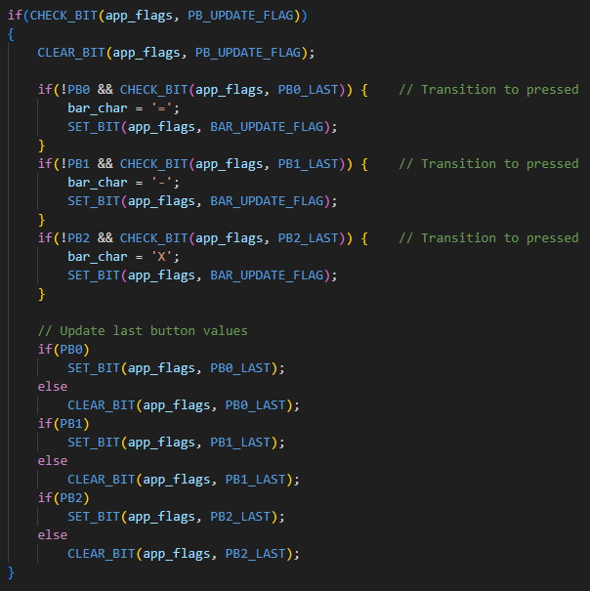
Inside the while(1) loop, the code checks to see if a button event has occurred, if it has it will compare each button position with its last state to determine if a button becomes pressed, after which it will update the bar_char value accordingly and raise the BAR_UPDATE_FLAG. Afterwards it will update the last state of each flag for each of the buttons to be able to determine if a button press has occurred next time.

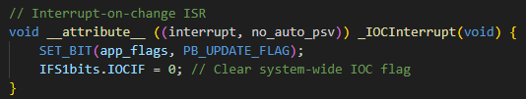
This is the where the PB_UPDATE_FLAG gets raised upon an IOC interrupt, after which the aforementioned button logic will run next time the while(1) loop repeats.
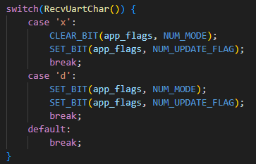
Next it reads the input from the UART and determines if the pressed key was either ‘x’ or ‘d’, if it is, it will update the NUM_MODE flag accordingly and also raise the NUM_UPDATE_FLAG. This informs the code that it needs to update that part of the terminal. If any other key is pressed, nothing happens.
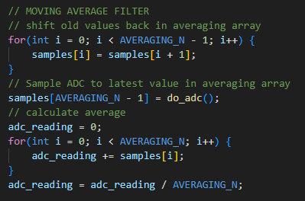
This section is where the moving average filter and ADC read occur. First, we shift the contents of the samples array down one index and update the highest index with the new ADC reading. Then we reset adc_reading (holding the value from last time) and sum the contents of the array before and then divide by the length of the samples array. This gives us a moving average filter to eliminate noise from the potentiometer and ADC.
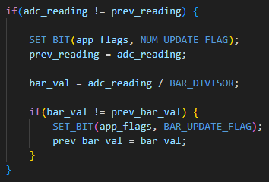
Next we check if the new value of the ADC differs from the previous, if so we must update the displayed number next to our graph. Then we divide the reading by the amount of bar positions which is 1024/64 = 16, this means that only when the ADC value changes 16 times a character changes on the screen. If the new bar_val differs from prev_bar_val, the BAR_UPDATE_FLAG is asserted.
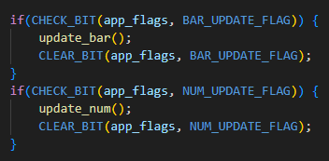
Finally, we check to see if the BAR_UPDATE_FLAG or NUM_UPDATE_FLAG has been asserted and call the corresponding function.
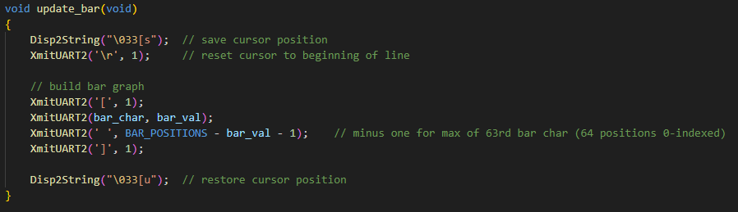
The update_bar function saves the ‘home’ position (between the graphical bar and the numerical output of the ADC value), goes to the beginning of the line and prints the selected bar_char, bar_val times the rest of the space is filled with a blank space. The cursor is then returned to the ‘home’ position.
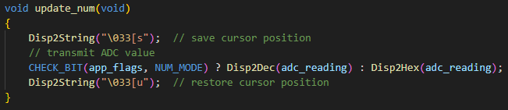
The update_num function also saves the ‘home’ position, checks to see if NUM_MODE is high and displays the adc reading in decimal or if its low displays the adc reading in hex and then returns the cursor.
At the end of all this we delay for 10ms so slow down this loop.
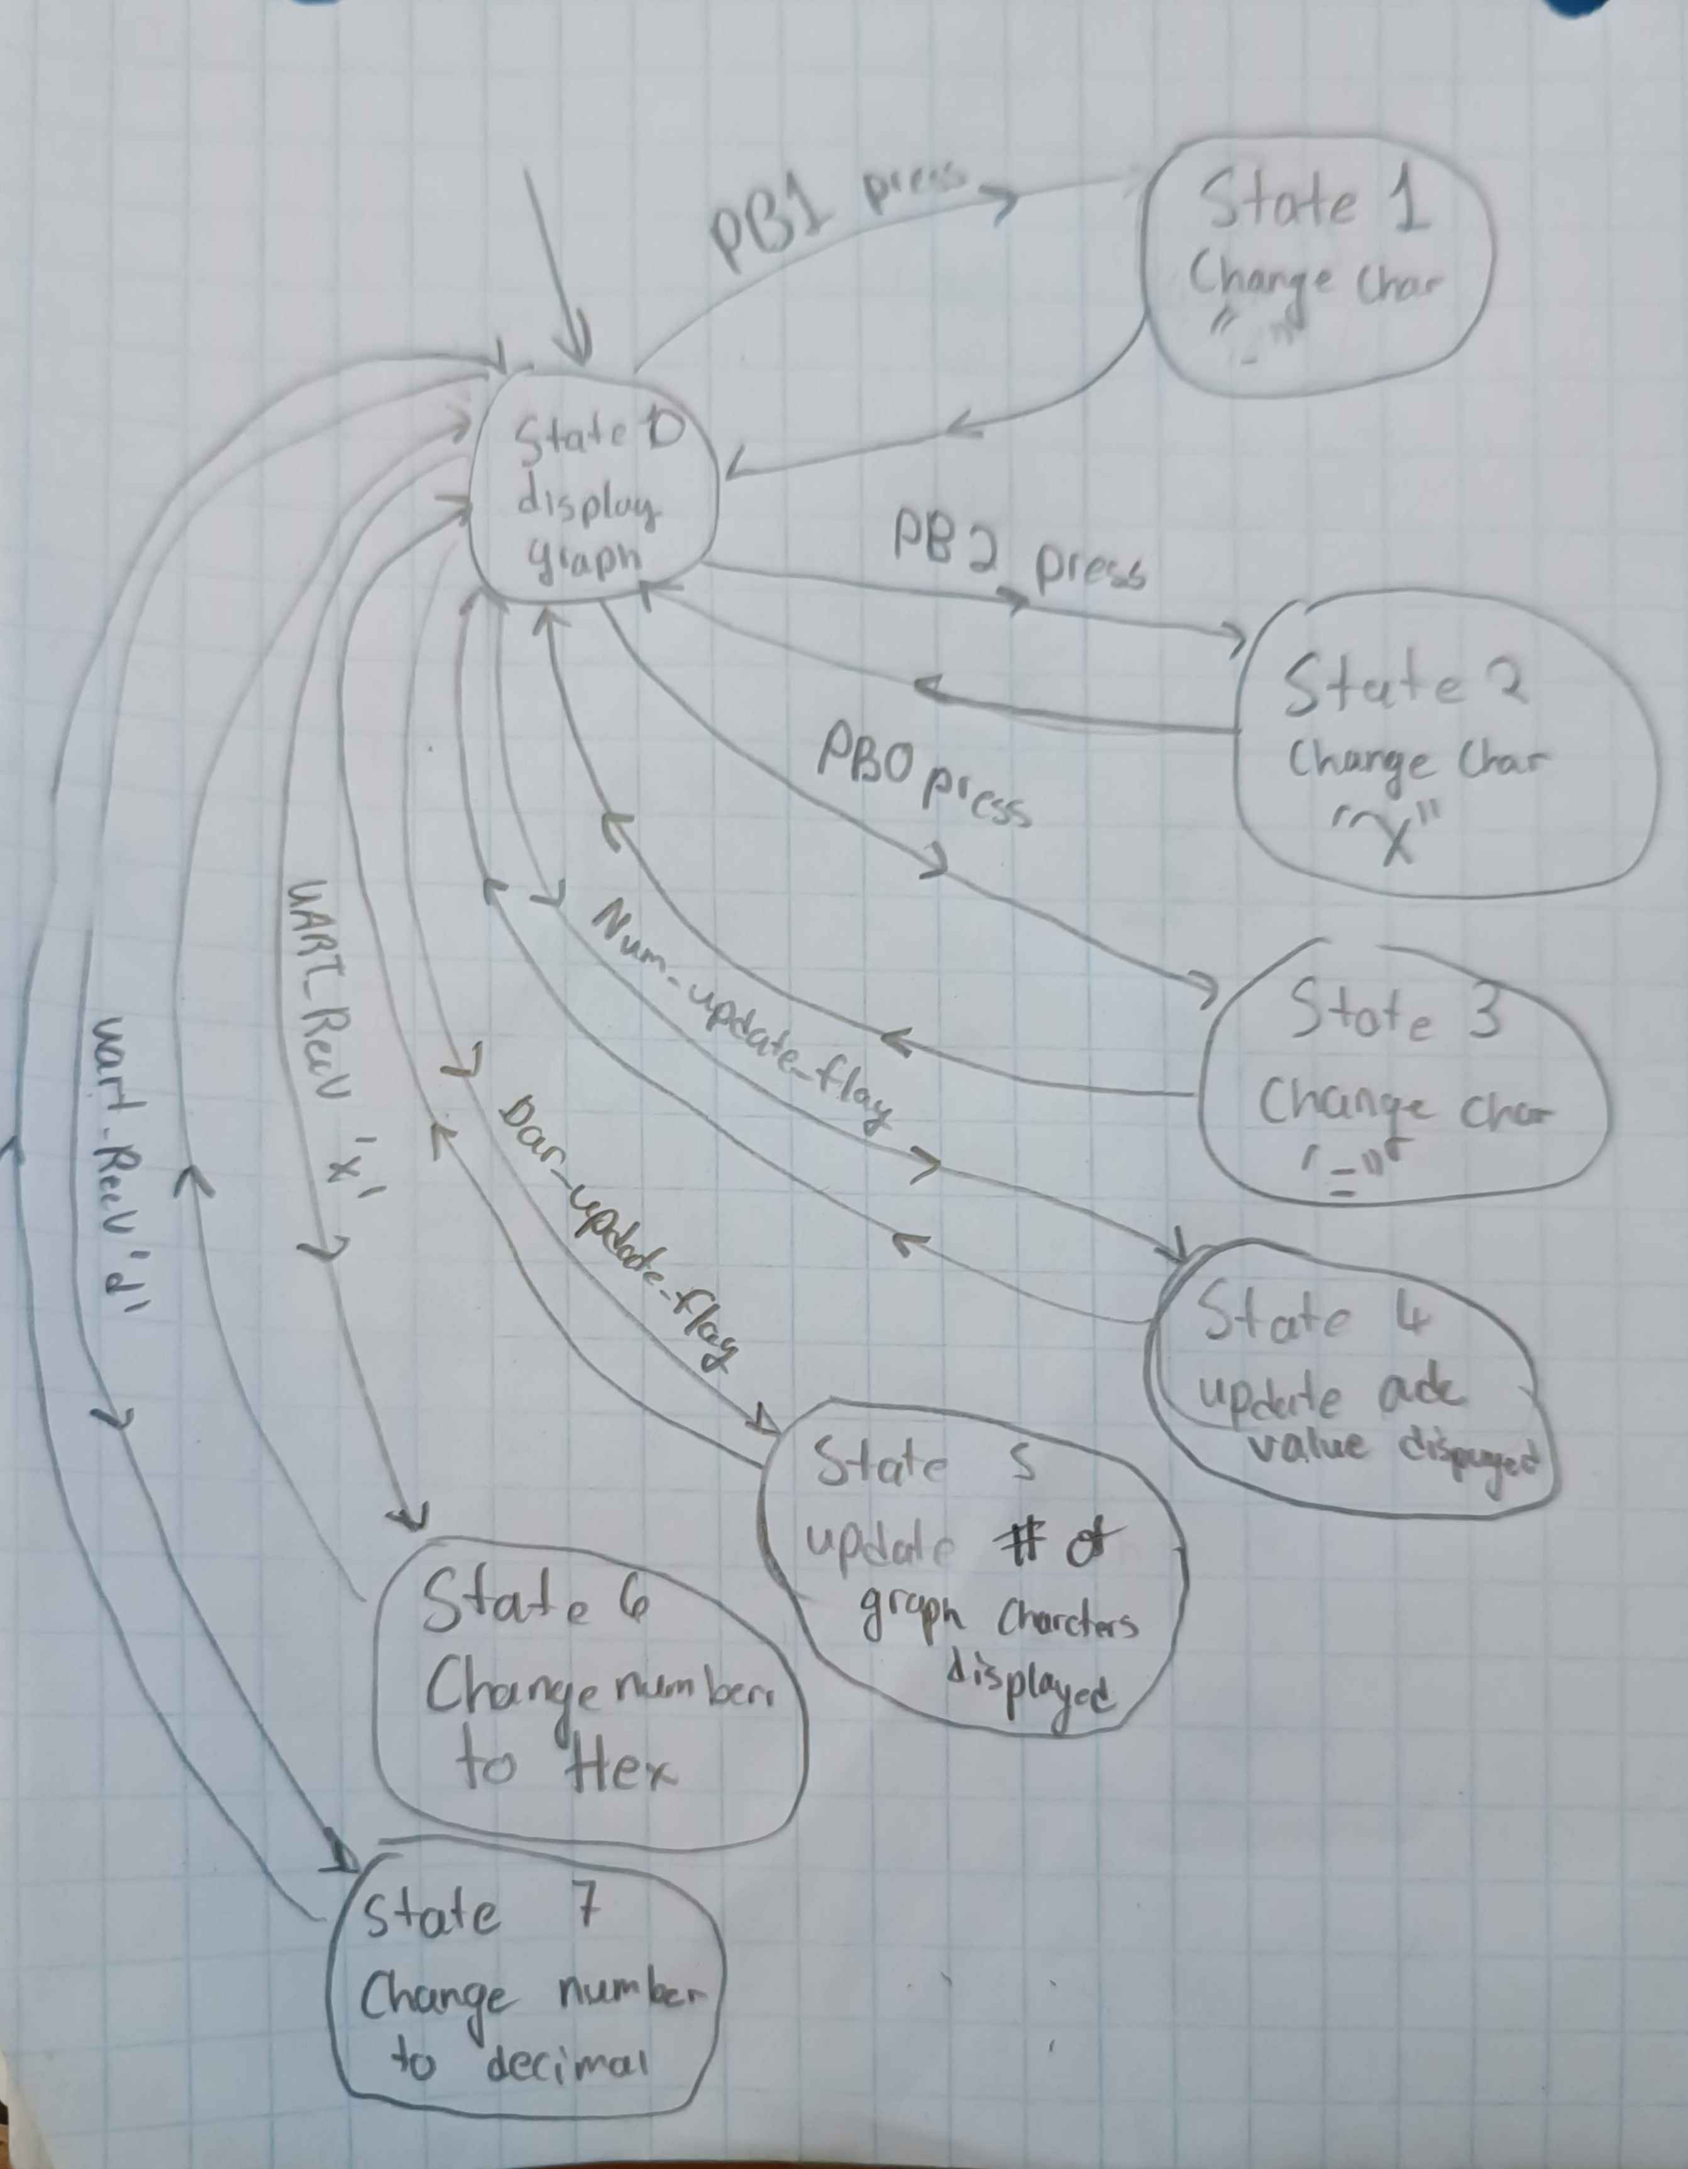
This is the state diagram based off the code. Each state simply changes a part of the ASCII terminal display and then it immediately goes to state 0, where it waits for an input to change.

  - Answers to Lab Questions
In your assignment part, how do you accept the keyboard press at any time?
Whenever a UART character is received it is immediately loaded into the U2RXREG register by hardware and an interrupt flag is set. When the interrupt occurs, the value is then loaded into the received_char variable. Then when the RecvUartChar function is eventually called from the main loop, the program reads the value in the received_char variable.
How did you setup the ADC?
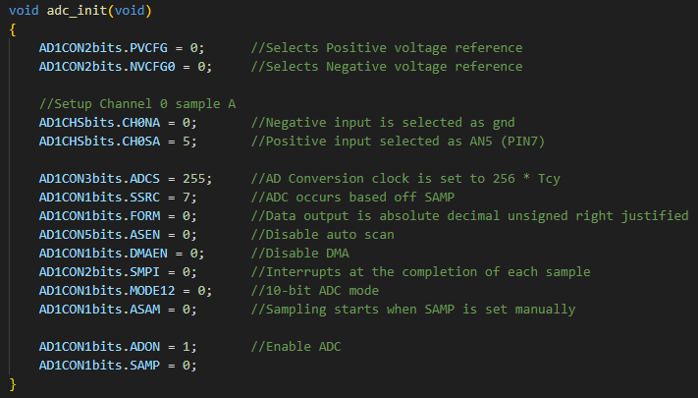
Some highlights of the init function are, we set MODE12 to zero to select 10 bit ADC mode, set ASAM to zero to enable sampling when the SAMP bit is manually set, and we set FORM to zero to have the contents of the ADCBUFF to be absolute decimal values of the ADC steps and they are unsigned right justified so that the content are in the lower part of the 16bits of ADCBUFF0.

