ENCM 511 Final Project

Common
A set of common source and header files (common.c/common.h) are used to define commonly used helper macros and other global variables used across other source files in the program.
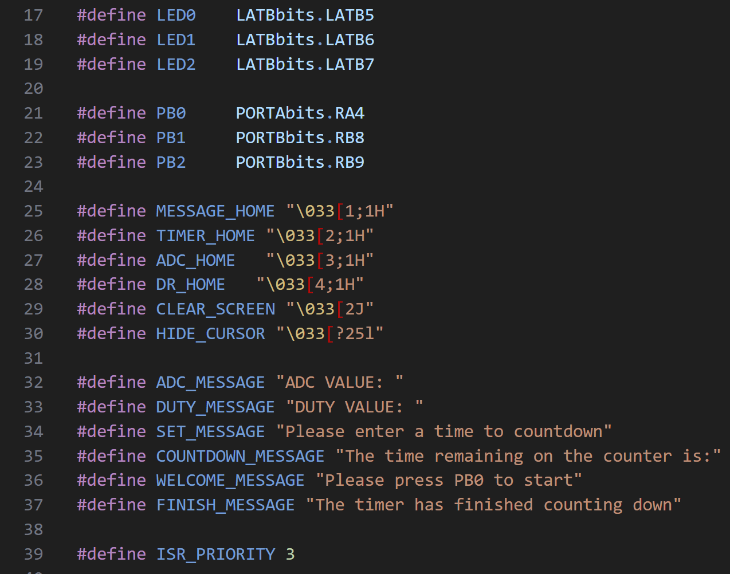
Shown above are various macros to improve code readability and prevent repetition of hardcoded literal values.
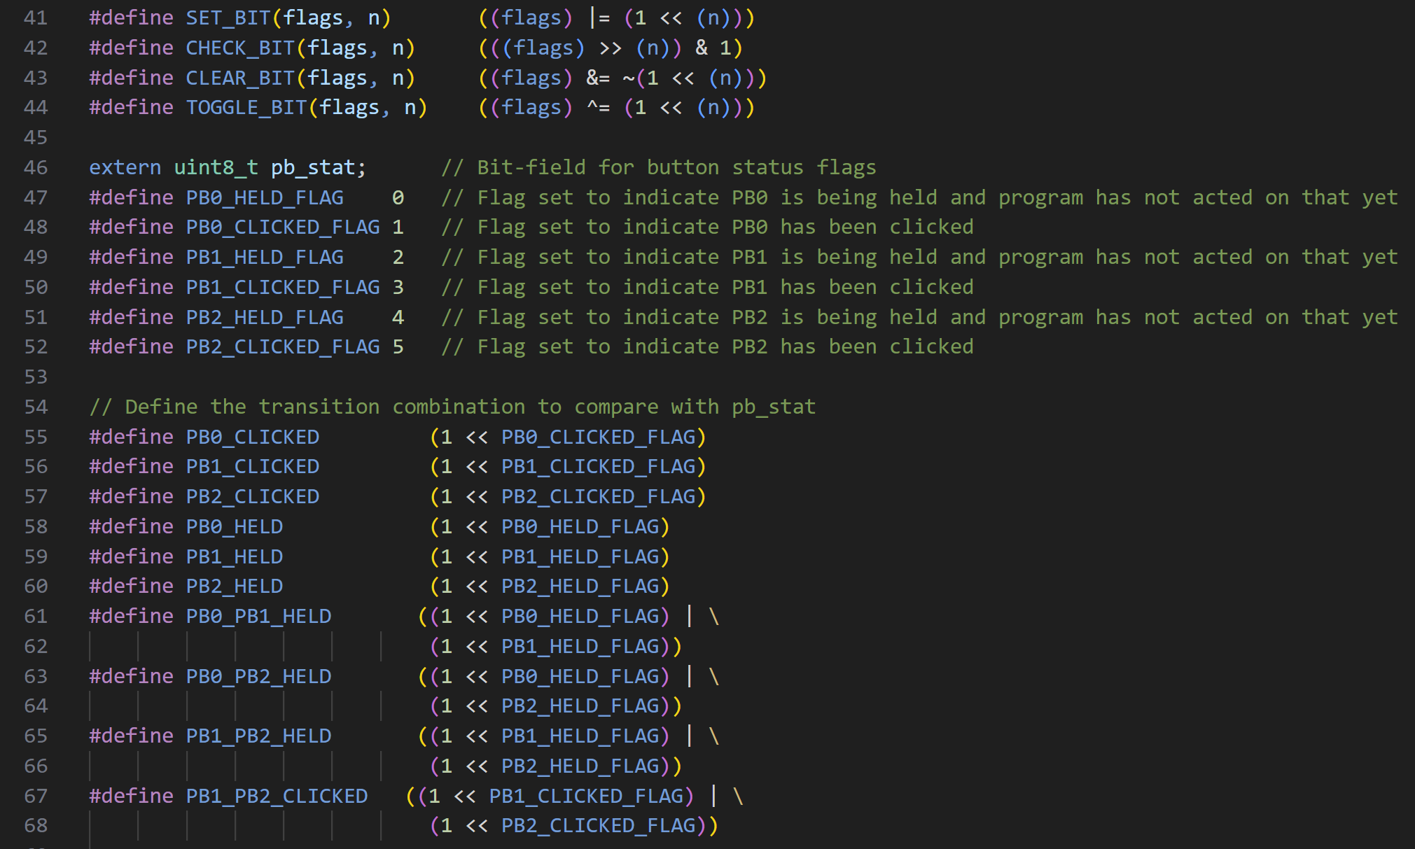
Shown above are helper macros for manipulating bitfields along with a variable to hold button states, which is used in conjunction with the bitfield helper macros in the code to check and modify button states. Additionally, there are some logical defines that can be compared to the pb_stat variable in order to easily check for a particular pushbutton condition without manually using the bitfield positions. Example usages in code are shown below:
Show below are the global variables defined in common.c, explained by the comments on each line.
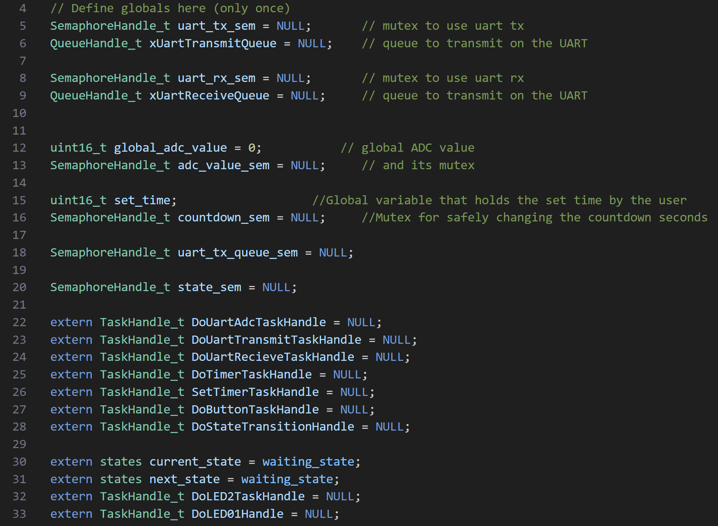

Peripheral Configuration
Below is initialization for the ADC peripheral, explained in the comments line by line.
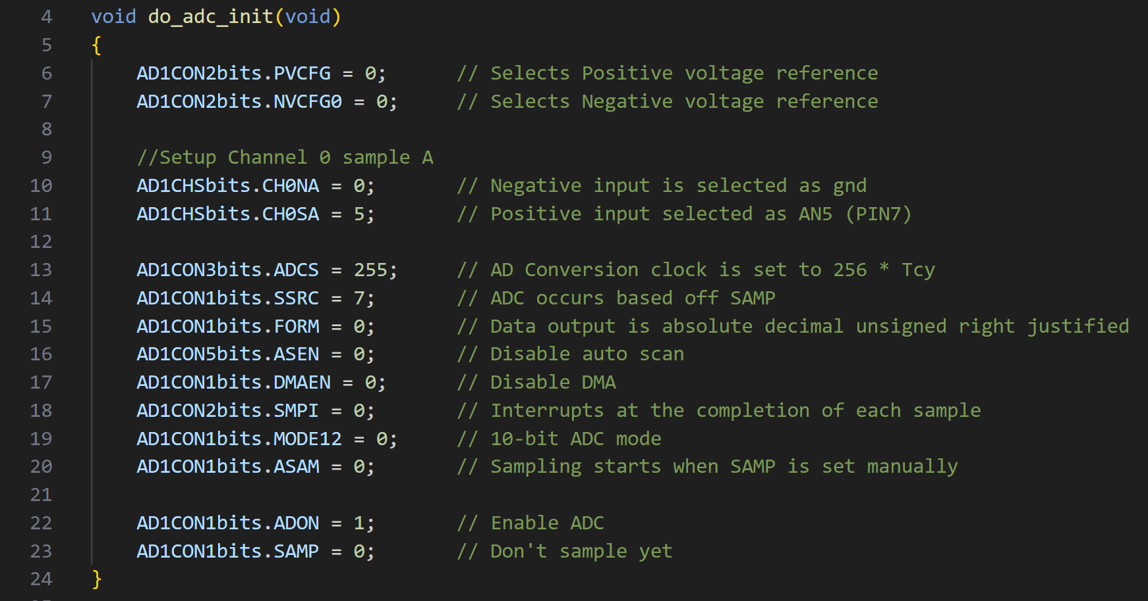
Below is initialization for the GPIO peripheral, explained in the comments line by line.
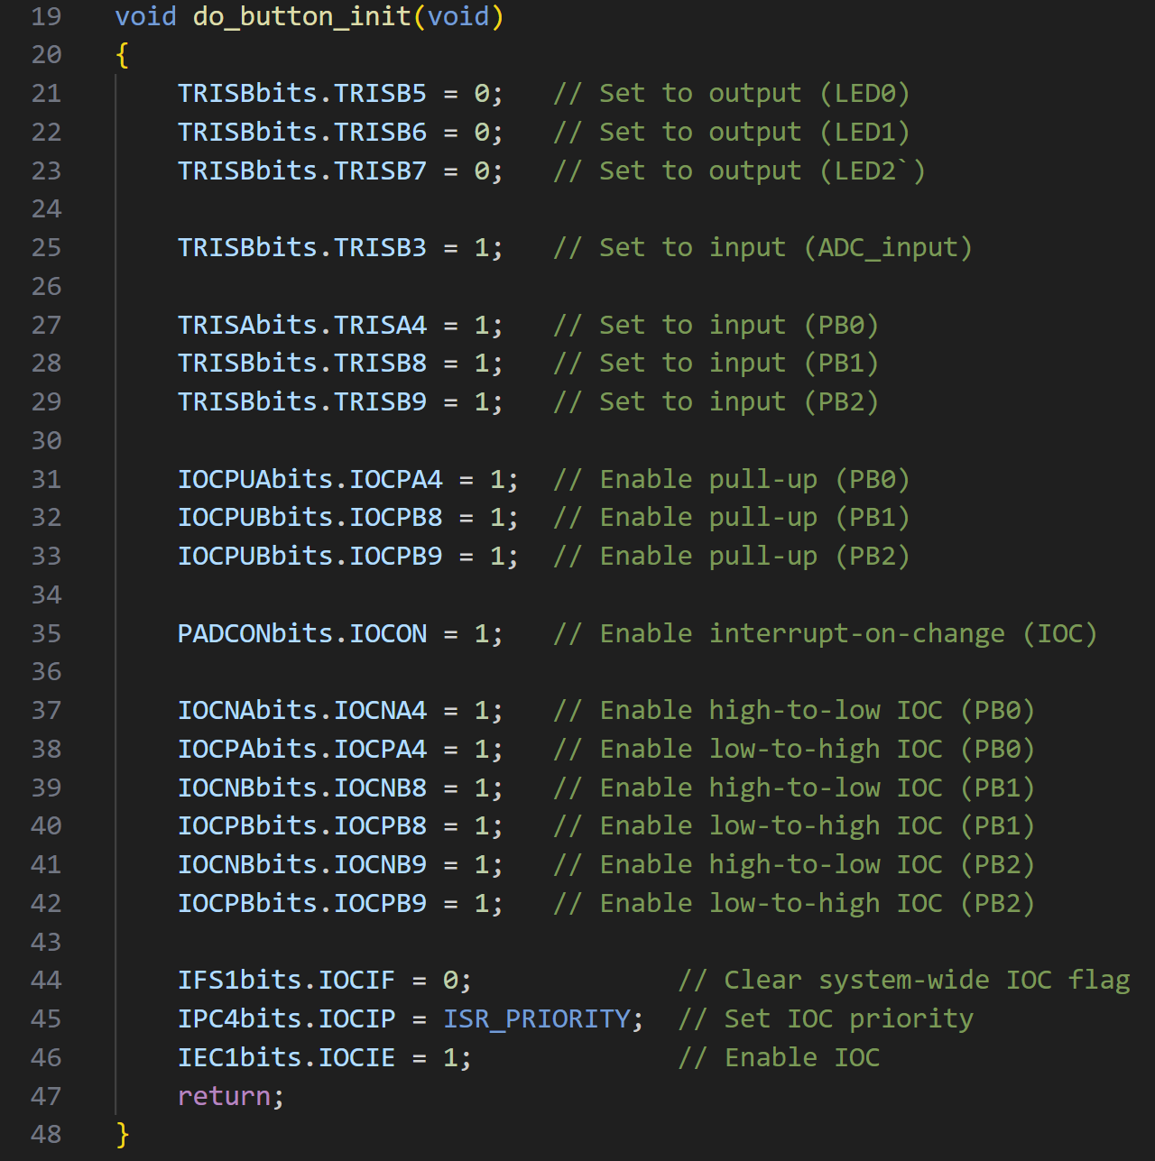
Below is initialization for the ADC peripheral, explained in the comments line by line.
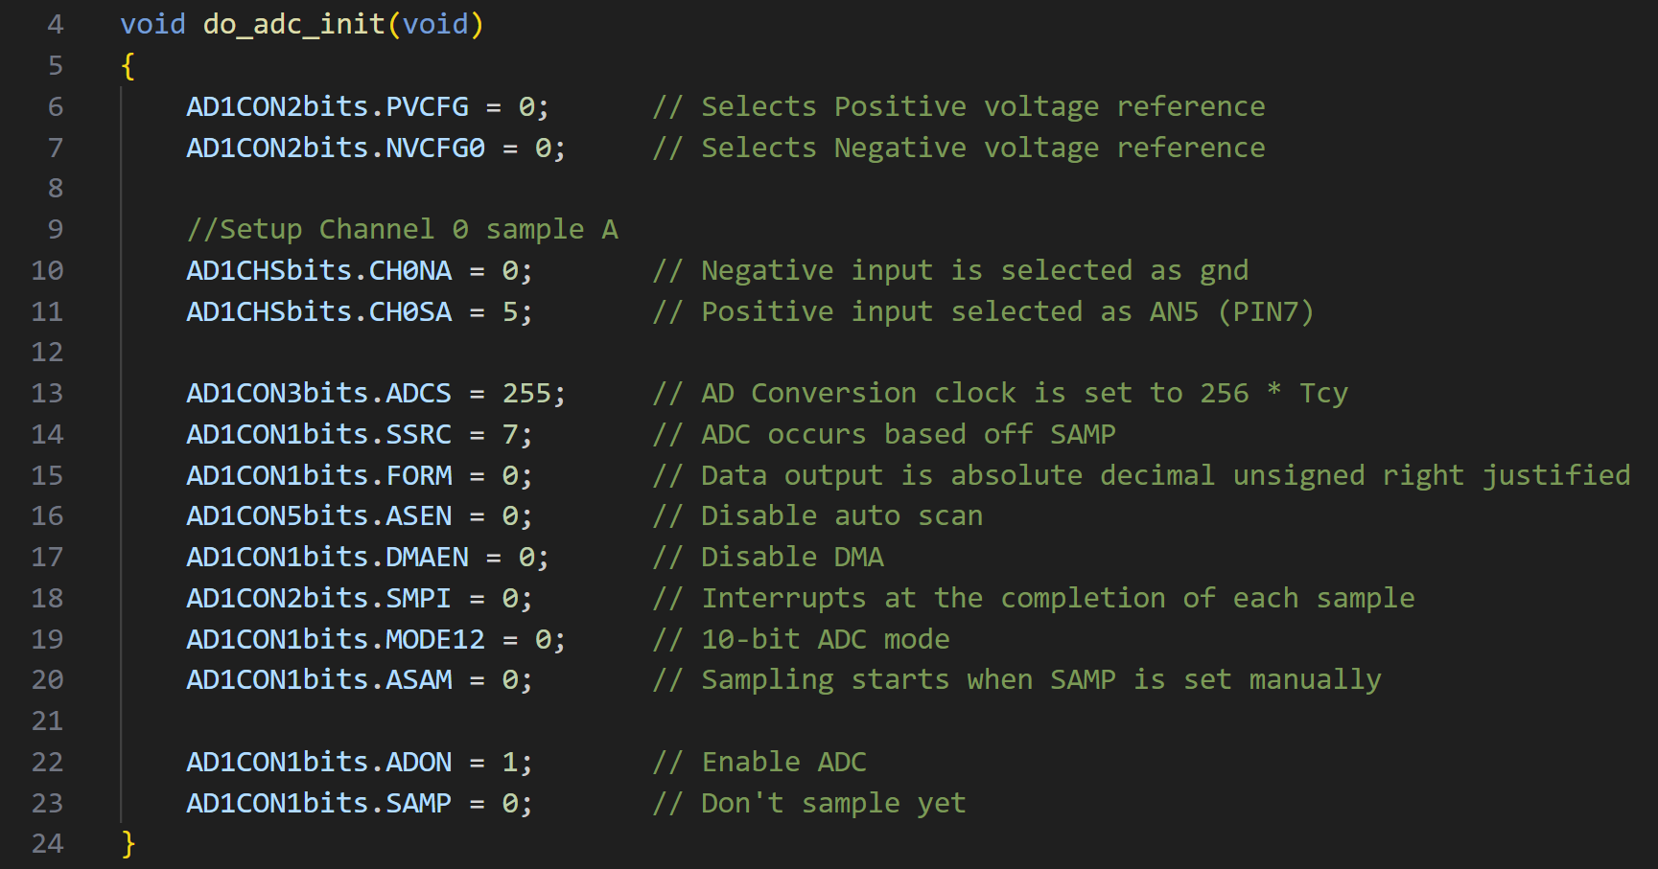
Below is initialization for the Timer 2 peripheral, explained in the comments line by line.
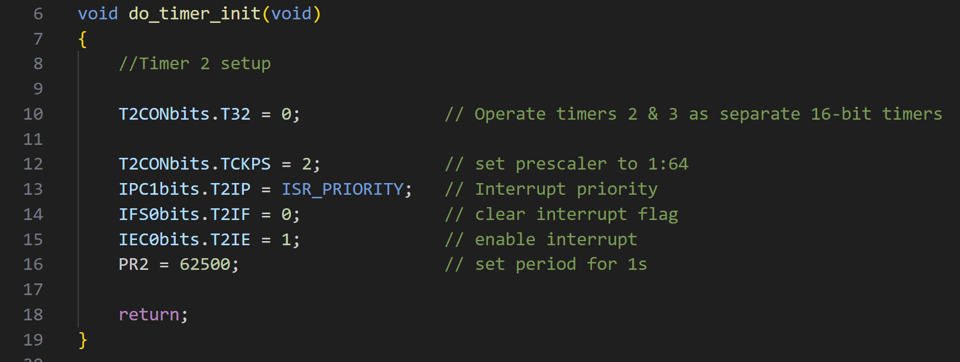
Below is initialization for the Timer 3 peripheral, explained in the comments line by line.
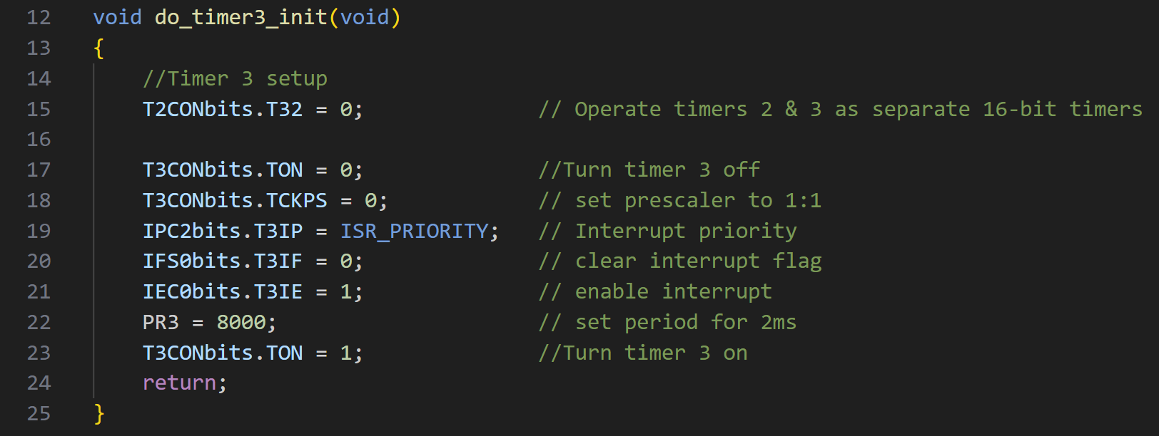
Below is initialization for the UART 2 peripheral, explained in the comments line by line.
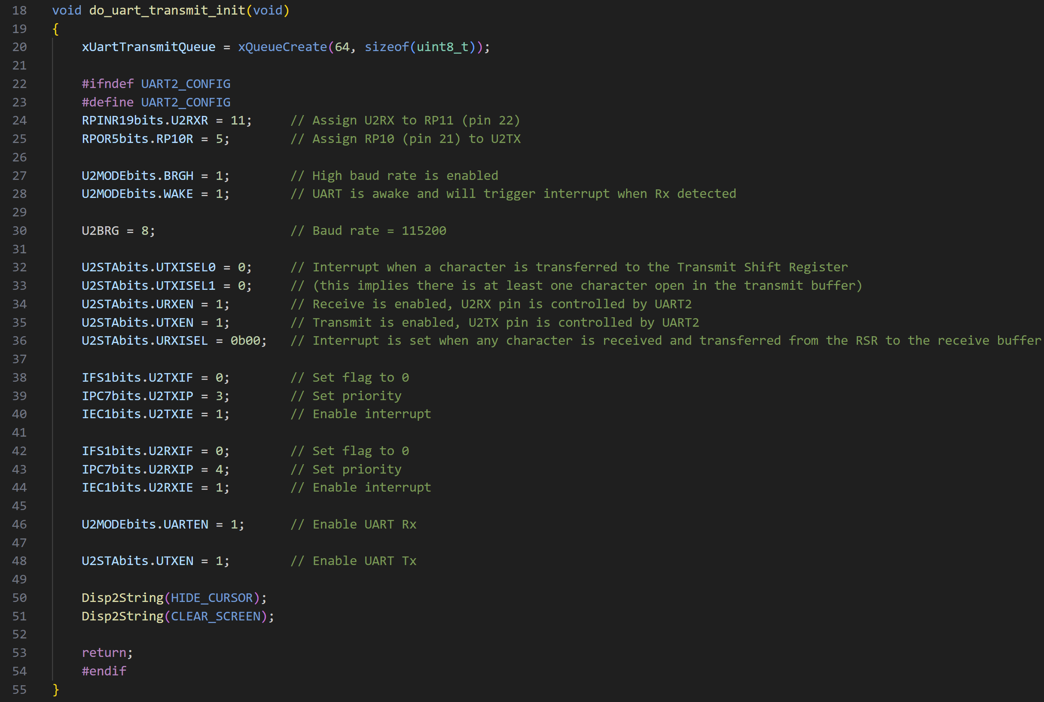

Implemented Functions/Tasks
For brevity of this report, full code for each function/task will not be pasted here, but the functionality of each will be explained. Full code can be found in the project submission.

void vDoAdcTask(void * pvParameters)
This function is a FreeRTOS task that runs every 10ms. It performs the ADC conversion (reading the potentiometer voltage), and if in an appropriate state will also display the value over UART. Mutexes are used to control access to the ADC reading value variable and the UART transmission queue.

void vDoButtonTask(void *pvParameters)
This function is a FreeRTOS task that runs every 10ms. It contains logic to read current and record past button input values and then update the corresponding flags (clicked, held, etc) in pb_stat for the rest of the program to reference.

void vDoLED01Task(void *pvParameters)
This function is a FreeRTOS task that runs every 250ms. If in the timer_finished state, it toggles LED0 and LED1 alternately. Otherwise it turns off LED0.

void vDoLED2Task(void *pvParameters)
This function is a FreeRTOS task that runs every 150ms. Depending on the state, LED2 will either be pulsed (breath), blink, or not blink, taking into account the intensity setting for blinking. Also depending on the state, the duty ratio is displayed on the UART terminal. Mutexes are used to control access to the ADC reading value variable and the UART transmission queue.

void vDoStateTransitionTask(void * pvParameters)
This function is a FreeRTOS task that runs every 100ms. It transitions the state of the program according to the logic defined in the diagram (see later section). It also sends a command to clear the UART terminal screen, and depending on state will also send either a welcome or timer finished message. Mutexes are used to control access to the state variable and the UART transmission queue.

void vDoTimerTask(void *pvParameters)
This function is a FreeRTOS task that runs every 200ms. When the program is in a state with the timer running, this task continuously updates the display of the remaining time.
void vDoUartRecieveTask(void * pvParameters)
This function is a FreeRTOS task that runs every 10ms. When it runs, it reads the UART receive buffer, and if the buffer holds the value of a new character it will be added to the UART receive queue (FreeRTOS queue). A mutex controls access to the UART receive buffer.

void vDoUartTransmitTask(void * pvParameters)
This function is a FreeRTOS task that runs every 10ms. If there is an item in the UART transmit queue (FreeRTOS queue), it will be displayed by putting it in the UART 2 transmit buffer. A mutex controls access to the UART transmit buffer.

void vSetTimerTask(void * pvParameters)
This function is a FreeRTOS task that runs every 100ms. When in the set_timer state, this task handles the display of the UART terminal screen where the user enters the desired time. Mutexes are used in accessing the current state, countdown value, and UART transmit and receive queues.

Program Flow Diagram
Below is a diagram showing the flow of the program, with the current state labelled within each bubble, and state transition logic shown on the arrows.
