GameFlix Module 4 Working Output
Ryleigh Jones | October 19, 2026
Registration, password authentication, signed JWT issuance, and a protected profile route are implemented and verified. The automated evidence option uses SpringBootTest and MockMvc with the real Spring Security filter chain and MySQL.
GitHub repository and complete assignment branch
github.com/ryleighJ0128/gameflix-app/tree/module4-jwt-assignment
Verification result: 15 tests passed, 0 failures, 0 errors, 0 skipped. Java 21.0.8, Spring Boot 3.5.7, and MySQL 8.0.39.
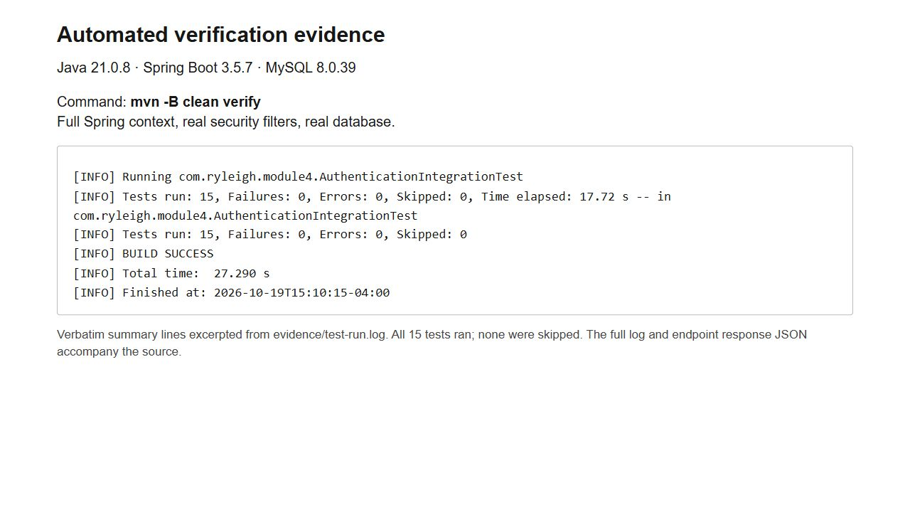
Figure 1 Actual Maven output summary from the final clean verify run
Screenshots show captured test responses and an actual MySQL query, opened in a local evidence viewer. Full logs, response JSON, schema, configuration example, and source accompany the project. The README records the setup, security decisions, Module 3 changes, and AI assistance.

Registration success and duplicate rejection
POST /api/auth/register returns 201 with a UUID, username, email, and creation time. Repeating the email with a different username returns 409 because MySQL enforces the email unique constraint.
The disclosed test password is Module4Throwaway!2026. It is a disposable fixture used only for this demonstration. The request includes username, email, and password; the response excludes the password and hash.
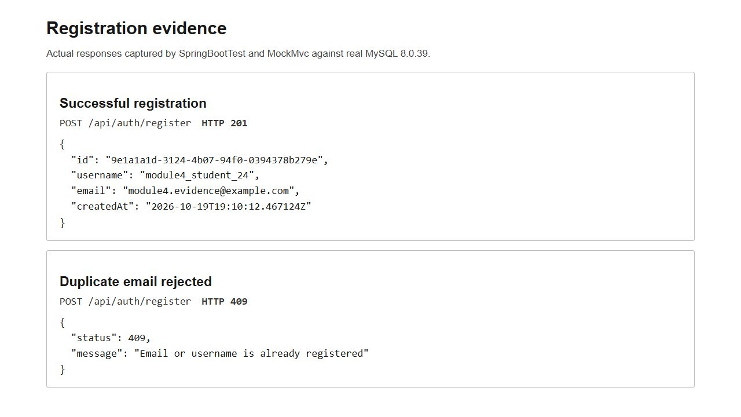
Figure 2 Registration succeeds and the database rejects a duplicate email
A separate concurrent test sends two registrations for the same email. Exactly one returns 201 and one returns 409. A direct SQL duplicate insert is also rejected, demonstrating that uniqueness is enforced below the application layer.

Authentication success and failure
POST /api/auth/login returns a signed HS256 bearer token with a 900 second lifetime. An incorrect password returns the same generic 401 body as an unknown email address.
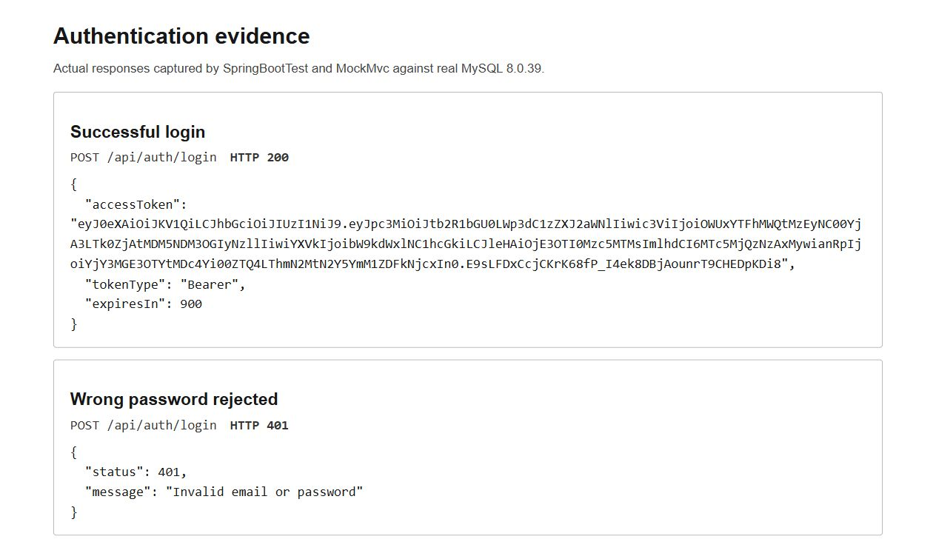
Figure 3 Login returns a token and rejects incorrect credentials
The token contains issuer, audience, UUID subject, issue time, expiration, and a random token identifier. Its Base64URL payload is readable encoding; the signature detects unauthorized changes. No password, password hash, or confidential profile data is included.

Protected route success and failure
GET /api/users/me derives identity from the verified token. The same route returns 401 when the token is missing or its expiration claim is changed without a new signature.
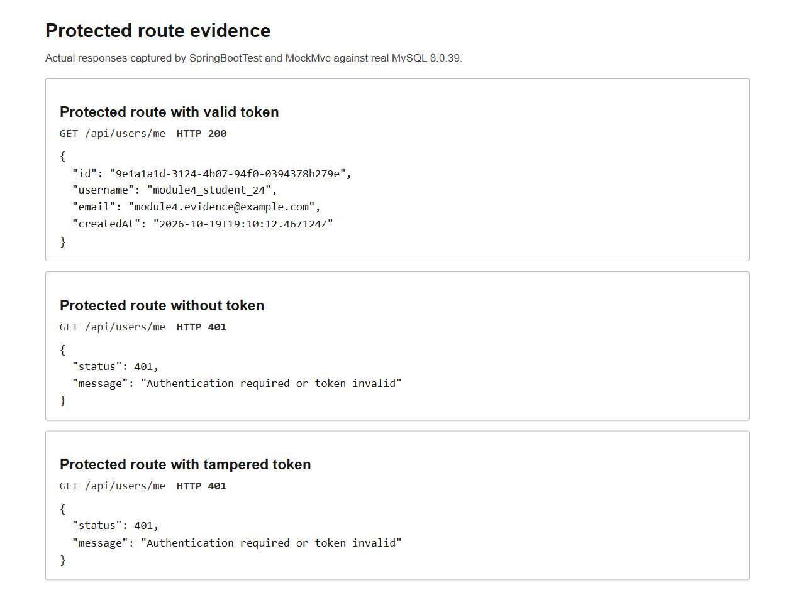
Figure 4 The protected profile requires a valid signed bearer token
Additional tests reject expired tokens, missing expiration, incorrect issuer or audience, invalid UUID subject, wrong signing key, and incorrect algorithm. Negative token checks use an existing user and a valid positive control so unrelated failures cannot conceal a broken security check.

MySQL persistence and password hashing
After registration, the exact SELECT id, email, password FROM users query runs through JDBC against MySQL. The UUID and email match the successful registration and protected route responses.
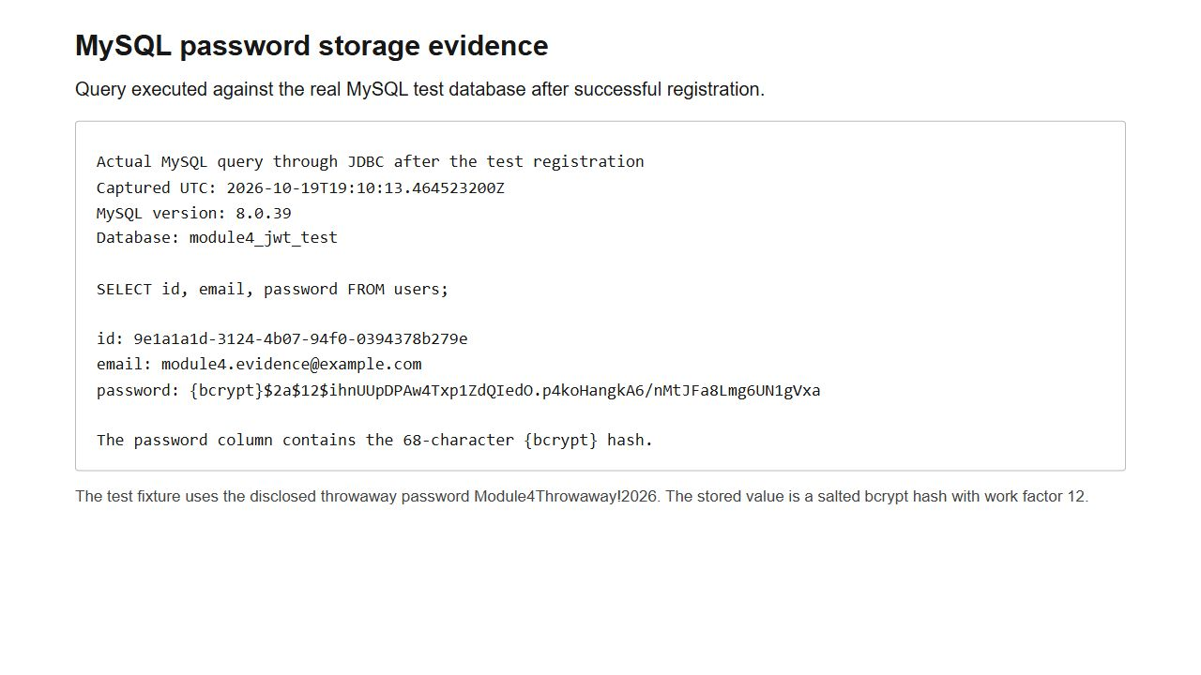
Figure 5 Actual MySQL storage contains the 68 character bcrypt encoding
The {bcrypt} prefix identifies the algorithm and $12$ identifies the work factor. Passwords use a deliberate bcrypt factor of 12, a 64 character limit, and a separate 72 byte UTF-8 limit. The password column is VARCHAR(255), allowing the full hash and future encoder migration.
The Module 3 User design retains UUID identity, unique username VARCHAR(50), unique email VARCHAR(254), and a creation timestamp. Physical columns user_id and password_hash become id and password for the assignment query. The Java field remains passwordHash. Full DDL is in schema.sql and evidence/show-create-table.sql.
Hibernate uses ddl-auto=update to retain registered users between runs. Database credentials and the signing key come from the environment or an untracked application-local.properties file. The repository includes application.properties.example with placeholders.
AI Usage
I used OpenAI Codex to help organize my thoughts and support each stage of the project, including planning, coding, troubleshooting, testing, and documentation. One suggested user model was revised to match my Module 3 ERD, including UUIDs, usernames, and creation timestamps.

