# CS 499 Module One Assignment Template

Complete this template by replacing the bracketed text with the relevant information.

1. **Self-Introduction:** Address all of the following questions to introduce yourself.
   1. How long have you been in the Computer Science program?

**I have been in the Computer Science program for almost four years and I am currently in my final term befoe completing my degree.**

* 1. What have you learned while in the program? List three of the most important concepts or skills you have learned.

**Throughout the program, I have gained knowledge in various core concepts, including:**

* + 1. **Software engineering and design – understanding software development methodologies, system architecture, and industry best practices for writing maintainable, scalable code.**
    2. **Algorithms and data structures – learning how to design efficient algorithms and use appropriate data structures to optimize performance.**
    3. **Databases – gaining proficiency in database management systems, SQL, and data modeling to store, retrieve, and manipulate structured data effectively.**
  1. Discuss the specific skills you aim to demonstrate through your enhancements to reach each of the course outcomes.

**The specific skills I am to demonstrate through my enhancements include problem-solving and critical thinking. I will apply algorithmic principles and computational thinking to solve complex problems efficiently. I will demonstrate software development and debugging skills by writing clean, well-documented code while effectively debugging and testing to ensure reliability.**

* 1. How do the specific skills you will demonstrate align with your career plans related to your degree?

**These skills align with my future career plans by providing me with a strong technical foundation. Regardless of the path I choose, having expertise in software development, algorithms, and databases will allow me to contribute meaningfully to various roles in technology.**

* 1. How does this contribute to the specialization you are targeting for your career?

**While I am not set on a specific career path, I am interested in project management. The technical background I have built will allow me to effectively oversee software development projects, communicate with development teams, and make informed decisions based on my knowledge of industry best practices. Additionally, my diverse skill set will enable me to adapt to different roles, providing flexibility in my career growth.**

1. **ePortfolio Set Up:**

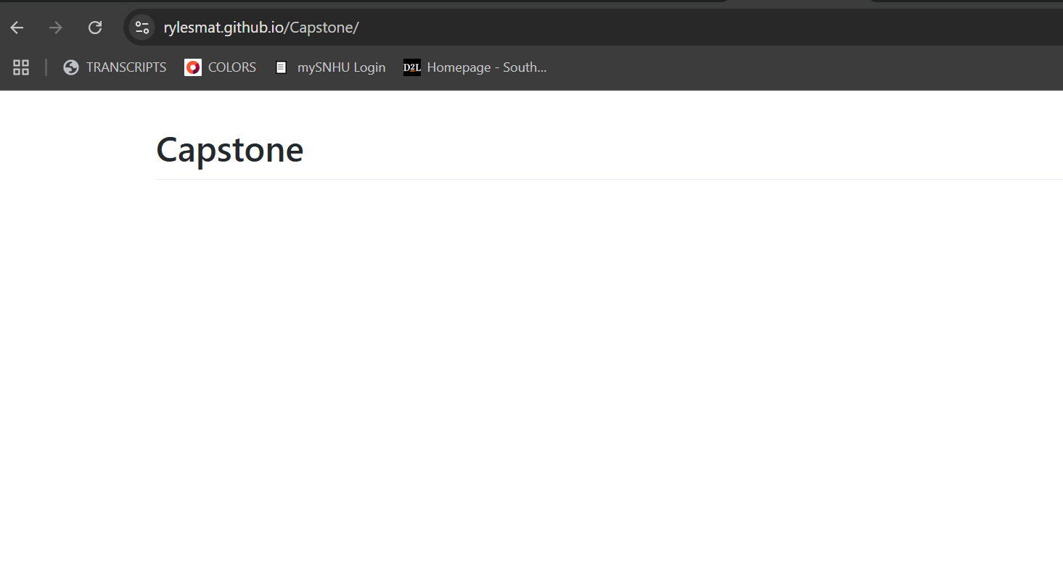

1. **Enhancement Plan:** 
   1. **Category One:** Software Engineering and Design
      1. **Select an** **artifact** that is **aligned with** **the** software engineering and design **category** and explain its origin. Submit a file containing the code for the artifact you choose with your enhancement plan.

**My artifact is the final project from IT140. The artifiact is a text based adventure game.**

* + 1. **Describe** a practical, well-illustrated **plan** for enhancement in alignment with the category, including a pseudocode or flowchart that illustrates the planned enhancement.

**To enhance this artifact I will make the game web facing. This will be achieved by implementing a Flask backend and a frontend using HTML, CSS, and JavaScript.**

* + 1. Explain how the planned enhancement will **demonstrate** specific **skills** and align with course outcomes.
       1. Identify and describe the specific skills you will demonstrate that align with the course outcome.

**The planned enhancement will demonstrate several key skills:**

* + - * + **Web Development Skills**
        + **Database Management**
        + **Full-Stack Development**
        + **User Experience (UX) and Interface Design**
        + **Software Engineering and Design Principles**

* + - 1. Select one or more of the course outcomes below that your enhancement will align with.

**The enhancement aligns with the following course outcomes:**

***“Design, develop, and deliver professional-quality oral, written, and visual communications that are coherent, technically sound, and appropriately adapted to specific audiences and contexts.”* – The transition to a web-based platform requires clear documentation, structured code, and a well-designed interface tailored to an online audience.**

***“Demonstrate an ability to use well-founded and innovative techniques, skills, and tools in computing practices for the purpose of implementing computer solutions that deliver value and accomplish industry-specific goals.”* – By utilizing Flaskm MySQL, and front-end technologies, I am demonstrating my ability to use industry-standard tools and techniques to create an interactive and accessible web-based game experience.**

* 1. **Category Two:** Algorithms and Data Structures

1. **Select an artifact** that is **aligned with the** algorithms and data structures **category** and explain its origin. Submit a file containing the code for the artifact you choose with your enhancement plan. You may choose work from the courses listed under Category One.

**My artifact is the final project from IT140. The artifact is a text based adventure game.**

1. **Describe** a practical, well-illustrated **plan** for enhancement in alignment with the category, including a pseudocode or flowchart that illustrates the planned enhancement.

**To enhance this artifact I will utilize data structures and algorithms in my program. First I will implement a graph for room navigation. I will represent the map of Hogwarts using a graph where rooms are nodes and paths are edges. I will use Breadth-First Search (BFS) or Depth-First Search (DFS) to find the shortest path between rooms. I will also implement a hash map for inventory management. I will store inventory items using a dictionary (hash map) for quick lookup. This ensures efficient item handling and scalability (if additional mechanics are introduced, hash maps allow for efficient data management).**

1. Explain how the planned enhancement will **demonstrate** specific **skills** and align with course outcomes.
   1. Identify and describe the specific skills you will demonstrate to align with the course outcome.

**Using a graph structure to model room connections and a hash map for inventory management demonstrates my understanding of data structures and their appropriate applications. This ali**

* 1. Select one or more of the course outcomes listed under Category One that your enhancement will align with.

***“Deisgn and evalulate computing solutions that solve a given problem using algorithmic principles and computer science practices and standards appropriate to its solution while managing the trade-offs involved in design choices”* – By implementing graph traversal algorithms for room navigation and utilizing a hash map for inventory management, I am designing an optimized computing solution that effectively solves game challenges. I will also evaluate trade-offs such as time complexity, memory usage, and scalability when choosing the most appropriate data structures and algorithms.**

* 1. **Category Three: Databases**
     1. **Select an artifact** that is **aligned with the** databases **category** and explain its origin. Submit a file containing the code for the artifact you choose with your enhancement plan. You may choose work from the courses listed under Category One.

**My artifact is the final project from IT140. The artifact is a text based adventure game.**

* + 1. **Describe** a practical, well-illustrated **plan** for enhancement in alignment with the category, including a pseudocode or flowchart that illustrates the planned enhancement.

**To enhance this artificat I will integrate a database for stored wins and losses with MySQL. The players’ game history is recorded allowing them to track progress over multiple sessions.**

* + 1. Explain how the planned enhancement will **demonstrate** specific **skills** and align with course outcomes.
       1. Identify and describe the specific skills you will demonstrate that align with the course outcome.

**By implementing a MySQL database to store player game history, I will demonstrate my ability to design and manage relational databases, ensuring data is efficiently stored, retrieved, and maintained. This aligns with the course outcome of using appropriate computing techniques to develop effective solutions.**

* + - 1. Select one or more of the course outcomes listed under Category One that your enhancement will align with.

***“Demonstrate an ability to use well-founded and innovative techniques, skills, and tools in computing practices for the purpose of implementing computer solutions that deliver value and accomplish industry-specifc goals”* – Integrating a database with MySQL demonstrates my ability to use industry-stnadard database technologies and best practices in software development. This enhancement improves user experience through win/loss tracking, making the application more engaging and functional.**

1. **ePortfolio Overall Skill Set**
   1. Accurately describe the **skill set** to be illustrated by the **ePortfolio** **overall**.
      1. Skills and outcomes planned to be illustrated in the code review

**The code review will demonstrate my ability to apply software engineering principles to enhance my existing project. It will highlight my skills in software development and design by implementing web features using Flask for the backend and HTML/CSS + JavaScript for the frontend. I will also showcase my understanding of data structures and algorithms by using graphs for room navigation and hash maps for inventory management to boost efficiency. Additionally, I will integrate MySQL to store player progress, improving data management and the user experience. These enhancements reflect my ability to write efficient, scalable, and well-structured code while following industry best practices.**

* + 1. Skills and outcomes planned to be illustrated in the narratives

**These narratives will showcase how I apply theory to real projects and solve problems effectively. They will highlight key skills like analytical thinking, software engineering best practices (focusing on maintainability, modularity, and user-friendly design), and technical communication (documenting code and improvements). By explaining the reasoning behind each enhancement, the narratives will reflect my growth in using computer science concepts in practical applications.**

* + 1. Skills and outcomes planned to be illustrated in the professional self-assessment

**My professional self-assessment will show how my technical skills align with my career goals. It will emphasize my ability to manage projects by organizing tasks and timelines, my flexibility to grow in different roles, and my industry-relevant expertise in software engineering, data structures and algorithms, and databases. Overall, my ePortfolio will highlight a well-rounded skill set in software engineering, problem-solving, and project execution, preparing me for future career success.**