Maintenance Guide

Icon
See the label below.
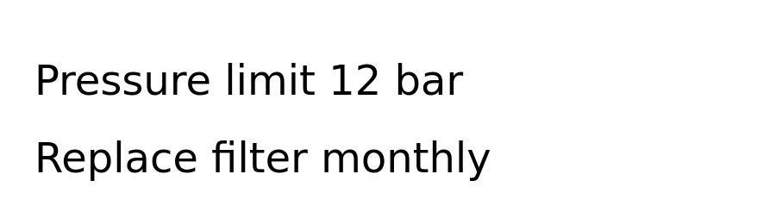
Label
End of guide.

