

Pre-release Guide V2

by Ricardo Y. Maeda

Oct 2025

1. Overview
MorphMuse lets you build surface geometries in CamBam by combining one open curve with one closed outline. It automatically generates a smooth surface:
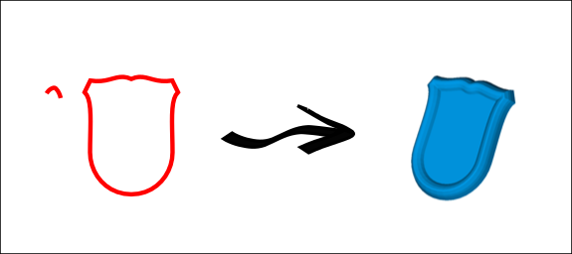
The open polyline acts as the surface generatrix, with its initial point sliding along the closed polyline to generate the surface. To switch the starting point of the open polyline, go to [Edit] → [Polyline] → [Reverse].

An interesting ability is the possibility to generate two surfaces from two separate open polylines, both referencing the same closed polyline. This allows the creation of a fully enclosed geometry that can be exported as a .stl file for 3D applications or machining workflows.
Two open polylines and one closed polyline:
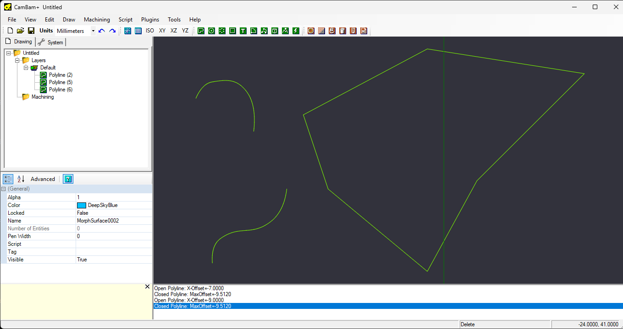
Aplying MorphMuse twice:
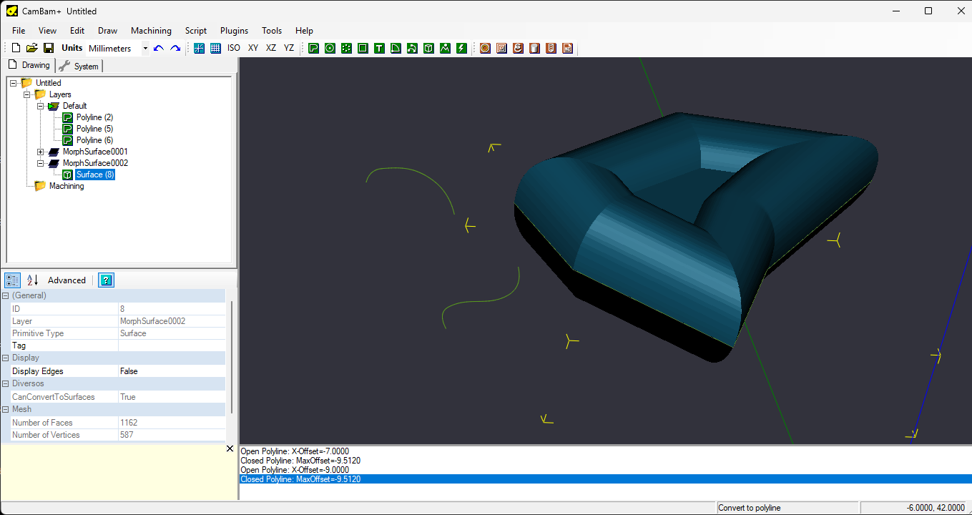
Inverting the botton surface and joining both:
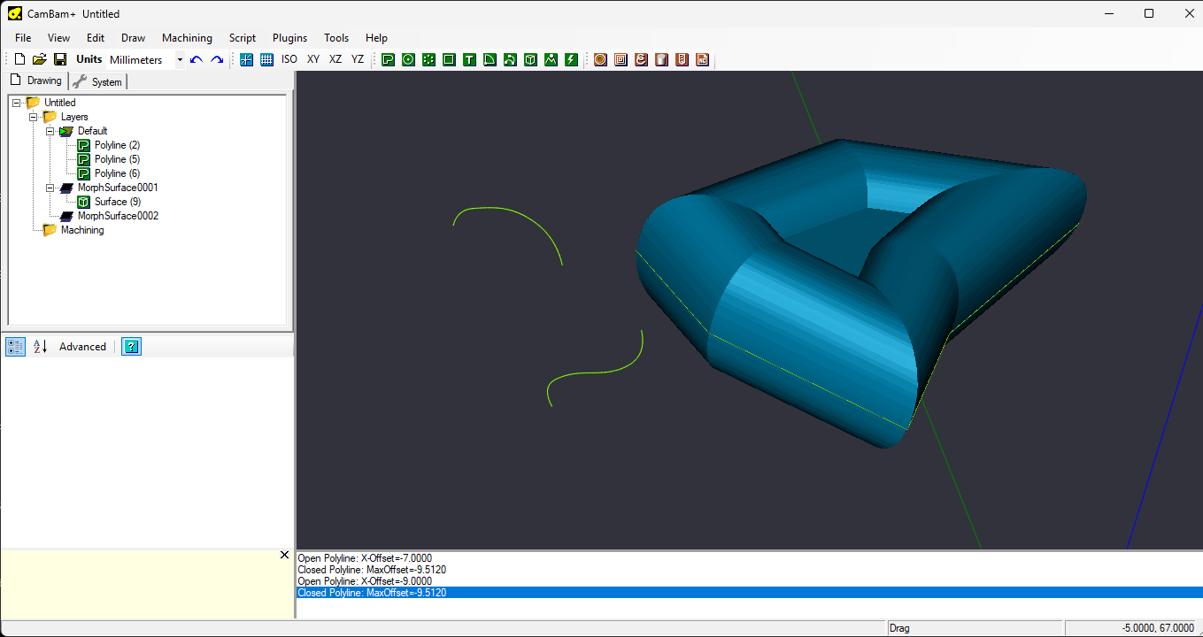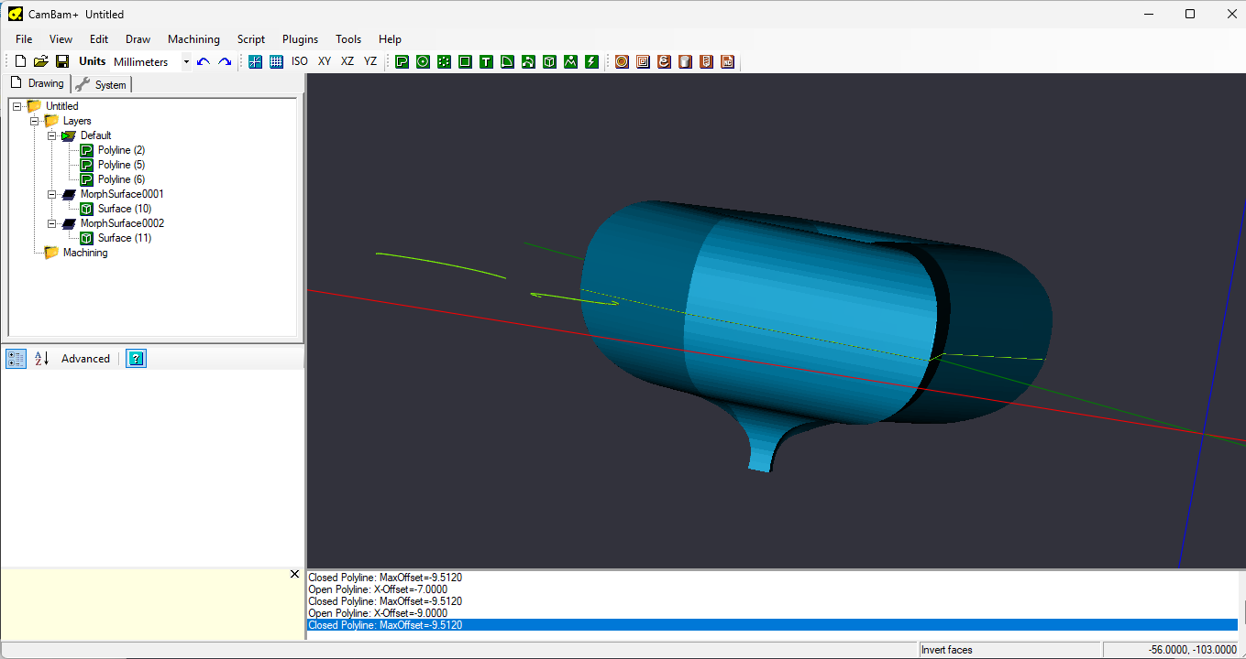
Surface invertion: [Edit]→[Surface]→[Invert Faces]
Joining surfaces: [Edit]→[Join]

2. Important Notice on Unit Settings⚠️
To ensure optimal performance and accurate surface generation, users must verify that the drawing units in CamBam are correctly configured before using the plugin.
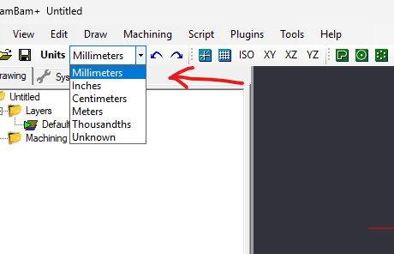

Why this matters:
- The plugin’s internal parameters (such as tolerance, sampling step, and smoothing) are stored in millimeters.
- These values are automatically converted to match the current unit system (e.g., inches, centimeters).
- If the unit setting is incorrect or inconsistent with the scale of the drawing, the resulting surface may be:
  - Too coarse, leading to visible artifacts or loss of detail.
  - Too refined, which can dramatically increase memory usage and make the model difficult to manipulate or export.

Recommended practice:
- Always confirm that the drawing units reflect the intended measurement system (e.g., millimeters for metric designs).
- Avoid switching units mid-project unless all geometry and plugin parameters are recalibrated accordingly.
- For high-resolution surfaces, consider simplifying curves before applying the plugin to reduce computational load.

3. System Requirements
- CamBam version required CamBam 1.0, x86 or x64.
- NET Framework 4.8.

4. Installation Instructions
- Where to download the plugin xxxxxxxxxxx
- How to install:
  - Copy ‘morphmuse.dll’ file to CamBam’s plugin directory.
  - Restart CamBam.
  - Confirm plugin appears in the plugins menu.

5. How to Use the Plugin
- Step-by-step usage:
  - Select one open polyline and one closed polyline.
  - Run the plugin via menu.
  - View generated surface in a new layer.
  - The plugin is sensitive to the orientation of the polylines. The direction of the closed polyline (clockwise or counterclockwise) and the starting point of the open polyline both influence the result. If the generated surface does not behave as expected, try reversing the open polyline to correct the thing.

- Limitations:
  - Only works with 2D polylines on XY plane.
  - Requires at least one closed and one open polylines.
  - Supported input: polylines only. Other entity types are not compatible.
  - Surface generation may fail if geometry is too complex.

6. Feedback Instructions
- This is a pre-release version of the plugin, and your feedback is highly appreciated. If you encounter any issues or unexpected behavior, please share your observations on the CamBam forum. Whenever possible, include screenshots or sample files to assist with troubleshooting. Please note that I maintain this project in my spare time, so responses may take a little while — thanks for your understanding!

7. Disclaimer
- Remember: this is a pre-release version.
- Use at your own risk.
- Not intended for production-critical workflows yet;

8. Development Note
- This plugin was developed with the assistance of Microsoft Copilot, an AI companion that supported code generation, logic refinement, and documentation drafting throughout the process. While Copilot played a valuable role in accelerating development, all final decisions, testing, integration and many bugs fixes were carried out manually. Please note that this project is independently maintained and not affiliated with or endorsed by Microsoft.
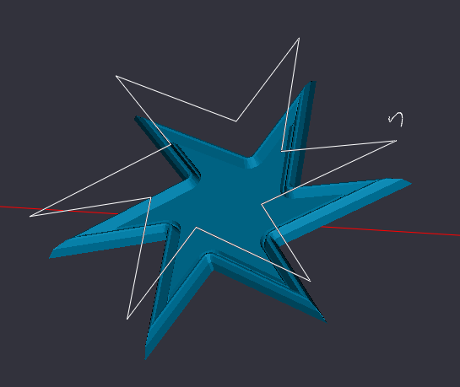

9. How to Simplify a Mesh in MeshLab
Mesh simplification reduces the number of faces or vertices in a mesh while preserving its overall shape. This is useful for optimizing performance, reducing file size, or preparing models for export.

Step-by-Step Instructions:
- Open the Mesh
  - Go to File → Import Mesh and select your mesh file.
- Select the Mesh
  - Make sure your mesh is selected in the Layer Panel on the right side of the screen.
- Access the Simplification Filter
  - Navigate to Filters → Remeshing, Simplification and Reconstruction → Quadric Edge Collapse Decimation.
- Configure the Parameters
  - Target number of faces: Set the desired number of faces (e.g., 1000).
  - Preserve Boundary: Enable this option to keep the mesh edges intact.
  - Preserve Normal: Enable to maintain smooth shading and surface appearance.
  - Quality Threshold: Leave at 1.0 for maximum detail retention.
- Apply the Filter
  - Click Apply to simplify the mesh. You will see the result immediately in the viewport.
- Check the Result
  - To view the updated face and vertex count, go to Render → Show Vertex/Face Count.
- Export the Simplified Mesh
  - Go to File → Export Mesh As... and save your simplified model.

