

Plugin Guide

by Ricardo Y. Maeda

April 2026

1. Overview
MorphMuse lets you build surface geometries in CamBam by combining one open curve with one closed outline or you can combine two open curves too. It automatically generates a smooth surface:
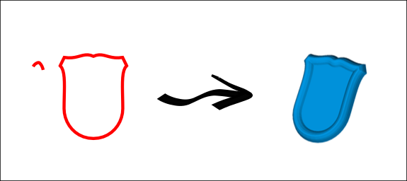
The one of the curves acts as the surface generatrix, with its initial point sliding along the other curve to generate the surface.

📦 Installation
Before installation, choose the plugin file that matches your CamBam version:
- There are two builds available — 32-bit and 64-bit.
- These versions are identified by their suffixes:
  - morphmuse_x86.dll → for 32-bit CamBam installations.
  - morphmuse_x64.dll → for 64-bit CamBam installations.
Once you have the correct file:
- Copy morphmuse.dll (or the appropriate version) into the /plugins directory of your CamBam installation.
- Restart CamBam to load the plugin.
- The plugin will appear in the CamBam menu.

🛠️ Functionality Overview
Morphmuse generates 3D surfaces by combining polylines:
- Open + Closed Polyline → Creates a surface swept along the open curve, capped at the end.
- Open + Open Polyline → Creates a surface swept along one open curve (rail) by another open curve (profile).
This allows machinists to build complex surfaces directly from 2D geometry.

📋 Step-by-Step Usage
- Select Input Geometry
  - Choose one open polyline and one closed polyline, OR two open polylines.
- Run the Plugin
  - Access Morphmuse from the CamBam plugin menu.
  - If two open polylines are selected, a dialog will ask which one should act as the rail.
- View the Result
  - The generated surface will appear in a new layer.
- Adjust Orientation if Needed
  - The plugin is sensitive to polyline orientation:
    - Closed polyline direction (clockwise vs. counterclockwise) affects the sweep.
    - The starting point of the open polyline influences the surface.
  - If the result looks incorrect, try reversing the open polyline.

⚠️ Limitations
- Works only with 2D polylines on the XY plane.
- Requires at least one closed and one open polyline.
- Input must be polylines only (other entity types are not supported).
- Surface generation may fail if the geometry is too complex.

✅ Notes for Use
- Keep polylines simple and clean to avoid errors.
- Always check orientation before running the plugin.
- Generated surfaces are best used as a starting point for machining paths.

8. Development Note
- This plugin was developed on his first versions with the assistance of Microsoft Copilot and Meta Manus, two AI companions that supported code generation, logic refinement, and documentation drafting throughout the process. While AIs assistents played a valuable role in accelerating development, all final decisions, testing, integration and many bugs fixes were carried out manually. Please note that this project is independently maintained and not affiliated with or endorsed by Microsoft nor Meta.
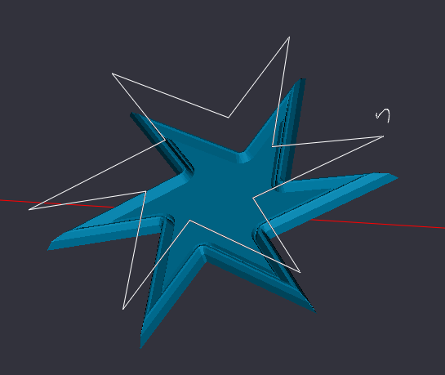

9. How to Simplify a Mesh in MeshLab
Mesh simplification reduces the number of faces or vertices in a mesh while preserving its overall shape. This is useful for optimizing performance, reducing file size, or preparing models for export.

Step-by-Step Instructions:
- Open the Mesh
  - Go to File → Import Mesh and select your mesh file.
- Select the Mesh
  - Make sure your mesh is selected in the Layer Panel on the right side of the screen.
- Access the Simplification Filter
  - Navigate to Filters → Remeshing, Simplification and Reconstruction → Quadric Edge Collapse Decimation.
- Configure the Parameters
  - Target number of faces: Set the desired number of faces (e.g., 1000).
  - Preserve Boundary: Enable this option to keep the mesh edges intact.
  - Preserve Normal: Enable to maintain smooth shading and surface appearance.
  - Quality Threshold: Leave at 1.0 for maximum detail retention.
- Apply the Filter
  - Click Apply to simplify the mesh. You will see the result immediately in the viewport.
- Check the Result
  - To view the updated face and vertex count, go to Render → Show Vertex/Face Count.
- Export the Simplified Mesh
  - Go to File → Export Mesh As... and save your simplified model.

