INNSIGHT: AN INTEGRATED MICROSERVICES PROPERTY MANAGEMENT SYSTEMS AND OPERATIONAL SIMULATION
ENVIRONMENT FOR SOUTHERN LUZON STATE
UNIVERSITY HOSPITALITY MANAGEMENT

Arym Sherwin R. Vendiola
Yosefa Perry R. Paroan

Southern Luzon State University
College of Industrial Technology
February 2026

Chapter I

INTRODUCTION
The global hospitality industry continues to expand rapidly, with hotel operations becoming increasingly complex and technology-dependent. Modern hotels require sophisticated property management systems (PMS) to handle reservations, guest services, billing, and housekeeping coordination. The transition to cloud-based solutions has accelerated significantly since 2021, driven by the need for scalable, accessible, and cost-effective management platforms (Commey et al., 2023).
Property Management Systems have evolved from traditional on-premises software to cloud-native platforms that leverage microservices architecture for enhanced flexibility and maintainability. This architectural shift enables hotels to scale individual services independently, integrate with third-party systems seamlessly, and deploy updates without system-wide disruptions (Velepucha & Flores, 2023). Recent research demonstrates that microservices-based systems significantly improve operational efficiency compared to monolithic architectures, particularly in handling concurrent user requests and managing distributed data (Blinowski, Ojdowska, & Przybylek, 2022).
However, traditional training systems often failed to reflect the dynamic, real time demands of modern hotel operations such as limitation to access to enterprise grade software, disconnected departmental modules, and the inability to simulate high-pressure, real world operational scenarios making hospitality training, at times, theoretical rather than practical. Students train in isolated modules rather than interconnected systems, and access to enterprise-grade software is often restricted by institutional budgets (Zarezadeh et al., 2022).
In educational contexts, simulation-based learning has proven highly effective for developing practical skills in hospitality management. Students benefit from hands-on experience with realistic hotel scenarios without the risks and costs associated with real-world operations (Berger-Estilita et al., 2025). The integration of modern software architectures with educational simulation creates authentic learning environments that prepare students for industry demands (Granström & Nirme, 2023).

Background of the Study
A Property Management System (PMS) integrates a hotel's daily operations namely room reservations, front desk services, guest check-in and check-out, housekeeping, and billing into a single coordinated platform. Hotel departments depend on one another as these functions cannot run all by themselves. The front desk cannot assign a room until housekeeping has updated its status and billing accuracy depends on complete, timely records from reservations and service requests.
The integration of Information Technology (IT) has become a baseline requirement for operational viability in the hospitality industry, not merely a competitive advantage (D’Souza, E. & D’Souza, K., 2023). This has changed what academic programs are expected to produce. Hospitality graduates need to navigate technology-centered workflows, interpret system updates, and manage tasks using tools similar to those deployed in industry.
Most academic training tools fall short of this expectation. Standard platforms tend to cover basic data encoding rather than interconnected operational workflows. Institutions face constraints in accessing centralized hotel systems, whether due to licensing costs or infrastructure limitations (Zarezadeh et al., 2022). Controlled training environments, by design, remove the unpredictability that characterizes real hotel work such as the booking surges, room changes, guest complaints, and maintenance issues that require rapid cross-departmental decisions. Simulation addresses this gap by replicating connected operational sequences digitally, giving learners experience with interdependent tasks rather than isolated steps (Fouad et al., 2024). It also allows high-pressure scenarios to be practiced without the costs of real service failures (Granström et al., 2023). Studies on simulation-based learning further show that it builds digital literacy, critical thinking, and professional decision-making skills (Uddin, 2024).
InnSight responds to these needs by combining a microservices Property Management System with an operational training simulation for SLSU. A microservices architecture organizes an application as a set of independent services that communicate through defined interfaces (Accardo, 2022). In InnSight, core functions, namely reservations, front-desk stay management, billing, rooms and housekeeping, amenities, night audit, and reporting, are separated into independent services that can be modified or scaled individually without taking the whole system offline. This is particularly useful in an academic context where many students may use the system at the same time. Operational changes propagate to every connected screen in real time, and an immersive three-dimensional housekeeping simulation lets students practice room-turnover procedures and receive a competency assessment.

Objective of the Study
The main goal of this study is to develop a web-based integrated Property Management System (PMS) and operational simulation environment that improves the practical training and technical readiness of first-year Hospitality Management students at SLSU. The platform uses decoupled operational services and an immersive three-dimensional housekeeping simulation to create a training environment that approximates actual hotel operations without depending on physical mock-up rooms. System performance is evaluated by IT experts, while hospitality faculty assess usability and educational effectiveness, both measured against the ISO/IEC 25010:2023 standard.
The study has three specific objectives:

1. To design and develop a web-based integrated PMS and operational simulation environment using a Microservices architecture, with the following features:
- Independent, decoupled operational services for reservations, front-desk stay management, billing, rooms and housekeeping, amenities, maintenance, night audit, and reporting.
- An immersive three-dimensional housekeeping training simulation in which students perform room-turnover tasks in a walkable room and receive an automated competency assessment.
- Real-time propagation of operational changes to all connected screens, so that many students can use the system concurrently, together with a staff competency record through which instructors review individual training results.
- Role-based access across six operational roles, with dashboards displaying occupancy and revenue indicators, room availability, and operational status upon login.
2. To evaluate the system against the ISO/IEC 25010:2023 standard, as assessed by both IT and non-IT experts, in terms of:
  - IT Experts
    - Functional Suitability
    - Performance Efficiency
    - Compatibility
    - Interaction Capability
    - Reliability
    - Security
    - Maintainability
    - Flexibility
    - Safety.
  - User
    - Functional Suitability
    - Performance Efficiency
    - Interaction Capability
    - Reliability
    - Graphical User Interface (GUI)
3. To develop a deployment plan for InnSight, ensuring its successful implementation and effective utilization by Southern Luzon State University – Lucban Campus Hospitality Management Instructors and other relevant stakeholders.

Significance of the Study
InnSight addresses a specific institutional problem, SLSU's hospitality training program relies on physical mock-up rooms and manual procedures limiting its accessibility and accuracy. The system replaces these constraints with a supplementary web-based platform accessible from any internet-connected device.
At the technical level, InnSight separates the main hotel operations, namely reservations, billing, rooms and housekeeping, amenities, and more, into independent microservices, mirroring the structure of enterprise-grade PMS platforms in the hospitality industry: when one service fails, the others continue to function. Operational actions such as check-ins, check-outs, charge postings, and room-status changes are logged and propagated in real time, enabling continuous, concurrent use and assessment.
The study benefits several groups:
Educational Institution. Southern Luzon State University will benefit from a modernized, highly scalable digital training platform that elevates the standard of its Hospitality Management program, ensuring it produces digitally literate and globally competitive graduates.
College Administrators and Department Chairs. The system provides a centralized platform to standardize laboratory modules, manage academic resources efficiently, and overcome the logistical challenges and severe infrastructure limitations associated with physical mock-up rooms.
Instructors / Faculty Members. Faculty members can oversee many students using the system concurrently. The platform reduces the burden of manual, one-on-one assessment by recording operational activity and housekeeping-training competency results in real time, and by letting instructors configure room types, rates, and the training-simulation room layouts.
Students. Students can conveniently access an enterprise-grade PMS anytime, breaking free from strict laboratory-hour constraints. They gain a safe, risk-free environment to practice critical decision-making, navigate operational bottlenecks, and develop the technical proficiency required by the modern hospitality workforce.
IT Personnel. The system’s microservices architecture allows IT personnel to manage, maintain, and scale the application more efficiently. Updates or bug fixes to specific modules (e.g., the Billing Service) can be deployed independently without requiring system-wide downtime, ensuring stable and secure academic operations.
Future Researchers. Future researchers may build upon the strong architectural foundation established by this study to pursue further enhancements, such as implementing real-time digital payment gateways or scaling the platform for multi-campus deployment.

Scope and Limitations
InnSight is a web-based integrated Property Management System (PMS) and operational simulation environment for the Hospitality Management program at SLSU Lucban Campus. Access is through a secure username-and-password login that issues a JSON Web Token; server-side role-based authorization governs every sensitive action across six operational roles: Administrator, Manager, Front Desk, Housekeeping, Maintenance, and Auditor. In a laboratory setting the instructor takes an administrative role (Administrator or Manager), while students operate under the front-desk, housekeeping, and related roles they are training for. A light-and-dark theme toggle is provided for viewing comfort, and account creation and role assignment are performed by an administrator; there is no public self-registration.
The front-desk and reservations module opens, upon login, to an operational dashboard presenting arrivals, departures, and occupancy together with Average Daily Rate (ADR) and Revenue per Available Room (RevPAR) indicators and a multi-day availability outlook. Through this module, users create and manage reservations with live availability checking, process arrivals and departures, register walk-in guests, view a reservation calendar, and maintain guest profiles. A public, login-free booking engine and a guest portal allow guests to book directly and view their reservations.
The rooms and housekeeping module provides an interactive room-status map that shows every room’s cleanliness and occupancy state, whether Clean, Clean-Inspected, Dirty, Occupied, Out-of-Order, or Out-of-Service, and updates that state live across all screens. Within this module, housekeeping staff work an assignment queue and update room status, while administrators configure room types, nightly rates, and promotional codes.
The billing and amenities module maintains an itemized folio for each stay to which incidental charges are posted, and at check-out it settles and closes the folio atomically and issues an invoice number. Administrators configure priced facilities and amenities such as an event hall, gym and pool, restaurant, spa, parking, laundry, and meeting rooms, and reservable facilities support time-slot bookings and walk-in use billable through a one-click point-of-sale.
The oversight and operations module lets an auditor run the night audit to roll the business day, post room and tax charges, and snapshot occupancy and revenue metrics, while managers and auditors review a KPI dashboard and operational reports, including amenity revenue and a bookings schedule. Maintenance staff manage work orders against rooms and assets, and all operational changes propagate to connected clients in real time through a Server-Sent Events stream.
The operational simulation module is the training component of InnSight, an immersive three-dimensional housekeeping simulation launched from within the PMS in which a student walks a room and completes cleaning stations in any order. Each session is scored on both task execution and the reasoning behind it, and the result is written to a per-staff competency record that instructors review to identify knowledge gaps. Instructors can customize the room layouts used by the simulation through a built-in room-layout editor.
The system has several defined limitations. InnSight operates as a web-based platform, so it depends on stable internet connectivity and cannot be accessed offline. The system also does not integrate with physical hotel hardware such as key card encoders, POS receipt printers, or PABX telephone systems.
The billing module uses simulated financial data and does not connect to payment gateways such as Visa, Mastercard, GCash, or Maya, so all financial transactions are simulated. The training simulation uses instructor-configurable room layouts and does not incorporate adaptive, AI-driven guest behavior. The platform covers front-office and housekeeping operations only; it does not include food-and-beverage inventory management, human resources and payroll, or yield and revenue-management analytics. InnSight is also deployed at the SLSU Lucban Campus as a single-institution system, and multi-campus deployment is beyond the present scope.

Definition of Terms
This part aims to deepen the readers’ understanding of the overall concept of the project. To achieve this, the researchers present a list of operational and technical terms introduced in the previous sections.
Administrator refers to the SLSU Hospitality Management faculty who configure the operational environment, namely room types, rates, amenities, users and roles, and the training-simulation room layouts, and who review student performance and competency records in InnSight.
API Gateway is a server that receives requests from the frontend, enforces security policies, and routes them to the appropriate backend service. In InnSight, it connects the user-facing interface to each of the system's microservices.
Digital Learning Environment refers to a technology-based platform where students practice operational tasks without depending on physical mock-up facilities.
Dummy Data refers to simulated financial figures, guest profiles, and transaction records used in training exercises, containing no real money or personal information.
End-Users refers to hospitality students who interact with the PMS interface to carry out operational workflows and practice hotel scenarios.
Microservices Architecture is a software design pattern that organizes an application as a set of independent, modular services. Each service handles a specific function and can be scaled or updated without affecting the others.
Operational Simulation Environment is the training component of InnSight, an immersive three-dimensional housekeeping simulation set within the live PMS, that lets students practice room-turnover procedures and receive an automated competency assessment.
Property Management System (PMS) is software that manages the daily operations of a hotel, including reservations, front desk tasks, room management, and billing.
Simulation Scenarios refer to the realistic operational situations such as walk-in arrivals, incidental charges, and housekeeping room turnovers that students practice within InnSight’s live PMS and its three-dimensional training simulation.
Students’ Operational Skills refers to the practical abilities students develop while using InnSight, including front desk management, housekeeping coordination, billing, and guest service tasks.

Chapter II

REVIEW OF RELATED LITERATURE
This chapter reviews the literature underlying InnSight's development. It covers Property Management Systems, Educational Simulation Environments, Microservices Architecture, Polyglot Persistence and Database Design, Event-Driven Architecture and Message Brokers, System Security and Authentication, Containerization, Software Development Life Cycle, Software Development Tools, ISO 25010, and the Research Paradigm that guides the study.

Property Management System
Property Management Systems (PMSs) serve as the digital backbone of hotels, streamlining a wide range of operational tasks. In the hotel industry, a PMS handles everything from guest reservations and check-ins to billing and room tasks. It serves as a centralized hub for critical information, including room availability, rates, and guest preferences. Historically, these systems were primarily manual, posing accuracy and efficiency challenges. However, as technology has advanced, particularly with the incorporation of Artificial Intelligence (AI), PMS has undergone significant evolution. AI-powered PMS not only automates routine tasks but also improves decision-making processes, allowing hotels to provide seamless and personalized experiences to their guests (Bouchareb, 2023)
Moreover, as stated in the study by Azman and Ishak (2024), the realm of property management has also undergone significant transformations in recent years, spurred by technological advancements and the integration of sophisticated tools. In this context, Johor Bahru, with its dynamic real estate environment, serves as a compelling backdrop for investigating the impact of Property Management Software (PMS) applications on operational efficiency and overall effectiveness.
Commey et al. (2023) concluded that, despite the role PMS plays in improving efficiency, data management, and profitability in the hotel industry, little research has been conducted to assess the impact of PMS use. Therefore, this paper sought to investigate the application of PMS in the hotel industry to provide useful information to help bridge this gap. Moreover, this paper presents empirical results that highlight the need for hotels to adopt PMS and fully integrate it with other vital databases to improve guest satisfaction, thereby fostering customer loyalty and competitive positioning. This suggests that although the use of PMS and ICT in general is essential to operational functionality and success in the hotel industry, the application of PMS systems within hotel settings remains rare.

A review of existing Property Management Systems reveals both the maturity of commercial platforms and the gaps that remain for academic deployment. Systems such as the ACOR Property Management System, also referred to as the MyHotel Management System (MyHMS), represent conventional desktop-based hotel management platforms that consolidate reservations, front office operations, cashiering, and housekeeping into a unified application installed locally on hotel hardware (ACOR Software Solutions, 2018). Similarly, Oracle OPERA PMS stands as one of the most widely recognized enterprise-grade platforms in the global hospitality industry, offering centralized guest profile management, room availability tracking, billing, and reporting through a structured, role-based interface (Oracle Hospitality, 2015). These systems are designed for active hotel operations and are not configured for educational simulation, structured pedagogical objectives, or instructor-controlled scenario injection. Their deployment in academic settings is further constrained by institutional licensing costs, proprietary infrastructure dependencies, and the absence of concurrent multi-user monitoring tools suited to classroom environments. InnSight addresses these limitations by decomposing core PMS operations, specifically booking, billing, and housekeeping, into independently deployable microservices that can be hosted within an institution’s own infrastructure at no recurring licensing cost. More fundamentally, InnSight integrates an immersive three-dimensional housekeeping training simulation that lets students rehearse room-turnover procedures into student sessions, track performance concurrently across multiple users, and align assessments with structured, competency-based training. This combination of functional fidelity with enterprise PMS workflows and purpose-built simulation pedagogy constitutes the primary architectural and functional distinction between InnSight and existing comparable systems.
Educational Simulation Environments
According to the extensive research by Herrera-Aliaga and Estrada (2022), simulation scenarios can be predictable, standardized, controlled, safe, and reproducible. The simulation allows training in skills needed for infrequent situations, such as the management of cardiac arrest. Furthermore, the simulation scenarios are repeatable until an optimal level of training is achieved. This allows good performance in real clinical practice when an equivalent situation is faced. Moreover, repeated practice with adequate feedback allows for a high degree of training.
However, simulations may not be perfect and may not accurately represent reality. Thus, it is relevant to generate a “fiction contract” and communicate and guide the student, so that this “lack of reality” does not affect future performance. In addition, scenarios should be continually reviewed to ensure they remain up to date and valid. Taken together, we define simulation-based learning as an active, immersive experience in a virtual learning environment that recreates a realistic, authentic real-life event or a set of learning situations to solve a problem (Dai et al., 2022).

Furthermore, according to a recent study by Berger-Estilita et al. (2025), understanding how AI describes the age, gender, ethnicity, and professional specialties of simulation leaders is critical to identifying potential biases. This can provide insights into gaps in representation and the implications for simulation practices, such as learners’ ability to identify with leaders and receive emotional support. This study investigates the AI description of simulation instructors’ and lab heads’ demographic and professional profiles. This study examines the relationship between diversity and stereotypes, particularly those reflected in media representations, and how they shape identity formation and a sense of belonging (Lyu et al., 2022).

Microservices Architecture
Microservices architecture represents a paradigm shift from monolithic application design, decomposing complex systems into smaller, independently deployable services that communicate through lightweight protocols. Recent empirical research confirms that microservices significantly improve system maintainability, scalability, and development velocity compared to traditional monolithic approaches (Velepucha & Flores, 2023).
The architectural transition from monoliths to microservices involves identifying service boundaries aligned with business capabilities, establishing inter-service communication patterns, and implementing distributed data management strategies (Abgaz et al., 2023). Performance evaluations demonstrate that microservices architectures achieve superior scalability under high load conditions, with independent service scaling yielding 40-60% improved resource utilization compared to monolithic scaling (Blinowski et al., 2022).
Recent studies on microservices in industrial applications show that containerized microservices enable flexible deployment and real-time reconfiguration in complex operational environments (Martínez, Castaño, & Perafan, 2026). For e-commerce platforms, microservices architecture has proven effective in enhancing system scalability and reducing downtime through fault isolation mechanisms (Aden, Srivastava, & Gupta, 2026).
The decomposition process from monolithic architectures requires systematic analysis of domain boundaries and service dependencies. Automated approaches using machine learning show promise for identifying optimal service boundaries, though human domain expertise remains essential for validating decomposition decisions (Carvalho et al., 2024). Multi-case studies across different application domains reveal consistent architectural patterns: API Gateway for request routing, service discovery for dynamic service location, and circuit breakers for fault tolerance (Söylemez et al., 2024).
The evolution of microservices continues with AI-driven enhancements for autonomous service management and intelligent orchestration (Willard & Hutson, 2025). Cloud ERP systems increasingly adopt microservices architectures to achieve improved resilience and agility, particularly in distributed enterprise environments (Lee, Kim, & Lee, 2024).
Furthermore, asynchronous communication through Event-Driven Architecture has emerged as a key technique for modern distributed systems, where it enables independent service scalability and reduces coupling between microservices (Silva et al., 2025). However, studies also highlight that while microservices promote modularity through functional separation, they introduce complex explicit and implicit dependencies that require careful dependency management to prevent architectural degradation (Söylemez et al., 2024).
Polyglot Persistence and Database Design
According to Halili et al. (2025), polyglot persistence is the strategic use of multiple database technologies, such as relational, document, key-value, column-family, and graph databases within a single software system. So, instead of forcing a one-size-fits-all universal database, this approach enables developers to choose the database that best meets each microservice's needs. This study analyzes the operational trade-offs of applying polyglot persistence in a microservices architecture.Moreover, they demonstrate that the integration of various database types, including relational, document, key-value, and graph databases, improves the scalability and performance. On the other hand, this approach also creates challenges, particularly in handling the data integration and managing distributed transactions across the different database systems.
Ye et al. (2023) on the other hand, compares the unified multi-model database (ArangoDB) against a polyglot persistence architecture (MongoDB and Neo4j), this study assessed the performance of the four aspects, execution speed, CPU and memory usage, reliability, and system availability under the varies workloads that includes single-table, multi-threaded, and complex multi-table queries. The findings show that the polyglot persistence architecture performed better than the multi-model database which is ArangoDB with high-concurrency situations and complex multi-table joint queries that also demonstrate faster execution and also reduced the overall resources and the polyglot persistence system handled document deletions more efficiently rather than the ArangoDB where it was better for some single-table task.
Moreover, the findings stated that the polyglot persistence system was more reliable with fewer failed requests, while the multi-model database provided better overall system availability through faster recovery after faults. Similarly, with Sachdeva and Vasava (2024), the researchers evaluated the database performance in the complex field of healthcare where the result showed that the polyglot persistence enabled flexible and customized management for different types of data models. Nevertheless, it shows that it faced challenges in achieving the interoperability across heterogeneous healthcare datasets. Moreover, the ArangoDB improved the storage efficiency by also keeping the multiple data models in a single database that reduced the extra work the polyglot mediator had to perform.
Furthermore, Sharma et al. (2024) examines the performance of the multi-model and polyglot persistence strategies for managing the volume, velocity, and diverse datasets that are produced by modern e-commerce and social media platforms. Also, it assesses the situations where different NoSQL database models are better from one another in processing unstructured datasets.
The reviewed studies serves as the foundational guide for the InnSight’s architects as it validates the approach of using the polyglot architecture with specialized databases for microservices is justified over relying on a single multi-model database that attempts to handle everything. Moreover, by applying the polyglot persistence, InnSight can assign appropriate database technologies to different services that improve scalability and performance.

Event-Driven Architecture and Message Brokers
Recent studies highlight the increasing use of the Event-Driven Architecture (EDA) as a solution to the limitations of traditional synchronous communication in distributed systems. According to Ok and Eniola (2024), Event Driven Architecture represents a design where the system components communicate by producing and reacting to events instead of invoking direct service calls. They examine the core components of the Event Driven Architecture such as producers, consumers, and brokers. Where they focus on the architectural pattern like Event Sourcing where a strategy that the system records every event that changes the data instead of just only storing the final result. Moreover, the researchers also support more advanced design strategies, the Command Query Responsibility Segregation which divides the data that is part of the system that improves system performance.
Furthermore, asynchronous communication through the Event Driven Architecture is a key architectural technique for modern distributed systems where it shows that the Event Driven Architecture is now a strategy for building modern microservice systems having a big advantage, independent scalability (Silva et al., 2025). Moreover, the researcher stated that the implementation of the Event Driven Architecture
requires not only the use of the reliable message brokers such as Apache Kafka where the developers must also apply the architectural patterns such as the Saga Pattern and Command Query Responsibility Segregation. This approach helps maintain data consistency while allowing services to operate independently.
Anwar (2025) argues that the effectiveness of the even-driven system relies on three important technical strategies. One of the most important aspects is the design of an event contract where Anwar emphasizes the importance of the schema registries and semantic versioning usage to prevent errors. Next, the idempotent processing that prevents incorrect results and the repeated events don’t change the system state over time. It also highlights the Outbox Pattern where it ensures that the database updates and event publication occur within the same transaction. To improve fault tolerance, the technical strategy proposed by using Dead-Letter Queue systems where a message can’t be processed successfully, it’s moved to a special queue along with the information about the error where the developers can later review the messages to prevent data loss.
Overall, the reviewed literature proves that the Event Driven Architecture functions as the strategic architectural framework that supports resilience, scalability, and reliability of the modern distributed systems. In the Property Management System and the simulation sandbox environment, the adoption of the architectural patterns is critical for sustaining system stability under dynamic workloads. Through the use of Command Query Responsibility Segregation and asynchronous messaging, the system can separate heavy simulation commands like mass check-ins and billing surges, from the normal operational queries. This separation helps prevent user interface performance issues during high-volume educational activities. In addition, organizing the system into bounded contexts allows operational domains such as housekeeping and reservations to function independently. This design ensures that failures in one domain remain localized and don’t affect other system components, protecting the core functionality for other users.

System Security and Authentication
In the present study of Sousa et al. (2025), they evaluate the container-native Identity and Access Management (IAM) framework implemented with Keycloak and Kubernetes that is designed to meet the high concurrency and security requirements of the green mobility IoT ecosystems. Zero Trust encrypts all internal microservice communication with mutual TLS that allows the only authenticated workload that can exchange data. A Zero-Trust approach secures all internal microservice communication through mutual TLS, ensuring that only authenticated workloads can exchange data. The system also uses stateless, token-based authentication through short-lived JSON Web Tokens (JWTs) and supports modern authorization flows such as Authorization Code with PKCE for web and mobile applications, as well as Client Credentials for backend services. The researchers also stated to manage the complex access scenarios, the system integrates multi-layered authorization with the combination of Role-Based Access Control (RBAC), Attribute-Based Access Control (ABAC), and Policy-Based Access Control (PBAC) to control the access dynamically and containerized to provide the automatic scaling, fault tolerance, and high availability under the heavy workloads.
Furthermore, Kumar (2025) examines the operational strengths and limitations of Static Application Security Testing (SAST) and Dynamic Application Security Testing (DAST) for securing modern API-driven microservices architectures. It shows that Static Application Security Testing finds coding issues early while DAST tests vulnerabilities at runtime, but both struggle with complex APIs. Modern software systems implement security mechanisms dynamically across distributed microservices architectures, creating challenges that Static Application Security Testing (SAST) and Dynamic Application Security Testing (DAST) methodologies cannot fully address. Moreover, Almeida and Canedo (2022) investigates the challenges, mechanisms, and open-source technologies that are associated with the authentication and authorization within the microservice architectures. The findings show that the inter-service communication represents the most critical vulnerability where the researcher points out several main ways to reduce these risks such as API Gateways, Oauth 2.0, JSON Web Tokens, Single Sign-On, and Open-Source Tools. The API Gateway serves as a central entry point that validates and filters all external requests before they reach any microservice. Industry-standard protocols further enable secure access delegation and identity management without exposing user credentials.
Overall, the literature underscores that securing a decentralized microservices architecture necessitates a paradigm shift from conventional monolithic security to a Zero Trust approach. Moreover, to function effectively as both a Property Management System and a secure simulation sandbox for hospitality students, it must apply strong security measures at every level. The system routes all traffic through an API Gateway and uses stateless authentication through OAuth 2.0 and JSON Web Tokens (JWTs), thereby enforcing strict role-based separation between student simulation activities and administrative operations.

Containerization and Orchestration
Container technology, exemplified by Docker and Kubernetes, has revolutionized application deployment by packaging software with all dependencies into portable, isolated units. Containers provide consistency across development, testing, and production environments while offering lighter resource footprints compared to traditional virtual machines (Burns et al., 2022).
Kubernetes orchestration platforms manage containerized applications across clusters of machines, providing automated deployment, scaling, load balancing, and self-healing capabilities. Recent research on Kubernetes security emphasizes the importance of proper configuration, vulnerability management, and access control to prevent container security risks (Gajbhiye, Goel, & Pandian, 2024).
Studies on container orchestration for specialized applications demonstrate Kubernetes' flexibility for managing mixed-criticality workloads, real-time systems, and edge computing deployments (Lumpp, Fummi, Patel, & Bombieri, 2024). Multi-cloud containerization strategies enable portable deployment across different cloud providers while maintaining operational consistency (Waseem, Liang, Shahin, Di Salle, & Márquez, 2024).
Advanced orchestration approaches explore decentralized container management and participant-empowered node coordination to improve system resilience and reduce centralized control dependencies (Patel, 2025). For educational platforms, containerization simplifies deployment and ensures consistent system behavior across different institutional computing environments.
ISO25010
Hanggoro et al. (2025) analyze the quality of Low-Code/No-Code (LCNC) application development using the ISO/IEC 25010 software quality standard through a Systematic Literature Review (SLR). The review focused on articles published between 2020 and 2024 to identify trends in how LCNC application quality is evaluated. Furthermore, the ISO/IEC 25010 international standard was used to evaluate software quality. The evaluation focused on product quality characteristics, especially functional suitability and usability, to identify the system’s strengths and weaknesses from the user experience perspective (Nuzula & Rochimah, 2023).
According to Gintoro & Eko (2025), evaluating the maintainability of a microservice-based student registration platform using the ISO/IEC 25010 maintainability specification. Each maintainability sub-characteristic was translated into quantitative metrics and analyzed in a real production microservices environment, indicating that tools such as Structure101 and UML model inspection were used to measure metrics such as component dependency, propagation cost, and cohesion.
The feasibility of a virtual laboratory for basic electronics courses can be evaluated using ISO 25010 standards. The assessment focuses on four main ISO 25010 quality characteristics: functional suitability, compatibility, usability, and performance efficiency. Usability testing involved 53 students, while functional suitability was evaluated by four experts. The results show that the virtual laboratory meets ISO 25010 standards, providing effective practical experience and helping improve student competence (Hamid et al., 2025).
Based on the study by Fabiola et al. (2026), a model for evaluating the quality of metaverse platforms is proposed, using a hybrid approach that incorporates aspects of the ISO/IEC 25000 family of standards. The model uses 35 evaluation attributes, grouped into 7 categories, to provide a comprehensive assessment of platform quality. Using this model, 23 metaverse platforms were ranked hierarchically. The results offer a reproducible framework that adheres to ISO standards, enabling systematic comparison across platforms in various contexts.
Different applications of the ISO standard provide a useful framework for evaluating InnSight. Methods used in previous studies to assess microservices system architecture offer guidance for evaluating InnSight’s distributed backend. The use of ISO 25010 in virtual laboratories helps in evaluating InnSight’s simulation sandbox. These studies show that the standard can effectively measure how interactive environments give practical experience and help students improve their skills.

Functional Suitability
According to Qiang et al. (2024), sustainability is an important factor in evaluating the quality of modern software systems. The researchers developed an automated tool that assesses software sustainability by combining Life Cycle Analysis (LCA) with the ISO/IEC 25010:2023 Software Quality Model. The tool evaluates sustainability-related aspects such as software maintainability and energy efficiency, which are connected to functional sustainability in the ISO quality framework. Furthermore, Enriquez et al. (2025) analyze 1,613 research articles about the ISO/IEC 25010:2023 Software Quality Model used to evaluate software quality.
Based on the study of Hanggoro et al. (2025), the Software Quality Model is a widely recognized framework for evaluating software quality, including aspects related to functional sustainability such as efficient system performance and long-term maintainability. Considering the rapid growth of digital transformation, Low-Code/No-Code (LCNC) platforms have gained attention because they enable users with limited programming expertise to develop applications using visual interfaces and prebuilt components.
Rojas et al. (2025) reviewed researches from 2014 to 2024, focusing on performance efficiency aspects such as time behavior, resource use, and capacity, which are important for reliable and sustainable software. A total of 38 studies were analyzed, identifying 68 metrics and 46 tools used to measure these aspects. The results show that time behavior has been studied the most, followed by resource use and capacity, showing what matters most for efficient software. Overall, the study helps understand and improve software performance efficiency using the ISO/IEC 25010 framework.
According to Nugraha & Rachman (2024), the software Quality Model is used to assess software quality, ensure it works reliably and sustainably, and evaluate the Ixitask web application used by an ISP company to improve the efficiency of its marketing division. The assessment focused on functional sustainability features like functional suitability, reliability, interaction capability, and security. Results show that functional suitability is important for productivity, accurate data, and real-time monitoring. The study also provides recommendations to improve Ixitask’s quality, better supporting the marketing team while adhering to ISO/IEC 25010:2023 standards.
Existing studies indicate that functional suitability cannot be assessed independently, as it is closely interconnected with other quality characteristics such as sustainability, performance efficiency, and system reliability. Consequently, adhering to this standardized framework guarantees that software solutions can reliably support operational demands, enhance productivity, and maintain long-term stability.
Performance Efficiency
ISO/IEC 25010:2023, the Software Quality Model, is a framework for assessing software quality and supporting functional sustainability in microservice systems. These metrics show how well the system can operate reliably and efficiently over time. Using ISO/IEC 25010:2023 metrics provides a clear, standardized way to maintain functional sustainability in complex distributed systems (Knoll & Lichtenthaler, 2023).
According to Encaranacion et al. (2025), the ISO/IEC 25010:2023 provides a framework for evaluating software quality attributes that uses functional sustainability, including functional suitability and performance efficiency. This study evaluates the advanced Property Management System (PMS) developed for property owners, tenants, and managers in Siargao Island, Philippines, using ISO/IEC 25010:2023 standards, and divides them into three primary indicators: time behavior, resource use, and capacity. The results showed that performance efficiency received the highest rating from stakeholders, including property managers and tenants.
For web-based systems that utilize distributed or client–server architectures, maintaining high performance efficiency is closely associated with system resilience and operational stability. According to Periera et al. (2023), centralized architectures are often experience a “single point of failure,” where a problem in one server node can interrupt the entire system To reduce this risk and maintain the efficiency standards defined in the ISO/IEC 25010 Software Quality Model, load balancing is recommended where distributing incoming user requests across multiple server nodes, load balancing enhances system availability, prevents resource bottlenecks, and preserves optimal time behavior even handling heavy workload.
In conclusion, drawing on the empirical validation of the ISO/IEC 25010:2023 Software Quality Model in assessing property management systems and the importance of load balancing in distributed systems. Performance efficiency is recognized as a key measure for modern web applications. Focusing on metrics such as load-balancing effectiveness across isolated microservices, efficient resource use, and system response times during heavy sandbox simulations will be crucial to demonstrate that the system is resilient, operationally reliable, and able to handle multiple users simultaneously without slowing down.

Interaction Capability
As digital learning platforms emerge, software systems must place greater emphasis on user experience and satisfaction. The ISO/IEC 25010 Software Quality Model describes this requirement through the quality characteristic called Interaction Capability, which was previously known as usability. This evaluates how easily users can understand a system, learn its functions, and perform tasks through its interface.
A recent study of Ndia (2026) has examined how Interaction Capability affects the overall success of educational technologies. Where the researcher collected data from university students using stratified random sampling and measured the five main aspects of Interaction Capability. These include appropriateness, recognizability, learnability, operability, user error protection, and user engagement. The findings revealed that most of the main aspects are important in influencing user satisfaction. The use of multiple regression models revealed that user engagement and user error protection have the strongest positive influence, increasing student satisfaction by 12.5% and 10.6%, respectively.
Carrión-León et al. (2025) emphasized the interaction capability based on an operability-based model, which shows that system difficulty plays an important role in usability. Systems that allow users to adjust or gradually increase difficulty tend to support better learning and engagement. Instead of forcing users to work in a fixed environment, adaptive features let them progress at their own pace and ability. The research also found that technical indicators, such as interaction speed or the number of movements, provide limited insight into usability compared to the user's comprehension of system processes and their ability to navigate tasks successfully. In the other study, Ariningsih and Muhammad (2024), adopted the ISO/IEC 25010:2023 Software Quality Model as the primary framework for assessing system quality. Their methodology combined black-box testing to validate system functionality with user perception data gathered through questionnaires using a Likert scale to measure user satisfaction and perception.
To summarize, Interaction Capability has been shown to strongly influence both user satisfaction and overall system effectiveness. The findings suggest that systems should encourage active user interaction while also protecting users from mistakes during operation. Also, Technical indicators such as interaction speed or the number of clicks provide limited insight into usability when compared with the user's overall understanding of system processes. In this regard, the study InnSight emphasizes intuitive navigation, adaptive learning support, and robust user error protection. Evaluating InnSight's interaction capabilities through functional testing and user feedback will help ensure the platform functions effectively as both an operational system and a training environment.
Reliability
The ISO/IEC 25010:2023 Software Quality Model explains that Reliability defines the ability of a software system to continue performing its intended functions under specific conditions over a period of time.
Research explains that errors cannot always be completely prevented in modern software environments. The systems must include mechanisms that allow them to continue operating even when failures occur (Bayramova, 2025).
As of the ISO250 framework, the reliability is evaluated through several key sub characteristics where maturity refers to the stability of the system as it improves and corrects errors over time, availability is to the readiness of the system that provide services when required by the users, and last is the recoverability that focuses on the system’s ability to restore data and return to normal operation after a failure. Based on Shabbir et al. (2025), they focused on evaluating non-functional requirements specifically within APIs that focus on Reliability and Resiliency, where the industry experts stated that resiliency and maintainability are among the most critical quality attributes in the development of modern application programming interfaces. Moreover, the research shows that ignoring these attributes during system development can lead to expensive corrections after deployment and may expose the system to larger vulnerabilities. It recommends integrating reliability mechanisms and automated recovery processes to ensure a continuous operation in complex API networks.
Furthermore, a recent study evaluating system reliability proposed a method that transforms qualitative reliability assessments into a single, measurable percentage. Using Multi-Criteria Decision-Making techniques such as ARAS, CoCoSo, and TOPSIS, the researchers developed an overall reliability indicator that can assess system performance. Moreover, the methodology demonstrated consistent, stable ratings, as the quantitative approach enables developers to clearly identify system weaknesses, make informed modernization decisions, and manage the quality of digital systems more effectively (Sissenov et al., 2026).
To sum up, the reliability of modern information systems is a critical factor in ensuring continuous, stable operation, particularly on platforms that support both administrative functions and training simulations. Reliability frameworks such as ISO/IEC 25010:2023 emphasize important attributes, including availability, recoverability, and fault tolerance, which help systems remain operational even when unexpected errors occur. In microservice environments, maintaining these characteristics is important because multiple components interact simultaneously, and system failures can easily propagate if not properly controlled. Research further highlights the importance of quantifiable reliability evaluation methods that transform qualitative system metrics into measurable indicators. In addition, implementing a quantifiable, multi-criteria evaluation framework, as proposed by Sissenov et al. (2026), enables a weighted assessment of each module within InnSight. Focusing on fault tolerance and automated recovery, the system can be confirmed as stable, reliable, and capable of supporting both educational activities and practical property management functions.

Compatibility
According to Cannonito (2024), formalizing quality requirements through this standard helps bridge the gap between technical system design and end-user satisfaction, where compatibility is defined as how well a system, product, or component works with other software or systems.
Based on Jornadal et al. (2025), they evaluate the practical application of these principles in the evaluation of the Alumni Information Management System (AIMS). Where they apply the ISO/IEC 25010 standard. Moreover, the study reported Compatibility as the highest-rated characteristic, due to its sub-characteristics of Co-existence and interoperability, indicating that effective systems must facilitate seamless data exchange, operate without disrupting shared resources, and maintain stable performance. Their study showed that systems work best when they can operate with the other even without causing errors or slowing down.
Furthermore, Lewis et al. (2026) explain that coexistence, a part of compatibility, refers to a product’s ability to perform its required functions effectively while sharing a common environment and resources with other products, without causing adverse effects. Moreover, the research stated that a system-level assessment is required to evaluate compatibility and that coexistence can’t be evaluated solely at the component level.
Overall, the reviewed literature and studies stated that checking and evaluating the compatibility is important when building a system that combines many features without causing problems. In microservice-based architectures, modules need to communicate via internal APIs to function as a single system. To ensure compatibility, the study InnSight can successfully operate as a comprehensive Property Management System and run heavy simulations without causing data errors, slowdowns, or disruptions to the main administrative functions.

Security
Cyber threats are constantly changing that's why it’s essential to have strong security measures in software development. The ISO 250:2023 and the SQUARE framework. Security is the key to delivering high-quality software. Security is important for protecting data; software must focus on three core security attributes: confidentiality, integrity, and accountability. Conducting regular security assessments and adhering to these standardized attributes, organizations can help prevent problems, comply with regulations, and build user trust (QMII, 2024).
In the study by Santos et al. (2025), they emphasize that evaluating core security is crucial when developing mature software that not only meets technical requirements but also effectively protects user data. In their study, they analyze that using structured security assessments during system development helps to improve the overall quality of the system. Approaches such as Behavior-Driven Development (BDD) enable automated security testing, allowing developers to detect vulnerabilities early in the software development lifecycle and improve system security, potentially reducing risk and increasing user confidence and satisfaction with the system.
Moreover, Ponce et al. (2024) explores the specific challenges in security smells in microservices architectures where it defines as a symptom of bad design decisions and how to mitigate these vulnerabilities impacts based on the ISO 25010 quality metrics. Moreover, the study uses strong authentication methods such as OAuth 2.0 helps protect system access. However, the researcher stated that these mechanisms may introduce additional latency during token generation and validation processes, thereby affecting the system’s time behavior. The developers must balance the security with the system performance to make sure that the software remains fast and also easy to maintain.
In conclusion, strong security and careful system design are very important in developing a system. Moreover, handling sensitive administrative data is important and keeping the information private and accurate is necessary specially in microservices-based Property Management System (PMS). The system will use strong authentication and strict access controls so students using the simulation can’t access or change real administrative records. By aligning the platform’s evaluation with the security metrics, the development of the study aims to achieve protecting institutional data and maintaining the performance efficiency necessary for a seamless academic and operational experience.

Maintainability
In ISO 25010 Software Quality Model, the Maintainability refers to how easy it is to update or improve a software system. A study has been examined this quality attribute by evaluating maintainability in microservices-based systems and to measure the software metrics by mapping maintainability sub-characteristics such as such as modularity, reusability, analyzability, and modifiability whereas they use automated analysis tools that has indicators like Average Component Dependency (ACD), Propagation Cost (PC), and Depth of Inheritance Tree (DIT) can be measured to evaluate system structure. Moreover, the results show that systems perform better when the inheritance structure is simple and when components are organized with minimal dependency on one another (Fx & Nugroho, 2025). Institutional regulations, hospitality industry standards, and academic training requirements evolve regularly, that need a flexible and maintainable software architecture. Evaluating InnSight according to the maintainability criteria defined in ISO/IEC 25010, the system can be designed to maintain low component dependency and strong modular boundaries across its microservices.
Moreover, other studies investigate how microservices influence the architecture in terms of maintainability. Although the microservices promote modularity by separating functionalities into independent services, they also introduce complex explicit and implicit dependencies that may reduce the maintainability. The aforementioned tools that are designed for older systems often can’t track how the changes in one service affect the others, with effective dependency management becoming critical to preventing architectural degradation and minimizing unintended ripple effects during system updates (Cerny et al., 2024).
An article that many system problems actually come from hidden dependencies, like event-based messaging, shared data structures, or security rules such as Role-Based Access Control. The five sub-characteristics of maintainability, the study stated that these hidden interconnections are complicating the system updates and if not manage properly it might risk of failures that’s why the Uddin (2024) stated that to prevent, with mapping all dependencies in the system, including data, control, and resource connections that will help developers understand how changes will affect other parts of the system and improves the system’s ability to be tested and modified.
The existing literature and studies stated achieving high maintainability in decentralized architectures requires careful management of dependencies and clear modular design. The ISO/IEC 25010 standard highlights the need for software components to be easy to analyze, modify, and adapt as the system changes.

Flexibility
In the ISO250:2023, the former quality characteristic of the Portability has been replaced by Flexibility where it defines as the system or product can be adapted to different or evolving hardware, software, and operational environments. According Pacific Certifications (2023), the Flexibility is divided into four core characteristics, adaptability that measures how easily the system adjust to new situations, scalability that handles users and tasks, instability which addresses the ease of deploying the system, and replaceability which considers the system’s ability to be updated with minimal disruption.
A study on multi-criteria decision models (MCDM) shows that a software framework’s main strength comes from its flexibility, which allows it to integrate many tools and features in a structured way. Moreover, the study evaluates the develop system where the features are related to flexibility, it shows how well the system adapts that has 3.68 that results were rated as "Strongly Agree" by IT professionals, faculty, and administrators, showing that the system is structurally flexible. The study also noted that the modular design allows for easy scaling and integration with other systems (Wouters, 2025).
Jereb and Kajba (2023), where their study of supply chain and logistics systems demonstrates that adherence to standardized software quality characteristics, such as maintainability, efficiency, and flexibility, supports transparency, continuous improvement, and effective risk management in highly interconnected workflows.
The studies and related literature showed that flexibility is essential for dynamic environments. As the reviewed literature highlighted, a modular framework ensures that the system can accommodate increasing student demands, integrate a variety of hospitality-related functionalities, and undergo updates in isolated components without affecting the overall system. Following these standardized metrics, InnSight delivers a strong, reliable, and flexible learning environment for the Hospitality Management program.

Safety
The ISO/IEC 25010:2023 update introduces Safety as a top-level quality characteristic. This change fixes a gap in the 2011 version, which did not include high-level requirements to prevent harm or damage while using software. The standard now considers not only technical and functional performance but also the system’s impact on its environment (Yu II et al., 2025). The standard emphasizes operational integrity, requiring developers to incorporate protection against physical and environmental hazards as a fundamental element of software quality. Moreover, according to Rithala (2026), the operational risk management is a strategic requirement for maintaining the safety itself. In environments such as autonomous vehicles or industrial plants, failures in the Internet of Things (IoT) layer, for example an actuator failing to stop machinery, or in the network layer, such as latency delaying critical commands, can lead to direct physical harm.
Quality models for systems studies demonstrate that safety and reliability must be associated with the user behavior and established informatics standards to ensure secure and responsible system interactions. This perspective is further developed by Kim (2024), who proposes a revised framework of the ISO/IEC 25010 made for AI-based systems. The author explains that safety in AI shouldn’t only be part of Reliability. Instead, it should belong to a broader concept called Trustworthiness. In this approach, Intervenability becomes an important requirement. This means that humans must be able to override or control an AI system’s decisions to prevent potential risks posed by automated actions.
In conclusion, safety has become more important in modern software and is now considered a key part of trustworthiness rather than merely a component of reliability. The system provides accurate learning experiences and ensures the simulation environment works correctly. Applying safety principles, the study InnSight provides a safe, reliable, and effective learning environment.

Software Development Life Cycle (SDLC)
Recognized as the comprehensive framework that extends beyond technical coding, the Software Development Life Cycle (SDLC) is a systematic and multi-paced process for designing, deploying, and long-term maintenance of resilient software systems as defined by Al-Azzoni et al. (2024). This organized process is essential for guaranteeing that an application remains stable throughout its operational life. Recent literature by Souri et al. (2023) emphasizes that risk management must be integrated into every stage of SDLC to prevent project failure as this often stems from inadequate planning for system reliability. For a platform for hotel simulation such as InnSight, managing complex hotel operations and student performance data, a risk-aware SDLC is vital in ensuring that the system remains responsive during high-traffic simulation periods.
Research indicates that the final quality of a software product is correlated on rigor and flexibility of its development lifecycle. This becomes more evident as the shift towards a “digital-first” development has redefined the SDLC as highlighted by Kaur and Singh (2022) as it is no longer a plan rather a tool that ensures both transparency and high-quality software output. While traditional industries previously relied on linear models and rigid approaches, the current technological landscape requires the SDLC to be able to adapt to the ever-changing operational needs. This adaptability is particularly relevant in the case of this system, where the microservices architecture requires a lifecycle capable of managing nine independent backend services simultaneously.
Additionally, modern innovations in the SDLC prioritizes iterative flexibility, allowing the development teams to adjust to technological shifts in real time. Comparable to traditional SDLC models such as the Waterfall or other models which cannot keep up or are deemed insufficient in today’s standard (Mehta & Sood, 2023). Appropriating it for the event-driven services integrated within InnSight, which must process real-time operational events and real-time adjustments. Adopting an agile-influenced SDLC with a modular nature, developing the system is ensured to maintain a high standard of functional performance.
Moreover, a structured SDLC also facilitates the clear distinction between the Functional Requirements (FRs) and Non-Functional Requirements (NFRs) (Oladimeji et al., 2024). In the case of InnSight, FRs define core operations like conflict-free room assignment and guest billings, while the NFRs establish the benchmark for system speed, security, and user experience. Furthermore, recent literature suggests that intelligent programs such as those utilizing automated decision-making or complex simulations are argued by Hassan et al. (2024) for older SDLC models must be augmented with data-driven reasoning to handle system complexity. Consequently, a structured and flexible SDLC provides the necessary foundation for InnSight to automate hospitality tasks while maintaining a reliable and high-quality education environment.
Iterative and Incremental Methodology
The iterative and incremental development is a highly adaptive approach to software development. This manner of development is constructed through repeated developmental cycles that systematically adds new functionality in manageable stages (Metha & Sood, 2023). Rather than attempting to deliver an entire application all at once, development begins with a functional version of the system that serves as its core. The foundations of other features are being incorporated with each subsequent iteration. This allows for better integration of changes based on user feedback and in addressing potential issues early in the Software Development Life Cycle (SLDC). This methodology is particularly well suited for distributed systems like the microservices architecture employed by InnSight, as it supports the independent deployment and testing of complex services.
Recent literature by Al-Baik et al. (2024) highlights the effectiveness of this approach in managing dynamic technical requirements. Breaking the back and infrastructure into distinct faces, the creation of the system ensures that the core logic functions dependently before introducing additional modules to it. Contextualizing it to this system, the method ensures the fundamental Node.js operations such as the JWT authentication and database querying can operate seamlessly before being integrated real-time in the Redis message queue that drives the automated housekeeping and room-status workflows.
Furthermore, prioritizing or subsistence is a critical strategy with an iterative framework. Referencing the work of Shaheen et al. (2025), it was noted that assessing the overall value of different modules ensures that the most essential system components are developed and deployed first, significantly reducing architectural inconsistencies. For InnSight, this principle dictates that foundational services like the Auth service and the Reservation service must be established in the initial increments. Only after these modules are stable does the team iteratively introduce advanced features, in this case the instructor controlled Scenario Injector and automated Task Engine.
A successful iterative and incremental development relies on careful planning and a design system that is modular by nature. Dividing a complex project into smaller, independent components, the system can be released and tested with its basic functionalities early on the project timeline (Rasheedh et al., 2022). As the platform evolves, each delivery ensures that both student-manned Front Desk operations and administrative Dashboard interfaces are systematically tested and refined, allowing for “future-proofing”.

Software Development Tools
The growing demand for efficiency, automation, and better collaboration in the workplace has continuously pushed software engineering to adapt accordingly. Development tools are essential throughout the entire Software Development Life Cycle (SLDC). As it supports tasks from initial coding to testing, deployment, and its ongoing maintenance. According to the extensive research of Rajpara (2024), the increasing global reliance on these tools highlights their vital roles in minimizing manual work and boosting system reliability. For an integrated platform such as InnSight, selecting the appropriate incorporation of technologies such as React for the user interface and Node.js for backend services is crucial. The long-term scalability, security, and efficiency of the system solely rely on the direct impact of its technology stack.
Quiroz-Vázquez (2026) indicated that modern software creation relies on a well-defined SDLC as this ensures that the system meets the needs of the users securely and effectively. In order to manage the complexities of the system design, developers often use iterative methodologies. This breaks up the project into manageable phases as it allows for continuous testing and improvement. This structured approach strongly supports full-stack development, where the front-end interface is tightly integrated with the logic of the back-end. In the instance of InnSight, a microservice architecture is utilized to separate core hotel operations such as authentication, reservations, and housekeeping into independent and modular services. Additionally, an Express API Gateway then serves to seamlessly connect these distinct backend services to the frontend, creating a reliable experience for both students and instructors.
Furthermore, the broader software industry is experiencing a major shift towards systems that are automated and highly intelligent. Based on the comprehensive study of Odusote et al. (2026), the industry pushes towards AI-driven agents to automate and provide productivity-enhancing solutions. In line with this, the market for the global application software is projected to reach $780 billion by 2030 with the simple goal of lessening the manual effort for complex and repetitive tasks. InnSight applies this core concept of automation through its event-driven room-status and housekeeping workflows. In order to achieve this, the integration of Redis message queue automatically triggers rooms status updates and assigns staff tasks the moment a guest checks out which mirrors the real-time efficiency expected in a modern enterprise software.
Leveraging the right development tools allows for complex backend processes to communicate smoothly with the frontend. In the context of the project, utilizing containerization through docker and managing the data across the per-service PostgreSQL databases ensures that the simulated hotel environment runs consistently. This technical foundation not only accelerates the development process but also guarantees that the platform remains stable and responsive during active classroom simulations

PostgreSQL, Prisma ORM, and Polyglot Persistence
Managing data within modern software ecosystems requires highly adaptable architectural strategies. Unlike traditional systems that are singular and have centralized database solutions, decentralized applications are increasingly leveraging a “polyglot persistence” strategy. Polyglot persistence involves utilizing multiple distinct database technologies within a single application, allowing development teams to match each microservice with the storage engine that is best suited for its specific workload and data structure. Rather than routing all services into a one model, this architectural strategy deliberately integrates both relational and document-oriented databases to maximize overall system performance, scalability, and resilience (Avula & Kavuluri, 2024). This approach is highly relevant to modern property management environments that should be capable of processing complex mixtures of strict financial records and flexible guest data.
Within this polyglot framework, the relational database management system (RDBMS) like PostgreSQL remains foundational for components that require strict data integrity and transactional consistency. In addition to the claims of Avula and Kavulari (2024), PostgreSQL is highly effective in microservices that demand strict ACID (Atomicity, Consistency, Isolation, Durability) compliance, such as processing secure transactions or maintaining structured inventories. Relational databases organize data into rigid, tabular schemas with predefined relationships, making them ideal for handling structured, read-dominant workloads where data consistency is non-negotiable. For a decentralized system like InnSight, PostgreSQL is strategically employed in the Authentication and Housekeeping services, where strict relationships between user roles, access credentials, and fixed room statuses must be consistently maintained without structural ambiguity.
Conversely, the growing need to process dynamic and semi-structured data has driven the widespread adoption of NoSQL document databases, with MongoDB serving as a leading industry standard. Unlike traditional relational databases, MongoDB stores data in flexible, JSON-like documents (BSON) rather than rigid tables, allowing applications to efficiently manage unstructured data and scale horizontally under heavy system loads. According to recent research on microservices data architecture, document databases are particularly advantageous for services requiring continuous schema evolution and high-speed data ingestion, as they eliminate the operational overhead of complex table joins (Özer et al., 2025). In the InnSight architecture, however, this variability is accommodated within PostgreSQL through the Prisma ORM: JSON/JSONB columns capture semi-structured details such as guest preferences, room features, and folio metadata, so the Reservation, Folio, and Guest services retain strict relational integrity without a separate document database.
Within InnSight, persistence is handled uniformly by PostgreSQL through the Prisma ORM, with each microservice owning its own database. This per-service relational design preserves strict data integrity and clear ownership while retaining the independence that a microservices ecosystem requires.

React
React has established itself as a premier JavaScript library in the realm of modern web development for its ability for constructing highly interactive and scalable Single Page Application (SPAs). Utilizing the component-based architecture, React enables developers to build encapsulated, reusable user interface (UI) elements that manage their own state. According to recent software engineering literature conducted by Sharma and Kumar (2024), this modular approach significantly accelerates development timelines and improves code maintainability, especially across complex enterprise systems. One of the key advantages of React is its implementation of the Virtual Document Object Model (Virtual DOM). Instead of reloading the whole web page when underlying data gets altered, the Virtual DOM efficiently calculates the minimal set of UI alterations required. This results in the rapid rendering and optimized systems performance. This is highly critical for applications processing continuous and real-time data streams (Nguyen et al., 2023).
Contextualizing it to InnSight, a dynamic and multi-faceted supplementary platform, React provides an ideal foundation for the frontend architecture. The system requires responsive interfaces to serve distinct user roles seamlessly. Leveraging React’s robust state management capabilities, the system’s frontend can effortlessly handle the complex data generated by the backend services. For instance, as staff update room status or trigger unexpected operational events via the Scenario Injector, React ensures that the student-facing Front Desk, Room Management, and Billing modules update instantaneously without requiring disruptive page reloads.
Additionally, the integration of React with modern ecosystem tools enhances the overall agility of a microservices architecture. Contemporary studies emphasizes that pairing React with fast build tools like Vite and asynchronous HTTP clients Axios significantly optimizes API communication and frontend stack allows the application to communicate seamlessly with the backend API Gateway, fetching live operational data and pushing real-time alerts to the Notifications Panel. Consequently, utilizing React not only elevates the user experience through a fluid, app-like interface but also ensures that the rigorous, high-concurrency demands of a simulated hospitality management environment are met with robust technical stability.

Vite
The efficiency of build tools significantly impacts both the productivity of the developers and the overall performance of the application being developed. Traditional module bundlers, although powerful, often suffer from performance bottlenecks such as slow server startup times and delayed compilation as projects get increasingly complex. To address these limitations, Vite has emerged as the next-generation frontend build tool that is specifically designed to provide a faster and leaner development experience. Based on the comparative study of Gurung (2024), Vite achieves “near instantaneous” server startup by leveraging native browser ES Modules (ESM) during development, entirely bypassing the need to pre-bundle the application before executing it to the browser. Furthermore, Vite utilizes heavily optimized underlying technologies that results in substantial reductions in build times and memory usage compared to legacy bundlers (Nguyen, 2025).
A technical advantage of Vite is its exceptionally fast Hot Module Replacement (HMR). HMR allows developers to update specific modules in the browser instantaneously without losing the application’s current state. This feature is essential for building complex, state-heavy interactive interfaces. Vite serves as a primary building tool powering InnSight’s frontend. The platform relies on a dynamic, event-driven backend with real-time live updates, maintaining a seamless state across the student-manned Front Desk and Room Management modules is paramount. Vite’s lightning-fast HMR ensures that as the system processes live updates such as sudden room status changes or scenario injections from the instructor all the while the interface remains highly responsive and stable without requiring disruptive page reloads.
Moreover, recent research into web-based management systems highlights the efficacy of combining React with Vite to build scalable architectures without unnecessary configuration overhead (International Journal for Research in Applied Science and Engineering Technology, 2026). Defaulting to modern JavaScript standards and offering out-of-the-box support for ecosystem tools, Vite reduces the cognitive load on developers, allowing them to focus entirely on core application logic. For InnSight, adopting Vite guarantees that the frontend infrastructure is optimized for rapid prototyping during the academic development phase, while still delivering a highly performant, production-grade experience for both administrative and student users.

Node.js
Node.js is an open-source, cross-platform JavaScript runtime environment built on Chrome’s highly optimized V8 engine, functioning as the core server-side execution layer for distributed applications. According to recent software engineering literature, its primary architectural advantage lies in its asynchronous, event-driven, and non-blocking I/O (Input/Output) model. Node.js operates on a single-threaded event loop unlike traditional multithreaded server environments that allocate a new thread for every user request that often leads to heavy memory consumption . This allows the server to handle thousands of concurrent connections efficiently without waiting for database queries or file system operations to complete before moving on to the next task (Kurniawan & Patel, 2024).
For the InnSight microservices architecture, Node.js provides the foundational backend infrastructure. The platform is composed of distinct, decentralized services specifically in Authentication, Reservation, Billing, and Housekeeping that must constantly communicate with both their respective databases and the frontend API Gateway. Node.js is inherently lightweight, each of these microservices can be deployed independently without creating significant server overhead. Furthermore, recent studies highlight that utilizing JavaScript across both React as the frontend and the backend streamlines the development life cycle, allowing developers to maintain consistent data structures, such as JSON, across the entire application stack (Ocampo et al., 2025).
Beyond standard request handling, Node.js is well suited to the event-driven background work the system requires: services publish and consume operational events over Redis so that changes such as check-outs and room-status updates propagate across services and, through a Server-Sent Events stream, to every connected screen in real time.

Express.js
Express.js is a minimal, unopinionated web application framework for Node.js, functioning as the standard routing and middleware execution layer for building RESTful Application Programming Interfaces (APIs). Referencing recent software engineering literature, its primary architectural advantage is its lightweight design, which provides essential web server functionalities such as HTTP utility methods, URL routing, and request payload parsing without obscuring the high performance of the underlying Node.js environment. Abstracting the complexities of native Node.js HTTP modules, Express allows developers to construct modular, highly maintainable server-side logic. This efficiency makes it the framework of choice for developing scalable, distributed systems where rapid data exchange between microservices is required (Rahman & Smith, 2024).
For the InnSight platform, Express.js acts as the structural backbone for the entire microservices architecture. Each of the system's independent backend modules such as Authentication, Reservation, Billing, and Housekeeping, it utilizes Express to expose specific RESTful endpoints. More importantly, Express powers the system’s central API Gateway. When the React-based frontend makes a request via Axios, the Express API Gateway intercepts the call, resolves Cross-Origin Resource Sharing (CORS) policies, and intelligently routes the request to the appropriate internal microservice. Recent studies on backend design patterns confirm that utilizing a lightweight framework like Express for an API Gateway significantly reduces network latency and centralizes routing logic, ensuring that complex multi-service requests are handled efficiently (Zhao et al., 2025).
Furthermore, the robust middleware capabilities of Express.js are critical to maintaining the security and stability of InnSight’s simulated environment. Middleware functions in Express act as sequential processing layers that can inspect, modify, or reject incoming requests before they reach the core business logic. In InnSight, custom Express middleware is heavily utilized to parse JSON payloads and validate JSON Web Tokens (JWT) for authentication, ensuring that only authorized students and instructors can access sensitive Front Desk or Dashboard operations. Additionally, centralized error-handling middleware guarantees that if a student triggers an invalid operational scenario or database conflict, the server catches the error gracefully rather than crashing the active simulation, thereby maintaining a stable educational experience (Martinez & Lee, 2025).

Prisma ORM
Ensuring data integrity and minimizing runtime errors at the database access layer are among the most critical challenges in developing distributed backend systems. Traditionally, developers relied on manual SQL queries or loosely typed Object-Relational Mappers (ORMs), which often led to structural mismatches between the application code and the database schema. To address these vulnerabilities, Prisma has emerged as a next-generation ORM designed specifically for Node.js environments. According to recent database engineering literature, Prisma solves these inherent issues by utilizing a strictly typed query builder and a declarative schema definition. Generating automatic customized data access that is based on the client application's exact schema, Prisma ensures complete type safety at compile time, thereby eliminating the manual, error-prone query writing that often plagues complex server environments (Katz & Silva, 2024).
Within the InnSight microservices architecture, Prisma serves as the primary data management tool for services utilizing PostgreSQL, specifically the Authentication and Housekeeping modules. These services rely on rigid data integrity such as enforcing strict relationships between user credentials, role-based access levels, and fixed room inventories, Prisma’s schema validation ensures that all database transactions remain perfectly ACID-compliant. When a student registers an account or a housekeeping task is updated, the Prisma client executes the transaction with guaranteed structural accuracy. Research on polyglot persistence models indicates that deploying a type-safe ORM for relational components within a distributed system significantly accelerates database interactions and fortifies the entire application against data corruption (Villarreal et al., 2025).
Furthermore, Prisma highly optimizes the iterative development process through its automated migration system. In modern Software Development Life Cycles (SDLC), adapting the database structure to changing application requirements can cause significant production bottlenecks. Prisma circumvents this by using its central schema file as the single source of truth, automatically generating and applying migration scripts whenever the data model evolves. For the development of the InnSight project, this capability allows the development team to rapidly adjust the properties of housekeeping tasks or user roles without manually restructuring the underlying PostgreSQL tables, thereby maintaining a highly agile, stable, and academically rigorous development workflow (Al-Mansoori & Chen, 2025).

Docker
One of the most persistent challenges in software engineering is the "dependency hell" or environment inconsistency that occurs when an application runs successfully on a developer's local machine but fails in a staging or production environment.
This discrepancy is often caused by differing operating system versions, missing libraries, or conflicting configurations. To resolve these deployment hurdles, Docker has emerged as the industry-standard containerization platform. According to recent cloud computing literature, Docker addresses these issues by packaging an application and all its dependencies into a single, lightweight "container." Unlike traditional Virtual Machines (VMs) that require a full guest operating system, Docker containers share the host system's kernel, making them significantly faster to start and more efficient in terms of resource utilization (Bhardwaj & Sharma, 2024).
Since the system consists of nine backend microservices, a dedicated PostgreSQL database per service, a Redis event broker, an object store, an email-capture service, and an nginx API Gateway, Docker Compose is essential for orchestrating the full multi-service stack reproducibly across development, testing, and deployment.
Furthermore, Docker enhances the scalability and isolation required for modern educational simulations. Research into microservices deployment indicates that containerization allows individual services to be scaled or updated independently without affecting the rest of the system (Khan et al., 2024). For InnSight, this means the Reservation Service or Folio Service can be modified and redeployed in isolation, ensuring that the overall Property Management System remains operational even during system updates. The project achieves a professional-grade infrastructure that simplifies deployment, ensures environment parity, and mirrors the standard DevOps practices found in the global hospitality technology industry.
Conceptual Framework
A comprehensive review of relevant studies, technologies, and software development standards informed the development of InnSight: An Integrated Microservices PMS and Operational Simulation Environment for Southern State University Hospitality Management, integrated into the hospitality management curriculum for the first year students. Its development is motivated by a gap in existing training infrastructure currently implemented guided by the curriculum. Conventional PMS platforms used in academic settings tend to follow outdated formats that obscure the distributed, service-oriented nature of enterprise hotel systems. Alongside the availability of simulation tools that rarely expose students to the kind of unpredictable, time-sensitive decision-making that characterizes real hotel operations. InnSight addresses both limitations within a single integrated platform.
The system operates across two functional layers that run concurrently. At the operational level, students interact with a fully functional PMS covering the core workflows of hotel front office management namely guest check-in and check-out, room assignment, folio billing, incidental charge posting, and housekeeping status updates. Room state is governed by a defined lifecycle with five codes VC (Vacant Clean), VD (Vacant Dirty), OC (Occupied Clean), OD (Occupied Dirty), Out Of Order (OOO). Students are accountable for maintaining the accuracy of this lifecycle throughout each session. At the simulation level, instructors control a parallel environment from which they inject operational disruptions in real time, monitor student performance, and issue scores based on response time and decision quality. Scenarios are drawn from a pre-built library of eight challenges that include VIP early arrivals, maintenance emergencies requiring guest relocation, overbooking conflicts, and walk-in surges.
Furthermore, the backend architecture comprises nine independent microservices, namely Authentication, Reservation, Stay, Folio, Guest, Inventory, Maintenance, Audit, and Reports, orchestrated behind an nginx API Gateway. This separation of concerns follows the distributed design principles of a microservices architecture, with each service owning its own PostgreSQL database.
Operational state changes, on the other hand, are propagated asynchronously over a Redis publish-subscribe event bus; for example, a check-out event automatically transitions a room to a dirty status and updates availability. The browser receives these changes live through a Server-Sent Events stream, keeping every connected screen synchronized.
Lastly, security and access control are enforced through JSON Web Token authentication and bcrypt password hashing, with server-side role-based authorization across six operational roles governing every sensitive action so that administrative and operational functions remain protected.

Research Paradigm

Knowledge Requirements:
Property Management System (PMS) Workflows
- Booking
- Billing
- Housekeeping

Software Requirements:
- Frontend: React, Vite, Axios
- Backend & API: Node.js, Express.js
- Databases: PostgreSQL (Relational), one database per service
- Message Broker & State: Redis
- ORM & Security: Prisma ORM, JSON Web Tokens (JWT), BCrypt
- Deployment: Docker, Docker Compose

Hardware Requirements:
- Minimum 4GB RAM (Recommended 8GB).
- 2 to 4 Core CPU.
- 5GB to 10GB Disk Space.
- Local LAN network connection.
Inputs

Iterative and Incremental Methodology:
- Requirements Gathering
- Analysis
- Design
- Coding
- Software Product (Increment 1)
- Next Iteration Loop
System Development & Integration:
- Design a decoupled microservices architecture
- Develop role-based dashboards for Instructors Students
- Implement the operational three-dimensional housekeeping simulation
Testing and Evaluation:
- Evaluate the system's software quality based on the ISO/IEC 25010:2023 standard
- Evaluate the level of acceptability

Process
InnSight: An Integrated Microservices Property Management System and Operational Simulation Environment for Southern State University Hospitality Management
Outputs

Figure 1. Input-Process-Output (IPO) model of InnSight

The Input-Process-Output (IPO) model outlines the framework guiding the development of the proposed system. The input encompasses the knowledge, software, and hardware requirements necessary for building the system. The knowledge requirements center on an understanding of Property Management System (PMS) workflows, with particular attention to booking, billing, and housekeeping operations.
The software requirements include React, Vite, and Axios for the frontend; Node.js and Express.js for the backend services and an nginx API Gateway; PostgreSQL with the Prisma ORM for all persistence, with one database per service; Redis as the event broker and live-update source; and Docker with Docker Compose for containerized orchestration.
The Iterative and Incremental Methodology guides system construction through continuous development cycles, each moving through requirements gathering, analysis, design, coding, and the production of a software increment. The primary development activities include designing a decoupled microservices architecture, developing role-based dashboards for instructors and students, and implementing the operational three-dimensional housekeeping simulation. The process also involves systematic testing and evaluation, concluding with an assessment of software quality based on the ISO/IEC 25010:2023 standard alongside an evaluation of the system's overall acceptability.
The output of this process is InnSight: An Integrated Microservices Property Management System and Operational Simulation Environment for Southern State University Hospitality Management. The system provides a platform for managing hotel operations and supports the practical training of hospitality students through a realistic, scenario-based simulation environment.

Chapter III
METHODOLOGY
This chapter presents the methods and procedures employed in developing and evaluating InnSight, an integrated hotel Property Management System (PMS) and operational simulation platform for hospitality education. The discussion covers the research locale, research design, requirements analysis and documentation, the design of the software and its supporting infrastructure, the development and testing procedures, a description of the prototypes, the implementation plan, and the research instrument, respondents, data-gathering procedures, and statistical treatment used in the evaluation. The chapter also presents a complete set of Unified Modelling Language (UML) diagrams, Use Case, Activity, Sequence, Class, Database (Entity-Relationship), and Deployment, together with a Data Flow Diagram, all of which describe the system exactly as built.
Research Locale
The study was conducted at Southern Luzon State University (SLSU) Lucban Campus, specifically within the College of Hospitality Management, which administers the Bachelor of Science in Hospitality Management (BSHM) program. SLSU Lucban is the primary higher-education institution serving the municipality of Lucban and its surrounding communities in the Province of Quezon, Philippines. Lucban is a heritage municipality in the CALABARZON region known for its cultural festivals, colonial-era architecture, and vibrant hospitality industry, all of which make it a contextually fitting setting for hospitality-education research. Tourism and hospitality are among the primary economic drivers of the community, reinforcing the practical relevance of equipping hospitality students with industry-standard operational skills.
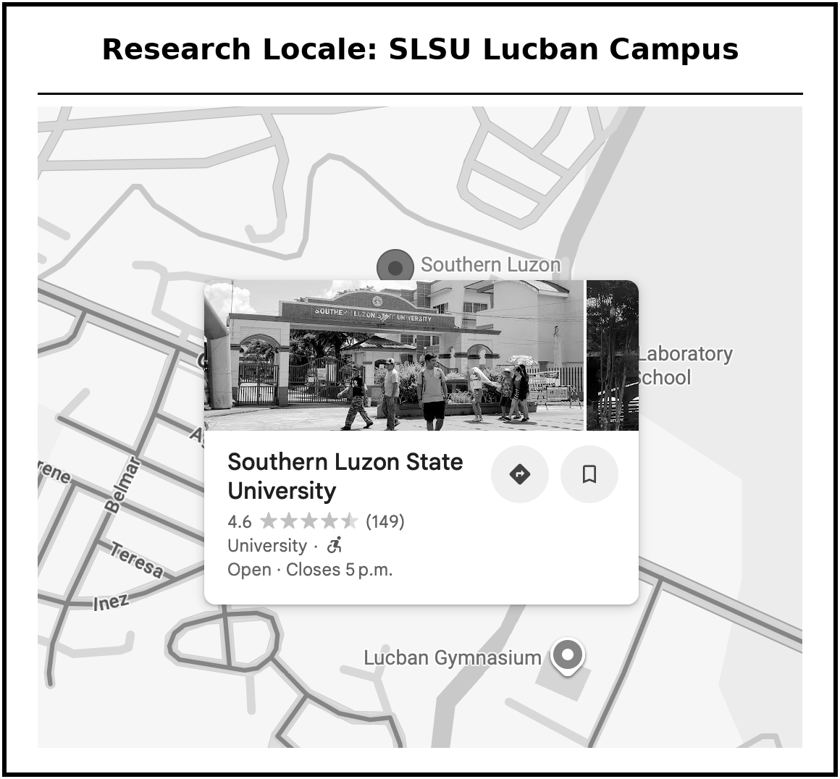
Figure 2. Research Locale, SLSU Lucban Campus
Research Design
This study utilized the developmental research method to design, build, and evaluate an integrated Property Management System and operational simulation environment tailored for hospitality education. Developmental research is the systematic study of designing, developing, and evaluating instructional programs, processes, and products that must meet criteria of internal consistency and effectiveness. The approach was selected because the objective was not merely to observe a phenomenon but to create and rigorously assess a functional product that resolves a specific gap in the SLSU Hospitality Management program.
The developmental design is distinguished by its emphasis on producing a usable artifact, in this case a web-based platform, and then subjecting that artifact to formal quality evaluation. This two-phase structure aligns with the dual objectives of the study: to produce the InnSight system and to assess its quality using the ISO/IEC 25010:2023 software-product-quality standard as the primary evaluation framework. ISO/IEC 25010:2023 was chosen because it provides an internationally recognized model spanning nine characteristics, namely Functional Suitability, Performance Efficiency, Compatibility, Interaction Capability, Reliability, Security, Maintainability, Flexibility, and Safety, allowing a multi-dimensional evaluation appropriate to a complex, multi-service educational platform.
The development of InnSight followed the Iterative and Incremental methodology as its Software Development Life Cycle (SDLC). Under this model the system was built through successive cycles rather than delivered all at once. Each cycle begins with requirements gathering and concludes with a tested, deployable increment. This approach was chosen over linear models such as Waterfall because the microservices architecture requires that individual services be developed, validated, and stabilized independently before more interdependent modules are introduced.
Requirements Analysis
The requirements analysis covers the functional and non-functional specifications necessary for the development and deployment of InnSight, establishing the technical foundation that guided the entire process and ensuring the system aligns with its intended use in the BSHM curriculum. Prior to formalizing requirements, the researchers conducted consultative interviews with the Hospitality Management faculty at SLSU Lucban, including the program’s lead instructor and the program chair, to document the current state of laboratory instruction, identify operational gaps, and define the functional scope of the platform.
The interviews revealed three primary deficiencies in the existing instructional approach: (1) the absence of a controlled environment in which students could practice the complete hotel guest cycle, including check-in and check-out procedures; (2) the lack of a realistic operational system in which routine hotel scenarios could be rehearsed; and (3) no mechanism for instructors to monitor individual student progress or competency during laboratory sessions. These findings directly informed the system’s functional requirements. The figure below presents the pre-InnSight laboratory workflow and the gaps the system was designed to close.
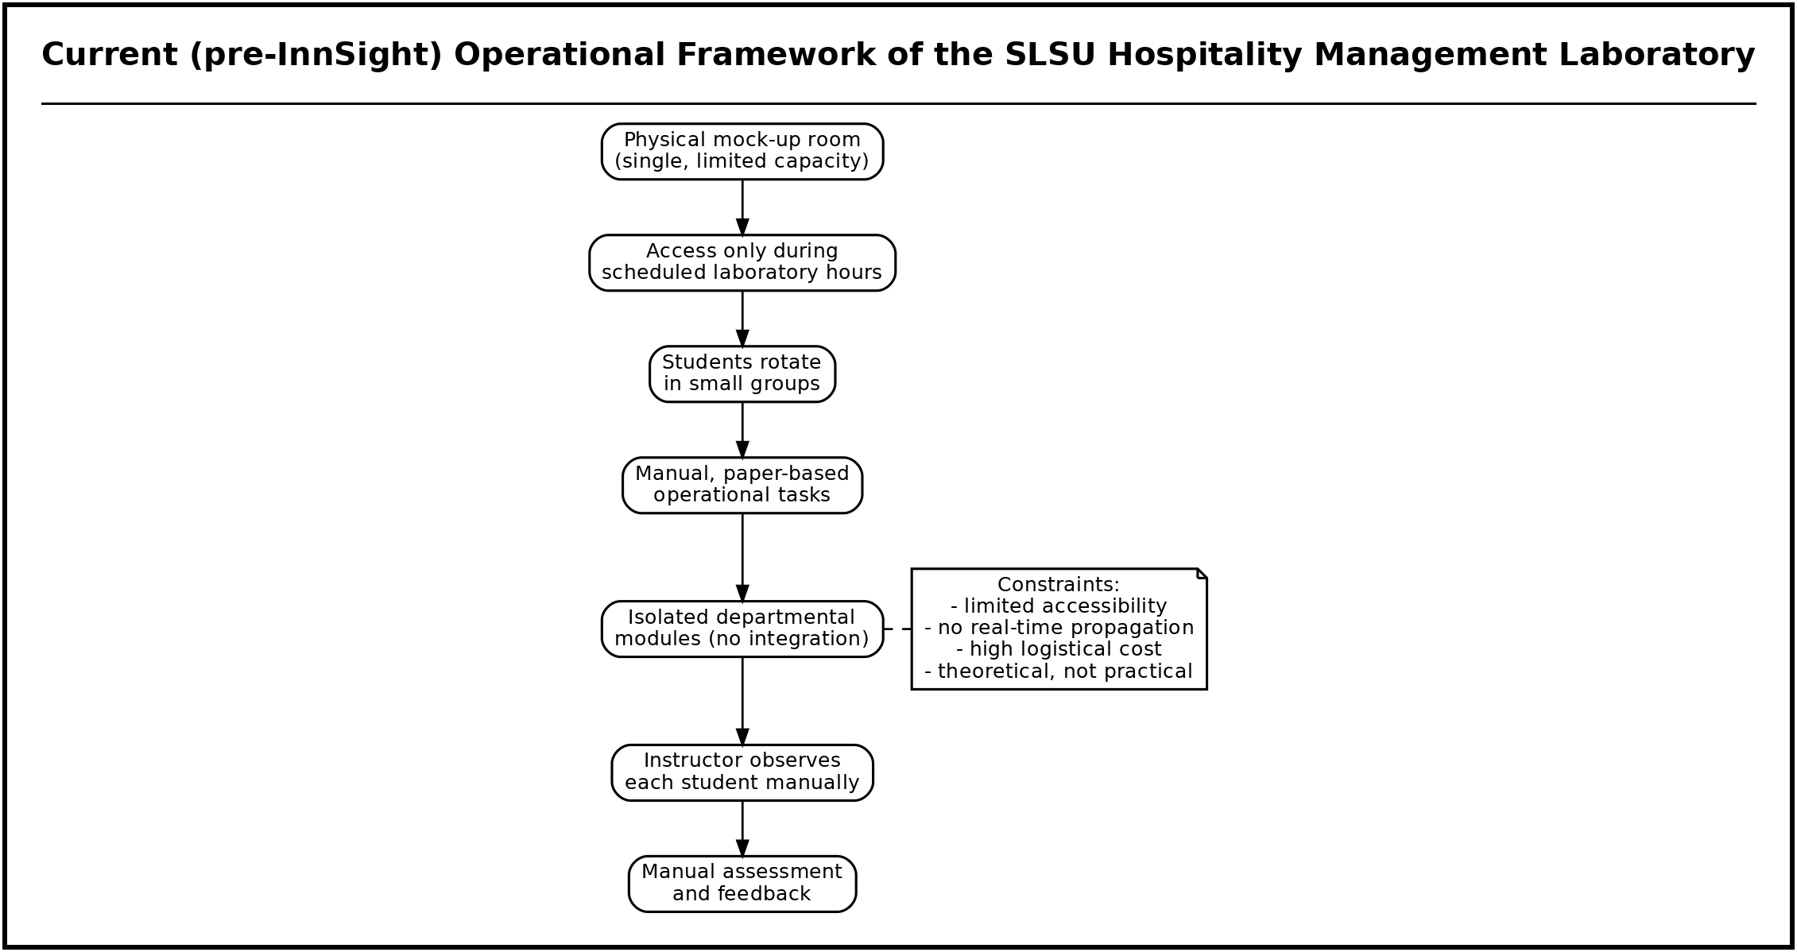
Figure 3. Current (pre-InnSight) Operational Framework of the SLSU Hospitality Management Laboratory
Requirements Documentation
Functional Requirements
The functional requirements were derived from the stakeholder interviews and a review of related literature, and serve as a reference throughout development. They describe the system as it was actually implemented.
Account Management and Role-Based Access. The system shall authenticate users through a secure username-and-password login and issue signed JSON Web Tokens carrying role claims. Access shall be governed by six operational roles, Administrator, Manager, Front Desk, Housekeeping, Maintenance, and Auditor, with every sensitive or state-changing endpoint guarded on the server. Account creation and role assignment are performed by an Administrator or Manager through the Users & Roles screen; there is no public self-registration.
Reservations and Availability. Front-desk users shall create, search, modify, and cancel reservations. The system shall check live availability against per-night inventory before confirming a booking, initialize the guest record, and issue a unique confirmation number. A public, login-free booking engine shall allow guests to check availability and book directly, receiving a confirmation email and a guest-portal link.
Front-Desk Stay Management. The system shall process guest arrivals (check-in) by assigning a guest-ready room and opening a guest folio, and departures (check-out) by settling and closing the folio, issuing an invoice number, and returning the room to the housekeeping queue. Walk-in registration shall be supported for guests without a prior booking.
Billing and Folio. Each stay shall maintain an itemized folio to which incidental charges (for example, mini-bar, food and beverage, and laundry) may be posted. Balances shall be recomputed on every posting, payments and deposits recorded, and money stored with integer precision to prevent rounding error. Check-out shall settle the folio atomically.
Rooms, Housekeeping, and the Room-Status Map. The system shall present an interactive room-status map showing each room’s cleanliness and occupancy state (Clean, Clean-Inspected, Dirty, Occupied, Out-of-Order, Out-of-Service). Housekeeping users shall update room status and receive rooms in their assignment queue; status changes shall propagate to every connected screen in real time.
Amenities and Point-of-Sale. Administrators shall configure priced facilities and amenities (for example, event hall, gym and pool, restaurant, spa, parking, laundry, and meeting rooms). Reservable facilities shall support time-slot bookings, and walk-in amenity use shall be billable through a one-click point-of-sale that opens a walk-in folio and issues a receipt.
Night Audit and Reporting. An Auditor shall run the night audit to roll the business day, post room and tax charges to in-house folios, and snapshot occupancy, Average Daily Rate (ADR), and Revenue per Available Room (RevPAR). Managers and auditors shall view a KPI dashboard and operational reports, including amenity revenue and a bookings schedule.
Maintenance. Maintenance users shall create and track work orders against rooms and assets; taking a room out of service shall be reflected on the room-status map and in availability.
Operational Simulation and Competency Tracking. The system shall provide an immersive three-dimensional housekeeping training simulation in which a trainee walks a room and completes cleaning stations in any order. Each session is scored on both task execution and the reasoning behind it, and the result is written to a per-staff competency record that managers can review to identify knowledge gaps. Instructors shall be able to customize the room layouts used by the simulation.
Design of Software, System, Product, and Process
System Architecture
InnSight employs a decentralized microservices architecture. Nine independent, loosely coupled Node.js and Express services are orchestrated behind a single nginx API Gateway, with a React single-page application as the client. Every service owns a private PostgreSQL database and communicates asynchronously with the others over a Redis publish-subscribe event bus; no service reaches into another service’s database. This decomposition was adopted for independent scalability, isolated failure domains, and incremental deployability. The diagram below presents the architecture as deployed.
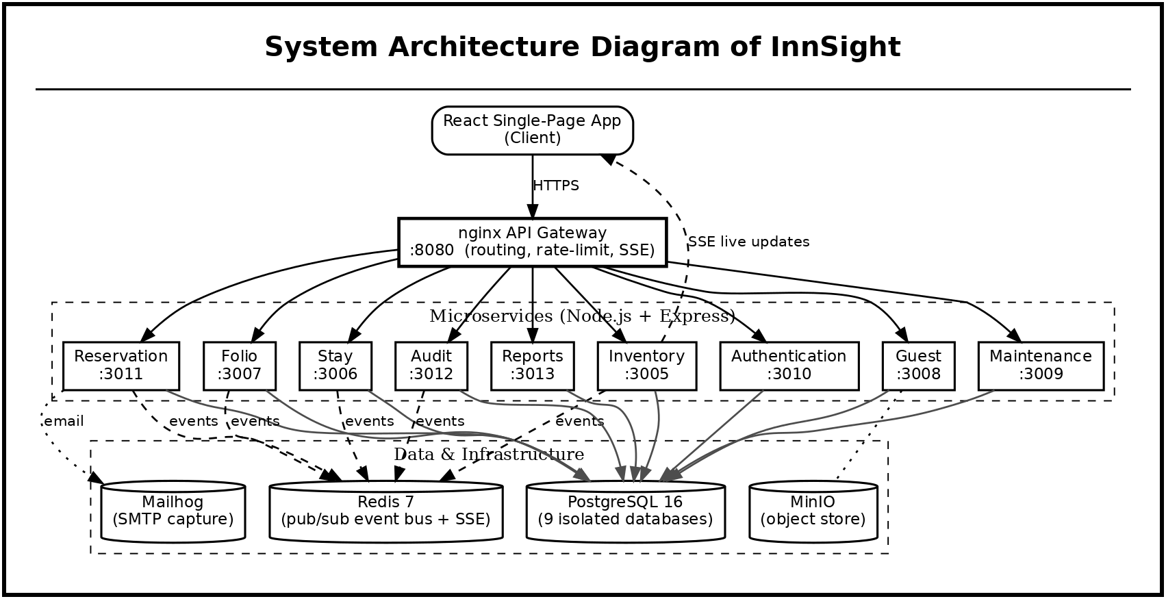
Figure 4. System Architecture Diagram of InnSight
nginx API Gateway (port 8080). The single entry point for all client traffic. It routes each request to the appropriate service, applies rate-limiting, and transparently forwards the Server-Sent Events (SSE) stream used for live updates. Upstream hostnames are re-resolved per request so services can be restarted or replaced without a gateway restart.
Authentication Service (:3010). Manages users, roles, permissions, and session tokens; hashes passwords with bcrypt; issues and validates JWTs; and stores the housekeeping training-competency records.
Reservation Service (:3011). Owns the reservation lifecycle from booking to cancellation, including the public booking endpoints, and publishes reservation events consumed by inventory.
Stay Service (:3006). Handles arrivals, in-house stays, walk-ins, no-shows, check-in, and check-out, coordinating room status and folio opening/closing.
Folio Service (:3007). Maintains folios, transactions, charge codes, payments, and the one-click amenity point-of-sale, and performs atomic settlement.
Guest Service (:3008). Stores guest profiles, contacts, preferences, loyalty accounts, and consent records.
Inventory Service (:3005). Owns rooms, room types, rate plans, promo codes, per-night inventory holds, and facilities, and hosts the live-events (SSE) endpoint that fans Redis events out to clients.
Maintenance Service (:3009). Manages work orders, assets, and parts, and toggles rooms out of and back into service.
Audit Service (:3012). Runs the night audit and manages business-day state.
Reports Service (:3013). Aggregates operational and revenue KPIs for the dashboard and reports.
Supporting infrastructure includes a single PostgreSQL 16 instance hosting nine isolated databases, a Redis 7 broker, a MinIO object store, and a Mailhog SMTP capture service used for confirmation emails during development. Notably, the system uses PostgreSQL uniformly for all persistence; no document database is used.
Iterative and Incremental Development
Development proceeded through three increments, each ending in a tested, deployable release. The diagram below illustrates the approach.
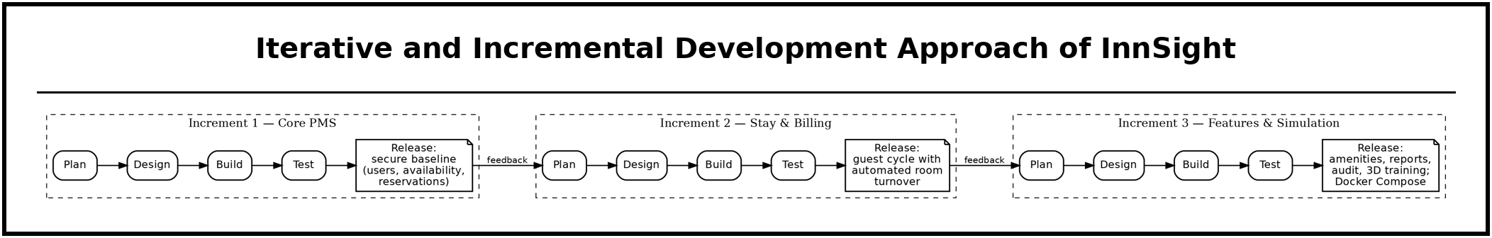
Figure 5. Iterative and Incremental Development Approach of InnSight
Increment 1, Core PMS. Established authentication and role-based access, the reservation lifecycle, and the room and rate inventory, all exposed through the gateway. The milestone was a secure baseline capable of managing users, availability, and reservations.
Increment 2, Stay and Billing. Added front-desk check-in and check-out, the folio and billing ledger, and the housekeeping room-status lifecycle, with Redis events transitioning rooms automatically on check-in and check-out. The milestone was a working guest cycle with automated room turnover.
Increment 3, Feature Services and Simulation. Delivered amenities and the point-of-sale, the KPI dashboard and reports, the night audit, maintenance, and the three-dimensional housekeeping training simulation with competency tracking, followed by a system-wide quality-and-security hardening pass. The release was packaged as a Docker Compose deployment.
Software Requirements
The following technologies were used to build InnSight.
• Visual Studio Code, primary integrated development environment for the frontend and the nine backend services.
• React and Vite, component-based single-page application and its fast build/hot-reload toolchain.
• React Three Fiber (Three.js), renders the immersive three-dimensional housekeeping training simulation in the browser.
• Axios, asynchronous HTTP client for communication with the API Gateway.
• Node.js and Express.js, runtime and web framework for all nine microservices and the service endpoints.
• nginx, reverse-proxy API Gateway providing routing, rate-limiting, and SSE passthrough.
• PostgreSQL and Prisma ORM, relational databases (one per service) with a type-safe query layer; used uniformly for all persistence.
• Redis, publish-subscribe event bus and the source of the Server-Sent Events live-update stream.
• bcrypt and JSON Web Tokens, password hashing and stateless, role-aware authentication.
• MinIO and Mailhog, S3-compatible object storage and development SMTP capture.
• Docker and Docker Compose, containerization and single-command orchestration of the full stack.
Hardware Requirements
Developer, instructor/administrator, and student/end-user machines each require a 64-bit Windows 10/11, macOS, or Ubuntu Linux system with at least 8 GB of RAM, an Intel Core i5 (8th generation or newer) or AMD Ryzen 5 processor, 256 GB SSD storage, a 1920 × 1080 display, and a broadband connection (10 Mbps or higher). Because the operational simulation is rendered in three dimensions in the browser, a WebGL-capable integrated or dedicated GPU is required on machines used to run the training simulation.
Use Case Diagram
The Use Case Diagram below identifies the system actors and their functions. InnSight recognizes six operational roles plus two external actors. Front Desk creates and manages reservations, processes check-in and check-out, records walk-ins, posts charges, and operates the amenity point-of-sale. Housekeeping views and updates the room-status map, works its assignment queue, and completes the three-dimensional training simulation. Maintenance manages work orders and room out-of-service state. Auditor runs the night audit and reviews reports. Manager and Administrator configure room types, rates, promotions, facilities, users, and roles, and review the KPI dashboard and staff competency records, the Administrator holding the exclusive property-configuration rights. Externally, a Guest books through the public engine and views the guest portal, and a Trainee (any staff member) uses the training simulation. Because access is enforced on the server for every sensitive action, each actor sees and can invoke only the functions appropriate to its role.
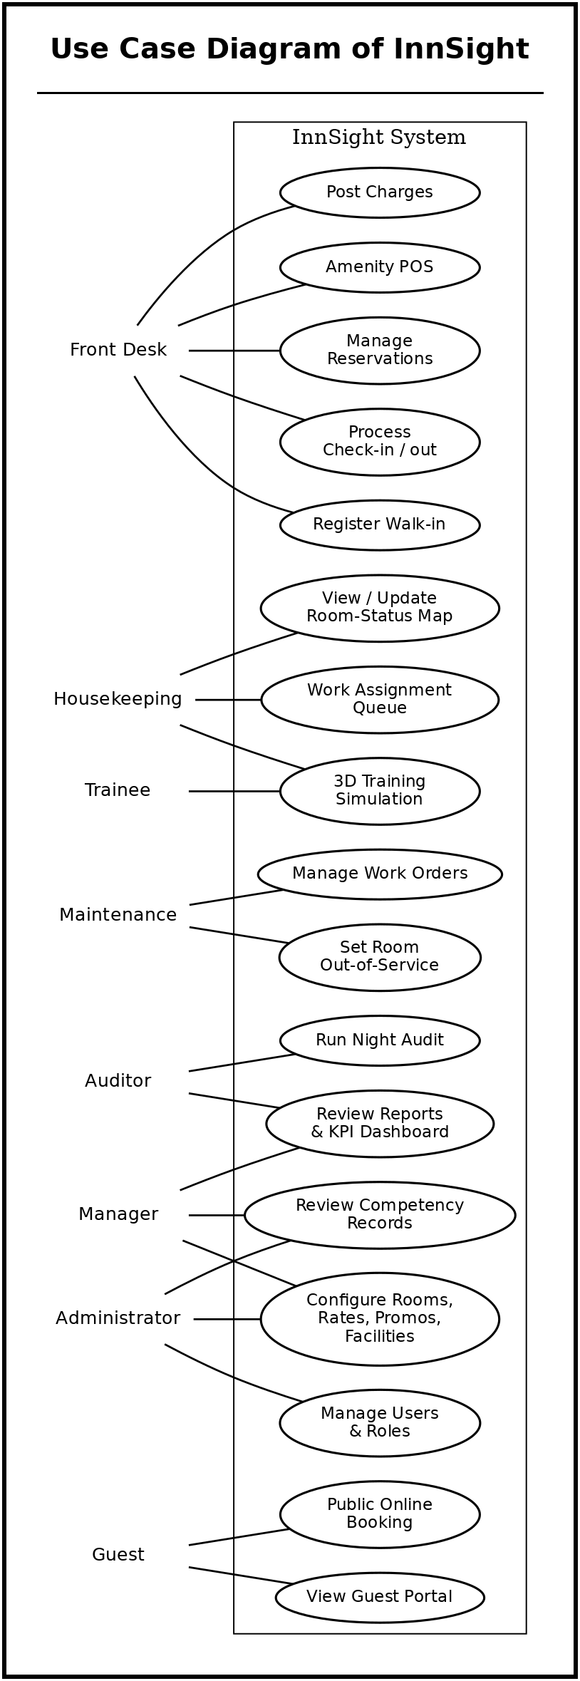
Figure 6. Use Case Diagram of InnSight
Activity Diagrams
The following activity diagrams model the flow of control through the system’s principal operational processes as implemented.
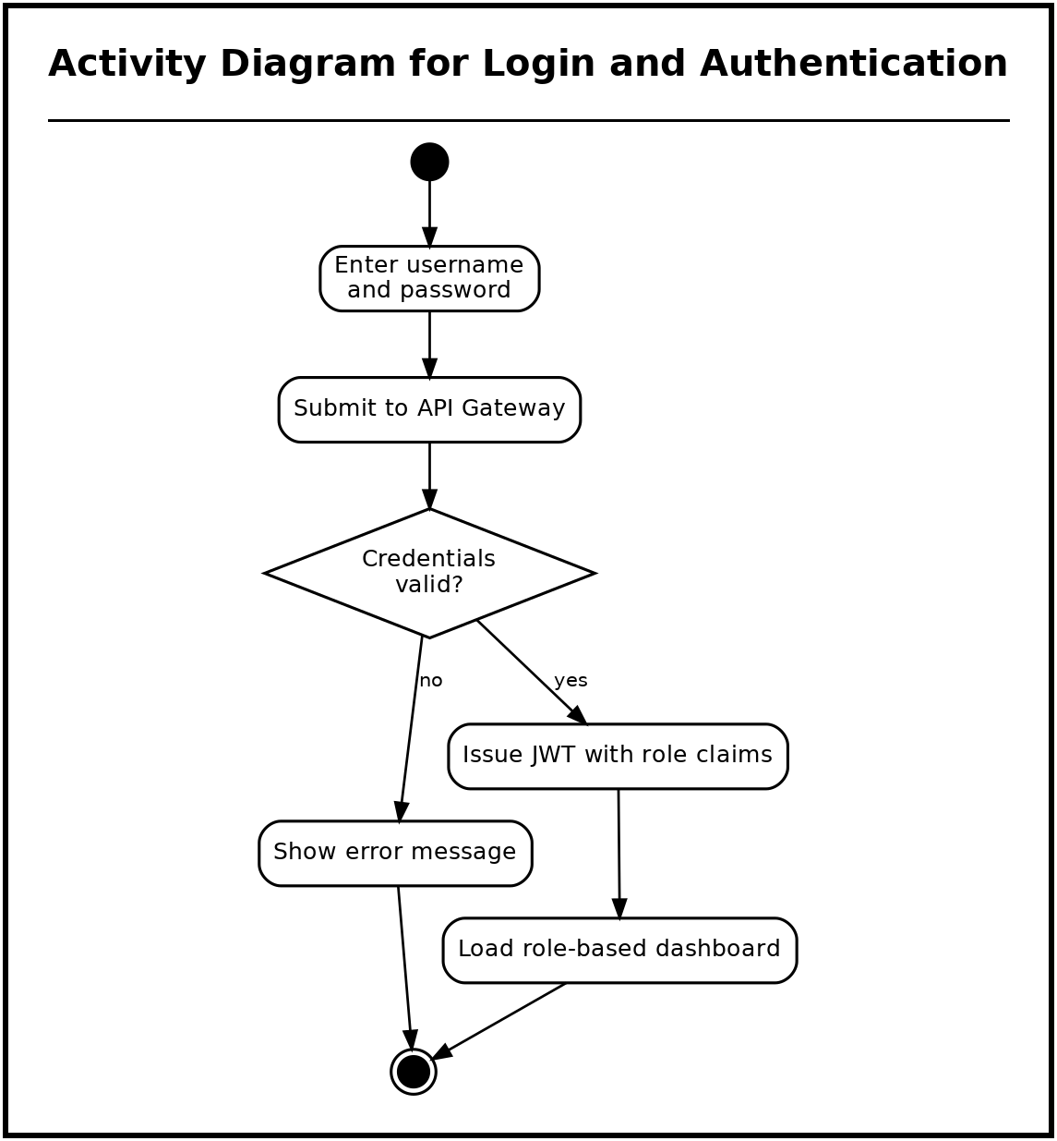
Figure 7. Activity Diagram for Login and Authentication
A user submits credentials, which the gateway forwards to the authentication service. On success the service issues a role-scoped JWT and the client loads the role-appropriate navigation; on failure the attempt is counted and an error is shown.
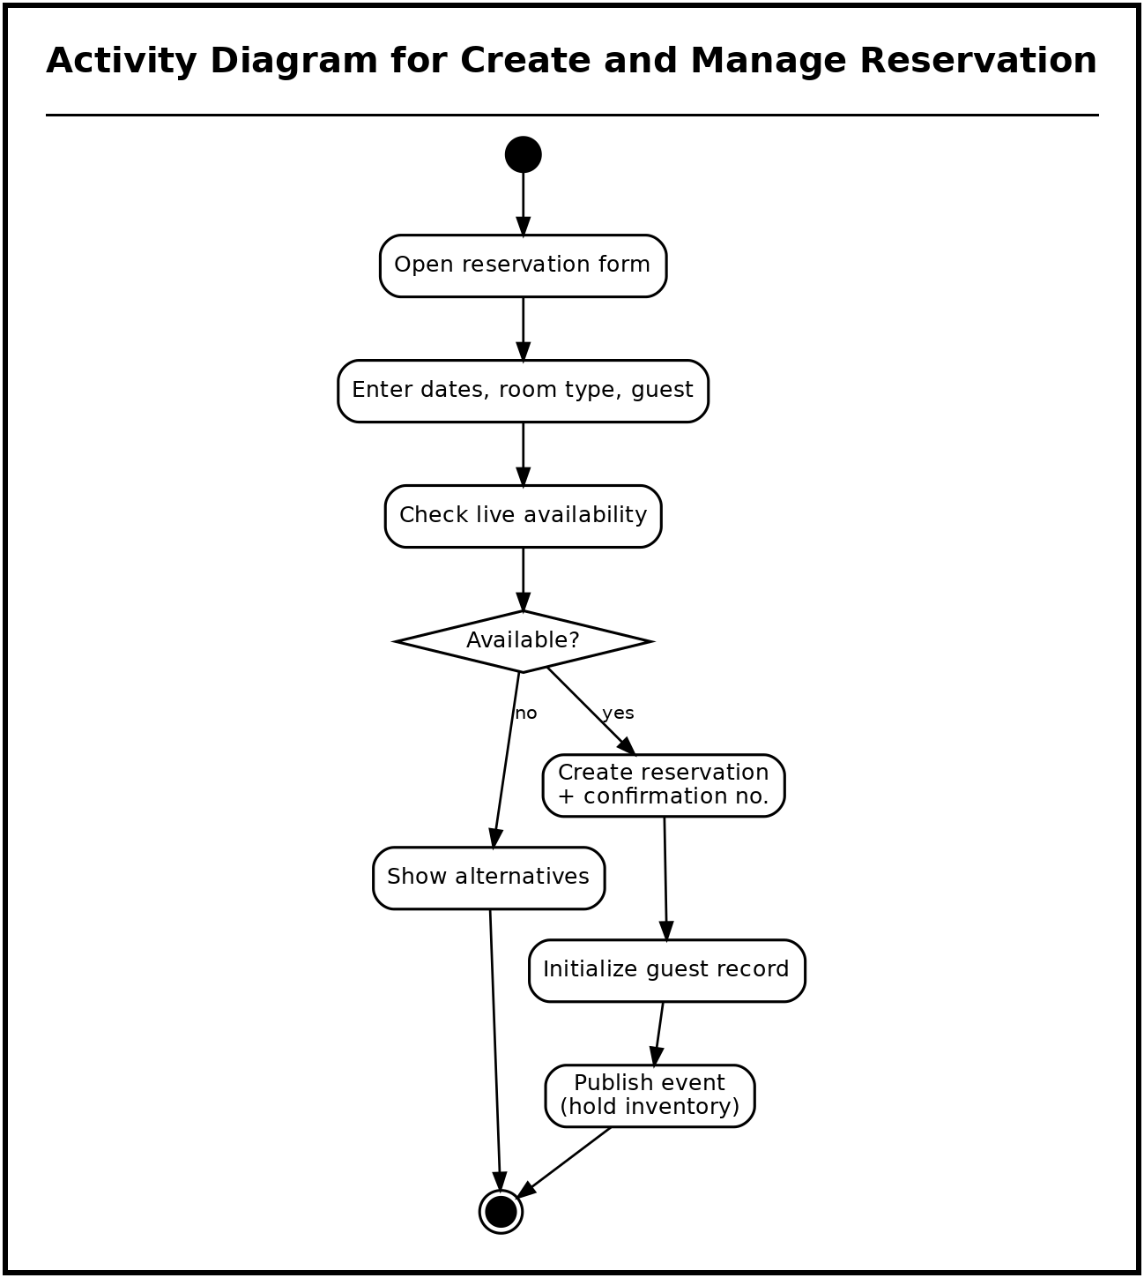
Figure 8. Activity Diagram for Create and Manage Reservation
The reservation service checks live availability with the inventory service before persisting a confirmed reservation, then publishes an event that causes a per-night inventory hold to be placed.
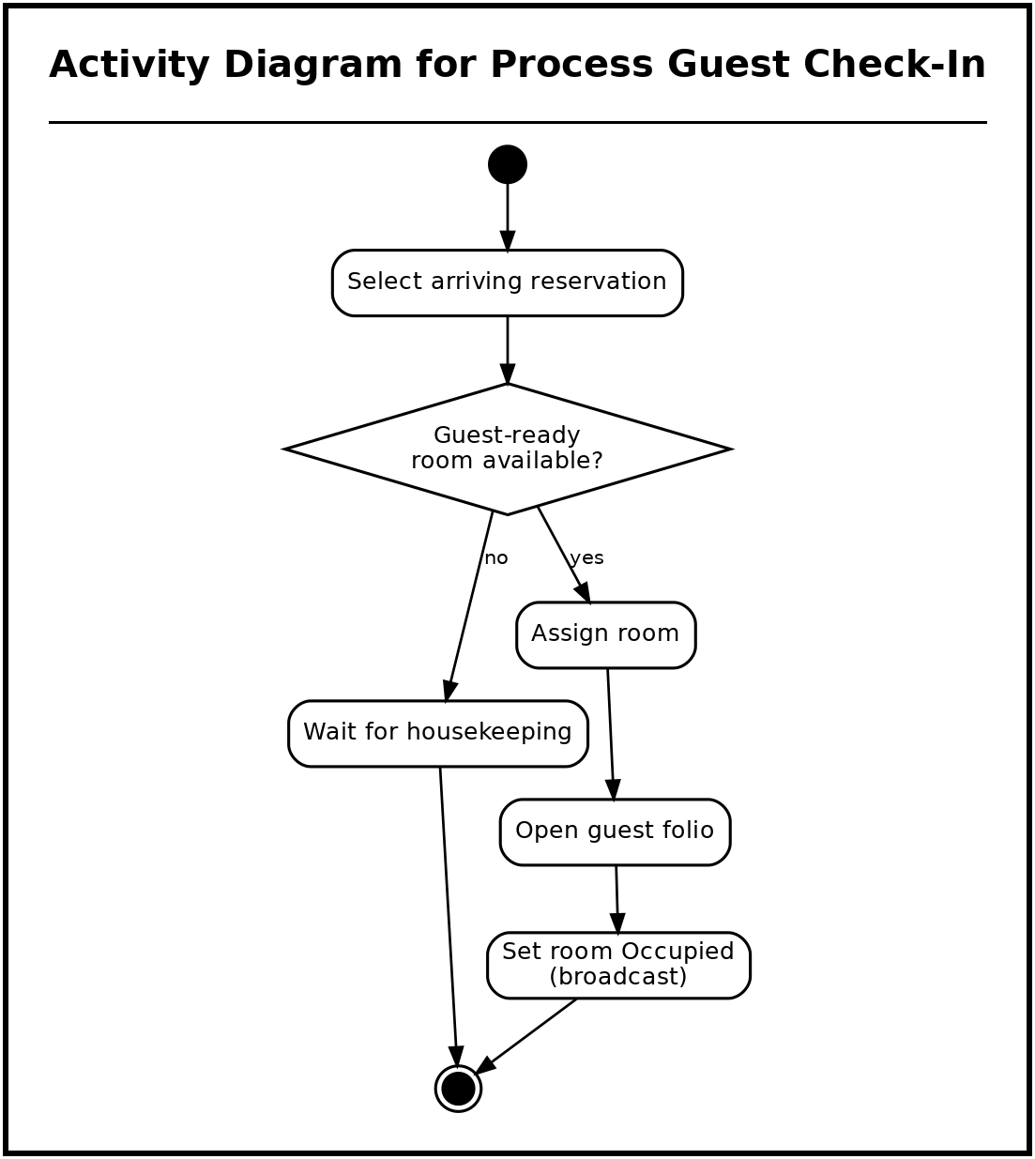
Figure 9. Activity Diagram for Process Guest Check-In
Selecting a guest-ready room creates a stay; a published check-in event drives the room to Occupied and opens the guest folio, and the reservation moves to in-house.
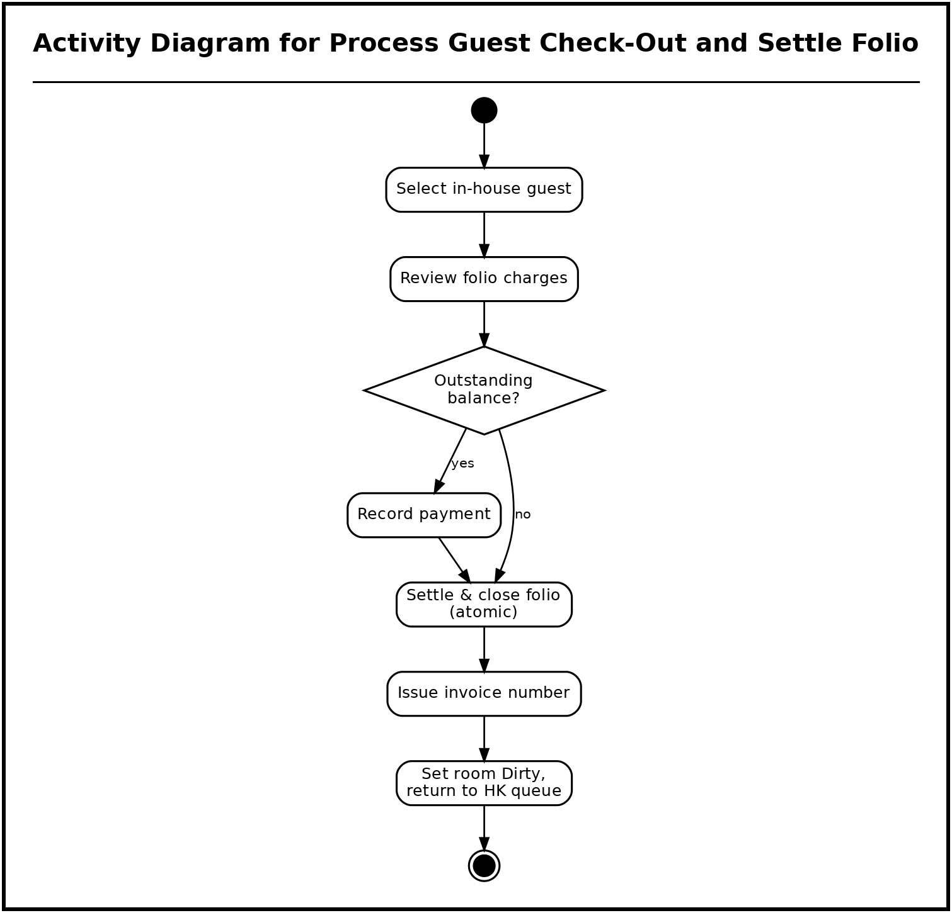
Figure 10. Activity Diagram for Process Guest Check-Out and Settle Folio
The folio is reviewed and settled atomically, an invoice number is assigned, the stay is marked departed, and a published event returns the room to the housekeeping queue as Dirty.
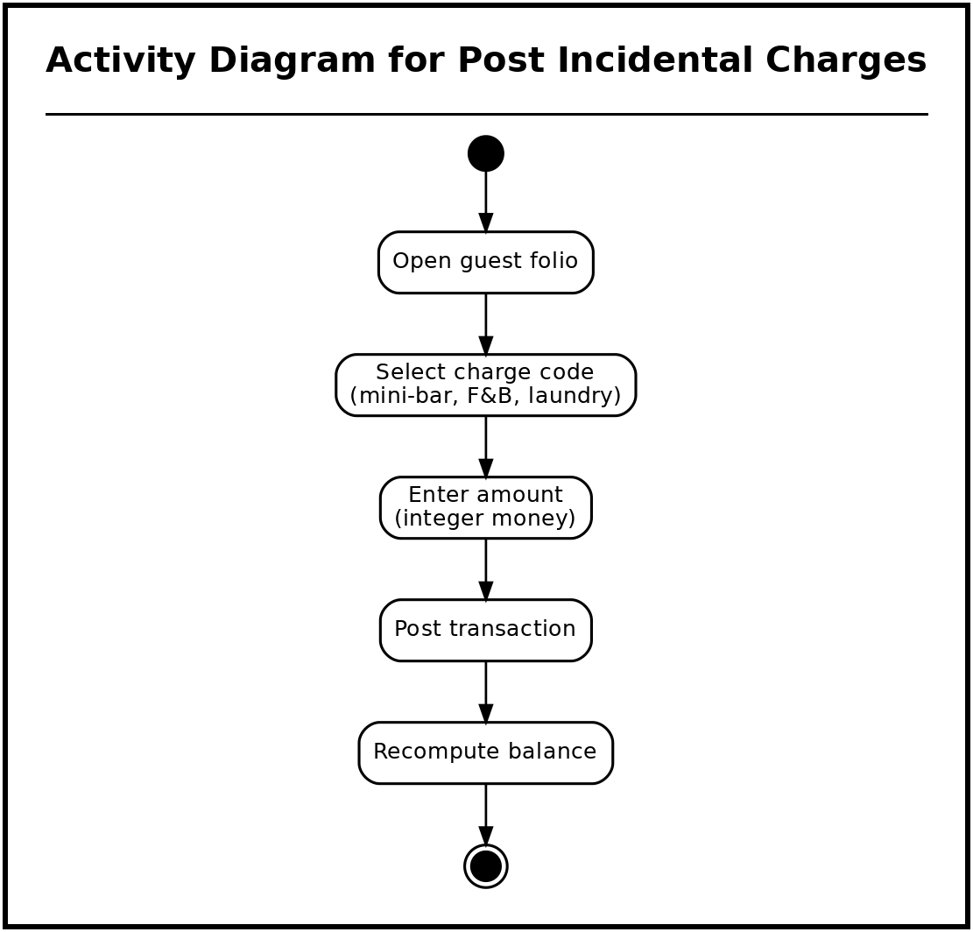
Figure 11. Activity Diagram for Post Incidental Charges
A charge code and amount are posted to the open folio, the balance is recomputed, and a live-refresh event updates every viewer.
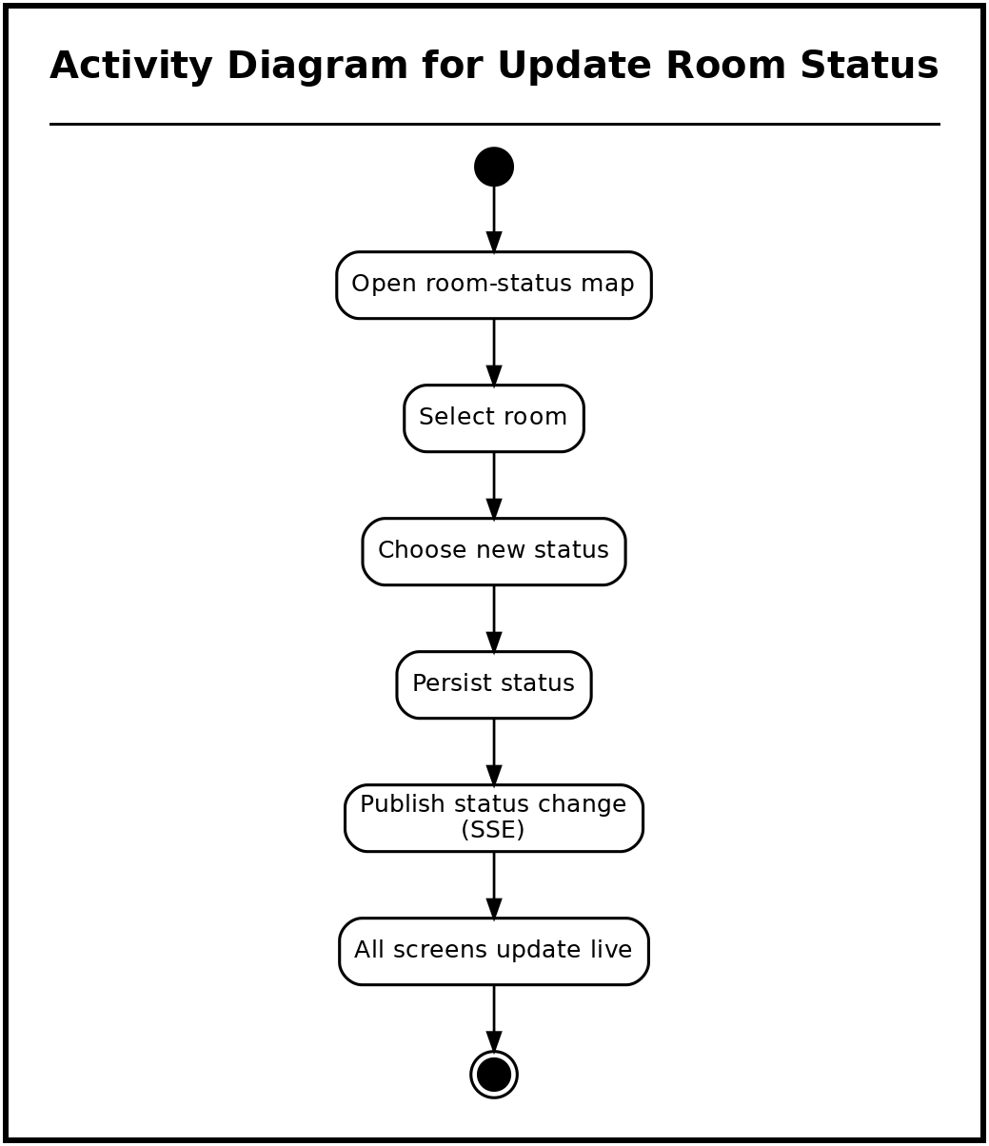
Figure 12. Activity Diagram for Update Room Status
A room-status change is persisted by the inventory service and broadcast over Server-Sent Events so all connected screens reflect it immediately.
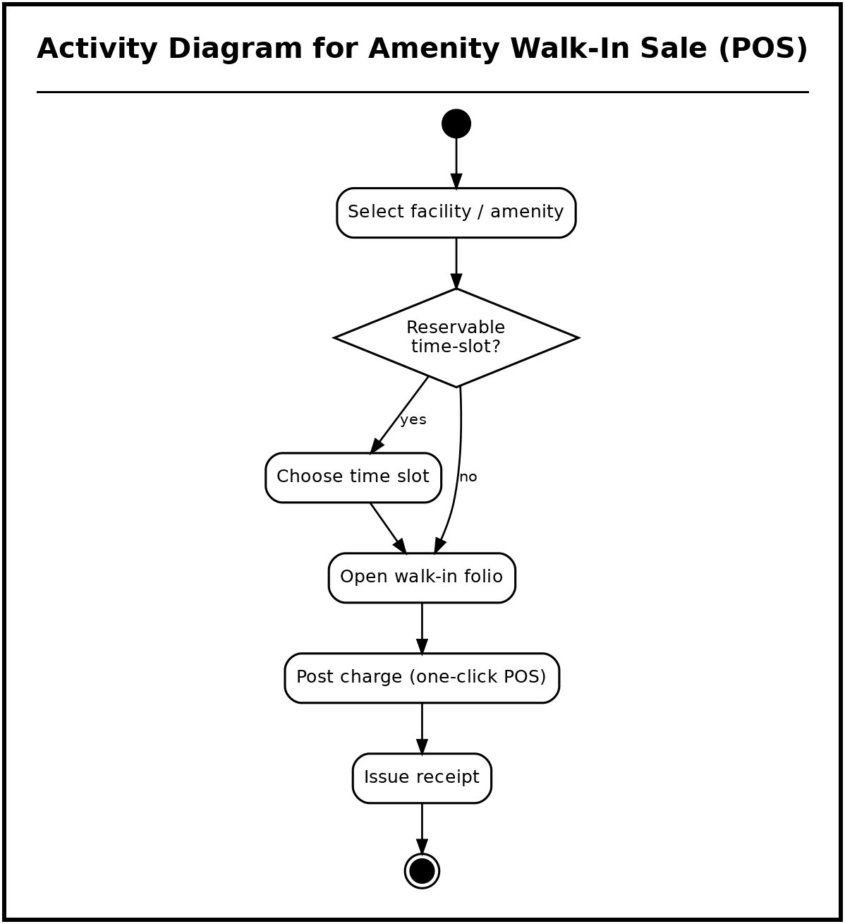
Figure 13. Activity Diagram for Amenity Walk-In Sale (POS)
A facility is selected; reservable facilities create a booking, and in all cases a walk-in folio is opened, the charge posted, and a receipt issued.
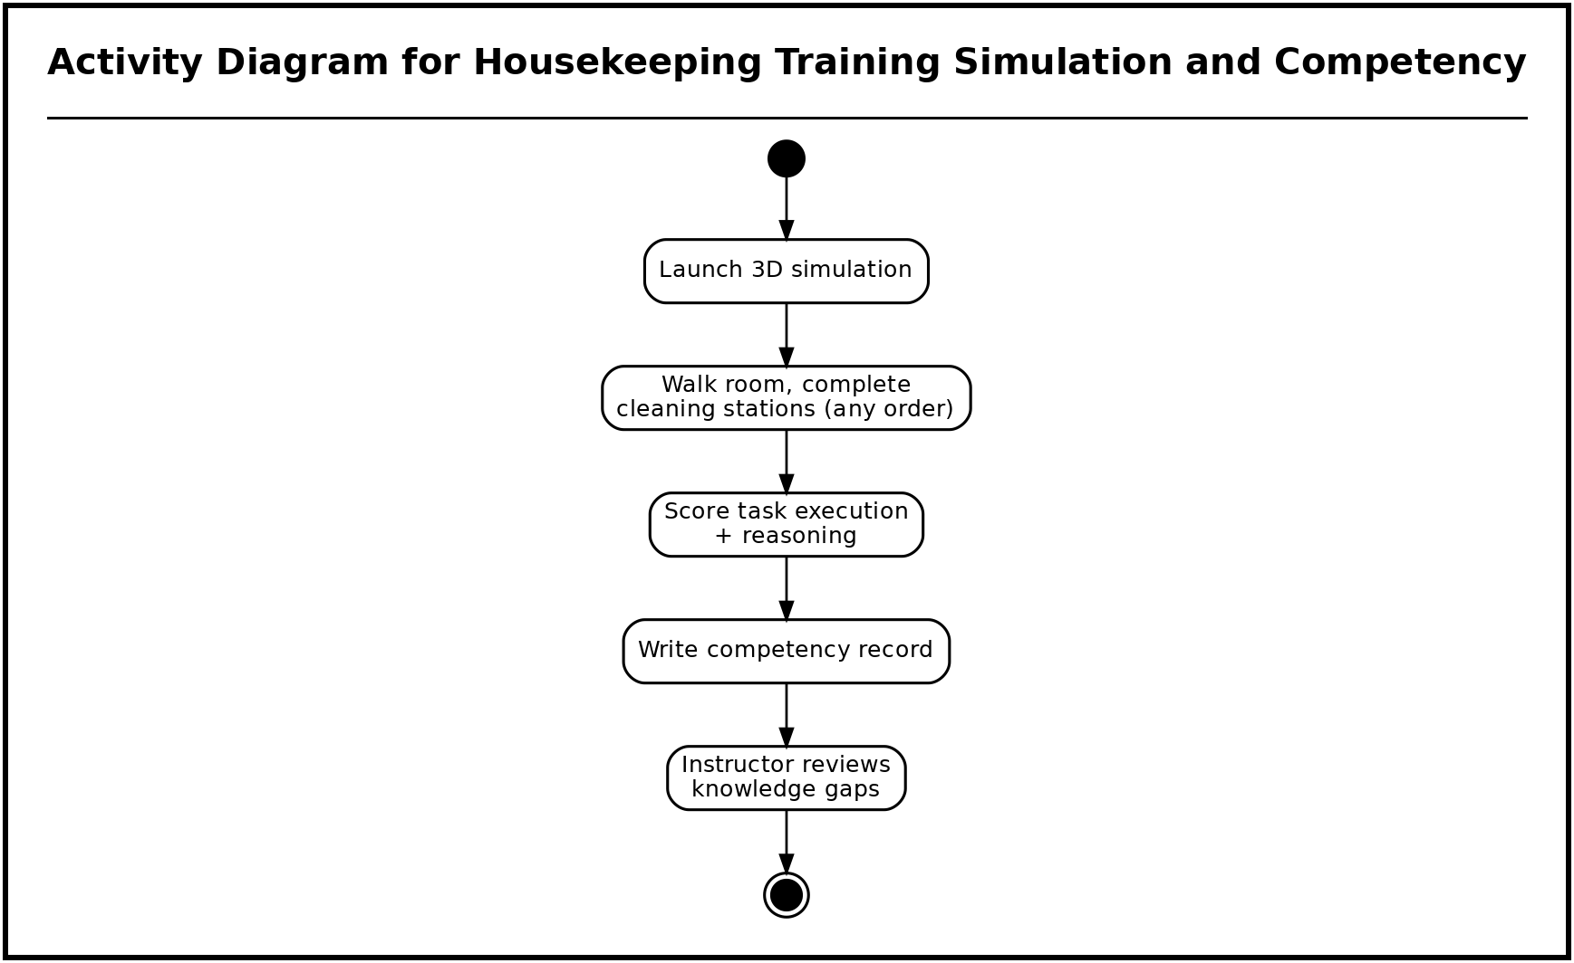
Figure 14. Activity Diagram for Housekeeping Training Simulation and Competency
The trainee works the room’s cleaning stations in any order, answering a brief reasoning probe at each; the session is scored on execution and reasoning and written to the competency record.
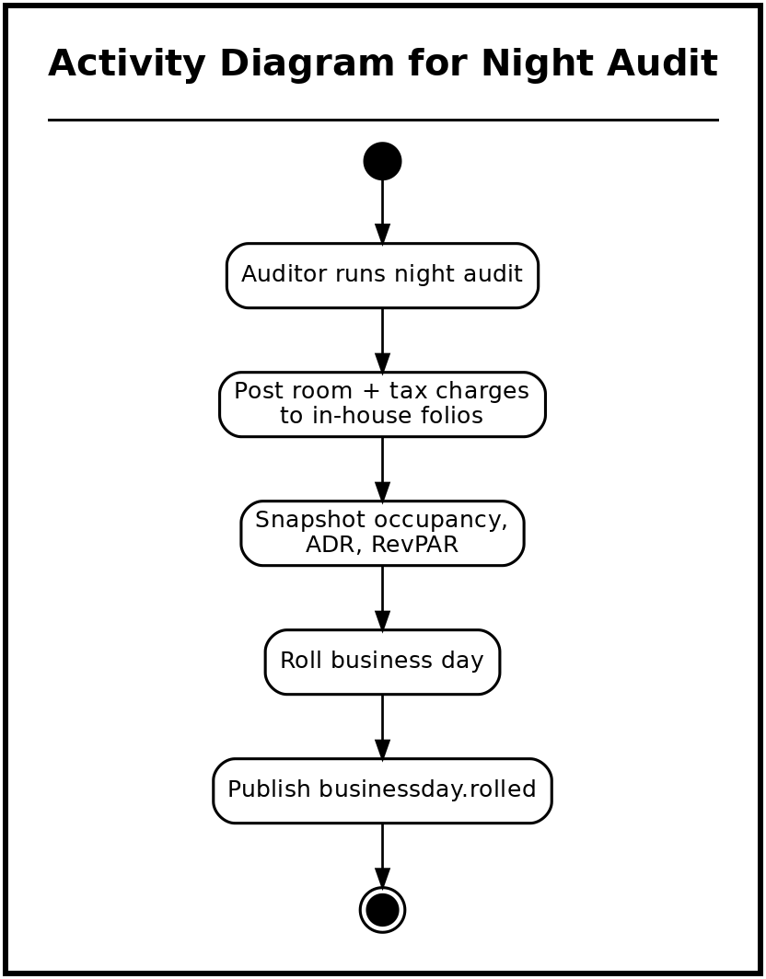
Figure 15. Activity Diagram for Night Audit
The auditor rolls the business day, posts room and tax charges to in-house folios, snapshots the occupancy and revenue metrics, and closes the day, refreshing the reports.
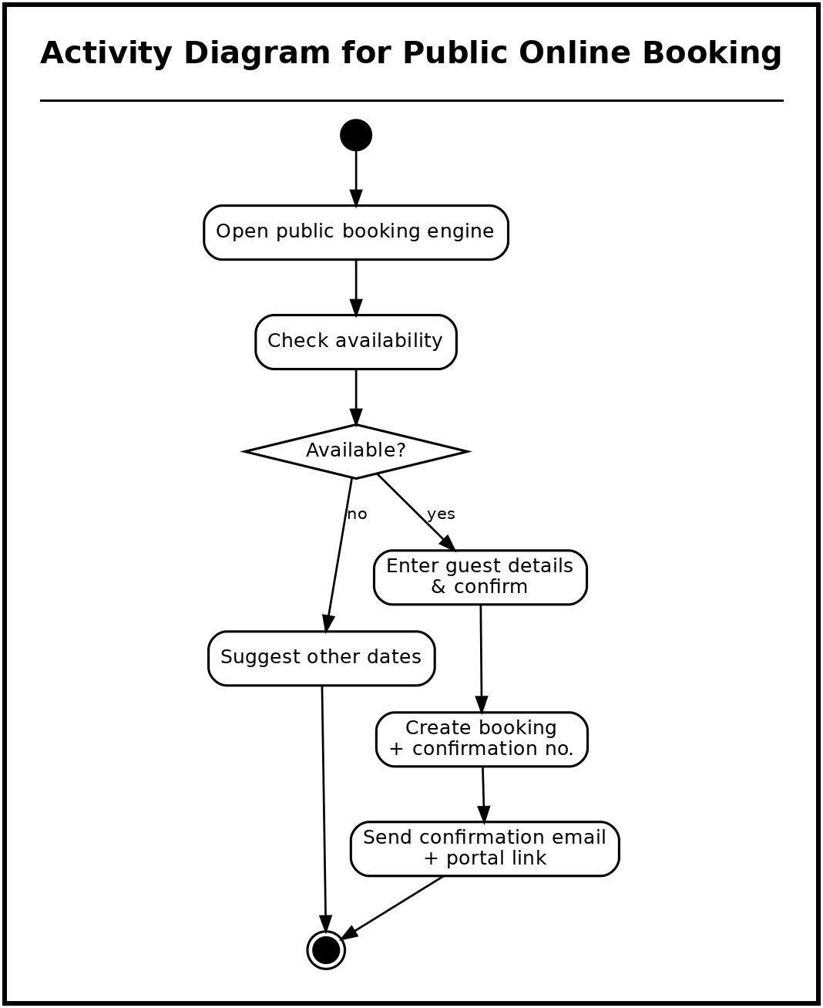
Figure 16. Activity Diagram for Public Online Booking
A guest checks availability and books through the public engine; a confirmation email and guest-portal link are issued.
Sequence Diagrams
The sequence diagrams show the chronological interaction among the client, gateway, services, Redis, and databases for the same processes.
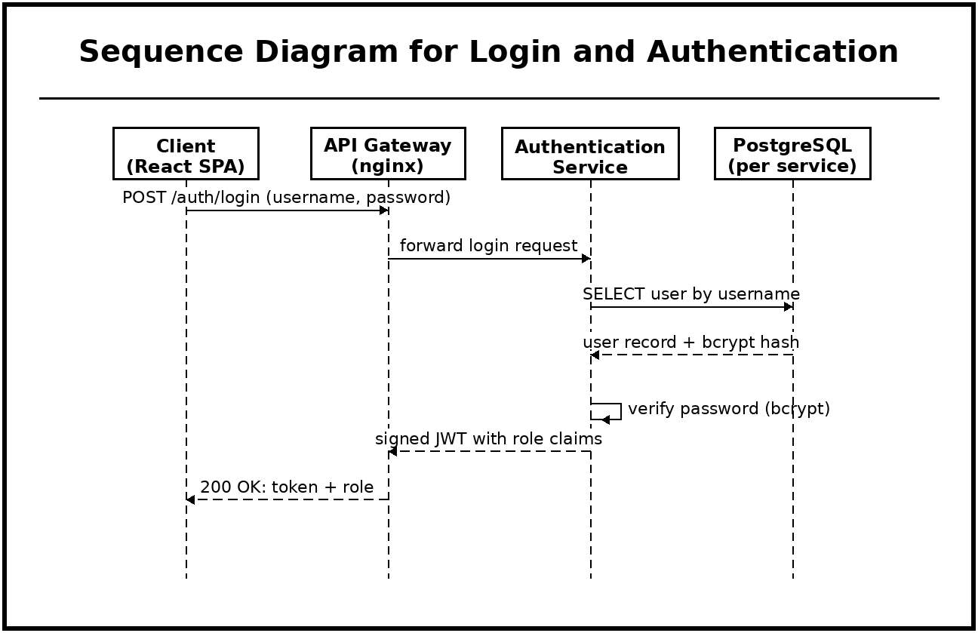
Figure 17. Sequence Diagram for Login and Authentication
The login sequence routes every credential through the single nginx gateway, so authentication is enforced at one controlled entry point. The Authentication Service, which owns the user store, verifies the submitted password against a bcrypt hash rather than a plaintext value, then returns a signed JSON Web Token carrying the user's role. A stateless token is used so that later requests can be authorized by any service without a shared session store, which keeps the services independent.
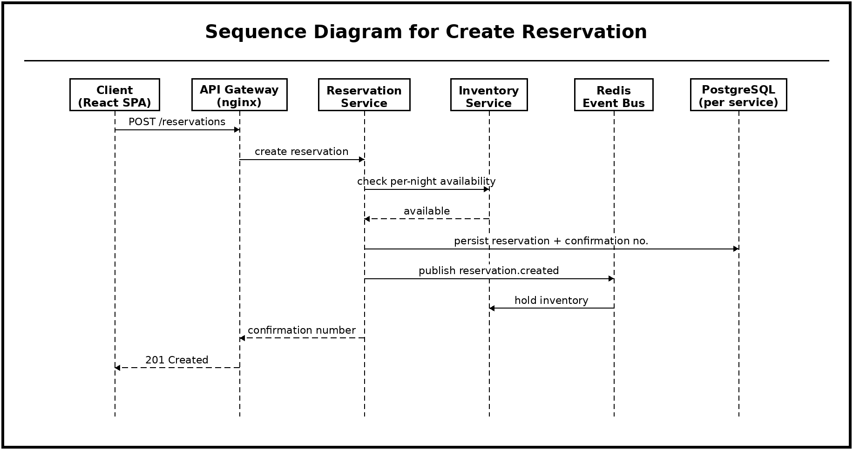
Figure 18. Sequence Diagram for Create Reservation
Reservation creation is kept separate from inventory so that availability is confirmed by the Inventory Service, the single owner of per-night stock, before any booking is committed. The Reservation Service persists the booking and its confirmation number, initializes the guest record, and then publishes a reservation event to Redis rather than writing into another service's database. Inventory consumes that event to place the hold, preserving the rule that no service reaches into another service's data.
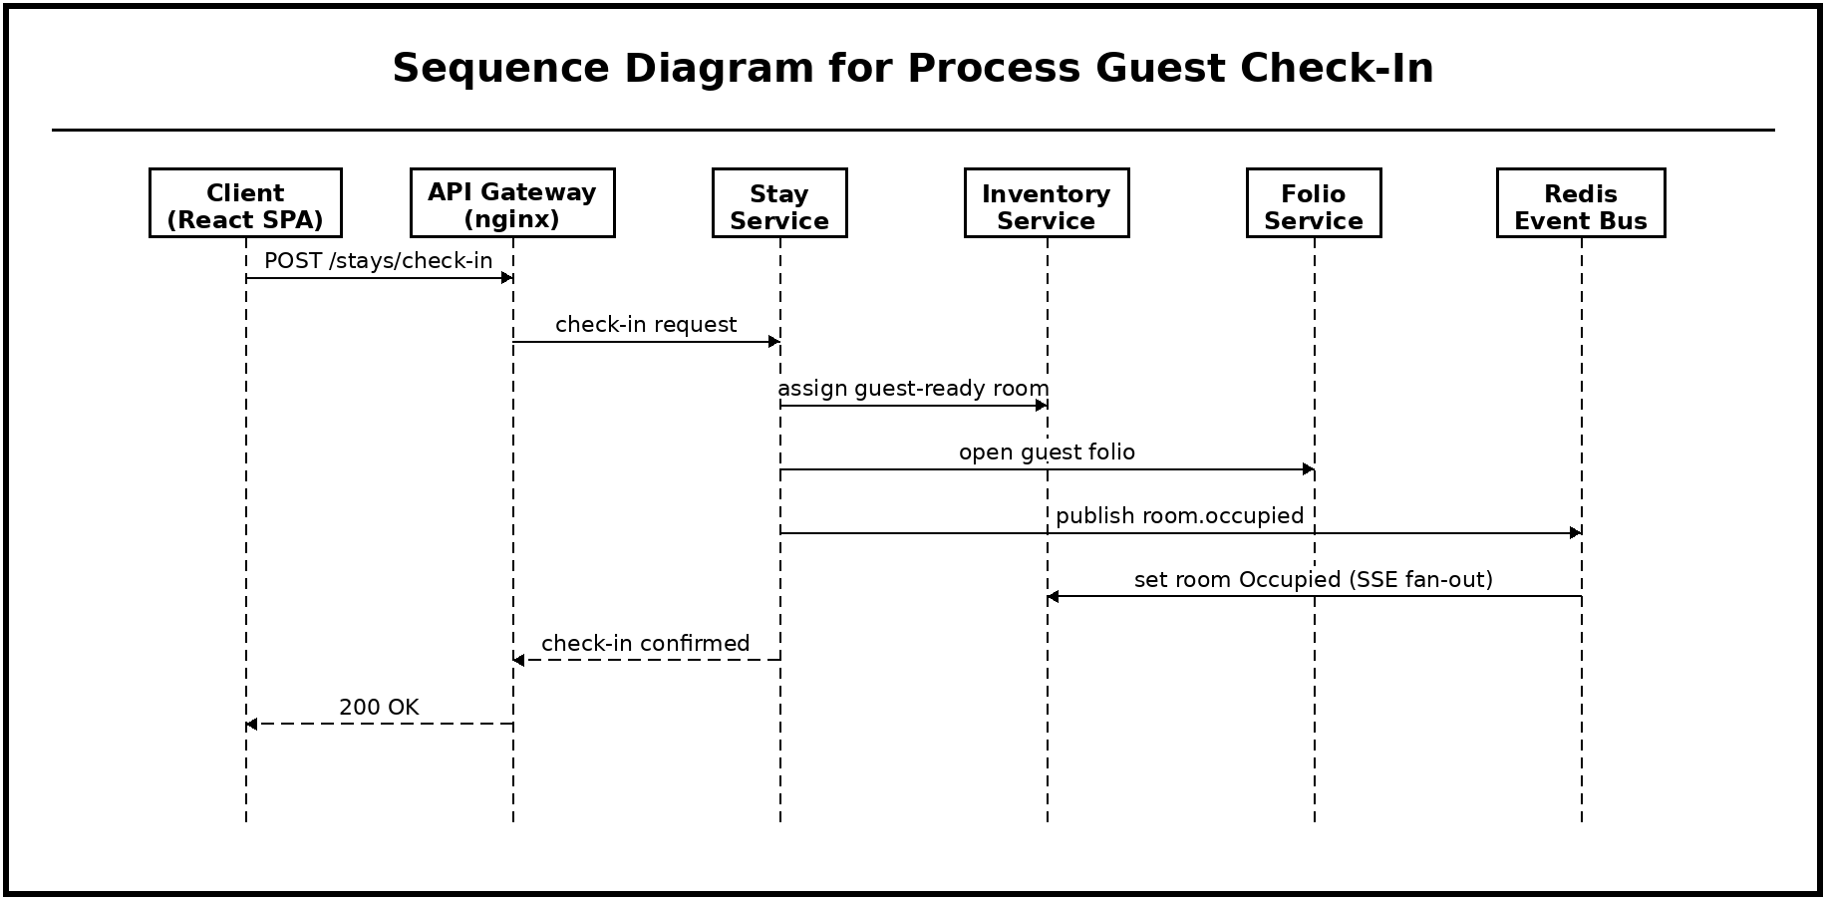
Figure 19. Sequence Diagram for Process Guest Check-In
Check-in is coordinated by the Stay Service, which asks the Inventory Service for a guest-ready room and asks the Folio Service to open the guest folio, keeping room state and billing with their respective owners. The room is then marked Occupied by publishing an event to Redis, which fans the change out over Server-Sent Events so that every connected screen updates live without polling.
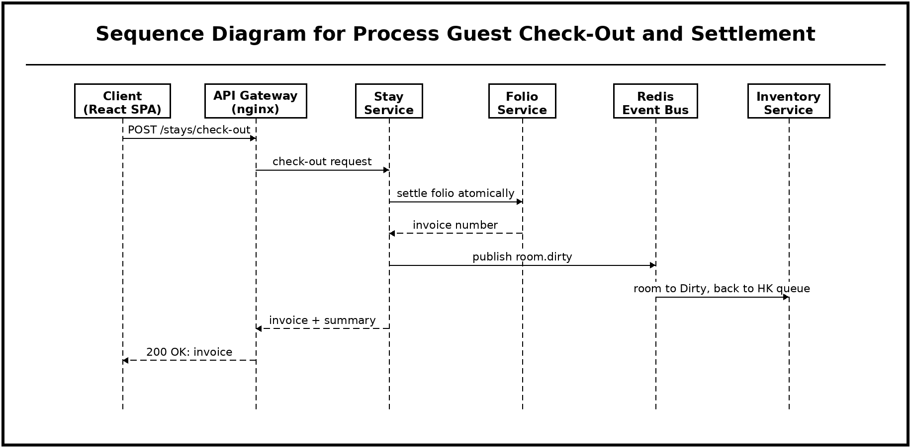
Figure 20. Sequence Diagram for Process Guest Check-Out and Settlement
At check-out the Stay Service delegates settlement to the Folio Service, which closes the folio atomically and issues the invoice number, so a stay can never be left partially billed. Only after settlement does the Stay Service publish the room-dirty event, so the Inventory Service returns the room to the housekeeping queue exactly once and only after the guest has truly departed.
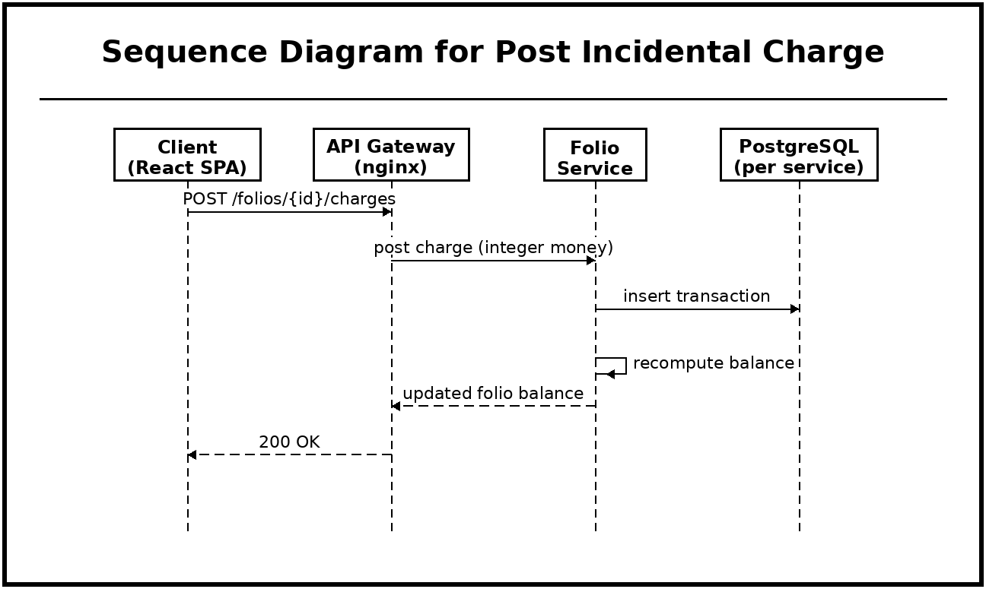
Figure 21. Sequence Diagram for Post Incidental Charge
Charges are posted directly to the Folio Service because it is the sole owner of financial records. Money is stored with integer precision and the balance is recomputed on every posting, which prevents rounding drift and ensures the displayed balance always matches the stored transactions.
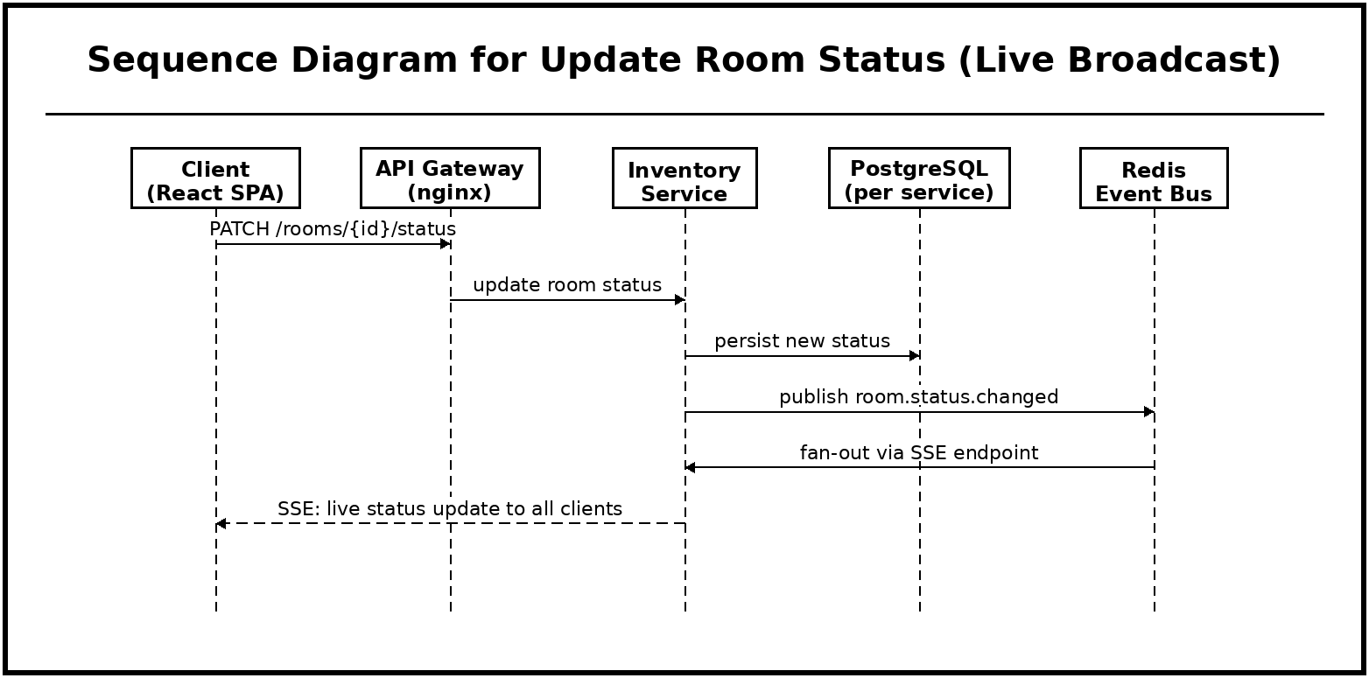
Figure 22. Sequence Diagram for Update Room Status (Live Broadcast)
A status change is written once by the Inventory Service and then broadcast through Redis to the Server-Sent Events endpoint, which pushes the update to every client. This publish-and-fan-out design is what allows many students to view the same live room-status map at once, and it decouples the single writer from the many readers.
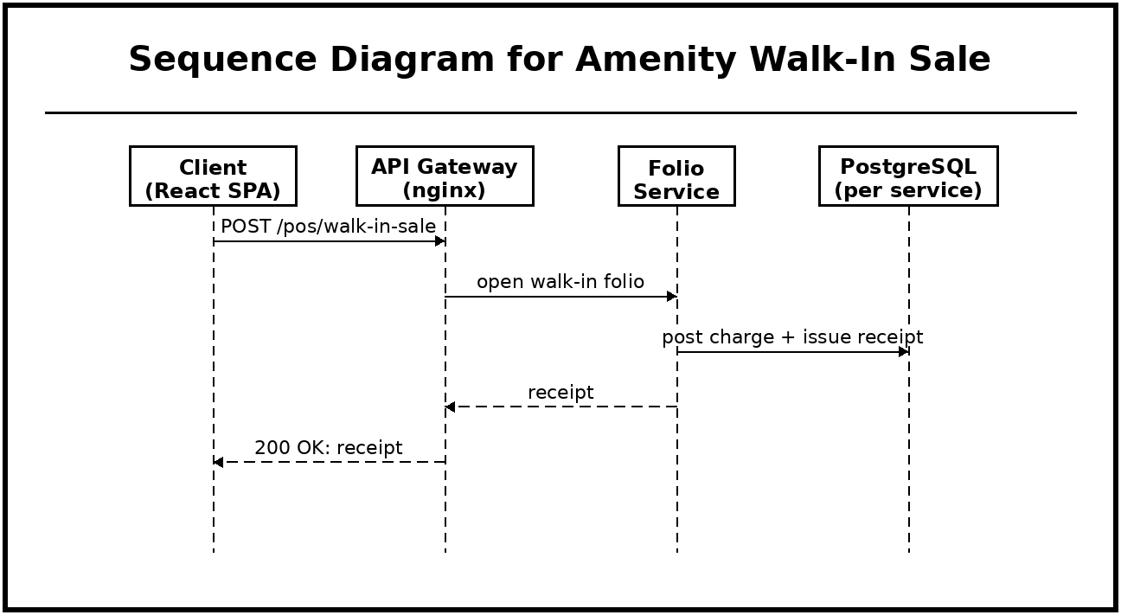
Figure 23. Sequence Diagram for Amenity Walk-In Sale
A walk-in sale reuses the Folio Service so that ad-hoc amenity purchases are billed through the same ledger as room charges. The service opens a dedicated walk-in folio and issues a receipt in a single step, giving the one-click point-of-sale behavior while keeping all money in one auditable place.
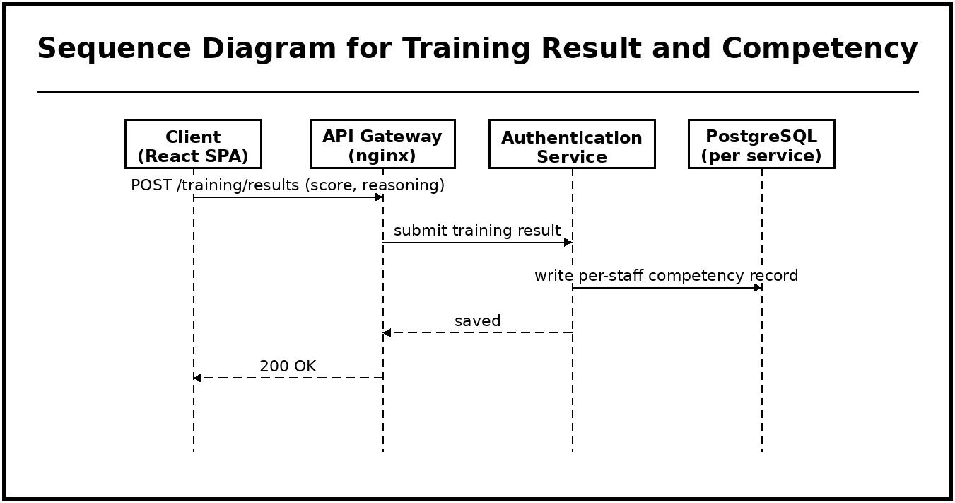
Figure 24. Sequence Diagram for Training Result and Competency
The training result is sent to the Authentication Service because that service owns the per-staff competency records alongside user identity. Recording both the score and the reasoning captures not only whether a task was completed but why it was done, which is what lets instructors pinpoint specific knowledge gaps.
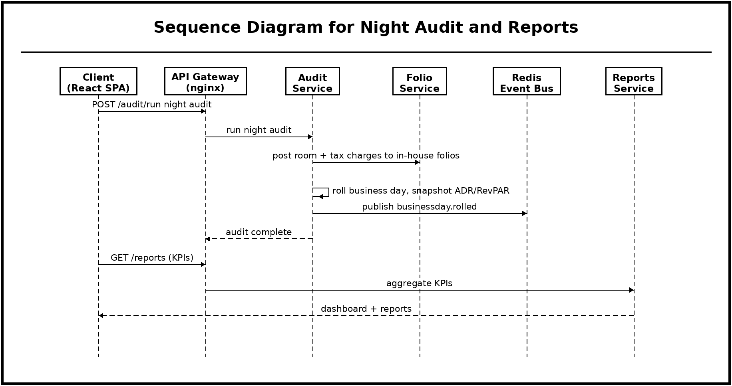
Figure 25. Sequence Diagram for Night Audit and Reports
The Audit Service drives the end-of-day sequence: it posts room and tax charges to in-house folios, rolls the business day, and snapshots occupancy, ADR, and RevPAR, then announces completion through Redis. Reporting is a separate read path handled by the Reports Service, which aggregates KPIs on demand, so heavy reporting queries never interfere with live operational writes.
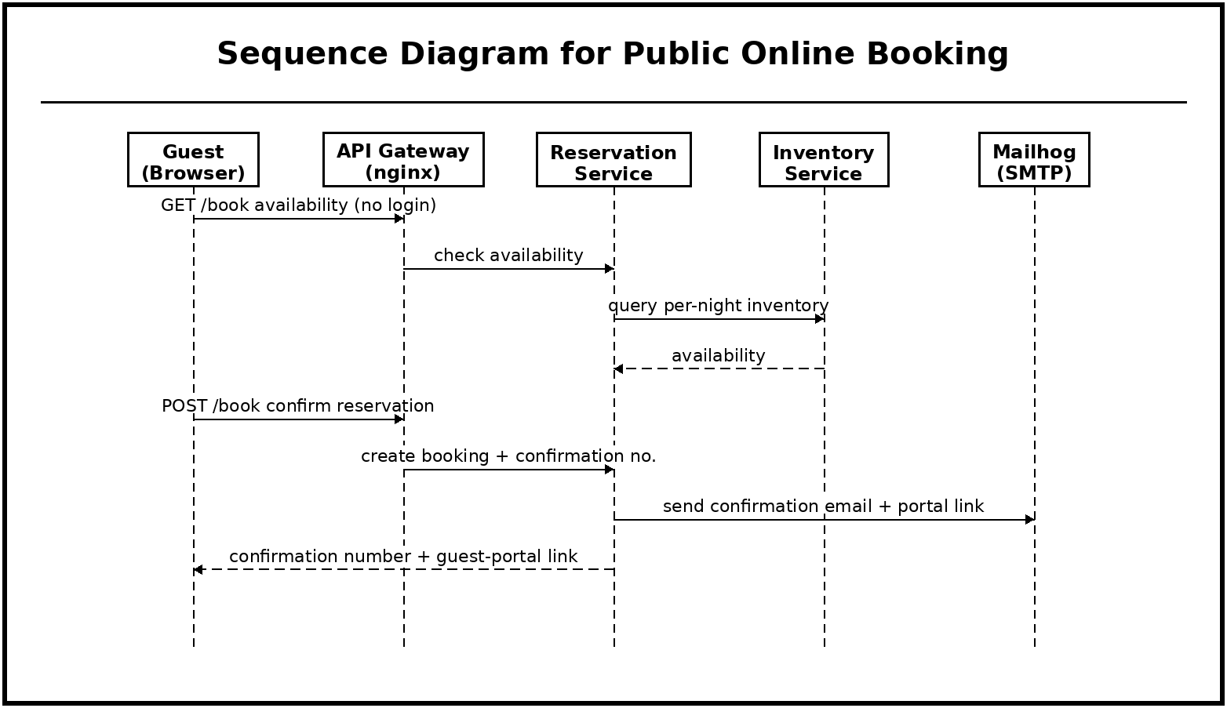
Figure 26. Sequence Diagram for Public Online Booking
The public booking path deliberately bypasses login, because guests are external actors, but it still flows through the gateway and the same Reservation and Inventory services used internally, so public and staff bookings draw on one source of availability. A confirmation email and a guest-portal link are then issued through the mail service, giving the guest a way to return to the booking without creating an account.
Class Diagram
The class diagram below documents the core data entities across the services, their attributes, and their relationships, spanning authentication and training, reservations, stays, folios and payments, guests and loyalty, rooms, rate plans, promotions, inventory holds, facilities, work orders, and business-day records.
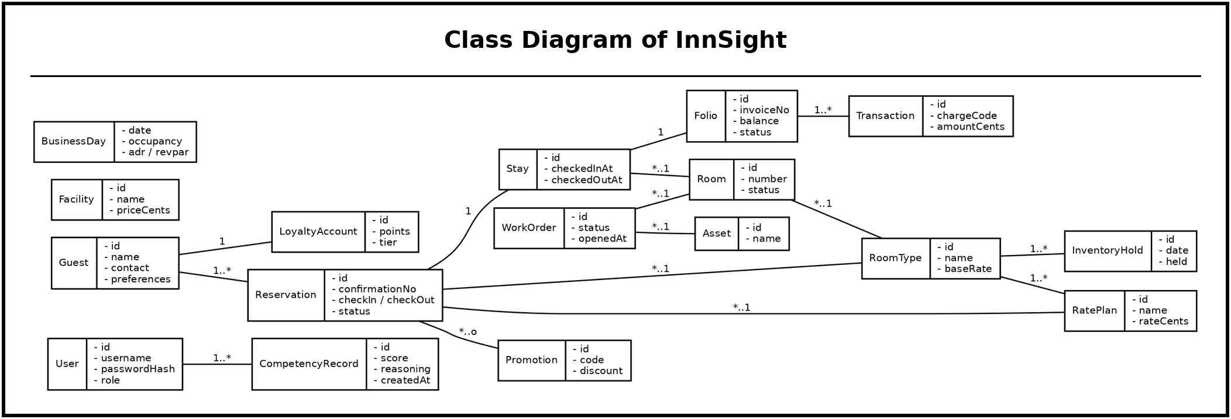
Figure 27. Class Diagram of InnSight
Database Diagram
The Entity-Relationship model is presented below. Reflecting the system’s per-service persistence, each service owns a separate PostgreSQL database; the diagram shows the principal tables, their keys, and their foreign-key relationships. All persistence is relational; no document database is used.
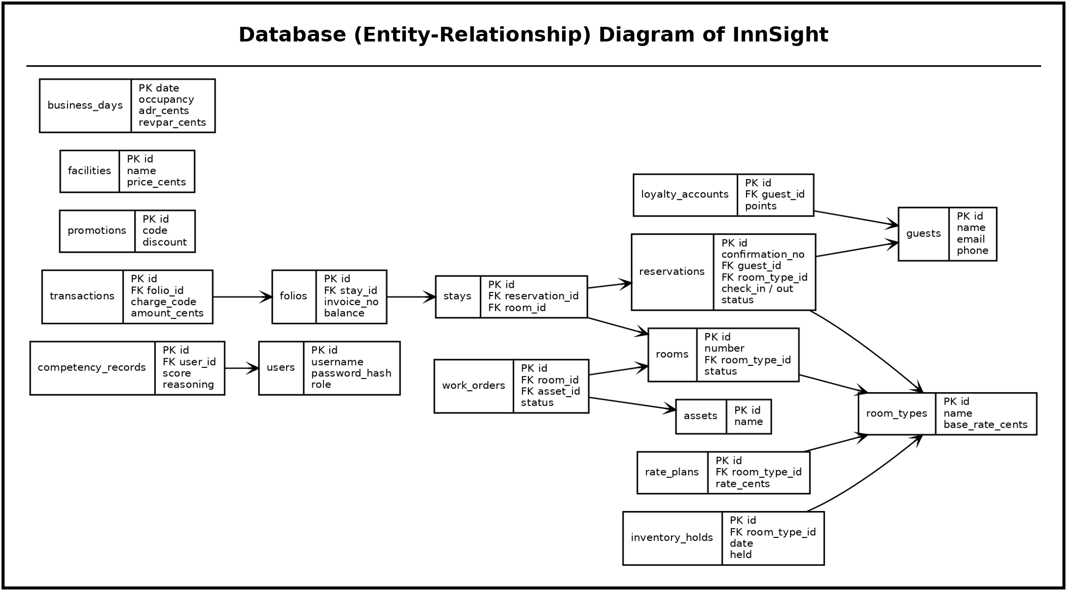
Figure 28. Database (Entity-Relationship) Diagram of InnSight
Deployment Diagram
The deployment diagram below models the runtime topology. A single host runs Docker Engine with a Docker Compose network of containers: the web client, the nginx gateway, the nine services, and the PostgreSQL, Redis, MinIO, and Mailhog infrastructure. Only the web client (port 5180) and the gateway (port 8080) are published to the host; all services, databases, and the broker remain on the internal bridge network, preventing direct external access to any data store.
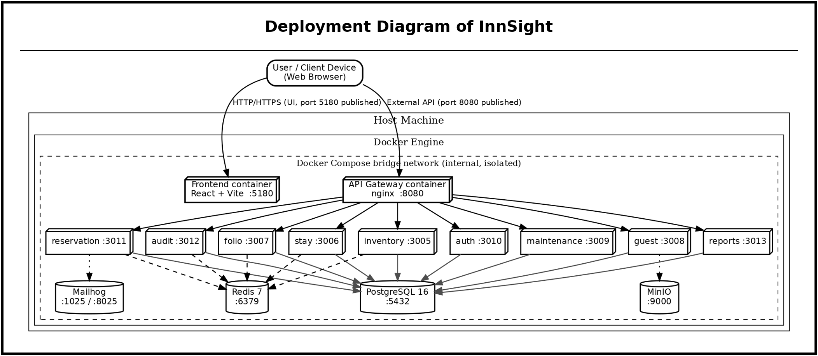
Figure 29. Deployment Diagram of InnSight
Data Flow Diagram
The Data Flow Diagram below models the movement of data among external actors, processes, and data stores. Staff (by role), auditors, administrators, and guests provide inputs that flow through the authentication, reservation-and-availability, front-desk stay, billing, rooms-and-training, and night-audit-and-reports processes, each reading from and writing to its own PostgreSQL store, with the Redis event bus propagating state changes across processes.
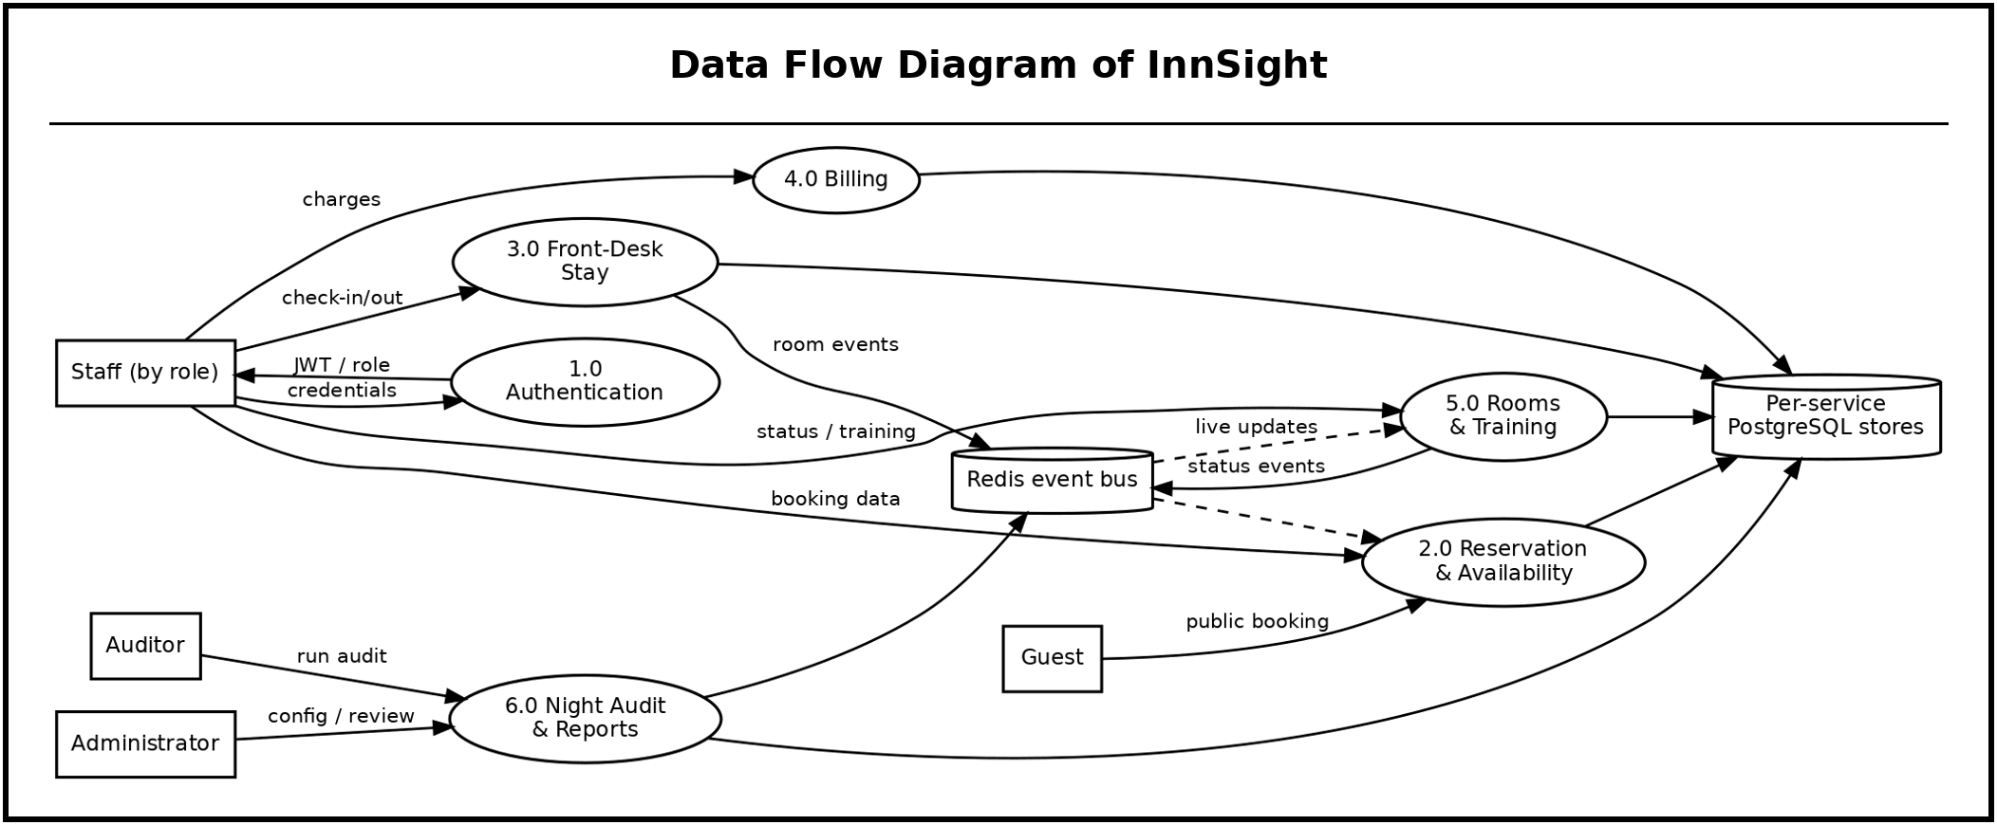
Figure 30. Data Flow Diagram of InnSight
Development and Testing Procedures
Development and testing followed the Iterative and Incremental SDLC to ensure continuous feedback and incremental stabilization. An initial phase reviewed related literature and conducted stakeholder interviews, producing a requirements specification aligned with the BSHM curriculum and confirming the ISO/IEC 25010:2023 evaluation framework. The system-design phase produced the complete UML set and the API contracts for the nine services, together with the Prisma schema for each PostgreSQL database.
Core-service development built the authentication, reservation, and inventory foundations with JWT role enforcement at the gateway, followed by the stay, folio, and housekeeping services with a Redis event pipeline driving automatic room-status transitions. Feature-service development added amenities and the point-of-sale, reports and the KPI dashboard, the night audit, maintenance, and the three-dimensional training simulation with competency tracking. Unit tests validated individual service functions and integration tests verified cross-service workflows such as check-in-triggered room transitions and check-out settlement.
The integration-and-system-testing phase consolidated all services under Docker Compose and validated every inter-service pathway, and a system-wide quality-and-security audit was performed. The system was then evaluated through a User Acceptance Testing session in which IT experts and Hospitality Management respondents interacted with the deployed platform and completed the ISO/IEC 25010:2023 questionnaire; feedback was incorporated before final deployment and documentation.
Description of Prototypes
This section presents the principal screens of InnSight as deployed. Except where noted, screens are shown in the system’s light theme with representative demonstration data.
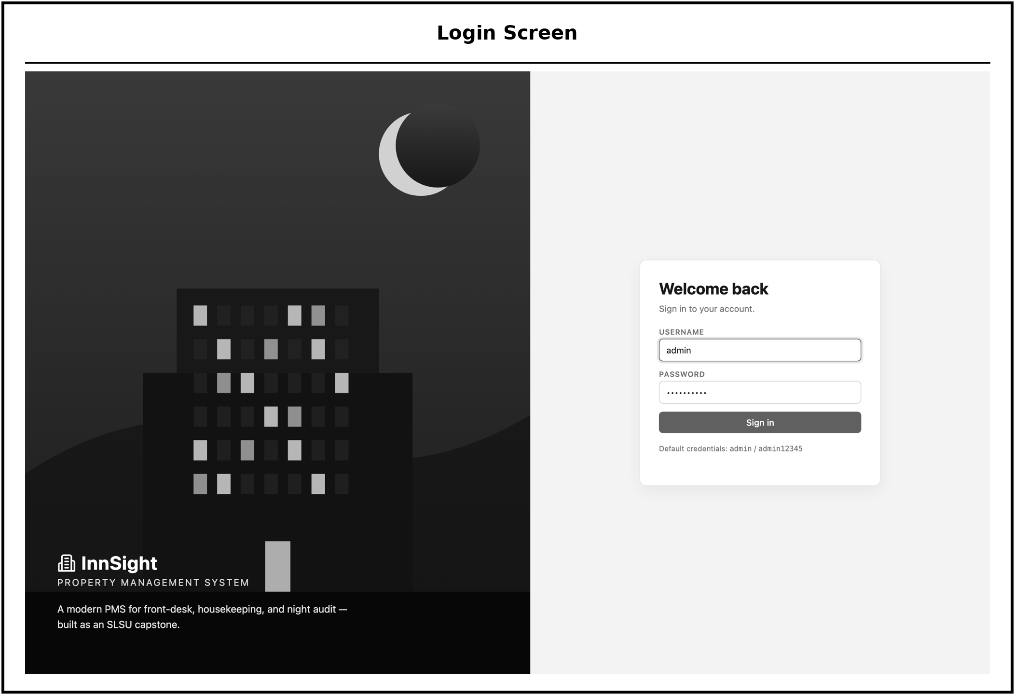
Figure 31. Login, username-and-password sign-in (accounts are created by an administrator; there is no public self-registration).
The login screen is the single entry point to InnSight. A user signs in with a username and password, and the Authentication Service validates the credentials and issues a role-bearing token that determines which modules and actions become available. Because accounts are provisioned by an administrator and there is no public self-registration, access to the operational system is limited to authorized staff and students.
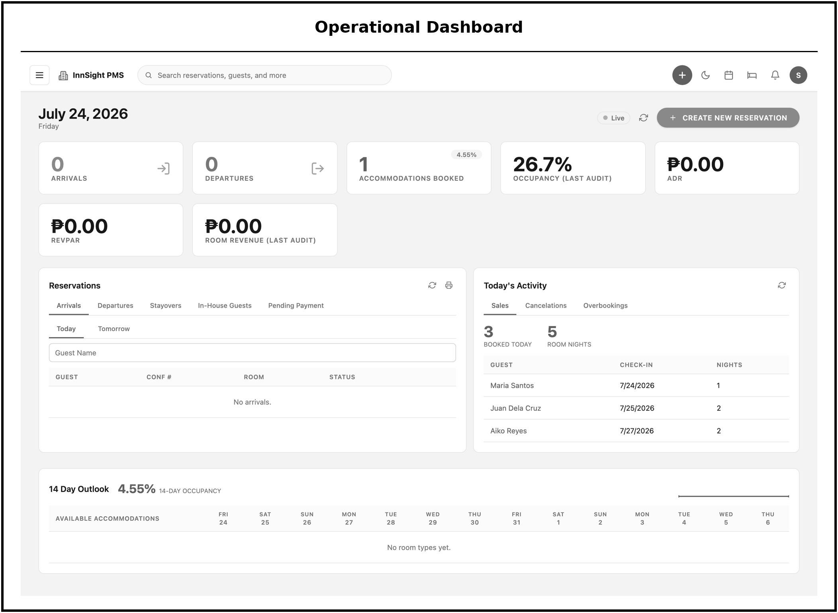
Figure 32. Operational Dashboard, arrivals, departures, accommodations booked, and occupancy, ADR, RevPAR and room-revenue KPIs, with reservation and activity panels and a 14-day availability outlook.
The operational dashboard is the first screen a signed-in user reaches, giving an at-a-glance view of the property's current state. It presents the day's arrivals, departures, and accommodations booked alongside occupancy, Average Daily Rate (ADR), Revenue per Available Room (RevPAR), and room-revenue indicators, together with reservation and activity panels and a fourteen-day availability outlook. The panel lets front-desk and management users judge the day's workload and revenue position without opening individual records.
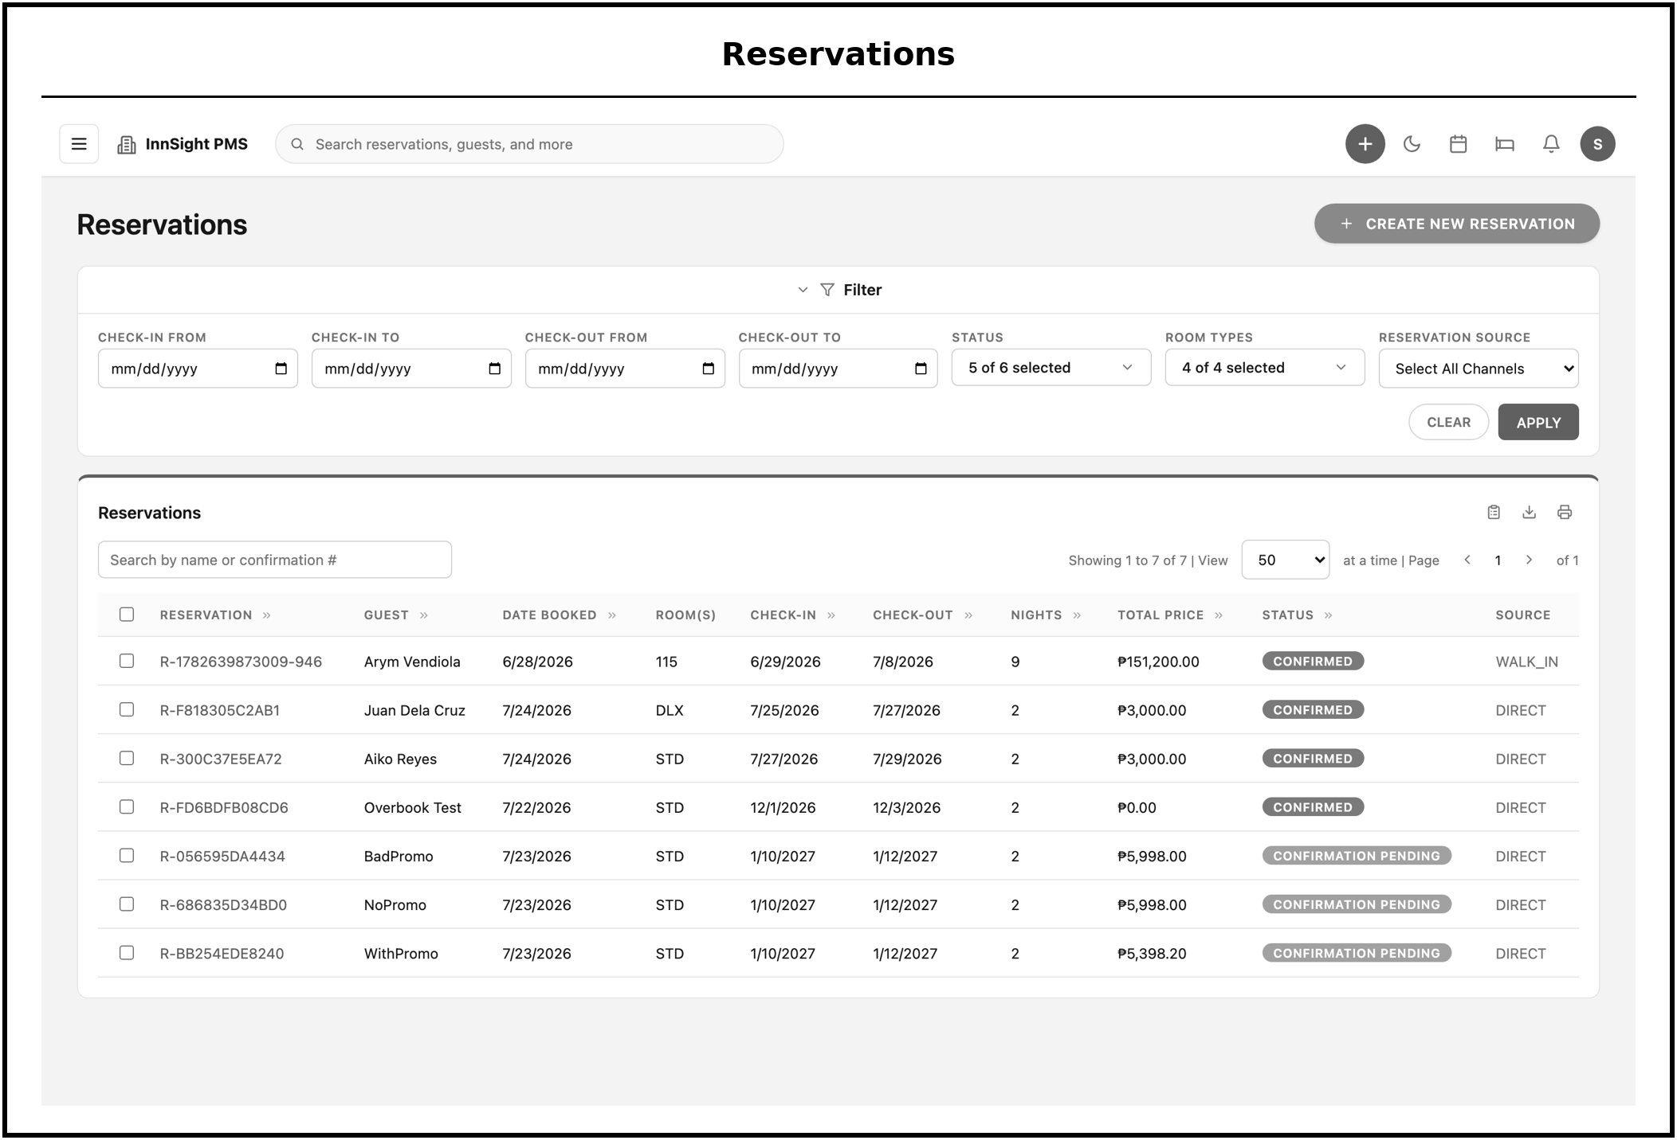
Figure 33. Reservations, searchable, status-filterable list of all reservations with inline detail.
The reservations screen lists every reservation in a searchable, status-filterable table. Users can filter by status and open any row inline to inspect its details, which keeps locating a specific booking quick even as the volume of reservations grows. It serves as the working list from which front-desk staff manage the full reservation lifecycle.
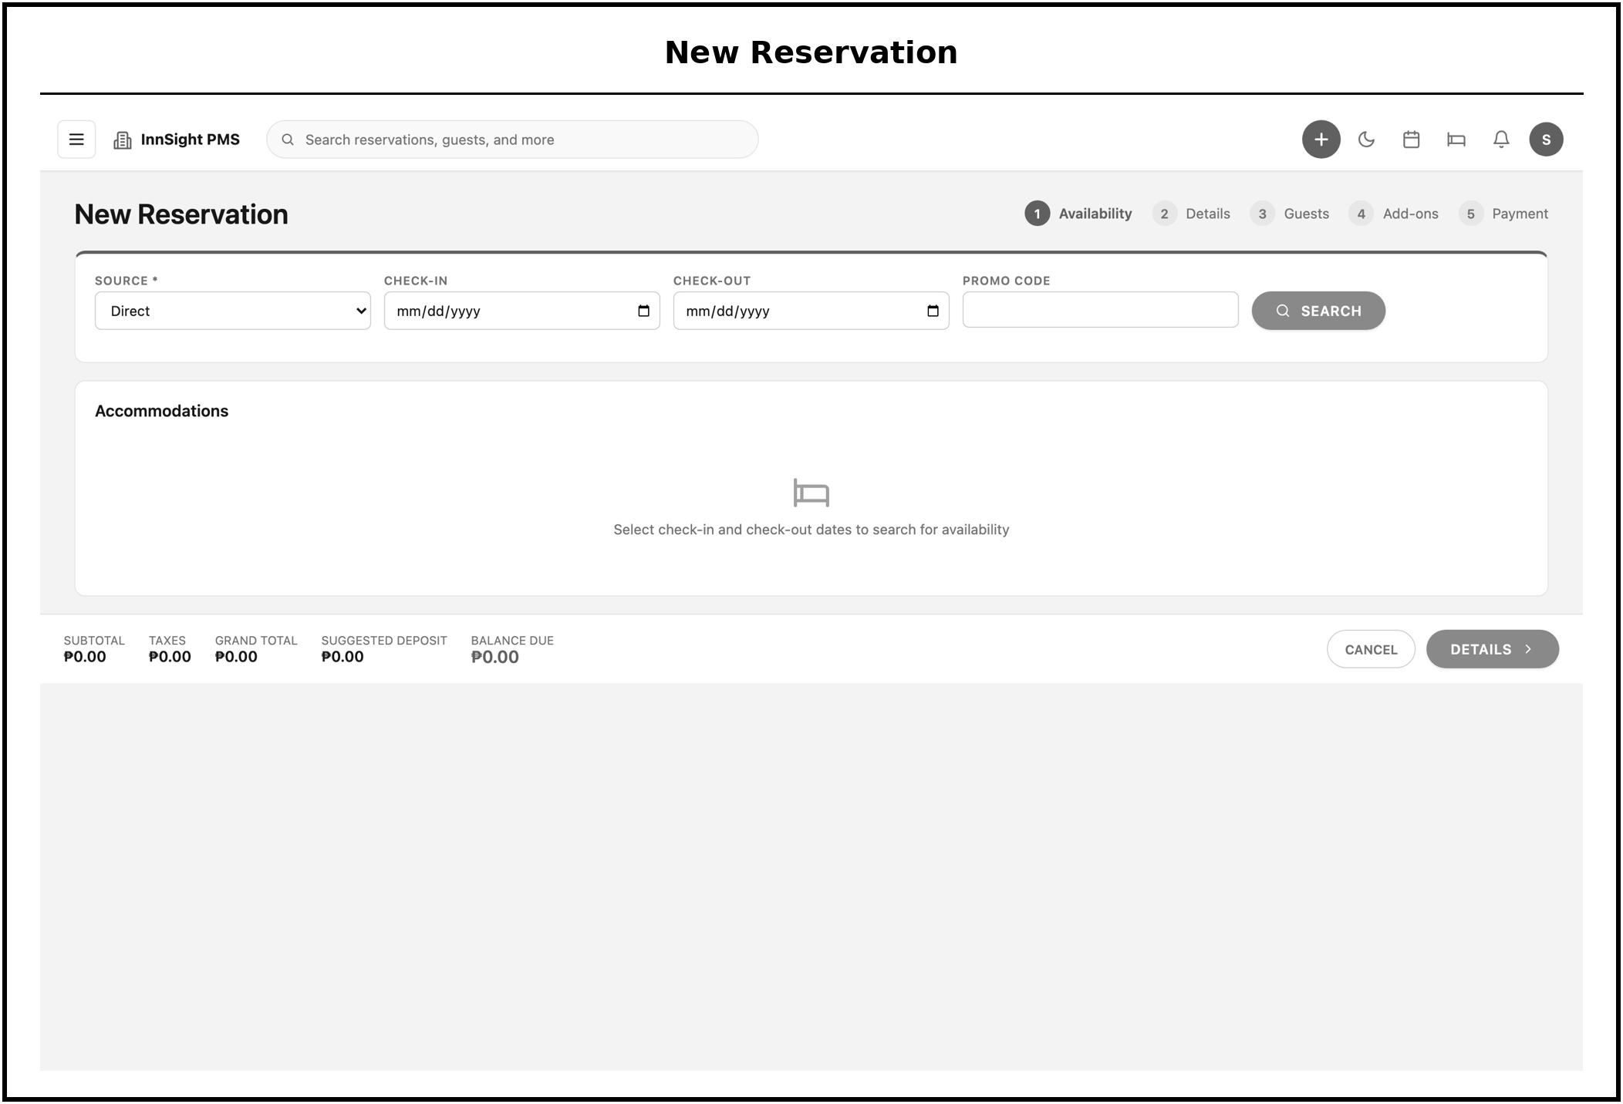
Figure 34. New Reservation, availability-checked booking form with room, dates, occupancy, promo code, and channel.
The new-reservation form captures a booking in a single guided step. As dates, room type, occupancy, promo code, and channel are entered, the system checks live availability against per-night inventory before the booking can be confirmed, which prevents double-booking. On confirmation a unique confirmation number is issued and the guest record is initialized.
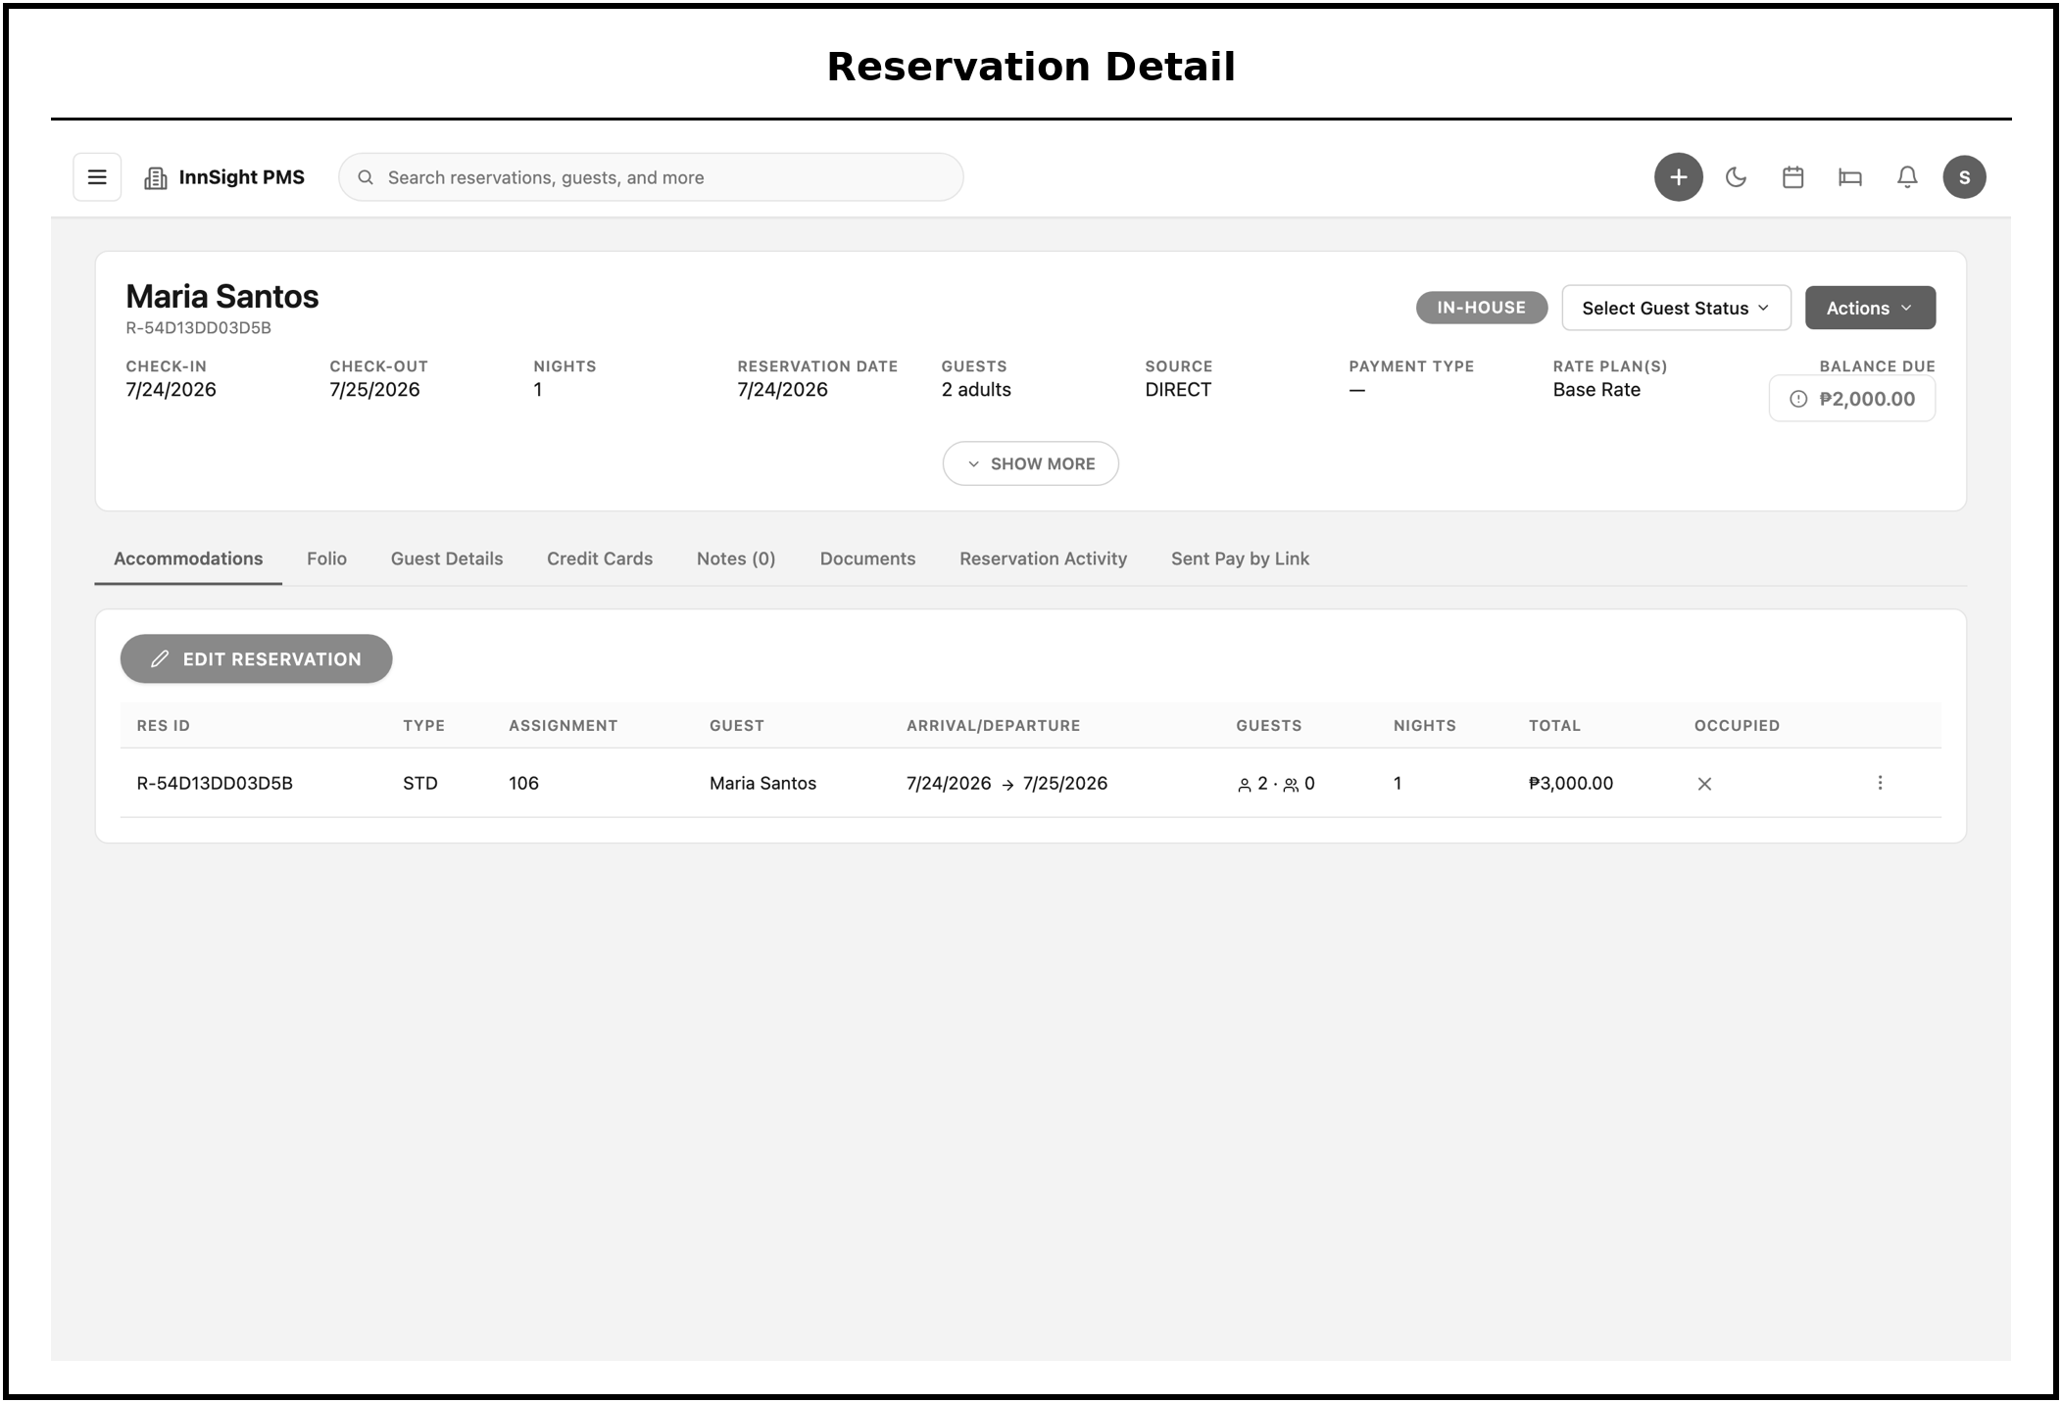
Figure 35. Reservation Detail, full record with accommodations, folio, guest and credit-card tabs, and reservation activity.
The reservation detail view is the complete record for a single booking. Tabbed sections expose the assigned accommodations, the folio, guest and credit-card information, and a running reservation-activity log, so a user can review or act on every aspect of the stay from one place. This consolidation reduces the need to move between separate screens while servicing a guest.
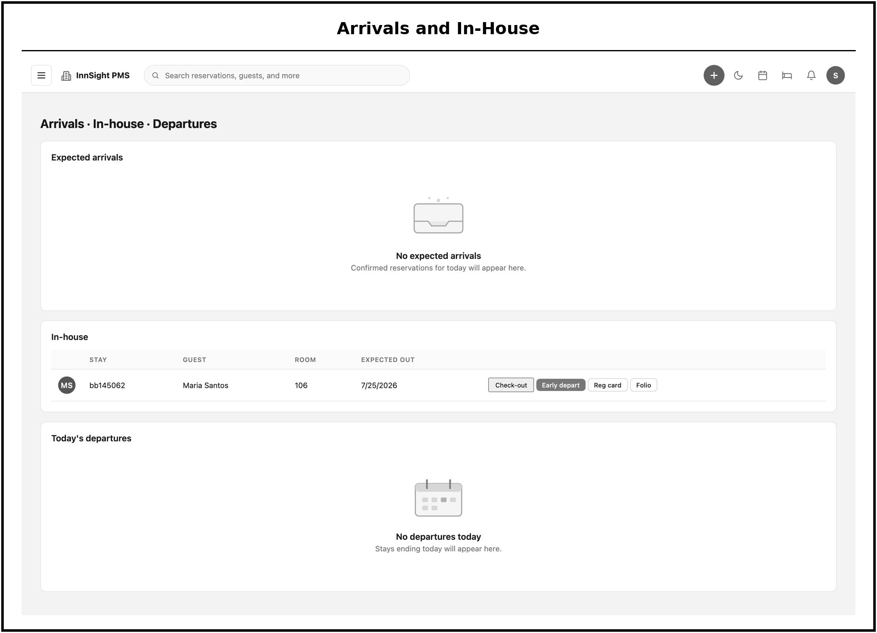
Figure 36. Arrivals & In-House, expected arrivals, in-house guests, and departures, with check-in and check-out actions.
The arrivals and in-house screen is the front desk's daily operations board. It separates expected arrivals, guests currently in-house, and departures, and exposes the check-in and check-out actions directly, so staff can process the guest cycle in the order it occurs. Acting here triggers the room-status and folio changes handled by the Stay and Folio services.
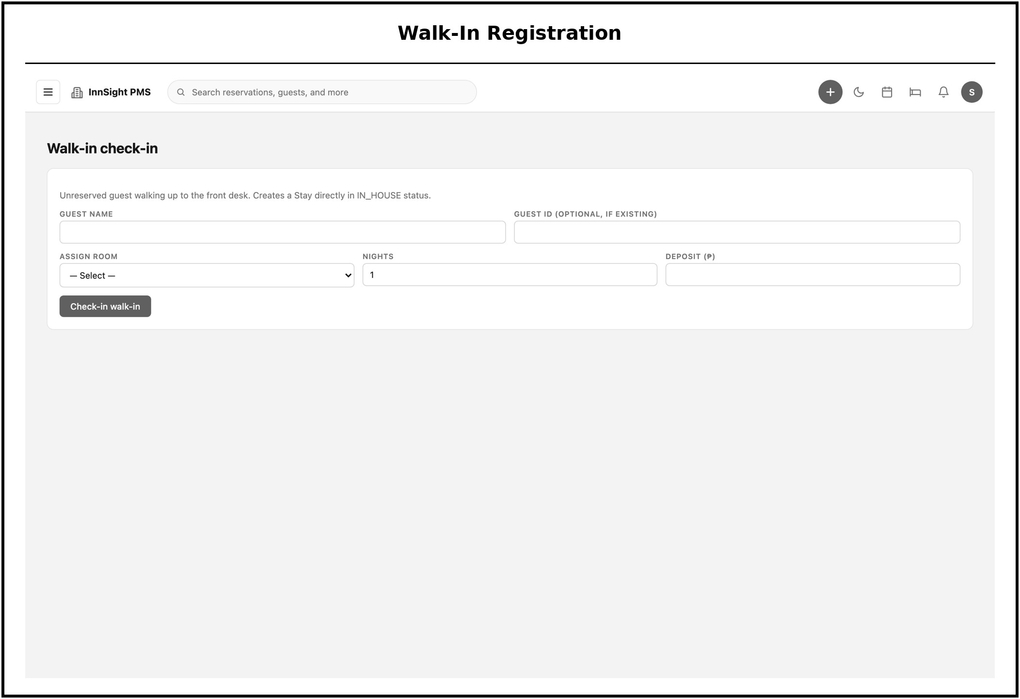
Figure 37. Walk-In, registration for guests arriving without a prior booking.
The walk-in screen registers a guest who arrives without a prior booking. It creates the guest and reservation records and proceeds directly to room assignment and folio opening, mirroring the standard arrival flow so that unplanned arrivals are handled with the same controls as booked ones.
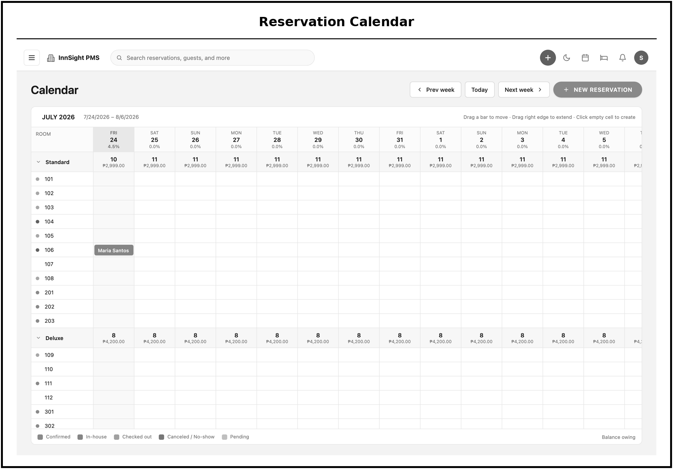
Figure 38. Reservation Calendar, weekly grid of bookings by room type.
The reservation calendar presents bookings as a weekly grid organized by room type. This visual layout makes occupancy patterns, gaps, and clustering easy to read at a glance, complementing the list view for planning and availability decisions.
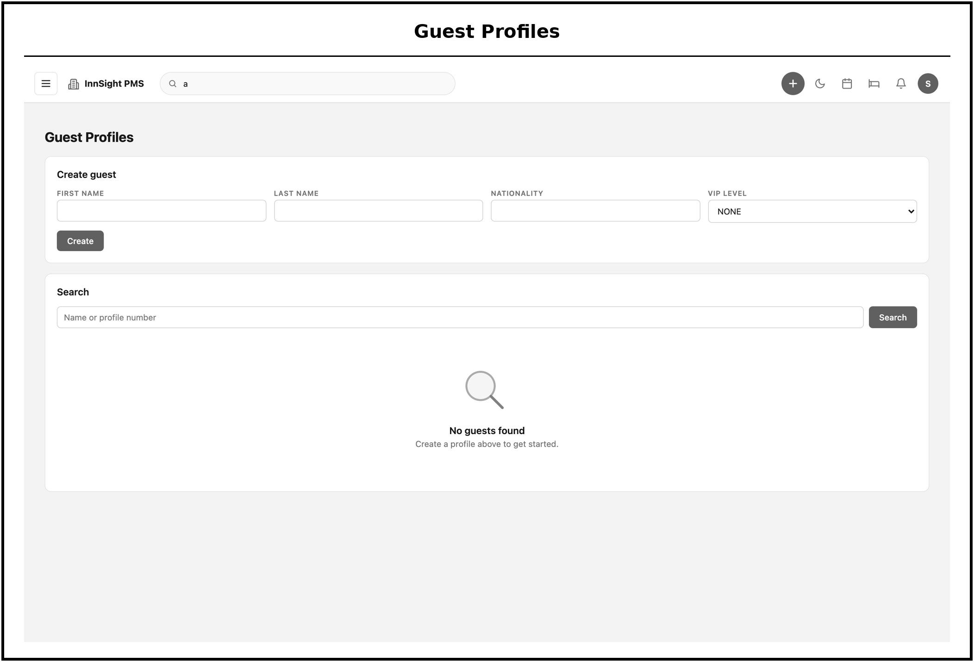
Figure 39. Guest Profiles, searchable guest directory with profile creation.
The guest profiles screen is a searchable directory of guests with the ability to create new profiles. Maintaining persistent guest records supports repeat-stay recognition, preferences, and loyalty, and provides the guest data that reservations and folios reference.
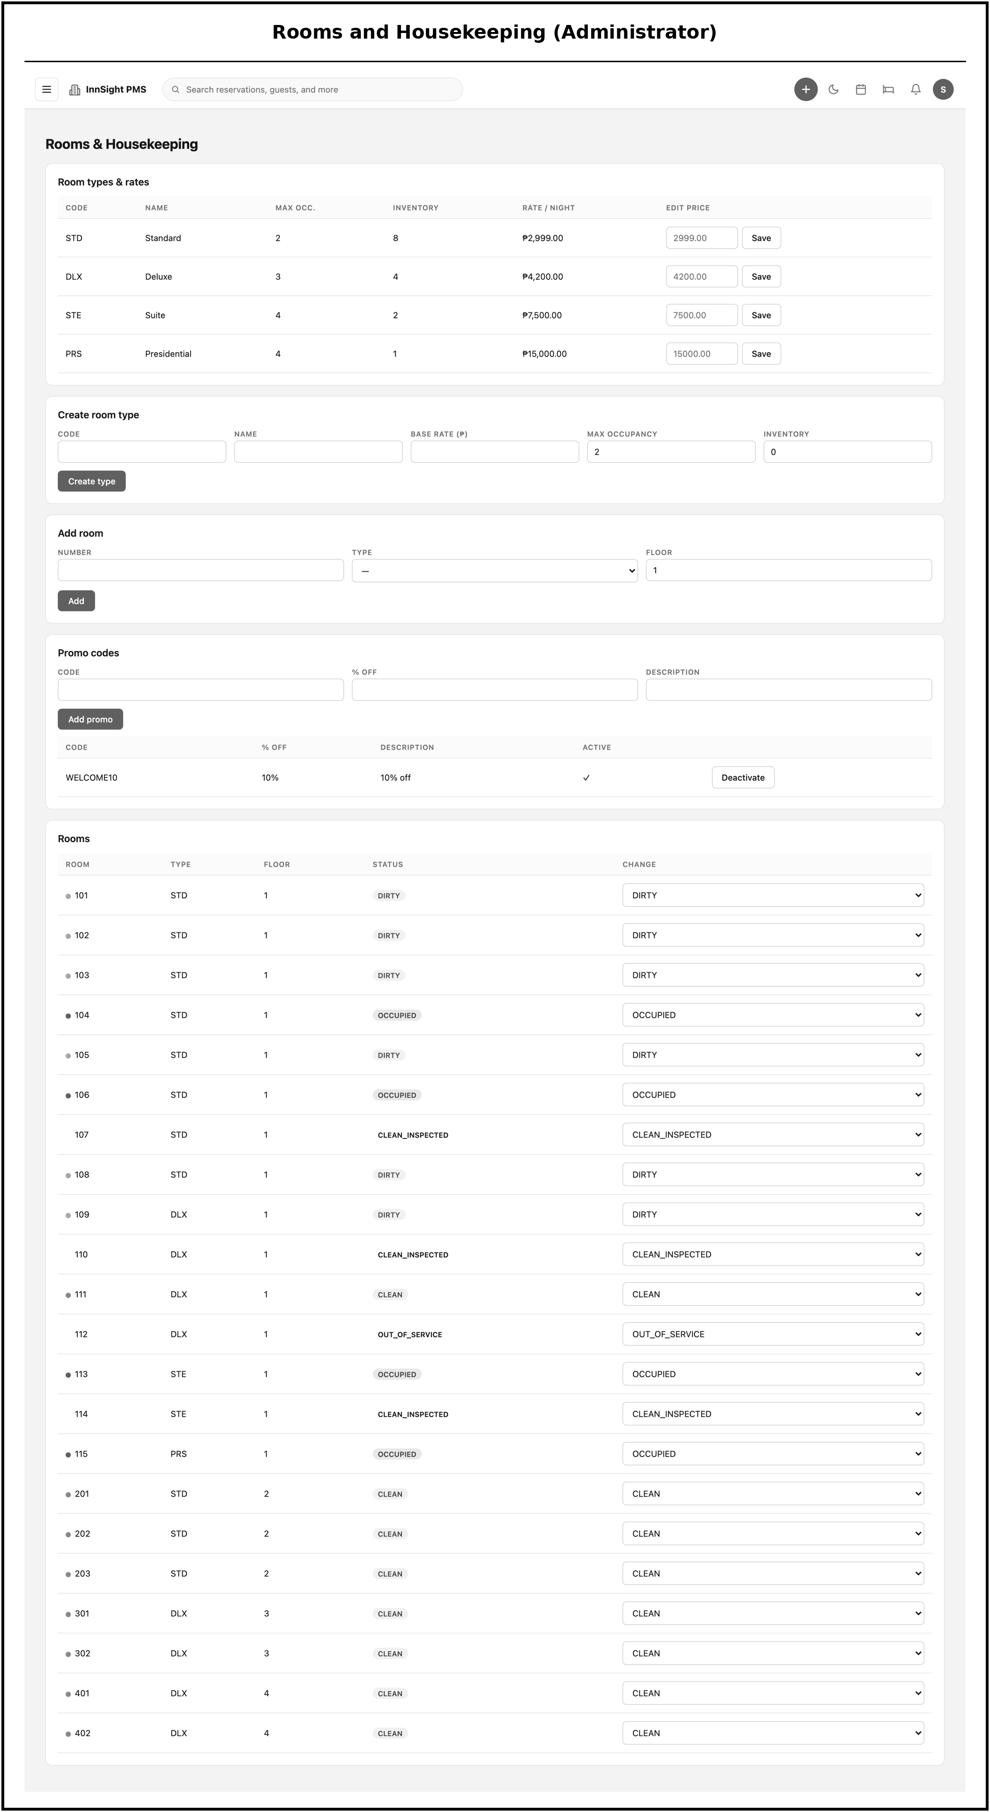
Figure 40. Rooms & Housekeeping (Administrator), room types and rates, room creation, price editing, and promo-code management.
This administrator screen is where the property's sellable inventory is defined. Administrators create rooms, configure room types and nightly rates, edit prices, and manage promo codes, and these settings feed availability, pricing, and the housekeeping map used across the system. Restricting this configuration to the administrator role keeps property setup under controlled ownership.
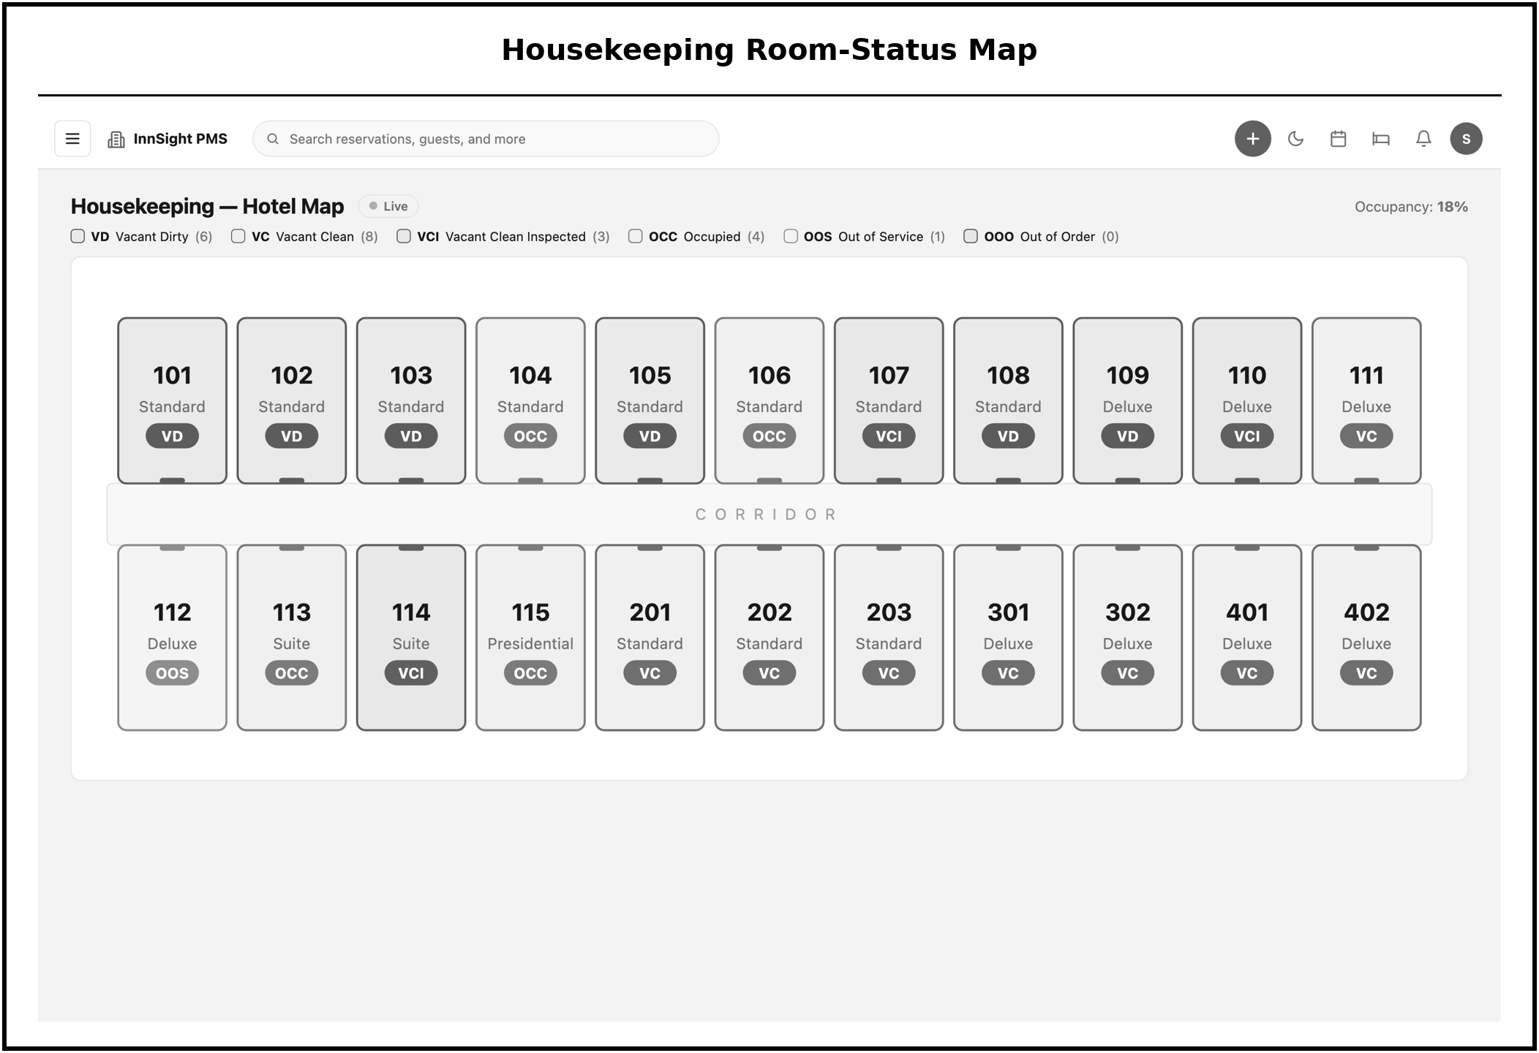
Figure 41. Housekeeping Room-Status Map, color-coded grid of every room’s cleanliness and occupancy state, updated live.
The housekeeping room-status map is a color-coded grid showing every room's cleanliness and occupancy state, such as Clean, Clean-Inspected, Dirty, Occupied, Out-of-Order, or Out-of-Service. Because the grid updates live across all screens through the Server-Sent Events stream, housekeeping and front desk always see the same current picture, which is central to coordinating room turnover.
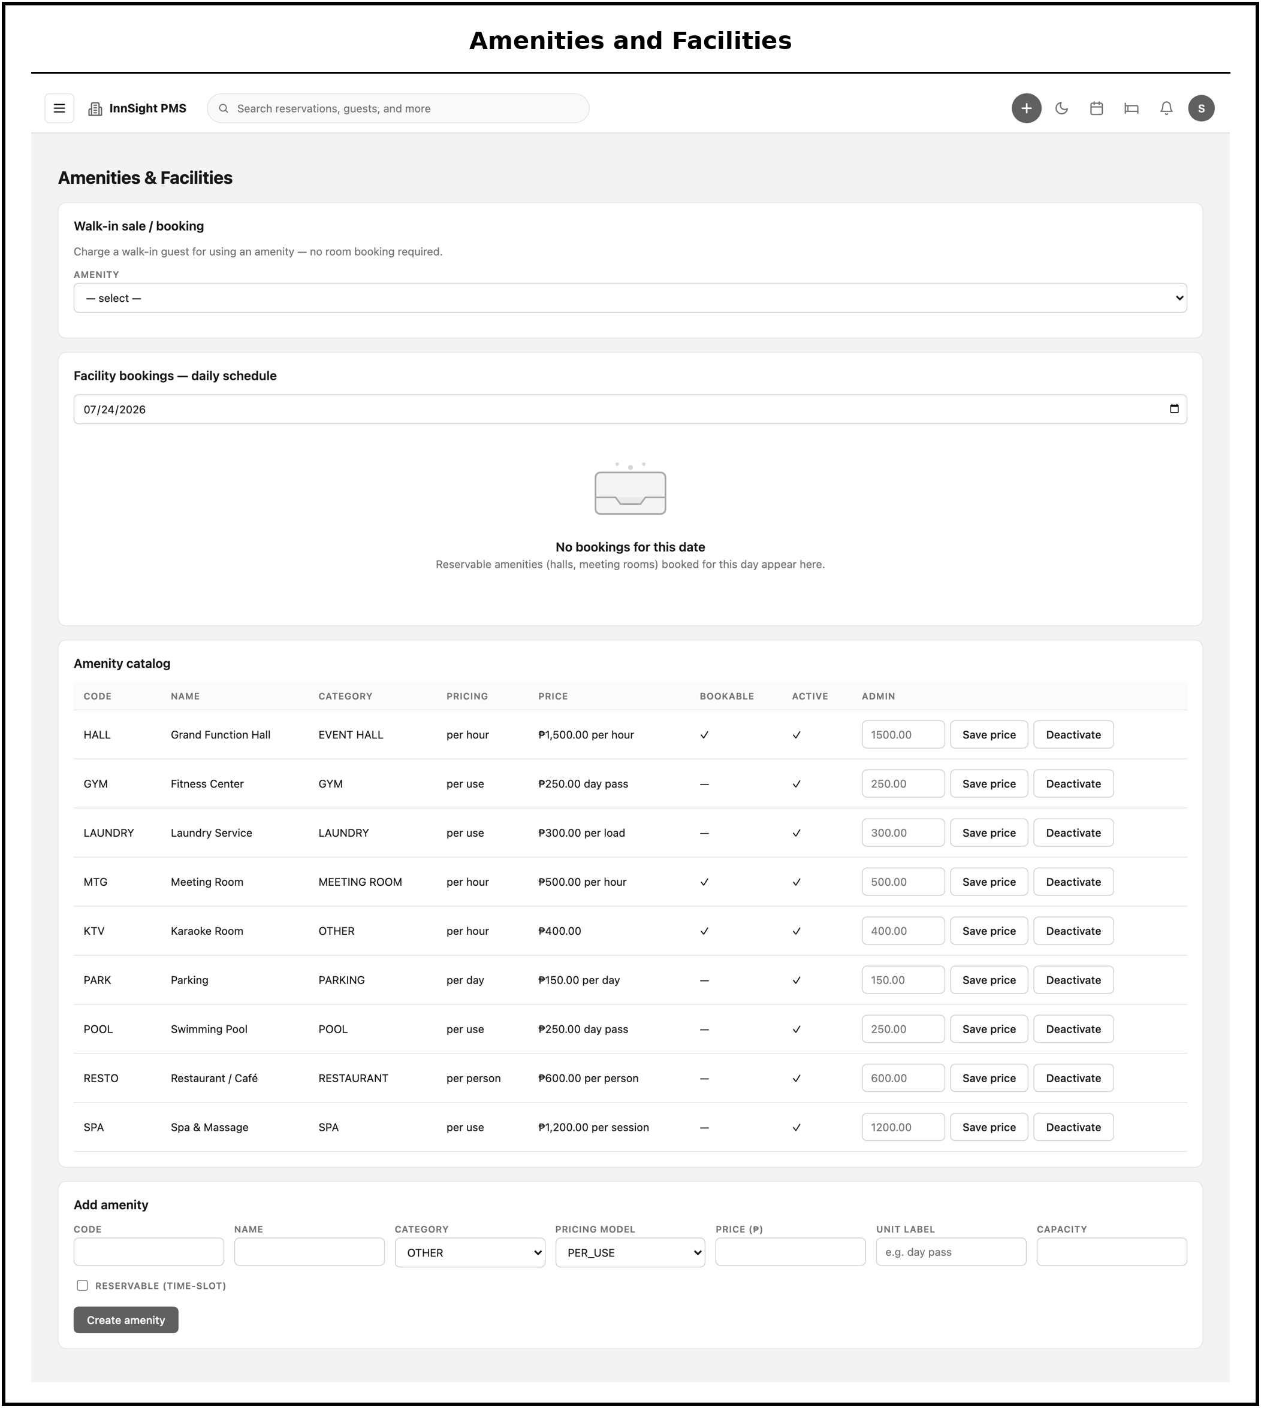
Figure 42. Amenities & Facilities, priced facility catalog with walk-in sale and daily booking schedule.
The amenities and facilities screen is the priced catalog of the property's non-room services, such as the event hall, spa, and meeting rooms. It supports walk-in sales through a one-click point-of-sale and shows the daily booking schedule for reservable facilities, so amenity revenue is captured through the same folio and billing path as room charges.
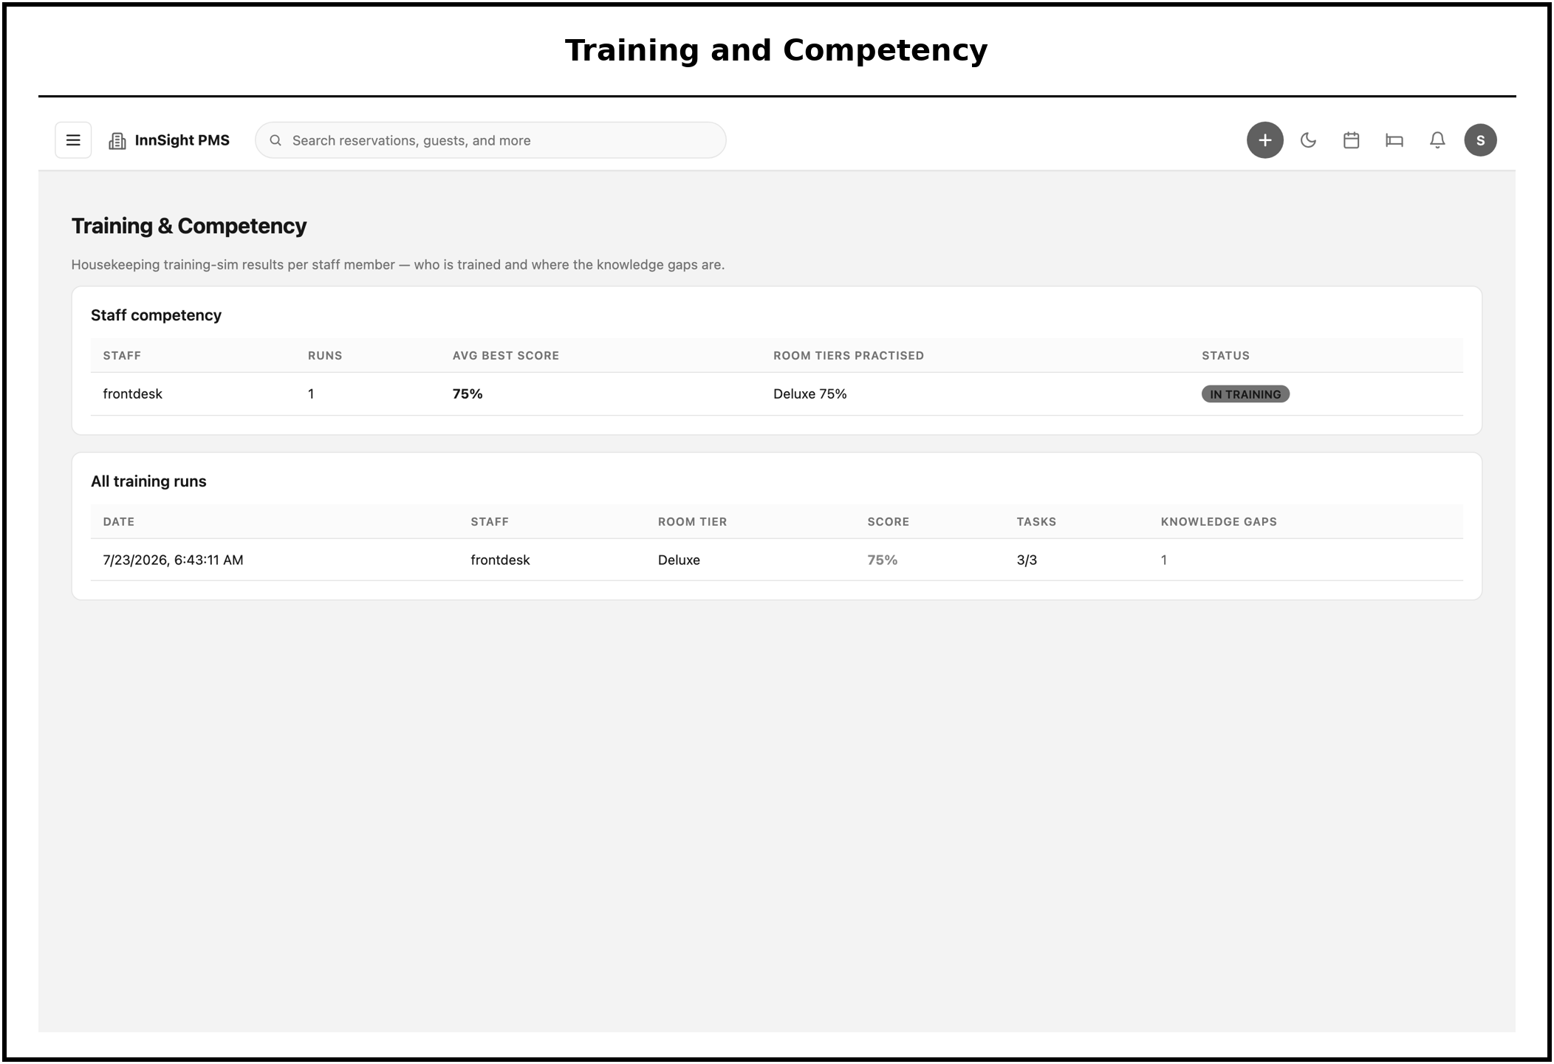
Figure 43. Training & Competency, per-staff housekeeping training-simulation results and knowledge-gap view.
The training and competency screen presents each staff member's results from the three-dimensional housekeeping training simulation. By recording scores and highlighting knowledge gaps per person, it gives instructors an objective, per-student view of practical readiness that replaces manual one-on-one assessment.
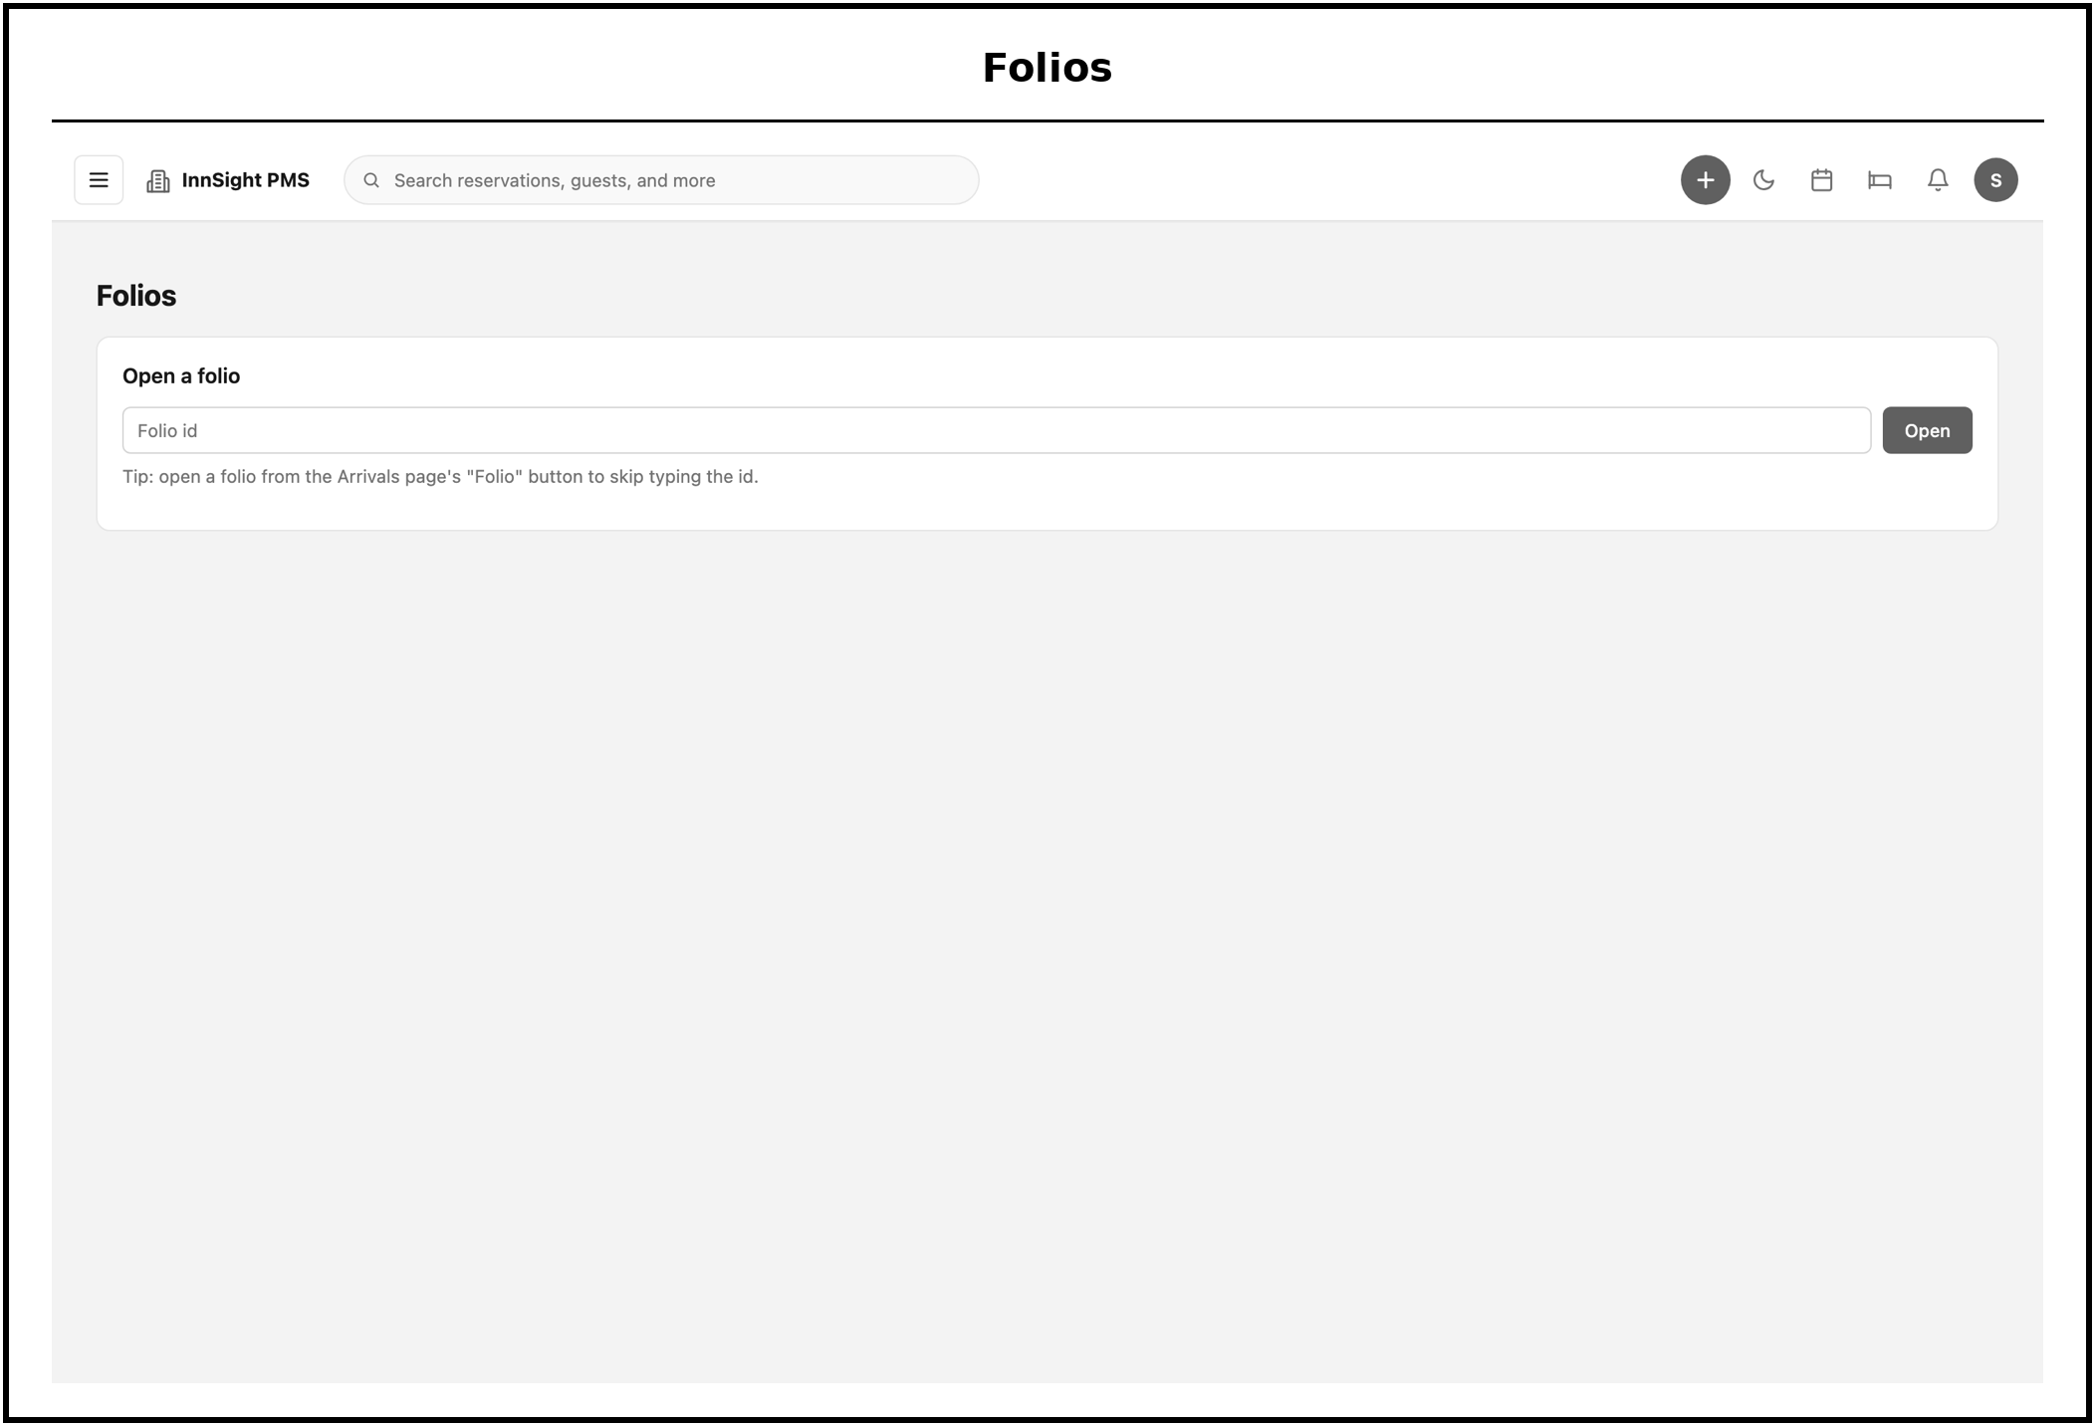
Figure 44. Folios, open a folio by number to review or post to it.
The folios screen lets a user open a folio by its number to review it or post to it. It is the entry point to the billing ledger for any stay, from which incidental charges and payments are recorded.
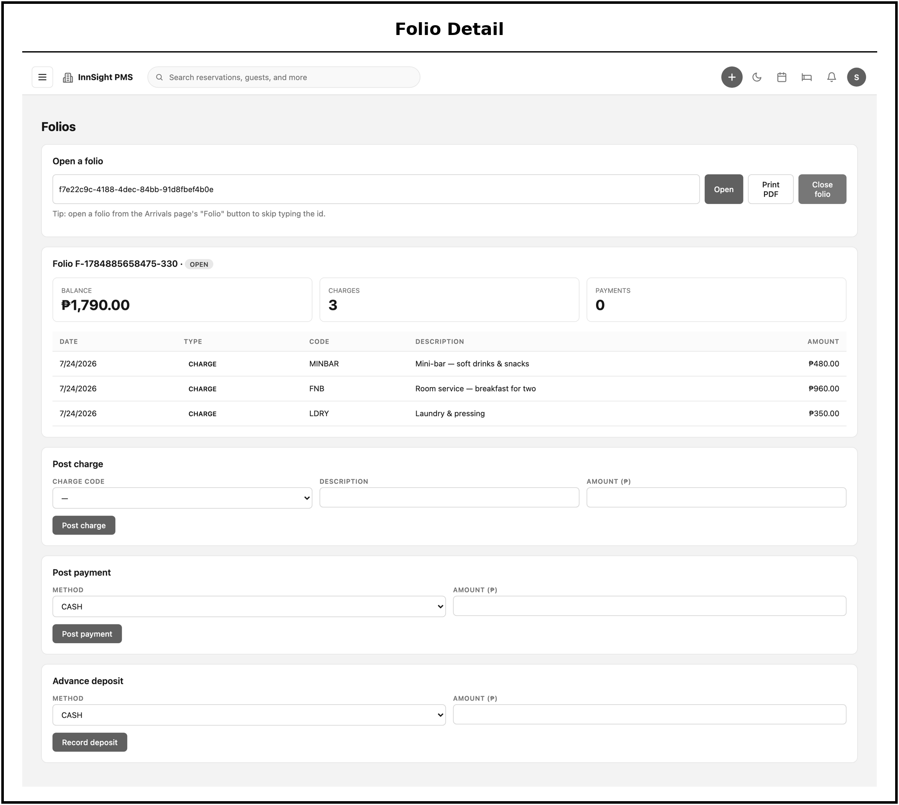
Figure 45. Folio Detail, itemized transactions, running balance, and charge/payment posting.
The folio detail view shows a folio's itemized transactions and running balance and allows charges and payments to be posted. Because money is stored with integer precision and the balance is recomputed on every posting, the figure displayed here always reconciles with the underlying transactions, and check-out settles this folio atomically.
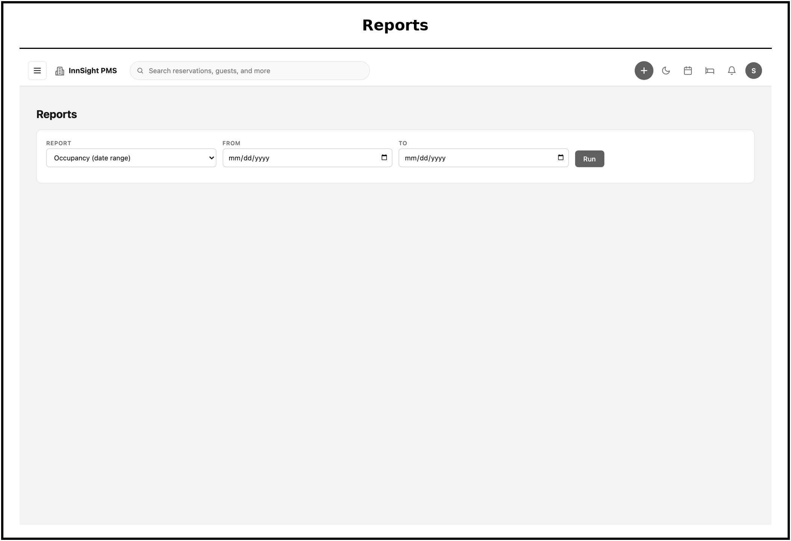
Figure 46. Reports, parameterized operational and revenue reports.
The reports screen produces parameterized operational and revenue reports on demand. Handling reporting as a separate read path keeps these queries from interfering with live operational activity, and lets managers and auditors pull the specific figures they need for a chosen period.
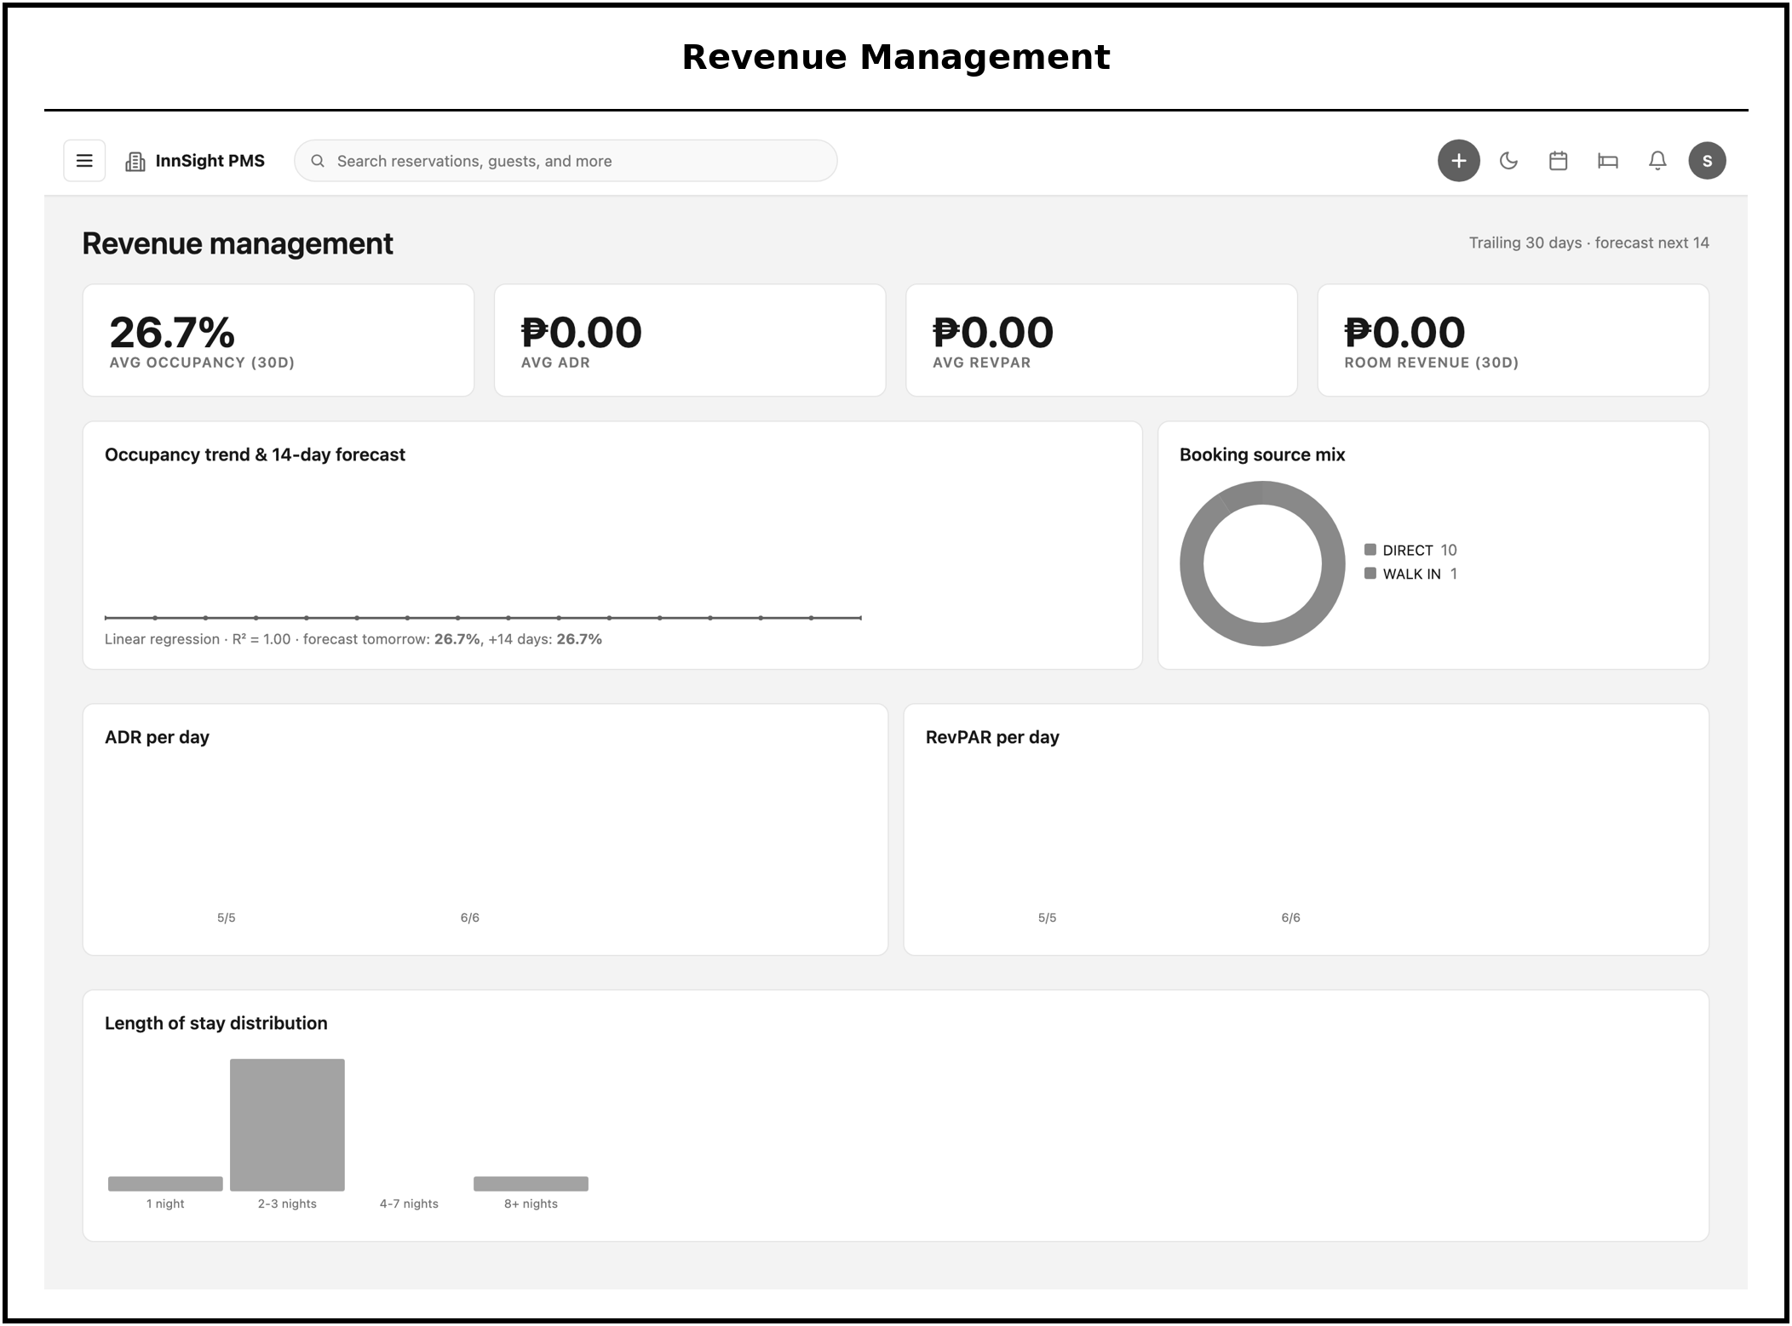
Figure 47. Revenue Management, occupancy, ADR, and RevPAR trends, booking-source mix, and length-of-stay distribution.
The revenue management screen visualizes performance trends, including occupancy, ADR, and RevPAR over time, the mix of booking sources, and the distribution of length of stay. These analytics turn the raw operational data into the indicators managers use to assess and steer the property's commercial performance.
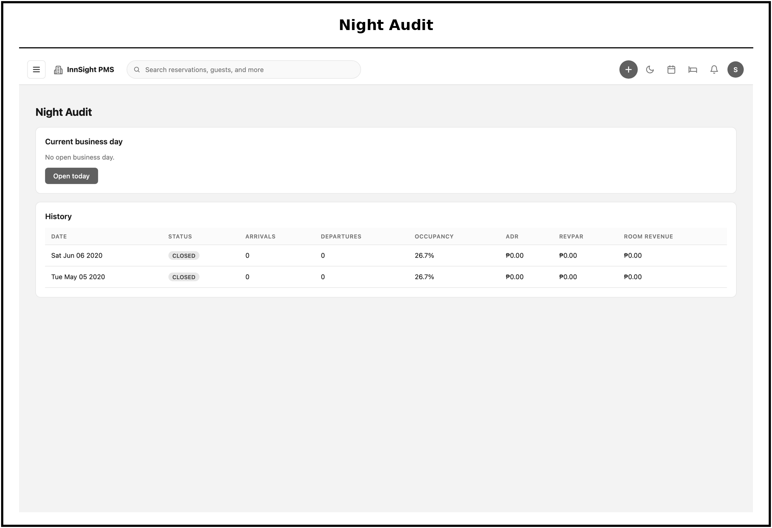
Figure 48. Night Audit, business-day status and audit history.
The night audit screen shows the current business-day status and the history of completed audits. From here an auditor rolls the business day, an operation that posts room and tax charges to in-house folios and snapshots the day's occupancy and revenue metrics, closing one operating day and opening the next.
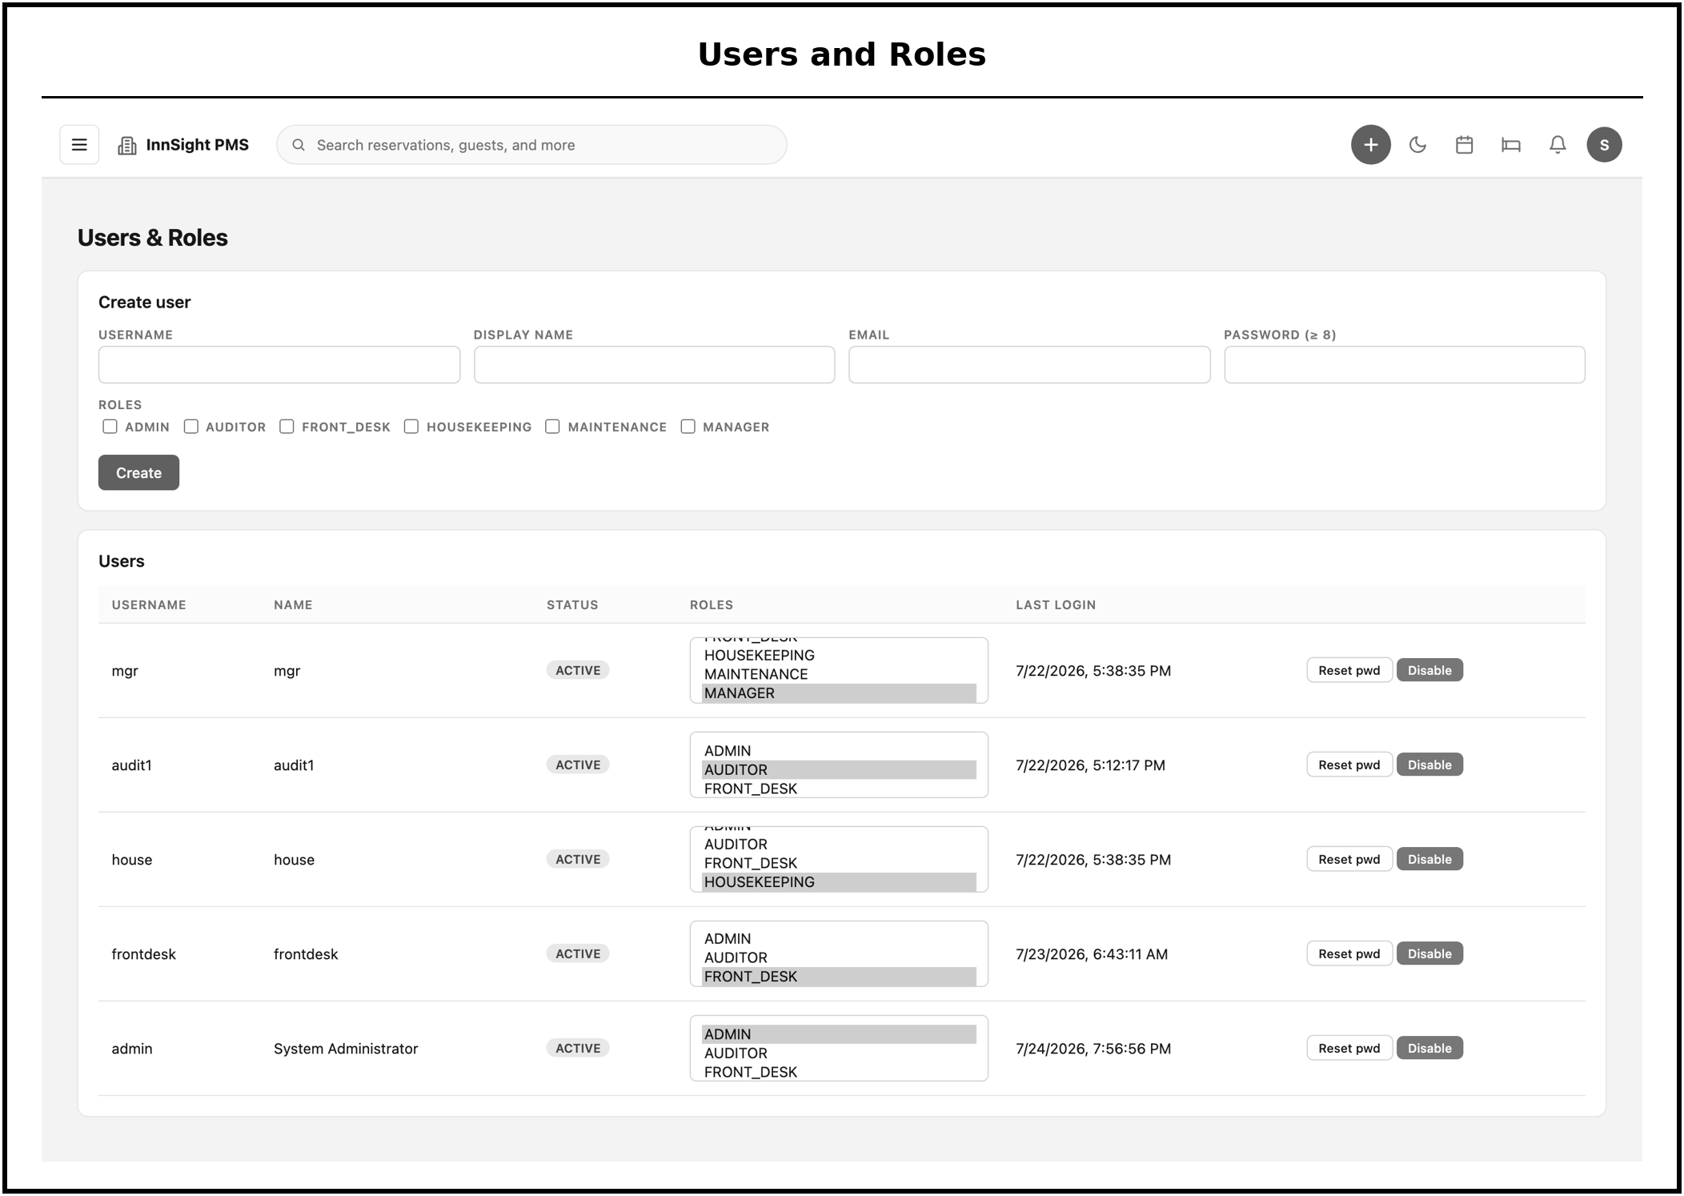
Figure 49. Users & Roles, account creation and role assignment across the six operational roles.
The users and roles screen is where accounts are created and assigned to one of the six operational roles: Administrator, Manager, Front Desk, Housekeeping, Maintenance, and Auditor. Because authorization is enforced on the server for every sensitive action, the role set here directly governs what each user can see and do.
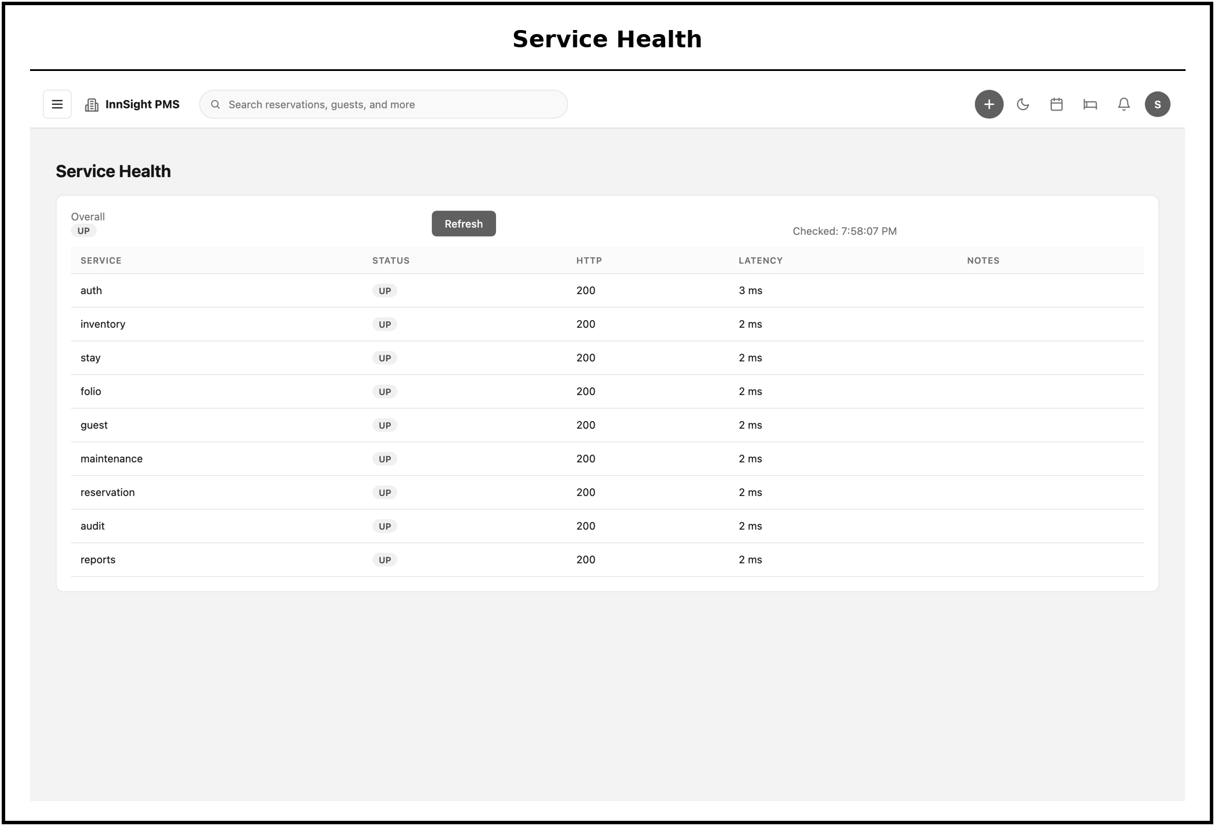
Figure 50. Service Health, live status and latency of every microservice.
The service health screen reports the live status and response latency of every microservice. This operational view reflects the decoupled architecture directly, letting an administrator confirm that each independent service is running and responsive, and isolate any single service that is degraded without guessing at the whole system.
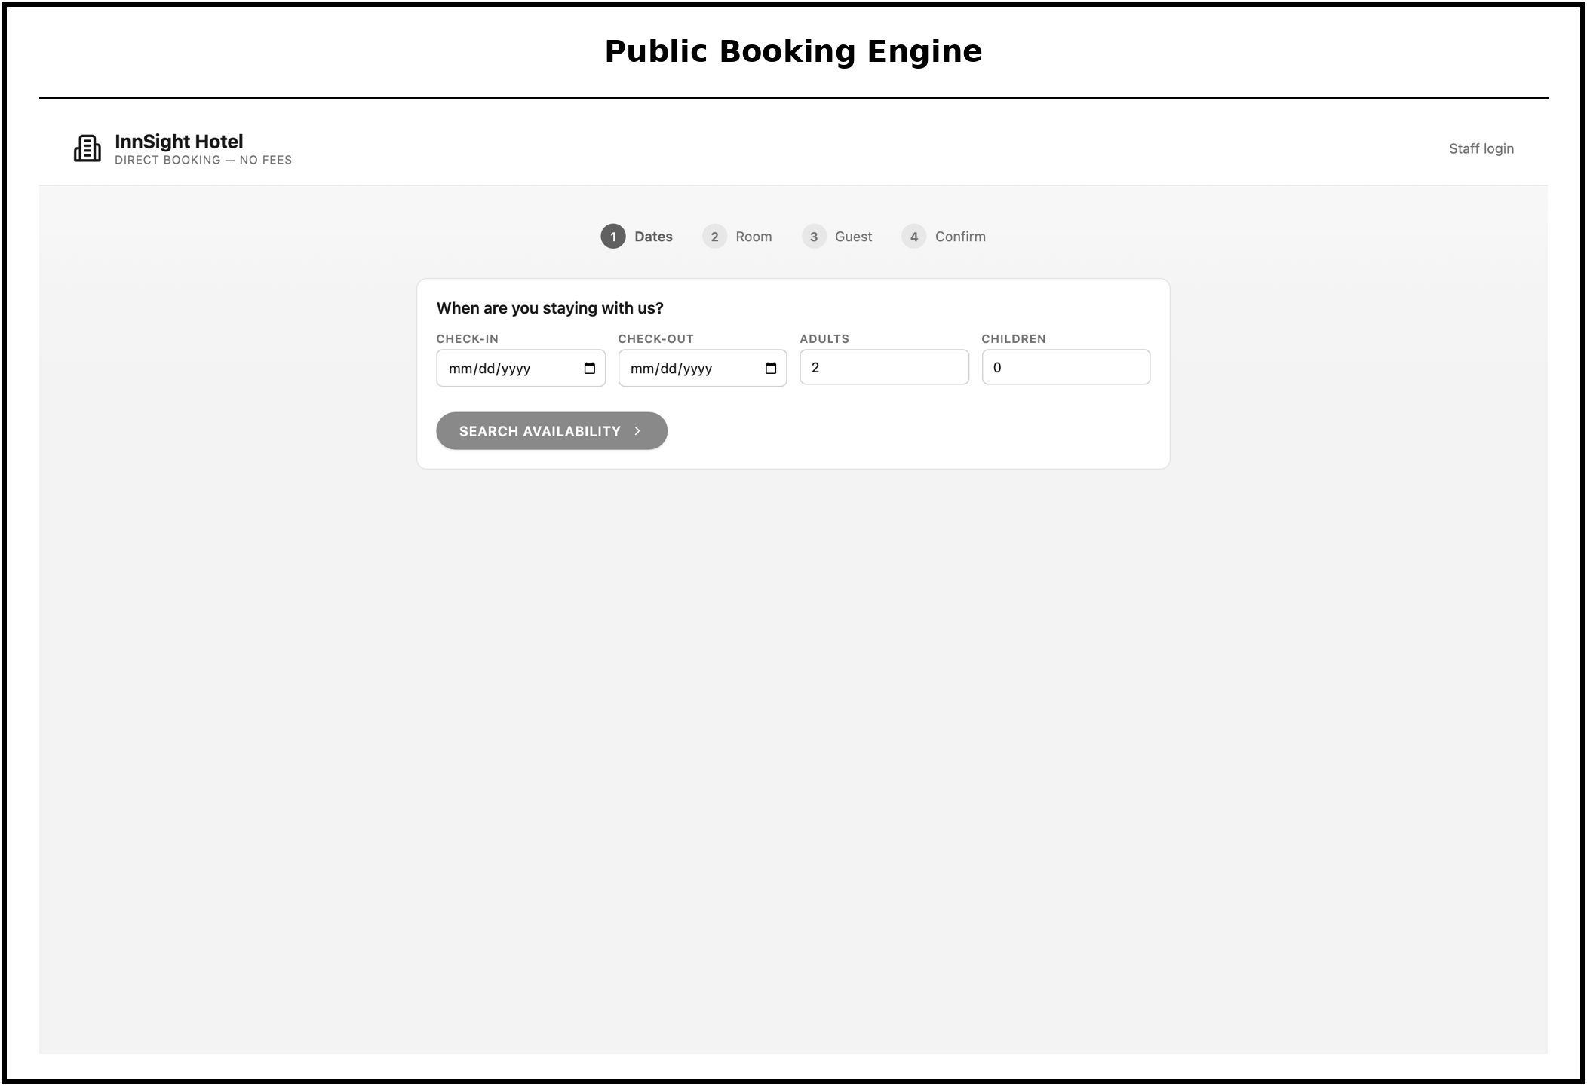
Figure 51. Public Booking Engine, the login-free guest booking wizard mounted at /book.
The public booking engine is the login-free wizard mounted at /book through which a guest books directly. It draws on the same Reservation and Inventory services used internally, so public bookings consume the same live availability as staff bookings, and completing a booking issues a confirmation and a guest-portal link.
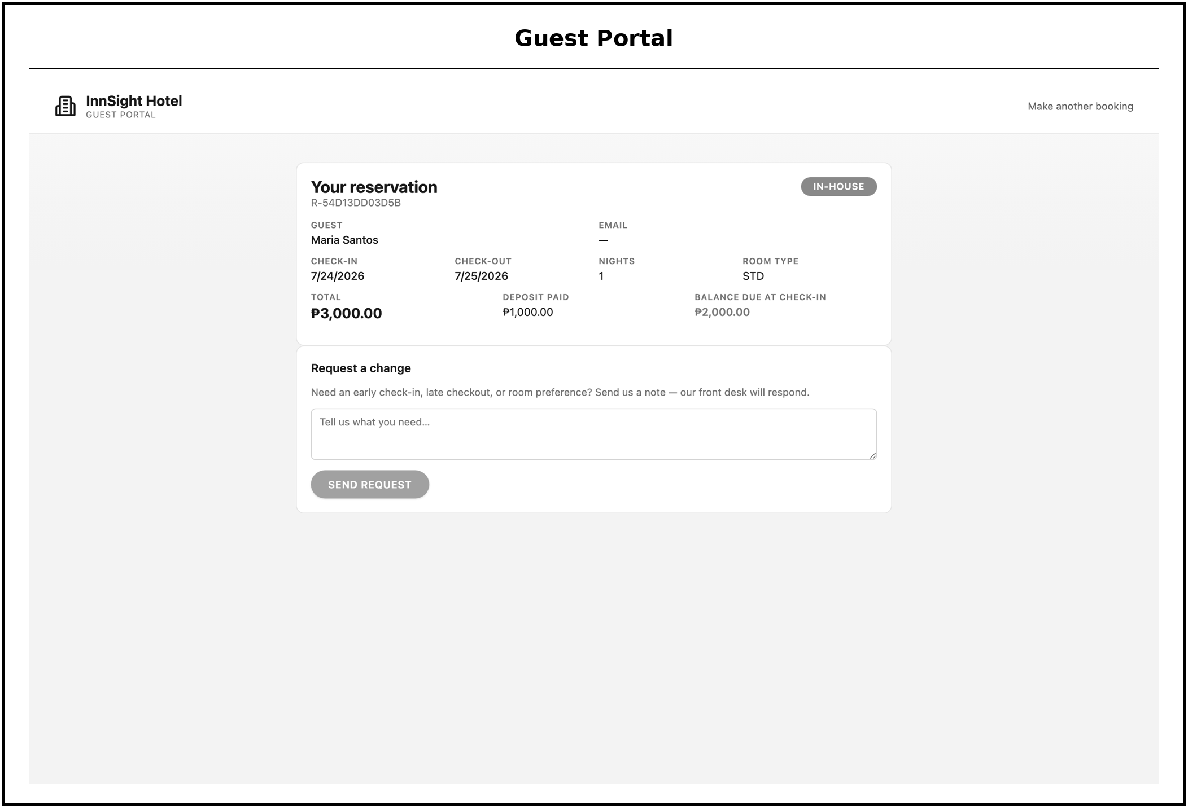
Figure 52. Guest Portal, the guest-facing reservation view reached by confirmation number.
The guest portal is the guest-facing view of a reservation, reached with a confirmation number rather than an account. It lets a guest review their booking without staff involvement, extending self-service beyond the initial booking while keeping the operational system closed to the public.
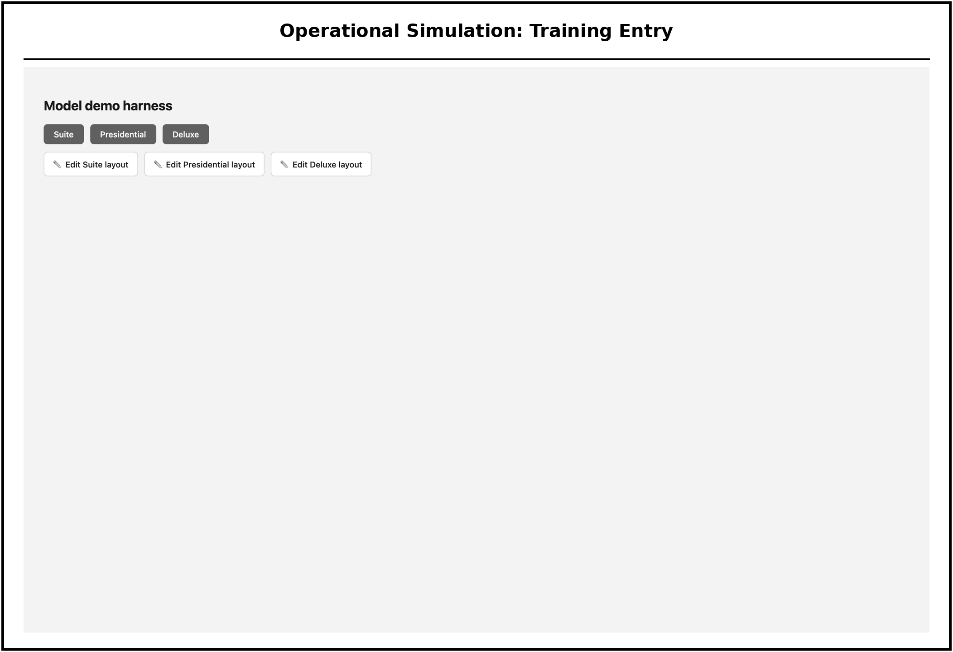
Figure 53. Operational Simulation, the training entry point with room tiers and the instructor Room Layout Editor.
This screen is the entry point to the operational simulation. Trainees select a room tier to practice, while instructors reach the built-in Room Layout Editor used to customize the rooms the simulation presents. It connects the classroom-configurable setup to the immersive exercise that follows.
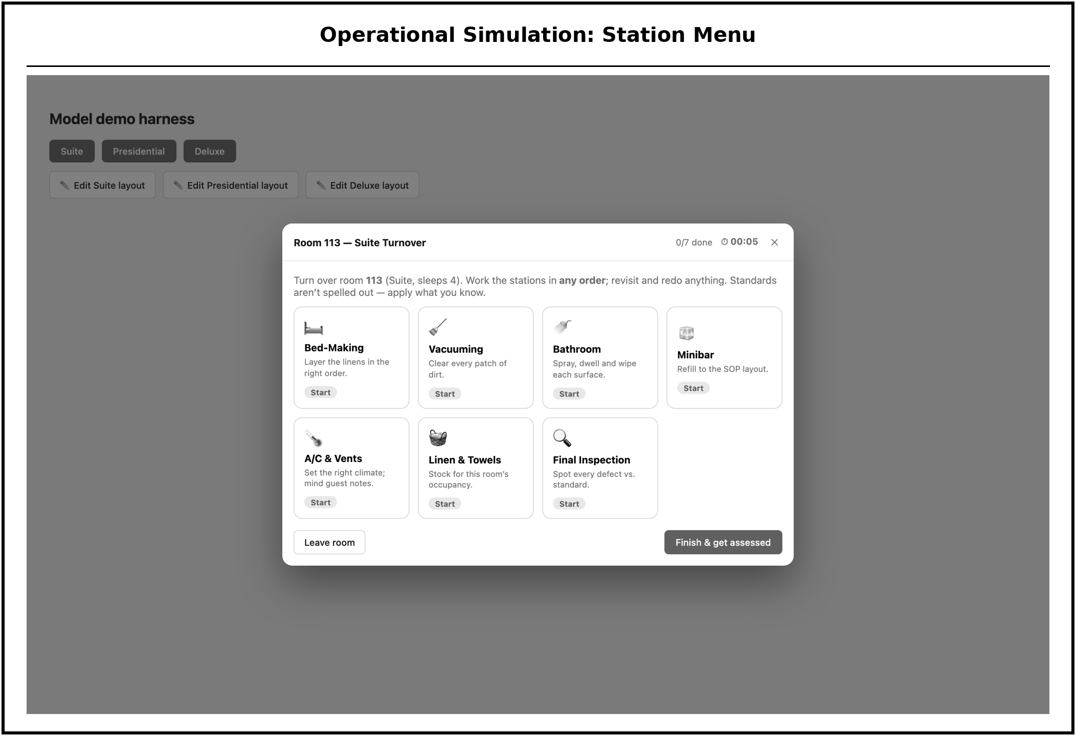
Figure 54. Operational Simulation, the room-turnover station menu (work stations in any order).
This screen shows the room-turnover station menu. A trainee can work the cleaning stations in any order, which reflects how real room turnover is not strictly sequential and lets the exercise assess judgment about task order rather than rote following of fixed steps.
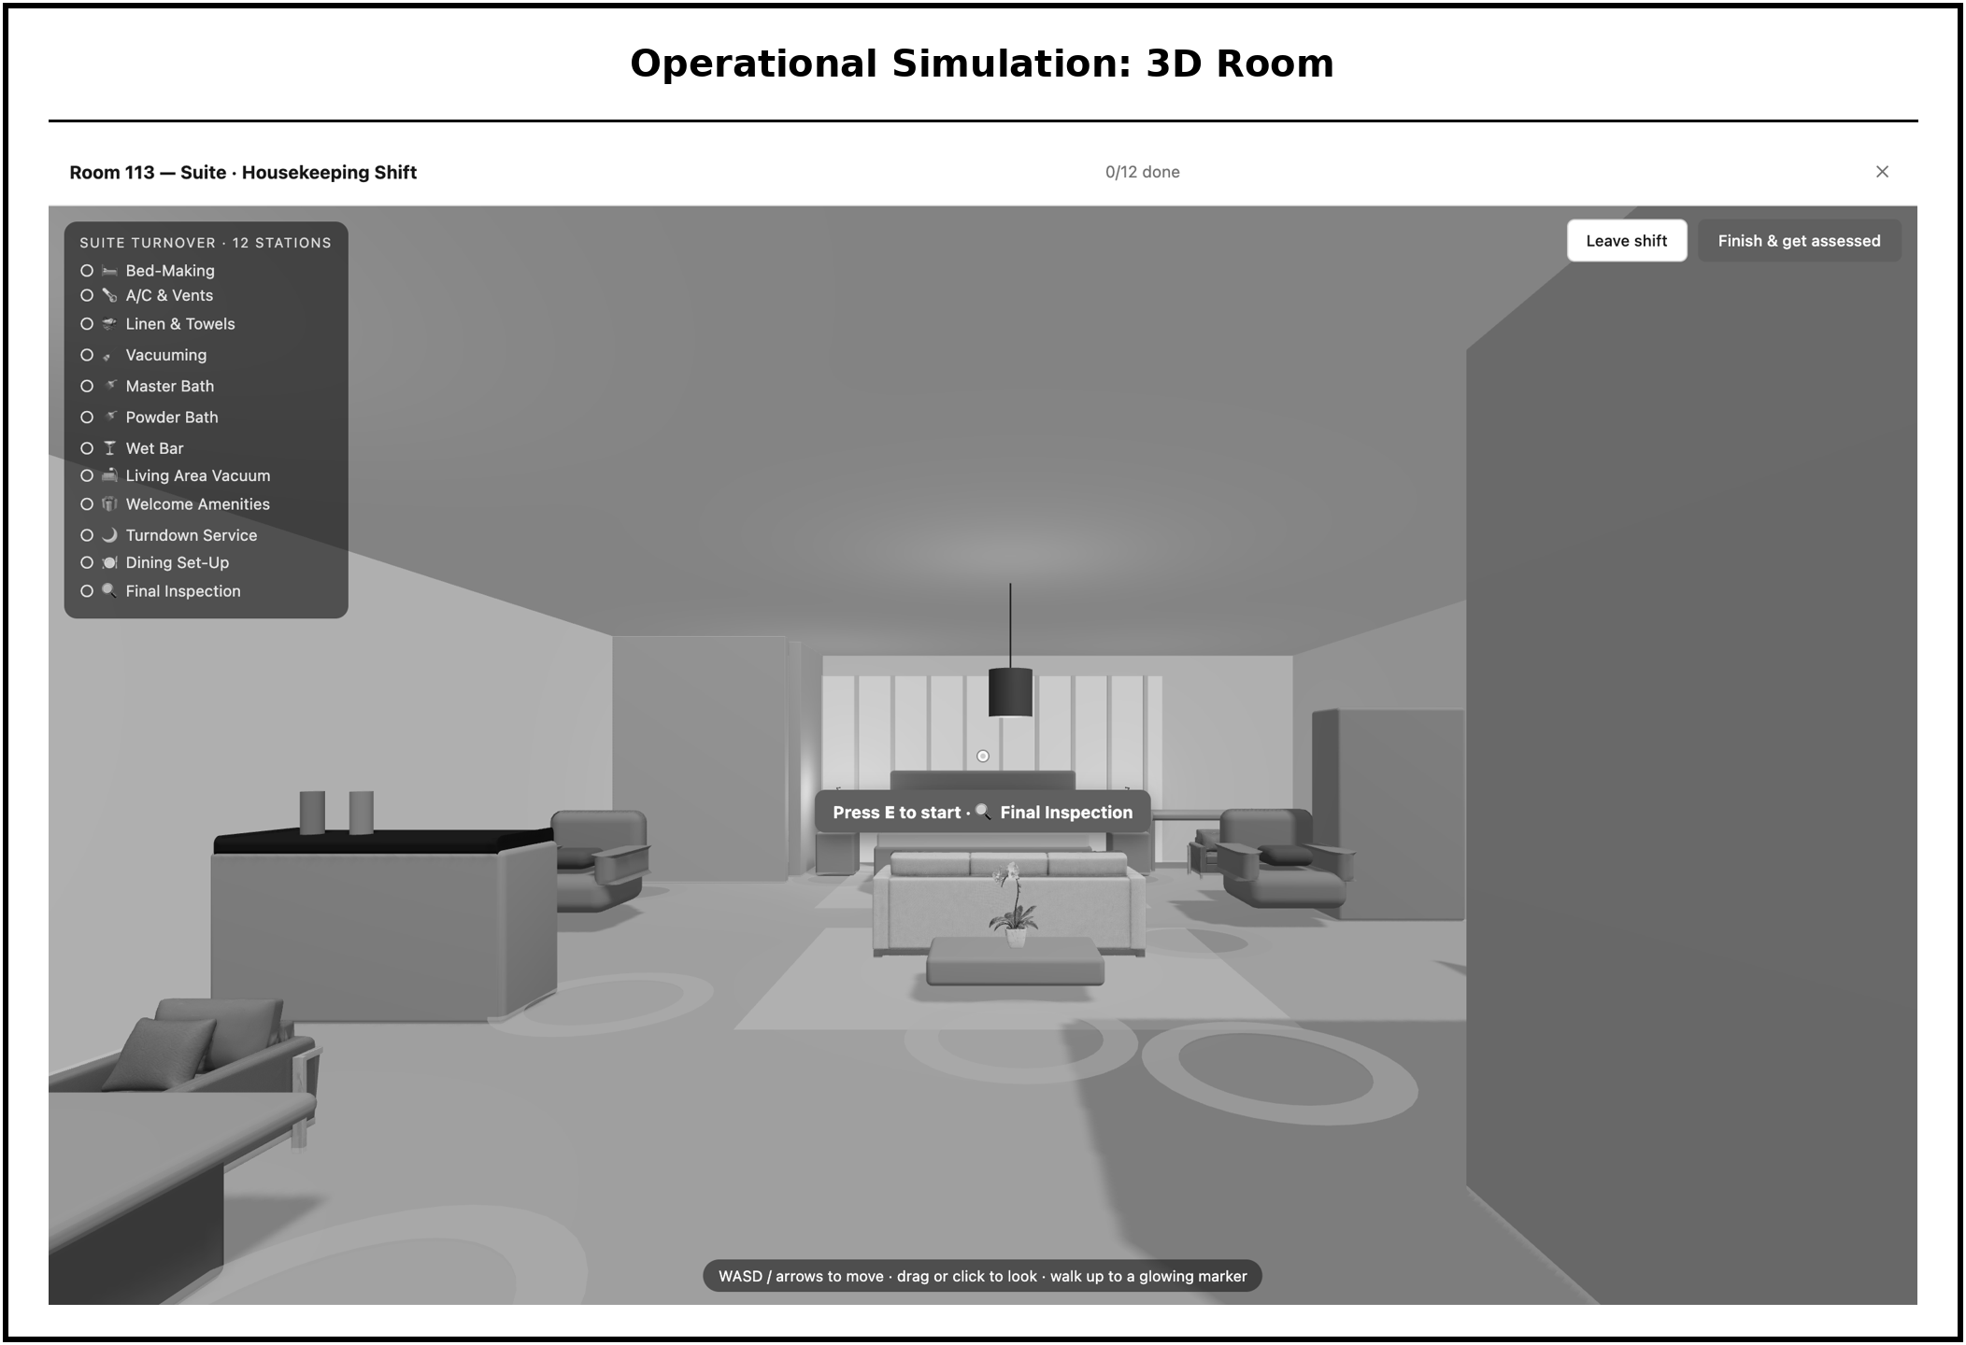
Figure 55. Operational Simulation, the immersive, walkable three-dimensional room with housekeeping stations and an on-floor task marker.
This screen is the immersive, walkable three-dimensional room in which the trainee performs the turnover. Housekeeping stations and an on-floor task marker guide movement through the space, and each session is scored on both task execution and the reasoning behind it, producing the competency result that instructors review.
Implementation Plan
The implementation of the InnSight platform is guided by the principles of Agile development with the Iterative and Incremental methodology as the Software Development Lifecycle (SDLC) to ensure a systematic and iterative delivery of the system.
Through an initial phase of planning and requirements analysis, the researchers conducted stakeholder interviews and literature reviews to establish a comprehensive requirements specification aligned with the Southern Luzon State University (SLSU) Hospitality Management curriculum.
Consequently, the project transitioned into a system design phase where detailed architectural diagrams, API contracts, and database schemas were drafted to serve as a technical blueprint. The development of the system was then executed in two distinct stages, beginning with the construction of core system modules to establish the security infrastructure and primary operational functions, followed by the implementation of advanced feature modules that integrated the operational three-dimensional housekeeping simulation and competency tracking.
Integration and system testing were subsequently performed using standard containerization platforms to ensure environment consistency and optimal performance under concurrent student loads. This process was followed by a formal User Acceptance Testing (UAT) involving both technical and hospitality industry experts to validate the quality and pedagogical effectiveness of the platform.
Finally, the project culminated in the analysis of evaluation results, the incorporation of final revisions based on respondent feedback, and the formal deployment of the InnSight system at the SLSU Lucban Campus, which was supported by the finalization of comprehensive system documentation and instructional guides.

Table 1.
Implementation Plan
Phase | Activities | Duration
Planning and Requirements Analysis | Review related literature; conduct stakeholder interviews with HM faculty; identify functional and non-functional requirements; finalize ISO/IEC 25010:2023 framework; validate research instruments. | 2 Weeks
System Design | Prepare complete UML diagram set; define API contracts for all microservices; design the per-service PostgreSQL schemas. | 2 Weeks
Core Service Development (Increments 1 & 2) | Implement Authentication Service, API Gateway, and Reservation Service; implement JWT security; develop Housekeeping Service and Redis event pipeline; conduct unit and integration testing. | 4 Weeks
Feature Service Development (Increment 3) | Implement the feature services (amenities, reports, night audit, and maintenance) and the operational three-dimensional housekeeping training simulation; conduct integration and end-to-end testing. | 3 Weeks
Integration and System Testing | Orchestrate all services via Docker Compose; perform load and integration testing; verify responsive design; conduct formal UAT with IT experts and HM respondents. | 2 Weeks
Evaluation, Deployment, and Documentation | Analyze evaluation data; incorporate final revisions; deploy system at SLSU Lucban Campus; finalize technical documentation and research paper. | 2 Weeks

Research Instrument
A self-constructed questionnaire was used as the primary research instrument to assess the quality and acceptability of the InnSight system. The questionnaire was organized into two major parts: the first part evaluated the system's software quality based on the characteristics defined in the ISO/IEC 25010:2023 standard, and the second part assessed the system's level of acceptability in terms of its physical features, interface, operability, and user-friendliness.
The researchers used a Four-Point Likert Scale to assign numerical values to the responses gathered from the questionnaire. The scale assigns the following values: Acceptable (4), Slightly Acceptable (3), Unacceptable (2), and Not Acceptable (1).
Moreover, the instrument was developed with reference to the ISO/IEC 25010:2023 Software Quality Model and was tailored to the specific functions of the InnSight platform. The questions covering Functional Suitability, Performance Efficiency, Compatibility, Interaction Capability, Reliability, Security, Maintainability, Flexibility, and Safety were included in the ISO section. The acceptability section covered Physical Features, Interface, Operability, and User-Friendliness.
An open-ended comment section was included at the end of the questionnaire to allow respondents to provide additional feedback and improvement suggestions. The input acquired in this section can then be categorized accordingly and put into consideration for later developments of the system.
Table 2
ISO/IEC 25010:2023 Quality Characteristics Evaluated per Respondent Group
ISO/IEC 25010:2023 Quality Characteristic | IT Experts | HM Experts (Instructor & Chair) | Students
Functional Suitability |  | ✓
Performance Efficiency | ✓
Compatibility | ✓
Interaction Capability |  | ✓ | ✓
Reliability | ✓
Security | ✓
Maintainability | ✓
Flexibility | ✓
Safety | ✓ | ✓
Level of Acceptability (Physical Features, Interface, Operability, User-Friendliness) |  |  | ✓

Each ISO/IEC 25010:2023 quality characteristic in the questionnaire is operationalized through five (5) specific evaluation statements derived from the standard's defined sub-characteristics. Each statement was written to reflect a concrete, observable behavior of the InnSight system, ensuring that respondents could provide informed ratings based on direct system interaction rather than general impressions.
The instrument was validated through a two-stage process. In the first stage, the questionnaire was reviewed and validated by the research adviser for alignment with the ISO/IEC 25010:2023 framework and the specific functions of the InnSight platform. In the second stage, the instrument was reviewed by subject matter experts such as the HM faculty and one IT professional not included in the evaluation sample for clarity, relevance, and appropriateness of each item. Revisions were incorporated based on the validators' recommendations before the instrument was administered to the respondent groups.
All questionnaires included an informed consent section at the beginning, informing respondents of the study's purpose, the voluntary nature of their participation, the confidentiality of their responses, and their right to withdraw at any time. The researchers used a Four-Point Likert Scale to assign numerical values to each response.
Respondents of the Study
The respondents of this study were selected through purposive sampling to ensure that relevant and specific data were gathered from the intended users, academic evaluators, and technical experts of the system. Purposive sampling was deemed appropriate because the study requires respondents with direct knowledge of either hospitality management education or information technology systems evaluation. The three respondent groups, their roles in the evaluation, and their sample sizes are presented in Table 3.
Table 3
Respondent Groups, Roles in Evaluation, and Sample Sizes
Respondent Group | Role in Evaluation | n | Percentage
First-Year BSHM Students | Evaluate Interaction Capability and the Level of Acceptability (Physical Features, Interface, Operability, User-Friendliness) based on guided system exploration sessions. | 50 | 79.4%
HM Instructor and Program Chair | Assess Functional Suitability, Interaction Capability, and Safety based on domain expertise in hospitality operations and curriculum standards. | 2 | 3.2%
Information Technology Experts | Evaluate Performance Efficiency, Compatibility, Reliability, Security, Maintainability, Flexibility, and Safety through live system demonstrations and technical walkthroughs. | 10 | 15.9%
Total |  | 62 | 100%

The first respondent group consists of first-year BSHM students enrolled in one section at SLSU Lucban, with an approximate enrollment of fifty (50) students. Only one of the two available first-year sections was selected to serve as the evaluation group, while the other section served as a non-participant control group. This delimitation was established to confine data collection to a manageable and uniform cohort and to prevent cross-contamination of evaluation responses between sections. The inclusion criterion for this group was current enrollment in the first-year BSHM program at SLSU Lucban during the semester of system deployment.
The second respondent group comprises the Hospitality Management instructor directly responsible for laboratory instruction in the BSHM program and the BSHM Program Chair. Both individuals were included by virtue of their direct professional involvement in hospitality education and their familiarity with the operational standards and workflows that the InnSight simulation is designed to replicate. Their evaluation specifically addressed whether the system's functional outputs are accurate, appropriate, and aligned with hospitality management curriculum standards.
The third respondent group consists of ten (10) Information Technology professionals selected based on their expertise in software development, systems evaluation, or web application architecture. These experts were drawn from IT faculty and technical staff with demonstrated knowledge of software quality evaluation frameworks. The inclusion criteria for this group were: (1) possession of at least a bachelor's degree in Information Technology, Computer Science, or a related field; and (2) professional or academic experience in software development, systems analysis, or IT project management. This group evaluated the technical quality characteristics of InnSight through live demonstrations and hands-on interaction with the deployed system.
Procedures/Data Gathering
All necessary data were gathered through structured system evaluation sessions and survey questionnaires administered to the selected respondents. The evaluation process was conducted in three stages corresponding to the three respondent groups, ensuring that each group's assessment was aligned with their specific evaluation scope as defined in Table 2. Prior to any data collection activity, all respondents were provided with an informed consent form explaining the study's purpose, the voluntary nature of their participation, the confidentiality of their individual responses, and their right to withdraw participation at any point without consequence.
Stage 1: Student Evaluation (Non-Expert Evaluation). The fifty first-year BSHM students underwent a structured system orientation session in the Hospitality Management laboratory, during which the researchers demonstrated the key modules of InnSight and allowed students to explore the system independently. Following the exploration session, students completed the printed evaluation questionnaire, which covered Interaction Capability and the Level of Acceptability dimensions. The questionnaires were collected on the same day to ensure completeness of responses.
Stage 2: Hospitality Management Expert Evaluation. The HM instructor and program chair participated in a guided system walkthrough conducted by the researchers, covering all student-facing and instructor-facing modules of InnSight. After the walkthrough, both experts completed the printed evaluation questionnaire covering Functional Suitability, Interaction Capability, and Safety. Respondents were given the opportunity to ask clarifying questions before completing the instrument to ensure that their ratings were based on accurate system understanding.
Stage 3: Information Technology Expert Evaluation. Ten IT experts participated in live system demonstrations and technical walkthroughs conducted by the researchers. During these sessions, the system's architecture, deployment configuration, service communication mechanisms, security implementation, and performance behaviors were demonstrated and explained. Following the demonstration, each expert completed the printed evaluation questionnaire covering the nine ISO/IEC 25010:2023 characteristics within their evaluation scope. Respondents were also given the opportunity to submit written comments and recommendations in the open-ended section of the instrument.
All completed questionnaire responses were encoded into a structured data matrix using spreadsheet software. Responses were organized by respondent group and quality characteristic for statistical processing. Open-ended comments were reviewed, categorized thematically, and used to guide the final system refinements incorporated prior to deployment.
Ethical Considerations
The conduct of this study adhered to the ethical principles governing research involving human participants. All respondents were provided with a written informed consent form prior to participation, which explained the study's objectives, the voluntary nature of their involvement, the scope of data to be collected, and the measures taken to protect their privacy and confidentiality. No respondent was required to participate, and all were informed of their right to withdraw at any time without penalty.
To protect respondent privacy, all completed questionnaires were anonymized during data encoding and analysis. Individual response data were not attributed to any named participant in the study's findings. Completed physical questionnaires were stored securely and accessible only to the research team. No personally identifiable information was collected beyond what was necessary to classify respondents by group (e.g., student, HM expert, IT expert).
The system itself was evaluated within an institutional sandbox environment, ensuring that no real guest data, financial transactions, or personally sensitive information was processed or stored during evaluation sessions. The InnSight system's Authentication Service implements BCrypt password hashing and JWT-based session management, ensuring that student account credentials created for evaluation purposes were stored securely and are not accessible in plaintext.
Statistical Treatment
The data gathered from the evaluation and acceptability questionnaires were subjected to descriptive statistical analysis. The primary statistical tool applied was the Weighted Mean, which consolidated the individual Likert-scale ratings of all respondents within each group into a single representative score for each questionnaire item and each ISO/IEC 25010:2023 quality characteristic or acceptability dimension. The Weighted Mean was computed using the following formula:
WM = ΣfX / N
Where:
WM = the Weighted Mean
Σ = the summation operator
f = the frequency of respondents selecting a particular rating value
X = the numerical value assigned to that rating on the Four-Point Likert Scale
N = the total number of respondents who answered that item

In addition to the Weighted Mean, frequency distribution and percentage computations were used to describe the distribution of individual ratings across each questionnaire item, providing supplementary insight into the concentration and spread of respondent evaluations.
The resulting weighted mean value for each item was interpreted against the scale of means presented in Table 4. The verbal interpretations which are Acceptable, Slightly Acceptable, Unacceptable, and Not Acceptable are applied consistently in all results tables throughout Chapter IV

Table 4
Four-Point Likert Scale, Scale of Means, and Descriptive Interpretation
Scale | Verbal Interpretation | Scale of Means | Descriptive Meaning
4 | Acceptable | 3.26 – 4.00 | The system characteristic or feature meets the needs and expectations of the respondents.
3 | Slightly Acceptable | 2.51 – 3.25 | The system characteristic or feature partially meets the needs and expectations of the respondents.
2 | Unacceptable | 1.76 – 2.50 | The system characteristic or feature does not sufficiently meet the needs and expectations of the respondents and requires improvement.
1 | Not Acceptable | 1.00 – 1.75 | The system characteristic or feature does not meet the needs and expectations of the respondents and requires significant revision.

The Weighted Mean and its corresponding verbal interpretation were calculated separately for each ISO/IEC 25010:2023 quality characteristic and for each acceptability dimension within each respondent group, providing a structured and comparable evaluation across all groups. The overall rating for each major evaluation category was derived from the mean of the weighted means of all items within that category. These aggregate scores were used to assess the overall quality and acceptability of InnSight and to identify specific areas requiring refinement prior to final deployment at the SLSU Lucban Campus.

CITED
Abgaz, Y., McCarren, A., Elger, P., Solan, D., Lapuz, N., Bivol, M., Jackson, G., Yilmaz, M., Buckley, J., & Clarke, P. (2023). The monolith to microservices decomposition framework: Navigating the complex architectural transition. Journal of Systems and Software, 195, 111–125.
Aden, A.A., Srivastava, A., & Gupta, N. (2026). Leveraging microservices architecture to enhance scalability and resilience in e-commerce platforms. In A. Bhattacharya, S. Dutta, X.S. Yang, & S. Bose (Eds.), Proceedings of International Conference on Computational Intelligence and Information Retrieval (ICCIIR 2025) (pp. 37-50). Springer. https://doi.org/10.1007/978-3-032-02790-0_4
Accardo, L. (2022). Principles of microservices architecture in modern web applications. International Journal of Software Engineering, 14(3), 45-58.
Al-Mansoori, S., & Chen, Y. (2025). Automated migration systems and type-safe object-relational mapping in agile development. Database Engineering Quarterly, 11(1), 102-118.
Almeida, F., & Canedo, E. (2022). Authentication and authorization challenges in microservice architectures: A review of OAuth 2.0 and JWT. Computers & Security, 112, 102-115.
Anwar, A. (2025). Event-driven architecture strategies: Schema registries, idempotency, and outbox patterns. Distributed Computing Systems Journal, 19(1), 45-60.
Ariningsih, A., & Muhammad, F. (2024). Assessing software quality using the ISO/IEC 25010:2023 model: A focus on interaction capability. Journal of Information Technology Evaluation, 13(4), 211-225.
Athamakuri, R., & Thiruveedula, M. (2025). Domain-driven design and containerization in distributed backend services. Cloud Computing Review, 17(3), 88-104.
Avula, S., & Kavuluri, R. (2024). Polyglot persistence strategies in decentralized applications. International Journal of Database Management, 21(2), 56-72.
Azman, N., & Ishak, M. (2024). The impact of property management software on operational efficiency in Johor Bahru. Asian Journal of Real Estate and Property Management, 9(1), 22-38.
Bayramova, A. (2025). System reliability and fault tolerance in modern software environments. Journal of Software Reliability Engineering, 14(2), 110-125.
Berger-Estilita, J., Gisselbaek, M., Devos, A., Chan, A., Ingrassia, P. L., Meco, B. C., ... & Saxena, S. (2025). AI and inclusion in simulation education and leadership: a global cross-sectional evaluation of diversity. Advances in Simulation, 10(1), 26.
Blinowski, G., Ojdowska, A., & Przybylek, A. (2022). Monolithic vs. microservice architecture: A performance and scalability evaluation. IEEE Access, 10, 20357-20374. https://doi.org/10.1109/ACCESS.2022.3152803
Bouchareb, M. (2023). Artificial intelligence in property management systems: Automating hotel workflows. International Journal of Hospitality Technology, 11(2), 85-99.
Burns, B., Beda, J., Hightower, K., & Evenson, L. (2022). Kubernetes: Up and Running (3rd ed.). O'Reilly Media.
Carvalho, L., Colanzi, T., Assunção, W., Garcia, A., Pereira, J. A., Kalinowski, M., de Mello, R. M., de Lima, M. J., & Lucena, C. (2024). On the usefulness of automatically generated microservice architectures. IEEE Transactions on Software Engineering, 50(3), 651–667. https://doi.org/10.1109/TSE.2023.3326207
Cannonito, R. (2024). Formalizing software quality requirements: Bridging technical design and end-user satisfaction. Quality Assurance in Software, 16(3), 200-215.
Carrión-León, C., et al. (2025). Operability-based models for system interaction and adaptive learning environments. Human-Computer Interaction Journal, 29(1), 60-78.
Commey, V., Akonnor, P. O., Commey, D., & Mensah, N. (2023). Prospects and Challenges of Property Management System in the Hotel Industry in Ghana: Evidence from Seleected Hotels in the Kumasi, Ghana. International Journal of Innovation and Development, 1(1).
Cruz, J., & Santos, L. (2024). The role of gamification in Philippine higher education: A study on operational simulations. Philippine Journal of Educational Technology, 12(3), 45-62.
D’Souza, E., & D’Souza, K. (2023). Information technology integration as a baseline requirement in the hospitality industry. Journal of Hospitality Business Research, 28(4), 310-325.
Duggirala, M., & Singh, P. (2025). Advanced testing and deployment strategies for microservices reliability. Software Quality Professional, 22(1), 33-48.
Enriquez, M., Renteria, R., Martinez Duran, V., Tomaylla Gutiérrez, Y., Ibarra Cabrera, M., & Aminuddin, A.. (2025). A comprehensive review of the ISO/IEC 25010:2023 software quality model applications. International Journal of Systems Evaluation, 19(1), 15-32.
Fx, R., & Nugroho, A. (2025). Evaluating maintainability and modularity in microservices-based systems. Software Architecture and Metrics Journal, 11(2), 80-95.
Gajbhiye, B., Goel, O., & Pandian, P. K. G. (2024). Managing vulnerabilities in containerized and Kubernetes environments. Journal of Quantum Science and Technology, 2(1), 45-58.
Gintoro, A., & Eko, S. (2025). Applying ISO/IEC 25010 maintainability specifications in student registration platforms. Educational Technology Systems, 20(3), 210-225.
Granström, M., & Nirme, J. (2023). Simulation-based crisis resource management training in prehospital care: A scoping review. BMC Emergency Medicine, 23, 100. https://doi.org/10.1186/s12873-023-00871-w
Granström, M., & Nirme, J. (2023). High-pressure scenario training in virtual operational environments. Simulation in Healthcare and Operations, 18(4), 305-320.
Gurung, A. (2024). Next-generation frontend build tools: A comparative study of Vite and legacy bundlers. Web Development Practices, 9(2), 55-70.
Halili, F., Nuhiji, A., & Mustafai Veliu, D. (2025). Polyglot persistence in microservices: Managing data diversity in distributed systems. arXiv. https://doi.org/10.48550/arXiv.2509.08014
Hanggoro, B., & El Kamouchi, I. (2025). Systematic literature review of low-code/no-code application quality evaluation. Journal of Software Engineering Research, 23(1), 101-118.
Herrera-Aliaga, J., & Estrada, C. (2022). The impact of predictable and reproducible simulation scenarios on skill training. Journal of Simulation Pedagogy, 16(1), 45-60.
International Journal for Research in Applied Science and Engineering Technology. (2026). Scalable architectures with React and Vite for web-based management systems. IJRASET, 14(2), 302-315.
ISO/IEC 25010:2023. Systems and software engineering, Systems and software Quality Requirements and Evaluation (SQuaRE), Product quality model. International Organization for Standardization. Retrieved from https://www.iso.org/standard/78176.html
Jereb, B., & Kajba, M. (2023). Standardized software quality characteristics in highly interconnected supply chain workflows. Journal of Logistics Information Systems, 19(4), 210-225.
Journal of Machine and Computing. (2025). Hybrid database management: Reducing query response latency with structured and unstructured data. JMC, 10(3), 115-130.
Katz, D., & Silva, R. (2024). Strictly typed query builders and schema definitions in Node.js environments. Journal of Backend Development, 8(2), 70-85.
Kaur, P., & Singh, A. (2022). The shift towards digital-first software development life cycles. Modern Software Engineering Practices, 15(1), 22-38.
Kim, S. (2024). Trustworthiness and safety in AI-based systems under the revised ISO/IEC 25010 framework. Journal of AI Ethics and Quality, 7(2), 50-65.
Knoll, J., & Lichtenthaler, E. (2023). Standardized functional sustainability in complex distributed systems. Journal of Software Quality Assurance, 18(4), 205-220.
Kumar, R. (2025). Evaluating SAST and DAST methodologies in API-driven microservices architectures. Journal of Cyber Security and Operations, 21(1), 88-104.
Kurniawan, B., & Patel, S. (2024). Asynchronous event-driven I/O models in Node.js for high-concurrency systems. Server-Side Architecture Review, 10(2), 45-60.
Lee, C., Kim, H. F., & Lee, B. G. (2024). A systematic literature review on the strategic shift to cloud ERP: Leveraging microservice architecture and MSPs for resilience and agility. Electronics, 13(14), 1-31. https://doi.org/10.3390/electronics13142754
Lumpp, F., Fummi, F., Patel, H., & Bombieri, N. (2024). Enabling Kubernetes orchestration of mixed-criticality software for autonomous mobile robots. IEEE Transactions on Robotics, 40(2), 512-529. https://doi.org/10.1109/TRO.2023.3334642
Lyu, Z., Pons, D., Zhang, Y., & Ji, Z. (2022). Minimum Viable Model (MVM) methodology for integration of agile methods into operational simulation of logistics. Logistics, 6(2), 37. https://doi.org/10.3390/logistics6020037
Lyu, Z., Pons, D., Zhang, Y., & Ji, Z. (2022). Minimum Viable Model (MVM) methodology for integration of agile methods into operational simulation of logistics. Logistics, 6(2), 37.

Martínez, D., Castaño, S. L., & Perafan, J. C. (2026). Microservices-based architecture to support automation applications in smart industries with end-to-end real-time requirements. Tsinghua Science and Technology, 31(2), 708-725. https://doi.org/10.26599/TST.2024.9010235
Martinez, J., & Lee, K. (2025). Centralized error-handling middleware in Express.js microservices. Web API Development Journal, 9(1), 25-40.
Mateus-Coelho, N., Cruz-Cunha, M., & Ferreira, L. G. (2021). Security in microservices architectures. Procedia Computer Science, 181, 1225-1236.
Mehta, S., & Sood, M. (2023). Iterative and incremental development: Adapting SDLC to modern technological shifts. Journal of Agile Practices, 16(3), 120-135.
Naqvi, B., Kedziora, D., Zhang, L., & Oyedeji, S. (2025). Quality of low-code/no-code development platforms through the lens of ISO 25010:2023. Computer, 58(3), 30–40. https://doi.org/10.1109/MC.2024.3511668
Ndia, P. (2026). The influence of interaction capability on user satisfaction in educational technologies. Journal of EdTech Evaluation, 11(1), 40-55.
Nguyen, H. (2025). Memory usage and build time optimization in modern frontend bundlers. Journal of Web Engineering, 14(2), 77-92.
Nugraha, A., & Rachman, F. (2024). Functional sustainability and reliability assessment using the software quality model. Journal of IT and Marketing Integration, 8(2), 50-65.
Nuzula, F., & Rochimah, S. (2023). Evaluating product quality characteristics of low-code platforms from a user experience perspective. Software Quality Journal, 21(3), 180-195.
Ok, T., & Eniola, B. (2024). Event-driven architecture and asynchronous communication in distributed systems. Journal of Network Systems, 17(2), 115-130.
OWASP Foundation. (2021). *OWASP Top Ten 2021*. Retrieved from https://owasp.org/www-project-top-ten/Pacific Certifications. (2023). Core characteristics of flexibility in software quality assurance. International Standards Review, 9(4), 210-225.
Patel, I. (2025). D-K8S: Container orchestration through nodes empowerment and participation. International Journal of Computer Trends and Technology (IJCTT), 73(2), 23-30. https://doi.org/10.14445/22312803/IJCTT-V73I2P104
Ponce, F., Soldani, J., Astudillo, H., & Brogi, A. (2022). Smells and refactorings for microservices security: A multivocal literature review. Journal of Systems and Software, 192, 111393. https://doi.org/10.1016/j.jss.2022.111393
QMII. (2024). Core security attributes in software development: Confidentiality, integrity, and accountability. Quality Management Institute Journal, 15(2), 100-115.
Quiroz-Vázquez, J. (2026). Integrating frontend interfaces with backend logic in full-stack development. Journal of Full-Stack Engineering, 8(1), 22-38.
Rahman, S., & Smith, J. (2024). Abstracting Node.js HTTP modules with Express.js for scalable backend APIs. Journal of Backend Frameworks, 14(3), 90-105.
Rajpara, D. (2024). The role of development tools in minimizing manual work and boosting system reliability. Software Tools and Productivity Journal, 11(2), 40-55.
Ramu, K. (2023). Performance implications and latency in inter-service microservices communication. Journal of Distributed Systems Performance, 18(1), 75-90.
Rithala, A. (2026). Operational risk management and safety characteristics in modern software environments. Journal of Systems Safety, 10(1), 50-65.
Rojas, H., Renteria, R., Duran, V. M., Gutiérrez, Y. T., Cabrera, M. J. I., & Aminuddin, A. (2025). Mapping the evolution and future directions of ISO/IEC 25010: A bibliometric and thematic analysis. *Engineering, Technology & Applied Science Research*, 15(1), 18811-18819. https://doi.org/10.48084/etasr.11772
Sachdeva, M., & Vasava, P. (2024). Polyglot persistence for heterogeneous data models in complex systems. Database Engineering Journal, 16(1), 55-70.
Sharma, N., & Kumar, A. (2024). Component-based architecture and state management in complex enterprise systems. Journal of React and Frontend Frameworks, 9(2), 45-60.
Sharma, S., Dubey, R. K., & Khatri, P. (2024). Review of the literature on big data and performance analysis of multimodel and polyglot persistence. In Proceedings of the 2024 International Conference on Advances in Computing Research on Science Engineering and Technology (ACROSET)* (pp. 1–6). IEEE. https://doi.org/10.1109/ACROSET62108.2024.10743284
Sharma, S., Dubey, R. K., & Khatri, P. (2024). Review of the literature on big data and performance analysis of multimodel and polyglot persistence. In Proceedings of the 2024 International Conference on Advances in Computing Research on Science Engineering and Technology (ACROSET) (pp. 1–6). Indore, India. IEEE. https://doi.org/10.1109/ACROSET62108.2024.10743284
Silva, M. V. S., Santos, L. F. C., Soares, M. S., & Rocha, F. G. (2025). Guidelines for the application of event driven architecture in micro services with high volume of data. SCITEPRESS – Science and Technology Publications. https://www.scitepress.org/Papers/2025/133486/133486.pdf.
Sousa, A., Branco, F., Reis, A., & Reis, M. J. C. S. (2025). A container-native IAM framework for secure green mobility: A case study with Keycloak and Kubernetes. Information, 16(9), 802. https://doi.org/10.3390/info16090802
Söylemez, M., Tekinerdogan, B., & Tarhan, A. K. (2024). Microservice reference architecture design: A multi-case study. Software: Practice and Experience, 54(3), 412-438. https://doi.org/10.1002/spe.3241
Tan, J. (2023). Event-driven state management with Redis in educational simulation engines. Journal of Educational Data Architecture, 11(2), 67-82.
Thummala, S., & Singh, R. (2025). Continuous integration and vulnerability scanning in containerized deployment pipelines. Journal of DevOps and Security, 12(1), 40-55.
Uddin, M. (2024). Building digital literacy and professional decision-making through simulation-based learning. International Journal of EdTech Research, 17(1), 30-45.
Valeriano, C. (2024). API Gateways as central routing mechanisms for decentralized academic platforms. Asian Journal of Computer Science, 15(4), 102-118.

Velepucha, V., & Flores, P. (2023). A survey on microservices architecture: Principles, patterns and migration challenges. IEEE Access, 11, 87501-87528. https://doi.org/10.1109/ACCESS.2023.330568
Velepucha, C., & Flores, N. (2023). Migration strategies from monolithic applications to microservices architecture. Journal of Software Migration, 8(2), 55-70.
Veloso, R., & Reyes, T. (2025). Gamification strategies for Front Desk operation training in the hospitality sector. Journal of Tourism and Hospitality Pedagogy, 19(1), 112-127.
Villanueva, E. (2022). Evaluating instructional software using the updated ISO/IEC 25010 standard. Journal of Software Quality Evaluation, 9(3), 88-103.
Waseem, M., Liang, P., Shahin, M., Di Salle, A., & Márquez, G. (2024). Containerization in multi-cloud environment: Roles, strategies, challenges, and solutions for effective implementation. Journal of Systems and Software, 210, 111965. https://doi.org/10.1016/j.jss.2024.111965
Wouters, J. (2025). Structural flexibility and modular design in multi-criteria decision models. Journal of Software Frameworks, 11(1), 35-50.
Ye, F., Sheng, X., Nedjah, N., Sun, J., & Zhang, P. (2023). A benchmark for performance evaluation of a multi-model database vs. polyglot persistence. Journal of Database Management, 34(3), 1–20. https://doi.org/10.4018/JDM.321756
Willard, J., & Hutson, J. (2025). The evolution and future of microservices architecture with AI-driven enhancements. International Journal of Recent Engineering Science (IJRES), 12(1), 16-22. https://doi.org/10.14445/23497157/IJRES-V12I1P103

Ye, F., Sheng, X., Nedjah, N., Sun, J., & Zhang, P. (2023). A benchmark for performance evaluation of a multi-model database vs. polyglot persistence. Journal of Database Management, 34(3), 1–20. https://doi.org/10.4018/JDM.321756

