CSE594 Fall 2012
Template of Micromouse Simulation Project
Prepared by Haiyan Qiao

- Introduction (revise based on your needs)

Micromouse maze is a 16 x 16 square-grid maze. Maze has walls along the boundaries of each position and allows a path in between the starting cell and destination. The objective is to simulate the mouse path-finding and reach the destination in the shortest time. Mouse can start at any corner of the maze and have to the find its way to the destination. The destination is the center four grid blocks of the maze which will have one opening into it. Mouse will use its sensors to see if a wall is around it in current position and chooses its path accordingly. Simulation is done taking head direction of the mouse and assuming real-time environment around the mouse inside the maze.

Note: the micromouse can only turn left or right, move back or forward. It cannot make U-turn due to the size constraint.

- Description (revise based on your needs)

Programing language: JAVA is used to program the algorithm. GUI is made using the swings in JAVA.
Input File: Input to the program is taken from the text file. The text file is a 33 x 33 matrix with " | " and "-" symbols with spaces in between them. " | " represent a vertical wall and "-" represent a horizontal wall. This representation is shown in the following screenshot. The path of this text file is given in the program.

Input Text File

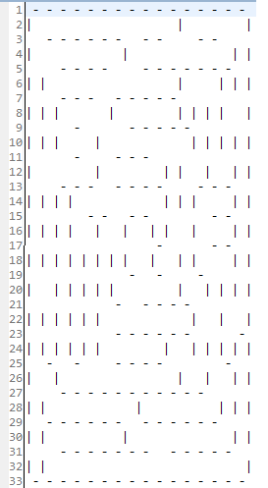
Two arrays Horizontal 17 x 16 and Vertical 16x 17 are used to store the horizontal walls and vertical wall respectively. They are used to tell where there is an open side for a particular individual cell.

- Algorithm

For each and every cell in the maze, follow the following steps

- Procedure

- System should have the Eclipse (IDE) and JDK environment to run the JAVA applications.
- Two JAVA classes MicroMouse.java and Direction.java are provided, one for the direction and another for the actually algorithm. The GUI part is provided in MicroMouse.java, without the algorithm included.
- In the MicroMouse.java file the input text file (the maze) is read. As shown in the screenshot.
- Implment the algorithm in MicroMouse.java
- Save, complie and run the MicroMouse.java file.
- Output: The output path flow is shown in the GUI. Along with GUI a 16 x 16 Matrix which shows number of times each cell visited and the output path is printed. An example figure is shown as below.
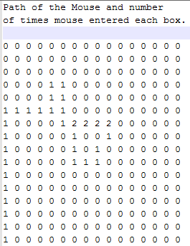

- Testing & Results

Each group/person needs to provide a maze configuration and all these maze configurations will be utilized for testing. Include all the testing results.
Have a table to compute the mean of total steps and the mean of the difference between total steps and the shortest path.

Examples:

- Maze1 configuration Output
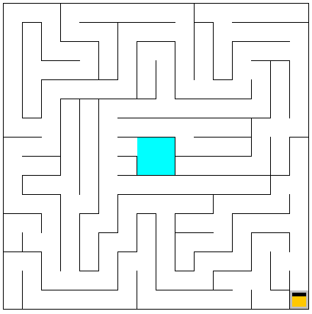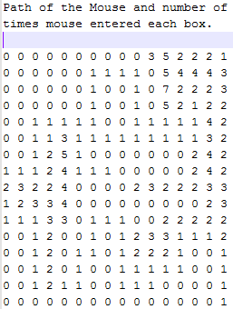

2) Maze2 configuration Output
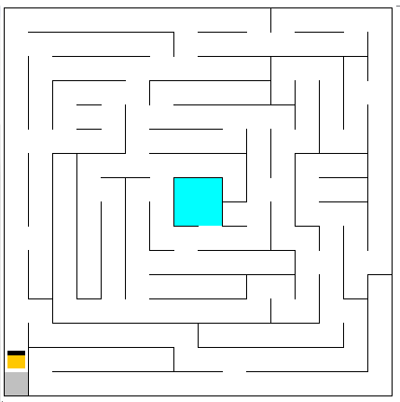

- Discussions and Conclusion

References

[1] MicroMouse URL: http://www.micromouseinfo.com/index.html
[2]

