Chapter 3
RESULTS AND DISCUSSIONS

User Requirements of a Web-based System
<Enumerate here the user requirements as specified by the LGU and other features that are in the system. Explain each feature. >
Example: (this is Ai-generated, presented for sample purposes)
“The system is composed of five core modules:
- User Authentication Module – Handles secure login, account roles, and permissions.
- Data Entry Module – Allows users to input and manage records.
- Processing Module – Automates calculations, validations, or workflows.
- Reporting Module – Generates downloadable reports and analytics.
- Admin Module – Manages user accounts, settings, and system configuration.
<Your presentation may be per feature not per module, your choice>

Design and Development of GovConnect
<Create a preliminary statement before the actual discussion of the system>
Virtual Table of Contents
Present and discuss
Use Case
Present and discuss
(sample is presented)

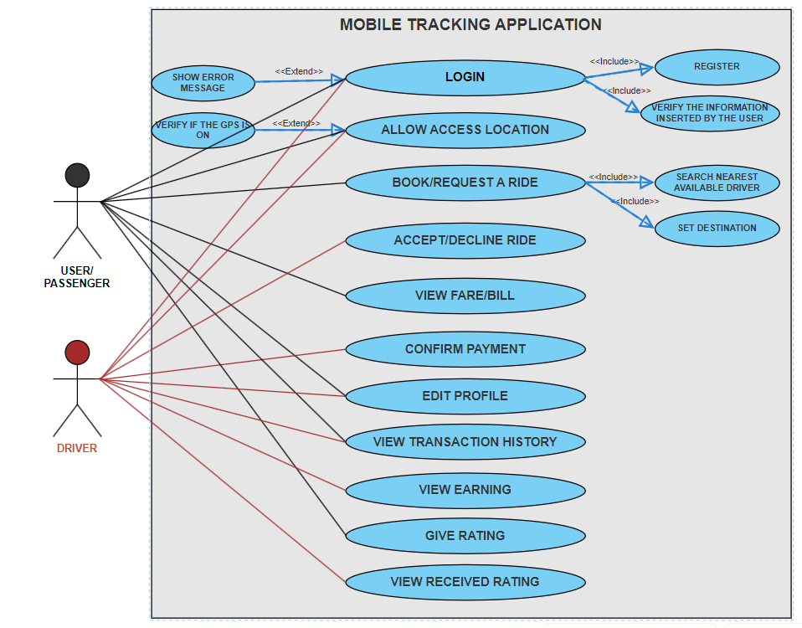
Fig. 5. Use Case Diagram of GrabTrik

The following are the interfaces of the web-based system presented according to the Scrum framework
Sprint 1: Offices, Barangays, Services
<Present the user interfaces (screenshots labeled as Plate 1, Plate 2, etc.) involved in this and then discuss>
Example:
Data Entry Form
<Present and discuss>s
The Data Entry Form allows users to encode information with required…
<Also refer to documentations per sprint review/ retrospective in the appendix>
<Also state the feedbacks/ comments / suggesitons made by the client per sprint.>
Sample plate:
Plate 1 shows the Log-in Page for Driver/Passenger. This is used to gain access to the system’s functionality. The log-in form asks for the email and password of the user. Users can login using their created email account in registration page together with their password.

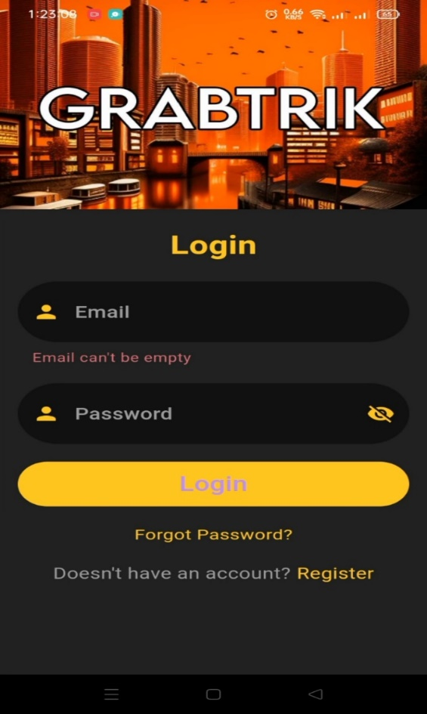

Plate 1. Log-in Page for Driver/Passenger

Sprint 2: Government Executive Orders, Ordinances, and Resolutions, Downloadable Forms, Government Officials, Tourism, Projects
<Present the user interfaces (screenshots) involved in this and then discuss>
<Also state the feedbacks/ comments / suggesitons made by the client per sprint.>
<Also refer to documentations per sprint review/ retrospective in the appendix>

Sprint 3: Features/News
<Present the user interfaces (screenshots) involved in this and then discuss>
<Also state the feedbacks/ comments / suggesitons made by the client per sprint.>
<Also refer to documentations per sprint review/ retrospective in the appendix>

Sprint 4: Forum (Newsfeed, Post, Comments, Notifications, Messages)
<Present the user interfaces (screenshots) involved in this and then discuss>
<Also state the feedbacks/ comments / suggestions made by the client per sprint.>
<Also refer to documentations per sprint review/ retrospective in the appendix>

Sprint 5: About Page, Home Page, User/Role Permission
Dashboard Interface
Present and discuss
For the Dashboard Interface, the system shows navigation menu and…
Sprint 6: - Log in/Sign Up, Search, FAQ
<Present the user interfaces (screenshots) involved in this and then discuss>
<Also state the feedbacks/ comments / suggestions made by the client per sprint.>
<Also refer to documentations per sprint review/ retrospective in the appendix>

Wire Frame (this may be placed in the appendix part)

Evaluation of GovConnect
<Present the results of the survey. Include introductory statemen there before presenting the results. Include table and discuss.>
As to Ease of Use
Sample table and discussion

Table 2. Acceptability of the Developed GrabTrik in Terms of Performance
Expectancy Among Drivers

Indicators | Mean | Descriptive Equivalent Rating | Descriptive Interpretations
I would find the GrabTrik service useful for my travel. | 4.77 | Strongly Agree | Acceptable
I think using GrabTrik in my day-to-day commuting would be better and more convenient than my existing form of travel. | 4.60 | Strongly Agree | Acceptable
I think using GrabTrik will enhance my productivity in my job. | 4.46 | Strongly Agree | Acceptable
I think using GrabTrik will help me save travel time. | 4.49 | Strongly Agree | Acceptable
Average of Means | 4.58 | Strongly Agree | Acceptable

Table 2 shows the acceptability of the developed GrabTrik in terms of performance expectancy. The findings from the table assessing GrabTrik's performance expectancy among drivers revealed a significant consensus across the four (4) indicators.
The results show that drivers consistently rated the service with high ratings for its perceived performance in travel (average rating of 4.77), convenience in comparison to existing transportation options (average rating of 4.60), potential to increase productivity (average rating of 4.46), and time-saving capabilities (average rating of 4.49). With an aggregate rating of 4.58, these data suggest a significant liking for GrabTrik, indicating positive possibilities for market acceptance and adoption. These findings have important significance for GrabTrik's strategic alignment. They emphasize the service's competitive edge, notably in terms of convenience, productivity increase, and time-saving features.

As to Hyperlinks
<present results and discussion>

As to Structure
<present results and discussion>

As to Relevance
<present results and discussion>

As to Comprehension
<present results and discussion>

As to Completeness
<present results and discussion>

As to Layout
<present results and discussion>

As to Search Option
<present results and discussion>

<After this, present summary table, sample presented below>

Table 15 shows the summary of results of the assessment of GrabTrik's among drivers. Strong levels of acceptability are found in the results across the indicators, which range from 4.33 to 4.58. The data among these indicators imply good reception among the drivers. With an average mean score of 4.43, GrabTrik's driver interface is generally considered to be acceptable. These results highlight how well the platform satisfies user needs and expectations, offering encouraging chances for drivers to adopt and use it.

Table 15. Summary of the Acceptability Results of the Developed GrabTrik: A
Mobile Application for Drivers and Passengers.
Indicator | Mean | Descriptive Equivalent Rating | Descriptive Interpretation
Performance Expectancy | 4.58 | Strongly Agree | Acceptable
Effort Expectancy | 4.42 | Strongly Agree | Acceptable
Social Influence | 4.33 | Strongly Agree | Acceptable
Hedonic Motivation | 4.47 | Strongly Agree | Acceptable
Familiarity with GrabTrik | 4.36 | Strongly Agree | Acceptable
Behavioral Intention | 4.44 | Strongly Agree | Acceptable
Average of Means | 4.43 | Strongly Agree | Acceptable

