GOVCONNECT: A WEB-BASED SYSTEM FOR LOCAL GOVERNMENT UNIT
(LGU) SERVICES

RAYNELL VICK F. ABUAN
ROY ALDRIN C. AGBUYA
NOVELYN R. CABILITAZAN
ORLANDO B. DACLAN JR.
BRANDON V. GARCIA
PRINCESS D. PANIS

DON MARIANO MARCOS MEMORIAL STATE UNIVERSITY
SOUTH LA UNION CAMPUS
COLLEGE OF COMPUTER SCIENCE
AGOO, LA UNION

BACHELOR OF SCIENCE IN COMPUTER SCIENCE

SEPTEMBER 2025
APPROVAL SHEET

This thesis proposal, GovConnect: A Web-based System for Local Government Unit (LGU) Services, prepared and submitted by Raynell Vick F. Abuan, Roy Aldrin C. Agbuya, Novelyn R. Cabilitazan, Orlando B. Daclan Jr, Brandon V. Garcia, Princess D. Panis, in partial fulfillment of the requirements for the degree Bachelor of Science in Computer Science was examined and passed on September 30, 2025 by the Thesis Committee composed of:

MARIA JESECA C. BACULO, MIT EMELY A. MUNAR, MIT
Chair Adviser

LUCILLE D. SANCHEZ, MIT ENRICO G. DACANAY, MIT
Member Member

RAYMUND E. DILAN, DIT
Member

Accepted and approved in partial fulfillment of the requirements for the degree, Bachelor of Science in Computer Science.

RAYMUND E. DILAN, DIT
Chairperson, BS Computer Science
_______________________
Date Signed

ENRICO G. DACANAY, MIT
Dean, College of Computer Science
_______________________
Date Signed

ACKNOWLEDGEMENTS
The researchers sincerely thank the individuals and institutions whose invaluable support made this study possible.
To Dr. Jaime I. Manuel Jr., President of Don Mariano Marcos Memorial State University (DMMMSU), for his steadfast commitment to academic excellence and his continuous efforts to enhance the University’s global standing;
To Hon. Genefer G. Bulao-Madriaga, esteemed Mayor of Caba, is sincerely appreciated for sharing her expertise, which greatly contributed to the relevance and success of this research;
To Dr. Joanne C. Rivera, Chancellor of DMMMSU South La Union Campus, for her visionary leadership and dedication to fostering a research-driven academic environment;
To Prof. Enrico G. Dacanay, Dean of the College of Computer Science and Thesis Writing Instructor, for his constant encouragement, valuable advice and motivation to pursue and realize this study.
The authors express their gratitude to their Thesis Adviser, Prof. Emely A. Munar, for her significant contribution to this work through her valuable advice and suggestions as well as her unending support. The authors appreciate the panel members Prof. Maria Jeseca C. Baculo, Prof. Lucille D. Sanchez, Prof. Enrico G. Dacanay, and Dr. Raymund E. Dilan for their valuable comments and constructive criticism and encouragement that enhanced this work and its completion.
Finally, the authors thank all subjects who enabled us to use the data from this study and those who offered data. It was their willingness to share key data which made it possible to carry out this study accurately. Their openness in providing critical data was crucial to successfully pursuing this study and for its accuracy.
The authors would like to thank Almighty God for giving them strength, knowledge and guidance in the accomplishment of this study.
RVFA
RACA
NRC
OBD
BVG
PDP
DEDICATION
This research is dedicated to those who have always been our
constant source of support on this journey.
To our parents, who have always cheered us on, and believed in us,
for being so inspiring and believing in us.
This study is dedicated to our mentors, friends, and classmates.
They gave us insights and encouragement. They helped us to thrive.
For that someone special real or imaginary who pushes us
and inspires with the inexplicable desire to complete this work.
Thanks to our research adviser, who worked with us
to refine our work and strengthen its foundation.
We express gratitude to God Almighty for His wisdom, strength,
and grace that have helped us in facing challenges and completing this work.
Finally, this project is proof of all the support, commitment, and generosity
shown by the numerous people who have shared this journey with us.
For that, we extend our deepest gratitude.
RVFA
RACA
NRC
OBD
BVG
PDP

TABLE OF CONTENTS
Page
TITLE PAGE i
APPROVAL SHEET ii
ACKNOWLEDGEMENT iii
DEDICATION v
LIST OF TABLES viii
LIST OF FIGURES ix
LIST OF PLATES x
ABSTRACT xi

CHAPTER
- INTRODUCTION
Situation Analysis 1
Statement of Objectives 12
Time and Place of Study 13
Definition of Terms 13

- METHODOLOGY
Research Design 16
Materials and Procedures 17
Data Gathered 22
Data Analysis 23
Ethical Consideration 24

LITERATURE CITED 26
APPENDICES
A Letter to the Adviser 31
B Letter to the Panel Members 32
C Interview Guide Questionnaire 36
D Website Evaluation Questionnaire (WEQ) 41
E Compliance Matrix 43

CURRICULUM VITAE
Raynell Vick. F. Abuan 45
Roy Aldrin C. Agbuya 48
Novelyn R. Cabilitazan 50
Orlando B. Daclan Jr. 52
Brandon V. Garcia 54
Princess D. Panis 56

LIST OF TABLES

Table Page
No

LIST OF FIGURES

Figure Page
No
1 Scrum Framework……………………………………………………19

LIST OF PLATES

Plates Page
No

ABSTRACT

ABUAN, RAYNELL VICK F., AGBUYA, ROY ALDRIN C., CABILITAZAN, NOVELYN R., DACLAN, ORLANDO JR. B., GARCIA, BRANDON V., AND PANIS, PRINCESS D. (2025). GovConnect: A Web-based System for Local Government Unit (LGU) Services. Bachelor of Science in Computer Science. Don Mariano Marcos Memorial State University South La Union Campus, College of Computer Science, Agoo, La Union.

Adviser: Munar, Emely A., MIT

Caba, a fourth-class municipality in La Union, currently does not have an official website, limiting access to essential services and information. Developing a digital platform will not only provide quick and accurate information but also encourage citizen engagement, promote tourism, and support business activities, thereby strengthening connections between the LGU and its stakeholders.
This study aimed to develop a web-based system that enhanced public participation and service accessibility at the local level. Specifically, it sought to: 1) determine the user requirements of a web-based system for Local Government Unit (LGU) services; 2) design a web-based system using Scrum Framework; and 3) evaluate the web-based system using the Website Evaluation Questionnaire (WEQ) in terms of ease of use, hyperlinks, structure, relevance, comprehension, completeness, layout, and search option.
The study utilized the Agile software development cycle, specifically the Scrum framework, and tools available online such as React js, tailwind CSS, Node js, PostgreSQL, Figma, and Lucidchart. The Website Evaluation Questionnaires (WEQ) were employed to assess the quality of the system.

Keywords: e-Governance, LGU web, municipal web, agile, scrum, Website Evaluation Questionnaire (WEQ, CMS

Chapter 1
INTRODUCTION

Situation Analysis
The transition to the digital age alters how governments engage with their citizens, provides public services and administers operations. According to Asadon et al. (2024), digital instruments such as social media and e-voting as digital platforms help redefine society’s civic engagement via informal interaction with public authorities. Digital governance does not just mean automating what exists. It is about thinking differently about how government functions and relates to citizens. Present e-governance systems are more user-centric, query driven and anticipatory in nature. The government can interact with the community using these technologies to provide the needed service and aid better civic engagement as the community interacts, collaborates and provides feedback.
E-governance platforms can remedy the lack of touch between the government and the people (Toro-Maureira et al., 2025). The government should use the politically-driven digital development agendas to receive enhanced satisfaction and the service efficiencies with their investments on e-government plans (UN e-Gov Survey, 2022).
Most global best practices on e-governance underline a user-centered and inclusive design of e-government programs. E-governance programs must be easy to use by everyone. Countries such as South Korea, Estonia and Singapore show that either good government-sponsored campaigns for digital literacy or user-centered design can fill digital access gaps. Through their investments, services delivery and citizen engagement is not only being improved upon, but also trust in government is on the rise as these investments work to ensure that marginalized groups can access services properly (Ishak et al., 2024). These best practices serve as an important learning for Philippine LGUs which are all seeking to promote digital inclusion and transform service delivery of the LGUs.
In the Philippines, digital solutions have become indispensable in ensuring continuity of government operations in the immediate post-pandemic period (World Bank & NEDA, 2020). Digital transformation becomes not an option but rather a prerequisite for governments to be able to address the increasing number of crises and societal issues they will have to deal with (Eom & Lee, 2022). In 2024, the Department of Information and Communications Technology (DICT) stated that more than 70% of government services in the Philippines are now online (KPMG Philippines, 2024). It will denote a transition from using a pen and paper.
The Local Government Units (LGUs) in the Philippines are responsible for the provision of these services. E-governance at the grassroots level is going to create abundant opportunities in reshaping management practices, facing challenges and exploring for strategic alternatives (Debbarma & Chinnadurai, 2023). It will be one of the key tools that will transform governments across the world because of the growing influence of Information and Communication Technologies (ICTs) in this digital age. These units shall bring government services closer to the people. If LGUs invest in digital technologies, it can help millions of Filipinos, especially those who live in the countryside or small towns.
The Philippine government seeks to digitalize its country by 2030. And, local governments are key role players for the successful implementation of the Digital Philippines initiative. The focus is on digitally powerful infrastructure, digital skills and citizen-centric online services. However, many Local Government Units (LGUs) in the Philippines are not able to effectively adopt digital means of presence and service offerings despite the national push. A comprehensive study reveals that the Local Government Units (LGUs) of the Philippines are having a hard time implementing efficient and useful digital means of presence and service provision (Khalid & Lavilles, 2019).
Philippine local government unit (LGU) websites have too many inherent limits to properly allow citizens to participate and for services to be delivered. Many of the platforms have an outdated design and use paradigm that focuses on the display of information, not on user interaction and service. These websites may be static sources of information rather than dynamic places for citizens to engage and receive services. This will impose the additional burden of learning different ways to deal with the LGUs and making it more difficult for them to satisfy their clients (Shin et al., 2024).
Another possible issue is the digital divide in the Philippines, which is still evident in the regions and demographic groups. While households in cities have reasonably good access, a huge section is offline - lots of them lack essential digital literacy skills (BusinessWorld, 2024). Despite the country’s focus on digital innovation, many LGU websites are not mobile friendly, despite the fact that mobile comprises about 87.6% of web traffic in the Philippines (Howe, 2025). This restriction prevents many from accessing online information from the government and especially in rural areas were mobile is the primary way of accessing the internet.
Many of the current LGU digital platforms also suffer from security and privacy issues. The lack of mature security practices and compliance with data protection legislation erodes citizen confidence in e-government services. According to the DICT (2024), the requirements to protect the mutual trust in digital government also involves a beefed-up and efficient cyber security. The question on “how safe are the digital platforms that some LGUs are taking sensitive personal data from their constituents?” must be addressed.
Although national initiatives such as the e-Government Master Plan 2.0, Open Data Philippines, and the Free Wi-Fi for All program have enhanced digital governance in the Philippines, gaps persisted at the grassroots level where citizens still had limited access to timely local information, financial data, and essential services. According to Albano (2024), LGU of Cabagan which is under the provincial government of Isabela recognized the need to enhance transparency, accessibility, and efficiency in the delivery of public services. The LGU was inspired to undertake a project that would promote transparency and allow citizens to engage with it through technology. Albano researched a web-based system that dynamically provides rise and cost information. The system created for the benefit of the constituents shall be a one-stop platform where citizens can access all municipal accomplishments, reports, services and local products. Also, the project added a feedback forum and a way to contact city staff. This made it easy for the community to stay involved. The Cabagan local government unit has been optimally utilizing open-source technologies to address local governance problems. The findings show that even low-resourced municipalities can build user-friendly and transparent digital solutions that enhance the delivery of public services and strengthen engagement with their citizens.
The absence of real-time information updates proved to be a major constraint in the digital systems of LGUs. There are countless instances where a citizen finds old information about services, requirements, and procedures, but because so much static web content prevails, citizen reliance on this information only increases which means not being able to use the real-time content provided. This is exacerbated by a lack of feedback loops citizens could use to report misinformation or suggest improvements to online services. The outcome is a lack of correlation between what is published on the Internet and what citizens actually experience when they attempt to access public services online (Buntaine et al., 2021).
This is why content management is a continuing concern for most LGUs, especially those with few technical staff and resources. For many local government staff with no web programming skills, keeping website information to the latest is daunting and time consuming. This capacity deficiency generates outdated websites that are unable to function as effective communication and service delivery tools. Database and content management solves plenty of the problems on information organization and maintenance of most LGUs. In the case of non-technical government staff, well-designed content management systems (CMS) can allow the quick updating and management of website information flows without programming skill.
Additionally, responsive web design techniques would aid on building websites which will be easily usable even under different screen sizes, and this could help in responding to the immediate need for mobile-friendly government services in the Philippines. Frameworks like React JS and Tailwind CSS can build native mobile app-like website with continuity of vision and accessibility for client. The field of human-computer interaction has developed an array of frameworks for designing interfaces to ensure they are natural, welcoming and useful to a broad array of users, including those with low digital experience. Local government units (LGUs) will find these technologies useful because their constituents mainly access the Internet through mobile phones (Awasthi et al., 2025).
A robust web solution for the Local Government Unit can produce a whole range of significant value for users with diverse needs and considerations regarding the web solution.
This push for digital transformation is timely given the national government public sector push for digital transformation revealed with the PHP 38.75 billion allocation for 2024, 60.6% more than the PHP 24.93 in 2023 (Department of Budget and Management 2023). The money will backstop, provide technical support, and potentially finance city governments whose objectives are aligned with national digital modernization initiatives.
As technology is constantly evolving, the longer businesses delay on digital transformation projects, the more costly and complicated the rollout will be. LGUs can respond more effectively to changing user demands and standards, and develop a platform that can evolve, as opposed to requiring costly system rework or major refactor to accommodate future standards and user preference, through adopting the use of new web technologies.
Studies have shown that if the e-governance programs are well designed, it can achieve cost and service quality. Moreover, it can lead to higher satisfaction among citizens. Local government units have more options and power to do more with less when they go digital. Over time, it can also assist them in expanding and offering higher quality services. Creating digital platforms will lead to productivity gains that can free up human resources and finances to perform other urban jobs and deliver urban services flagged by experts as essential.
At present, there is still a municipality without online presence. It is the Local Government Unit of Caba located in the province of La Union. Caba is a 4th-class municipality covering an area of about 4,862 hectares. It is politically subdivided into 17 barangays (PGLU, 2025). Based on the 2020 Census of Population and Housing, the municipality’s population stands at 23,119, representing a modest average annual growth rate of 1.01 % from 2015 to 2020 (PSA-RSSO I, 2024). The household population was recorded at 23,093, distributed across 5,923 households, yielding an average household size of 3.9 persons, which shows a downward trend from previous census data (PSA-RSSO I, 2024). The population density is approximately 499 persons per square kilometer, underscoring a moderately populated municipality (Invest La Union, 2025). Reflecting a well-educated community, literacy rate among residents aged 5 years and over reached 98.97 % in 2020 (PSA-RSSO I, 2024).
Economically, Caba posts an average annual income of ₱31,888,118.68, which aligns with its 4th-class municipal status (PGLU, 2025). Historical data also show progressive growth in revenue, with annual regular income climbing to over ₱107 million by 2016 (PhilAtlas, 2025). Situated between Bauang (north) and Aringay (south), Caba is well-connected via primary road networks and features local transportation hubs such as a tricycle terminal at the town plaza (PGLU, 2025). Caba has a notable tourism and cultural footprint, hosting attractions like the Diego Silang Monument, Bamboo Craft Industry Area, San Carlos Beach, the Kimmalugong Eco-trail, Wenceslao Centennial Tree, and is known for its Bamboo Industry and OTOP (One Town One Product) offerings (Invest La Union, n.d.). The town also celebrates significant cultural events including the Feast of Saint John the Baptist on June 24, its town fiesta from April 15 to 18, and the annual Paskua Ti Umili every December (PGLU, 2025).
With the LGUs profile in terms of economy, location, infrastructure, tourism, education and population, a local e-government platform is important so LGU Caba will be able to deliver its digital services to serve its people. Services include access to civil registration, real property tax payments, and community announcements. The other user groups are businesses for which business permit licensing and local business tax transactions and others can be made, including individuals seeking civil registry services and property owners in managing tax obligations, entrepreneurs in processing business applications, and community members looking for local program information (Palma et al., 2023).
The tourism industry is one of the important services being provided by an LGU due to its considerable contribution to the municipality’s economic profile. When traveling across an area, tourists not just help in accumulating a good amount of earning, but they also enable exchange knowledge, appreciation and interaction. And yet, visitors and tourists who come to Caba are yet another often neglected with the absence of Caba’s online platform. In the recent years, technology has improved the tourism marketing and experience. Digital marketing, online information systems, mobile applications and social media are the most useful tools to attract potential tourists and improving visibility of the destination. Digital instruments help local governments respond more effectively to tourists, as well as enhance their experience and satisfaction (Sharafuddin et al., 2024).
Schools, colleges, and other training center institutions located in the municipality may also benefit to an improved access to government education-related information and services on education policy, funding options and regulatory compliance. An online platform can be employed by students and researchers to analyze public data for academic use and may help the youth to be more informed and engaged with the civilization (Liu et al., 2025).
Applying e-governance without regard to the local infrastructure, users, organizational capability, and cultural sensitivities cannot be effective. The different skills and abilities of users should inform the consideration of the adoption of existing digital technologies to promote digital literacy. This is a particular problem for towns like Caba that have both urban and rural users, with different requirements and technological capabilities.
Thus, investment of a fully featured web solution for LGUs like Caba is essential towards the future capability of the municipality to effectively deliver services to its constituents, compete economically in the national setting and attain broader national development goals.
It will cater to the different LGU services which include civil registry services (birth, marriage, death certificates), issuance of building permits, business permits, licenses, and clearances and other related documents, health services (check-ups, immunizations, rural health unit (RHU) services, medical missions), social welfare services (financial assistance, relief goods, social case studies, rehabilitation referrals), livelihood programs and farmer/fisherfolk support and assistance, solid waste collection and management, disaster response and relief operations, infrastructure development and maintenance, educational support (scholarships, learning materials, youth development), and tourism promotion and cultural activities, and which will involve the different stakeholder groups composing of local government officials and personnel, residents and constituents, business proprietors, tourists and visitors, community-based organizations, educational institutions, health and social welfare agencies, agricultural and fisheries sectors, as well as partner government and non-government organizations.
There are five stages of Local Government Unit’s website presence as adapted from the UN-ASPA model. These five stages progress from an Emerging Web Presence (static info) to an Enhanced Web Presence (dynamic info), then an Interactive Web Presence (forms), followed by a Transactional Web Presence (online payments/transactions), and finally a Seamless Web Presence (fully integrated e-services across boundaries) (De Castro & De Castro, 2022).
The researchers will try to reach the third stage which is the Interactive Web Presence. At this stage, Caba will have an online presence serving as a public information source, can act as a portal to other departments, can provide access to regularly updated, specific information, and allows users to download useful documents and forms, offer basic search features and provide feedback or comments, and in addition to this, the researchers will add a forum. The researchers will not only create a static web presence for Caba, but a customizable, content-manageable and with a responsive web-design web-based system.
Customizability is a key component of a web-based system that ensures efficient management and maintenance of content. It allows administrators from different LGU offices to easily Create, Read, Update, and Delete (CRUD) information through an intuitive content management system. With this feature, each office can independently handle updates such as announcements, policies, project reports, or service schedules without the need for technical intervention. This not only streamlines the process of keeping information accurate and up to date but also promotes accountability among departments, as they become directly responsible for maintaining their respective pages. Recent studies emphasize that government content management systems designed with flexibility, modularity, and user-access control are more efficient, sustainable, and widely accepted by administrators and end-users (Tsamis et al., 2024).
The feedback collection is important as citizens can share their experiences and suggestions directly with the government through an LGU web system. Examples of integration tools include surveys, comment forms, satisfaction ratings, and others. This ensures continuous receipt of public input for improvement. The presence of effective feedback features can increase user satisfaction and encourage users to continuously engage in the digital platform (Nadhira et al., 2024). Further, responsive feedback also strengthens trust and transparency to the public as they would know that their voices matter in the process of making decision of government (Shin et al., 2024).
A forum component in the web system allows citizens not only to provide feedback but also to engage in conversations with other citizens and officials regarding local issues, policy proposals, or community needs. It promotes transparency and helps earn the trust of citizens. When citizens see discussions and debate public, they will feel more included in governance. As such, they will likely use the different systems the local government unit provides. A paper titled “A systematic analysis of digital tools for citizen participation” (2024) mention that tools that foster mutual interaction (forums and comment systems) contribute positively to democracy. However, these authors also point out that many of these tools lack information about accountability (how decisions are made). This is important to pair with participatory forums to ensure trust (Shin et al., 2024).
This web solution of Caba can be used as a model by other towns towards the realization of the wider regional and national e-governance goals. Awareness of successful cases and the best practice of implementation can be used for policy-making and resource allocation at a national level. This study is likewise intended to respond to the current technological needs and provide input to the growing body of literature that deals with implementation of e-governance by the local governments in the Philippine setting.

Statement of Objectives
The primary objective of this study is to develop a digital platform that promotes citizen participation, feedback collection, and transparent access to government services and information at the LGU.
Specifically, the study aims to achieve the following objectives:
- To determine the user requirements of a web-based system for Local Government Unit (LGU) services;
- To design a web-based system using the Scrum Framework; and
- To evaluate the web-based system using Website Evaluation Questionnaire (WEQ) in terms of:
- ease of use,
- hyperlinks,
- structure,
- relevance,
- comprehension,
- completeness,
- layout,
- search option.

Time and Place of Study
The study will take place from August 2025 to May 2026. During this period, the team will focus on data gathering, careful analysis of the data gathered, and the development of a unified web platform for the Municipality of Caba. This timeline allows enough time to test, refine, and ensure that the platform meets the needs of its users.
The research will be conducted at Don Mariano Marcos Memorial State University – South La Union Campus, with the Municipal Government of Caba, La Union.

Definition of Terms
For a better understanding of this research, the following terms are conceptually and operationally defined:
Completeness refers to the extent to which the website provides sufficient, accurate, and detailed information in accordance to the user’s requirements.
Comprehension refers to how clearly and understandably the information on the website is communicated to the users. It involves the simplicity of the language, the clarity of explanations, and the overall readability of the content.
Ease of use refers to how easy it is to learn, navigate and accomplish tasks in the platform, and on how easy the system is to operate without the user being confused or putting in unnecessary effort.
E-Governance refers to the government’s use of information and communication technologies (ICTs). The aim is to improve service delivery, access to information, and invite citizen participation.
Hyperlinks refer to the clickable links in the web system that help the user to find the information.
Layout refers to the so-called “look and feel” of the website. It is clear and should support users' task performance.
Local Government Unit refers to a political subdivision of the Philippines created by law. The Local Government Unit (LGU) that manages a certain area may be a province, city, municipality, barangay, as defined by the Local Government Code of 1991. In this study, the LGU is the municipality of Caba in La Union.
Local Government Unit Services refer to the programs, and activities delivered in the different sections of the LGU. The services include civil registry services, issuance of building permits, business permits, licenses, and clearances and other related documents, health services, social welfare services, livelihood programs and farmer/fisherfolk support and assistance, solid waste collection and management, disaster response and relief operations, infrastructure development and maintenance, educational support, and tourism promotion and cultural activities. Information about these services shall be presented in the proposed web-based system.
Relevance refers to the extent to which the information on the site is useful, meaningful and applicable to the user.
Scrum Framework is an Agile methodology which will be used by the researchers in developing the customizable web-based system for LGUs.
Search Option refers to the feature that helps the user find specific information.
Structure refers to the arrangement and navigation of all the content on the website. This refers to how pages are organized, menus and links are placed, sections are grouped.
Web-based System refers to an online platform that is accessible through web browsers to provide information. In this study, it covers features of a customizable digital platform for local government unit services which can be adapted by a local government unit.
Chapter 2
METHODOLOGY

Research Design
This research study used descriptive and developmental research designs. These designs helped the researchers satisfy the objectives of the study pertaining to the LGU services and the development of a customizable web-based system for LGUs.
Descriptive research design is defined as a method used to describe the characteristics, the current state, or the features of a population, a situation, or phenomenon as it exists. It aims to gather information about “what is” by using tools like questionnaires or interviews to capture people’s views, behaviors, or conditions (Sahin & Mete, 2021). In this study, the current status of the Municipality of Caba, La Union was presented using descriptive research. Surveys, interviews and consultations were used to gather information from municipal officials, employees, and constituents. The information showed how people accessed the services currently, what difficulties they faced, what improvements they wanted to integrate, and how users evaluated the web-based system in terms of ease of use, hyperlinks, structure, relevance, comprehension, completeness, layout, and search option. The municipality of Caba served as the benchmark of information and LGU services for the development of a possible solution which is a customizable web-based system which can be implemented by other LGUs.
Developmental research design was also employed following the framework described by Ibrahim as cited in Torion and Bacio (2024). Developmental research is a systematic process of creating, implementing, and assessing educational programs, processes, or products to ensure their internal consistency and effectiveness. By employing this design, the study integrated both innovation and inquiry supported by research-based evidence. Accordingly, this research was developmental in nature since it involved development and testing of the actual possible solution through a proposed web-based system named “GovConnect.” The design, development and testing followed an Agile methodology using the Scrum framework. The Scrum’s iterative nature made it possible to improve the system in response to the user.
The study’s objectives were fulfilled when both descriptive and developmental research designs were adapted.

Materials and Procedures
In this study, the researchers identifed the user requirements for the development of a web-based system through the use of an interview questionnaire (see appendix C) to the Local Government Unit (LGU). The aim was to identify the requirements, expectations, preferences, content, and functions of the system so that it would be consistent with the actual flow of work of the LGU and the needs of stakeholders.
The design of the system was based on the gathered user requirements. The researchers used a wireframe, Virtual Table of Contents (VTOC), and a Use Case Diagram.
During the development process, the researchers gathered system requirements through reviews or feedbacks, consultations and follow-up interviews after every sprint. During these sessions, the users and the LGU tested the new module and gave feedback. They identified the features that worked well and what needs to be improved or fixed. Researchers utilized this feedback for refining the already existing functions and setting out the next requirements. It ensured the system regularly improves and meets the real needs and wants of the users. This is the idea of the Scrum framework
The Scrum framework is an Agile methodology where the process is broken into sprints, with each producing functional increments of the system. Changes made based on feedback collected during the sprint were included in later iterations based on actual user needs. According to Wonohardjo et al. (2019), this approach allowed the researchers to tackle uncertainties and constraints without compromising the quality of the software product.
To ensure that the agreed-upon user specifications are implemented, stakeholder involvement was sustained via review sessions. The process of continuously planning, developing and giving feedback allowed for a well-structured practice for continuous improvement. The framework used by the authors is illustrated in Figure 1, and the detailed description of each part.
Product backlog. These refers to the prioritized list of features, functions and requirements to be needed in the system. It consisted of user stories, technical work, and improvements which help in achieving the project goal. The backlog changes all the time as new insights are gained through development and evaluation, ensuring that the system is based on user requirements and demands (Schwaber & Sutherland, 2020). In this study, the product backlog contained the user requirements.
Sprint Backlog. It is a collection of product backlog items that were developed and delivered in a sprint. It is translating requirements into smaller chunks and ensuring
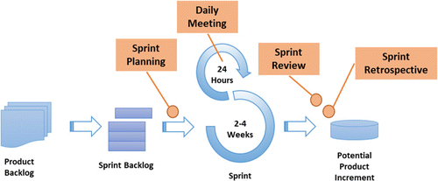
Fig. 1. Scrum Framework by Tavares et al., (2019).
that members of the development team are clear on the work they do (Schwaber & Sutherland, 2020). The items were selected by the researchers according to priority or flow of the development of the system.
Sprint. This typically spans for two to four weeks. During a sprint, the chosen backlog items were worked on into a potentially shippable product increment. Sprints promoted time-boxing, and focus, resulting to outputs that could be evaluated and refined at regular intervals (Schwaber & Sutherland, 2020). In this study, the estimated time of development for every sprint was two (2) weeks. The following were approximate items to be developed (Sprint backlog) for every sprint:
Sprint 1: Offices, Barangays, Services
Sprint 2: Government Executive Orders, Ordinances, and Resolutions, Downloadable Forms, Government Officials, Tourism, Projects
Sprint 3: Features/News
Sprint 4: Forum (Newsfeed, Post, Comments, Notifications, Messages)
Sprint 5: About Page, Home Page, User/Role Permission
Sprint 6: - Log in/Sign Up, Search, FAQ
Daily Scrum. This refers to a short meeting that occurred daily to track progress. The researchers monitored progress toward the sprint goals and made adjustments to the Sprint Backlog whenever necessary. The Daily Scrum meetings also served as a venue for communication and coordination among team members, which were essential in project management (Schwaber & Sutherland, 2020). The researchers showed documentation through pictures in their conducted Daily Scrum.
Sprint Review and Sprint Retrospective. By the end of every sprint, the researchers conducted both a Sprint Review and a Sprint Retrospective. The Sprint Review was where the demonstration of the completed work was conducted while the Retrospective allowed the researchers to check on the processes, identify challenges, and proposed improvements for the next cycles. Documentation was shown by the researchers through pictures and output of the review and retrospective.
For the technical requirements, the researchers used the PERN stack which consisted of PostgreSQL, Express, React JS and Node JS. PostgreSQL was the relational database management system, Express was the backend web framework, Node JS was the runtime environment and React JS was the frontend library. The developers also employed the PERN stack, Jason Web Tokens (JWT) for session management, and tailwind CSS for extra framework in the styling and designing of web solution proposed.
As for the evaluation of the completed software product, the researchers used the 26-item Website Evaluation Questionnaire (WEQ) (see appendix D). WEQ assesses the web quality of government websites along eight (8) different dimensions; ease of use, hyperlink usage, structure, relevance, comprehensibility, completeness, layout, and search option (Abdillah, Riski, & Asfari, 2025). It used five-point Likert scale, starting from 1 (strongly disagree) to 5 (strongly agree). The WEQ was administered to one official from each of the following offices in the municipality: Office of the Mayor, Office of the Vice Mayor & Sangguniang Bayan, Office of the Municipal Budget Officer, Office of the Municipal Accountant, Office of the Municipal Treasurer, Office of the Municipal Civil Registrar, Office of the Municipal Assessor, Office of the Municipal Engineer, Office of the Municipal Agriculturist, Office of the Municipal Health Officer, Office of the Municipal Planning and Development Officer (MPDO), Office of the Municipal Social Welfare and Development Officer (MSWDO), Office of the Local Disaster Risk Reduction and Management Officer (MDRRMO), Office of the Mayor – Human Resource Management Office (HRMO), Office of the Mayor – Business Permits and Licensing Office (BPLO), Office of the Mayor – General Services Office (GSO), and Office of the Mayor – Municipal Tourism, Culture and the Arts Office (MTCAO), as well as one representative from each of the stakeholder groups composing of local government officials and personnel, residents and constituents, business proprietors, tourists and visitors, community-based organizations, educational institutions, health and social welfare agencies, agricultural and fisheries sectors, partner government organizations, partner non-government organizations, totaling to twenty-seven (27). The study used a stratified random (representative) sampling method to make sure that all stakeholder groups were represented. From each group, one representative was chosen randomly to avoid bias in the selection. This method was used because the population is made up of different types of stakeholders who may have different opinions and experiences. By selecting randomly within each group, the study ensured fairness, accuracy, and diversity in the collected data. Using the data gathered, the researchers were able to evaluate the proposed website.
To ensure precision and relevance in the content after it had been deployed, each LGU office was assigned an administrator. This assigned administrator facilitated, updated, checked, and assisted in the maintenance of all information relating to their office.

Data Gathered
The researchers gathered information on the current state of service delivery of the different LGUs services. This included the limitations, the difficulties and problems that was raised in the delivery of services. The preferred features and functionalities of the proposed website were also gathered from the possible users from the municipality through an interview (see appendix C). This included but was not limited to online delivery of government services, downloadable forms, announcements and promotion of local attractions. These user requirements guided the design and development of the proposed web-based system.
During the process of the development, user feedback was gathered for every output of each sprint until the development was completed.
Likewise, the quality of the proposed web-based system was assessed by the use of the Website Evaluation Questionnaire (WEQ) from Abdillah et al. (2025) (see appendix D).

Data Analysis
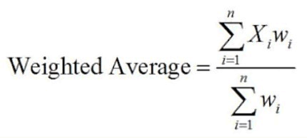
The gathered user requirements were carefully analyzed to be able to arrive at a good design. While, to assess the created web-based system, the Website Evaluation Questionnaire (WEQ) was utilized. The WEQ item consists of 26 questions covering the dimensions: components ease of use, hyperlinks, structure, relevance, comprehension, completeness, layout, and search option. The respondents’ rating was calculated by adding up the responses from the Likert scale divided by the number of respondents. The weighted average formula is presented below:
where:
W = the weight for each data point
X = the value of each data point
Below presents the average score and the corresponding verbal interpretation and description of results. This data analysis was patterned in the study of Abdillah, Riski, & Asfari (2025).
Scale | Average Score Range | Verbal Interpretation | Description
1 | 1.00 – 1.79 | Very Low | Website quality is perceived as very poor; users strongly disagree with positive statements.
2 | 1.80 – 2.59 | Low | Website quality is weak; users generally dissatisfied.
3 | 2.60 – 3.39 | Moderate | Website quality is average; neutral to slightly positive evaluation; room for improvement.
4 | 3.40 – 4.19 | High | Website quality is good; users agree with positive evaluation.
5 | 4.20 – 5.00 | Very High | Website quality is excellent; users strongly agree with positive evaluation.

Responses with a score ranging from 2.60 to 5.00 indicated varying levels of agreement with respect to website quality. Specifically, scores between 4.20 and 5.00 (Strongly Agree) indicated that the system is excellent. Scores between 3.40 and 4.19 (Agree) suggested that the website quality is good, while scores between 2.60 and 3.39 (Neutral) indicated that the system’s website quality is on the average. Conversely, responses falling below 2.60, specifically in the range of 1.80 to 2.59 (Disagree), indicated that users find the system weak and users are generally dissatisfied. Scores between 1.00 and 1.79 (Strongly Disagree) reflected very poor-quality signifying user dissatisfaction.

Ethical Consideration
This study followed strict ethical guidelines, ensuring respect for the rights, privacy, and welfare of all participants and institutions. Permission was obtained from the LGU of Caba, La Union before data collection, and informed consent was secured from respondents with assurance of confidentiality and academic use only. Transparency in data gathering, analysis, and reporting was maintained, and intellectual property rights respected.
Moreover, the study made sure that it complied with academic ethical standards, ensuring that the results promoted efficiency, accountability, and sustainable digital development beneficial to the LGU and its constituents.

LITERATURE CITED
Abdillah, R., Riski, R., Asfari, U. (2025). Indonesian Political Party Website Portal Evaluation Rank Based on Manual and Automated Usability Score. Sistemasi: Jurnal Sistem Informasi 14 (1), 54-65. https://sistemasi.ftik.unisi.ac.id/index.php/stmsi/article/view/4441
Albano, H. (2024). Empowering Local Government Units with open-source tools: Building a dynamic web-based information system. Isabela State University Linker: Journal of Engineering, Computing and Technology, 1(1), https://www.isujournals.ph/index.php/ject/article/view/19/12
Asadon, M., Brucal, A., Claveria, P., Lacson, J., Malang, B., & Malang, J. (2024). Enhancing public service delivery and citizen participation: The synergistic effects of e-governance and social media. International Journal of Multidisciplinary: Applied Business and Education Research, 5(11), 4740–4758. https://doi.org/10.11594/ijmaber.05.11.35
Awasthi, M., Tewari, N., Narayanasamy, V., & Gomathi, R. (2025). Human–computer interaction design principles for enhancing user experience in mobile applications. ITM Web of Conferences, 76, 05003. https://doi.org/10.1051/itmconf/20257605003
Buntaine, M. T., Hunnicutt, P., & Komakech, P. (2021). The challenges of using citizen reporting to improve public services: A field experiment on solid waste services in Uganda. Journal of Public Administration Research and Theory, 31(1), 108–127. https://doi.org/10.1093/jopart/muaa014
BusinessWorld. (2024). Addressing gaps in PHL’s digital connectivity. BusinessWorld Online. https://www.bworldonline.com/special-features/2024/04/29/591238/addressing-gaps-in-phls-digital-connectivity/
Debbarma, A. & Sharma, C. (2023). Digital Transformation in Local Governance: Opportunities, Challenges and Strategies. International Journal of Social Science Educational Economics Agriculture Research and Technology, 3(1), 152–156. https://doi.org/10.54443/ijset.v3i1.304
De Castro, C. & De Castro, E. (2022). E-Government initiatives of local governments in the Philippines. Journal of Community Development Research (Humanities and Social Sciences), 15(3), 55–70. https://doi.nrct.go.th/admin/doc/doc_624530.pdf
Department of Budget and Management. (2023, September 20). Gov’t seeks P38.75B for digitalization efforts in 2024. Philippine News Agency. https://www.pna.gov.ph/articles/1210206
Eom, S. J., & Lee, J. (2022). Digital government transformation in turbulent times: Responses, challenges, and future direction. Government Information Quarterly, 39(2), 101690. https://doi.org/10.1016/j.giq.2022.101690
Howe, S. (2025). Social media statistics in the Philippines [Updated 2025]. https://www.meltwater.com/en/blog/social-media-statistics-philippines
Invest La Union. (n.d.). Caba [Municipality profile]. Retrieved on October 2, 2025 from https://invest.launion.gov.ph/cost-of-doing-business/caba/
Ishak, M. A., Khalid, N. A., Jenal, K. R., Rashid, M. R. A., & Yahaya, M. (2024). Analyzing countries that have made significant progress in bridging the digital divide through e-government programs: Lesson learned from Estonia, Rwanda, South Korea, Singapore, Taiwan and United States. Journal of Media and Information Warfare, 17(2), 143–163. https://jmiw.uitm.edu.my/images/Journal/Vol17No2/11ANALYZING.pdf
Khalid, S. & Lavilles, R. (2019). Maturity Assessment of Local E-government Websites in the Philippines. Procedia Computer Science, 161, 99-106. 10.1016/j.procs.2019.11.104.
KPMG Philippines. (2024). Digital transformation for 2025 and beyond. https://kpmg.com/ph/en/home/insights/2024/12/digital-transformation-for-2025-and-beyond.html
Liu, T., Luo, Y. T., Pang, P. C.-I., & Kan, H. Y. (2025). Exploring the impact of information and communication technology on educational administration: A systematic scoping review. Education Sciences, 15(9), 1114. https://doi.org/10.3390/educsci15091114
Nadhira, R., Hamdi, H., Putri, T. S. A. E., & Ervi, T. S. (2024). Enhancing citizen satisfaction and loyalty in e-government: Lessons learned from Jakarta COVID-19 website. Information Services & Use. https://doi.org/10.3233/ISU-240229
Palma, J. P. B., Avila, L. S., Mag-iba, M. A. J., Buman-eg, L. D., Nacpil, E. E. Jr., Dayrit, D. J., & Rodelas, N. C. (2023). e-Governance: A critical review of e-government systems features and frameworks for success. International Journal of Computing Sciences Research, 7, 2004-2017. https://doi.org/10.25147/ijcsr.2017.001.1.138
PhilAtlas. (2025). Caba, La Union Profile. Retrieved September 08, 2025, from https://www.philatlas.com/luzon/r01/la-union/caba.html
Philippine Information Agency. (2024). DICT launches Cybersecurity Awareness Month 2024. https://pia.gov.ph/news/dict-launches-cybersecurity-awareness-month-2024/
Philippine Statistics Authority – Region I. (2024, October 31). Caba, La Union’s population increases at a rate of 1.01 percent (2020 Census of Population and Housing). https://rsso01.psa.gov.ph/statistics/cph/node/1684058036
Provincial Government of La Union (PGLU). (n.d.). Caba, La Union. Retrieved October 2, 2025, from https://launion.gov.ph/city-and-municipalities/caba-la-union/
Provincial Government of La Union (PGLU). (n.d.). Municipality of Caba — Average Annual Income: Php 31,888,118.68. Retrieved October 2, 2025, from https://launion.gov.ph/municipality-of-caba/
Sabatini, N., Janowski, T., Estevez, E., & Cantoni, L. (2017). When digital government matters for tourism: A stakeholder analysis. Information Technology & Tourism, 17(3), 315-333. https://doi.org/10.1007/s40558-017-0087-2
Sahin, S., & Mete, J. (2021). A brief study on descriptive research: Its nature and application in social science. International Journal of Research and Analysis in Humanities, 1(1), 11.
Schwaber, K., & Sutherland, J. (2020). The Scrum guide: The definitive guide to Scrum: The rules of the game (November 2020 ed.) [PDF]. ScrumGuides. https://scrumguides.org/docs/scrumguide/v2020/2020-Scrum-Guide-US.pdf
Sharafuddin, M. A., Madhavan, M., & Wangtueai, S. (2024). Assessing the effectiveness of digital marketing in enhancing tourist experiences and satisfaction: A study of Thailand’s tourism services. Administrative Sciences, 14(11), 273. https://doi.org/10.3390/admsci14110273
Shin, B., Floch, J., Rask, M., & Bæck, H. (2024). A systematic analysis of digital tools for citizen participation. Government Information Quarterly, 41(2). https://doi.org/10.1016/j.giq.2024.104467
Tavares, B. G., da Silva, C. E. S., & de Souza, A. D. (2019). Risk management analysis in Scrum software projects. International Transactions in Operational Research, 26(5), 1884–1905. https://doi.org/10.1111/itor.12401
Thomas J. (2024). Digital Transformation in Public Administration: Embracing the Future. Journal of Research in International Business and Management, 11(1), 002. https://www.interesjournals.org/articles/digital-transformation-in-public-administration-embracing-the-future-104633.html
Torion, P. M., & Bacio, S. P. Jr. (2024). Video lessons for the course Introduction to Computing through online/offline mode (ICOM): Its development and evaluation. International Journal of Information and Education Technology, 14(6), 845–854.
Toro-Maureira, S., Olivares, A., Saez-Vergara, R., Valenzuela, S., Valenzuela, M., & Correa, T. (2025). The Missing Link: Identifying Digital Intermediaries in E-Government (arXiv preprint arXiv:2501.10846). https://doi.org/10.48550/arXiv.2501.10846
Tsamis, G., Evangelos, G., Papakostas, A., Vassiliou, G., Grafanakis, M., Garefalakis, A., ..., & Papadakis, N. (2024). Cost-effective design, content management system implementation and artificial intelligence support of Greek Government AADE, myDATA web service for generic government infrastructure: A complete analysis. Algorithms, 18(6), 339. https://doi.org/10.3390/a18060339
United Nations, Department of Economic and Social Affairs, & Division for Public Institutions and Digital Government. (2022). E-Government Survey 2022. Retrieved from https://digitallibrary.un.org/record/3990059
Wonohardjo, E., Sunaryo, R., & Sudiyono, Y. (2019). A systematic review of SCRUM in software development. International Journal on Informatics Visualization, 3(2), 108. https://www.researchgate.net/publication/373149699_A_Systematic_Review_of_SCRUM_in_Software_Development
World Bank. (2020). Philippines Digital Economy Report 2020: A Better normal under COVID-19: Digitalizing the Philippine economy now (Report No. 34606). https://openknowledge.worldbank.org/entities/publication/1fdc7976-e6bf-555a-a206-57bd0acdf6fc

APPENDICES

APPENDIX A
Letter to the Adviser


APPENDIX B
Letter to the Panel Member
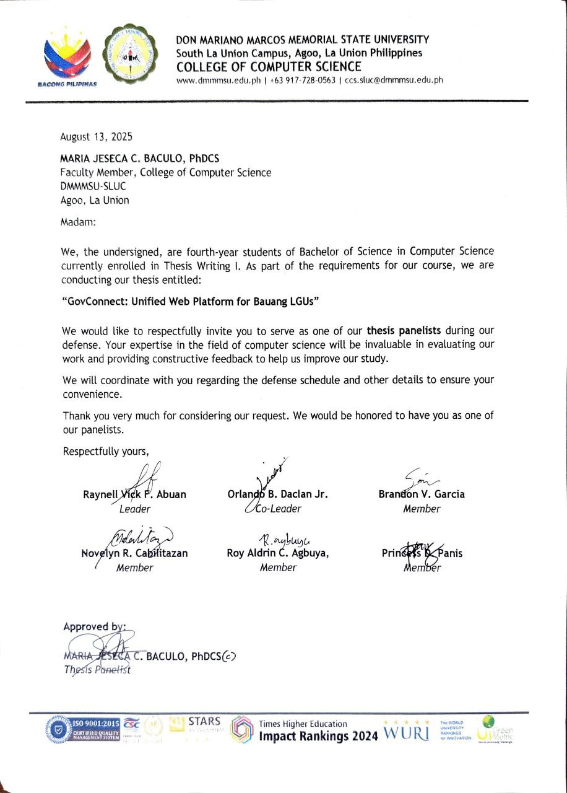

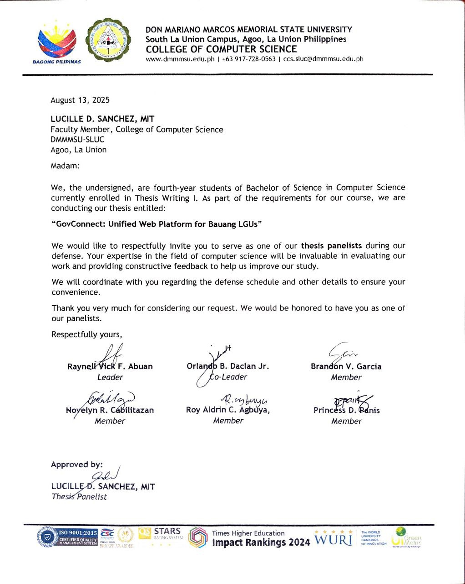

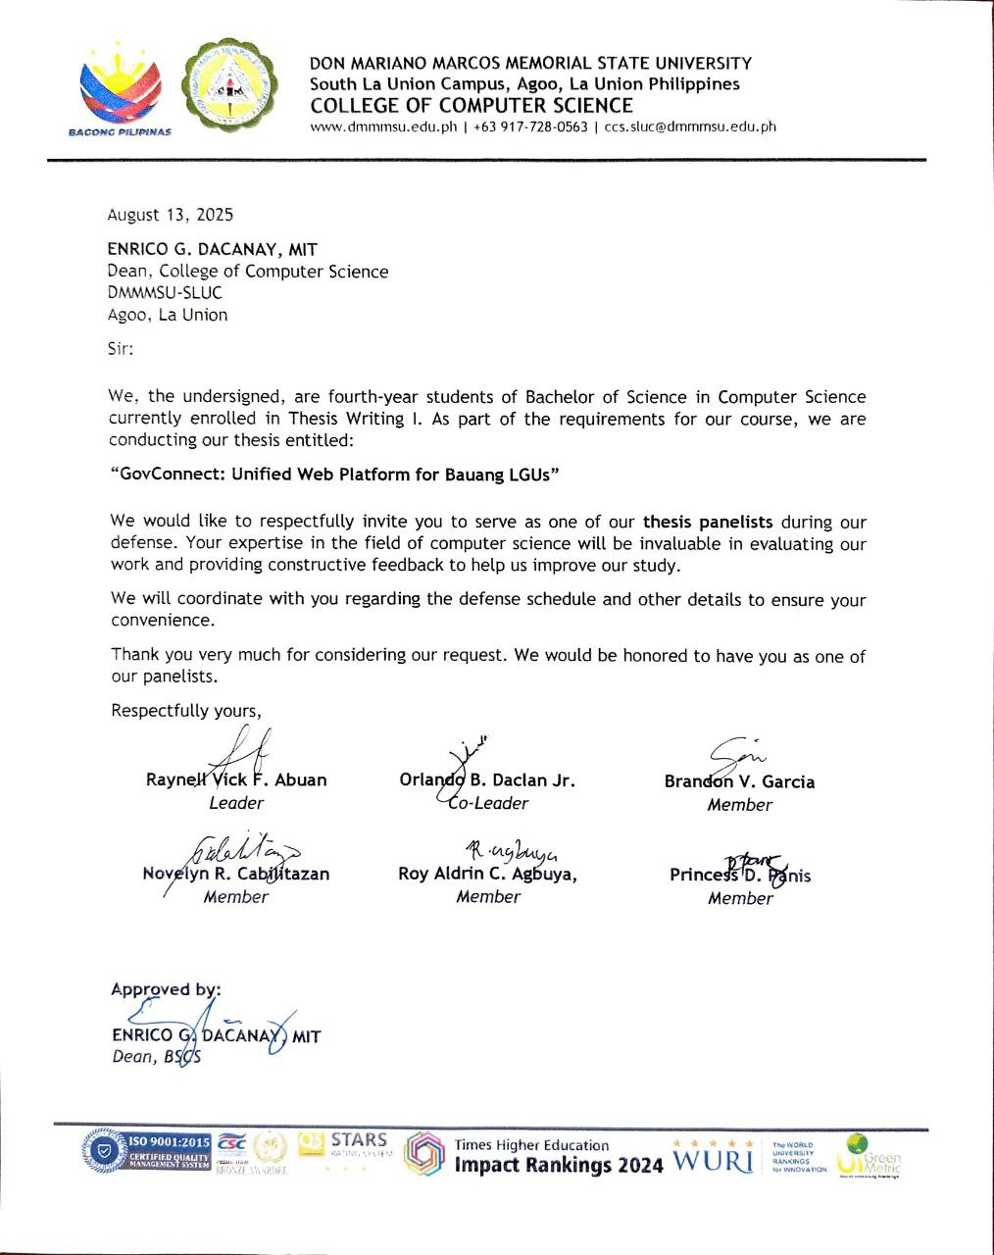

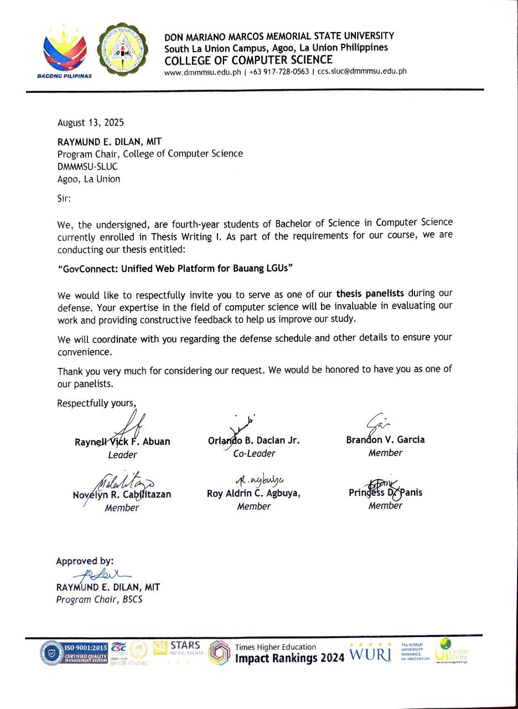

APPENDIX C
Interview Guide Questions
A. General Background
1. Kindly describe the mandate and primary functions of the LGU Caba?
________________________________________________________________________
________________________________________________________________________
________________________________________________________________________
2. What are the current priorities or flagship programs of the municipality?
________________________________________________________________________
________________________________________________________________________
________________________________________________________________________

B. Inventory of LGU Services
3. May we request a list of the offices/departments under LGU Caba and their key functions?
________________________________________________________________________
4. What services do the LGU currently provide to residents? (e.g., civil registry, health services, agriculture, social welfare, business permits, disaster management, etc.)
________________________________________________________________________
________________________________________________________________________
________________________________________________________________________

C. Tourism and Local Assets
6. What are the key tourist attractions, natural landmarks, or cultural sites in Caba?
________________________________________________________________________
________________________________________________________________________
______________________________________________________________________________
7. Does the municipality organize annual festivals, cultural events, or fairs that should be promoted through the website?
________________________________________________________________________
8. What are the local products, delicacies, or crafts that represent Caba’s identity?
________________________________________________________________________
________________________________________________________________________
________________________________________________________________________

D. Projects, Programs, and Activities
9. What are the current or ongoing projects of the LGU (infrastructure, social programs, livelihood assistance, environmental initiatives)?
________________________________________________________________________
________________________________________________________________________
________________________________________________________________________
________________________________________________________________________
________________________________________________________________________
________________________________________________________________________

10. What upcoming projects or long-term development plans should be showcased on the website?
________________________________________________________________________
________________________________________________________________________
________________________________________________________________________
________________________________________________________________________
________________________________________________________________________
________________________________________________________________________
11. Does the LGU have any means to report status of projects and activities to the public?
________________________________________________________________________
________________________________________________________________________
________________________________________________________________________

12. How does the LGU currently report the status of projects and activities to the public?
________________________________________________________________________
________________________________________________________________________
________________________________________________________________________

E. Stakeholders and Beneficiaries
13. Who are the main stakeholders of LGU Caba that the website should serve (residents, senior citizens, farmers, fisherfolk, students, businesses, PWDs, tourists, etc.)?
________________________________________________________________________
________________________________________________________________________
________________________________________________________________________

14. What specific needs or requirements do these groups often bring to the LGU?
________________________________________________________________________
________________________________________________________________________
________________________________________________________________________

15. Which groups do you think face the most difficulty accessing LGU information and services today?
________________________________________________________________________
________________________________________________________________________
________________________________________________________________________

F. Communication and Information Management
16. What communication channels are currently used (bulletin boards, social media, radio, etc.)?
________________________________________________________________________
________________________________________________________________________
________________________________________________________________________

17. Are there existing challenges in keeping the public updated on policies, ordinances, or activities? What are those challenges?
________________________________________________________________________
________________________________________________________________________
________________________________________________________________________

18. How does the LGU currently handle public feedback, complaints, or inquiries?
________________________________________________________________________
________________________________________________________________________
________________________________________________________________________

G. Expectations for the Website

19. What content should be included in the website? (checklist-type: announcements, ordinances, downloadable forms, organizational chart, directory, FAQs, tourism guide, etc.)
________________________________________________________________________
________________________________________________________________________
________________________________________________________________________

20. How do you envision the website improving transparency, participation, and service delivery?
________________________________________________________________________
________________________________________________________________________
________________________________________________________________________

H. Practical Considerations
21. Who in the LGU would likely manage and update the website?
________________________________________________________________________
________________________________________________________________________
________________________________________________________________________
22. What challenges do you foresee in sustaining the website (e.g., budget, manpower, training, internet connectivity)?
________________________________________________________________________
________________________________________________________________________
________________________________________________________________________

I. Closing Insights
23. Why do you think LGU Caba needs an official website at this time?
________________________________________________________________________
________________________________________________________________________
________________________________________________________________________
24. What is your vision for a municipal website that truly reflects Caba’s identity and serves its people?
________________________________________________________________________
________________________________________________________________________
________________________________________________________________________

APPENDIX D

WEBSITE EVALUATION QUESTIONNAIRE (WEQ)
Adopted from Abdillah et al. (2025)
Name: ____________________________ Date: ________________
Position: _________________________
Direction: Please evaluate the website by placing a checkmark (✔) under the option that best reflects your opinion. Use the following 5-point Likert scale
1 – Strongly Disagree
2 – Disagree
3 – Neutral
4 – Agree
5 – Strongly Agree
Usability Dimension | Questions |  | 5 | 4 | 3 | 2 | 1
a. Ease of Use | 1. | I find this website easy to use.
a. Ease of Use | 2. | I had not difficulty using this website.
a. Ease of Use | 3. | I consider this website user friendly.
b. Hyperlinks | 4. | The homepage clearly directs me towards the information I need.
b. Hyperlinks | 5. | The homepage immediately points me to the information I need.
b. Hyperlinks | 6. | It is clear which hyperlink will lead to the information I am looking for.
b. Hyperlinks | 7. | Under the hyperlinks, I found the information I expected to find there.
c. Structure | 8. | I know where to find the information I need on this website.
c. Structure | 9. | I was not constantly being redirected on this website while I was looking for information.
c. Structure | 10. | I find the structure of this website clear.
c. Structure | 11. | The convenient set-up of the website helps me find the information I am looking for.
d. Relevance | 12. | I find the information in this website helpful.
d. Relevance | 13. | The information in this website is of little use to me.
d. Relevance | 14. | This website offers information that I find useful.
e. Comprehension | 15. | The language used in this website is clear to me.
e. Comprehension | 16. | I find the information in this website easy to understand.
e. Comprehension | 17. | I do not find many words in this website difficult to understand.
f. Completeness | 18. | This website provides me with sufficient information.
f. Completeness | 19. | I find the information in this website incomplete.
f. Completeness | 20. | I find the information in this website precise.
g. Layout | 21. | I think this website looks unattractive.
g. Layout | 22. | I like the way this website looks.
g. Layout | 23. | I find the design of this website appealing.
h. Search Option (Optional) | 24. | The search option on this website helps me to find the right information quickly.
h. Search Option (Optional) | 25. | The search option on this website gives me useful results.
h. Search Option (Optional) | 26. | The search option on this website gives me too many irrelevant results.
Comments and Suggestions:
________________________________________________________________________
________________________________________________________________________
________________________________________________________________________
Thank you!
___________________________
Respondent’s Signature
APPENDIX E
Compliance Matrix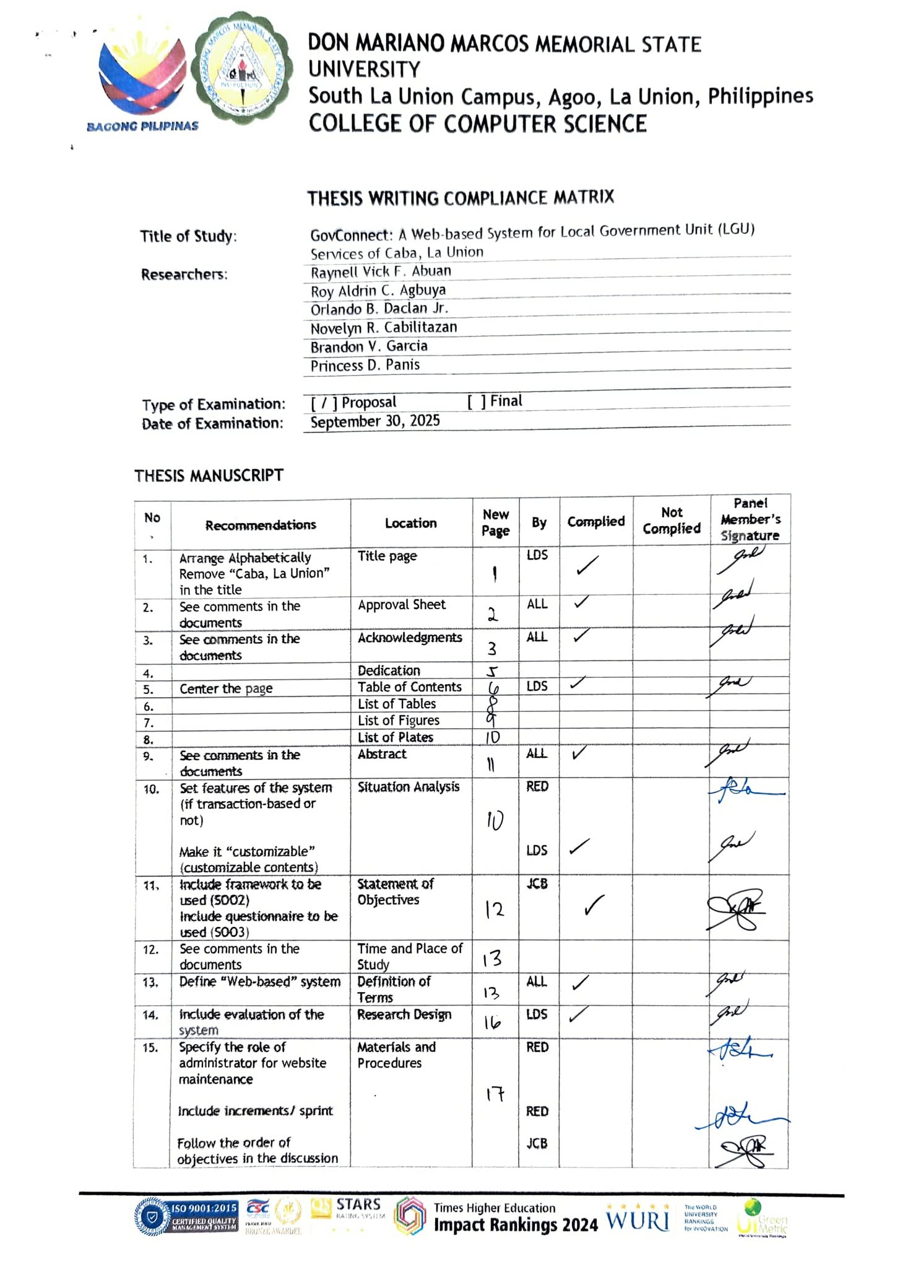
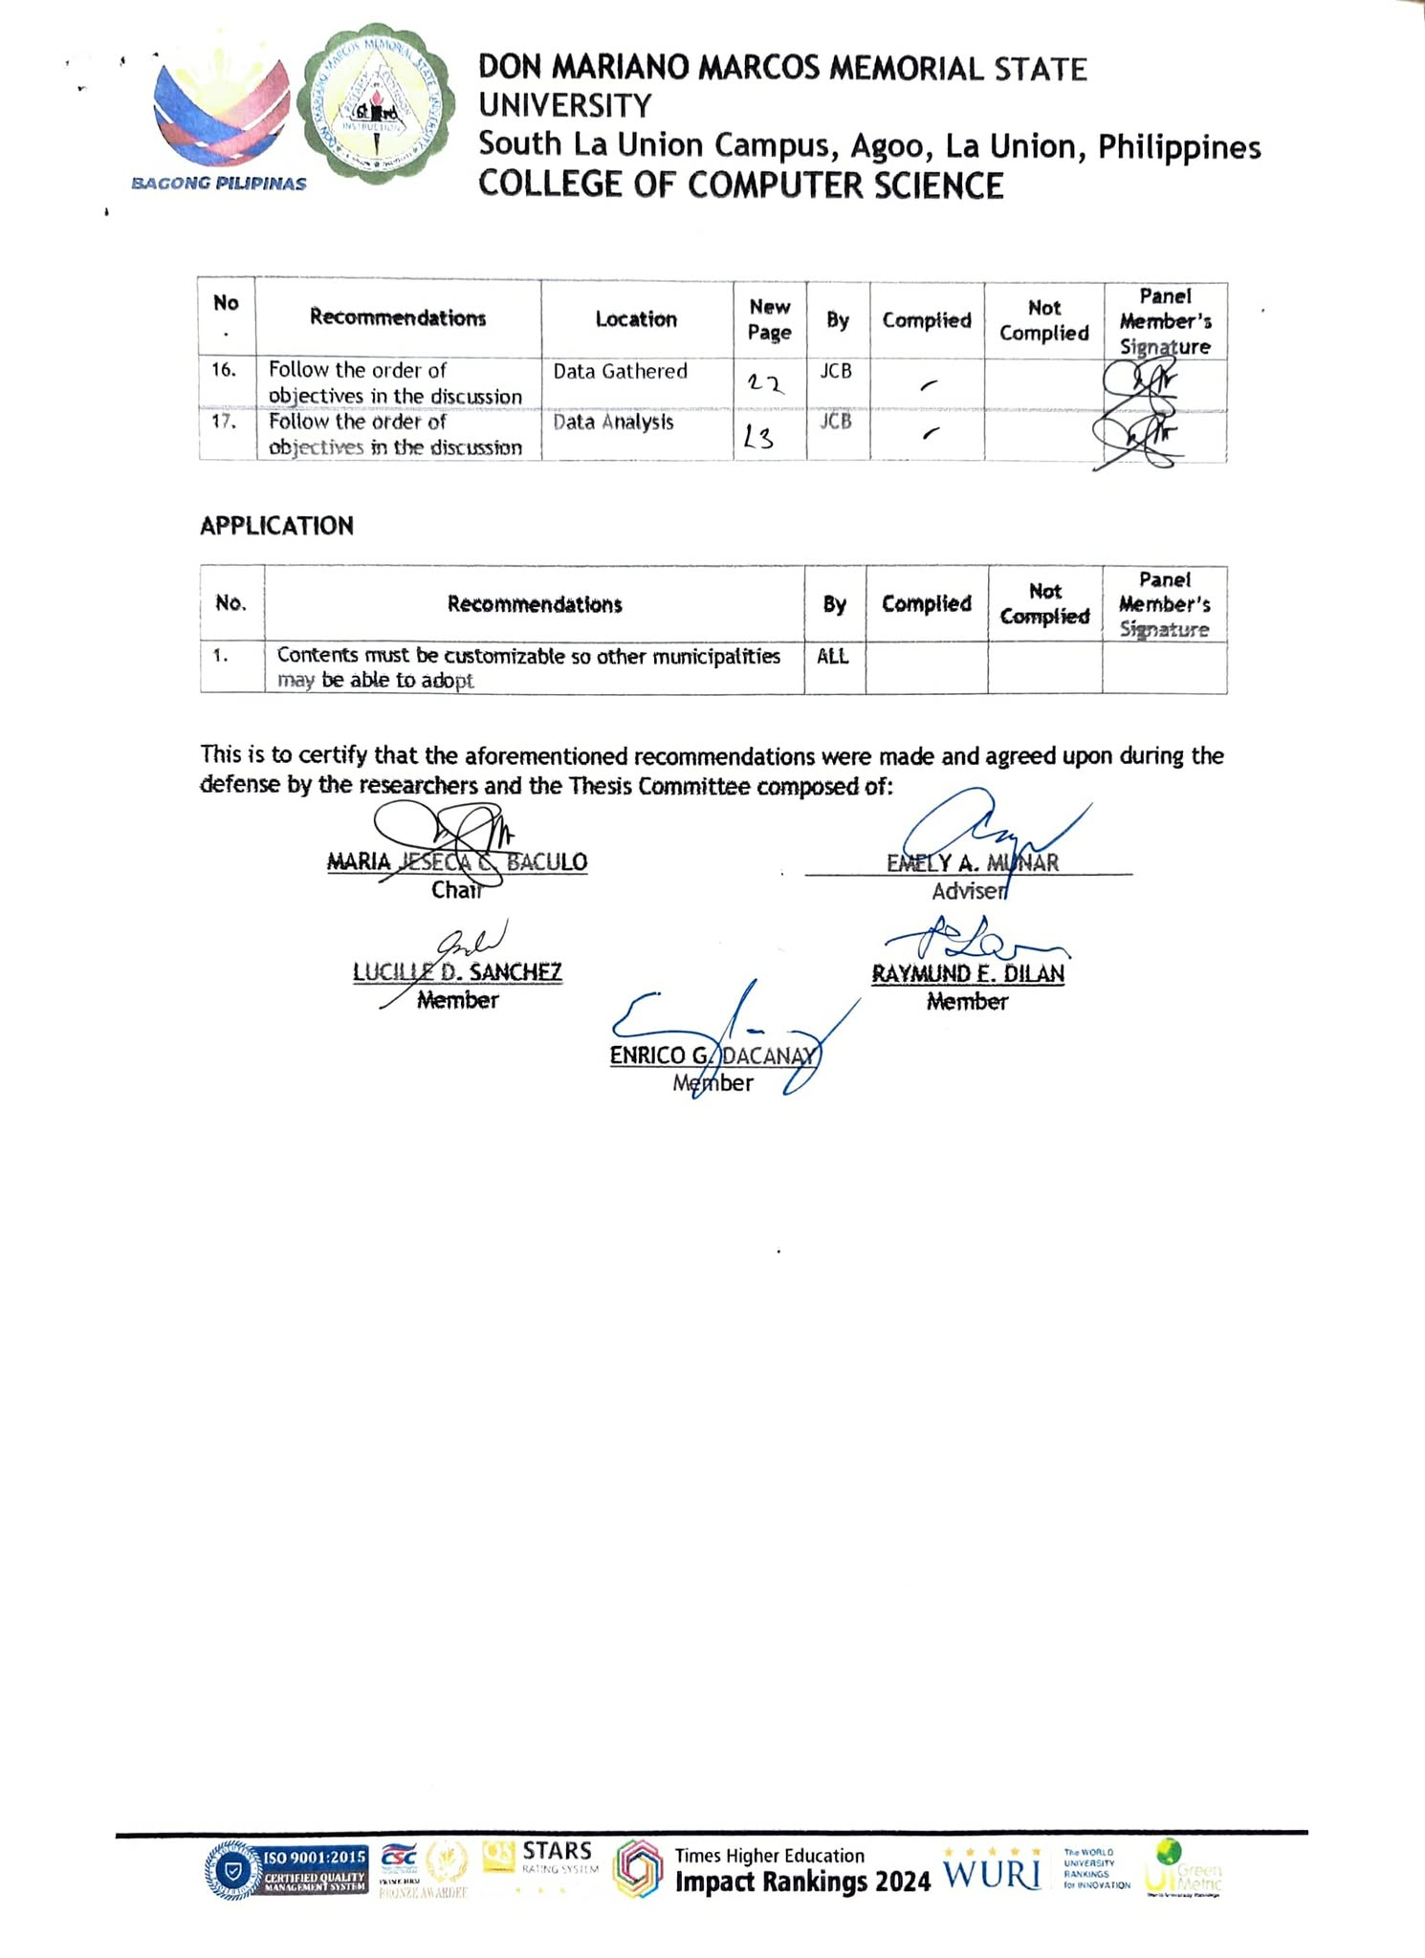

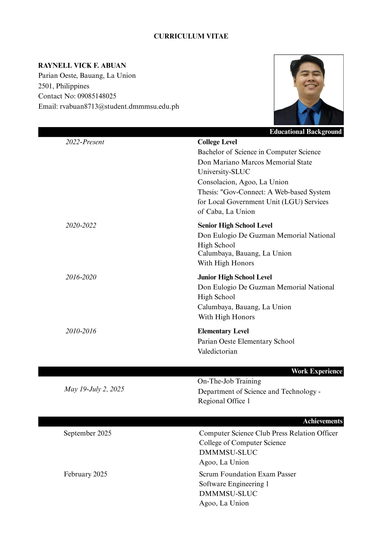
CURRICULUM VITAE

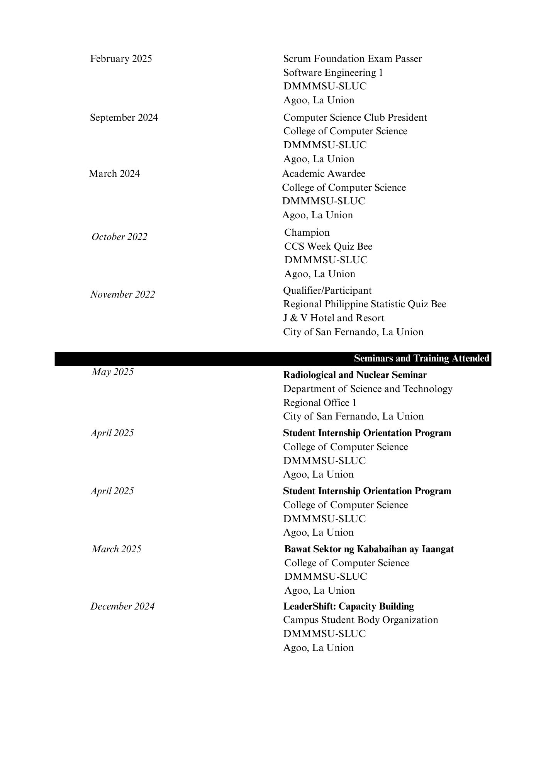

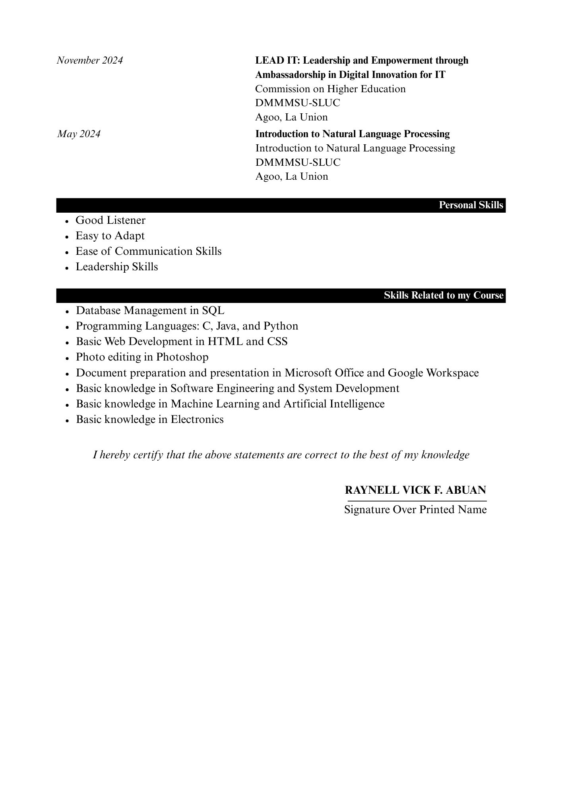

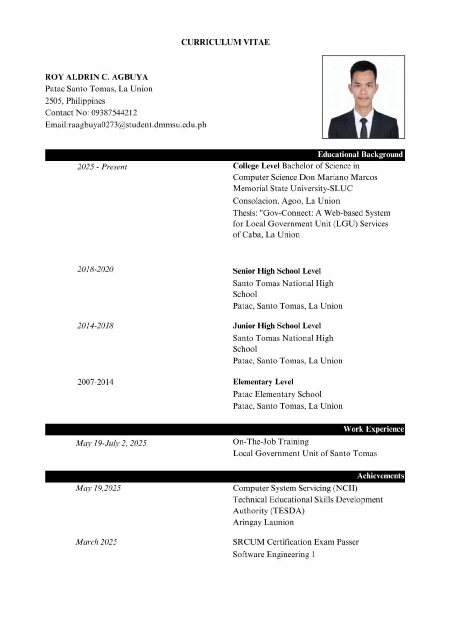
CURRICULUM VITAE

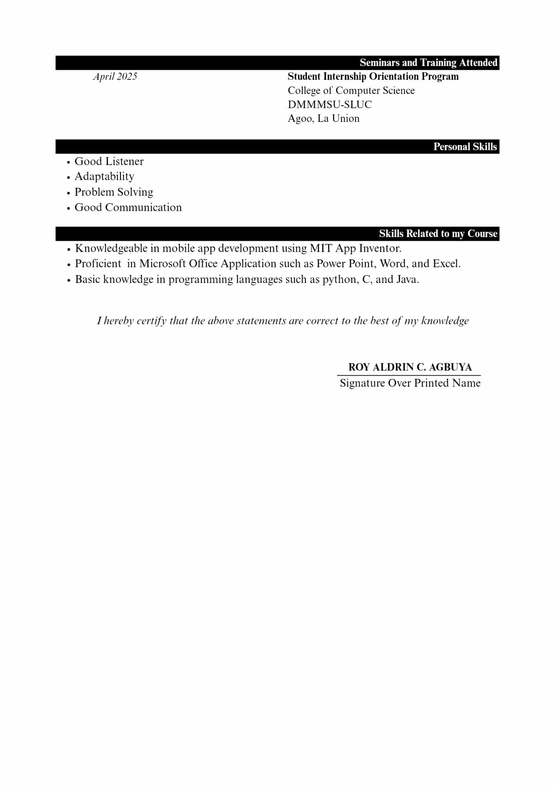

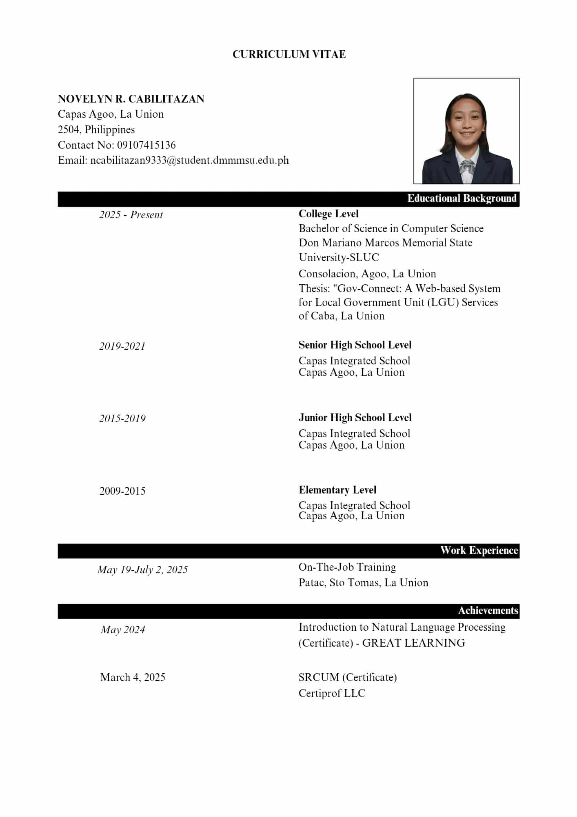
CURRICULUM VITAE

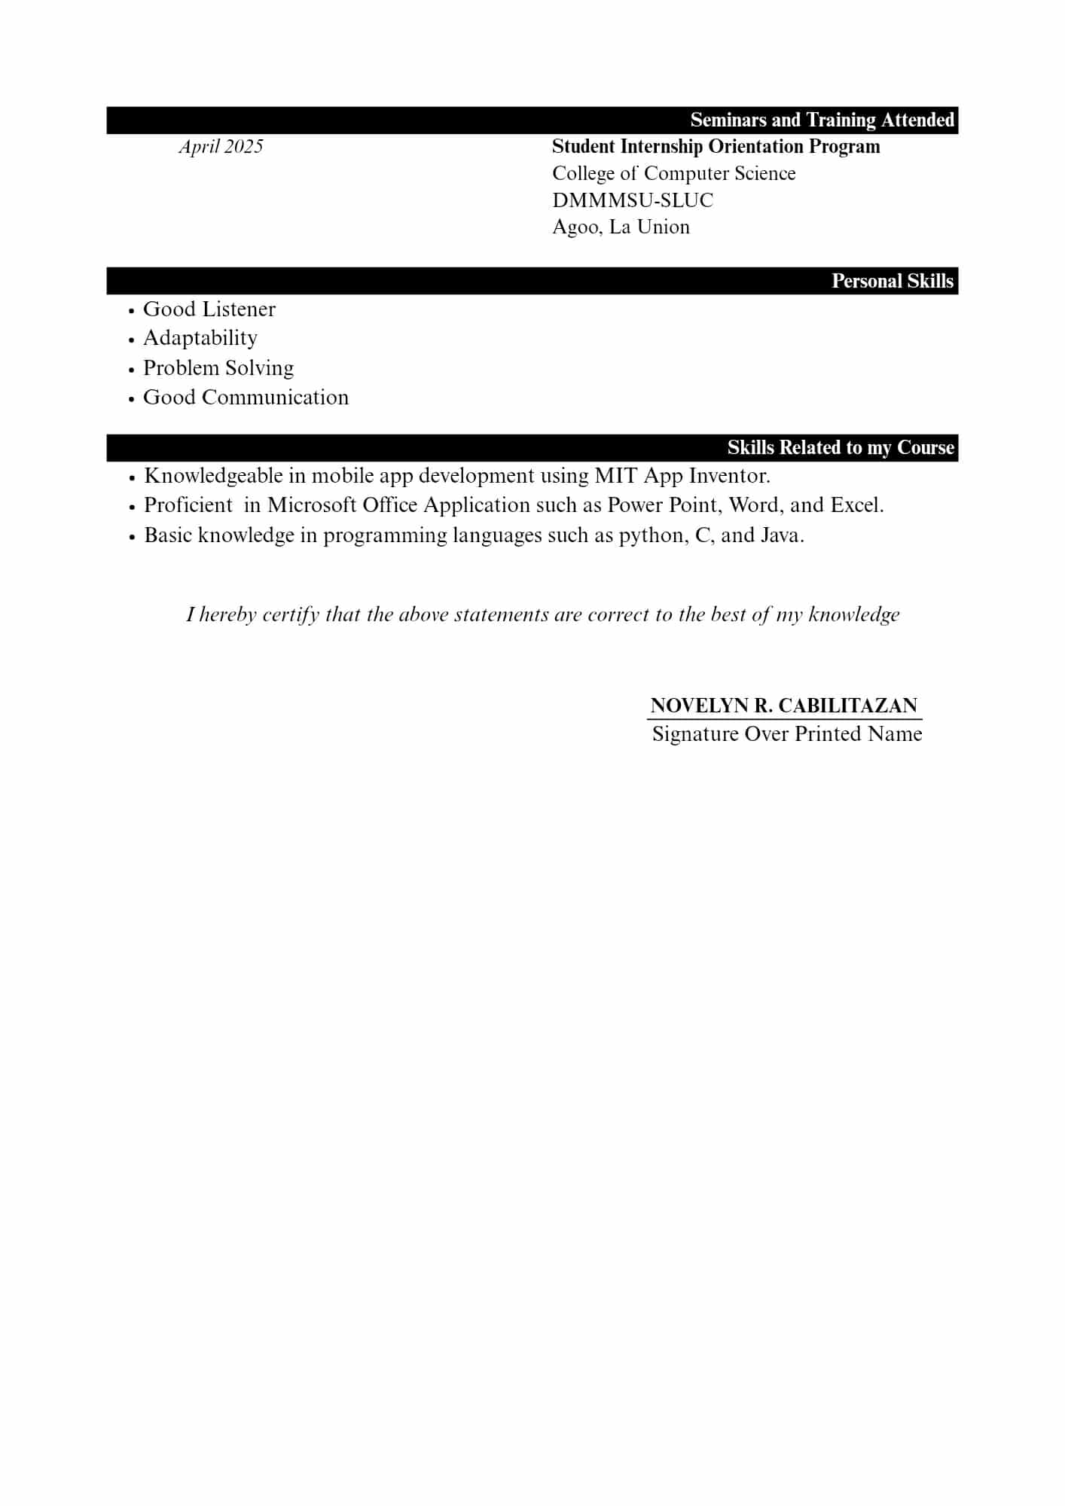

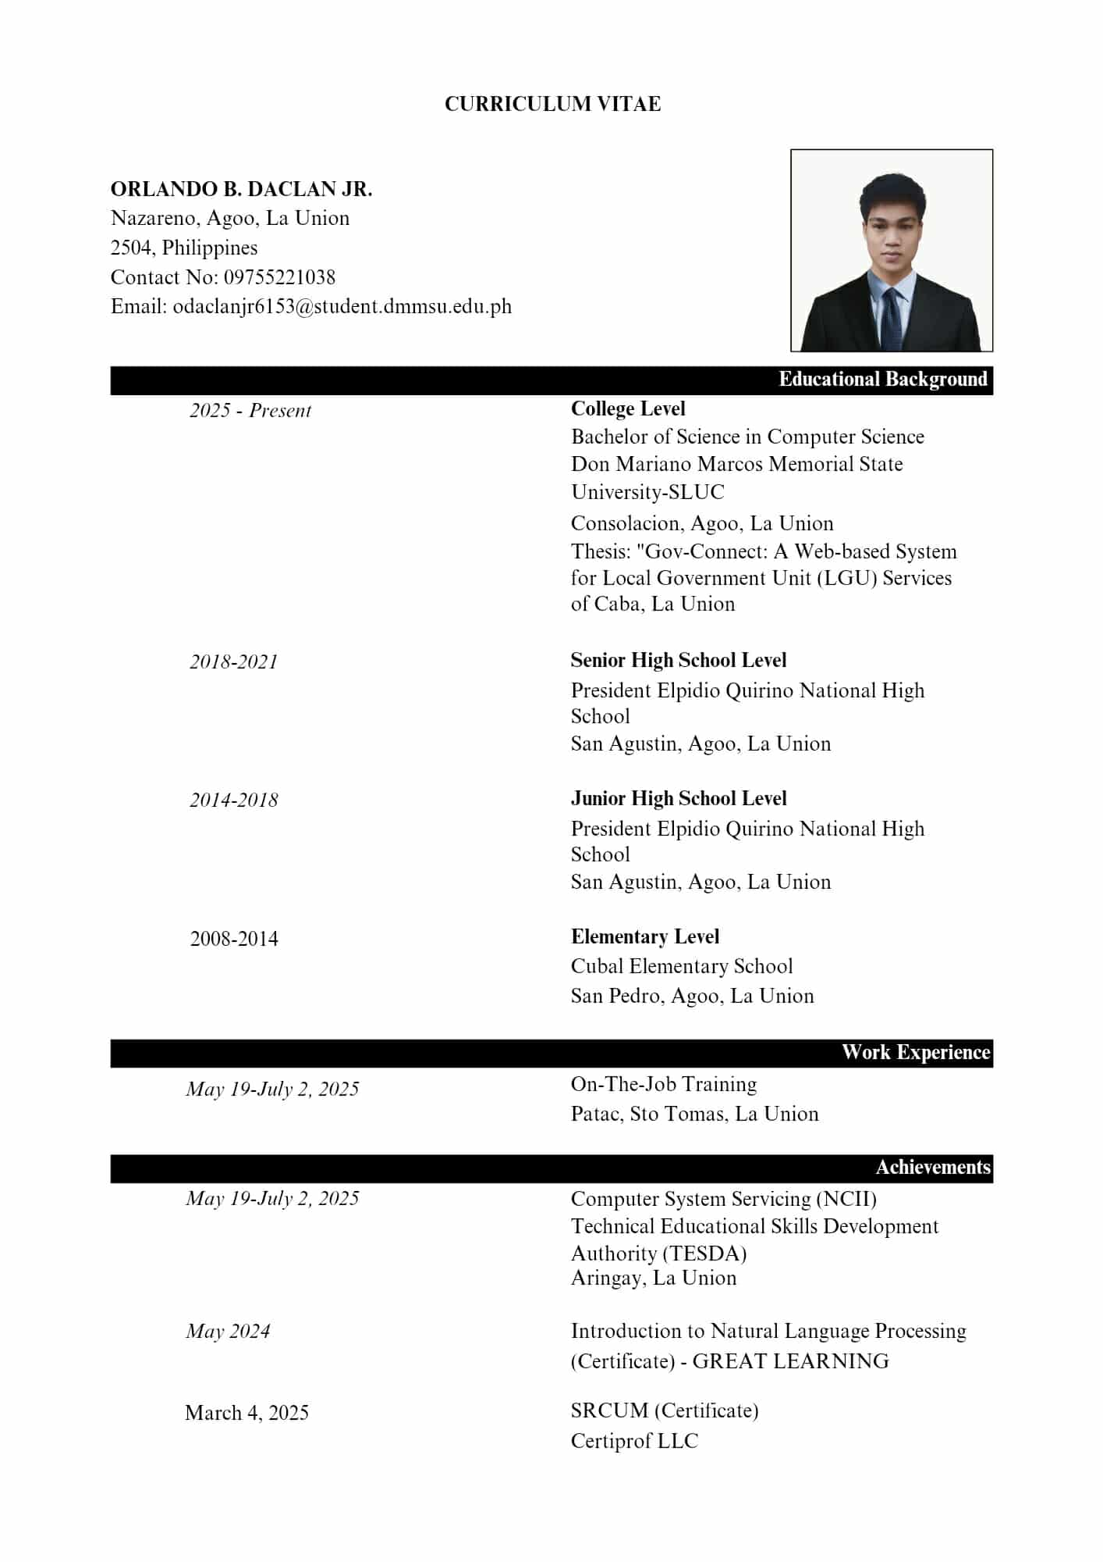
CURRICULUM VITAE

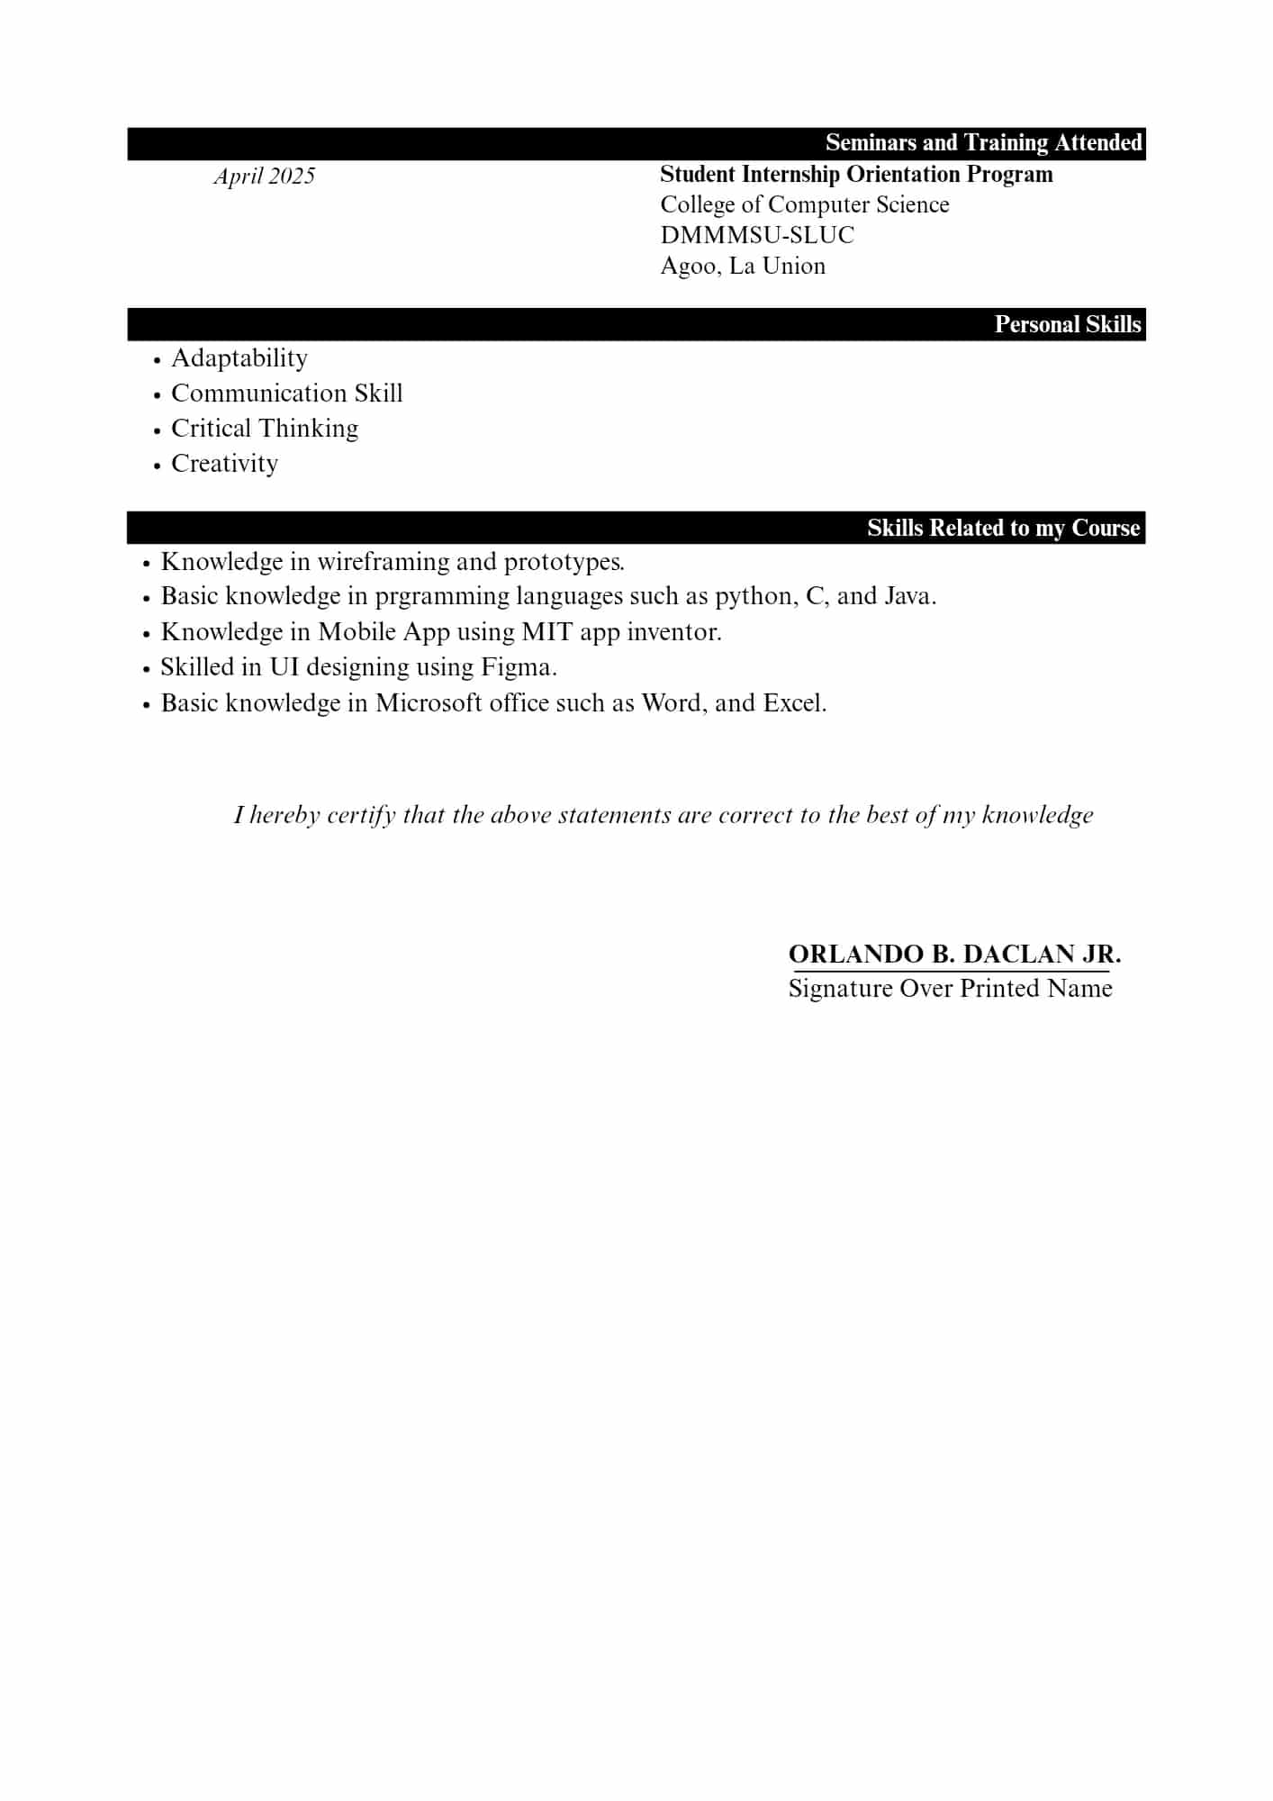

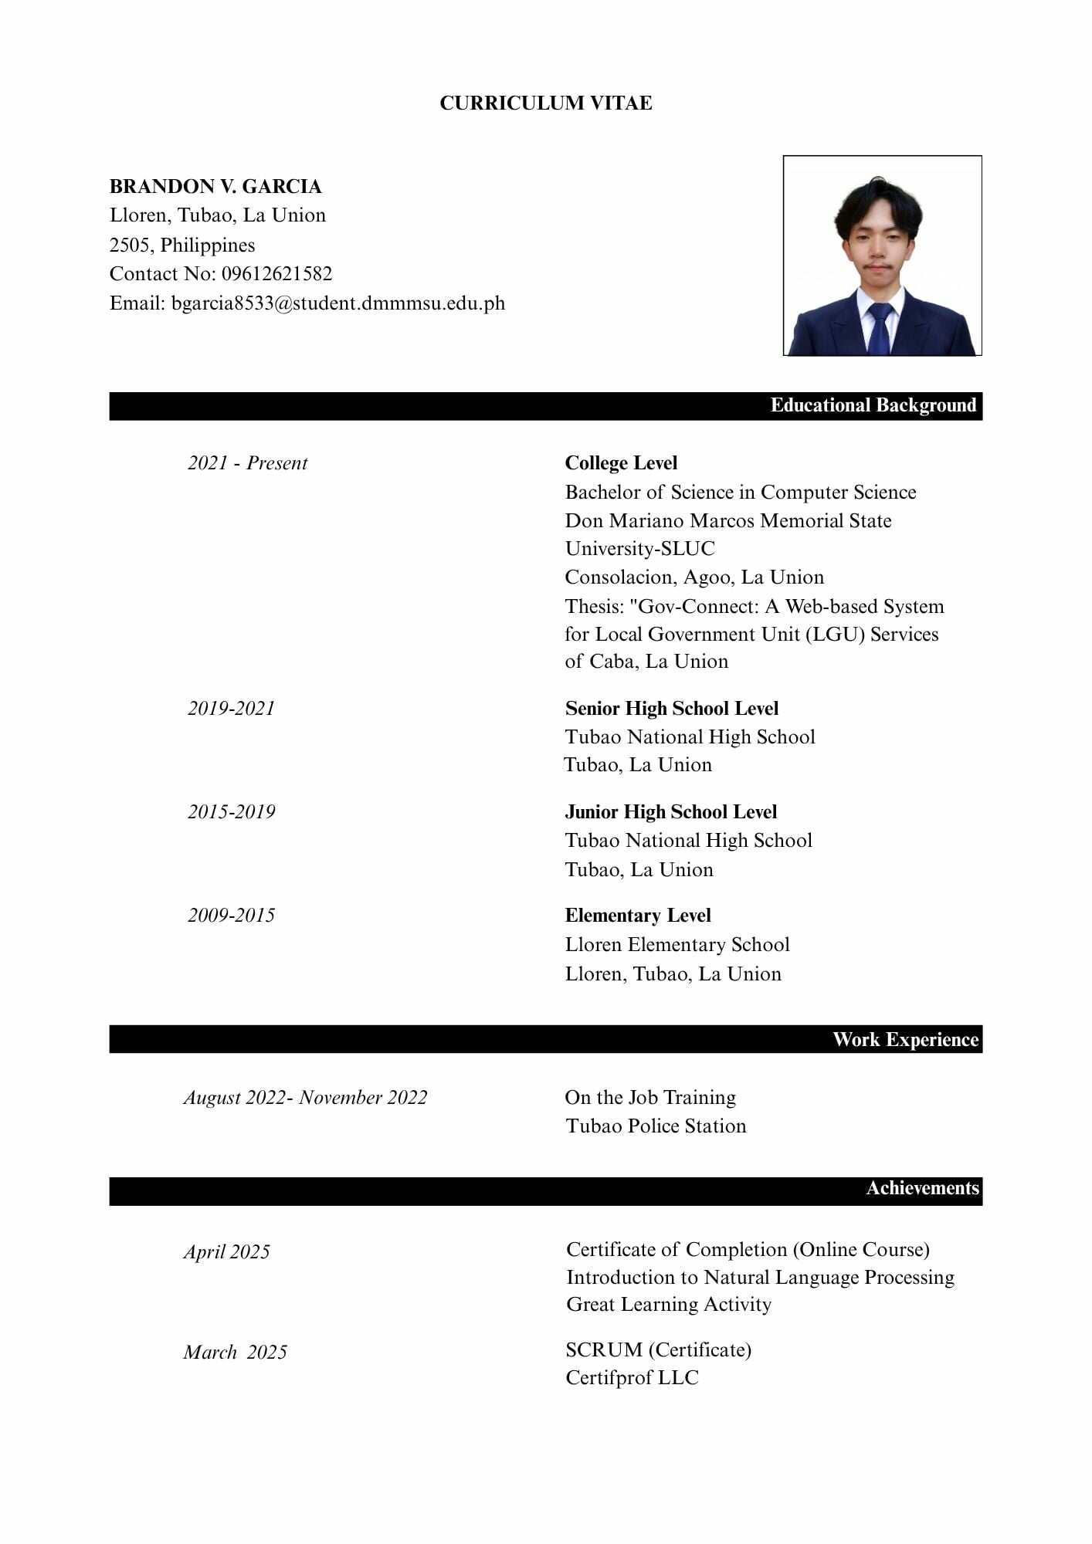
CURRICULUM VITAE

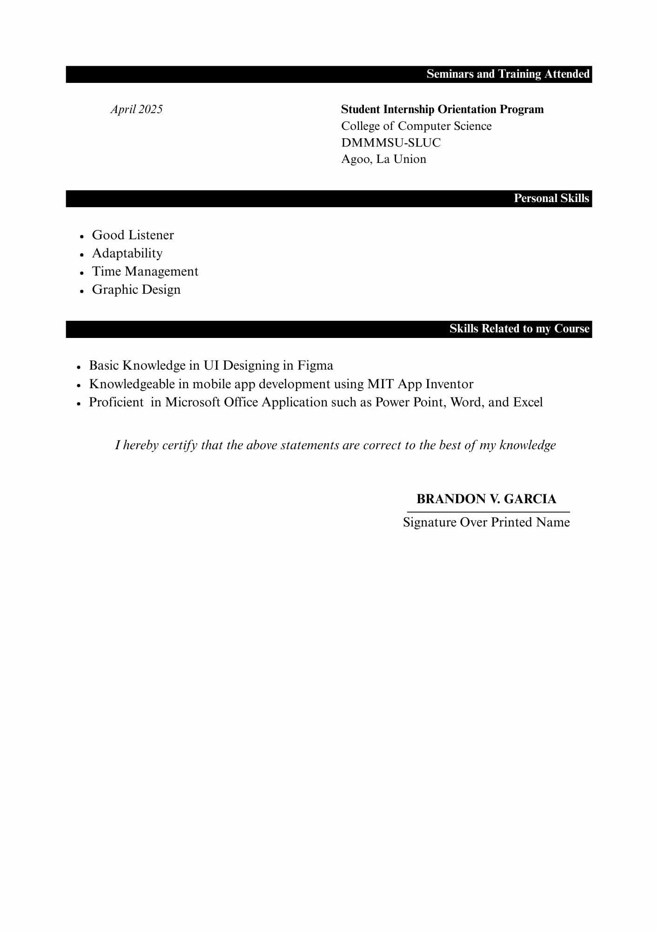
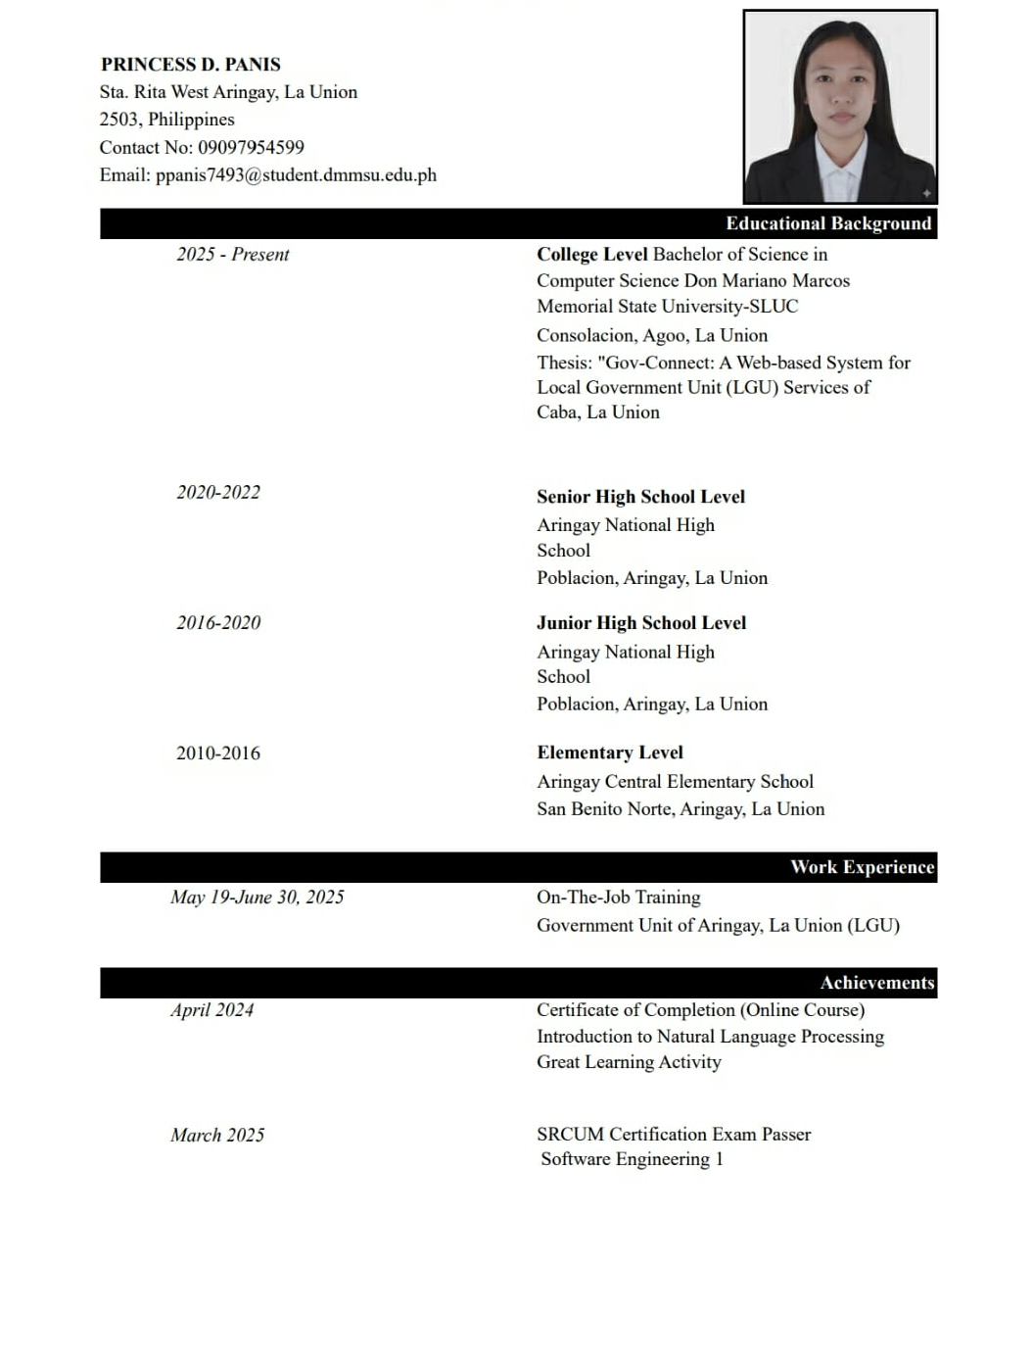
CURRICULUM VITAE

