Final Data Project

GRAD-E1244: Data Management (with R)

Ryo Haruta

161689

Table of Contents

1. Introduction 2

2. Data Preparation 2

3. Descriptive Statistics of Dataset and Hypotheses 3

4. Logit Model Analysis 5

5. Conclusion and Discussion 8

6. References 10

7. Appendix Figures & Tables 11

Appendix 1: Datasets and variables used in the study 12

Appendix 2: Guilty rates across names 18

Appendix 3: Logit models to examine quadratic function of number of confession 19

Appendix 4: Logit models to examine the mechanism regarding confession 19

Appendix 5: Logit model to examine the relationship between guilty propensity and names using initials of first names 20

Appendix 6: Logit model to examine the relationship between guilty propensity and names using initials of last names 21

Appendix 7: Logit model to examine the relationship between guilty propensity and names using ends of first names 22

Appendix 8: Logit model to examine the relationship between guilty propensity and names using ends of last names 23

Appendix 9: Logit model to examine the relationship between guilty propensity and other variables 24

# 1. Introduction

A witch-hunt prevailed in Europe from 15th century to 18th century. According to the previous studies, it is said that as many as 40,000 people was executed at most in Europe due to witch trials (*Briggs, 1996*; *Hutton, 2002*; *Behringe, 2004*). Although quite a few scholars have investigated the phenomenon of the witch-hunt, many things still remain a mystery. Especially, a lot of arguments exist regarding its cause and who was more likely to be judged as a witch. Michelet (1939) states that people identified or suspected as witches were peasants who believed in an ancient religion. Meanwhile, other scholars argue that those people were female healers and witches meetings were ones to exchange medical information among such women (*Ehrenreich and English, 2010*). Even though there are many studies, why the witch-hunt occurred and its purpose have not completely been revealed yet. This essay, therefore, tries to find a clue about what drove people to conduct the witch-hunt by means of identifying factors which made accused people being judged as witches.

This paper is organized as follows: section 2 briefly explains how data used in this study was complied. In section 3, the descriptive statistics of the data and hypotheses induced by the statistics are presented. Section 4 indicates the methods and results of logit model analysis. Discussing these results, the conclusions are offered in section 5.

# 2. Data Preparation

In this study, the database of “The Survey of Scottish Witchcraft” (Goodare, 2003) is used. It contains data about witchcraft accusation and trial processes conducted from 1563 to 1736 regarding roughly 4,000 people. The database is network one and consists of three levels: Accused, Case and Trial. Accused level contains biographical information about people accused as witches. Case one does the information about series of events and specific accusations. The last one records data about trials as to each case. The database has 38 datasets, but only 6 datasets of them are used in the study to focus on critical factors which contributed for people to being judged as guilty, and they are combined into one dataset to be analyzed. Furthermore, this study uses only data about 375 people whose information about judgements or sentences is recorded in the database for the same reason. Also, when there are more than one trial concerning one accused person, the latest one is used to prevent data from being intermingled. For more detail information about the dataset in this study, see Appendix 1.

# 3. Descriptive Statistics of Dataset and Hypotheses

The witch-hunt tends to be seen as one that is related to only female people, but in fact, many men were executed as results of witch trials. Accordingly, the dataset also contains 53 male people out of 375 people (Table 1). It is examined, therefore, if there seems to be any gender difference regarding being judged as guilty. As Fig. 1 implicates, there seems to be no difference as to gender. So, it induces the following first hypothesis.

*Hypothesis 1: no gender difference about being judged as guilty*

On the other hand, there seems to be difference depending on regions (Fig. 2). From this implication, the second hypothesis is obtained as below.

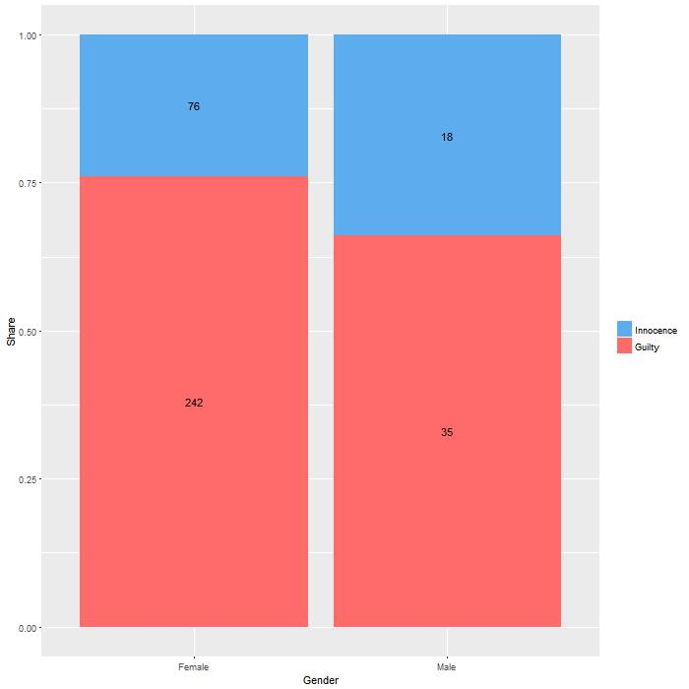

Table 1: Number of observations in each sex and region

Fig. 1: Gender difference in guilty rates

Fig. 2: Regional difference in guilty rates

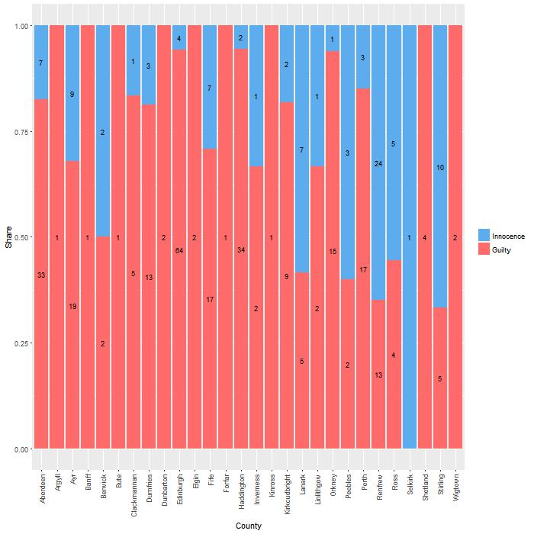

*Hypothesis 2: guilty rates vary depending on regions*

Also, it is well-known that until the modern era, confessed suspects are more likely to be judged as guilty even if no sufficient evidence exists. Taking into account this point, the following third hypothesis would be conceivable.

Table 1: Values regarding gender and regions

*Hypothesis 3: confessed people are more likely to be judged as guilty*

Moreover, analyzing difference in guilty rates depending on accused people’s names, the rates seems to vary depending on them (see Appendix 2).

From this perspective, the last hypothesis is constructed as below.

*Hypothesis 4: Guilty rates vary depending on names*

In the following section, the dataset is analyzed using logit model to examine these hypotheses.

# 4. Logit Model Analysis

At first, simple logit models are constructed to examine hypothesis 1, 2 and 3. Table 2 shows their results, and it could be said that all these hypothesis are correct since the coefficients of existence or number of confessions and those of some regions are statistically significant while those of gender is not. For further examination, quadratic model regarding the confession variable are implemented, but the coefficient of the quadratic confession variable is not significant (see Appendix 3). Also, to clarify the mechanism regarding what drove people to confess or the effect of confession on being judged as guilty, other models are implemented, but they doesn’t give any clue (see Appendix 4).

As next, the relationship between names and being judged as witches is examined using other logit models. Yet, any statistically significant results aren’t obtained (Table 3 and data not shown in the paper). To investigate further, other models are built using initials of names and ends of them because their distribution can vary depending on ethnic or religious background, but they don’t acquire significant coefficients either (see Appendix 5-8).

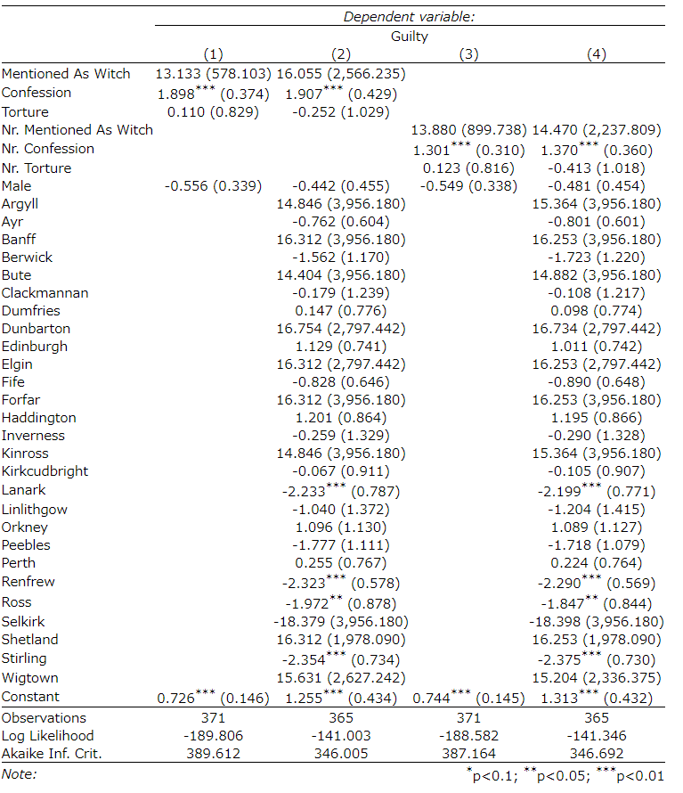

Table 2: Logit models to examine hypothesis 1-3

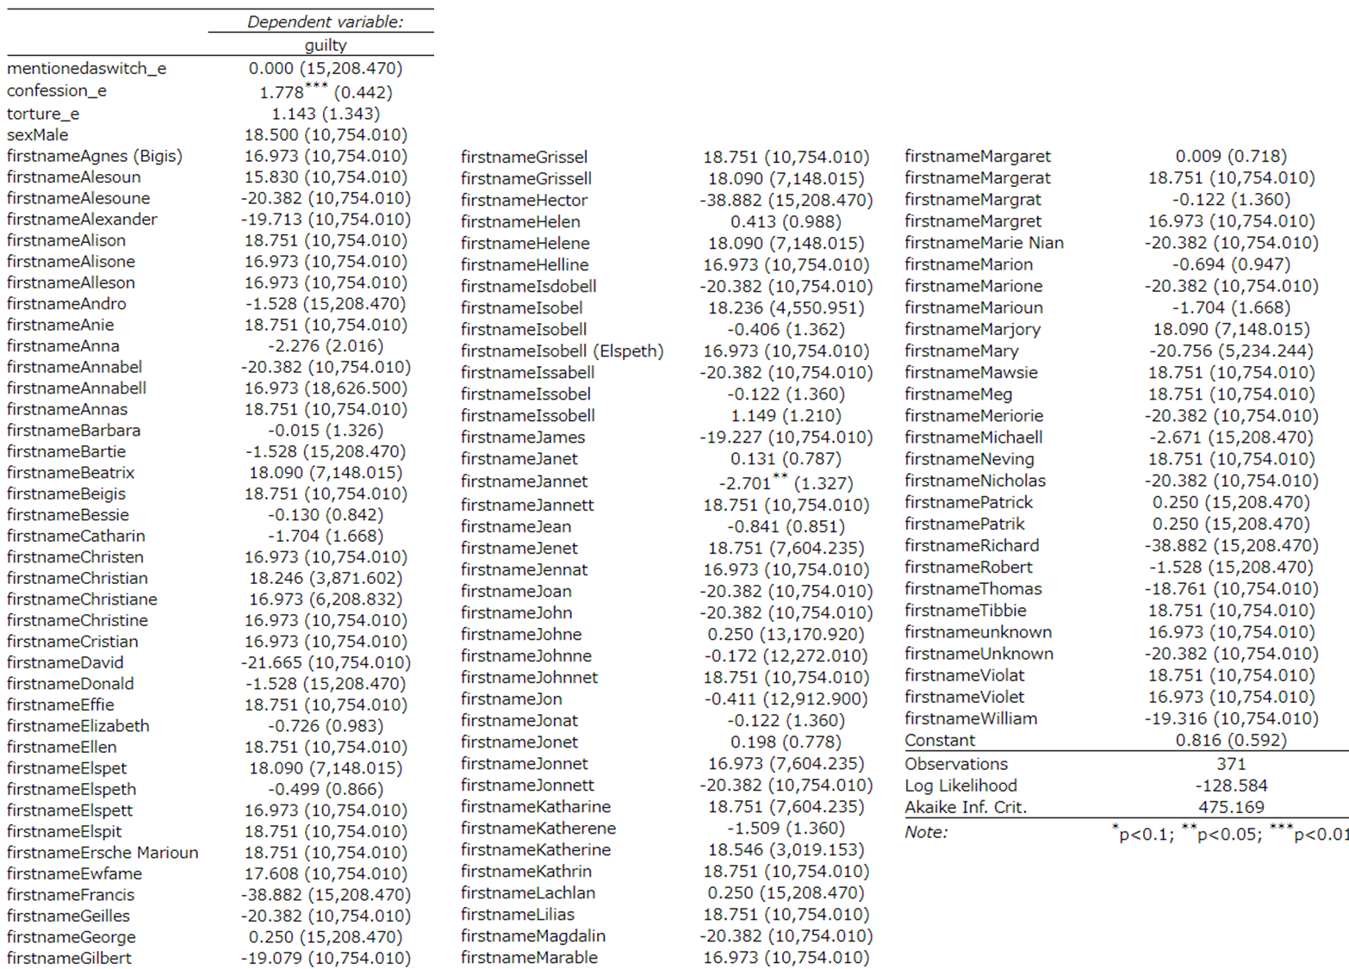

Table 3: Logit model to examine hypothesis 4

# 5. Conclusion and Discussion

From the results presented above, the following four conclusion can be obtained. The first one is that there is no correlation between gender and propensity to have been judged as guilty or witches. So, people might not have been afraid of witches as a symbol or imaginary one such as female ones in fairy tales, but they might rather have been scared of ones who could really do something evil.

The second conclusion is that people living in some regions were less likely to be identified as witches compared to other regions (Fig. 3). These regions are Lanark, Renfrew, Ross, Stirling. Seeing the locations of them, there seems to not be large difference in terms of geography. So, the reason why people living in these areas were less likely to be judged as guilty should be examined in future study.

Thirdly, it can be concluded that confessed people tended to be judged as guilty as is the case with trials until the modern era (Fig. 4). Also, according to the result, the more people confessed, the more likely they were identified as witches (Table 2 and Fig. 5).

Fig. 3: Guilty probabilities across regions

Fig. 4: Guilty probabilities depending on confession

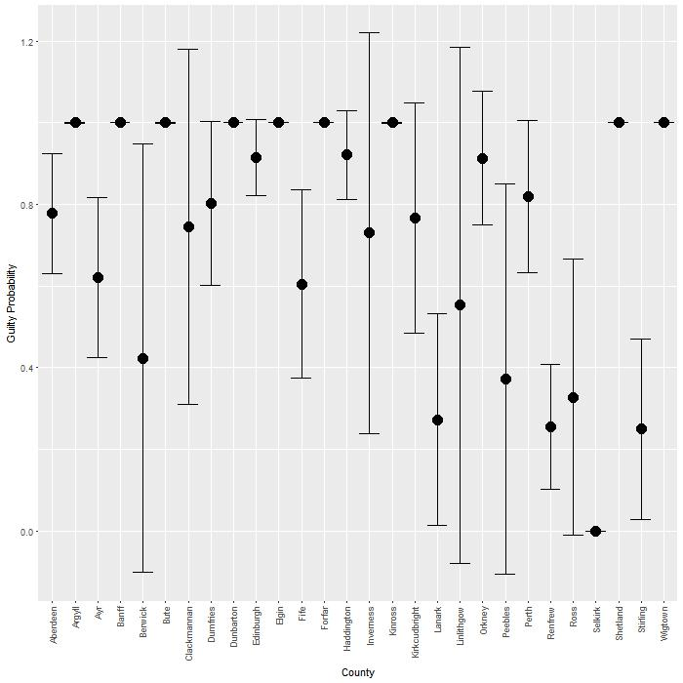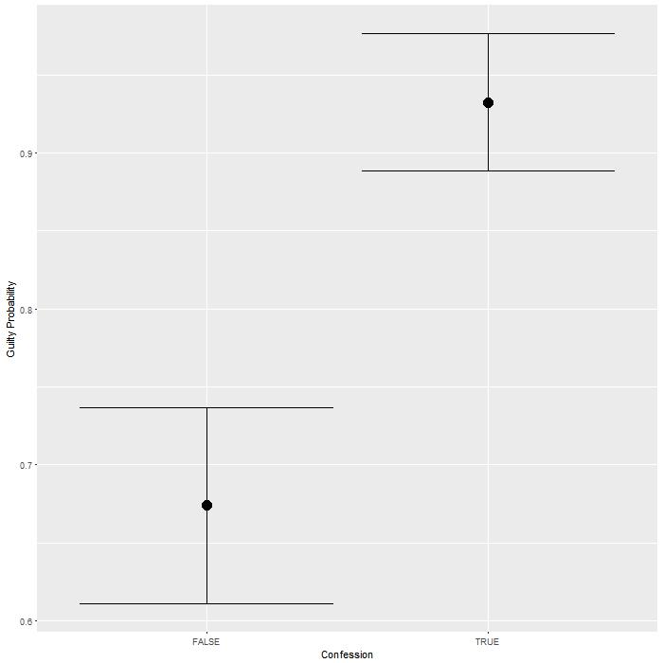

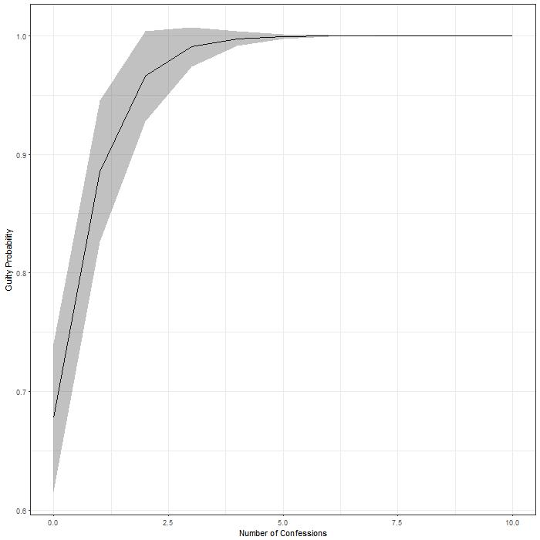

Fig. 5: Guilty probabilities depending on number of confessions

The last but not least conclusion is that in this study, no relationship between names and propensity to be judged as witches are identified. It would imply that some persecution wasn’t the reason why the witch-hunt prevailed in the early modern period. There is possibility, however, that we can identify the correlation if the names are properly categorized using dictionaries of names related to ethnicity or religion.  
 According the results discussed above, it can be said that the witch-hunt emerged from mass hysteria rather than discrimination or persecution, since there is no relationship between guilty propensity and names but there is between the former and confession in trials. The fact that people deemed to do something good (e.g. consulting or healing human) were less likely to be judged as guilty also support this idea (see Appendix 9). Even further study is necessary, however, to more completely understand this weird phenomenon.

# 6. References

Behringer, W. (2004). *Witches and witch-hunts: a global history*. Polity.

Briggs, R. (1996). *Witches & neighbours: the social and cultural context of European witchcraft* (p. 93115137). New York: Viking

Ehrenreich, B., & English, D. (2010). *Witches, midwives, & nurses: A history of women healers*. The Feminist Press at CUNY.

Goodare, J., Martin, L., Miller, J. and Yeoman, L. (2003). *The Survey of Scottish Witchcraft* [Data file]. Retrieved from https://github.com/mhaber  
/HertieDataScience/blob/master/finalProject/history-scottish-witchcraft.zip

Hutton, R. (2002). The global context of the Scottish witch-hunt. *The Scottish witch-hunt in context*, 16-32.

Michelet, J. (1939). *Satanism and witchcraft: A study in Medieval Superstition, trans. A. R. Allinson*. New York: Citadel Press.

# 7. Appendix Figures & Tables

## Appendix 1: Datasets and variables used in the study

|  |  |  |
| --- | --- | --- |
| **WDB_Accused** | |  |
| **Column** | **Data Type** | **Description** |
| FirstName | Character(50) | First name as given in the source |
| LastName | Character(50) | Surname as given in the source |
| M_Firstname | Character(50) | Standard modern first name |
| M_Surname | Character(50) | Standard modern surname |
| Sex | Character(6) | Sex of the accused |
| Res_county | Character(50) | Place of residence - county |
| **WDB_Case** | |  |
| **Column** | **Data Type** | **Description** |
| UNorthodoxRelPract_p | Yes/No | Unorthodox religious practice as primary characterisation of case - the team decided this was the main theme |
| UNorthodoxRelPract_s | Yes/No | Unorthodox religious practice as secondary characterisation of case - the team found this mentioned in the documentation |
| Consulting_p | Yes/No | Consulting a witch as primary characterisation of case - the team decided this was the main theme |
| Consulting_s | Yes/No | Consulting a witch as secondary characterisation of case - the team found this mentioned in the documentation |
| Demonic_p | Yes/No | Demonic elements as primary characterisation of case - the team decided this was the main theme |
| Demonic_s | Yes/No | Demonic elements as secondary characterisation of case - the team found this mentioned in the documentation |
| Demonic_possess_p | Yes/No | Demonic possession as primary characterisation of case - the team decided this was the main theme |
| Demonic_possess_s | Yes/No | Demonic possession as secondary characterisation of case - the team found this mentioned in the documentation |
| Fairies_p | Yes/No | Fairies as primary characterisation of case - the team decided this was the main theme |
| Fairies_s | Yes/No | Fairies as secondary characterisation of case - the team found this mentioned in the documentation |
| Folk_healing_p | Yes/No | Folk healing as primary characterisation of case - the team decided this was the main theme |
| Folk_healing_s | Yes/No | Folk healing as secondary characterisation of case - the team found this mentioned in the documentation |
| Maleficium_p | Yes/No | Maleficium as primary characterisation of case - the team decided this was the main theme |
| Maleficium_s | Yes/No | Maleficium as secondary characterisation of case - the team found this mentioned in the documentation |
| Midwifery_p | Yes/No | Midwifery as primary characterisation of case - the team decided this was the main theme |
| Midwifery_s | Yes/No | Midwifery as secondary characterisation of case - the team found this mentioned in the documentation |
| ImplicatedByAnother_p | Yes/No | Named as accomplice as primary characterisation of case - the team decided this was the main theme |
| ImplicatedByAnother_s | Yes/No | Named as accomplice as secondary characterisation of case - the team found this mentioned in the documentation |
| Neighbhd_dispute_p | Yes/No | Neighbourhood dispute as primary characterisation of case - the team decided this was the main theme |
| Neighbhd_dispute_s | Yes/No | Neighbourhood dispute as secondary characterisation of case - the team found this mentioned in the documentation |
| PoliticalMotive_p | Yes/No | Political motive as primary characterisation of case - the team decided this was the main theme |
| PoliticalMotive_s | Yes/No | Political motive as secondary characterisation of case - the team found this mentioned in the documentation |
| PropertyMotive_p | Yes/No | Property motive as primary characterisation of case - the team decided this was the main theme |
| PropertyMotive_s | Yes/No | Property motive as secondary characterisation of case - the team found this mentioned in the documentation |
| RefusedCharity_p | Yes/No | Refused Charity as primary characterisation of case - the team decided this was the main theme |
| RefusedCharity_s | Yes/No | Refused Charity as secondary characterisation of case - the team found this mentioned in the documentation |
| Treason_p | Yes/No | Treason as primary characterisation of case - the team decided this was the main theme |
| Treason_s | Yes/No | Treason as secondary characterisation of case - the team found this mentioned in the documentation |
| Other_p | Yes/No | Other primary characterisation |
| Other_s | Yes/No | Other secondary characterisation |
| WhiteMagic_p | Yes/No | White Magic as primary characterisation - the team decided this was the main theme |
| WhiteMagic_s | Yes/No | White Magic as secondary characterisation - the team found this mentioned in the documentation |
| WitchesMeeting | Yes/No | Witches' meetings - accused attended |
| DevilPresent | Yes/No | Witches' meetings - Devil Present at a meeting |
| Maleficium | Yes/No | Witches' meetings - Collective maleficium organised or committed at a meeting |
| CommunalSex | Yes/No | Witches' meetings - Communal sex at a meeting |
| DevilWorship | Yes/No | Witches' meetings - Worship of the Devil at a meeting |
| FoodAndDrink | Yes/No | Witches' meetings - Food and Drink consumed at a meeting |
| Dancing | Yes/No | Witches' meetings - Dancing at a meeting |
| Singing | Yes/No | Witches' meetings - Singing at a meeting |
| Elphane/Fairyland | Yes/No | Folk Culture - Elphane/Fairyland mentioned or described |
| Food/Drink | Yes/No | Folk Culture - Food/Drink consumed at Elphane or fairyland |
| SpecificVerbalFormulae | Yes/No | Folk Culture - Specific Verbal Formulae used for curing or any other ritual were discussed in the documentation |
| SpecificRitualActs | Yes/No | Folk Culture - Specific Ritual Acts were discussed in the documentation |
| Familiars | Yes/No | Folk Culture - The accused had a familiar (a small animal or spirit that did her bidding) |
| Shape-Changing | Yes/No | Folk Culture - The documentation mentioned shape-changing of the accused |
| Dreams/Visions | Yes/No | Folk Culture - Accused appeared in a Dream or Visions |
| UnorthodoxReligiousPractice | Yes/No | Folk Culture - Accused used an Unorthodox Religious Practice |
| SympatheticMagic | Yes/No | Folk Culture - Sympathetic magic (use of an object to stand in for a person) was alleged |
| Ridingdead | Yes/No | Folk Culture - Riding with the dead |
| HumanIllness | Yes/No | Diseases/Illness - Accused caused Human illness |
| HumanDeath | Yes/No | Diseases/Illness - Accused caused Human death |
| AnimalIllness | Yes/No | Diseases/Illness - Accused caused Animal illness |
| AnimalDeath | Yes/No | Diseases/Illness - Accused caused Animal death |
| FemaleInfertility | Yes/No | Diseases/Illness - Accused caused Female infertility |
| MaleImpotence | Yes/No | Diseases/Illness - Accused caused Male impotence |
| AggravatingDisease | Yes/No | Diseases/Illness - Accused Aggravated an already existing disease |
| TransferringDisease | Yes/No | Diseases/Illness - Accused Transferred a disease from sick person to someone or something else |
| LayingOn | Yes/No | Diseases/Illness - Accused Layed on and took off a disease |
| Removalbewitchment | Yes/No | Diseases/Illness - Accused Removed a bewitchment |
| Quarreling | Yes/No | Diseases/Illness - Accused Quarrelled |
| Cursing | Yes/No | Diseases/Illness - Accused Cursed someone |
| Poisoning | Yes/No | Diseases/Illness - Accused Poisoned someone |
| RecHealer | Yes/No | Diseases/Illness - Accused was a Recognised healer |
| HealingHumans | Yes/No | Diseases/Illness - Accused Healed humans |
| HealingAnimals | Yes/No | Diseases/Illness - Accused Healed animals |
| Midwifery | Yes/No | Diseases/Illness - Accused practised Midwifery |
| **WDB_Confession** | |  |
| **Column** | **Data Type** | **Description** |
| Trialref | Character(20) | Local identifier for trial  * used to create the variables indicating existence of confession and number of confession |
| **WDB_MentionedAsWitch** | |  |
| **Column** | **Data Type** | **Description** |
| Trialref | Character(20) | Local identifier for trial  * used to create the variables indicating existence of mentioned as a witch in another trial and number of that |
| **WDB_Torture** | |  |
| **Column** | **Data Type** | **Description** |
| Trialref | Character(20) | Local identifier for trial  * used to create the variables indicating existence of torture and number of torture |
| **WDB_Trial** | |  |
| **Column** | **Data Type** | **Description** |
| TrialType | Byte | Type of trial |
| Verdict | Character(50) | Verdict |
| Sentence | Character(50) | Sentence |

* From *Verdict* and *Sentence,* the variable indicating guilty or non-guilty is created

## Appendix 2: Guilty rates across names

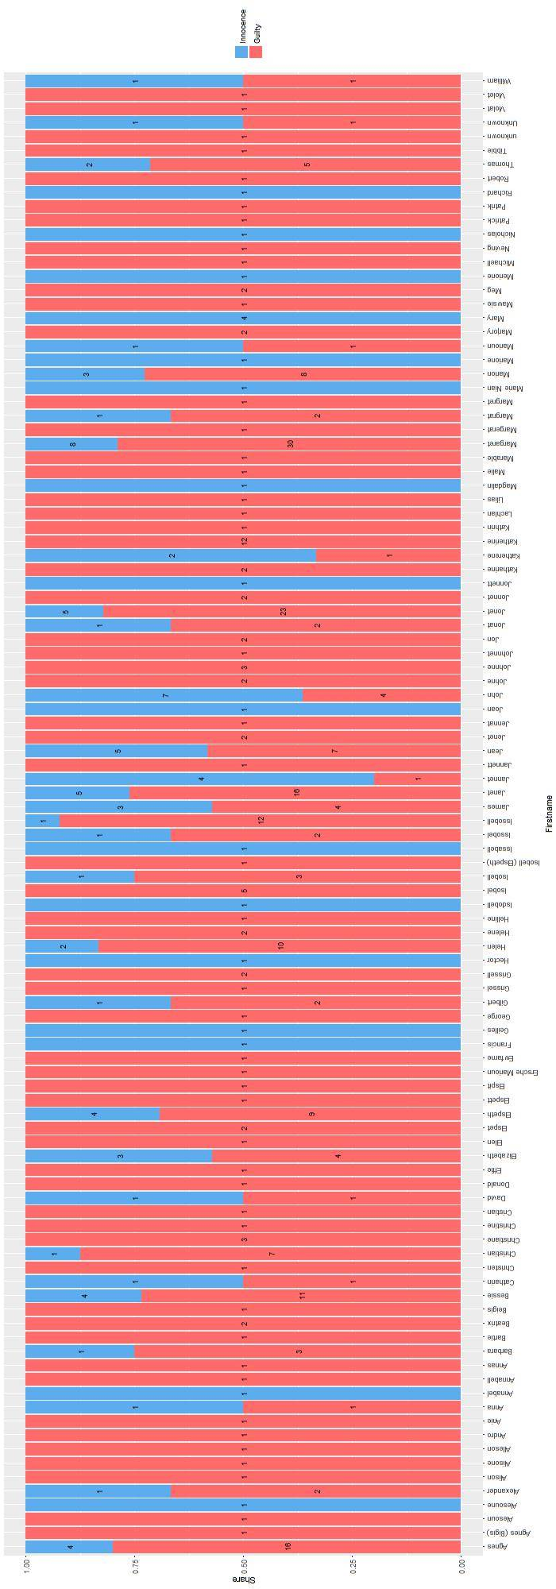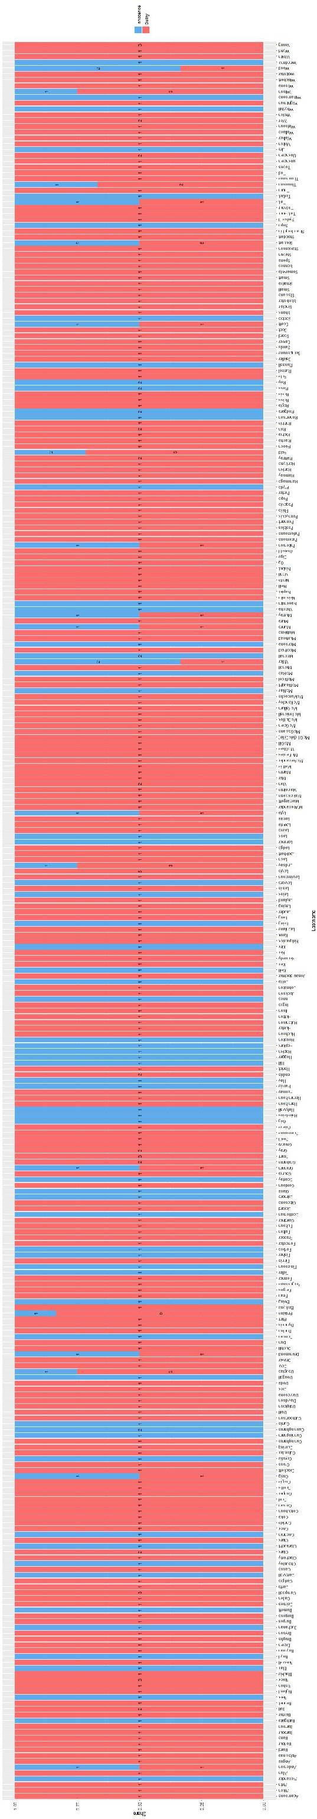

## Appendix 3: Logit models to examine quadratic function of number of confession

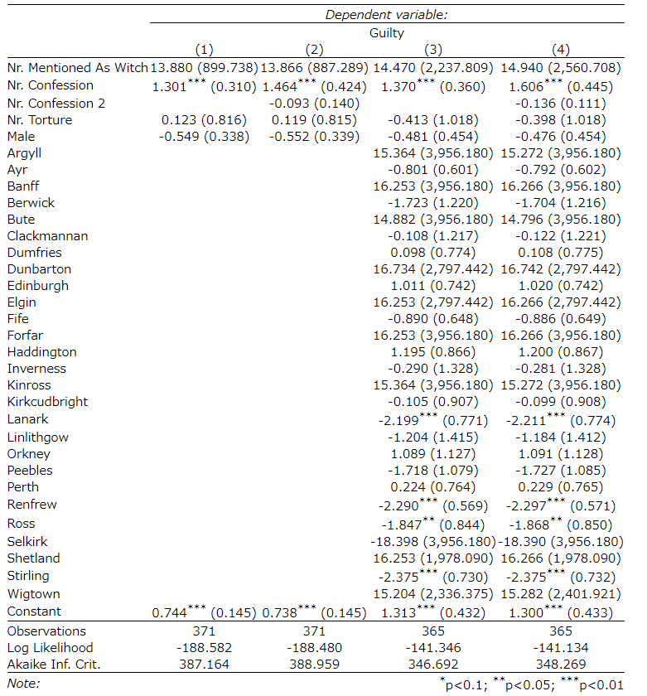

## Appendix 4: Logit models to examine the mechanism regarding confession

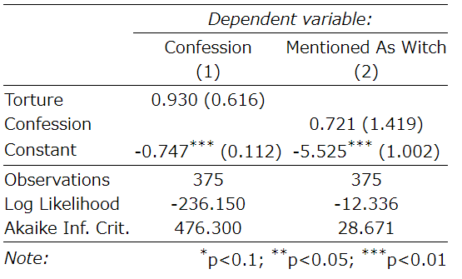

## Appendix 5: Logit model to examine the relationship between guilty propensity and names using initials of first names

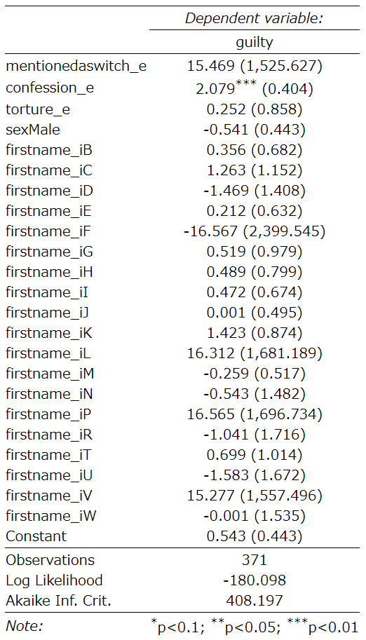

## Appendix 6: Logit model to examine the relationship between guilty propensity and names using initials of last names

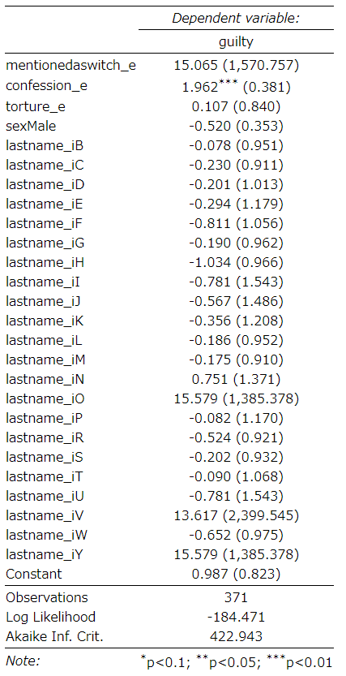

## Appendix 7: Logit model to examine the relationship between guilty propensity and names using ends of first names

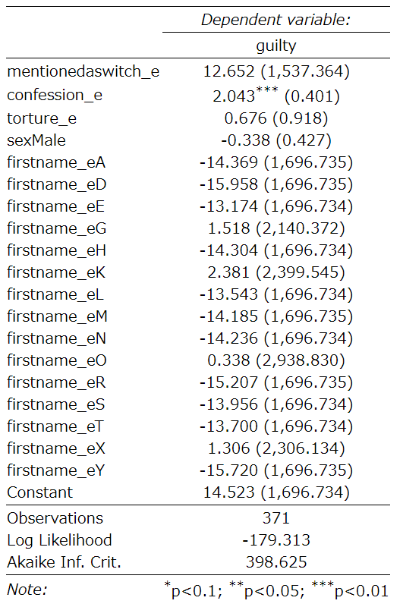

## Appendix 8: Logit model to examine the relationship between guilty propensity and names using ends of last names

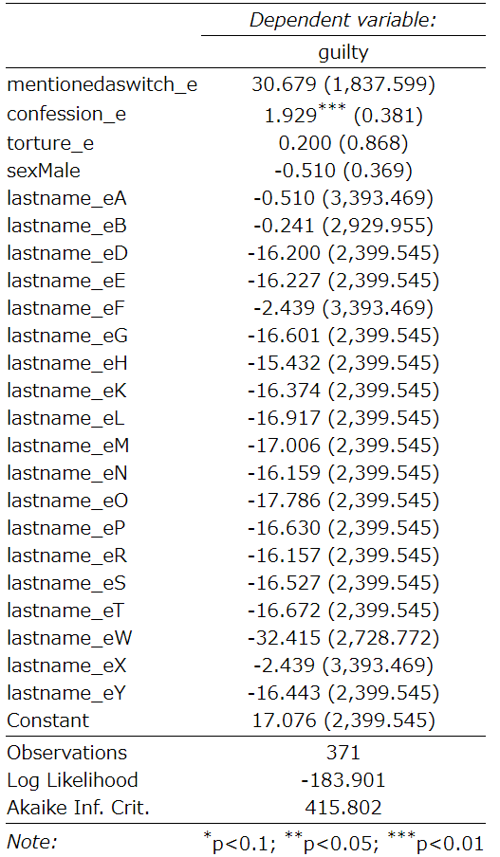

## Appendix 9: Logit model to examine the relationship between guilty propensity and other variables

