|  |
| --- |
| МИНОБРНАУКИ РОССИИ |
| Федеральное государственное бюджетное образовательное учреждение высшего образования **«МИРЭА − Российский технологический университет»**  **РТУ МИРЭА** |

**Институт информационных технологий (ИИТ)**

**Кафедра практической и прикладной информатики (ППИ)**

**ОТЧЕТ ПО ПРАКТИЧЕСКОЙ РАБОТЕ**

по дисциплине «Разработка баз данных»

**Практическое занятие № 3**

|  |  |  |  |
| --- | --- | --- | --- |
| Студент группы ИНБО-01-17 | *ИНБО-08-22, Самойлов М.М.* | (подпись) | |
| Преподаватель | *Placeholder* | (подпись) | |
| Отчет представлен | «___»________202__г. | |  | |

Москва 2024 г.

**Цель занятия:** научиться формировать модель БД, переносить БД на другой сервер, изучить команды модификации данных, хранимые процедуры, функции и триггеры.

**Постановка задачи:**

1. Сформировать свою БД;
2. Осуществить перенос БД на другой сервер;
3. Протестировать команды модификации данных (DML);
4. Осуществить выборку данных по своей теме с помощью различных операторов;
5. Применить к своей БД хранимые процедуры, функции и триггеры.

**Результат работы:**

# **Задание 1 – Сформировать свою БД**

Выполнено в первой практической работе.

# **Задание 2 – Сделать резервную копию БД**

Создадим резервную копию БД.

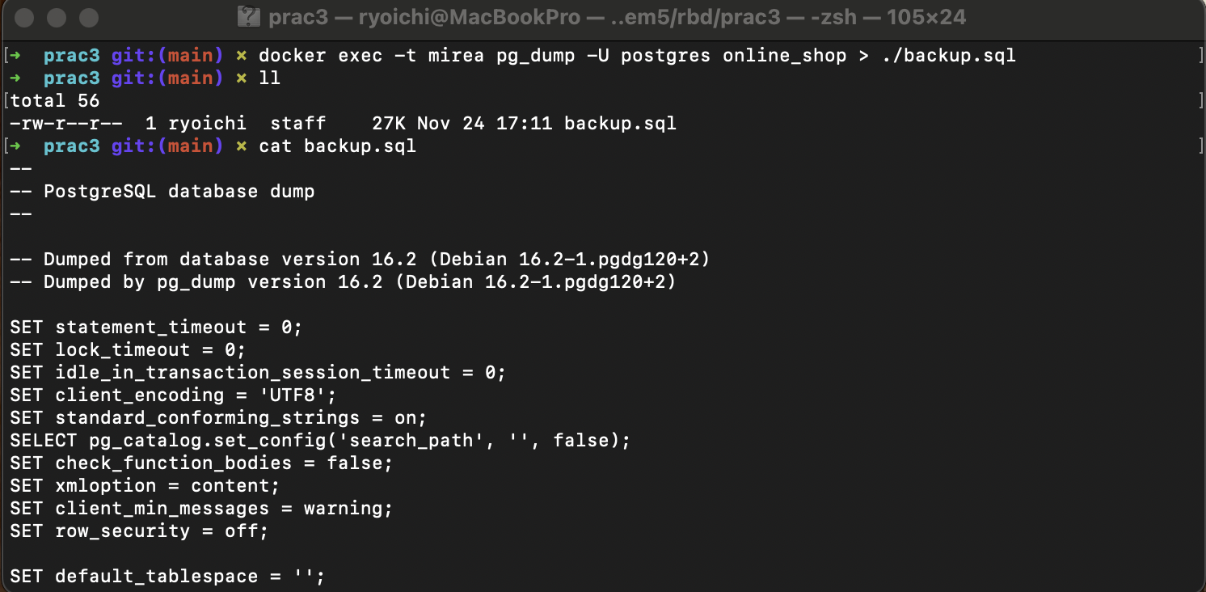

Рисунок 1 – Создание резервной копии бд

В результате будет сгенерирован следующий SQL-код:

--

-- PostgreSQL database dump

--

-- Dumped from database version 16.2 (Debian 16.2-1.pgdg120+2)

-- Dumped by pg_dump version 16.2 (Debian 16.2-1.pgdg120+2)

SET statement_timeout = 0;

SET lock_timeout = 0;

SET idle_in_transaction_session_timeout = 0;

SET client_encoding = 'UTF8';

SET standard_conforming_strings = on;

SELECT pg_catalog.set_config('search_path', '', false);

SET check_function_bodies = false;

SET xmloption = content;

SET client_min_messages = warning;

SET row_security = off;

SET default_tablespace = '';

SET default_table_access_method = heap;

--

-- Name: cart_items; Type: TABLE; Schema: public; Owner: postgres

--

CREATE TABLE public.cart_items (

cart_item_id integer NOT NULL,

cart_id integer,

product_id integer,

quantity integer NOT NULL

);

ALTER TABLE public.cart_items OWNER TO postgres;

--

-- Name: cart_items_cart_item_id_seq; Type: SEQUENCE; Schema: public; Owner: postgres

--

CREATE SEQUENCE public.cart_items_cart_item_id_seq

AS integer

START WITH 1

INCREMENT BY 1

NO MINVALUE

NO MAXVALUE

CACHE 1;

ALTER SEQUENCE public.cart_items_cart_item_id_seq OWNER TO postgres;

--

-- Name: cart_items_cart_item_id_seq; Type: SEQUENCE OWNED BY; Schema: public; Owner: postgres

--

ALTER SEQUENCE public.cart_items_cart_item_id_seq OWNED BY public.cart_items.cart_item_id;

--

-- Name: carts; Type: TABLE; Schema: public; Owner: postgres

--

CREATE TABLE public.carts (

cart_id integer NOT NULL,

user_id integer,

created_at timestamp without time zone DEFAULT CURRENT_TIMESTAMP

);

ALTER TABLE public.carts OWNER TO postgres;

--

-- Name: carts_cart_id_seq; Type: SEQUENCE; Schema: public; Owner: postgres

--

CREATE SEQUENCE public.carts_cart_id_seq

AS integer

START WITH 1

INCREMENT BY 1

NO MINVALUE

NO MAXVALUE

CACHE 1;

ALTER SEQUENCE public.carts_cart_id_seq OWNER TO postgres;

--

-- Name: carts_cart_id_seq; Type: SEQUENCE OWNED BY; Schema: public; Owner: postgres

--

ALTER SEQUENCE public.carts_cart_id_seq OWNED BY public.carts.cart_id;

--

-- Name: categories; Type: TABLE; Schema: public; Owner: postgres

--

CREATE TABLE public.categories (

category_id integer NOT NULL,

category_name character varying(100) NOT NULL,

description text

);

ALTER TABLE public.categories OWNER TO postgres;

--

-- Name: categories_category_id_seq; Type: SEQUENCE; Schema: public; Owner: postgres

--

CREATE SEQUENCE public.categories_category_id_seq

AS integer

START WITH 1

INCREMENT BY 1

NO MINVALUE

NO MAXVALUE

CACHE 1;

ALTER SEQUENCE public.categories_category_id_seq OWNER TO postgres;

--

-- Name: categories_category_id_seq; Type: SEQUENCE OWNED BY; Schema: public; Owner: postgres

--

ALTER SEQUENCE public.categories_category_id_seq OWNED BY public.categories.category_id;

--

-- Name: companies; Type: TABLE; Schema: public; Owner: postgres

--

CREATE TABLE public.companies (

company_id integer NOT NULL,

company_name character varying(255) NOT NULL,

company_description text,

created_at timestamp without time zone DEFAULT CURRENT_TIMESTAMP

);

ALTER TABLE public.companies OWNER TO postgres;

--

-- Name: companies_company_id_seq; Type: SEQUENCE; Schema: public; Owner: postgres

--

CREATE SEQUENCE public.companies_company_id_seq

AS integer

START WITH 1

INCREMENT BY 1

NO MINVALUE

NO MAXVALUE

CACHE 1;

ALTER SEQUENCE public.companies_company_id_seq OWNER TO postgres;

--

-- Name: companies_company_id_seq; Type: SEQUENCE OWNED BY; Schema: public; Owner: postgres

--

ALTER SEQUENCE public.companies_company_id_seq OWNED BY public.companies.company_id;

--

-- Name: order_items; Type: TABLE; Schema: public; Owner: postgres

--

CREATE TABLE public.order_items (

order_item_id integer NOT NULL,

order_id integer,

product_id integer,

quantity integer NOT NULL,

price numeric(10,2) NOT NULL

);

ALTER TABLE public.order_items OWNER TO postgres;

--

-- Name: order_items_order_item_id_seq; Type: SEQUENCE; Schema: public; Owner: postgres

--

CREATE SEQUENCE public.order_items_order_item_id_seq

AS integer

START WITH 1

INCREMENT BY 1

NO MINVALUE

NO MAXVALUE

CACHE 1;

ALTER SEQUENCE public.order_items_order_item_id_seq OWNER TO postgres;

--

-- Name: order_items_order_item_id_seq; Type: SEQUENCE OWNED BY; Schema: public; Owner: postgres

--

ALTER SEQUENCE public.order_items_order_item_id_seq OWNED BY public.order_items.order_item_id;

--

-- Name: orders; Type: TABLE; Schema: public; Owner: postgres

--

CREATE TABLE public.orders (

order_id integer NOT NULL,

user_id integer,

total_price numeric(10,2) NOT NULL,

status character varying(50) DEFAULT 'pending'::character varying,

created_at timestamp without time zone DEFAULT CURRENT_TIMESTAMP

);

ALTER TABLE public.orders OWNER TO postgres;

--

-- Name: orders_order_id_seq; Type: SEQUENCE; Schema: public; Owner: postgres

--

CREATE SEQUENCE public.orders_order_id_seq

AS integer

START WITH 1

INCREMENT BY 1

NO MINVALUE

NO MAXVALUE

CACHE 1;

ALTER SEQUENCE public.orders_order_id_seq OWNER TO postgres;

--

-- Name: orders_order_id_seq; Type: SEQUENCE OWNED BY; Schema: public; Owner: postgres

--

ALTER SEQUENCE public.orders_order_id_seq OWNED BY public.orders.order_id;

--

-- Name: payments; Type: TABLE; Schema: public; Owner: postgres

--

CREATE TABLE public.payments (

payment_id integer NOT NULL,

order_id integer,

payment_method character varying(50) NOT NULL,

payment_date timestamp without time zone DEFAULT CURRENT_TIMESTAMP,

amount numeric(10,2) NOT NULL

);

ALTER TABLE public.payments OWNER TO postgres;

--

-- Name: payments_payment_id_seq; Type: SEQUENCE; Schema: public; Owner: postgres

--

CREATE SEQUENCE public.payments_payment_id_seq

AS integer

START WITH 1

INCREMENT BY 1

NO MINVALUE

NO MAXVALUE

CACHE 1;

ALTER SEQUENCE public.payments_payment_id_seq OWNER TO postgres;

--

-- Name: payments_payment_id_seq; Type: SEQUENCE OWNED BY; Schema: public; Owner: postgres

--

ALTER SEQUENCE public.payments_payment_id_seq OWNED BY public.payments.payment_id;

--

-- Name: products; Type: TABLE; Schema: public; Owner: postgres

--

CREATE TABLE public.products (

product_id integer NOT NULL,

category_id integer,

product_name character varying(255) NOT NULL,

description text,

price numeric(10,2) NOT NULL,

stock_quantity integer NOT NULL,

created_at timestamp without time zone DEFAULT CURRENT_TIMESTAMP,

company_id integer

);

ALTER TABLE public.products OWNER TO postgres;

--

-- Name: products_product_id_seq; Type: SEQUENCE; Schema: public; Owner: postgres

--

CREATE SEQUENCE public.products_product_id_seq

AS integer

START WITH 1

INCREMENT BY 1

NO MINVALUE

NO MAXVALUE

CACHE 1;

ALTER SEQUENCE public.products_product_id_seq OWNER TO postgres;

--

-- Name: products_product_id_seq; Type: SEQUENCE OWNED BY; Schema: public; Owner: postgres

--

ALTER SEQUENCE public.products_product_id_seq OWNED BY public.products.product_id;

--

-- Name: replies; Type: TABLE; Schema: public; Owner: postgres

--

CREATE TABLE public.replies (

reply_id integer NOT NULL,

review_id integer,

company_id integer,

reply_text text NOT NULL,

replied_at timestamp without time zone DEFAULT CURRENT_TIMESTAMP

);

ALTER TABLE public.replies OWNER TO postgres;

--

-- Name: replies_reply_id_seq; Type: SEQUENCE; Schema: public; Owner: postgres

--

CREATE SEQUENCE public.replies_reply_id_seq

AS integer

START WITH 1

INCREMENT BY 1

NO MINVALUE

NO MAXVALUE

CACHE 1;

ALTER SEQUENCE public.replies_reply_id_seq OWNER TO postgres;

--

-- Name: replies_reply_id_seq; Type: SEQUENCE OWNED BY; Schema: public; Owner: postgres

--

ALTER SEQUENCE public.replies_reply_id_seq OWNED BY public.replies.reply_id;

--

-- Name: reviews; Type: TABLE; Schema: public; Owner: postgres

--

CREATE TABLE public.reviews (

review_id integer NOT NULL,

user_id integer,

product_id integer,

rating integer,

comment text,

created_at timestamp without time zone DEFAULT CURRENT_TIMESTAMP,

CONSTRAINT reviews_rating_check CHECK (((rating >= 1) AND (rating <= 5)))

);

ALTER TABLE public.reviews OWNER TO postgres;

--

-- Name: reviews_review_id_seq; Type: SEQUENCE; Schema: public; Owner: postgres

--

CREATE SEQUENCE public.reviews_review_id_seq

AS integer

START WITH 1

INCREMENT BY 1

NO MINVALUE

NO MAXVALUE

CACHE 1;

ALTER SEQUENCE public.reviews_review_id_seq OWNER TO postgres;

--

-- Name: reviews_review_id_seq; Type: SEQUENCE OWNED BY; Schema: public; Owner: postgres

--

ALTER SEQUENCE public.reviews_review_id_seq OWNED BY public.reviews.review_id;

--

-- Name: users; Type: TABLE; Schema: public; Owner: postgres

--

CREATE TABLE public.users (

user_id integer NOT NULL,

username character varying(100) NOT NULL,

email character varying(100) NOT NULL,

password_hash character varying(255) NOT NULL,

first_name character varying(50),

last_name character varying(50),

phone_number character varying(20),

address text,

created_at timestamp without time zone DEFAULT CURRENT_TIMESTAMP,

is_banned boolean DEFAULT false

);

ALTER TABLE public.users OWNER TO postgres;

--

-- Name: users_user_id_seq; Type: SEQUENCE; Schema: public; Owner: postgres

--

CREATE SEQUENCE public.users_user_id_seq

AS integer

START WITH 1

INCREMENT BY 1

NO MINVALUE

NO MAXVALUE

CACHE 1;

ALTER SEQUENCE public.users_user_id_seq OWNER TO postgres;

--

-- Name: users_user_id_seq; Type: SEQUENCE OWNED BY; Schema: public; Owner: postgres

--

ALTER SEQUENCE public.users_user_id_seq OWNED BY public.users.user_id;

--

-- Name: cart_items cart_item_id; Type: DEFAULT; Schema: public; Owner: postgres

--

ALTER TABLE ONLY public.cart_items ALTER COLUMN cart_item_id SET DEFAULT nextval('public.cart_items_cart_item_id_seq'::regclass);

--

-- Name: carts cart_id; Type: DEFAULT; Schema: public; Owner: postgres

--

ALTER TABLE ONLY public.carts ALTER COLUMN cart_id SET DEFAULT nextval('public.carts_cart_id_seq'::regclass);

--

-- Name: categories category_id; Type: DEFAULT; Schema: public; Owner: postgres

--

ALTER TABLE ONLY public.categories ALTER COLUMN category_id SET DEFAULT nextval('public.categories_category_id_seq'::regclass);

--

-- Name: companies company_id; Type: DEFAULT; Schema: public; Owner: postgres

--

ALTER TABLE ONLY public.companies ALTER COLUMN company_id SET DEFAULT nextval('public.companies_company_id_seq'::regclass);

--

-- Name: order_items order_item_id; Type: DEFAULT; Schema: public; Owner: postgres

--

ALTER TABLE ONLY public.order_items ALTER COLUMN order_item_id SET DEFAULT nextval('public.order_items_order_item_id_seq'::regclass);

--

-- Name: orders order_id; Type: DEFAULT; Schema: public; Owner: postgres

--

ALTER TABLE ONLY public.orders ALTER COLUMN order_id SET DEFAULT nextval('public.orders_order_id_seq'::regclass);

--

-- Name: payments payment_id; Type: DEFAULT; Schema: public; Owner: postgres

--

ALTER TABLE ONLY public.payments ALTER COLUMN payment_id SET DEFAULT nextval('public.payments_payment_id_seq'::regclass);

--

-- Name: products product_id; Type: DEFAULT; Schema: public; Owner: postgres

--

ALTER TABLE ONLY public.products ALTER COLUMN product_id SET DEFAULT nextval('public.products_product_id_seq'::regclass);

--

-- Name: replies reply_id; Type: DEFAULT; Schema: public; Owner: postgres

--

ALTER TABLE ONLY public.replies ALTER COLUMN reply_id SET DEFAULT nextval('public.replies_reply_id_seq'::regclass);

--

-- Name: reviews review_id; Type: DEFAULT; Schema: public; Owner: postgres

--

ALTER TABLE ONLY public.reviews ALTER COLUMN review_id SET DEFAULT nextval('public.reviews_review_id_seq'::regclass);

--

-- Name: users user_id; Type: DEFAULT; Schema: public; Owner: postgres

--

ALTER TABLE ONLY public.users ALTER COLUMN user_id SET DEFAULT nextval('public.users_user_id_seq'::regclass);

--

-- Data for Name: cart_items; Type: TABLE DATA; Schema: public; Owner: postgres

--

COPY public.cart_items (cart_item_id, cart_id, product_id, quantity) FROM stdin;

1 1 1 3

2 1 2 1

3 2 3 1

4 3 4 2

5 4 5 5

6 5 1 2

7 6 3 1

8 7 2 2

9 8 4 1

10 9 5 3

\.

--

-- Data for Name: carts; Type: TABLE DATA; Schema: public; Owner: postgres

--

COPY public.carts (cart_id, user_id, created_at) FROM stdin;

1 1 2024-09-21 21:31:21.422699

2 2 2024-09-21 21:31:21.422699

3 3 2024-09-21 21:31:21.422699

4 4 2024-09-21 21:31:21.422699

5 5 2024-09-21 21:31:21.422699

6 6 2024-09-21 21:31:21.422699

7 7 2024-09-21 21:31:21.422699

8 8 2024-09-21 21:31:21.422699

9 9 2024-09-21 21:31:21.422699

10 10 2024-09-21 21:31:21.422699

\.

--

-- Data for Name: categories; Type: TABLE DATA; Schema: public; Owner: postgres

--

COPY public.categories (category_id, category_name, description) FROM stdin;

1 Одежда Одежда для мужчин и женщин

2 Мебель Домашняя мебель

3 Электроника Бытовая электроника

4 Книги Художественная и учебная литература

5 Продукты Продукты питания

\.

--

-- Data for Name: companies; Type: TABLE DATA; Schema: public; Owner: postgres

--

COPY public.companies (company_id, company_name, company_description, created_at) FROM stdin;

1 Товары для дома Компания, специализирующаяся на производстве товаров для дома. 2024-09-23 19:58:46.892897

2 Электроника Плюс Современная электроника и аксессуары. 2024-09-23 19:58:46.892897

3 Мир Книг Издательство и распространение книг всех жанров. 2024-09-23 19:58:46.892897

4 Одежда XXI века Производство одежды для всех возрастов. 2024-09-23 19:58:46.892897

\.

--

-- Data for Name: order_items; Type: TABLE DATA; Schema: public; Owner: postgres

--

COPY public.order_items (order_item_id, order_id, product_id, quantity, price) FROM stdin;

1 1 1 4 199.99

2 1 2 1 599.99

3 2 3 1 29999.99

4 3 4 2 499.99

5 4 5 5 49.99

6 5 1 2 199.99

\.

--

-- Data for Name: orders; Type: TABLE DATA; Schema: public; Owner: postgres

--

COPY public.orders (order_id, user_id, total_price, status, created_at) FROM stdin;

1 1 799.98 completed 2024-09-21 21:31:21.446827

2 2 29999.99 pending 2024-09-21 21:31:21.446827

3 3 999.98 shipped 2024-09-21 21:31:21.446827

4 4 249.95 pending 2024-09-21 21:31:21.446827

5 5 399.98 completed 2024-09-21 21:31:21.446827

\.

--

-- Data for Name: payments; Type: TABLE DATA; Schema: public; Owner: postgres

--

COPY public.payments (payment_id, order_id, payment_method, payment_date, amount) FROM stdin;

1 1 credit_card 2024-09-21 21:31:21.489546 799.98

2 2 paypal 2024-09-21 21:31:21.489546 29999.99

3 3 credit_card 2024-09-21 21:31:21.489546 999.98

\.

--

-- Data for Name: products; Type: TABLE DATA; Schema: public; Owner: postgres

--

COPY public.products (product_id, category_id, product_name, description, price, stock_quantity, created_at, company_id) FROM stdin;

1 1 Носки Мягкие и теплые носки 199.99 100 2024-09-21 21:31:21.406312 \N

2 2 Табуретка Деревянная табуретка для кухни 599.99 50 2024-09-21 21:31:21.406312 \N

3 3 Смартфон Современный смартфон с большим экраном 29999.99 30 2024-09-21 21:31:21.406312 \N

4 4 Книга: Война и мир Роман Льва Толстого 499.99 20 2024-09-21 21:31:21.406312 \N

5 5 Хлеб Свежий хлеб из пекарни 49.99 200 2024-09-21 21:31:21.406312 \N

11 1 Носки Мягкие и теплые носки 199.99 100 2024-09-23 19:58:46.905767 4

12 2 Табуретка Деревянная табуретка для кухни 599.99 50 2024-09-23 19:58:46.905767 1

13 3 Смартфон Современный смартфон с большим экраном 29999.99 30 2024-09-23 19:58:46.905767 2

14 4 Книга: Война и мир Роман Льва Толстого 499.99 20 2024-09-23 19:58:46.905767 3

15 5 Хлеб Свежий хлеб из пекарни 49.99 200 2024-09-23 19:58:46.905767 1

\.

--

-- Data for Name: replies; Type: TABLE DATA; Schema: public; Owner: postgres

--

COPY public.replies (reply_id, review_id, company_id, reply_text, replied_at) FROM stdin;

1 1 4 Спасибо за отзыв, рады, что вам понравилось! 2024-09-23 19:58:46.926439

2 2 2 Мы стараемся улучшить качество наших товаров. 2024-09-23 19:58:46.926439

3 3 3 Спасибо, что выбрали наше издательство! 2024-09-23 19:58:46.926439

\.

--

-- Data for Name: reviews; Type: TABLE DATA; Schema: public; Owner: postgres

--

COPY public.reviews (review_id, user_id, product_id, rating, comment, created_at) FROM stdin;

1 1 1 5 Очень хорошие носки, рекомендую! 2024-09-21 21:31:21.477976

2 2 3 4 Смартфон отличный, но дороговат 2024-09-21 21:31:21.477976

3 3 4 5 Любимая книга, качество издания на высоте! 2024-09-21 21:31:21.477976

4 1 1 5 Очень хорошие носки, рекомендую! 2024-09-23 19:58:46.915682

5 2 3 4 Смартфон отличный, но дороговат 2024-09-23 19:58:46.915682

6 3 4 5 Любимая книга, качество издания на высоте! 2024-09-23 19:58:46.915682

\.

--

-- Data for Name: users; Type: TABLE DATA; Schema: public; Owner: postgres

--

COPY public.users (user_id, username, email, password_hash, first_name, last_name, phone_number, address, created_at, is_banned) FROM stdin;

2 petr_petrov petr@example.com hash2 Петр Петров +79161234568 Санкт-Петербург, ул. Мира, 20 2024-09-21 21:31:21.377767 f

3 sergey_sergeev sergey@example.com hash3 Сергей Сергеев +79161234569 Новосибирск, ул. Лесная, 5 2024-09-21 21:31:21.377767 f

4 maria_smirnova maria@example.com hash4 Мария Смирнова +79161234570 Екатеринбург, ул. Центральная, 15 2024-09-21 21:31:21.377767 f

5 anna_kuznetsova anna@example.com hash5 Анна Кузнецова +79161234571 Казань, ул. Гоголя, 8 2024-09-21 21:31:21.377767 f

6 oleg_ivanov oleg@example.com hash6 Олег Иванов +79161234572 Нижний Новгород, ул. Чехова, 12 2024-09-21 21:31:21.377767 f

7 elena_petrova elena@example.com hash7 Елена Петрова +79161234573 Челябинск, ул. Комсомольская, 6 2024-09-21 21:31:21.377767 f

8 dmitry_sidorov dmitry@example.com hash8 Дмитрий Сидоров +79161234574 Ростов-на-Дону, ул. Пушкина, 18 2024-09-21 21:31:21.377767 f

9 viktor_fedorov viktor@example.com hash9 Виктор Федоров +79161234575 Самара, ул. Куйбышева, 2 2024-09-21 21:31:21.377767 f

10 olga_morozova olga@example.com hash10 Ольга Морозова +79161234576 Волгоград, ул. Карла Маркса, 4 2024-09-21 21:31:21.377767 f

1 ivan_ivanov ivan@example.com hash1 Иван Иванов +79161234567 Москва, ул. Ленина, 10 2024-09-21 21:31:21.377767 t

\.

--

-- Name: cart_items_cart_item_id_seq; Type: SEQUENCE SET; Schema: public; Owner: postgres

--

SELECT pg_catalog.setval('public.cart_items_cart_item_id_seq', 10, true);

--

-- Name: carts_cart_id_seq; Type: SEQUENCE SET; Schema: public; Owner: postgres

--

SELECT pg_catalog.setval('public.carts_cart_id_seq', 10, true);

--

-- Name: categories_category_id_seq; Type: SEQUENCE SET; Schema: public; Owner: postgres

--

SELECT pg_catalog.setval('public.categories_category_id_seq', 5, true);

--

-- Name: companies_company_id_seq; Type: SEQUENCE SET; Schema: public; Owner: postgres

--

SELECT pg_catalog.setval('public.companies_company_id_seq', 4, true);

--

-- Name: order_items_order_item_id_seq; Type: SEQUENCE SET; Schema: public; Owner: postgres

--

SELECT pg_catalog.setval('public.order_items_order_item_id_seq', 6, true);

--

-- Name: orders_order_id_seq; Type: SEQUENCE SET; Schema: public; Owner: postgres

--

SELECT pg_catalog.setval('public.orders_order_id_seq', 5, true);

--

-- Name: payments_payment_id_seq; Type: SEQUENCE SET; Schema: public; Owner: postgres

--

SELECT pg_catalog.setval('public.payments_payment_id_seq', 3, true);

--

-- Name: products_product_id_seq; Type: SEQUENCE SET; Schema: public; Owner: postgres

--

SELECT pg_catalog.setval('public.products_product_id_seq', 15, true);

--

-- Name: replies_reply_id_seq; Type: SEQUENCE SET; Schema: public; Owner: postgres

--

SELECT pg_catalog.setval('public.replies_reply_id_seq', 3, true);

--

-- Name: reviews_review_id_seq; Type: SEQUENCE SET; Schema: public; Owner: postgres

--

SELECT pg_catalog.setval('public.reviews_review_id_seq', 6, true);

--

-- Name: users_user_id_seq; Type: SEQUENCE SET; Schema: public; Owner: postgres

--

SELECT pg_catalog.setval('public.users_user_id_seq', 10, true);

--

-- Name: cart_items cart_items_pkey; Type: CONSTRAINT; Schema: public; Owner: postgres

--

ALTER TABLE ONLY public.cart_items

ADD CONSTRAINT cart_items_pkey PRIMARY KEY (cart_item_id);

--

-- Name: carts carts_pkey; Type: CONSTRAINT; Schema: public; Owner: postgres

--

ALTER TABLE ONLY public.carts

ADD CONSTRAINT carts_pkey PRIMARY KEY (cart_id);

--

-- Name: categories categories_pkey; Type: CONSTRAINT; Schema: public; Owner: postgres

--

ALTER TABLE ONLY public.categories

ADD CONSTRAINT categories_pkey PRIMARY KEY (category_id);

--

-- Name: companies companies_pkey; Type: CONSTRAINT; Schema: public; Owner: postgres

--

ALTER TABLE ONLY public.companies

ADD CONSTRAINT companies_pkey PRIMARY KEY (company_id);

--

-- Name: order_items order_items_pkey; Type: CONSTRAINT; Schema: public; Owner: postgres

--

ALTER TABLE ONLY public.order_items

ADD CONSTRAINT order_items_pkey PRIMARY KEY (order_item_id);

--

-- Name: orders orders_pkey; Type: CONSTRAINT; Schema: public; Owner: postgres

--

ALTER TABLE ONLY public.orders

ADD CONSTRAINT orders_pkey PRIMARY KEY (order_id);

--

-- Name: payments payments_pkey; Type: CONSTRAINT; Schema: public; Owner: postgres

--

ALTER TABLE ONLY public.payments

ADD CONSTRAINT payments_pkey PRIMARY KEY (payment_id);

--

-- Name: products products_pkey; Type: CONSTRAINT; Schema: public; Owner: postgres

--

ALTER TABLE ONLY public.products

ADD CONSTRAINT products_pkey PRIMARY KEY (product_id);

--

-- Name: replies replies_pkey; Type: CONSTRAINT; Schema: public; Owner: postgres

--

ALTER TABLE ONLY public.replies

ADD CONSTRAINT replies_pkey PRIMARY KEY (reply_id);

--

-- Name: reviews reviews_pkey; Type: CONSTRAINT; Schema: public; Owner: postgres

--

ALTER TABLE ONLY public.reviews

ADD CONSTRAINT reviews_pkey PRIMARY KEY (review_id);

--

-- Name: users users_email_key; Type: CONSTRAINT; Schema: public; Owner: postgres

--

ALTER TABLE ONLY public.users

ADD CONSTRAINT users_email_key UNIQUE (email);

--

-- Name: users users_pkey; Type: CONSTRAINT; Schema: public; Owner: postgres

--

ALTER TABLE ONLY public.users

ADD CONSTRAINT users_pkey PRIMARY KEY (user_id);

--

-- Name: users users_username_key; Type: CONSTRAINT; Schema: public; Owner: postgres

--

ALTER TABLE ONLY public.users

ADD CONSTRAINT users_username_key UNIQUE (username);

--

-- Name: cart_items cart_items_cart_id_fkey; Type: FK CONSTRAINT; Schema: public; Owner: postgres

--

ALTER TABLE ONLY public.cart_items

ADD CONSTRAINT cart_items_cart_id_fkey FOREIGN KEY (cart_id) REFERENCES public.carts(cart_id) ON DELETE CASCADE;

--

-- Name: cart_items cart_items_product_id_fkey; Type: FK CONSTRAINT; Schema: public; Owner: postgres

--

ALTER TABLE ONLY public.cart_items

ADD CONSTRAINT cart_items_product_id_fkey FOREIGN KEY (product_id) REFERENCES public.products(product_id) ON DELETE CASCADE;

--

-- Name: carts carts_user_id_fkey; Type: FK CONSTRAINT; Schema: public; Owner: postgres

--

ALTER TABLE ONLY public.carts

ADD CONSTRAINT carts_user_id_fkey FOREIGN KEY (user_id) REFERENCES public.users(user_id) ON DELETE CASCADE;

--

-- Name: order_items order_items_order_id_fkey; Type: FK CONSTRAINT; Schema: public; Owner: postgres

--

ALTER TABLE ONLY public.order_items

ADD CONSTRAINT order_items_order_id_fkey FOREIGN KEY (order_id) REFERENCES public.orders(order_id) ON DELETE CASCADE;

--

-- Name: order_items order_items_product_id_fkey; Type: FK CONSTRAINT; Schema: public; Owner: postgres

--

ALTER TABLE ONLY public.order_items

ADD CONSTRAINT order_items_product_id_fkey FOREIGN KEY (product_id) REFERENCES public.products(product_id) ON DELETE CASCADE;

--

-- Name: orders orders_user_id_fkey; Type: FK CONSTRAINT; Schema: public; Owner: postgres

--

ALTER TABLE ONLY public.orders

ADD CONSTRAINT orders_user_id_fkey FOREIGN KEY (user_id) REFERENCES public.users(user_id) ON DELETE CASCADE;

--

-- Name: payments payments_order_id_fkey; Type: FK CONSTRAINT; Schema: public; Owner: postgres

--

ALTER TABLE ONLY public.payments

ADD CONSTRAINT payments_order_id_fkey FOREIGN KEY (order_id) REFERENCES public.orders(order_id) ON DELETE CASCADE;

--

-- Name: products products_category_id_fkey; Type: FK CONSTRAINT; Schema: public; Owner: postgres

--

ALTER TABLE ONLY public.products

ADD CONSTRAINT products_category_id_fkey FOREIGN KEY (category_id) REFERENCES public.categories(category_id) ON DELETE SET NULL;

--

-- Name: products products_company_id_fkey; Type: FK CONSTRAINT; Schema: public; Owner: postgres

--

ALTER TABLE ONLY public.products

ADD CONSTRAINT products_company_id_fkey FOREIGN KEY (company_id) REFERENCES public.companies(company_id) ON DELETE SET NULL;

--

-- Name: replies replies_company_id_fkey; Type: FK CONSTRAINT; Schema: public; Owner: postgres

--

ALTER TABLE ONLY public.replies

ADD CONSTRAINT replies_company_id_fkey FOREIGN KEY (company_id) REFERENCES public.companies(company_id) ON DELETE CASCADE;

--

-- Name: replies replies_review_id_fkey; Type: FK CONSTRAINT; Schema: public; Owner: postgres

--

ALTER TABLE ONLY public.replies

ADD CONSTRAINT replies_review_id_fkey FOREIGN KEY (review_id) REFERENCES public.reviews(review_id) ON DELETE CASCADE;

--

-- Name: reviews reviews_product_id_fkey; Type: FK CONSTRAINT; Schema: public; Owner: postgres

--

ALTER TABLE ONLY public.reviews

ADD CONSTRAINT reviews_product_id_fkey FOREIGN KEY (product_id) REFERENCES public.products(product_id) ON DELETE CASCADE;

--

-- Name: reviews reviews_user_id_fkey; Type: FK CONSTRAINT; Schema: public; Owner: postgres

--

ALTER TABLE ONLY public.reviews

ADD CONSTRAINT reviews_user_id_fkey FOREIGN KEY (user_id) REFERENCES public.users(user_id) ON DELETE CASCADE;

--

-- PostgreSQL database dump complete

--

# **Задание 3 – Команды модификации данных (DML)**

Операции по добавлению данных в БД (INSERT INTO) были осуществлены в первой практической работе.

# **Задание 4 – Операторы**

1. Проекция

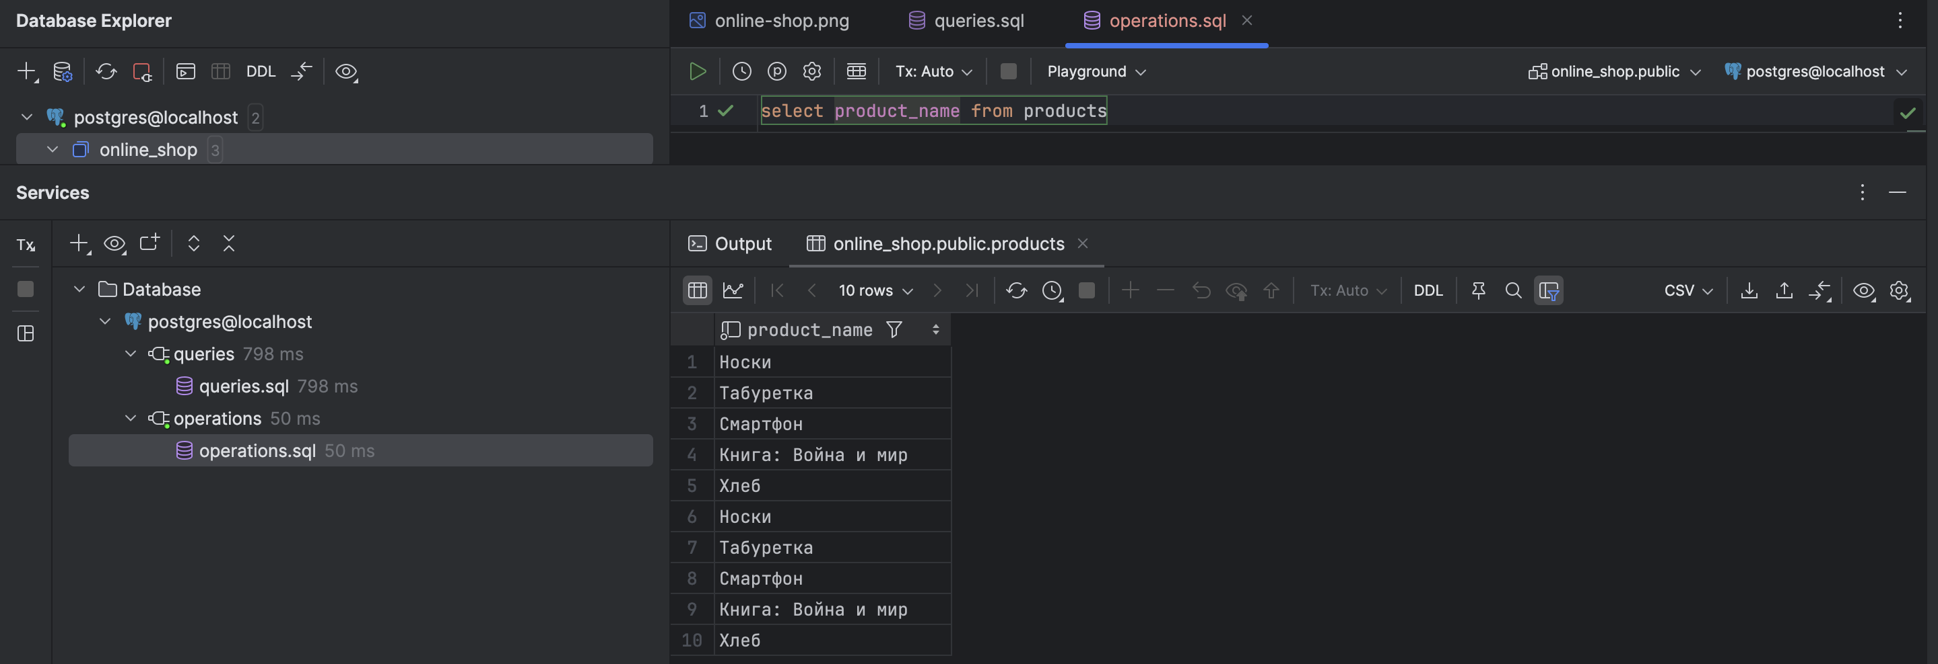

Рисунок 2 – Проекция

1. Операция селекции

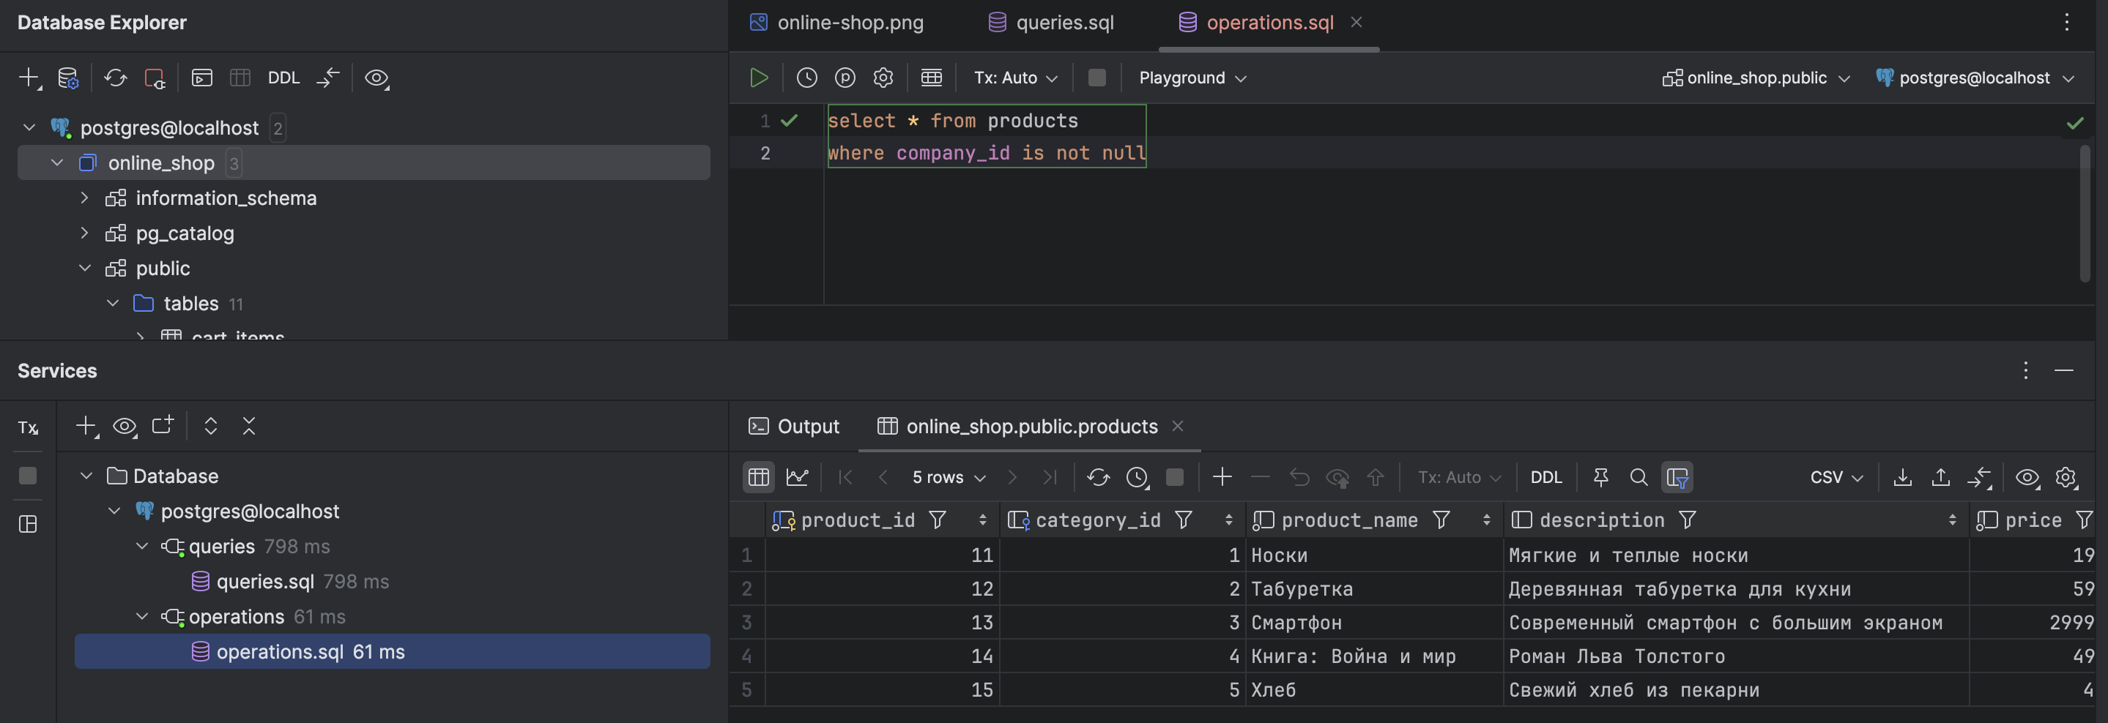

Рисунок 3 – Селекция

1. Соединение

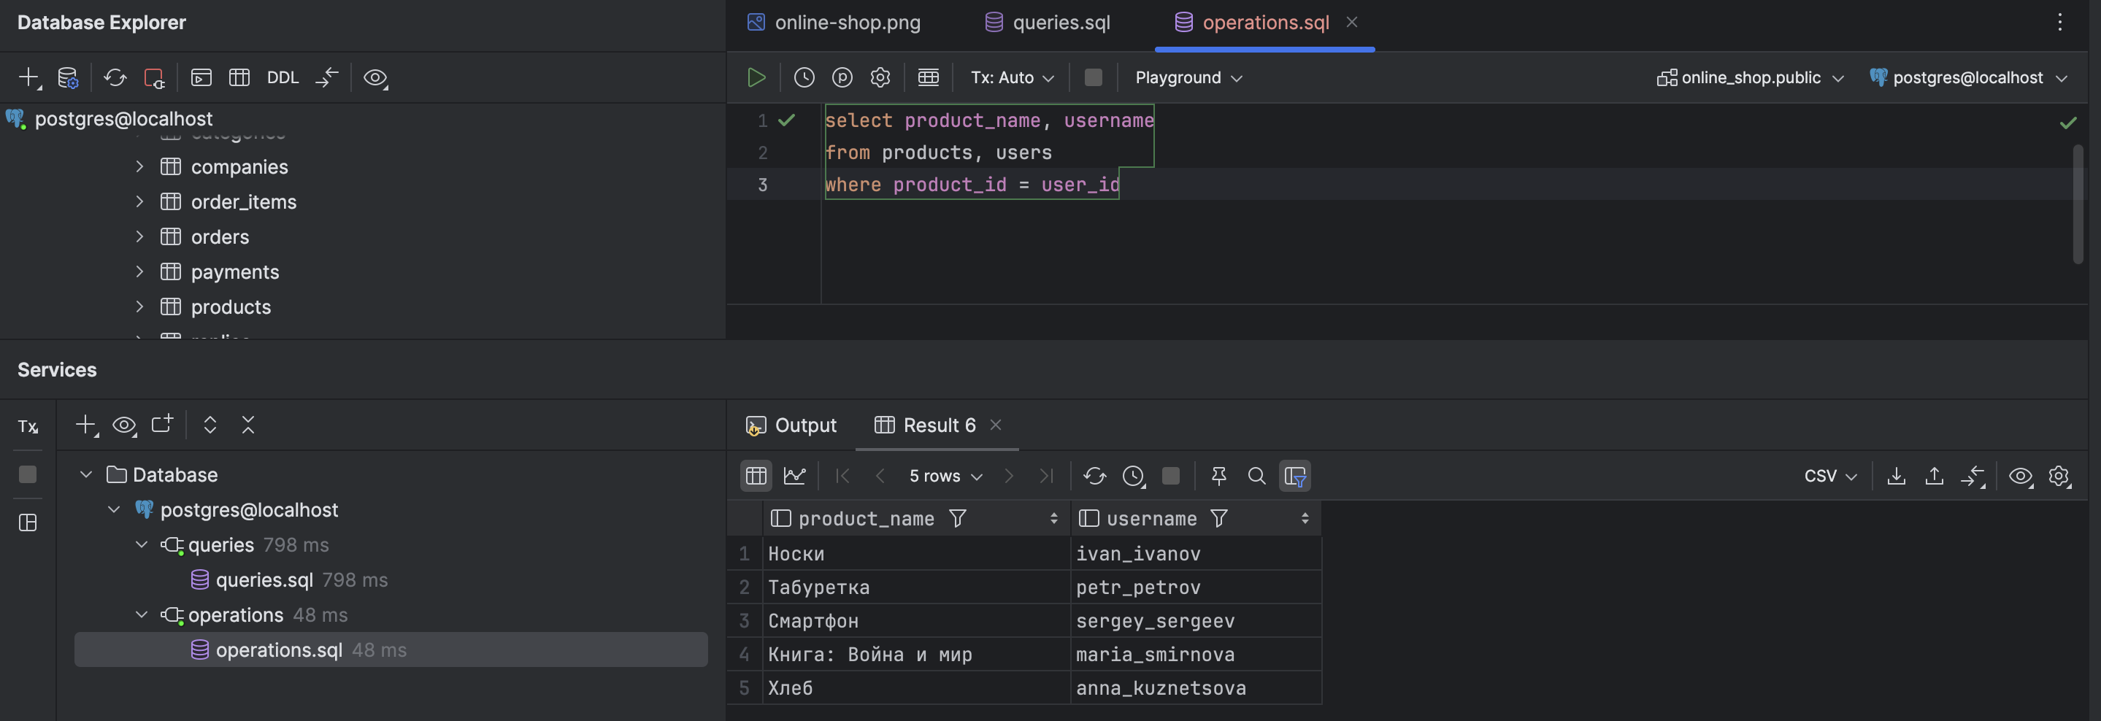

Рисунок 4 – Соединение

1. Объединение

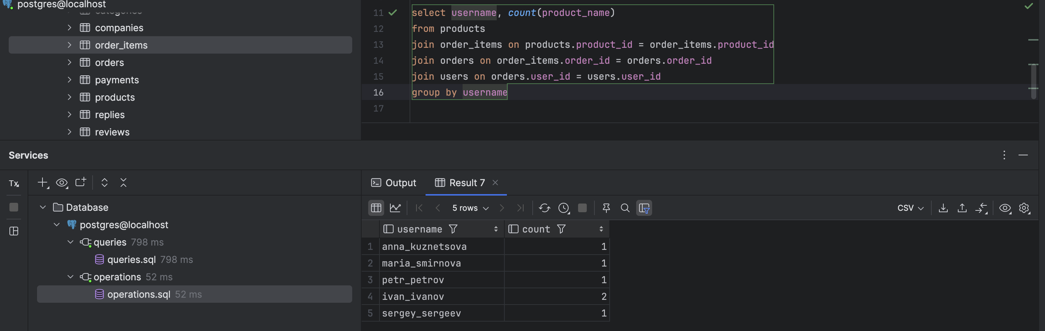

Рисунок 5 – Объединение

1. Пересечение

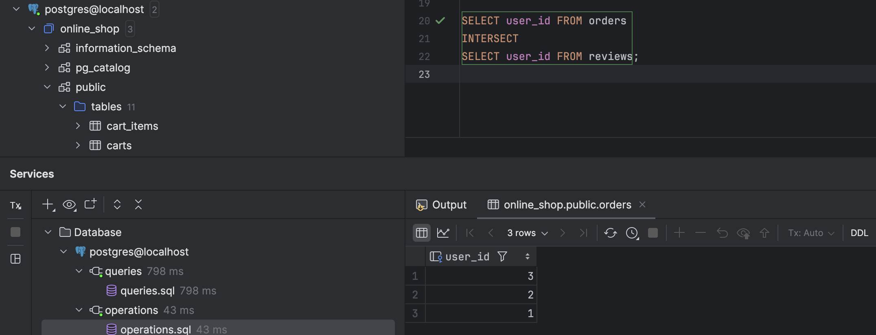

Рисунок 6 – Пересечение

1. Разность

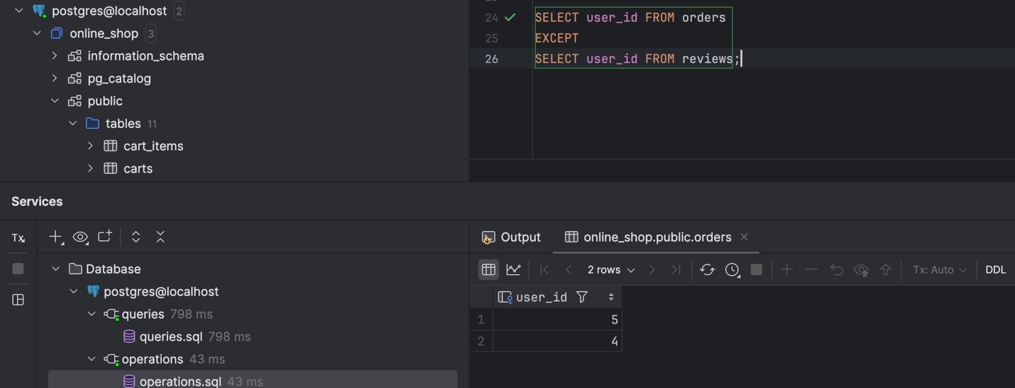

Рисунок 7 – Разность

1. Группировка

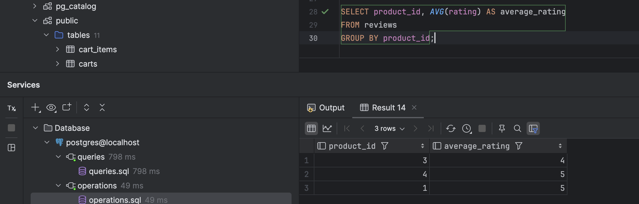

Рисунок 7 – Группировка

1. Сортировка

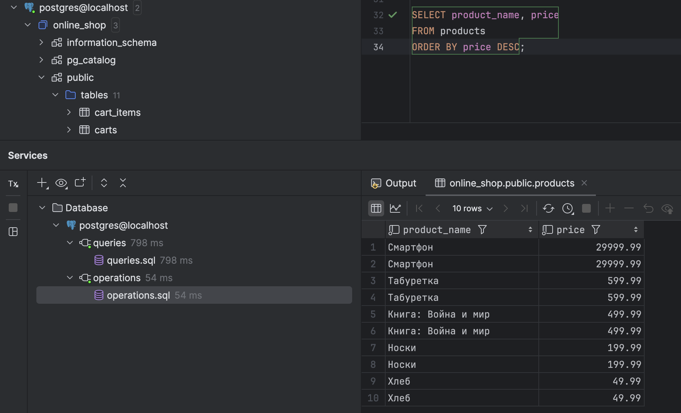

Рисунок 8 – Сортировка

1. Деление

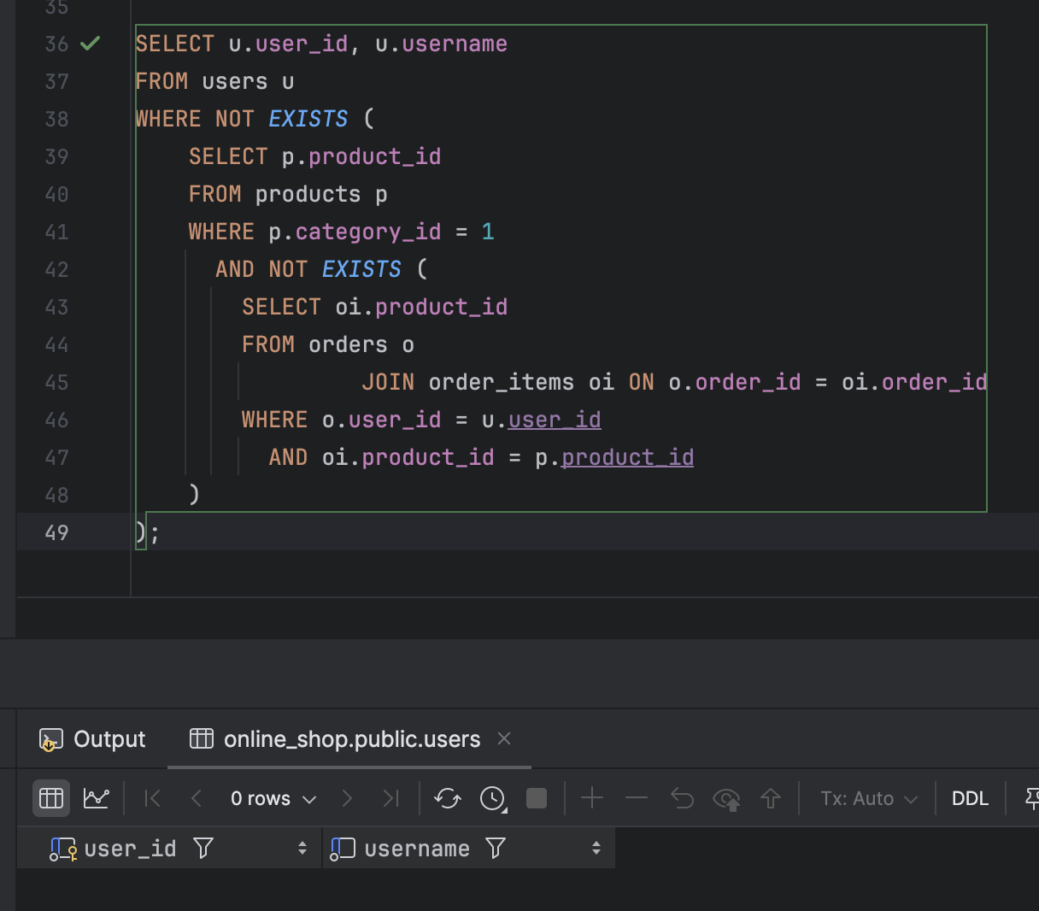

Рисунок 9 – Деление

1. Представление

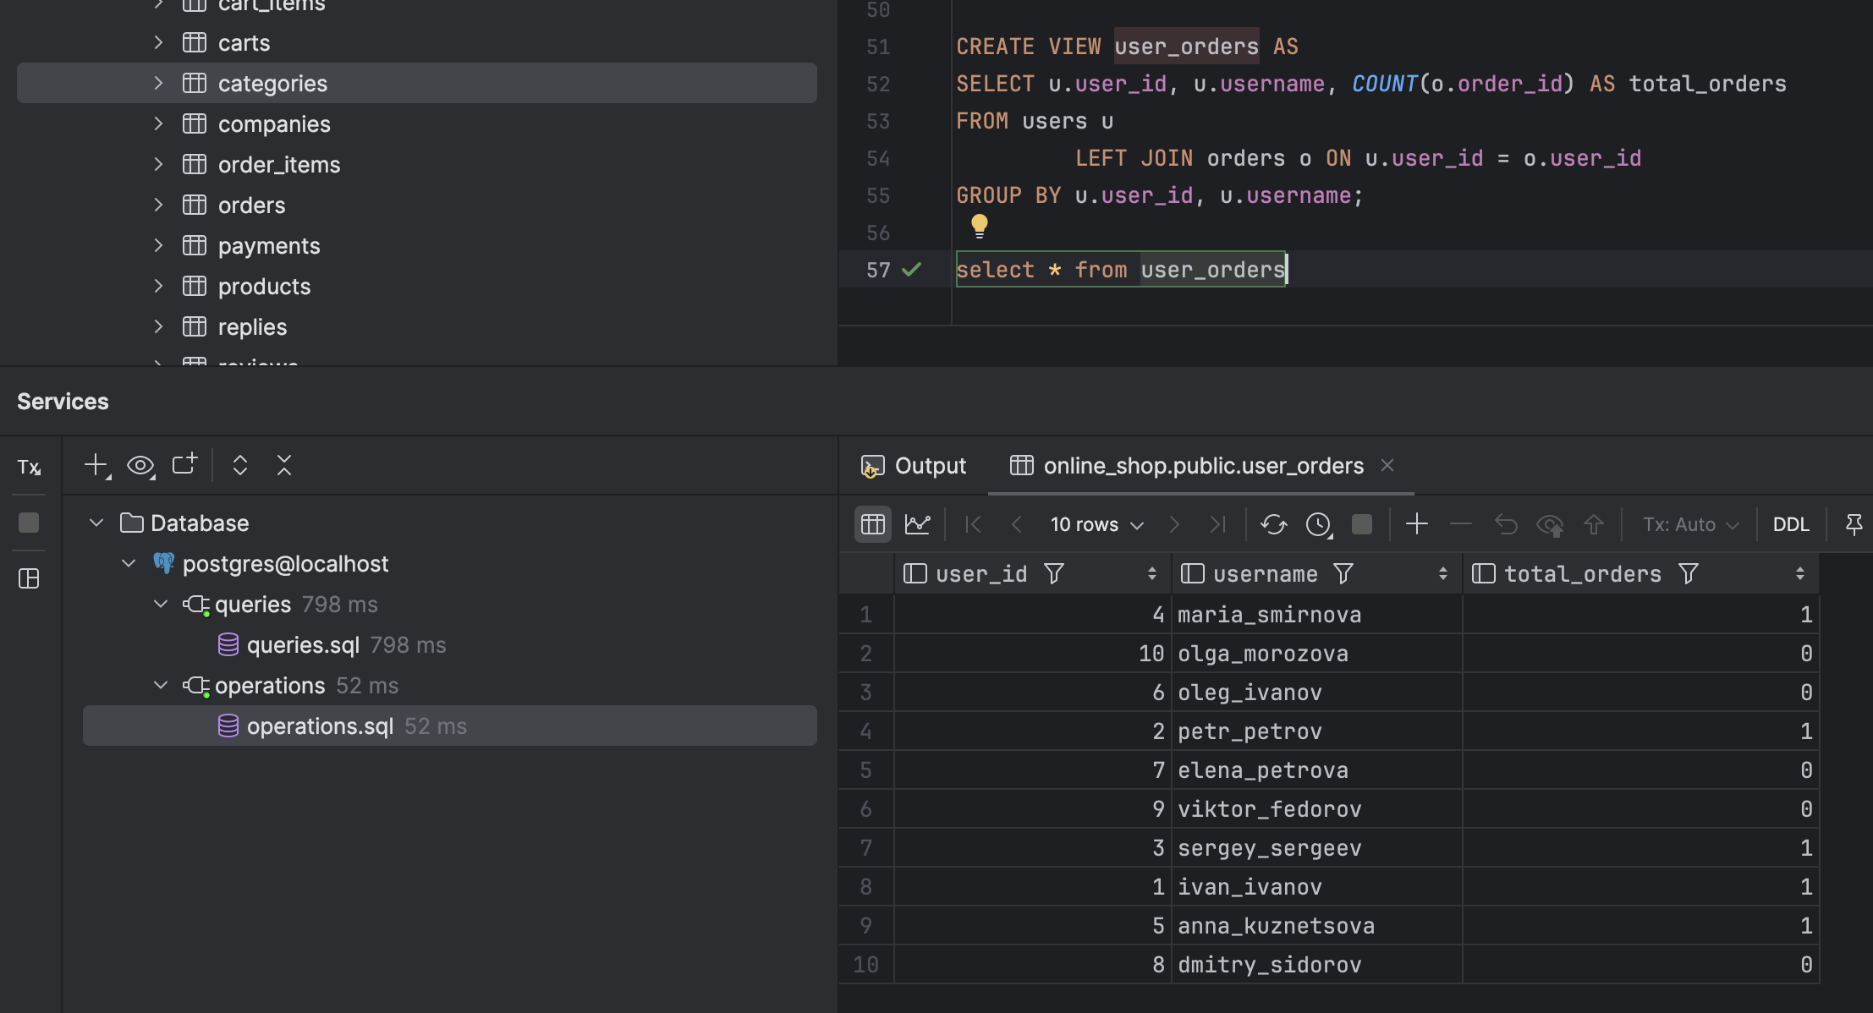

Рисунок 10 – Представление

# **Задание 5 – Функции и триггеры**

Postgresql не позволяет создавать процедуры. Здесь используются только функции. Еще одна особенность состоит в том, что функцию можно написать на разных языках. Наиболее распространены sql и plpgsql. Основное отличие языков состоит в том, что в sql доступны только операторы sql, а plpgsql имеет также операторы управления.

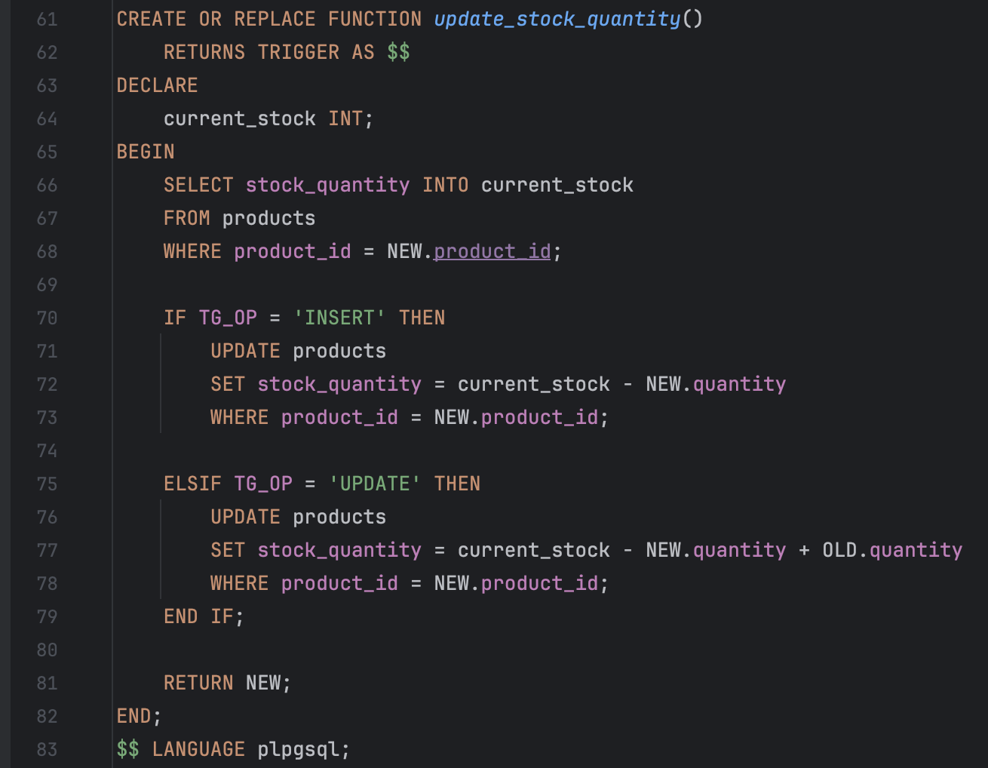

Рисунок 11 - Функция

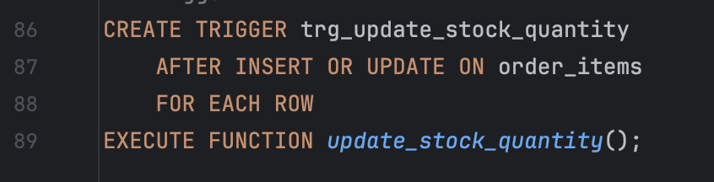

Рисунок 12 – Триггер