The Fable Computer
An introduction: room-temperature terahertz computing on a graphene-plasmon fabric — what it is, how far the case has been built, and what remains open.
Ryoji Furui · www.ryoji.info · July 2026 · companion to the Part I and Part II manuscripts · github.com/ryoji-info/FableComputer
Where this honestly stands. The Fable Computer is a design study, not a demonstrated device. Its claims are “in-model”: established within a transparent, reduced-order model chain that anyone can run from the public repository — not measured on hardware. The central physical assumption (regenerative gain in a Dyakonov–Shur graphene-plasmon cell at room temperature) has never been demonstrated experimentally. The manuscripts are not peer-reviewed, were prepared by an independent researcher with disclosed AI assistance, and say all of this on page one. This document keeps the same discipline: every number below is either a literature result (cited as such) or an in-model result you can regenerate with one command.

1. The problem: a bit that dies in a picosecond
Modern processors switch a few billion times per second. Pushing clock rates a thousandfold higher — into the terahertz — has stalled for decades: transistors run out of gain, wires become antennas, and optical approaches struggle to miniaturize. One candidate carrier has been hiding in plain sight. A graphene plasmon — a ripple in the electron fluid of an atomically thin carbon sheet — naturally oscillates near one terahertz, hundreds of times faster than a conventional clock, and it compresses that wave into a footprint about a hundred times smaller than its free-space wavelength. It does this at room temperature, in a material that wafer-scale fabrication already handles.
The catch is brutal: the ripple dies in about a picosecond. In transparent numbers, a passive plasmonic signal losing 2–4 dB per gate falls below any usable read threshold within five to ten gates — far too few to compute with. This single fact is why plasmonic logic has remained a curiosity: the medium is fast beyond anything electronics can offer, and it forgets the message almost immediately.
The established alternatives each pay a different price for speed. Superconducting single-flux-quantum logic reaches hundreds of gigahertz but lives at liquid-helium temperatures. Photonic processors multiply at the speed of light but struggle to restore digital levels, so errors accumulate, and their optics resist miniaturization. The question the Fable Computer asks is whether the plasmon’s one great defect — that everything decays — can be turned into the design’s organizing principle instead of its death sentence.

2. The idea: every gate is an amplifier
The Fable Computer is an architecture built around one answer: if the signal dies everywhere, it must be reborn everywhere — every gate is an amplifier. Each logic gate is the same physical object: a resonant plasmon cavity about 576 nanometres long, carrying a DC drift current, biased just below the threshold where it would self-oscillate (the Dyakonov–Shur instability). Held at 70% of threshold, the cell behaves as a regenerative amplifier: in-model, a passing pulse leaves roughly 8 dB stronger per pass, more than repaying the losses of the gate it just traversed. Logic levels are restored at every step against a saturating rail, so decisions never erode — the same discipline that made early vacuum-tube machines viable, rebuilt in an electron fluid.
The gain mechanism deserves a plain-language sketch. Run a DC current through a short plasmon cavity whose two ends are electrically different — one boundary open, one closed — and the drifting electron fluid does work on waves bouncing between them: each round trip, a wave returns slightly stronger. Push the current past a threshold and the cell breaks into spontaneous oscillation (that is the Dyakonov–Shur instability, predicted in 1993); hold it just below, and the cell is a stable, resonant amplifier that strengthens whatever coherent signal is fed into it. Because the amplified wave saturates against a nonlinear rail, the cell also cleans: a weak “1” grows toward the rail, a stray wisp of noise on a “0” does not. Amplification and level restoration — the two things a logic family cannot live without — come from the same physics. The residual ring-down between clock slots is real (the cavity rings for a few picoseconds) and is handled architecturally, by per-slot bias gating and periodic re-synchronization, rather than assumed away.
Three more choices complete the machine. The clock is a phase-stable optical pulse train, generated off-chip by a microcomb-photomixing chain and launched at the fabric edge, giving every cell a common femtosecond-class phase reference at a 0.25-THz slot rate. Memory lives in gate charge between operations. And logic is programmed, not wired: junction weights and per-cell bias set whether a cell computes an AND, an XOR, or a comparator — one cell family, many functions.

3. The demonstrator: a half adder
Part I designs the smallest machine that exercises everything a computer needs — gain, logic, fan-out, a carry: a half adder of five regenerative cells computing Sum and Carry. Its in-model operating point:
Quantity | In-model value | Note
Symbol rate | one addition per 4-ps slot (0.25 THz) | wave-pipelined
Throughput | 2.5 × 10¹¹ additions per second | one five-cell block
Energy | ≈ 0.4 fJ per addition (fabric-side) | excludes the photonic drive chain
Footprint | ≈ 12 × 16 µm | five cells and interconnect
Operating point | n = 10¹² cm⁻², L ≈ 576 nm, E_F = 117 meV | cavity tuned to 1 THz
Gain vs loss | +9.7 dB CW regenerative gain; ≈ +8 dB per pulse | against 2.17 dB per-gate loss at 300 K
Environment | room temperature, chip ≤ 80 °C | no cryogenics in Part I

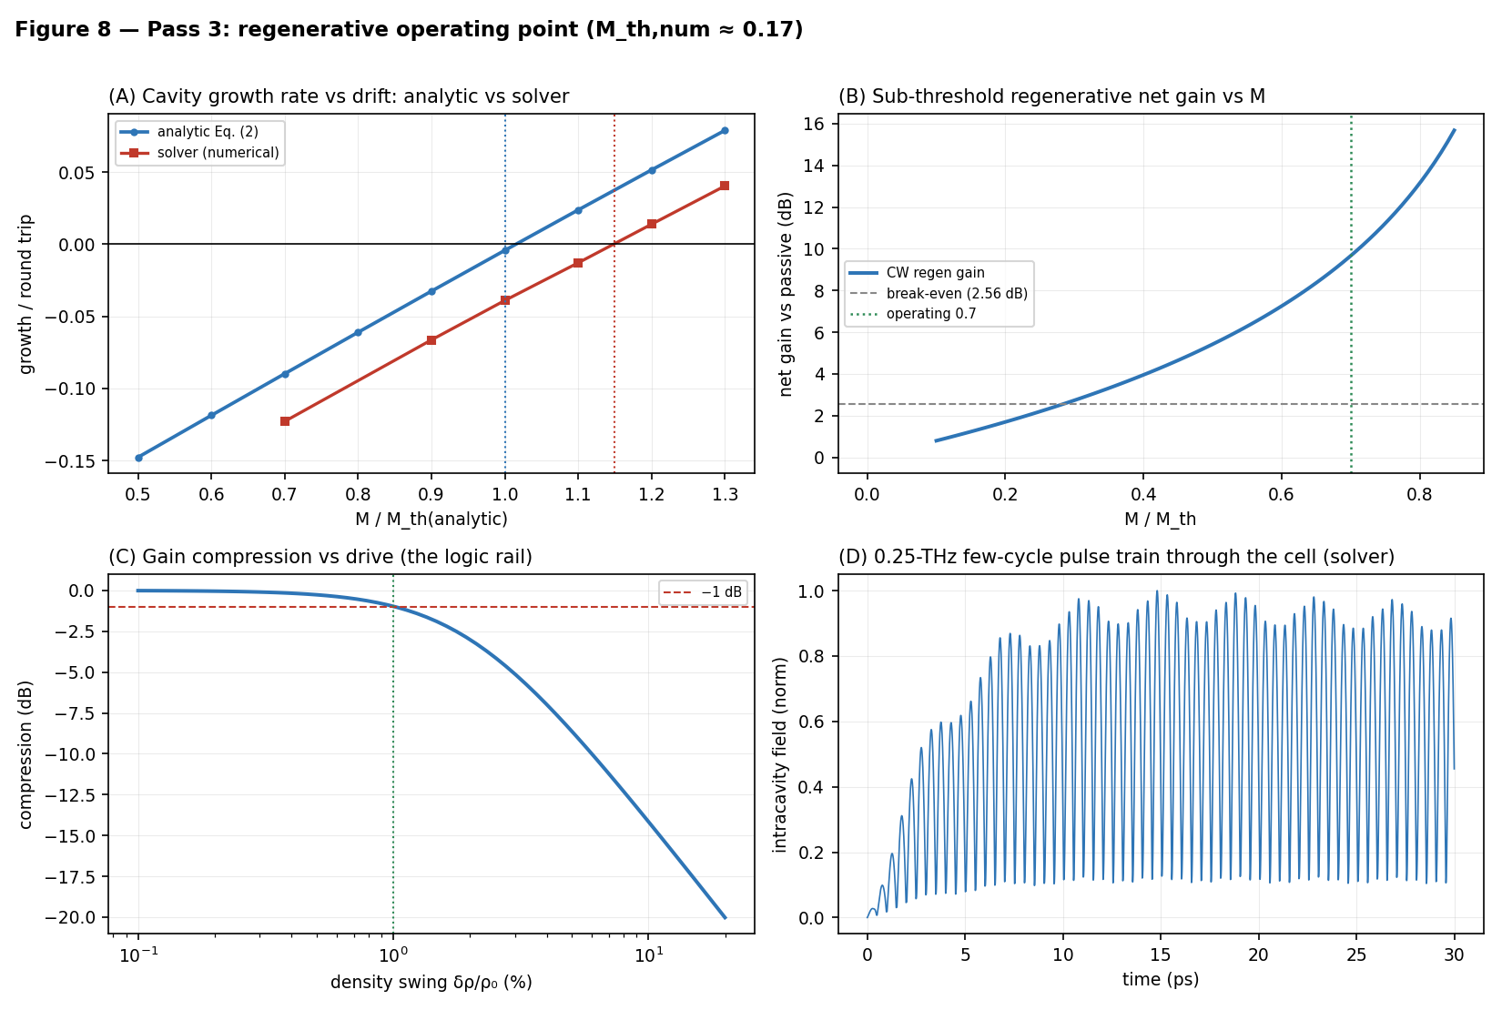
Figure 8 of Part I, regenerated by the public code: the regenerative operating point — analytic vs numerical threshold, sub-threshold gain, gain compression (the logic rail), and a 0.25-THz pulse train through the cell.

4. How the case is built — and what “in-model” means
A design like this is easy to claim and easy to fool yourself about. Part I therefore builds its case as a five-pass feasibility chain, each pass a transparent, reduced-order model with its assumptions stated:
- Pass 1 — brute limits. Could any operating point work at all? Bulk gain versus drift velocity, and the raw thermal budget of a chip that must stay below 80 °C.
- Pass 2 — the linear cell. Plasmon speed, cavity tuning, oscillation threshold, and per-gate loss (2.17 dB at 300 K) from first principles at the chosen operating point.
- Pass 3 — regenerative gain, computed twice. An analytic cavity transfer and an independent nonlinear shallow-water solver must agree — and do, to within a documented numerical artifact that shrinks as the grid is refined.
- Pass 4 — noise and yield. Every amplifier adds noise (the chain carries the standard regenerative noise figure, F = 2 − 1/G) and real graphene is disordered: a Monte-Carlo model ties cell yield to measured charge-puddle statistics and a stated threshold-sharpness rule.
- Pass 5 — validity. The hydrodynamic description itself is checked (electron–electron scattering at 115 fs keeps the fluid picture honest at the operating temperature), along with the stability of two coupled cells — the seed of a larger fabric.
Every number in the manuscripts is reproduced by pure-Python model chains published in the project repository. One command (run_all.py --json) regenerates them all; each module prints a self-check against the manuscript values. “In-model” is the project’s honesty label: established within this chain, under its stated assumptions — no more, no less. The chain’s own caveats (a numerically diffused solver threshold, calibration items owned by a future full simulation tier) are documented in the open, next to the code that produces them.

5. What quantum mechanics says (Part II)
Part II asks a question most architecture papers never reach: what happens when the machine’s pulses are treated as what they are — quantum fields? Quantizing the Part-I cell shows a logic pulse is a mesoscopic object: one plasmon is a 0.16% density swing, the cell’s linear range ends near 38 plasmons, and the full logic rail holds only about 3,800. Quantum noise is therefore a design input, not a footnote. Two results follow.
- An honest no-go. This fabric cannot host plasmonic qubits: the single-plasmon nonlinearity misses the blockade condition by five orders of magnitude, and closing the gap would demand ~3-nm cells that could not hold a 1-THz mode at all. Part II states the exclusion plainly rather than gesturing at “quantum computing”.
- A constructive result. Below its linear knee the fabric is a quantum-limited analog computer: coherent pulses interfere at gate-programmed junctions, and the same threshold cells that ran digital logic re-program into a 1–2-bit on-chip decoder (QMAC-1: two inputs, one interference, one decoded output — the Part-I half adder re-emerging as the decoder of a quantum interference).
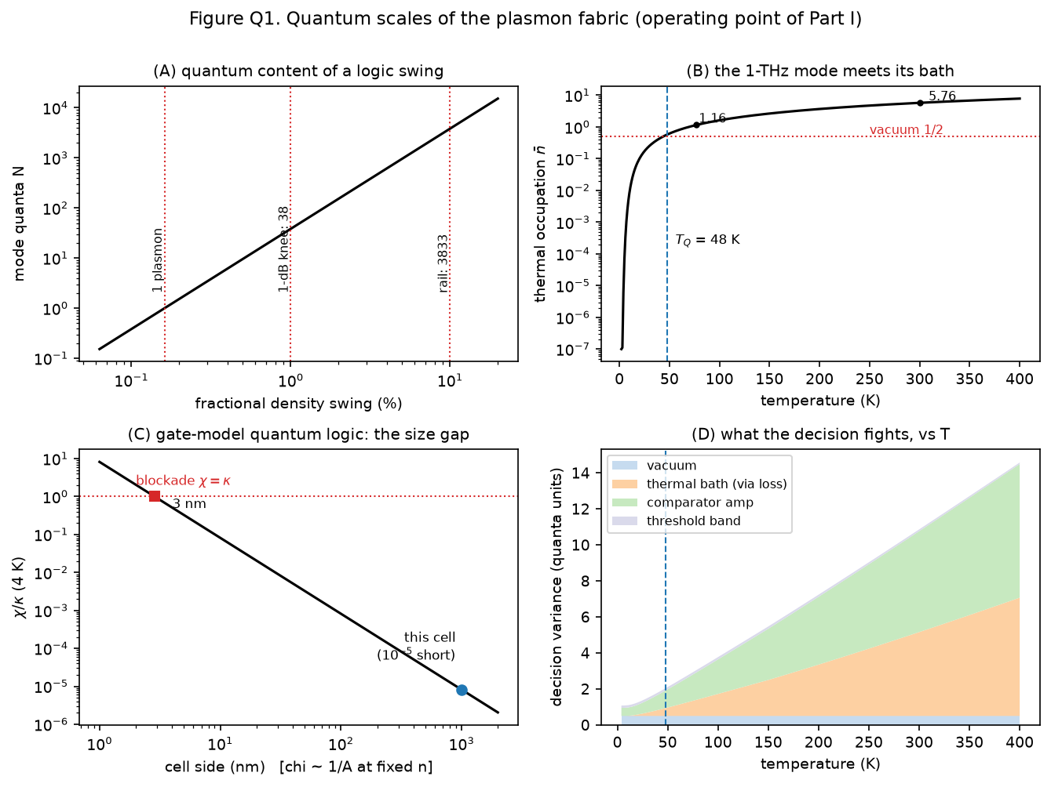
Figure Q1 of Part II, regenerated by the public code: the quantum scales of the fabric — quanta per logic swing, the 1-THz mode against its thermal bath (T_Q ≈ 48 K), the photon-blockade size gap, and what a decision fights versus temperature.
Part II then computes error rates versus temperature, locating the quantum–classical crossover at T_Q ≈ 48 K. Per-shot 2-bit decoding is unusable at room temperature (error 0.14) but reaches 3.1 × 10⁻³ at 77 K and a vacuum-set floor of 1.3 × 10⁻⁶ below about 20 K; 1-bit decoding already works warm (3.9 × 10⁻³ at 300 K); and averaging over 16 slots buys the 2-bit mode back at room temperature (~5 × 10⁻⁷) at one-sixteenth throughput. Below roughly 15–20 K the error curves stop improving no matter how cold the chip gets — that saturation is the quantum limit made visible, and observing it is one of the project’s pre-registered experimental gates. The cold operating classes are an explicit fork from Part I’s no-cryogenics charter, and are labeled as such.
Part II also sharpens the hardware requirements in two ways a builder should know. Quantum operation demands a near-shot-noise launch: a conventional classical source, whose noise sits a fixed 20 dB below its signal, pins every decode near a one-percent error at all temperatures — the analog modes only pay off if pulses are launched clean. And junction quality is a first-order lever: moving from the optimistic to the pessimistic end of Part I’s junction-loss band costs the cold-temperature error rates several orders of magnitude. Both are exactly the kind of constraint a feasibility study exists to surface before anyone spends money on a bench.

6. Where it would sit among the alternatives
If — and only if — the bench gates pass, the niche the Fable Computer claims is specific: restored, cascadable, wave-pipelined logic at a 0.25-THz symbol rate, without cryogenics, in a micrometre-scale footprint. That combination is what none of the incumbents offers: CMOS restores and cascades but two orders of magnitude slower; superconducting logic is fast but cryogenic; photonic tensor cores are fast and parallel but analog end-to-end, with weights and routing largely fixed at fabrication and results handed off to external electronics for digitization. The quantum-analog extension of Part II differs from photonic accelerators in the same three ways: the THz carrier is confined about a hundredfold below its free-space wavelength, weights are gate-voltage-programmable on chip, and the result is quantized by the same regenerative cell family that computes — no electronic converter enters the signal path.
The manuscripts are careful about the status of such comparisons: they are motivation, not superiority claims. Every incumbent above is demonstrated technology with decades of engineering behind it; the Fable Computer’s own gain cell is a published prediction with a single adjacent experiment. The comparison earns its place only by being falsifiable — which is what the bench protocol is for.

7. Demonstrated, modeled, open
The project’s credibility rests on keeping three categories separate:
- Demonstrated (literature). Every subsystem rests on a published precedent — on-chip THz plasmon transport, microcomb-photomixing clock chains, monolithic THz striplines. Room-temperature, current-driven amplification of THz radiation by graphene plasmons has been reported once (≈9% gain, 2020); its authors attribute the effect to a different mechanism than the one this design assumes. There is no second experiment. Part I, Section 2 states this plainly.
- In-model (this project). The operating point, gain budget, logic transfer, noise figure, disorder yield, thermal ceiling, and all of Part II’s error-rate curves.
- Open (the work ahead). A full kinetic-plus-electromagnetic simulation tier to replace the reduced-order calibrations; a pulsed extension of the demonstrated continuous-wave clock chain; and the bench experiment — five pre-registered pass/fail gates for Part I (G1–G5) and five for Part II (QG1–QG5), with thresholds fixed before any measurement. The single most informative outcome in the whole program, pass or fail, is the first cascade of two room-temperature plasmonic gain cells.

8. An open project
Everything lives in the public repository: both manuscripts (DOI 10.5281/zenodo.20674840 for Part I, 10.5281/zenodo.21185177 for Part II — the repository PDFs are byte-identical to the deposits), the model chains, the figures, and the documents that organize the work — a roadmap of adoptable work packages, a replication tracker that logs every reproduction attempt (failed ones prominently included), and community rules designed so that decisions, credit, and money are all recorded in plain, auditable files.
The project is built to be checked. Run the chain. Try to break it. If you find the error that kills the design, that is a headline contribution — and if no one can, each surviving pass is a reason to fund the next tier and, eventually, the bench. The companion document, Fable Computer Community Guidelines, explains how to take part.

Where to go next
If you want to… | Go to
Read the full technical case | papers/ in the repository · Part I: doi.org/10.5281/zenodo.20674840 · Part II: doi.org/10.5281/zenodo.21185177
Rerun every number yourself | fable-model-chain/ and fable-model-quantum/ · python run_all.py --json
Join in — code, critique, or a reproduction report | Fable Computer Community Guidelines (companion document) · CONTRIBUTING.md
See what needs doing | ROADMAP.md (work packages WP1–WP5) · REPLICATIONS.md (the tracker)

github.com/ryoji-info/FableComputer · info@ryoji.info · www.ryoji.info
© 2026 Ryoji Furui. This document is licensed CC BY 4.0. The Fable Computer code is Apache-2.0; manuscripts and figures are CC BY 4.0.

