The Fable Computer: A Room-Temperature Terahertz Half Adder on a Regenerative Graphene-Plasmon Logic Fabric
Concept, Architecture, and Reduced-Order Feasibility — Revision v5
Ryoji Furui · www.ryoji.info · June 2026
The machine described here is named the Fable Computer: a half adder — two input bits in, Sum and Carry out — realized on a clocked, regenerative graphene-plasmon logic fabric. Throughout this manuscript, “the fabric” names the technology and “the half-adder block” names the demonstrator built from it.
Authorship and Status Disclaimer. This manuscript is derived from the author’s original paper [1]. Generation of content involved the use of an AI, Anthropic’s Fable 5, at the author’s direction, including an AI-orchestrated literature-verification and consistency audit (June 2026) in which every reference was checked against its primary source and every quantitative claim independently re-derived. The author declares a lack of formal expertise in graphene-plasmonic device fabrication and full-wave electromagnetic simulation, and the document has not received independent expert review. The architectural and quantitative claims herein must be treated solely as a starting point for discussion, not as peer-reviewed engineering guidance. Formal expert review is required prior to any practical implementation.

Abstract
We present a machine model for room-temperature terahertz logic. The bit is a gate-screened (acoustic) graphene plasmon. Every logic gate is the same physical object — a resonant Dyakonov–Shur (DS) cell biased below its self-oscillation threshold and operated as a regenerative amplifier — and the system clock is a phase-stable pulse train launched at the fabric edge by a microcomb-photomixing chain. Logic levels are restored at every gate by saturating regenerative gain; inversion is a bias choice. Two constraints are locked from the outset: no cryogenics, and chip temperature ≤ 80 °C.
The demonstrator is a half adder: five regenerative cells computing Sum and Carry at one addition per 4-ps slot (2.5×10¹¹ additions/s, wave-pipelined), at ~0.4 fJ per addition on the fabric side, in roughly 12 × 16 µm. A five-pass reduced-order feasibility chain converges on one self-consistent operating point — n = 10¹² cm⁻², cell length L ≈ 576 nm tuned to 1 THz, drift bias parked at 0.7 of the self-oscillation threshold (the tracked ratio M/M_th = 0.7, Section 5) — at which a single cell delivers ~+8 dB net gain per pulse (a +9.7 dB continuous-wave regenerative gain) and two cascaded cells hold +8.4–9.3 dB per cell through junctions as lossy as −6 dB, all in-model (a term defined in Section 7: established within the reduced-order chain, not measured).
Three items remain open and are stated as such: a Boltzmann–Maxwell solve owning electromagnetic coupling and absolute calibration; the photonic synthesis of the pulsed clock, which extends a demonstrated continuous-wave chain; and a bench experiment, for which a five-gate pass/fail protocol with pre-registered thresholds is specified. The most informative single outcome, pass or fail, is the first cascade of two room-temperature plasmonic gain cells.

1. Introduction: the problem of the picosecond bit
A graphene plasmon is an attractive carrier for logic. It is programmable — a gate voltage sets, point by point, whether a region of the sheet supports the wave at all — and at terahertz frequencies the gate-screened (acoustic) mode confines the field to deep-sub-wavelength scales on a chip that needs no cryostat. Whether the bit is a genuine wave or an overdamped relaxation is decided by one number, the quality factor Q = ωτ, where τ is the plasmon’s momentum-relaxation lifetime. With the best graphene encapsulated in hexagonal boron nitride (hBN) — τ ≈ 1 ps at 300 K, a best-case value examined in Section 4 — Q reaches ≈ 6 at 1 THz.
The choice of ~1 THz as the carrier is a systems compromise, not a materials ceiling. Below ~0.5 THz two floors intrude: the quarter-wave cell grows well past its ~500-nm lithography pitch, surrendering the footprint advantage that justifies plasmons in the first place, and the carrier falls to within a few multiples of the 0.2–0.5 THz symbol rate, leaving too few carrier cycles to form a clean clock pulse; far above 1 THz the drive and read-out chain (photomixer power, demonstrated stripline bandwidth, Section 3) runs out first. The intrinsic loss channels of the stack — acoustic phonons and residual impurities — vary smoothly across this band; graphene’s optical phonons (≈ 47 THz) and hBN’s Reststrahlen bands (≈ 23–48 THz) lie more than an order of magnitude higher and play no role at 1 THz.
The same Q states the central obstacle. A lifetime of a picosecond means the wave loses ~4.3 dB of power per plasmon wavelength at 300 K (5.1 dB at the 80 °C cap): launched passively, a bit decays below any usable read threshold within a handful of gates. A machine — as opposed to a one-shot demonstration — therefore needs four things a bare plasmonic circuit does not have: distributed gain that at least cancels the loss at every gate; level restoration, so that decisions made early in a cascade do not erode; a clock distributable across millimetres at femtosecond-class phase; and memory, since nothing plasmonic survives between operations.
Each requirement is assigned to hardware that can plausibly deliver it. Gain is electrical. Each gate is a tiny plasmon cavity carrying a DC drift current — the configuration in which Dyakonov and Shur predicted that a gated transistor channel with asymmetric terminations goes unstable and self-oscillates at its plasma resonance [11]. Biased just below that self-oscillation threshold, the cavity acts as a regenerative amplifier: an injected pulse recirculates through the gain region many times before it leaves, and the saturating response doubles as the logic nonlinearity (Section 5). The experimental basis is deliberately stated with care: room-temperature, current-driven amplification of terahertz radiation by graphene plasmons has been demonstrated once, by Boubanga-Tombet et al. [2] — but its authors explicitly attribute the effect to a dissipative, phase-shift mechanism without any plasma instability, not to the DS mechanism, and follow-up theory offers a third reading [22]. Reference [2] therefore proves that DC current can pump energy into graphene plasmons at 300 K; it does not demonstrate the DS-cavity gain this design assumes, which remains experimentally unconfirmed (Section 2). Optically pumped gain, for its part, cannot be sustained beyond a sub-picosecond transient [3].
Timing is optical: the bias plane’s RC corner (~1 MHz at chip scale, ~10 GHz even per 10-µm segment) is orders of magnitude below 1 THz, so no electrically modulated clock is physically available; a microcomb-photomixing chain at the fabric edge launches the clock as a pulse train (Section 3.2 — with the pulse synthesis itself an extension of demonstrated hardware, flagged there). Restoration is intrinsic: every gate is the same gain cell, and its rails re-clamp the levels. Memory is electronic: bits persist as gate charge, not as plasmons (Section 6.4).
The machine built from these answers is deliberately the smallest complete one: a half adder — five regenerative cells computing Sum and Carry — specified to the level of cell map, timing, gain budget, and energy in Section 6.5, and feasibility-checked end to end by the five-pass model chain of Section 7. Section 8 gives the energy and thermal accounting; Section 9 collects device-implementation considerations; Section 10 reduces everything still unproven to five bench gates — pre-registered pass/fail milestones for the experiment, “gate” in the protocol sense, not logic gates — and one remaining solve.

2. Related work and positioning
Current-driven plasmon gain. The experimental anchor is the single demonstration of room-temperature, DC-current-driven terahertz plasmonic amplification, in asymmetric dual-grating-gate graphene structures: ~9 % radiation gain (≈ 0.4 dB), probed by pulsed time-domain spectroscopy [2]. Its authors exclude the Dyakonov–Shur instability as the explanation (resonance width does not narrow with current) and propose a dissipative phase-shift mechanism; later theory re-reads the same data as an amplified-mode-switching effect [22]. No second experiment has appeared as of June 2026. The DS instability itself [11] — asymmetric boundary conditions (AC-shorted gate-to-channel voltage at source, AC-open current at drain) driving a cavity instability — has a substantial theory literature for graphene, including hydrodynamic treatments with radiative loading [19], giant-gain grating-gate variants in simulation [21], and amplified-reflection instabilities below the Cherenkov threshold [20]. A kinetic Boltzmann–Maxwell treatment of drift-driven gain in gated graphene has recently appeared [18]. What does not exist anywhere in the literature, to the author’s knowledge, is this design’s elemental operation: sub-threshold regenerative amplification of injected plasmon pulses by a DS cavity. The closest precedents are regenerative resonance narrowing below threshold, demonstrated for detection [23], and the amplified drain-boundary reflection that is the textbook gain event of the DS mechanism [20]. This gap is exactly what bench gates G1–G4 of Section 10 test.
Drift nonreciprocity. A separate literature establishes how a DC drift bias breaks reciprocity for graphene plasmons: the co-drift (downstream) wave is dragged to longer wavelength and lower spatial damping, the counter-drift wave to stronger damping — measured directly as plasmonic Fizeau drag [24, 25] and analyzed for nonreciprocal devices [26, 27]. Section 6.1 builds the fabric’s routing on this sign: signals travel with the electron drift.
Competing room-temperature logic platforms. Table 1 positions the proposed fabric against the technologies a referee would name. The honest summary: CMOS wins on every axis except clock rate; superconducting single-flux-quantum logic (RSFQ, with its adiabatic AQFP variant) is excluded here by the no-cryogenics constraint; THz-capable electronic amplifiers (indium-phosphide high-electron-mobility transistors, InP HEMT: 9 dB at 1 THz [28]) and oscillators (resonant-tunneling diodes, RTD, to 1.92 THz [29]) exist but lack a restoring, cascadable logic family at those frequencies; graphene THz nonlinearities are strong [30] but unclocked. The niche claimed by this design is specific: restored, cascadable, wave-pipelined logic at a 0.2–0.5 THz symbol rate without cryogenics — a niche currently occupied by nothing, including this design, whose own gain cell is unproven. The comparison is offered as motivation, not as a claim of superiority.
Technology | Clock | Energy/op | Restoring logic? | Cryo-free? | Status
CMOS (IRDS 2023 [17]) | ~GHz | ~aJ–fJ | yes | yes | manufactured
RSFQ/AQFP supercond. [31] | 10–100 GHz | ~aJ | yes | no (4 K) | mature niche
InP HEMT THz amps [28] | to ~1 THz (analog) | — | no (amplifier) | yes | demonstrated
RTD oscillators/latches [29] | to ~2 THz (osc.) | ~fJ | latch only | yes | demonstrated
Photonic logic [16] | 10–100 GHz | ~fJ system | weakly | yes | research
Spin-wave/magnonic [32] | ~GHz | ~fJ | weakly | yes | research
This fabric (proposed) | 0.2–0.5 THz | ~0.4 fJ fabric-side (Section 8) | yes (regenerative) | yes (≤ 80 °C) | paper design; gain cell unproven

Table 1. Room-temperature-relevant logic technologies. Energy figures are order-of-magnitude and not normalized for function; the fabric-side figure excludes the photonic drive chain, which dominates (Section 8.1).
Subsystem precedents. Every subsystem of the fabric rests on a demonstrated technology; the fabric is the integration. Table 2 collects them, with the demonstration conditions stated — two of the five were demonstrated under conditions weaker than the fabric requires, and are flagged.
Subsystem | Demonstrated basis | Condition flags
Clock/data generation | microcomb-photomixing chain, chip-scale, phase-coherent [5] | CW two-tone at 560 GHz; pulsed-clock synthesis is a proposed extension (Section 3.2)
Clock-distribution phase control | optical interferometric locking, 9 mrad RMS residual [6] | demonstrated in a squeezed-light optical parametric amplifier at optical frequencies; cited as plausibility, not as a THz-clock demonstration
Launch, read-out, in-situ reference | monolithic generator/detector stripline circuit [7] | −3 dB bandwidth 440 GHz; extension toward 1 THz untested
Substrate and plasmon transport | sapphire / coplanar-waveguide (CPW) / hBN-graphene stack, on-chip THz plasmon wave packets [4] | demonstrated at 4 K; gated (screened) mode used a metal top gate
Free-space port (option) | graphene THz MIMO patch antenna, simulation-only, 3.75–6.46 THz [8] | no fabrication or measurement; cited as a design style
Per-cell gain mechanism | current-driven plasmonic THz amplification at 300 K [2] | ~9 % radiative gain; mechanism attributed by its authors to dissipative phase shift, not DS

Table 2. Subsystem precedents with demonstration-condition flags. The flags are part of the claim: where a precedent is weaker than the fabric’s requirement, the gap is named here and re-appears among the open items of Sections 9–10.
Relation to the author’s previous paper [1]. This manuscript supersedes [1] in four ways: the carrier moves from 100 GHz to ~1 THz with the symbol rate carried by a comb-locked pulse train; the gain element changes from a generic amplifying section to a specific resonant DS cell operated regeneratively below threshold; the feasibility argument is rebuilt as the five-pass chain of Section 7 with every parameter exposed; and the claims are bounded by a pre-registered bench protocol (Section 10). The machine-learning design-optimisation thread of [1] is dropped entirely.

3. Physical platform and drive chain

3.1 Substrate, stack, and the programmable gate lattice
The chip is built on sapphire (ε_r ≈ 9.4, tan δ < 10⁻⁴) carrying a segmented Au gate lattice, hBN-encapsulated monolayer graphene with one-dimensional edge contacts [33], and a top cap; the cell cross-section is shown in Figure 3a. The stack follows the on-chip terahertz plasmon circuit of Yoshioka et al. [4], with two caveats stated plainly. First, that demonstration was performed at 4 K; it is precedent for the launch-and-transport architecture, not for room-temperature plasmonics. Second, in [4] the gate-screened (acoustic) mode this design uses was obtained under a Ti/Au top gate, while the ZnO-capped device hosted the unscreened mode; the fabric’s cells therefore assume metal top-gate segments, with hBN of thickness d = 10 nm as the gate dielectric, and ZnO remains an option only where a THz-transparent global window is wanted.
The graphene channel is dual-gated: a global back gate sets the working density (n = 10¹² cm⁻², E_F ≈ 117 meV), while an electrode-mapping controller writes a per-segment voltage map onto the top-gate lattice. That density map is the program: it defines which cells are doped (active, amplifying) and which sit at the charge-neutrality point, CNP (dark, absorbing guard cells). The lattice pitch follows the gain cell of Section 5 — DS elements of L ≈ 576 nm — comfortably within deep-UV lithography.

3.2 The photonic clock chain: microcomb → DFB pair → photomixer
The clock generator builds on the microcomb-photomixing chain demonstrated by Tokizane et al. [5] as a chip-scale, fiber-bonded, phase-coherent terahertz source: a SiN soliton microcomb (one endurance run sustained > 24 h at 1 W pump) whose adjacent lines injection-lock a pair of distributed-feedback (DFB) lasers (one IQ-modulated for data), recombined and photomixed in a uni-traveling-carrier photodiode (UTC-PD), achieving 112 Gbps wireless transmission at 560 GHz (Figure 1).
One distinction is load-bearing: the demonstrated chain is two-tone photomixing, and a two-tone photomixer emits a continuous-wave (CW) carrier — it cannot emit a pulse train of any kind. The fabric’s clock — few-cycle pulses on a ~1 THz carrier at a 0.2–0.5 THz repetition rate — has a spectrum of four to six comb lines spaced at the symbol rate around 1 THz, and synthesizing it photonically requires (i) selecting that many phase-coherent comb lines (microcombs with 0.2–0.56 THz line spacing are demonstrated hardware [5, 34]), (ii) line-by-line amplitude and phase shaping, the established optical-arbitrary-waveform-generation technique [35], and (iii) a photomixer with adequate response across 0.5–1.5 THz [36]. Each ingredient exists; their combination at these frequencies does not yet. The pulsed clock is therefore classified as a proposed extension of demonstrated hardware, and joins the open-items list (Section 10).
Available launch power bounds the budget. Demonstrated CW UTC-PD output falls from ~mW at 300 GHz to single-digit µW at 1 THz (2.9–10.9 µW across device classes [36, 37, 38]); at ~3 µW, one 4-ps clock slot carries ~10 aJ — comparable to the fabric’s ~10 aJ/bit field energy (Section 8.1) before any coupling loss. The launch budget therefore closes only if the edge transducer from the photomixer’s mode into the acoustic-plasmon mode is efficient; that coupling efficiency is unquantified by any cited work and is named as an open item (Sections 9, 10).
Phase across the fabric is the easier half. Optical interferometric locks reach ~9 mrad RMS residuals [6] — 1.4 fs at 1 THz against the fabric’s 42 fs (±15°) budget, a ~30-fold margin. The cited demonstration is from a squeezed-light parametric-amplifier system at optical frequencies, so it is invoked as evidence of the achievable class of optical phase control, not as a THz-clock demonstration.
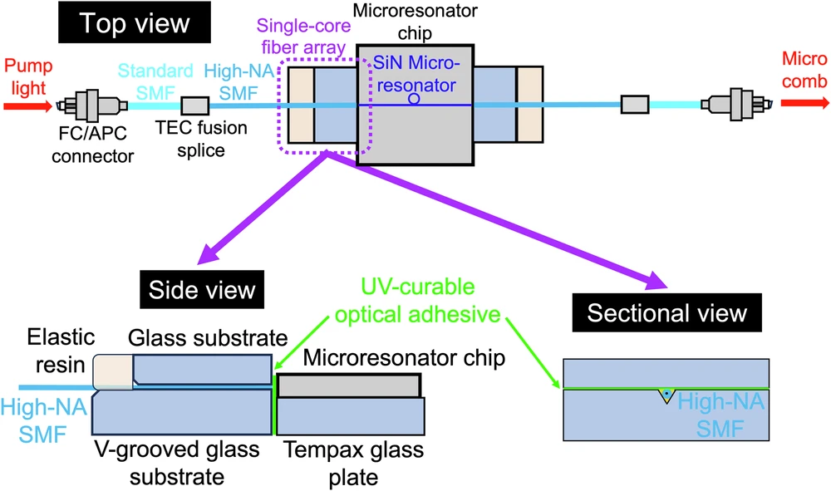
Figure 1. The drive/clock chain, reproduced from Tokizane et al. [5] (CC BY 4.0): a fiber-coupled SiN soliton microcomb feeds bandpass filters selecting two comb lines; these injection-lock two DFB lasers (one IQ-modulated); the recombined beams photomix in a UTC-PD to emit the carrier. As demonstrated, the chain emits a CW (data-modulated) carrier; the pulsed clock of this design requires the multi-line extension described in Section 3.2.

3.3 Launch, read-out, and in-situ reference
On-chip terahertz launch and detection follow the monolithic optoelectronic circuit of Kusyak et al. [7]: a generator photoconductive switch at the center of a coplanar stripline with two symmetric detector switches, providing odd-mode propagation, galvanic isolation between generation and detection, and — critically for a fabric that must be trimmed against fabrication spread — simultaneous in-situ measurement of signal and reference under identical conditions (Figure 2). The demonstrated switches are amorphous-silicon on sapphire, driven by 310-fs, 515-nm pulses; the demonstrated −3 dB bandwidth is 440 GHz, and its extension toward 1-THz carriers is an engineering assumption the bench protocol tests directly.
The fabric uses this one-launcher / two-detector / one-reference topology at the fabric edges for launch and Sum/Carry read-out, and reuses the detector/reference elements mid-fabric as the optical taps of the re-sync stations (Section 6.2). What no cited work supplies is the transducer from the stripline’s micron-scale mode into the ~100×-confined acoustic-plasmon mode: the mode-area, impedance, and velocity mismatches make this the least-quantified link of the chain. Yoshioka et al. [4] demonstrate that photoconductive launch into gated graphene plasmons works (at 4 K); the efficiency at 300 K on this stack is assigned to the Boltzmann–Maxwell tier — the full kinetic-and-electromagnetic modeling level of Section 10, one rung above this paper’s reduced-order chain — and to the bench (Sections 9, 10). A graphene patch antenna of the kind designed by Haque et al. [8] remains the free-space port option — noting it is a simulation-only design at 3.75–6.46 THz, cited as a style, not a demonstrated port.
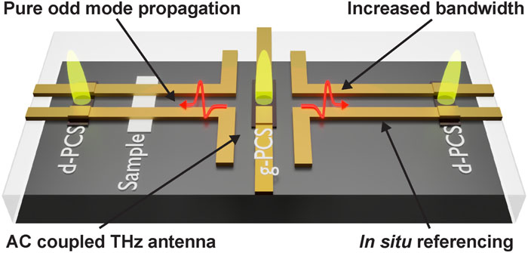
Figure 2. Monolithic launcher/detector/reference circuit, reproduced from Kusyak et al. [7] (CC BY-NC 4.0): APL Photonics 10, 076117 (2025): generator switch (g-PCS) centered on a coplanar stripline with two symmetric detector switches (d-PCS) — galvanic isolation plus in-situ referencing. Used at the fabric edges for launch/read-out and reused mid-fabric as re-sync clock taps.

4. Operating point
Parameter | Value | Note
Carrier frequency | ~1 THz (ħω ≈ 4.14 meV) | systems compromise: lithography and comb rate from below, drive/read-out chain from above (Section 1)
Symbol/clock rate | 0.2–0.5 THz (0.25 THz baseline) | few-cycle pulses; set by comb line spacing
Plasmon mode | acoustic / gate-screened (metal top gate) | required for confinement and gate programmability [4]
Quality factor Q = ωτ | 6.3 (300 K) / 5.3 (80 °C) | τ ≈ 1.0 ps → 0.85 ps at the cap; best-case material (see text)
Carrier density n | 10¹² cm⁻² (E_F ≈ 117 meV) | selected by disorder from below, gain and heat from above (Section 7)
Plasmon speed s | 2.2–2.3×10⁶ m/s (design value 2.33×10⁶) | Eq. (1) at d = 10 nm, ε_z(hBN) ≈ 3.4–3.8
Plasmon wavelength λ_p | ≈ 2.3 µm | s/f₀
Logic cell | DS cavity, L = (s/4f₀)(1−M²) ≈ 576 nm | drift-corrected quarter wave, Eq. (4); M is the drift Mach number v₀/s (Section 5)
Drift bias | M/M_th = 0.7 (tracked ratio); M ≈ 0.10, v₀ ≈ 2.4×10⁵ m/s at 80 °C | M_th ≈ 0.147 (80 °C), 0.125 (300 K), Eq. (3); calibrated in situ by approach to self-oscillation
Lithography class | ~500 nm | deep-UV
Chip temperature | ≤ 80 °C, no cryostat | locked requirement; 55 K rise budget over 25 °C ambient

Table 3. The operating point. Temperatures are tagged throughout the manuscript: τ, Q, M_th and the loss figures all differ between 300 K and the 353 K cap, and every number is quoted with its temperature. The bias row carries the deepest commitment: the operating point is a tracked ratio to the measured threshold, not an absolute Mach number (Section 5).
Three rows of Table 3 carry the design. The frequency row is the Q = ωτ argument of Section 1: at 1 THz the bit is a genuine wave, and passive loss (~4.3 dB per λ_p at 300 K, 5.1 dB at 80 °C; equivalently 27.3/Q dB) is steep enough to force distributed gain but shallow enough for a regenerative cell to beat.
The lifetime row is a best-case assumption, stated as such: τ = 1 ps at n = 10¹² cm⁻² corresponds to mobility ≈ 86,000 cm²/Vs at 300 K — inside the demonstrated envelope of hBN-encapsulated graphene (~140,000 cm²/Vs near the acoustic-phonon limit [33]) but premium-material territory. The measured room-temperature baseline for propagating acoustic THz plasmons is shorter (τ ≈ 0.4–0.6 ps, Q ≈ 2.4–3.8 [39, 40]); the fundamental, phonon-set ceiling on plasmon lifetime in this stack is mapped in [42]; and gate-metal ohmic loss, not included in τ, adds to the budget at small d [41]. The protocol’s calibration sequence measures τ on-die first (Section 10).
The density row is the most constrained choice, squeezed from both sides. From above: at n = 10¹³ cm⁻² the drift-gain route fails twice over — the saturation velocity caps the drift Mach number far below threshold, and the drive heat would allow < 1 % duty under the 80 °C cap (Sections 7.1–7.2). From below: at n = 10¹¹ cm⁻² the logic swing becomes comparable to the charge-puddle inhomogeneity of even the best material, and cell yield collapses (Sections 7.3–7.4). n = 10¹² cm⁻² survives all constraints simultaneously.

5. One cell, all gates: the regenerative threshold logic family
Every logic gate in the fabric is the same object: a resonant DS cell — a gated-graphene cavity with asymmetric boundary conditions (source side density-clamped, drain side current-clamped [11, 19]) carrying a DC drift of velocity v₀ = M·s, where the Mach number M measures the drift in units of the plasmon speed s — biased below its self-oscillation threshold (Figure 3a). This section states the cell’s working relations as numbered equations; everything quantitative in the manuscript leans on them.
The acoustic-plasmon speed under a metal gate at distance d follows the gated local-RPA dispersion [39, 40]:
s = v_F (1 + g) / √(1 + 2g), g = 2e²k_F d / (πε₀ ε_z ħ v_F) (1)
with k_F = √(πn) and ε_z the out-of-plane permittivity of the hBN spacer. At n = 10¹² cm⁻², d = 10 nm and ε_z ≈ 3.4–3.8, Eq. (1) gives s ≈ 2.2–2.3×10⁶ m/s; the design value 2.33×10⁶ m/s sits at the top of that band, and a ~5 % softer s would shorten L and the footprint proportionally without touching the threshold (see Eq. (3)). The constraint s > v_F against Landau damping is met with factor ≈ 2.3.
The DS small-signal increment for the asymmetric cavity — the per-second growth (positive) or decay (negative) rate of the cavity mode — with momentum relaxation included at the amplitude convention, is [11, 19]:
ω″ = [(s² − v₀²) / (2sL)] · ln[(s + v₀)/(s − v₀)] − 1/(2τ) (2)
Setting ω″ = 0 and expanding at small M gives the threshold in a form that exposes its invariances:
M_th ≈ L/(2sτ) ≈ 1/(8 f₀ τ) (3)
— independent of s and d once the cell is tuned to f₀, and proportional to temperature through 1/τ ∝ T. At f₀ = 1 THz: M_th ≈ 0.147 at the 80 °C cap (τ = 0.85 ps) and ≈ 0.125 at 300 K. The drift also retunes the cavity: the fundamental of the biased asymmetric cell is
f₀ = (s/4L)(1 − M²) (4)
so the 1-THz cell is slightly shorter than the zero-drift quarter wave (583 nm): L ≈ 576 nm at the operating bias.
The operating point is a tracked ratio. Because M_th scales with temperature, an absolute Mach number is not a valid specification: a bias fixed at 0.7·M_th(353 K) crosses the ringing onset at 0.8·M_th(T) — the bias ceiling established below — after only ~44 K of cooling. The specification is therefore the ratio M/M_th = 0.7, with M_th calibrated in situ by approach to self-oscillation — at the 80 °C cap this corresponds to M ≈ 0.10, v₀ = M·s ≈ 2.4×10⁵ m/s. For the same reason, every solver result in Section 7 is reported relative to the solver’s own threshold (Section 7.3), never as an absolute Mach number.
The cell’s compact transfer model is a sigmoid with saturating rails:
A_out = A_pump · g(n_local), g(n) = g_max · ½[1 + tanh((n − n_th)/Δn)] − ℓ, n_local = n_bias − β·A_in (5)
where A_pump is the clock-pulse amplitude the cell amplifies, A_in the logic-input amplitude arriving from upstream gates, g_max the small-signal gain, ℓ the linear loss, n_th and Δn the threshold center and width, and β converts input amplitude into a local density shift. Logic follows from bias and coupling sign. The input couples to the cell’s density through a gate segment, so its sign is a polarity choice: park n_bias above n_th with depleting coupling and a HIGH input pushes the cell below threshold (gain off → output LOW) — inversion as a bias choice. AND and OR are the same cell with enhancing coupling and the threshold applied to the sum of two input fields: a high threshold fires only on both inputs (AND), a low threshold on either (OR). Three quantitative properties make the family viable, all established within the model chain of Section 7:
Regeneration condition. The cell restores levels only if the threshold sharpness k = β·A_swing/Δn (A_swing is the rail-to-rail input swing) exceeds ~5; the design rule is k ≥ 8 with on/off extinction ≥ 10 dB, giving a static noise margin ≈ 0.2 of the logic swing (0.26–0.35 at k = 16, 13–20 dB extinction).
Saturating rails. The nonlinear solve shows 1-dB gain compression at δρ/ρ₀ ≈ 1 % and ~14 dB compression at 10 %: the logic swing belongs at the knee, and the rail is what re-clamps levels gate after gate (observed directly in the cascade solve, Section 7.4).
Bias ceiling. Above ~0.8·M_th the resonator rings between clock pulses (5 dB pulse-to-pulse spread at 0.94·M_th): the usable window is 0.5–0.8·M_th — at the 80 °C cap, M ≈ 0.073–0.117 — with 0.7·M_th the working point.
A precedent note, stated plainly: sub-threshold regenerative amplification of injected pulses by a DS cavity has no direct experimental or theoretical literature precedent. Its nearest relatives are regenerative resonance narrowing below threshold (demonstrated for detection [23]), amplified boundary reflection (standard DS theory [20]), and giant-gain grating-gate simulations [21]. The concept lives or dies at bench gate G1 (Section 10).
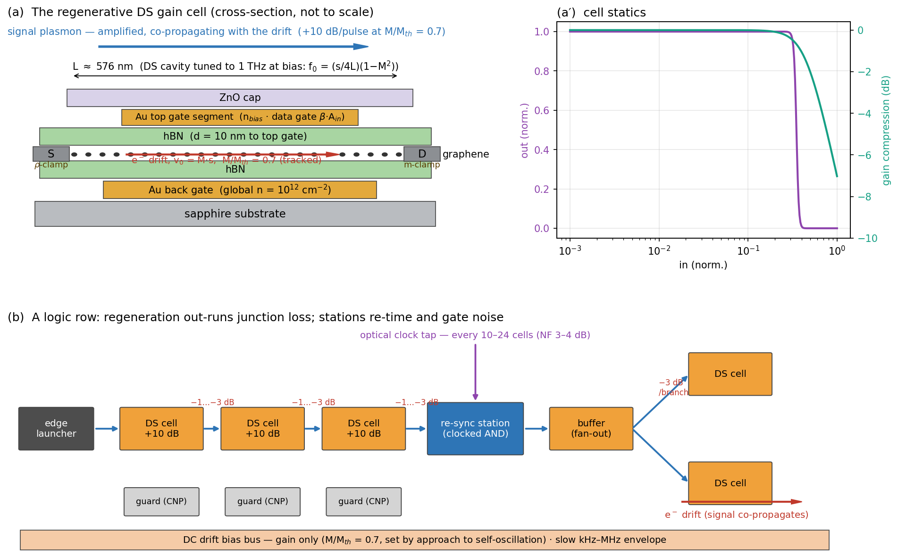
Figure 3. The regenerative DS gain cell and its use in a logic row. (a) Cross-section on the Section 3.1 stack: the L ≈ 576 nm cavity between a density-clamped source contact and a current-clamped drain; the signal co-propagates with the electron drift (Section 6.1). (a′) Cell statics: the inverting tanh transfer of Eq. (5) and the saturating rail. (b) A logic row: per-cell regeneration out-runs junction loss; a clocked re-sync station re-times pulses and blocks amplifier noise every 10–24 cells; fan-out branches from buffer cells; CNP guard cells absorb strays.

6. Architecture
Figure 4 assembles the whole machine: the photonic chain of Section 3.2 on the left generates clock and data pulses; the fabric of DS cells amplifies and routes them under the gate-map program; the DC bias bus below supplies gain only; the read-out elements of Section 3.3 sit on the right; and an electronic layer wraps the fabric for storage and trim.
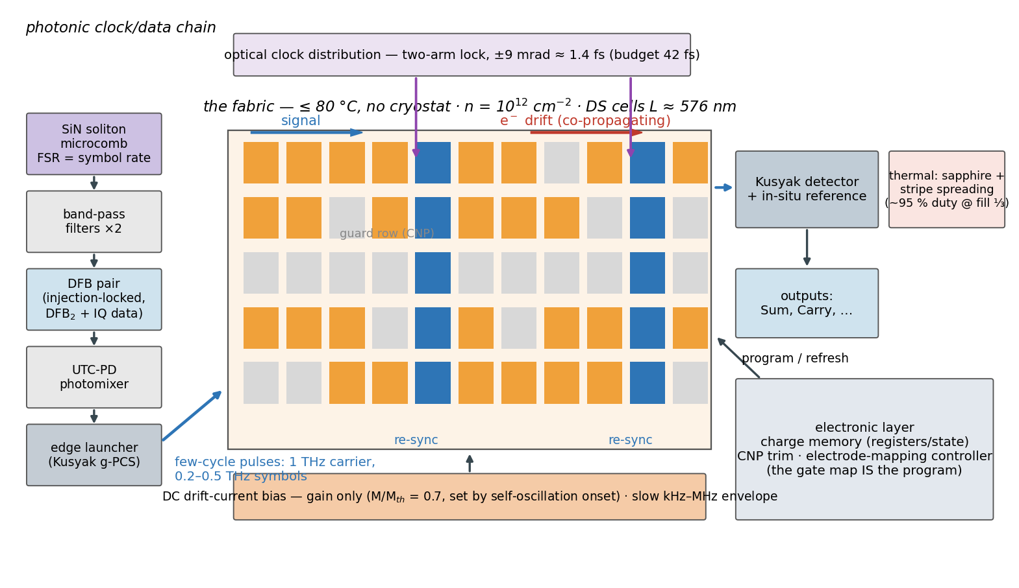
Figure 4. System view. Left: microcomb → injection-locked DFB pair (IQ data) → UTC-PD photomixer → edge launcher; few-cycle pulses at 1 THz carrier, 0.2–0.5 THz symbol rate (proposed extension of the demonstrated CW chain, Section 3.2). Center: the ≤ 80 °C fabric — rows of regenerative DS cells (one cell = one gate) with re-sync stations fed by optical clock taps, CNP guard rows, signal co-propagating with the electron drift. Bottom: the DC drift bias (gain only, M/M_th = 0.7) with slow envelope gating. Right: monolithic read-out and the electronic charge-memory/trim layer.

6.1 Gain and routing: one DC drift bias, two directional effects
A uniform DC drift bias supplies the gain; the gate map programs which cells couple to it. Cells parked at the charge-neutrality point are dark and absorbing — the gate pattern defines both the signal paths and the gain, suppressing cross-talk.
Two directional effects must be kept distinct, because they invite opposite intuitions. First, the DS gain is a cavity effect, not a traveling-wave gain: energy enters at the current-clamped drain boundary, whose reflection coefficient (s + v₀)/(s − v₀) exceeds unity, and the cell amplifies its resonant mode as a whole, returning energy to both ports. The cell’s directionality is a bias-orientation property — reversing the drift relative to the asymmetric boundaries turns the increment of Eq. (2) into a decrement — not a property of the signal’s transit direction. Second, the drift partitions the bulk damping nonreciprocally: both branches of ω = (s ± v₀)k decay at the same temporal rate 1/(2τ), so the spatial attenuation is
κ± = 1 / [2τ(s ± v₀)] (6)
per unit length — the wave co-propagating with the electron drift is the less damped one, in agreement with the drift-nonreciprocity literature and the Fizeau-drag experiments [24–27]. Signal routing therefore follows the electron drift. At the operating bias the contrast (s + v₀)/(s − v₀) ≈ 1.2–1.3 amounts, via Eq. (6), to ≈ 0.26 dB per cell transit at 300 K (≈ 0.31 dB at 80 °C) — a useful forward bias, but an order of magnitude short of isolation, and this design claims no built-in isolator from the drift.
Suppression of reflective loops is accordingly not claimed from the drift. It rests on four architectural mechanisms: the pulsed clock (gain exists only during clock slots), the noise-flushing re-sync stations (Section 6.2), the absorbing CNP guard cells, and junction loss. The residual round-trip stability of coupled cells through the charge channel is checked directly in Section 7.5; the radiative coupling channel remains with the Boltzmann–Maxwell tier (Section 10).

6.2 Clock: the launcher pulse train
Timing is generated at the fabric’s left-edge pulse generator — the Section 3.2 chain — emitting few-cycle 1-THz pulses at a 0.2–0.5 THz repetition rate. The DC bias carries no timing; it is gated only by a slow envelope (kHz–MHz, comfortably inside the bias-plane RC corner) for power management and noise flushing. The phase budget closes with ~30-fold margin (Section 3.2).
Three riders attach. (i) Re-sync stations: a launcher-only clock is a source-synchronous wave pipeline, so jitter accumulates; clocked-AND re-timing cells, fed optically by the same comb through mid-fabric taps (Section 3.3), are inserted every 10–24 gates — the spacing set by the noise budget: with launch SNR 20 dB and 6 dB margin, the accumulated noise (≈ NF + 10·log₁₀ N over N restoring cells) holds station spacing to ~12/6/3 cells for per-cell noise figures of 3/6/10 dB, making NF ≲ 4 dB the sharpest requirement on the cell (Section 7.2). (ii) ASE and ring-down flushing: the clocked re-sync stations pass energy only during their clock slots, flushing both accumulated amplified-spontaneous-emission (ASE) noise and residual cavity field. The DC bias itself carries no per-slot timing — it is gated only by the slow (kHz–MHz) envelope above, far below the symbol rate — so this flushing is the stations’ job, not the bias’s. (iii) Inter-symbol interference (ISI): two timescales matter. Carrier-density recovery (~τ ≈ 0.85 ps against 2–5 ps slots) leaves pattern-dependent gain negligible on its own (< 0.1 dB spread at the 0.25 THz baseline, Section 7.2). The binding effect is the regenerative cavity’s ring-down: at the working bias it is ~4–5 ps, comparable to the slot, so residual field carries pattern memory from one slot to the next. The same ring-down lifts the per-pulse gain toward its streaming value (Section 7.3); its data-dependent part is contained by the saturating rail at every cell and reset by the clocked re-sync stations, so the ring-down co-sets the re-sync spacing alongside noise. Quantifying the residual data ISI under realistic patterns and spacing is an open item for the bench and the Boltzmann–Maxwell tier (Section 10).

6.3 Fan-out
A Y-split costs 3 dB per branch plus junction loss. At the working point the regenerative cell delivers ~+8 dB per pulse (Section 7.3), so fan-out of 2 with restoration headroom closes: +8 dB against 3 dB split plus 1–3 dB junction loss leaves 2–4 dB of margin before the rail. The margin is real but modest; higher fan-out uses dedicated buffer tiles (Figure 3b).

6.4 Memory: compute in plasmons, store as charge
Stated plainly: there is no native plasmonic storage at ~1 ps lifetimes. The bit’s persistent home is the charge on a cell’s gate (DRAM-like, slow, refresh-limited); pumped bistable cells and recirculating loops serve only small fast registers. The fabric is a plasmonic datapath wrapped in an electronic memory layer — a hybrid by design, not by concession. The interface devices of that layer (charge sensing, refresh, level conversion to the launcher drive) are conventional electronics and are itemized in Section 9.

6.5 The machine: a half adder
The half-adder block computes the textbook decomposition S = (A OR B) AND NOT(A AND B), C = A AND B, mapped onto five active cells — OR (low threshold), AND (high threshold, doubling as the carry source), NOT (inverting bias), one delay buffer, and the output AND — plus two optional buffers that align the carry to the sum’s slot (Figure 5). Both fan-outs in the netlist are fan-out-2, exactly the budget Section 6.3 provides. The two inputs of the output AND arrive through equal depth (OR→DLY vs AND→NOT), so the design needs no asymmetric timing trim; total logic depth is three cells. Operation is wave-pipelined: successive additions follow one another through the fabric one clock slot apart, with no latches between gates. Table 4 gives the truth table including the intermediate signals; Table 5 collects the block specification.
A | B | OR | AND (= C) | NOT | S
0 | 0 | 0 | 0 | 1 | 0
1 | 0 | 1 | 0 | 1 | 1
0 | 1 | 1 | 0 | 1 | 1
1 | 1 | 1 | 1 | 0 | 0

Table 4. Half-adder truth table. The OR, AND and NOT columns are the intermediate plasmonic signals at the three internal cells; S and C are the read-out ports.
Metric | Value | Derived in
Throughput | one addition per 4-ps slot = 2.5×10¹¹ additions/s (wave-pipelined, 0.25 THz baseline) | Section 6.5
Latency | ≈ 1 ps (depth 3, sub-slot) | Figure 5c
Logic depth / fan-out | 3 cells / ≤ 2 everywhere | netlist, Figure 5a
Worst-path gain budget | launch → −3 dB split → +8 dB cell → −1…−3 dB junction → +8 dB cell → junction → +8 dB cell → read-out; rails re-clamp at every stage | Sections 6.3, 7.4
Footprint | ~11 × 7 lattice sites ≈ 12 × 16 µm incl. guards, clock tap, read-out boundary | Figure 5b
Drive power (7 biased cells: 5 logic + 2 carry-alignment buffers) | ~0.09 mW at the operating bias (1.2 kW/cm² × 7 × 10⁻⁸ cm²); up to ~0.12 mW at the upper calibration bound | Section 8.1
Energy per addition (fabric side) | ≈ 0.35–0.5 fJ | Section 8.1
Internal re-sync stations | none needed (depth 3 ≪ 10–24-cell spacing); one station at the read-out boundary | Section 6.2

Table 5. Half-adder block specification. The drive-power and energy ranges span the analytic operating bias and the upper, solver-class calibration bound; Section 8.1 derives both.
The block’s defining property is that its outputs are launch-grade: S and C leave at full rail amplitude, re-timed at the boundary station, and can drive the inputs of a following block — two half adders and an OR compose a full adder; full adders compose a ripple-carry word. Nothing about the five cells is special to addition: they are the generic gate vocabulary (threshold-AND/OR, bias-inversion, buffering) of the fabric at large. The half adder is simply the smallest machine that exercises all of it — which is why it, and not a larger demonstrator, is what the feasibility chain of Section 7 and the bench protocol of Section 10 are sized against.
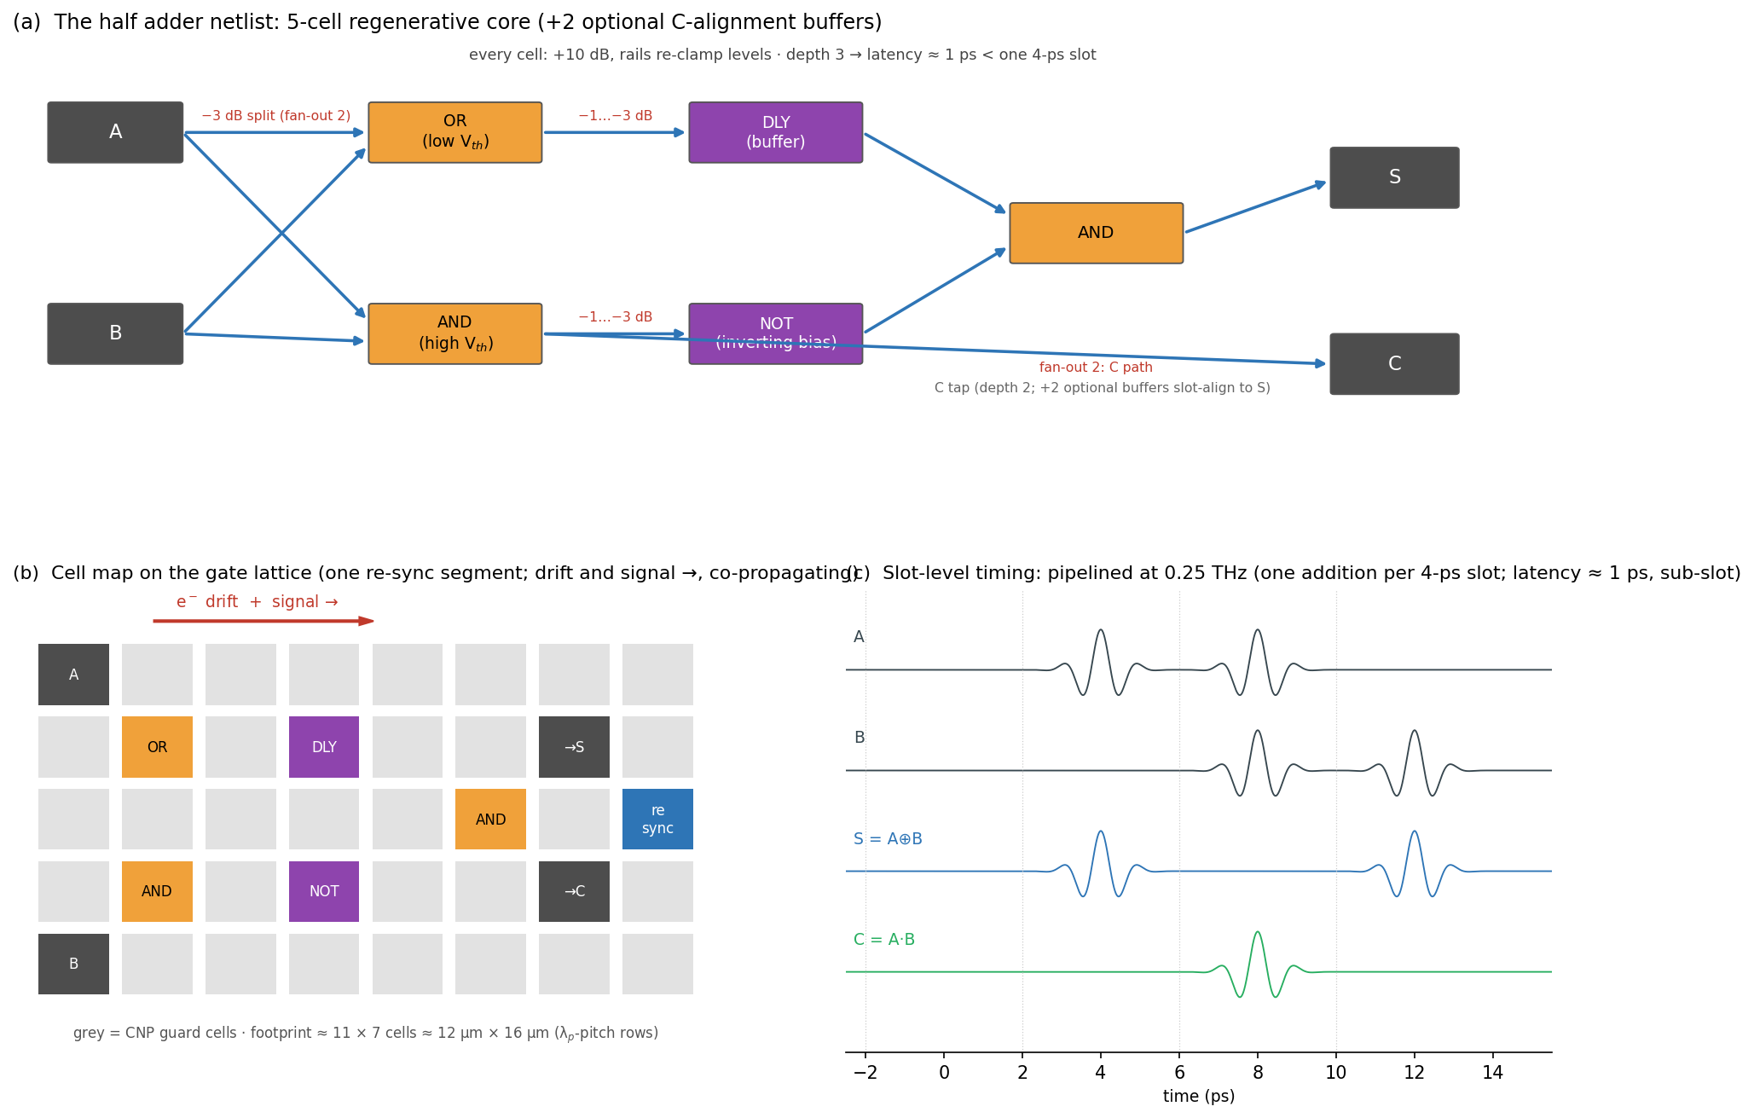
Figure 5. The half-adder block. (a) The netlist: five regenerative cells (OR, carry-AND, inverting-bias NOT, delay buffer, output AND) with fan-out-2 splits and per-edge junction losses annotated; two optional buffers slot-align the carry. (b) The cell map on the gate lattice — one re-sync segment; signal and electron drift co-propagate; gray cells are CNP guards. (c) Slot-level timing at 0.25 THz: a pipelined add stream with S = A XOR B and C = A·B emerging at sub-slot latency.

7. Feasibility: the five-pass chain
Each pass is a deliberately transparent reduced-order model. “In-model” throughout this manuscript means: established within this chain, under its stated assumptions, and not yet measured. The chain is ordered so that each pass either kills the design or sharpens the next pass’s question — in brief: Pass 1 rules out brute-force bulk gain and selects resonant cells; Pass 2 finds the low-density window where a resonant cell breaks even; Pass 3 locates the regenerative operating point; Pass 4 establishes cascade, noise, and yield; Pass 5 bounds the model’s own validity. This section reports results only; the governing equations, conventions, and the runnable solver for each pass are collected in Appendix A. All bias-dependent results are reported relative to threshold (Section 7.3).

7.1 Pass 1 — bulk gain and brute thermal limits (the double no-go)
A drift-Doppler cascade model established two independent failures at the highest candidate density, n = 10¹³ cm⁻² — the natural first choice for a robust, well-confined plasmon. Bulk convective gain is impossible: the density-dependent saturation velocity v_sat(n) ≈ ω_OP/k_F, with ω_OP the graphene optical-phonon frequency (≈ 4.5–5.4×10⁵ m/s at 10¹³ cm⁻² [9], against s ≈ 4×10⁶ m/s there) caps v_d/v_p at ≈ 0.13, so uniform drift can at best halve the per-gate loss — transparency is unreachable. Independently, the drive heat at that density (~190 kW/cm² at v_sat) caps the duty cycle at well under 1 % at any fill convention under the 80 °C budget. Both failures point the same way: lower density, resonant cells. The demonstrated amplification of [2] is consistent with this conclusion — it is a resonant, boundary-mediated effect by any of its candidate explanations (Section 2), not bulk traveling-wave gain.
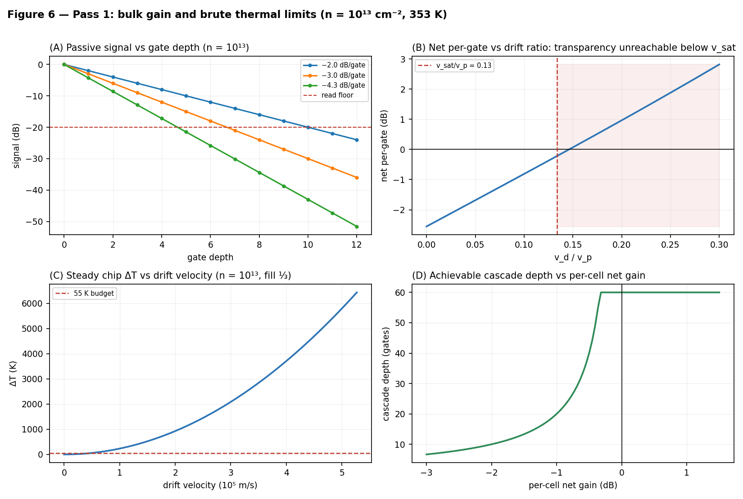
Figure 6. Pass 1, at n = 10¹³ cm⁻² and 353 K. (A) Passive signal vs gate depth for the candidate per-gate budgets. (B) Net per-gate result vs drift ratio v_d/v_p: transparency is unreachable below v_sat. (C) Steady-state chip ΔT vs drift velocity against the 55 K budget. (D) Achievable cascade depth vs per-cell net gain. Per-gate loss convention: one λ_p/2 of propagation (Appendix A).

7.2 Pass 2 — analytic resonant cells: break-even only at low density
Applying the DS increment, Eq. (2), to a 1-THz-tuned cell shows that a single, non-regenerative resonant cell can at best reach break-even. Biased as hard as the saturation velocity allows, the amplified drain reflection (s + v₀)/(s − v₀) only cancels the round-trip loss: net round-trip gain hovers near 0 dB across the whole low-density window and turns negative once v_sat caps the achievable drift below threshold — about −0.3 dB by 10¹³ cm⁻², where v_sat/s ≈ 0.13 holds M/M_th near 0.9. The low-density requirement is therefore a gain requirement, not only a thermal one; but reaching break-even is not reaching the +8 dB the logic needs, and a single transit never closes that gap. That is the work of the multi-pass regeneration of Pass 3. This pass also set the logic-margin design rule (k ≥ 8, extinction ≥ 10 dB), bounded the carrier-recovery ISI as benign, and derived the re-sync spacing law quoted in Section 6.2, making NF ≲ 4 dB the sharpest requirement on the cell. Fan-out-grade single-transit gain (a 3 dB split, 1–3 dB junction loss, and restoration headroom) was unreachable without regeneration — a gap the next pass closes.
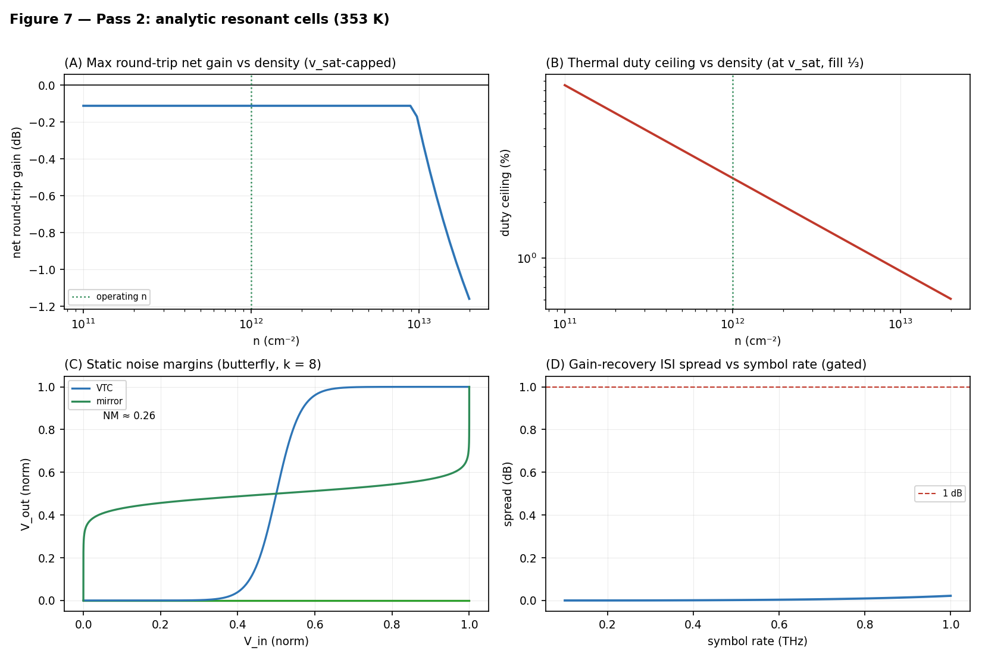
Figure 7. Pass 2, at 353 K unless noted. (A) DS single-transit net gain vs density, Eq. (2). (B) Thermal duty ceiling vs density, refined from Pass 1. (C) Static noise margins (butterfly construction) of the tanh cell at 6/10/20 dB extinction. (D) Pattern-dependent gain spread vs symbol rate at τ = 0.85 ps.

7.3 Pass 3 — the regenerative operating point (nonlinear time-domain solve)
A nonlinear shallow-water solver with the DS boundary conditions confirms what the transit picture misses: below its oscillation threshold the cell is a multi-pass regenerative amplifier. The cavity transfer is a Fabry-Perot below threshold — the current-clamped drain reflects with amplitude (s + v₀)/(s − v₀) > 1, the density-clamped source with |r| = 1, and the round-trip loop closes self-oscillation at loop gain unity, which recovers M_th of Eq. (3) exactly. The solver’s numerical dissipation inflates its measured threshold to M_th,num ≈ 0.17, about 15 % above the analytic 0.147 — a Lax-Friedrichs diffusion artifact that shrinks toward the analytic value as the grid is refined (Appendix A) — so all solver results are quoted at the ratio M/M_th,num. Net gain referenced to the identical passive cell rises from break-even (cancelling the 2.56 dB per-gate loss — one λ_p/2 of propagation, Appendix A) at M/M_th ≈ 0.3 through +9.7 dB continuous-wave at M/M_th ≈ 0.7 toward formal divergence at threshold. The cell is low-Q (Q ≈ 6), so a finite few-cycle pulse does not fully charge it: driven with the actual clock waveform — 3-cycle pulses at 0.25 THz — the solver delivers ≈ +8 dB per pulse in steady streaming operation (each pulse riding the cavity field left by its predecessors), below the continuous-wave ceiling. Near threshold the cell rings: the cavity ring-down reaches ~4–5 ps (comparable to the slot) and the pulse-to-pulse spread reaches 5 dB by 0.94·M_th. This is the regenerative amplifier’s classic gain-versus-stability trade-off, and it is why the working point is held at 0.7·M_th — where the ring-down both lifts the per-pulse gain to its +8 dB streaming value and sets the inter-symbol budget the re-sync stations manage (Section 6.2).
Because the operating drift sits far below v_sat(10¹²) ≈ 1.4×10⁶ m/s, Joule heat falls ~25-fold against an at-v_sat drive at the same density, and ~100-fold against the Pass-1 corner. Of that ~100×, the dominant ~32× comes from the density itself (heat ∝ n·m*·v², with the effective mass m* = E_F/v_F² ∝ √n) and only ~3× from operating below the v_sat ≈ 5×10⁵ m/s of the high-density case. The exact periodic-slab thermal solution then gives the duty figures of Section 8.2. Heat stops selecting the density — disorder takes over that role: the chain’s disorder Monte-Carlo (Figure 9D, reported with Pass 4) gave ~87–100 % cell yield at n = 10¹² over a broad disorder sweep, degrading steadily toward 10¹¹ as the logic swing approaches the puddle scale; restricting to the literature disorder values (Section 7.4) tightens the n = 10¹² yield to 98–100 %.
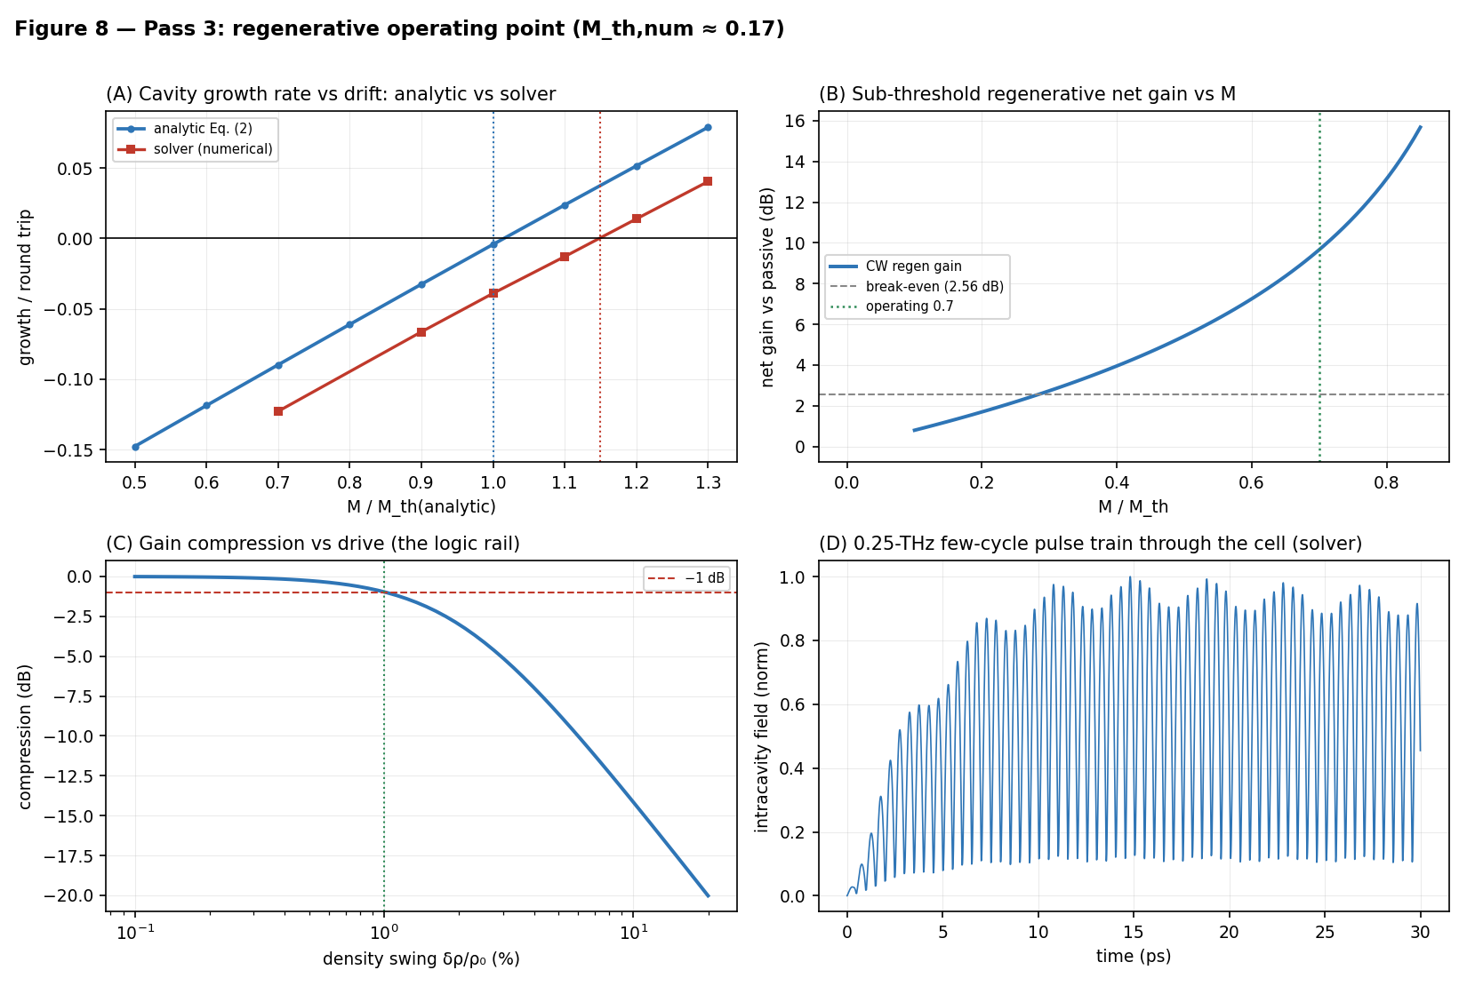
Figure 8. Pass 3 (M_th,num ≈ 0.17; operating ratio M/M_th = 0.7). (A) Cavity growth rate vs drift, analytic Eq. (2) vs the nonlinear solver, both thresholds marked — the solver’s numerical diffusion shifts its threshold ~15 % higher. (B) Sub-threshold CW regenerative net gain vs M; break-even at the per-gate (λ_p/2) loss; +9.7 dB at the working ratio. (C) Gain compression vs drive amplitude — the logic rail (1 dB at ≈1 % swing). (D) The 0.25 THz few-cycle pulse train building up in the cell (solver, intracavity field).

7.4 Pass 4 — cascade, noise, and measured disorder
The architecture’s load-bearing claim — cascadability — was then tested directly: two cells chained through junction transmissions of 0/−1/−3/−6 dB sustain +8.4 to +9.3 dB net per cell (two-cell total ~+17–19 dB over the passive chain), with cell 2 performing on cell 1’s output as on a clean train, and per-cell gain rising as junction loss moves the input below the saturation knee — the restoring rail in action. The per-cell figure tracks the single-cell streaming gain of Section 7.3 (+8 dB), edging higher only where junction loss unloads the rail.
Noise. For a matched-temperature, phase-insensitive amplifier the noise-figure floor is F = 2 − 1/G (Eq. 7), i.e. ≈ 2.8 dB at the operating gain; total output noise then sits ≈ G·F ≈ +12 dB above the input thermal floor. This floor is what the re-sync spacing law of Section 6.2 consumes, and it places the NF ≤ 4 dB cell requirement comfortably within reach. An absolute added-noise calibration against this floor — the one quantity the reduced-order chain bounds but does not pin — is assigned to the Boltzmann–Maxwell tier (Section 10).
F = 2 − 1/G (7)
Finally, literature disorder values (σ ≈ 2.5×10⁹ cm⁻² for graphene on ultra-flat hBN [12]; ~4×10¹⁰ cm⁻² for typical encapsulated stacks [14], with SiO₂-substrate values an order higher as the upper bound [13]) place cell yield at n = 10¹² at 98–100 % across the realistic range; 3×10¹¹ is a premium-material option (graphite-gate class). The yield criterion is explicit: a charge puddle of rms density σ broadens the cell’s threshold to √((n/k₀)² + σ²), so the puddle-broadened sharpness clears the regeneration floor only while σ stays below ≈ 0.16·n — the swing-to-puddle rule, tied directly to the k ≥ 8 design sharpness (Appendix A).
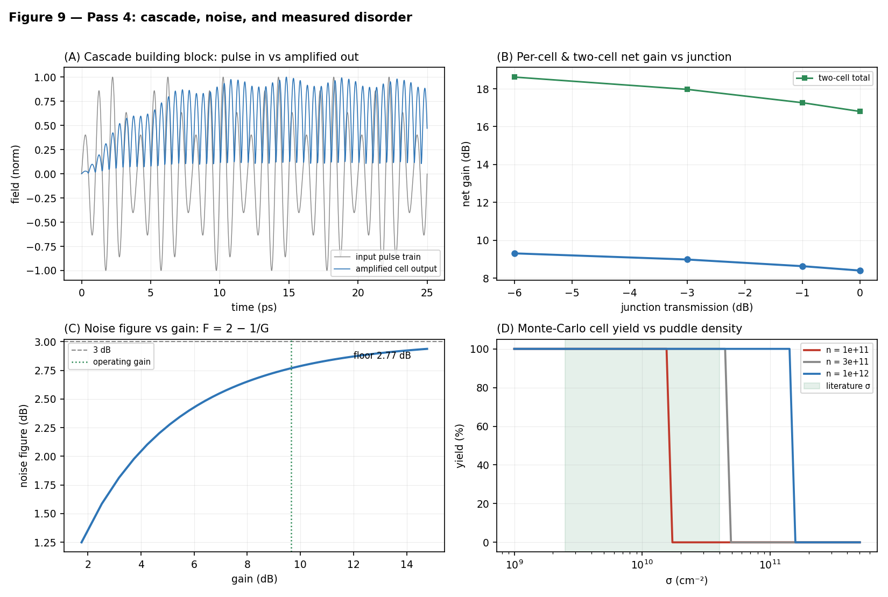
Figure 9. Pass 4. (A) Cascade building block: the input pulse train and the amplified cell output (solver). (B) Per-cell and two-cell net gain vs junction transmission — per-cell gain rises as junction loss unloads the saturating rail. (C) Noise figure F = 2 − 1/G vs gain; floor ≈ 2.8 dB at the operating gain. (D) Monte-Carlo cell yield vs puddle density σ, with the literature range shaded; n = 10¹² clears it with margin.

7.5 Pass 5 — validity bounds and the last parasitic channel
Kinetic validity. The hydrodynamic equations behind Eq. (2) and the Pass-3 solver assume electron-electron collisions fast enough to keep the electron system a local fluid — quantified by ωτ_ee ≪ 1. The standard estimate for graphene’s electron-electron rate, 1/τ_ee ≈ (k_BT)²/(ħE_F) [15], gives τ_ee ≈ 115 fs at 300 K and E_F = 117 meV — i.e. ωτ_ee ≈ 0.7 at 1 THz. The honest statement is that the hydrodynamic description at 1 THz and 300 K is marginal, not comfortable: ωτ_ee ≈ 0.7 sits at the collisional-to-collisionless crossover — the same crossover observed experimentally as the transition from acoustic plasmon to electronic sound [10] — with ℓ_ee/L ≈ 0.2, and the viscous correction ν q² (ν = v_F²τ_ee/4) is ≈ 20 % of 1/τ. The cell is marginal in space as well: L/ℓ_mfp ≈ 0.6–0.7 with ℓ_mfp = v_F·τ the momentum-relaxation mean free path, so transport in the cell is neither cleanly hydrodynamic nor cleanly ballistic. The gain numbers of Passes 3–4 therefore carry kinetic uncertainty at the tens-of-percent scale, and their certification passes to the Boltzmann–Maxwell tier as that tier’s highest-priority question (Section 10).
Coupled-cell stability. Two DS-active segments on one continuous channel, with a midpoint density clamp swept from hard contact to fully free, are stable at every coupling strength, even at 0.9·M_th — the DS increment’s 1/L scaling protects long parasitic cavities (Figure 10). Charge-channel parasitics are therefore excluded in-model; the only remaining coupling channel is radiative/electromagnetic, which is precisely scoped to the Boltzmann–Maxwell tier.
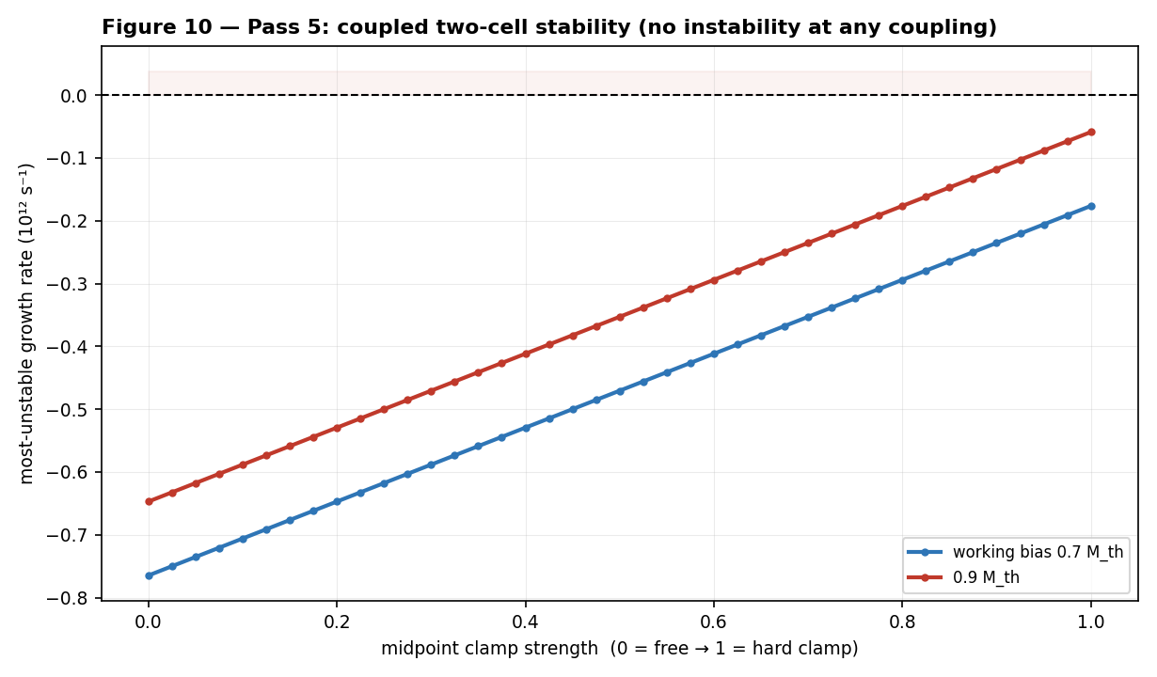
Figure 10. Pass 5: most-unstable growth rate of two coupled DS cells vs midpoint clamp strength, at the working bias and at 0.9·M_th — no instability region is entered at any coupling.

7.6 Scoreboard
Table 6 collects where the five passes leave each of the chain’s questions.
Question | Status after five passes
Net gain ≥ loss at 1 THz, ≤ 80 °C | in-model yes: regenerative cell, ~+8 dB/pulse (CW +9.7 dB) at M/M_th = 0.7
Cascadability | in-model yes: 2 cells, +8.4–9.3 dB/cell through −6 dB junctions
Noise | NF floor 2.8 dB (F = 2 − 1/G); ≤ 4 dB required; absolute calibration to the Maxwell tier
Disorder | 98–100 % yield at n = 10¹² for literature σ; swing-to-puddle criterion (σ ≲ 0.16 n); measured on-die in the protocol
Thermal | ~23 % margin at worst-case fill ⅓; real but thin (Section 8.2)
Kinetic validity | marginal (ωτ_ee ≈ 0.7): tens-of-percent uncertainty on gain; passes to the Boltzmann–Maxwell tier
Coupled-cell parasitics | charge channel stable at all couplings; radiative channel open
Clock synthesis | CW chain demonstrated; pulsed multi-line extension proposed, undemonstrated (Section 3.2)
Launch/read-out coupling | efficiency into the acoustic mode unquantified; open (Sections 3.3, 9)
Remaining | Boltzmann–Maxwell solve (EM coupling, kinetic gain, absolute calibration) and the bench (Section 10)

Table 6. The feasibility scoreboard: the ten questions the model chain was built to answer, and where each stands.

8. Energy accounting and thermal envelope

8.1 Energy
The intrinsic field energy is ~10 aJ per bit. The drive energy is set by the bias: at the operating point the per-cell dissipation is ~1.2 kW/cm² (P = n·m*·v₀²/τ with m* = E_F/v_F², v₀ ≈ 2.4×10⁵ m/s, τ = 0.85 ps), rising to ~1.7 kW/cm² if the in-situ threshold calibration lands at the solver-class bias (Section 7.3). For the half-adder block — seven biased cells (the five logic cells plus the two carry-alignment buffers, counted conservatively) of ~10⁻⁸ cm² each — that is 0.09–0.12 mW, i.e. ≈ 0.35–0.5 fJ per addition at one addition per 4 ps. This is CMOS-class, not below it.
The system energy — microcomb wall-plug, DFB lasers, photomixers, detectors — is far larger. A 1 W-class drive over 10⁴–10⁵ active cells at the 0.25 THz baseline symbol rate corresponds to ~40–400 aJ per operation (20–200 aJ at 0.5 THz). Any “orders below CMOS” claim survives only for the intrinsic field energy, never for the system [16, 17].

8.2 Thermal envelope
The ≤ 80 °C cap is a 55 K rise budget over 25 °C ambient, against an effective stack resistance R_th ≈ 0.10 K·cm²/W (consistent with ~500 µm of sapphire plus interface terms; the same R_th reproduces every duty figure in this manuscript). At the worst-case area fill of one-third, continuous drive at the operating bias gives ΔT ≈ 42 K — the budget closes with ~23 % margin. The margin is real but thin: at the upper, solver-class calibration bound of Section 8.1 the same calculation gives ΔT ≈ 55 K — the budget exactly saturated, zero margin, before any duty throttling. The budget therefore closes at the operating bias and sits right at the edge at the upper calibration bound; the thermal row of the scoreboard (Table 6) says both.
The half-adder block itself, at ~4 % fill, sits at ΔT ≈ 5 K and is thermally unconstrained. The positive-feedback loop (T → τ → Q → loss → more drive) is defanged by the ~150× headroom between the operating dissipation and the at-v_sat, high-density corner of Pass 1 (whose own duty ceiling, ~0.3 % at full fill or ~0.9 % at fill ⅓, is fatal either way). Local heat flux at the cell (12–17 MW/m²) is benign against demonstrated hBN/substrate interface conductances; the budget is set by the substrate spreading term, not the interface (Section 9.7).

8.3 Behaviour under cooling — and the validity window
The cap also has a cold side. Re-running the Pass-3 cell with the τ(T) = τ(300 K)·(300/T) loss model shows per-gate loss falling from 2.17 dB at 300 K to 1.45 dB at 200 K (per λ_p/2; Appendix A), the thermal noise floor dropping with T, and the servo-biased cell remaining regeneratively stable at every temperature swept. That stability is conditional on bias tracking: M_th scales with T (Eq. 3), so a bias fixed at 0.7·M_th(353 K) crosses the ~0.8·M_th ringing onset after only ~44 K of cooling — for an untracked bias, cooling, not heating, is the unstable direction.
The certifiable window, however, is set by model validity: with ωτ_ee ≈ 0.7 at 300 K (Section 7.5) growing as 1/T², the hydrodynamic tier that certifies every gain number here expires near ~250 K. Below that temperature the gain results pass to the Boltzmann–Maxwell tier; what the hydrodynamic chain certifies is the loss trend, the tracked-bias requirement, and the absence of any predicted instability under cooling with a tracked bias. (Below ~150 K the 1/T phonon scaling is itself optimistic — impurity scattering saturates τ.)

9. Device implementation considerations
This section collects what a fabrication-and-measurement team would need that the architecture sections do not state. Each item is either specified, bounded, or explicitly handed to the bench protocol or the Boltzmann–Maxwell solve.
9.1 Boundary conditions and contacts. The DS asymmetry is electrical, not geometric: density-clamped means AC-shorted gate-to-channel voltage at the source end; current-clamped means AC-open at the drain end [11, 19]. The practical realization is a low-impedance ohmic source contact (one-dimensional edge contacts at ~100 Ω·µm-class resistance [33]) under the gated region’s edge, and a drain side terminated by the gate-segment boundary into a depleted (CNP) region. No experiment has realized verified DS boundary conditions at the 576-nm scale; the design’s protection is that M_th is calibrated in situ by approach to self-oscillation, which absorbs boundary-condition imperfection into the measured threshold to first order. Residual non-ideality appears as a modified increment and is exactly what bench gate G1 measures.
9.2 Bias network and current density. The drift current density at the operating bias is J = n·e·v₀ ≈ 0.38 mA/µm — roughly an order of magnitude below the current-carrying capacity demonstrated for encapsulated graphene, so electromigration and channel burnout are not at risk at the operating point. Rows of cells in series share one bias current; parallel rows need per-row ballast so that a low-resistance row does not starve its neighbours. The bias envelope (kHz–MHz) is far inside the bias-plane RC corner.
9.3 Gate-lattice programming. The program is a static voltage map on ~576-nm-pitch top-gate segments, written by an electrode-mapping controller at kHz–MHz rates — orders of magnitude below the gate-line RC limit for millimetre-scale lines, so routing in two perimeter metal layers suffices. Fringing-field crosstalk between adjacent segments at d = 10 nm is at the percent level of the programmed density step and below the disorder scale the yield analysis already absorbs.
9.4 Inter-cell junctions. A junction is a gate-defined density step between adjacent segments. For the ideal step the velocity mismatch is mild (s ∝ n¹ᐟ⁴-class under Eq. (1)), and the reflective loss of even a 2× density step is < 0.1 dB — the −1 to −3 dB budgeted per junction is therefore dominated by non-ideal effects: scattering at the gate gap, mode mismatch through the ungated sliver, and radiation. Those belong to the Boltzmann–Maxwell tier; the bench die carries junction variants to measure them directly. The budget’s robustness to the answer is already established in-model (cascade closes through −6 dB junctions, Section 7.4).
9.5 Launch and read-out transducer. The unsolved link of the chain (Sections 3.2–3.3): the photomixer and stripline modes are micron-scale while the acoustic plasmon is confined ~100× tighter, and no cited work quantifies the coupling efficiency. With µW-class launch power at 1 THz (~10 aJ per slot) the budget tolerates little coupling loss. Mitigations in order of maturity: the photoconductive launch demonstrated on this stack at 4 K [4]; tapered-gate impedance transformers; and a resonant antenna-coupled gate segment. On the read-out side, photoconductive sampling is field-resolved and coherent, and the in-situ reference arm [7] removes absolute-calibration error; an InP HEMT THz low-noise amplifier (LNA; 9 dB at 1 THz [28]) inserted before detection is an optional hybrid that relaxes the detector requirement by an order of magnitude. Coupling efficiency joins the calibration sequence as a measured quantity (Section 10).
9.6 Re-sync station hardware. A re-sync station is a DS cell used as a clocked AND: its bias gate is driven by the optical clock tap through a photoconductive element beside the top-gate segment, so the cell has gain only during clock slots. The tap inherits the comb’s phase (Section 3.2 budget), needs only enough optical energy to swing the local n_bias across n_th (fJ-class at 10-fF-class segment capacitance), and doubles as the ASE flush of Section 6.2.
9.7 Tolerances and thermal interfaces. Cell-length error of ±5 % (±29 nm — loose for deep-UV overlay) detunes f₀ by ∓5 %, well inside the Q ≈ 6 linewidth (f₀/Q ≈ 16 %); hBN thickness is layer-quantized, and a ±1-layer error on d = 10 nm shifts s by under 2 % — both are absorbed by per-cell top-gate trim against the in-situ reference. The local heat flux (12–17 MW/m²) drops ~K-class temperature across demonstrated hBN/substrate interfaces; the thermal budget is set by substrate spreading (Section 8.2), so die layout should interleave active stripes with dark guard rows, which the cell map already does.
9.8 Hybrid integration: the device combination. The minimal bench die combines three device families: the fiber-bonded photonic chain (microcomb, DFB pair, UTC-PD [5]) at the edge; the photoconductive launch/read-out circuit on the substrate [7]; and the graphene fabric itself. The full machine adds two more: a conventional-CMOS perimeter layer for charge memory, refresh, trim DACs and the electrode-mapping controller (Section 6.4); and, optionally, room-temperature THz electronics as accelerators — an InP HEMT LNA before read-out [28], and RTD latches as fast electronic registers or an injection-locked local clock auxiliary [29]. Every member of this combination is room-temperature hardware; the integration, not any component, is the proposal.

10. Falsifiability: the experiment and the solve
The bench protocol is a lab-ready measurement plan. It fixes in advance the device, the drive and read-out chain, the calibration sequence, and the pass/fail gates. Each threshold is parameterized by the model predictions, so a large deviation is itself a result that recalibrates the model chain rather than a tuning failure.
The device under test: an hBN-encapsulated dual-gated DS cell on the Section 3.1 stack, L ≈ 576 nm, d = 10 nm, n = 10¹² cm⁻². M_th is calibrated in situ by approach to self-oscillation; the bias is then set at the tracked ratio M/M_th = 0.7. The five gates are listed in Table 7.
Gate | Observable | Pass threshold | Model target
G1 | single-cell per-pulse net gain at ≤ 80 °C | ≥ +2.6 dB (beats the per-gate loss) | +8 dB
G2 | pulse-to-pulse gain spread at 0.2–0.25 THz | < 1 dB | < 0.1 dB (clock train)
G3 | cell noise figure | ≤ 6 dB | ≈ 3 dB (floor 2.8 dB)
G4 | two cascaded cells, one junction | ≥ 1.7× the single-cell decibel gain | ≈ 2×
G5 | thermal compliance at operating duty | ΔT within the 55 K budget | ≈ 23 % margin at fill ⅓

Table 7. The five pre-registered pass/fail gates. G1 is the existence proof of regenerative DS gain; G4 — the first concatenation of room-temperature plasmonic gain ever attempted — is the single most informative outcome, pass or fail.
The die plan includes passive twins for differential measurement, junction variants (Section 9.4), a d = 5 nm variant (s ∝ √d in the classical limit; the model chain scores it as a +2.6 dB-class gain lever), and a graphite-gated disorder de-risk die. The calibration sequence measures on-die every quantity this manuscript has had to assume, in order: the disorder σ, the lifetime τ(T), the plasmon speed s (fixing ε_z in Eq. (1)), the threshold M_th, and the launch/read-out coupling efficiency (Section 9.5).
The remaining modeling tier — a Boltzmann–Maxwell grating-gate solve, with method precedent in [18] — owns five questions with fully specified inputs: the regenerative gain curve G(M/M_th) under kinetic and electromagnetic corrections (the tier’s highest priority, given ωτ_ee ≈ 0.7; Section 7.5); real junction loss; radiative coupling between cells (the one surviving parasitic channel, Section 7.5); absolute noise calibration against the 2.8 dB floor; and the launch-transducer coupling efficiency.
One open item from the abstract’s list does not appear above because it is not on the bench’s critical path: the photonic synthesis of the pulsed clock (Section 3.2). The bench drives its cells through the photoconductive launch chain of Section 3.3; the multi-line comb extension is what the full fabric — not the experiment — waits on.

11. Conclusion and outlook
The design’s feasibility rests on a single stated physics question — can room-temperature graphene deliver net plasmon gain at ~1 THz? Five passes of reduced-order modeling answer it as well as reduced-order physics can: yes in-model, by operating a resonant DS cell as a sub-threshold regenerative amplifier, at a density chosen by disorder rather than heat, clocked optically because electrical clocking was never physically available, cascaded without gain degradation, near the thermal noise floor.
The answer is bounded in four ways, each stated where it arises: the experimental cornerstone [2] is cited for what its authors claim — current-pumped plasmonic amplification — not for what the design needs (DS-cavity gain, which no experiment has shown); signals route with the electron drift, and loop suppression is architectural rather than free; the operating point exists only as a tracked threshold ratio, never as an absolute bias; and the hydrodynamic certification at 300 K is marginal, which is why the kinetic solve leads the remaining-work list. None of these boundaries kills the design. Each narrows what must be believed without measurement.
None of the in-model statements is yet a measurement. The design should be judged by the protocol gates of Section 10, and the most informative outcome — pass or fail — is G4: two cells, one junction, the first concatenation of room-temperature plasmonic gain ever attempted. It is the same property that lets the half-adder block of Section 6.5 drive its successor — the property that makes five cells a computer rather than a demonstration. The model chain is exhausted; the design is now exactly as falsifiable as it was always meant to become.

Appendix A. The model chain: conventions and the released code
The five passes are the manuscript’s entire evidentiary basis, and they are released as a small, runnable Python package (Table A1; depends only on NumPy, and Matplotlib for the figures). One command, run_all.py, reproduces every number in Sections 7–8 and writes them to a results file; figures.py regenerates Figures 6–10. The shared conventions are: damping enters at the amplitude convention, ω″ compared against 1/(2τ) (Eq. 2–3); “per-gate loss” means one λ_p/2 of propagation (2.17 dB at 300 K, 2.56 dB at 353 K at the design Q) — the quarter-wave cell’s single transit is half that; all temperatures are tagged, with τ(T) = τ(300 K)·(300/T); solver bias values are reported as ratios to the solver’s own threshold (M_th,num ≈ 0.17, vs analytic 0.147 at 353 K — the ~15 % offset is a Lax-Friedrichs numerical-diffusion artifact that the package measures directly and that shrinks toward the analytic value under grid refinement).
Two properties of the chain are stated plainly so the “in-model” label is never mistaken for more than it is. The analytic backbone (Eqs. 1–7, the thermal and kinetic estimates) is closed-form and reproduces the operating point from first principles. The regenerative gain is owned by the analytic cavity transfer (regen.py) and independently confirmed by the nonlinear shallow-water solver (solver.py); the solver’s absolute gain calibration carries the numerical-diffusion caveat above, which is why the per-pulse figure is quoted conservatively. Table A1 maps each pass to its module:
Pass | Model | Released module(s)
1 | drift-Doppler cascade + 1-D periodic-slab thermal solution | thermal.py, ds_cell.py — v_sat(n) = ω_OP/k_F, R_th, duty ceilings
2 | DS increment, Eq. (2); break-even analytics; butterfly margins; ISI | ds_cell.py, cell.py — per-gate loss, k ≥ 8 rule, gated ISI
3 | nonlinear 1-D shallow-water DS solver + analytic cavity transfer | solver.py, regen.py — M_th,num, CW & pulse gain, saturation
4 | two-cell cascade; noise floor F = 2 − 1/G; disorder Monte-Carlo | cell.py, noise.py, disorder.py — per-cell gain, NF, swing-to-puddle yield
5 | coupled two-cell eigenvalue scan; kinetic-validity estimates | coupled.py, kinetic.py — clamp-stability, τ_ee, ωτ_ee, viscosity

Table A1. The released model chain, pass by pass. Each module is independently runnable and self-checks against the manuscript values; run_all.py consolidates them. The package is archived with the manuscript under a persistent DOI and linked from the Data and Code Availability statement.
Data and code availability. The five-pass model chain is released as a runnable Python package (Appendix A) and is archived with the manuscript at https://github.com/r-coin/basic/blob/master/hardware%20solusions; run_all.py reproduces every quantitative claim in Sections 7–8 and figures.py regenerates Figures 6–10.

Appendix B. Symbols
Table B1 collects the symbols used throughout the manuscript, with their values at the operating point.
Symbol | Meaning | Value at the operating point
f₀, ω | carrier frequency, angular frequency | ~1 THz, 2π×10¹² s⁻¹
τ, Q | plasmon momentum-relaxation time; Q = ωτ | 1.0 ps / 6.3 (300 K); 0.85 ps / 5.3 (353 K)
n, E_F | carrier density; Fermi level | 10¹² cm⁻²; 117 meV
s, λ_p | acoustic-plasmon speed, Eq. (1); wavelength s/f₀ | 2.2–2.3×10⁶ m/s (design 2.33×10⁶); ≈ 2.3 µm
d, ε_z | gate–graphene hBN thickness; its out-of-plane permittivity | 10 nm; ≈ 3.4–3.8
L | cell length, Eq. (4) | ≈ 576 nm
v₀, M | drift velocity; Mach number v₀/s | ≈ 2.4×10⁵ m/s; ≈ 0.10 (at 353 K)
M_th | DS threshold, Eq. (3); tracked in situ | 0.147 (353 K), 0.125 (300 K); solver ≈ 0.17
g(n), n_th, Δn, β, ℓ | cell transfer model, Eq. (5) | —
A_pump, A_in, A_swing | clock-pulse and logic-input amplitudes, Eq. (5); rail-to-rail input swing (Section 5) | —
κ± | spatial attenuation of co-/counter-drift waves, Eq. (6) | contrast ≈ 0.26–0.31 dB per cell transit
k | threshold sharpness β·A_swing/Δn | ≥ 8 (design rule)
G, F | cell gain; noise figure, Eq. (7) | +8 dB/pulse (CW +9.7 dB); floor 2.8 dB
σ | charge-puddle density spread | 2.5×10⁹–4×10¹⁰ cm⁻² (literature)
τ_ee | electron-electron collision time | ≈ 115 fs (300 K) ⇒ ωτ_ee ≈ 0.7
J | drift current density n·e·v₀ | ≈ 0.38 mA/µm

Table B1. Nomenclature. Each value is quoted at the operating point of Table 3; the section where it is derived is cited in the text.

References
[1] R. Furui, “A 100-GHz Room-Temperature Half Adder Using Graphene Plasmons as Bits, Driven by a Microcomb-Photomixing Carrier: Architecture, Quantitative Roadmap, and Machine-Learning-Assisted Design Optimisation,” self-published manuscript, https://github.com/r-coin/basic/blob/master/hardware%20solusions/THz_Half_Adder_100GHz_RT.pdf
[2] S. Boubanga-Tombet, W. Knap, D. Yadav, A. Satou, D. B. But, V. V. Popov, I. V. Gorbenko, V. Yu. Kachorovskii, and T. Otsuji, “Room-Temperature Amplification of Terahertz Radiation by Grating-Gate Graphene Structures,” Phys. Rev. X 10, 031004 (2020). doi:10.1103/PhysRevX.10.031004
[3] V. Ryzhii, M. Ryzhii, and T. Otsuji, “Negative dynamic conductivity of graphene with optical pumping,” J. Appl. Phys. 101, 083114 (2007). doi:10.1063/1.2717566
[4] K. Yoshioka, G. Bernard, T. Wakamura, M. Hashisaka, K. Sasaki, S. Sasaki, K. Watanabe, T. Taniguchi, and N. Kumada, “On-chip transfer of ultrashort graphene plasmon wave packets using terahertz electronics,” Nat. Electron. 7, 537–544 (2024). doi:10.1038/s41928-024-01197-x
[5] Y. Tokizane, H. Kishikawa, T. Kikuhara, M. Talara, Y. Makimoto, K. Yamaji, Y. Okamura, K. Nishimoto, E. Hase, I. Morohashi, A. Kanno, S. Hisatake, N. Kuse, T. Nagatsuma, and T. Yasui, “Beyond 350 GHz: Single-channel 112 Gbps photonic wireless transmission at 560 GHz using soliton microcombs,” Commun. Eng. 5, 77 (2026). doi:10.1038/s44172-026-00659-8
[6] K. Hirota, T. Kashiwazaki, G. Ha, T. Yamashima, P. Jaturaphagorn, T. Suzuki, K. Takahashi, A. Kawasaki, A. Inoue, W. Asavanant, M. Endo, T. Umeki, and A. Furusawa, “Generation of 10-dB squeezed light from a broadband waveguide optical parametric amplifier with improved phase locking method,” Opt. Express 34, 7958–7972 (2026). doi:10.1364/OE.585323
[7] K. Kusyak, B. Schulte, T. Matsuyama, G. Kipp, H. M. Bretscher, M. W. Day, G. Meier, A. M. Potts, and J. W. McIver, “Monolithic optoelectronic circuit design for on-chip terahertz applications,” APL Photonics 10, 076117 (2025). doi:10.1063/5.0278183
[8] M. A. Haque, M. S. Akhter, I. Das, T. U. Zaman, J.-J. Tiang, N. S. S. Singh, A. D. Algarni, and A. A. Ateya, “Graphene based terahertz MIMO antenna with machine learning regression for 6G communications,” Sci. Rep. 16, 3900 (2026). doi:10.1038/s41598-025-32487-9
[9] V. E. Dorgan, M.-H. Bae, and E. Pop, “Mobility and saturation velocity in graphene on SiO₂,” Appl. Phys. Lett. 97, 082112 (2010). doi:10.1063/1.3483130
[10] D. Barcons Ruiz, N. C. H. Hesp, H. Herzig Sheinfux, C. Ramos Marimón, C. M. Maissen, A. Principi, R. Asgari, T. Taniguchi, K. Watanabe, M. Polini, R. Hillenbrand, I. Torre, and F. H. L. Koppens, “Experimental signatures of the transition from acoustic plasmon to electronic sound in graphene,” Sci. Adv. 9, eadi0415 (2023). doi:10.1126/sciadv.adi0415
[11] M. Dyakonov and M. Shur, “Shallow water analogy for a ballistic field effect transistor: New mechanism of plasma wave generation by dc current,” Phys. Rev. Lett. 71, 2465–2468 (1993). doi:10.1103/PhysRevLett.71.2465
[12] J. Xue, J. Sanchez-Yamagishi, D. Bulmash, P. Jacquod, A. Deshpande, K. Watanabe, T. Taniguchi, P. Jarillo-Herrero, and B. J. LeRoy, “Scanning tunnelling microscopy and spectroscopy of ultra-flat graphene on hexagonal boron nitride,” Nat. Mater. 10, 282–285 (2011). doi:10.1038/nmat2968
[13] K. Nagashio, T. Nishimura, and A. Toriumi, “Estimation of residual carrier density near the Dirac point in graphene through quantum capacitance measurement,” Appl. Phys. Lett. 102, 173507 (2013). doi:10.1063/1.4804430 (SiO₂-substrate measurement; cited as the disorder upper bound)
[14] P. Huang, E. Riccardi, S. Messelot, H. Graef, F. Valmorra, J. Tignon, T. Taniguchi, K. Watanabe, S. Dhillon, B. Plaçais, R. Ferreira, and J. Mangeney, “Ultra-long carrier lifetime in neutral graphene-hBN van der Waals heterostructures under mid-infrared illumination,” Nat. Commun. 11, 863 (2020). doi:10.1038/s41467-020-14714-1
[15] A. Lucas and K. C. Fong, “Hydrodynamics of electrons in graphene,” J. Phys.: Condens. Matter 30, 053001 (2018). doi:10.1088/1361-648X/aaa274
[16] D. A. B. Miller, “Attojoule optoelectronics for low-energy information processing and communications,” J. Lightwave Technol. 35(3), 346–396 (2017). doi:10.1109/JLT.2017.2647779
[17] IEEE, “International Roadmap for Devices and Systems (IRDS), 2023 Update,” IEEE (2023). https://irds.ieee.org/editions/2023
[18] Z. Qiu, S. Yang, S. Huang, S. Wang, P. Zhang, and Y. Gong, “Terahertz Amplification Induced by Electron–Phonon Interactions in Gated Graphene Plasmonic System,” Research 8, 1023 (2025). doi:10.34133/research.1023
[19] J. Crabb, X. Cantos-Roman, J. M. Jornet, and G. R. Aizin, “Hydrodynamic theory of the Dyakonov–Shur instability in graphene transistors,” Phys. Rev. B 104, 155440 (2021). doi:10.1103/PhysRevB.104.155440
[20] A. S. Petrov, D. Svintsov, V. Ryzhii, and M. S. Shur, “Amplified-reflection plasmon instabilities in grating-gate plasmonic crystals,” Phys. Rev. B 95, 045405 (2017). doi:10.1103/PhysRevB.95.045405
[21] Y. Koseki, V. Ryzhii, T. Otsuji, V. V. Popov, and A. Satou, “Giant plasmon instability in a dual-grating-gate graphene field-effect transistor,” Phys. Rev. B 93, 245408 (2016). doi:10.1103/PhysRevB.93.245408
[22] G. R. Aizin, J. Mikalopas, and M. S. Shur, “Plasma instability and amplified mode switching effect in THz field effect transistors with a grating gate,” Phys. Rev. B 107, 245424 (2023). doi:10.1103/PhysRevB.107.245424
[23] D. Veksler, F. Teppe, A. P. Dmitriev, V. Yu. Kachorovskii, W. Knap, and M. S. Shur, “Detection of terahertz radiation in gated two-dimensional structures governed by dc current,” Phys. Rev. B 73, 125328 (2006). doi:10.1103/PhysRevB.73.125328
[24] Y. Dong, L. Xiong, I. Y. Phinney, Z. Sun, R. Jing, A. S. McLeod, S. Zhang, S. Liu, F. L. Ruta, H. Gao, Z. Dong, R. Pan, J. H. Edgar, P. Jarillo-Herrero, L. S. Levitov, A. J. Millis, M. M. Fogler, D. A. Bandurin, and D. N. Basov, “Fizeau drag in graphene plasmonics,” Nature 594, 513–516 (2021). doi:10.1038/s41586-021-03640-x
[25] W. Zhao, S. Zhao, H. Li, S. Wang, S. Wang, M. I. B. Utama, S. Kahn, Y. Jiang, X. Xiao, S. Yoo, K. Watanabe, T. Taniguchi, A. Zettl, and F. Wang, “Efficient Fizeau drag from Dirac electrons in monolayer graphene,” Nature 594, 517–521 (2021). doi:10.1038/s41586-021-03574-4
[26] T. A. Morgado and M. G. Silveirinha, “Directional dependence of the plasmonic gain and nonreciprocity in drift-current biased graphene,” Nanophotonics 11, 4929–4936 (2022). doi:10.1515/nanoph-2022-0451
[27] D. Correas-Serrano and J. S. Gomez-Diaz, “Nonreciprocal and collimated surface plasmons in drift-biased graphene metasurfaces,” Phys. Rev. B 100, 081410(R) (2019). doi:10.1103/PhysRevB.100.081410
[28] X. Mei, W. Yoshida, M. Lange, J. Lee, J. Zhou, P.-H. Liu, K. Leong, A. Zamora, J. Padilla, S. Sarkozy, R. Lai, and W. R. Deal, “First Demonstration of Amplification at 1 THz Using 25-nm InP High Electron Mobility Transistor Process,” IEEE Electron Device Lett. 36, 327–329 (2015). doi:10.1109/LED.2015.2407193
[29] T. Maekawa, H. Kanaya, S. Suzuki, and M. Asada, “Oscillation up to 1.92 THz in resonant tunneling diode by reduced conduction loss,” Appl. Phys. Express 9, 024101 (2016). doi:10.7567/APEX.9.024101
[30] H. A. Hafez, S. Kovalev, J.-C. Deinert, Z. Mics, B. Green, N. Awari, M. Chen, S. Germanskiy, U. Lehnert, J. Teichert, Z. Wang, K.-J. Tielrooij, Z. Liu, Z. Chen, A. Narita, K. Müllen, M. Bonn, M. Gensch, and D. Turchinovich, “Extremely efficient terahertz high-harmonic generation in graphene by hot Dirac fermions,” Nature 561, 507–511 (2018). doi:10.1038/s41586-018-0508-1
[31] K. K. Likharev and V. K. Semenov, “RSFQ logic/memory family: a new Josephson-junction technology for sub-terahertz-clock-frequency digital systems,” IEEE Trans. Appl. Supercond. 1, 3–28 (1991). doi:10.1109/77.80745
[32] A. V. Chumak, V. I. Vasyuchka, A. A. Serga, and B. Hillebrands, “Magnon spintronics,” Nat. Phys. 11, 453–461 (2015). doi:10.1038/nphys3347
[33] L. Wang, I. Meric, P. Y. Huang, Q. Gao, Y. Gao, H. Tran, T. Taniguchi, K. Watanabe, L. M. Campos, D. A. Muller, J. Guo, P. Kim, J. Hone, K. L. Shepard, and C. R. Dean, “One-dimensional electrical contact to a two-dimensional material,” Science 342, 614–617 (2013). doi:10.1126/science.1244358
[34] S. Zhang, J. M. Silver, X. Shang, L. Del Bino, N. M. Ridler, and P. Del’Haye, “Terahertz wave generation using a soliton microcomb,” Opt. Express 27, 35257–35266 (2019). doi:10.1364/OE.27.035257
[35] S. T. Cundiff and A. M. Weiner, “Optical arbitrary waveform generation,” Nat. Photonics 4, 760–766 (2010). doi:10.1038/nphoton.2010.196
[36] E. Rouvalis, C. C. Renaud, D. G. Moodie, M. J. Robertson, and A. J. Seeds, “Traveling-wave uni-traveling carrier photodiodes for continuous wave THz generation,” Opt. Express 18, 11105–11110 (2010). doi:10.1364/OE.18.011105
[37] H. Ito, T. Furuta, F. Nakajima, K. Yoshino, and T. Ishibashi, “Photonic generation of continuous THz wave using uni-traveling-carrier photodiode,” J. Lightwave Technol. 23, 4016–4021 (2005). doi:10.1109/JLT.2005.858221
[38] T. Ishibashi and H. Ito, “Uni-traveling-carrier photodiodes,” J. Appl. Phys. 127, 031101 (2020). doi:10.1063/1.5128444
[39] P. Alonso-González, A. Y. Nikitin, Y. Gao, A. Woessner, M. B. Lundeberg, A. Principi, N. Forcellini, W. Yan, S. Vélez, A. J. Huber, K. Watanabe, T. Taniguchi, F. Casanova, L. E. Hueso, M. Polini, J. Hone, F. H. L. Koppens, and R. Hillenbrand, “Acoustic terahertz graphene plasmons revealed by photocurrent nanoscopy,” Nat. Nanotechnol. 12, 31–35 (2017). doi:10.1038/nnano.2016.185
[40] M. B. Lundeberg, Y. Gao, R. Asgari, C. Tan, B. Van Duppen, M. Autore, P. Alonso-González, A. Woessner, K. Watanabe, T. Taniguchi, R. Hillenbrand, J. Hone, M. Polini, and F. H. L. Koppens, “Tuning quantum nonlocal effects in graphene plasmonics,” Science 357, 187–191 (2017). doi:10.1126/science.aan2735
[41] A. Woessner, M. B. Lundeberg, Y. Gao, A. Principi, P. Alonso-González, M. Carrega, K. Watanabe, T. Taniguchi, G. Vignale, M. Polini, J. Hone, R. Hillenbrand, and F. H. L. Koppens, “Highly confined low-loss plasmons in graphene–boron nitride heterostructures,” Nat. Mater. 14, 421–425 (2015). doi:10.1038/nmat4169
[42] G. X. Ni, A. S. McLeod, Z. Sun, L. Wang, L. Xiong, K. W. Post, S. S. Sunku, B.-Y. Jiang, J. Hone, C. R. Dean, M. M. Fogler, and D. N. Basov, “Fundamental limits to graphene plasmonics,” Nature 557, 530–533 (2018). doi:10.1038/s41586-018-0136-9

