CGT270 Midterm Part II

Data Visualization Challenge

Student:

Ryoma Okano

Professor

Dr. Vetria Byrd

TA

Subia Ansari

Course:

CGT 27000 Data Visualization

Term:

Fall 2021

Contents

Halloween Visualization 3

Data Description 3

Location of home 4

Example 4

The Assignment 5

Data Visualization Process 6

Acquire 6

The Data 6

Parse & Mine 7

Represent 8

Filter 10

Critique 11

Refine 12

What’s the story? 15

# Halloween Visualization

This in-class assignment is to create data visualizations using data collected about trick-or-treaters in Cincinnati, OH. **You should create two (2) visualizations**, this can be a collection of charts or a dashboard, whatever is necessary to the story or analysis that is shown in your visualizations. Make sure you **READ and FOLLOW ALL Instructions**. The goal is to demonstrate your understanding of the data visualization process.

# Data Description

|  |  |  |
| --- | --- | --- |
| The data is available in two formats   * Halloween data for Excel 2020 is a crosstab table which is ideal for creating visualizations in Excel. Numbers in the data file for Excel are **cumulative**. * Halloween data for Tableau 2020” is unpivoted which is ideal for creating visualizations in Tableau. Numbers in the data file for Tableau are **not cumulative**. * The data has been collected since 2008. * The numbers in the table are cumulative totals of the number of trick-or-treaters who visited one house each year. * The numbers are measured at 30-minute intervals, except for the last 15-minute interval. |  | * The trick-or-treat count was recorded in 30-minute intervals except for the last 15-minute interval. * The night of trick-or-treating has always been on October 31st each year (some neighborhoods change the night of trick-or-treating). * Official tick or treat hours are from 6 PM to 8 PM, but there are often “stragglers” past 8 PM that are not turned away. These stragglers are counted in the 8PM – 8:15 PM time slot. There has never been a trick-or-treater past 8:15 PM. * The type of candy did not vary year-by-year. It is always a general mix of candy purchased in bulk variety bags. |

## Location of home

Neighborhood: East Walnut Hills/Evanston

City, State: Cincinnati, Ohio

Zip code: 45207

Being a corner house on the neighborhood border likely increases the number of trick-or-treaters.

## Example

Here’ an example of how previous Halloween data have been visualized. Be creative!

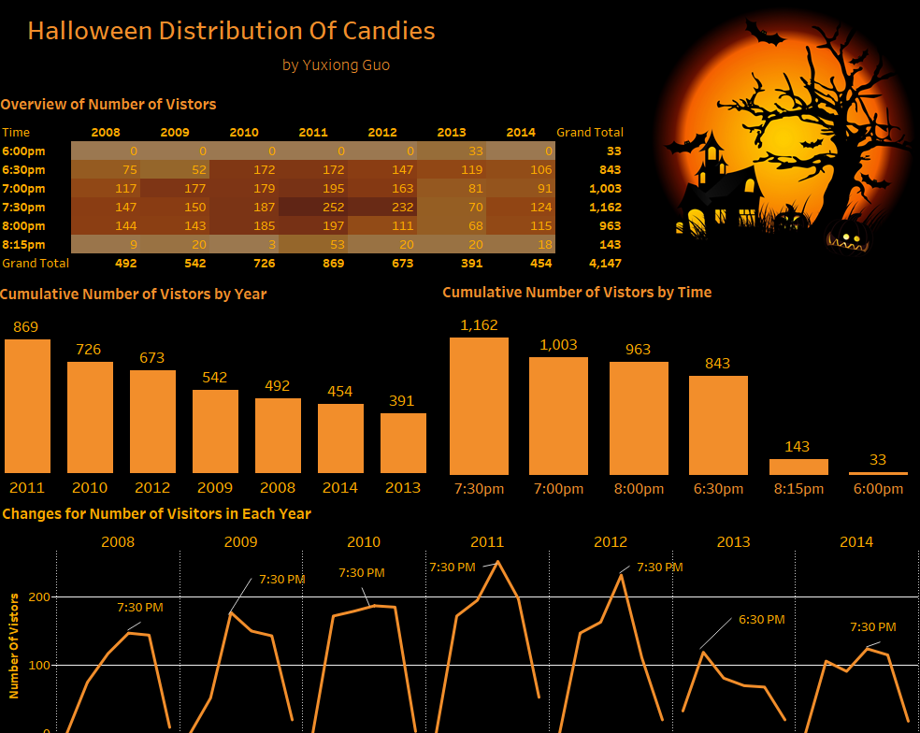

# The Assignment

There are multiple parts to this assignment. Make sure you read the entire assignment before starting.

Determine a story or goal to support the two (2) visualizations you will create using the Halloween data provided. Your two visualization MUST be different chart types. **This means DO NOT create two bar charts or two-line charts or two of the same chart types!** Challenge yourself. This is your time to show what you know.

Examples (these are examples):

* Homeowner dashboard summarizing Halloween
* Forecast future trick-or-treaters or estimate future candy needed
* Explore variation of the number of trick-or-treaters year by year
* **Be creative and think of other things you could do**

# Data Visualization Process

Show your understanding of the data visualization process.

# Acquire

## The Data

|  |  |  |  |  |  |  |
| --- | --- | --- | --- | --- | --- | --- |
| **Year** | **6pm** | **6:30pm** | **7pm** | **7:30pm** | **8pm** | **Total (8:15pm)** |
| 2020 | 11 | 55 | 107 | 155 | 211 | 219 |
| 2019 | 0 | 117 | 262 | 406 | 483 | 523 |
| 2018 | 18 | 191 | 342 | 497 | 589 | 600 |
| 2017 | 41 | 190 | 357 | 549 | 710 | 776 |
| 2016 | 22 | 160 | 386 | 612 | 759 | 822 |
| 2015 | 13 | 148 | 336 | 523 | 667 | 747 |
| 2014 | 0 | 106 | 197 | 321 | 436 | 454 |
| 2013 | 33 | 152 | 233 | 303 | 371 | 391 |
| 2012 | 0 | 147 | 310 | 542 | 653 | 673 |
| 2011 | 0 | 172 | 367 | 619 | 816 | 869 |
| 2010 | 0 | 172 | 351 | 538 | 723 | 726 |
| 2009 | 0 | 52 | 229 | 379 | 522 | 542 |
| 2008 | 0 | 75 | 192 | 339 | 483 | 492 |

Excel and Tableau versions of the data are provided in Brightspace. **Choose one (1) to work with**.

* HalloweenExcel
* HalloweenTableau

# Parse & Mine

Use this page to provide a parsing of the data. For quantitative fields list some basic statistical procedures that can be performed in the space below. To be clear, you are to list the procedure (you are not required to actually do any calculations here).

Use the Tab key to add more rows to the table below.

|  |  |  |
| --- | --- | --- |
| **Variable** | **Data type** | **Statistical Method**  **(where applicable)** |
| Date | Date | Min, Max |
| Date and Time | Date and Time | Min, Max |
| Time | String | Min, Max |
| Count | Integer | Min, Max, Average |
| Day of Week | String |  |

# Represent

# 

Figure 1. For each year of Halloween, the average number of visitors per time interval was graphed according to year.

**Helpful Tip: Utilize the space that you have. Do NOT create a tiny visualization that is unreadable. Remember, the purpose of visualization is insight, but all insight is lost if it cannot be seen.**

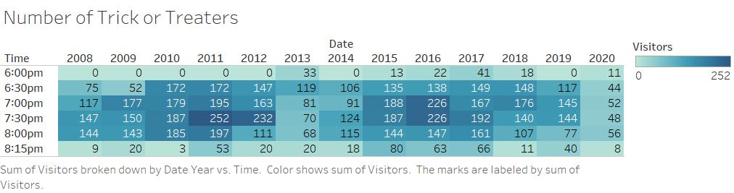

Figure 2. This heat map shows the number of trick or treaters (visitors) that came to the house per time interval per year.

# Filter

In this page show the data you used to create your visualizations.

**Figure 1**

Date (Year)

Count (Visitors, average)

**Figure 2**

Date (Year)

Time

Count (Visitors, Sum)

# Critique

Rate your visualizations (Figure 1 and Figure 2) using the link below

<https://stephanieevergreen.com/rate-your-visualization/>

**Figure 1 Rating**

**Figure 2 Rating**

# Refine

In this part of the visualization challenge, you should identify one or more characteristics of the visualizations you created (Figure 1 and Figure 2) and update the figures. Include an updated version of each Figure below. In the figure caption, state what changes were made.

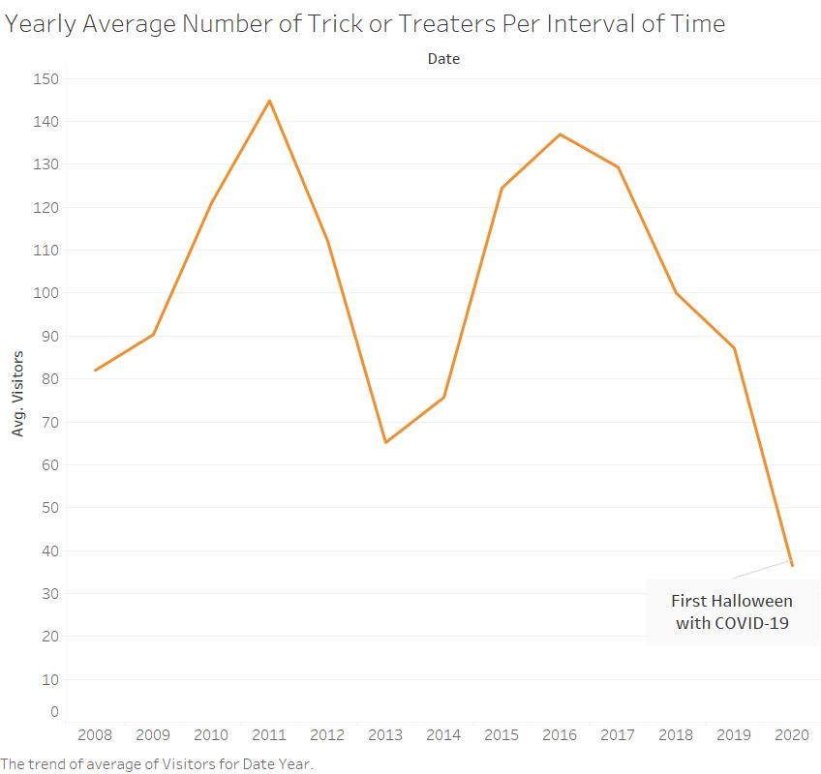

Figure 1. Updated title to be more specific, changed color to orange to match the theme, and added an annotation for 2020.

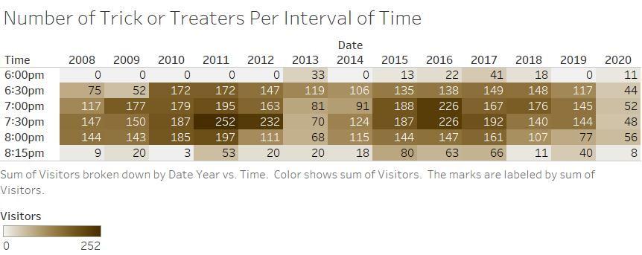

Figure 2 Updated title, changed color to brown/dark orange to suit the autumn theme, moved the legend to the bottom

Use this page if your visualizations require a landscape layout. Remove this page if it is not needed.



Figure 2. Updated title, changed color to brown/dark orange to fit the autumn theme, moved the legend to the bottom.

# What’s the story?

Every year on the thirty-first of October, children flock to the streets for candy. As displayed in Figure 2, in the initial hours of the night on any year, the consumers are few, as the rush has still yet to pass. The hours from 6:30 to 8:00 appear to be the busiest, with 7:00 and 7:30 especially being the busiest amongst them. Around 8:15 however, the traffic decreases dramatically, and the streets once again fall silent. This is probably because most parents would rather have their children stay indoors after dark.

Moving to Figure 2, it can be observed that the average amount of visitors per interval of time during a night seems to fall sharply in 2012 and 2013, perhaps due to inclement weather. If I recall, past years of Halloween have been rescheduled to the first of November because of that, and 2012 may have been one of those years. However, the most dramatic fall is 2020—where the average number drops lower than 40—something never achieved before since the beginning of the data. I assume that this has been largely since 2020 was the first year where COVID 19 affected much of public life.

Those who would be most interested in this data would maybe be planners of Halloween events or simple households giving out candy, as they could foresee the traffic that they would receive and plan accordingly.

Bonus points for REALLY GOOD stories!

**Checklist of what to submit:**

* **Save this file as LastnameFirstInitial_CGT270Fall2021_MidtermPartII.pdf**
* **Only submit one (1) file. All of your work should be contained in this file.**
* **Failure to follow these instructions will result in your work NOT being graded.**

**General Deductions (others made accordingly)**

* **No name on the first page of the document: -5 pts**
* **Altered template: -10 pts**
* **No figures included: -15 pts for each missing figure**
* **No figure captions: -10 pts for each missing caption**
* **Zip file submitted: See Checklist of what to submit (-80 pts)**
* **Late submissions: Will NOT be graded (-80 pts)**
* **Provided a link to visualizations instead of providing screenshot of the visualization: this will be treated as no figure, no figure caption (-25 pts)**
* **Failure to follow data visualization best practices (data visualization checklist): deductions made appropriately.**

**Keep in mind: one (1) second after the submission deadline is considered late.**



Byrd Data Visualization Lab