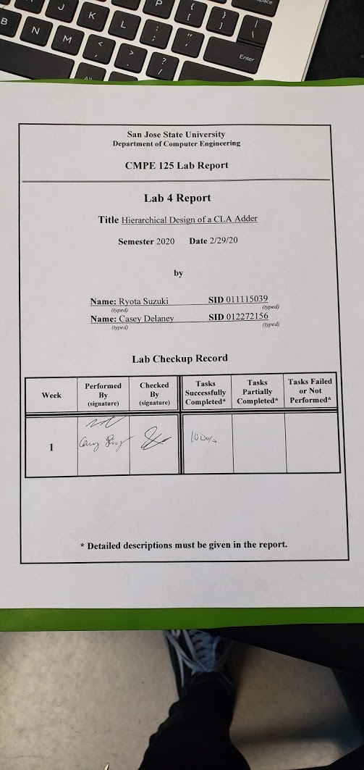

**Introduction**

The purpose of this lab is to familiarize ourselves with the hierarchical design methodology and design/verification /validation flow and the EDA tool. Our task was to create a 4-bit adder and run a simulation test via “inferred” design approach which required us to use the “+” sign. Then we designed and ran a 4-bit adder but this time using the carry look ahead method and implementing it on our BASYS3 board. Unlike the ripple carry adder, the carry look ahead adder is used because it removes the propagation delay that would be present in a ripple carry adder. It does this by computing all of the carries at the same time.

**Design Methodology**

When we designed the inferred method, we simply made the adder by using the ‘+’ sign and using an if statement to compare if it was greater than 15. If it was, we added a carry over bit and displayed the rest. However, when we made an adder using the Carry Look Ahead method, we had to compare each bit using an AND function to see if it had any carry over and using a XOR function to calculate the sum. Then we gathered that information and made a Carry Look Ahead module to calculate the 4 bit addition.

To calculate the carry, we used some relations from our adders to create our carryBits.v module, as shown in figure 7.

(1)

(2)

(3)

Utilizing formulas 1, 2 and 3, the carry for all of the bits in the CLA adders can be calculated, as shown below.

As seen in the equations above, none of the carry values depend on a previous carry value. All of the carries can be calculated in parallel vs in series as in the ripple adder which reduces the propagation delay. Unfortunately, there are some issues that arise with this method. If we were to calculate a 64 bit number, for example, there would be an enormous number of gates to computer all of the carries at the same time, and this would increase the manufacturing costs.

The modules are listed in table 1 below, and it describes the different modules used on this assignment.

*Table 1. Module descriptions*

|  |  |
| --- | --- |
| **Module** | **Function** |
| cla_adder.v | Performs a 4 bit addition w/ carry look ahead |
| carryBits.v | Calculates the carry bits in parallel |
| add_half.v | Calculates sum and carry over |
| bcd_to_7seg.v | Displays binary result on 7 seg LED |
| LEDSEL.v | Chooses which 7 seg to display to |
| inferred_adder.v | Performs a 4 bit addition operation in an “inferred” way |
| inferred_adder_self_checkingtb.v | Check all possible inputs of the inferred adder approach |
| clk_gen.v | Generates a clock signal to synchronize with |

As seen in figure 1, the top level module of the CLA utilizes 4 half bit adders (figure 2), and it computers the carry out in parallel using the carrybits module shown in figure 7.. This is very different from the top level design of the inferred adder module as shown in figure 6. Figures 3 through 5 show the modules used for our 7 segment display.

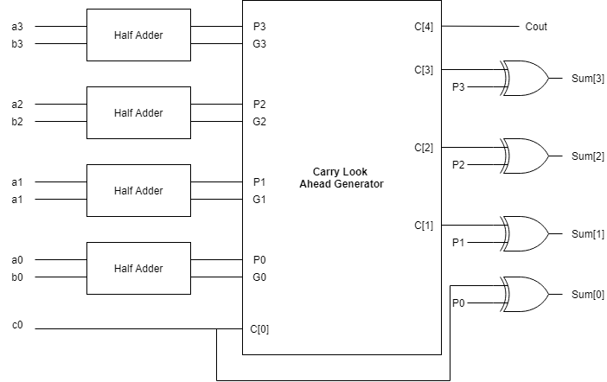

*Figure 1: Carry look ahead structure diagram*

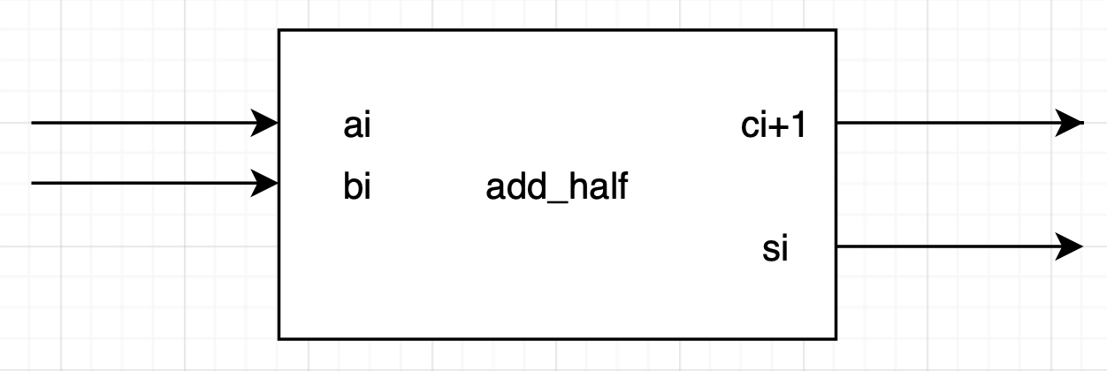

*Figure 2: add_half structure diagram*

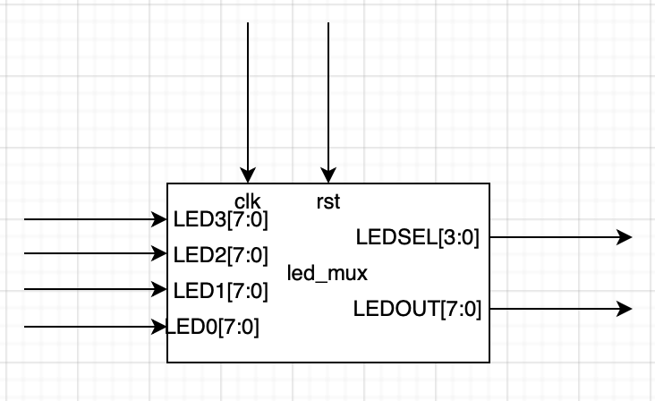

*Figure 3: led_mux structure diagram*

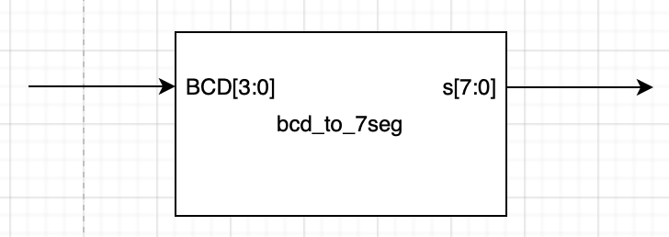

*Figure 4:bcd_to_7seg structure diagram*

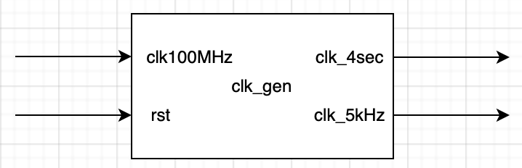

*Figure 5:clk_gen structure diagram*

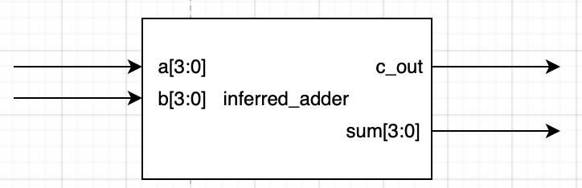

*Figure 6:inferred adder structure diagram*

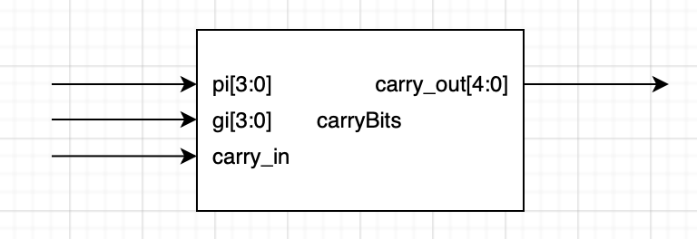

*Figure 7:carry bits structure diagram*

**Simulation results**

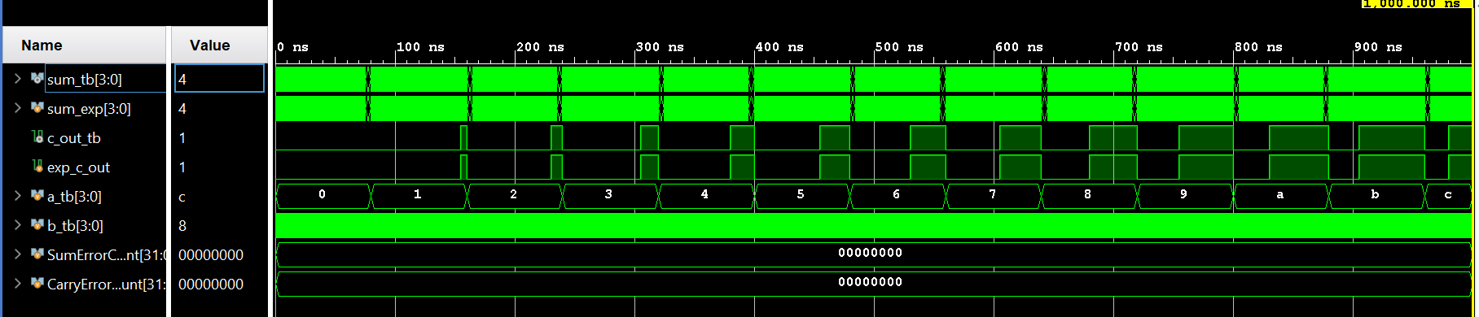

*Figure 7: Inferred method ALU waveform*

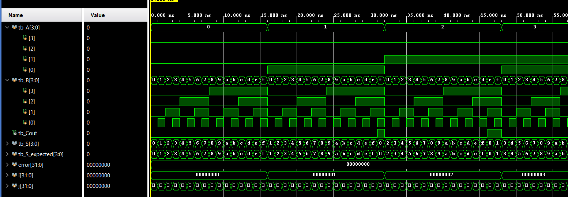

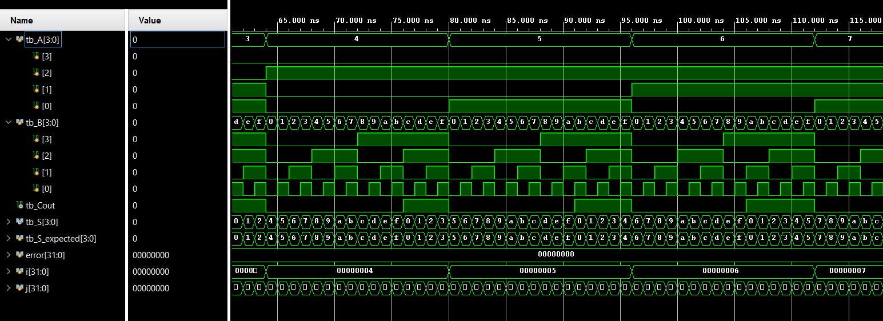

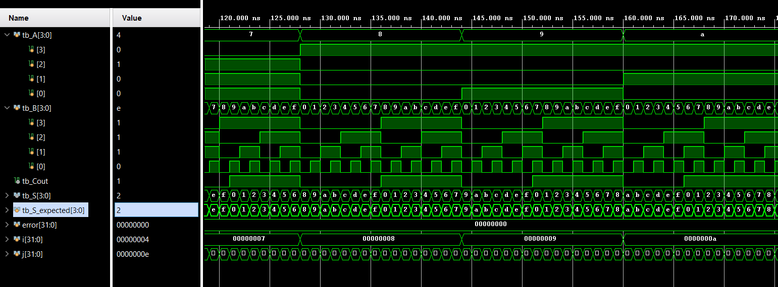

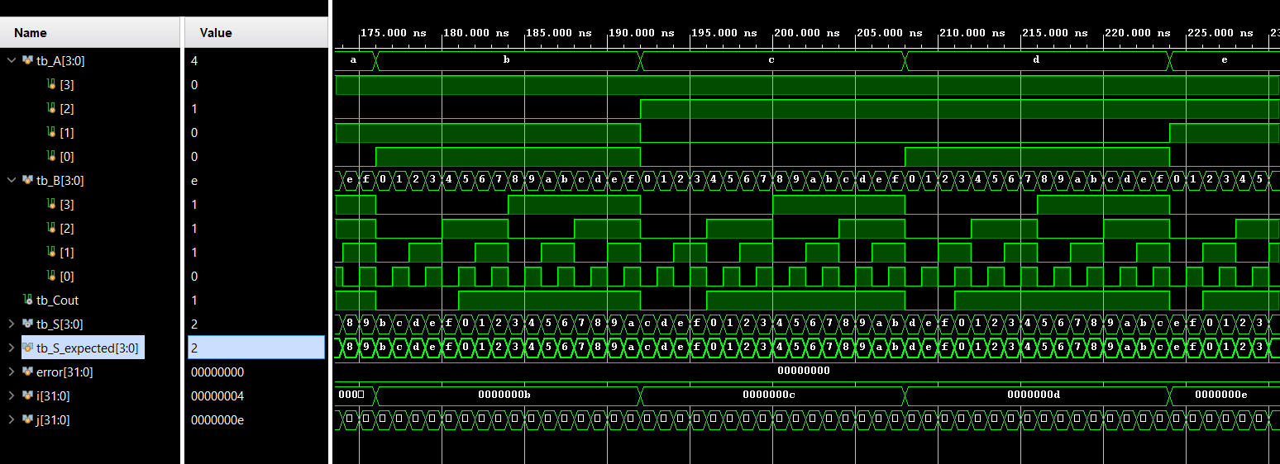

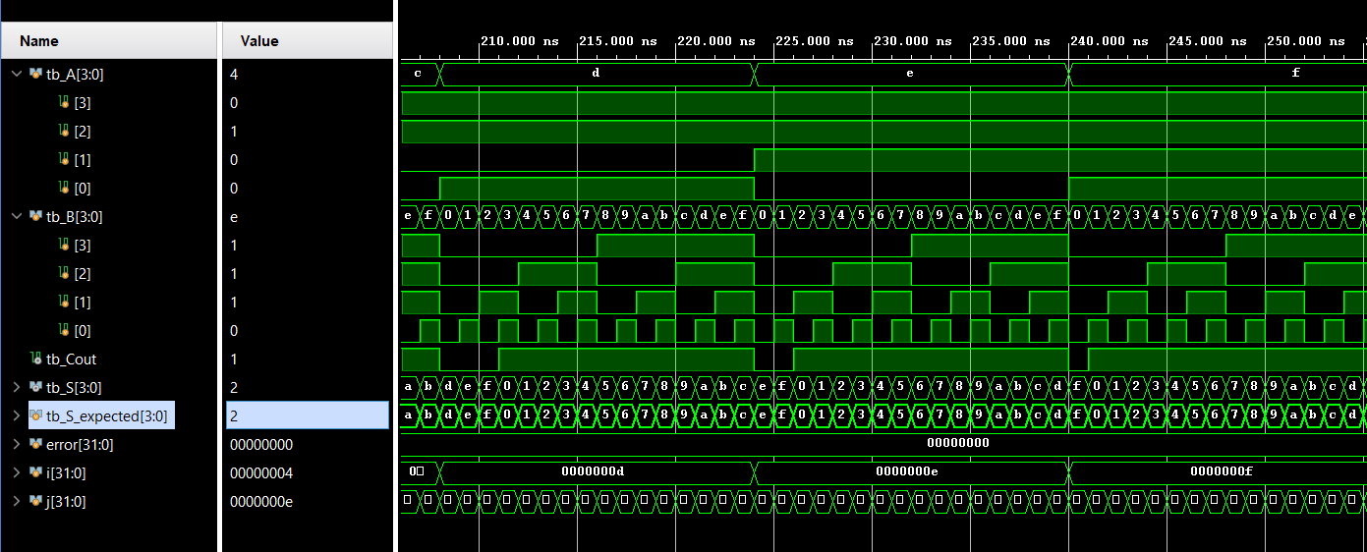

*Figure 8: Carry Look Ahead method ALU waveform*

**FPGA Validation**

When making the constraint file for the BASYS3, we made the left two 7-segment LED show the sum of the two inputs, with a max value of 15. When the sum goes past 16, then the 3rd 7-segment LED will turn on showing the carry over bit since 4 bit can only represent up till 15. The left two LED will show the remainder of the sum. When the carry in button is pressed, we added 1 to the two inputs and the most right LED will turn on, indicating that it is on.

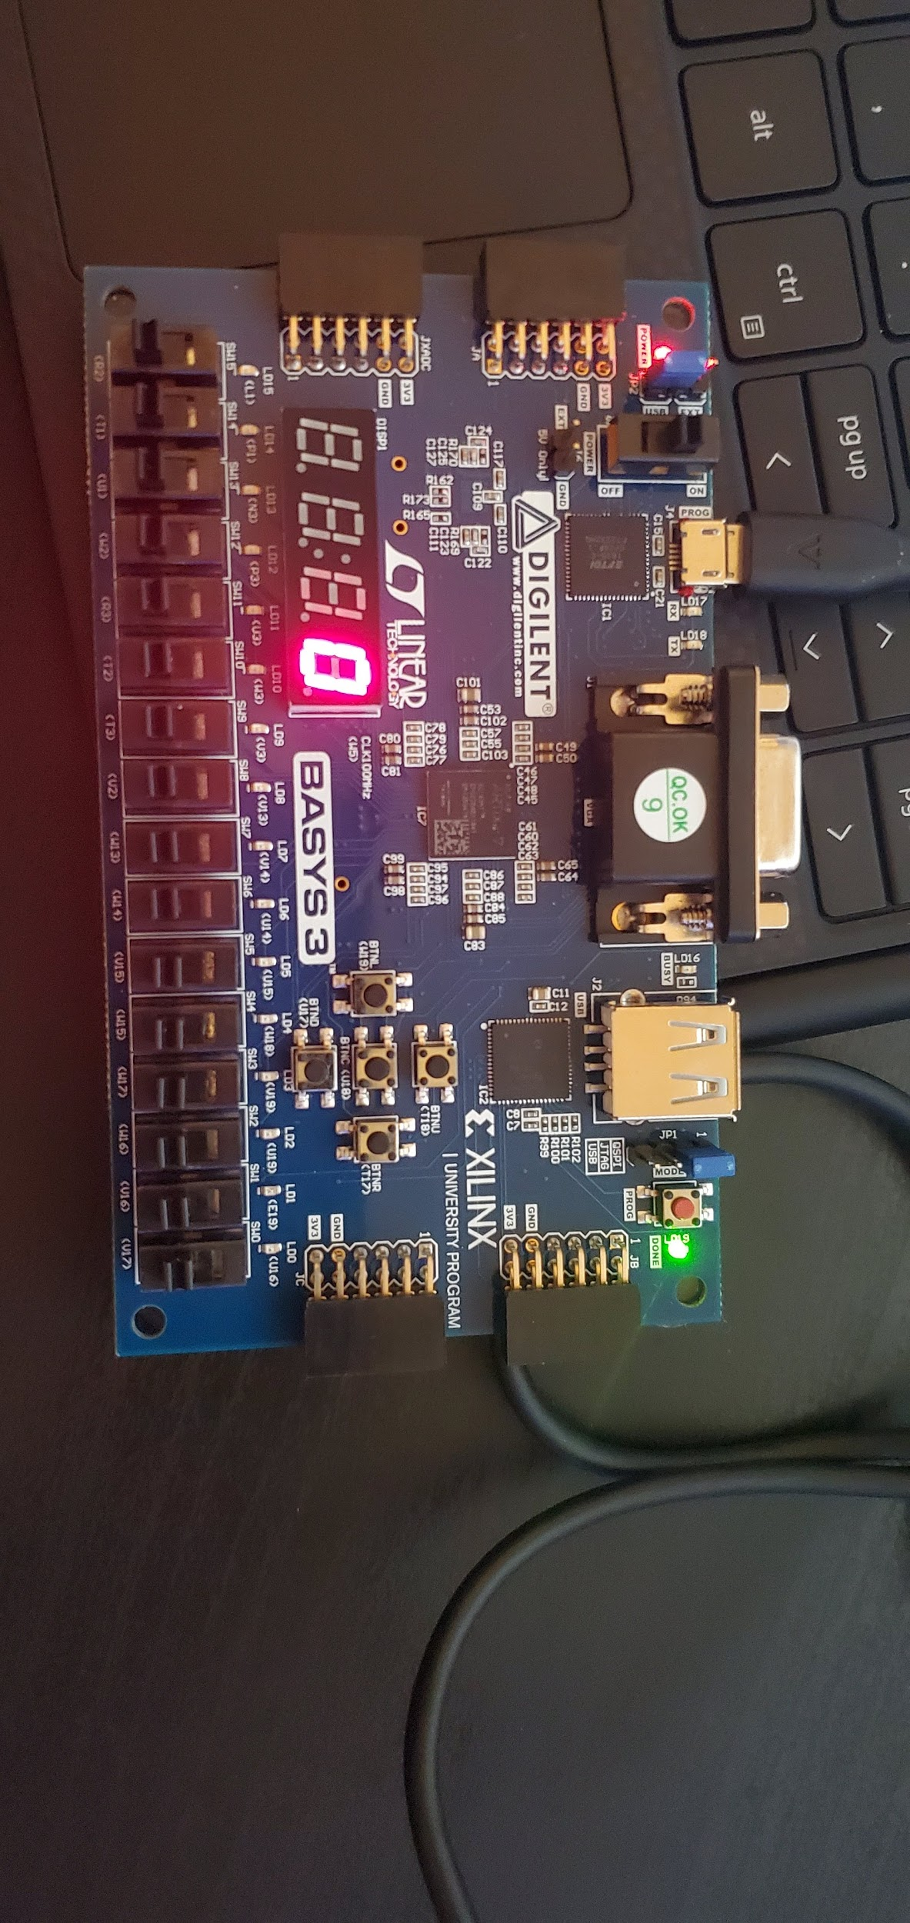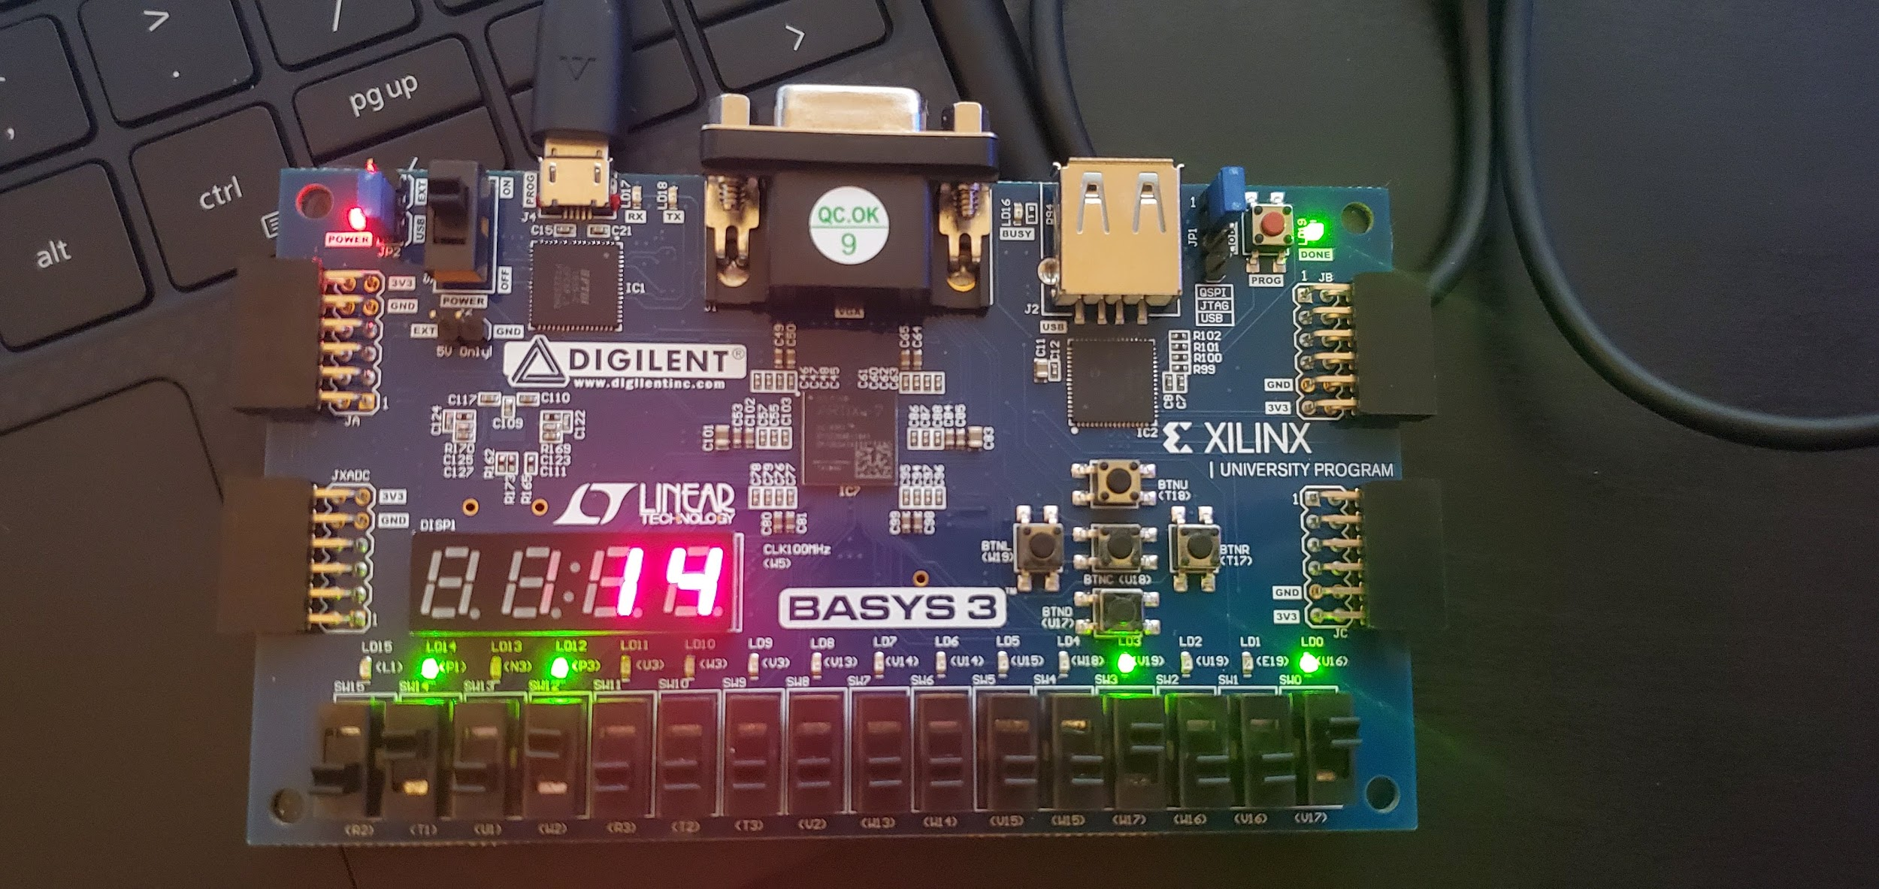

*Figure 9: Left-No switches on, Right-B[2]B[0] and A[3]A[0] on*

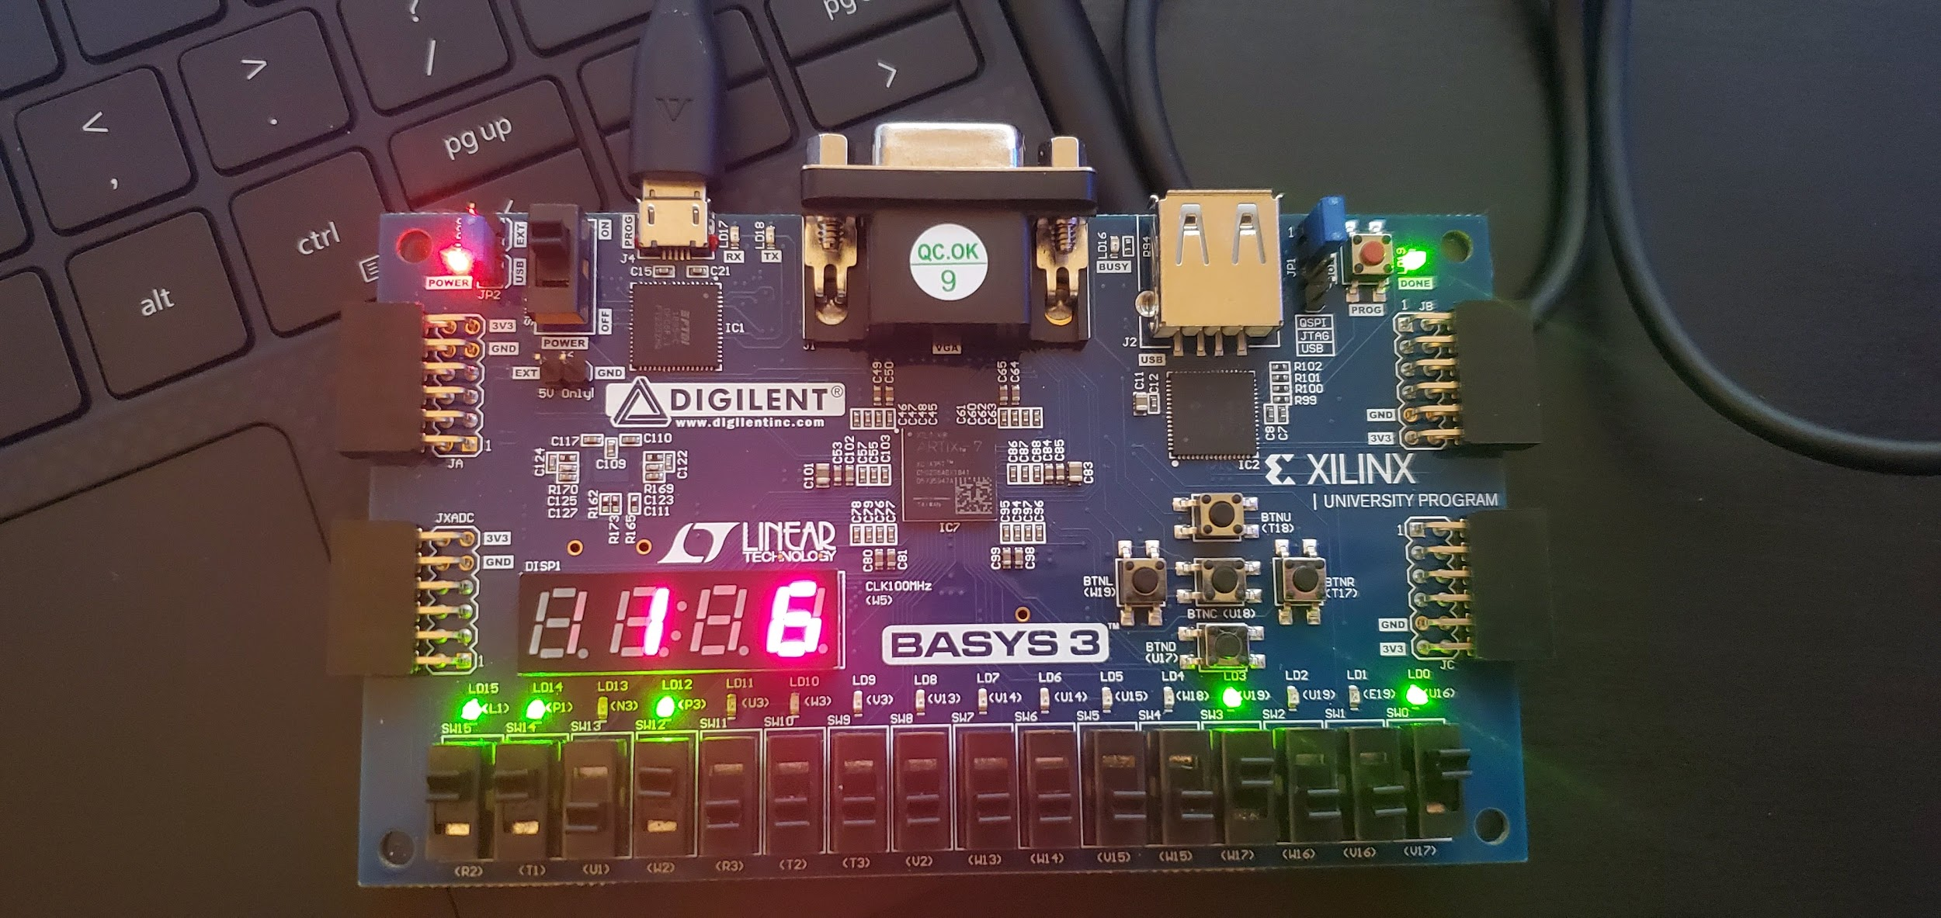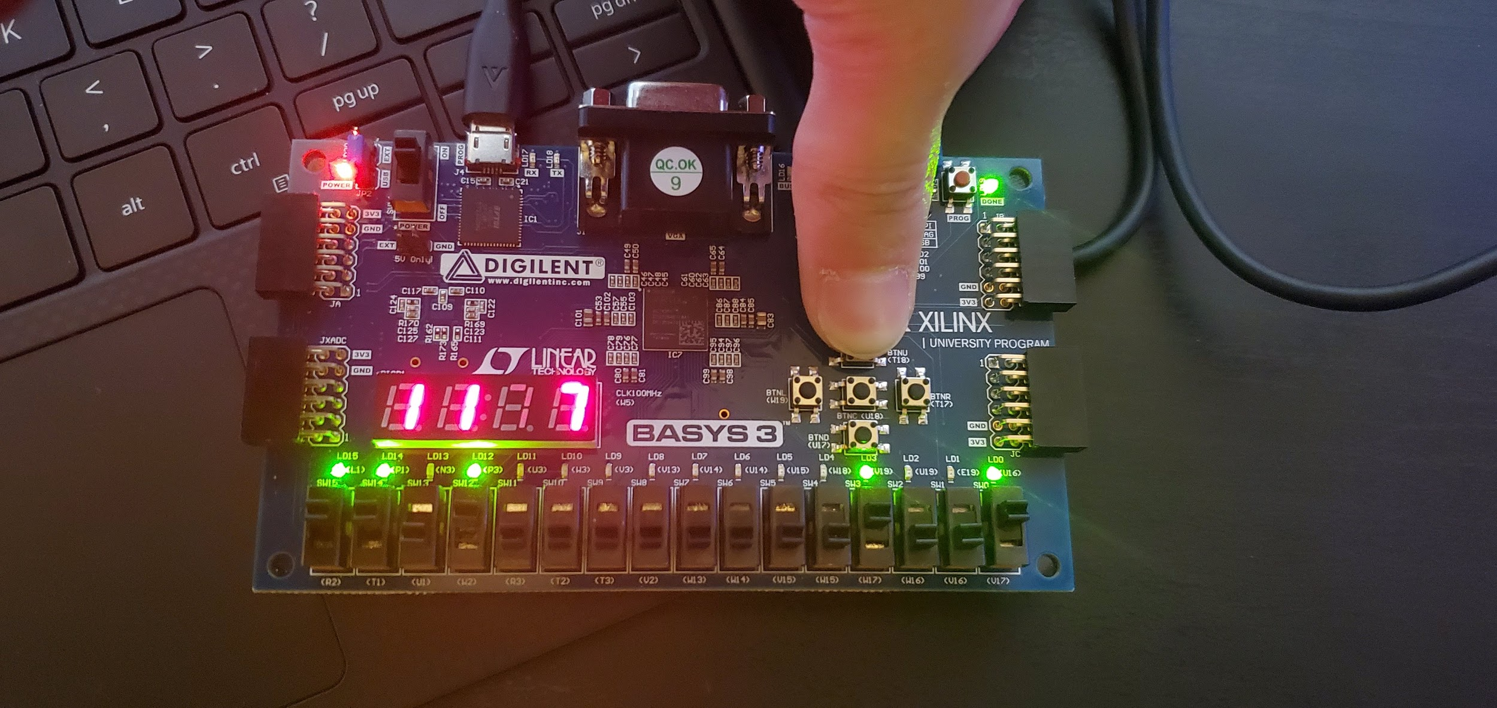

*Figure 10: Left-B[3]B[2]B[0] and A[3]A[0] on,, Right-B[3]B[2]B[0] and A[3]A[0]and carry switch on*

**Conclusion**

The purpose of this lab is to familiarize ourselves with the hierarchical design methodology and design/verification /validation flow and the EDA tool, as well as learning about the effect of propagation delay in an adder. We were successful in designing a 4-bit adder and running a simulation test via “inferred” design approach which required us to use the “+” sign. We were also successful designing and running a 4-bit adder using the carry look ahead method and implementing it on our BASYS3 board.

In designing our adder, we learned about the differences between a carry look ahead approach and a ripple carry approach. When we do the CLA method, we can compute all of the carry bits in parallel. Although this is important in reducing propagation delay, its disadvantage is that it requires a lot of gates if we were to make a 64 bit adder. To get the best of both propagation delay and the number of gates, it is possible to make multiple 4 bit CLA adders and then link these together using the ripple carry method to get to 64 bits. This was not a part of the lab, but our design gave us insight towards what we could do in a higher level design. Overall, the lab was successful and we learned how to program a button in our constraint file, which we had not previously done before.

**Appendix**

|  |
| --- |
| inferred_adder.v |
| module inferred_adder(sum, c_out, a, b);  output reg [3:0] sum;  output reg c_out;  input wire [3:0] a;  input wire [3:0] b;  always @ (a, b)  begin  if(a + b > 15) begin  c_out = 1;  sum = a + b;  end  else begin  c_out = 0;  sum = a + b;  end  end  endmodule |

|  |
| --- |
| inferred_adder_self_checkingtb.v |
| `timescale 1ns / 1ps  module self_checking_tb;  wire [3:0] sum_tb;  wire c_out_tb;  reg exp_c_out;  reg [3:0] sum_exp;  reg [3:0] a_tb;  reg [3:0] b_tb;  inferred_adder DUT(  .sum(sum_tb),  .c_out(c_out_tb),  .a(a_tb),  .b(b_tb)  );  integer i, j;  integer SumErrorCount;  integer CarryErrorCount;  initial  begin  SumErrorCount = 0;  CarryErrorCount = 0;  for(i = 4'b0000; i <= 4'b1111; i = i + 4'b0001) begin    a_tb = i;  for(j = 4'b0000; j <= 4'b1111; j = j + 4'b0001) begin  b_tb = j;    if(sum_exp[3:0] === sum_tb[3:0]) begin end  else begin SumErrorCount = SumErrorCount + 1; $display ("sum_exp =");  $display (sum_exp);  $display ("sum_tb = ");  $display (sum_tb); end  if(exp_c_out === c_out_tb) begin end  else begin CarryErrorCount = CarryErrorCount + 1; $display ("carry exp =");  $display (exp_c_out);  $display ("c_out_tb = ");  $display (c_out_tb); end  sum_exp = i + j;  exp_c_out = 0;  if(i + j > 15)begin exp_c_out = 1; end  #5;  end  end  $display ("Simulation Finished");  $finish;  end  endmodule |

|  |
| --- |
| clk_gen.v |
| `timescale 1ns / 1ps  module tb_cla_adder;  reg [3:0] tb_A;  reg [3:0] tb_B;  reg tb_Cin;  wire tb_Cout;  wire [3:0] tb_S;  reg [3:0]tb_S_expected;  integer error = 0;  integer i, j;    cla_adder DUT(.A(tb_A), .B(tb_B), .C_in(tb_Cin), .C_out(tb_Cout), .Sum(tb_S));  initial begin  for(i = 0; i < 16; i = i + 1) begin  for(j = 0; j < 16; j = j + 1) begin  tb_Cin = 0;  tb_A = i;  tb_B = j;  tb_S_expected = i + j;  #1;  if(tb_S != tb_S_expected) begin  $display("Error");  error =+1 ;  end  else begin  end  end  end  end  endmodule |

|  |
| --- |
| clk_gen.v |
| module clk_gen (  input wire clk100MHz,  input wire rst,  output reg clk_4sec,  output reg clk_5KHz  );  integer count1, count2;  always @ (posedge clk100MHz) begin  if (rst) begin  count1 = 0; clk_4sec = 0;  count2 = 0; clk_5KHz = 0;  end else begin  if (count1 == 200000000) begin  clk_4sec = ~clk_4sec;  count1 = 0;  end  if (count2 == 10000) begin  clk_5KHz = ~clk_5KHz;  count2 = 0; end  count1 = count1 + 1;  count2 = count2 + 1;  end  end  endmodule |

|  |
| --- |
| bcd_to_7seg.v |
| module bcd_to_7seg (  input wire [3:0] BCD,  output reg [7:0] s  );  always @ (BCD) begin  case (BCD)  4'd0: s = 8'b11000000;  4'd1: s = 8'b11111001;  4'd2: s = 8'b10100100;  4'd3: s = 8'b10110000;  4'd4: s = 8'b10011001;  4'd5: s = 8'b10010010;  4'd6: s = 8'b10000010;  4'd7: s = 8'b11111000;  4'd8: s = 8'b10000000;  4'd9: s = 8'b10010000;  default: s = 8'b01111111;    endcase  end  endmodule |

|  |
| --- |
| LEDSEL.v |
| module LEDSEL (  input wire clk,  input wire rst,  input wire [7:0] LED3,  input wire [7:0] LED2,  input wire [7:0] LED1,  input wire [7:0] LED0,  output wire [3:0] LEDOUT,  output wire [7:0] LEDOUT  );  reg [1:0] index;  reg [11:0] led_ctrl;  assign {LEDOUT, LEDOUT} = led_ctrl;  always @ (posedge clk) index <= (rst) ? 2'b0 : (index + 2'd1);  always @ (index, LED0, LED1, LED2, LED3) begin  case (index)  4'd0: led_ctrl <= {4'b1110, LED0};  4'd1: led_ctrl <= {4'b1101, LED1};  4'd2: led_ctrl <= {4'b1011, LED2};  4'd3: led_ctrl <= {4'b0111, LED3};  default: led_ctrl <= {8'b1111, 8'hFF};  endcase  end  endmodule |

|  |
| --- |
| cla_adder.v |
| module cla_adder(  input [3:0]A,  input [3:0]B,  input C_in,  output C_out,  output [3:0] Sum  );  wire [3:0] P;  wire [3:0] G;  wire [4:0] C;  carryBits cBits(.P(P), .G(G), .C_in(C_in), .C_out(C));  Add_half AH0(.a(A[0]), .b(B[0]), .c_out(P[0]), .sum(G[0]));  Add_half AH1(.an(A[1]), .b(B[1]), .c_out(P[1]), .sum(G[1]));  Add_half AH2(.a(A[2]), .b(B[2]), .c_out(P[2]), .sum(G[2]));  Add_half AH3(.a(A[3]), .b(B[3]), .c_out(P[3]), .sum(G[3]));  assign Sum[0] = P[0] ^ C[0];  assign Sum[1] = P[1] ^ C[1];  assign Sum[2] = P[2] ^ C[2];  assign Sum[3] = P[3] ^ C[3];  assign C_out = C[4];  endmodule |

|  |
| --- |
| cla_adder_fpga.v |
| `timescale 1ns / 1ps  module cla_adder_fpga(  input wire clk100mhz,  input wire cin_button,  input wire [3:0]inputA,  input wire [3:0]inputB,  output reg [3:0]outputA,  output reg [3:0]outputB,  output wire [7:0]LEDOUT,  output wire [3:0]LEDSEL  );    wire [3:0]sum_out;  wire carryOut;  wire dontuse;  Wire clk_5KHz;  Clk_gen CLK (  .clk100MHz (clk100MHz),  .rst (rst),  .clk_4sec (dontuse),  .clk_5KHz (clk_5KHz)  );  Bcd_to_7seg BCD (  .BCD (LEDSEL),  .s (LEDOUT)  );  Led_mux LED (  .clk (clk_5KHz),  .rst (rst),  .LED3 (LEDOUT),  .LED2 (LEDOUT),  .LED1 (LEDOUT),  .LED0 (LEDOUT).  .LEDSEL (LEDSEL),  .LEDOUT (LEDOUT)  );  carryBits cBits(  .P(inputA),  .G(inputB),  .C_in(cin_button),  .C_out(carryOut),  );  always @ (inputA, inputB, cin_button) begin  outputA = inputA;  outputB = inputB;  if(cin_button) begin  led0 = 4'b0001;  end  else begin  led0 = 4'b1111;  end  if(carryOut) begin  led1 = 4'b0001;  end  else begin  led1 = 4'b1111;  end  if(sum_out >= 10) begin  led2 = 4'b0001;  led3 = sum_out - 10;  end  else begin  led2 = 4'b1111;  led3 = sum_out;  end  end  endmodule |

|  |
| --- |
| carryBits.v |
| module carryBits(  input [3:0]P,  input [3:0]G,  input C_in,  output[4:0]C_out  );  assign C_out[0] = C_in;  assign C_out[1] = G[0] | P[0] & C_in;  assign C_out[2] = G[1] | P[1] & G[0] | P[1] & P[0] & C_in;  assign C_out[3] = G[2] | P[2] & G[1] | P[2] & P[1] & G[0] | P[2] & P[1] & P[0] & C_in;  assign C_out[4] = G[3] | P[3] & G[2] | P[3] & P[2] & G[1] | P[3] & P[2] & P[1] & G[0] | P[3] & P[2] & P[1] & P[0] & C_in;  endmodule |

|  |
| --- |
| Add_half.v |
| `timescale 1ns / 1ps  module Add_half(  input a,b;  output c_out, sum;  );  assign sum = a ^ b;  assign c_out = a & b;  endmodule |

|  |
| --- |
| cla_adder_fpga.xdc |
| # Clock  set_property -dict {PACKAGE_PIN W5 IOSTANDARD LVCMOS33} [get_ports {clk100mhz}];  create_clock -add -name sys_clk_pin -period 10.00 -waveform {0 5} [get_ports {clk100mhz}];  # Button  set_property -dict {PACKAGE_PIN T18 IOSTANDARD LVCMOS33} [get_ports {cin_button}]; #Button - cin  # Switches  set_property -dict {PACKAGE_PIN V17 IOSTANDARD LVCMOS33} [get_ports {inputB[0]}]; # Switch 0  set_property -dict {PACKAGE_PIN V16 IOSTANDARD LVCMOS33} [get_ports {inputB[1]}]; # Switch 1  set_property -dict {PACKAGE_PIN W16 IOSTANDARD LVCMOS33} [get_ports {inputB[2]}]; # Switch 2  set_property -dict {PACKAGE_PIN W17 IOSTANDARD LVCMOS33} [get_ports {inputB[3]}]; # Switch 3  set_property -dict {PACKAGE_PIN W2 IOSTANDARD LVCMOS33} [get_ports {inputA[0]}]; # Switch 4  set_property -dict {PACKAGE_PIN U1 IOSTANDARD LVCMOS33} [get_ports {inputA[1]}]; # Switch 5  set_property -dict {PACKAGE_PIN T1 IOSTANDARD LVCMOS33} [get_ports {inputA[2]}]; # Switch 6  set_property -dict {PACKAGE_PIN R2 IOSTANDARD LVCMOS33} [get_ports {inputA[3]}]; # Switch 7  # LEDs  set_property -dict {PACKAGE_PIN U16 IOSTANDARD LVCMOS33} [get_ports {outputB[0]}]; # LED 0  set_property -dict {PACKAGE_PIN E19 IOSTANDARD LVCMOS33} [get_ports {outputB[1]}]; # LED 1  set_property -dict {PACKAGE_PIN U19 IOSTANDARD LVCMOS33} [get_ports {outputB[2]}]; # LED 2  set_property -dict {PACKAGE_PIN V19 IOSTANDARD LVCMOS33} [get_ports {outputB[3]}]; # LED 3  set_property -dict {PACKAGE_PIN P3 IOSTANDARD LVCMOS33} [get_ports {outputA[0]}]; # LED 4  set_property -dict {PACKAGE_PIN N3 IOSTANDARD LVCMOS33} [get_ports {outputA[1]}]; # LED 5  set_property -dict {PACKAGE_PIN P1 IOSTANDARD LVCMOS33} [get_ports {outputA[2]}]; # LED 6  set_property -dict {PACKAGE_PIN L1 IOSTANDARD LVCMOS33} [get_ports {outputA[3]}]; # LED 7  # 7 Segment Display  set_property -dict {PACKAGE_PIN U2 IOSTANDARD LVCMOS33} [get_ports {LEDSEL[0]}]; # mux 0  set_property -dict {PACKAGE_PIN U4 IOSTANDARD LVCMOS33} [get_ports {LEDSEL[1]}]; # mux 1  set_property -dict {PACKAGE_PIN V4 IOSTANDARD LVCMOS33} [get_ports {LEDSEL[2]}]; # mux 2  set_property -dict {PACKAGE_PIN W4 IOSTANDARD LVCMOS33} [get_ports {LEDSEL[3]}]; # mux 3  set_property -dict {PACKAGE_PIN W7 IOSTANDARD LVCMOS33} [get_ports {LEDOUT[0]}]; # out 0  set_property -dict {PACKAGE_PIN W6 IOSTANDARD LVCMOS33} [get_ports {LEDOUT[1]}]; # out 1  set_property -dict {PACKAGE_PIN U8 IOSTANDARD LVCMOS33} [get_ports {LEDOUT[2]}]; # out 2  set_property -dict {PACKAGE_PIN V8 IOSTANDARD LVCMOS33} [get_ports {LEDOUT[3]}]; # out 3  set_property -dict {PACKAGE_PIN U5 IOSTANDARD LVCMOS33} [get_ports {LEDOUT[4]}]; # out 4  set_property -dict {PACKAGE_PIN V5 IOSTANDARD LVCMOS33} [get_ports {LEDOUT[5]}]; # out 5  set_property -dict {PACKAGE_PIN U7 IOSTANDARD LVCMOS33} [get_ports {LEDOUT[6]}]; # out 6  set_property -dict {PACKAGE_PIN V7 IOSTANDARD LVCMOS33} [get_ports {LEDOUT[7]}]; # out 7 |