**Assignment 9 (Extra Credit)**

**Unsigned Integer Multiplier Based On Shift Add Algorithm**

Completed by:

Casey Delaney 012272156

Ryota Suzuki 011115039

(Note: there was no cover page uploaded to canvas at the time of submitting our report)

**The items in this lab report are listed in the order shown in assignment 9.**

1. Successful Tasks - All tasks completed on time

* Datapath waveform simulation
* Control unit waveform simulation
* Full multiplier simulation
* FPGA validation

1. **Source Code**

|  |
| --- |
| multiplier.v |
| `timescale 1ns / 1ps  module multiplier(  input clk,  input [3:0] M1,  input [3:0] M2,  input go,  output done,  output [3:0] state,  output [7:0] Result  );    wire L1;  wire SL;  wire L2;  wire SR;  wire sel;  wire L3;  wire R2_q0;  wire M2_zero;    datapath dp(  .clk(clk),  .M1(M1),  .M2(M2),  .L1(L1),  .SL(SL),  .L2(L2),  .SR(SR),  .sel(sel),  .L3(L3),    .R2_q0(R2_q0),  .M2_zero(M2_zero),  .Result(Result)  );    control_unit cu(  .clk(clk),  .go(go),  .R2(R2_q0),  .M2_zero(M2_zero),    .L1(L1),  .SL(SL),  .L2(L2),  .SR(SR),  .sel(sel),  .L3(L3),  .done(done),  .state(state)  );    endmodule |

|  |
| --- |
| datapath.v |
| module datapath(  input clk,  input [3:0] M1,  input [3:0] M2,  input L1,  input SL,  input L2,  input SR,  input sel,  input L3,    output R2_q0,  output M2_zero,  output [7:0] Result  );  wire [7:0] R1_out;  wire [3:0] R2_out;  wire [7:0] R3_out;  wire [7:0] add_out;  wire [7:0] mux_out;  shift_register #(8) R1(  .CLK(clk),  .RST(0),  .SL(SL),  .SR(0),  .LD(L1),  .LeftIn(0),  .RightIn(0),  .D({4'b0000, M1}),  .Q(R1_out)  );  shift_register #(4) R2(  .CLK(clk),  .RST(0),  .SL(0),  .SR(SR),  .LD(L2),  .LeftIn(0),  .RightIn(0),  .D(M2),  .Q(R2_out)  );  shift_register #(8) R3(  .CLK(clk),  .RST(0),  .SL(0),  .SR(0),  .LD(L3),  .LeftIn(0),  .RightIn(0),  .D(mux_out),  .Q(R3_out)  );  NOR N(  .D(R2_out),  .Q(M2_zero)  );  adder add(  .A(R1_out),  .B(R3_out),  .C(add_out)  );  mux2 #(8) mux(  .d0(8'b00000000),  .d1(add_out),  .sel(sel),  .muxOut(mux_out)  );  assign Result = R3_out;  assign R2_q0 = R2_out[0];  endmodule |

|  |
| --- |
| shift_register.v |
| module shift_register #(parameter Data_width = 4)(CLK, RST, SL, SR, LD, LeftIn, RightIn, D, Q);  input CLK, RST, SL, SR, LD, LeftIn, RightIn;  input [Data_width-1:0] D;  output reg [Data_width-1:0] Q;  always @(posedge CLK)  begin  if (RST) Q = 0;  else if (LD) Q = D;  else if (SL) // shift left  begin  Q [Data_width-1:1] = Q [Data_width-2:0];  Q [0] = RightIn;  end  else if (SR) // shift right  begin  Q [Data_width-2:0] = Q [Data_width-1:1];  Q [Data_width -1] = LeftIn;  end  else Q [Data_width-1:0] = Q [Data_width-1:0];  end  endmodule |

|  |
| --- |
| NOR.v |
| `timescale 1ns / 1ps  module NOR(  input [3 : 0] D,  output Q  );  assign Q = !(D || 4'b0000);  endmodule |

|  |
| --- |
| adder.v |
| `timescale 1ns / 1ps  module adder(  input [7:0] A,  input [7:0] B,  output [7:0] C  );  assign C = (A+B);  endmodule |

|  |
| --- |
| mux2.v |
| module mux2 #(parameter WIDTH = 4)(  input [WIDTH - 1:0] d0,  input [WIDTH - 1:0] d1,  input sel,  output [WIDTH - 1:0] muxOut  );    assign muxOut = (sel) ? d1:d0;    endmodule |

|  |
| --- |
| control_unit.v |
| `timescale 1ns / 1ps  module control_unit(  input clk,  input go,  input R2,  input M2_zero,    output reg L1,  output reg SL,  output reg L2,  output reg SR,  output reg sel,  output reg L3,  output reg done,  output reg [3:0] state = 0  );      always@(negedge clk) begin  if(state == 0) begin  L1 = 0;  SL = 0;  L2 = 0;  SR = 0;  sel = 0;  L3 = 0;  done = 0;  if(go == 1) begin  state = 1;  end  end  else if(state == 1) begin  L1 = 1;  L2 = 1;  L3 = 1;  state = 2;  end  else if(state == 2) begin  if(M2_zero == 0 && R2 == 1) begin  L1 = 0;  SL = 0;  L2 = 0;  SR = 0;  sel = 1;  L3 = 1;  done = 0;  state = 3;  end  else if(M2_zero == 0 && R2 == 0)begin  L1 = 0;  SL = 0;  L2 = 0;  SR = 0;  sel = 0;  L3 = 0;  done = 0;  state = 3;  end  else begin  L1 = 0;  SL = 0;  L2 = 0;  SR = 0;  sel = 0;  L3 = 0;  done = 0;  state = 4;  end  end  else if(state == 3) begin  L1 = 0;  SL = 1;  L2 = 0;  SR = 1;  sel = 0;  L3 = 0;  done = 0;  state = 2;  end  else if(state == 4) begin  L1 = 0;  SL = 0;  L2 = 0;  SR = 0;  sel = 0;  L3 = 0;  done = 1;  state = 0;  end  end  endmodule |

|  |
| --- |
| button_debouncer.v |
| module button_debouncer #(parameter depth = 16) (  input wire clk, /* 5 KHz clock */  input wire button, /* Input button from constraints */  output reg debounced_button  );    localparam history_max = (2**depth)-1;  /* History of sampled input button */  reg [depth-1:0] history;  always @ (posedge clk) begin  /* Move history back one sample and insert new sample */  history <= { button, history[depth-1:1] };    /* Assert debounced button if it has been in a consistent state throughout history */  debounced_button <= (history == history_max) ? 1'b1 : 1'b0;  end    endmodule |

|  |
| --- |
| clk_gen.v |
| `timescale 1ns / 1ps  module clk_gen (  input wire clk100MHz,  input wire rst,  output reg clk_4sec,  output reg clk_5KHz  );  integer count1, count2;  always @ (posedge clk100MHz) begin  if (rst) begin  count1 = 0; clk_4sec = 0;  count2 = 0; clk_5KHz = 0;  end else begin  if (count1 == 200000000) begin  clk_4sec = ~clk_4sec;  count1 = 0;  end  if (count2 == 10000) begin  clk_5KHz = ~clk_5KHz;  count2 = 0; end  count1 = count1 + 1;  count2 = count2 + 1;  end  end  endmodule |

|  |
| --- |
| seg_handler.v |
| module seg_handler(  input clk100MHz,  input [3:0]led0,  input [3:0]led1,  input [3:0]led2,  input [3:0]led3,  output reg [7:0]led_out,  output reg [3:0]led_anode  );  reg clk_5KHz;  reg [1:0]led_sel;  reg [3:0]led_out_bcd;  integer count1, count2;  always @ (posedge clk100MHz) begin  if(count1 == 200000000) begin  count1 = 0;  end  if (count2 == 10000) begin  clk_5KHz = ~clk_5KHz;  count2 = 0;  end  count1 = count1 + 1;  count2 = count2 + 1;  end  always @ (posedge clk_5KHz) begin  led_sel = led_sel + 1;  case(led_sel)  2'b00: begin  led_anode = 4'b0111;  led_out_bcd = led0;  end  2'b01: begin  led_anode = 4'b1011;  led_out_bcd = led1;  end  2'b10: begin  led_anode = 4'b1101;  led_out_bcd = led2;  end  2'b11: begin  led_anode = 4'b1110;  led_out_bcd = led3;  end  endcase  case(led_out_bcd)  4'd0: led_out = 8'b11000000;  4'd1: led_out = 8'b11111001;  4'd2: led_out = 8'b10100100;  4'd3: led_out = 8'b10110000;  4'd4: led_out = 8'b10011001;  4'd5: led_out = 8'b10010010;  4'd6: led_out = 8'b10000010;  4'd7: led_out = 8'b11111000;  4'd8: led_out = 8'b10000000;  4'd9: led_out = 8'b10010000;  4'b10: led_out = 8'b01111111;  default: led_out = 8'b11111111;  endcase  end  endmodule |

|  |
| --- |
| mult_tb.v |
| `timescale 1ns / 1ps  module mult_tb;  reg clk_tb;  reg [3:0] M1_tb;  reg [3:0] M2_tb;  reg go_tb;  wire done_tb;  wire [3:0] state_tb;  wire [7:0] Result_tb;  reg [4:0] i;  reg [4:0] j;  reg [8:0] expected;  integer error=0;  multiplier DUT(  .clk(clk_tb),  .M1(M1_tb),  .M2(M2_tb),  .go(go_tb),  .done(done_tb),  .state(state_tb),  .Result(Result_tb)  );  task clock;  begin  clk_tb = 0;  #5;  clk_tb = 1;  #5;  end  endtask    initial begin  for(i=0; i<=15; i=i+1)begin  for(j=0; j<=15; j=j+1)begin  expected = i*j;  clk_tb=0;  M1_tb = i;  M2_tb = j;  go_tb = 0;  clock;  go_tb = 1;  clock;  go_tb = 0;  clock;  clock;  clock;  clock;  clock;  clock;  clock;  clock;  clock;  clock;  clock;  if(expected!=Result_tb)begin  error=error+1;  end  end  end  end  endmodule |

|  |
| --- |
| cu_tb.v |
| `timescale 1ns / 1ps  module cu_tb; //testbench for CU  reg clk_tb;  reg [3:0] M1_tb;  reg [3:0] M2_tb;  reg go_tb;  wire done_tb;  wire [3:0] state_tb;  reg [3:0] expected_state;  integer error=0;  multiplier DUT( //assigning signal to multiplier  .clk(clk_tb),  .M1(M1_tb),  .M2(M2_tb),  .go(go_tb),  .done(done_tb),  .state(state_tb),  .Result(Result_tb)  );  task clock;  begin  clk_tb = 0;  #5;  clk_tb = 1;  #5;  end  endtask    initial begin  clk_tb=0;  M1_tb = 11;  M2_tb = 2;  go_tb = 0;  expected_state=0; //initialize expected state  clock;  clock;  if(expected_state != state_tb)begin  error=error+1;  end  go_tb = 1;  expected_state=1; //change with accordance to state transition diagram  clock;  if(expected_state != state_tb)begin  error=error+1;  end  go_tb = 0;  expected_state = 2;  clock;  if(expected_state != state_tb)begin  error=error+1;  end    expected_state=3;  clock;  if(expected_state != state_tb)begin  error=error+1;  end    expected_state=2;  clock;  if(expected_state != state_tb)begin  error=error+1;  end    expected_state=3;  clock;  if(expected_state != state_tb)begin  error=error+1;  end    expected_state = 2;  clock;  if(expected_state != state_tb)begin  error=error+1;  end    expected_state = 4;  clock;  if(expected_state != state_tb)begin  error=error+1;  end    expected_state = 0;  clock;  if(expected_state != state_tb)begin  error=error+1;  end  end  endmodule |

|  |
| --- |
| datapath_tb.v |
| module datapath_tb;  reg clk_tb;  reg [3:0] M1_tb;  reg [3:0] M2_tb;    reg L1_tb;  reg SL_tb;  reg L2_tb;  reg SR_tb;  reg sel_tb;  reg L3_tb;    wire R2_q0_tb;  wire M2_zero_tb;  wire [7:0] Result_tb;    reg [3:0] state;    reg [8:0] expected;  reg done=0;  integer error=0;    datapath DUT(  clk_tb,  M1_tb,  M2_tb,    L1_tb,  SL_tb,  L2_tb,  SR_tb,  sel_tb,  L3_tb,    R2_q0_tb,  M2_zero_tb,  Result_tb  );    task clock;  begin  clk_tb = 0;  #5;  clk_tb = 1;  #5;  end  endtask      initial begin  //state 0  M1_tb = 11;  M2_tb = 2;  L1_tb = 0;  SL_tb = 0;  L2_tb = 0;  SR_tb = 0;  sel_tb = 0;  L3_tb = 0;  done = 0;  clock;    //state 1  L1_tb = 1;  L2_tb = 1;  L3_tb = 1;  clock;    //state 2  while(done==0)begin  if(M2_zero_tb == 0 && R2_q0_tb ==1)begin  L1_tb = 0;//assigning signals to what they should be  SL_tb = 0;  L2_tb = 0;  SR_tb = 0;  sel_tb = 1;  L3_tb = 1;  clock;      //state 3  L1_tb = 0;//assigning signals to what they should be  SL_tb = 1;  L2_tb = 0;  SR_tb = 1;  sel_tb = 0;  L3_tb = 0;  clock;    end  else if(M2_zero_tb == 0 && R2_q0_tb ==0)begin  L1_tb = 0;//assigning signals to what they should be  SL_tb = 0;  L2_tb = 0;  SR_tb = 0;  sel_tb = 0;  L3_tb = 0;  clock;    //state 3  L1_tb=0;//assigning signals to what they should be  SL_tb = 0;  L2_tb = 0;  SR_tb = 0;  sel_tb = 1;  L3_tb = 1;  clock;      end  else begin  L1_tb = 0;//assigning signals to what they should be  SL_tb = 0;  L2_tb = 0;  SR_tb = 0;  sel_tb = 0;  L3_tb = 0;  clock;    //state 4  L1_tb = 0; //assigning signals to what they should be  SL_tb = 0;  L2_tb = 0;  SR_tb = 0;  sel_tb = 0;  L3_tb = 0;  expected = M1_tb * M2_tb;  if(expected != Result_tb)begin  error = error+1; //adding to error counter if the output is not as expected  end  done = 1;  clock;    end  end  end  endmodule |

|  |
| --- |
| mult_fpga.v |
| `timescale 1ns / 1ps  //////////////////////////////////////////////////////////////////////////////////  // Company:  // Engineer:  //  // Create Date: 05/03/2020 09:45:18 PM  // Design Name:  // Module Name: mult_fpga  // Project Name:  // Target Devices:  // Tool Versions:  // Description:  //  // Dependencies:  //  // Revision:  // Revision 0.01 - File Created  // Additional Comments:  //  //////////////////////////////////////////////////////////////////////////////////  module mult_fpga(  input [3:0]Din1,  input [3:0]Din2,      input clk_FPGA,  input button_clk,  input button_go,  output [7:0]led_out_fpga,  output [3:0]led_anode_fpga,  output reg done_LED,  output reg [3:0]Dout1,  output reg [3:0]Dout2  );    wire done_fpga;  wire fiveKhz_clk;  wire button_w;  wire button_FPGA;  wire DONT_USE;  wire [7:0] Result_fpga;  wire [3:0] state_fpga;      multiplier fpga_mult(  .clk(button_FPGA),  .M1(Din1),  .M2(Din2),  .go(button_go),  .done(done_fpga),  .state(state_fpga),  .Result(Result_fpga)  );  clk_gen clk (  .clk100MHz(clk_FPGA),  .rst(1'b0),  .clk_4sec(DONT_USE),  .clk_5KHz(fiveKhz_clk)  );  button_debouncer db(  .clk(fiveKhz_clk),  .button(button_clk),  .debounced_button(button_FPGA)  );  wire [3:0] led0_w = state_fpga;  wire [3:0] led3_w = Result_fpga % 10;  wire [3:0] led2_w = ((Result_fpga % 100) - led3_w)/10;  wire [3:0] led1_w = ((Result_fpga % 1000) - led2_w)/100;  seg_handler segs(  .clk100MHz(clk_FPGA),  .led0(led0_w),  .led1(led1_w),  .led2(led2_w),  .led3(led3_w),  .led_out(led_out_fpga),  .led_anode(led_anode_fpga)  );  always @ (*) begin  Dout1 = Din1;  Dout2 = Din2;  done_LED = done_fpga;  end  endmodule |

|  |
| --- |
| constraints.xdc |
| # Clock input  set_property -dict {PACKAGE_PIN W5 IOSTANDARD LVCMOS33} [get_ports {clk_FPGA}];  create_clock -add -name sys_clk_pin -period 10.00 -waveform {0 5} [get_ports {clk_FPGA}];  # Button (debouncer and go)  set_property -dict {PACKAGE_PIN U18 IOSTANDARD LVCMOS33} [get_ports {button_clk}]; # Center Button  set_property -dict {PACKAGE_PIN T17 IOSTANDARD LVCMOS33} [get_ports {button_go}]; #Right button  # Input Switches  set_property -dict {PACKAGE_PIN V17 IOSTANDARD LVCMOS33} [get_ports {Din1[0]}]; # Din10  set_property -dict {PACKAGE_PIN V16 IOSTANDARD LVCMOS33} [get_ports {Din1[1]}]; # Din11  set_property -dict {PACKAGE_PIN W16 IOSTANDARD LVCMOS33} [get_ports {Din1[2]}]; # Din12  set_property -dict {PACKAGE_PIN W17 IOSTANDARD LVCMOS33} [get_ports {Din1[3]}]; # Din13  set_property -dict {PACKAGE_PIN W15 IOSTANDARD LVCMOS33} [get_ports {Din2[0]}]; # Din20  set_property -dict {PACKAGE_PIN V15 IOSTANDARD LVCMOS33} [get_ports {Din2[1]}]; # Din21  set_property -dict {PACKAGE_PIN W14 IOSTANDARD LVCMOS33} [get_ports {Din2[2]}]; # Din22  set_property -dict {PACKAGE_PIN W13 IOSTANDARD LVCMOS33} [get_ports {Din2[3]}]; # Din23  # LED Output  set_property -dict {PACKAGE_PIN U16 IOSTANDARD LVCMOS33} [get_ports {Dout1[0]}]; # Dout10  set_property -dict {PACKAGE_PIN E19 IOSTANDARD LVCMOS33} [get_ports {Dout1[1]}]; # Dout11  set_property -dict {PACKAGE_PIN U19 IOSTANDARD LVCMOS33} [get_ports {Dout1[2]}]; # Dout12  set_property -dict {PACKAGE_PIN V19 IOSTANDARD LVCMOS33} [get_ports {Dout1[3]}]; # Dout13  set_property -dict {PACKAGE_PIN W18 IOSTANDARD LVCMOS33} [get_ports {Dout2[0]}]; # Dout20  set_property -dict {PACKAGE_PIN U15 IOSTANDARD LVCMOS33} [get_ports {Dout2[1]}]; # Dout21  set_property -dict {PACKAGE_PIN U14 IOSTANDARD LVCMOS33} [get_ports {Dout2[2]}]; # Dout22  set_property -dict {PACKAGE_PIN V14 IOSTANDARD LVCMOS33} [get_ports {Dout2[3]}]; # Dout23  set_property -dict {PACKAGE_PIN P3 IOSTANDARD LVCMOS33} [get_ports {done_LED}]; # done LED  # 7 Segment Display  set_property -dict {PACKAGE_PIN W7 IOSTANDARD LVCMOS33} [get_ports {led_out_fpga[0]}]; # CA  set_property -dict {PACKAGE_PIN W6 IOSTANDARD LVCMOS33} [get_ports {led_out_fpga[1]}]; # CB  set_property -dict {PACKAGE_PIN U8 IOSTANDARD LVCMOS33} [get_ports {led_out_fpga[2]}]; # CC  set_property -dict {PACKAGE_PIN V8 IOSTANDARD LVCMOS33} [get_ports {led_out_fpga[3]}]; # CD  set_property -dict {PACKAGE_PIN U5 IOSTANDARD LVCMOS33} [get_ports {led_out_fpga[4]}]; # CE  set_property -dict {PACKAGE_PIN V5 IOSTANDARD LVCMOS33} [get_ports {led_out_fpga[5]}]; # CF  set_property -dict {PACKAGE_PIN U7 IOSTANDARD LVCMOS33} [get_ports {led_out_fpga[6]}]; # CG  set_property -dict {PACKAGE_PIN V7 IOSTANDARD LVCMOS33} [get_ports {led_out_fpga[7]}]; # DP  set_property -dict {PACKAGE_PIN U2 IOSTANDARD LVCMOS33} [get_ports {led_anode_fpga[0]}]; # AN0  set_property -dict {PACKAGE_PIN U4 IOSTANDARD LVCMOS33} [get_ports {led_anode_fpga[1]}]; # AN1  set_property -dict {PACKAGE_PIN V4 IOSTANDARD LVCMOS33} [get_ports {led_anode_fpga[2]}]; # AN2  set_property -dict {PACKAGE_PIN W4 IOSTANDARD LVCMOS33} [get_ports {led_anode_fpga[3]}]; # AN3 |

**3) Simulation Results**

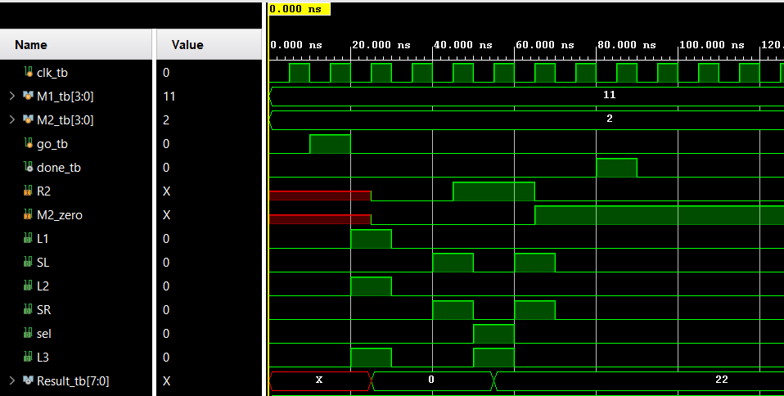

*Figure 1: Datapath waveform simulation*

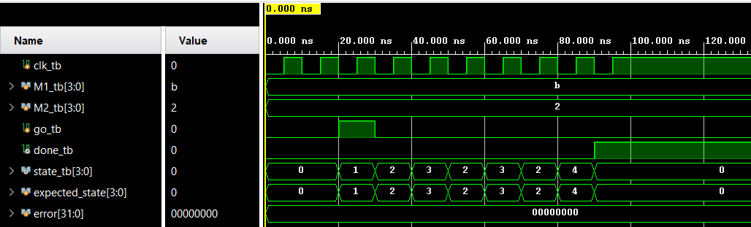

*Figure 2: Control unit waveform simulation*

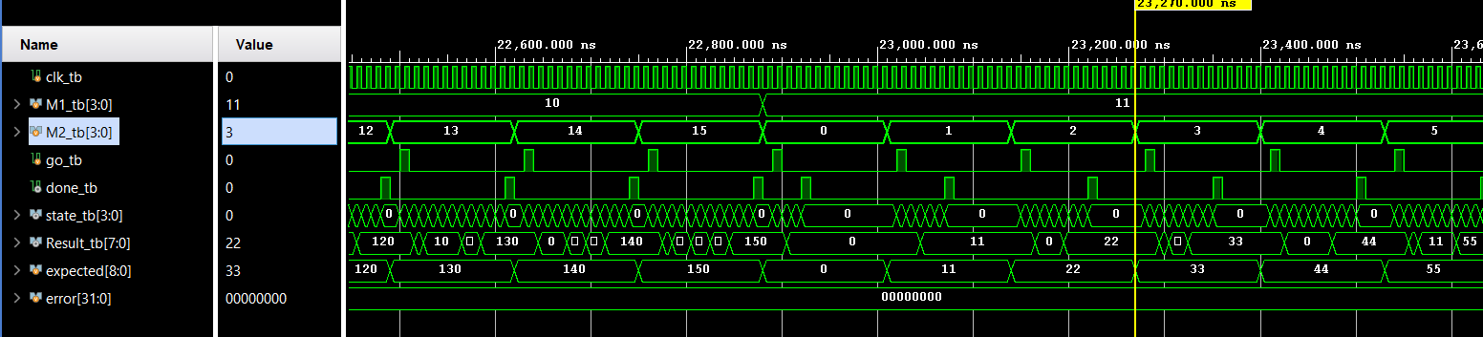

*Figure 3: Full multiplier self checking simulation*

**4) Hardware validation**

For our FPGA board, the 4 switches to the farthest right represent M1 and the next 4 switches represent M2. On the 7 segment display, the segment farthest to the left represents the current state while the three 7 segments to the right represent the product.

Also, the 4th led from the left represents the done flag, and it is off in this state because the calculation has not finished.

Also, note that the 7seg display will display a value in decimal.

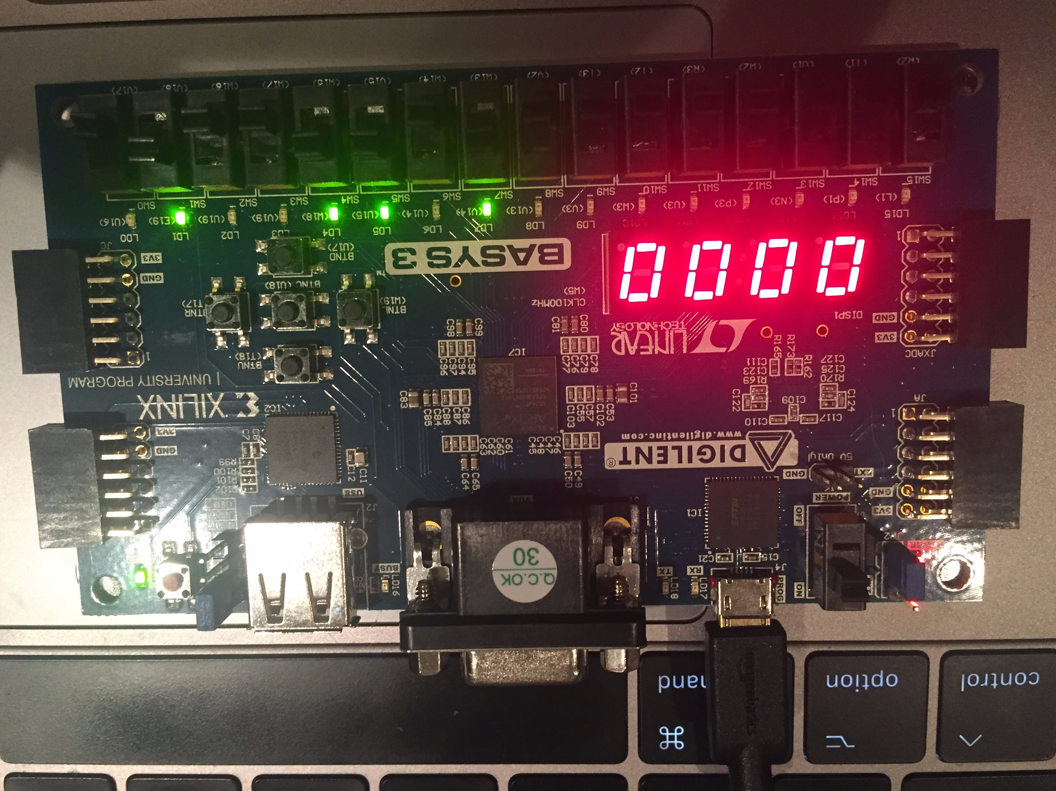

*Figure 4: State 0 before performing 1011 x 0010 calculation*

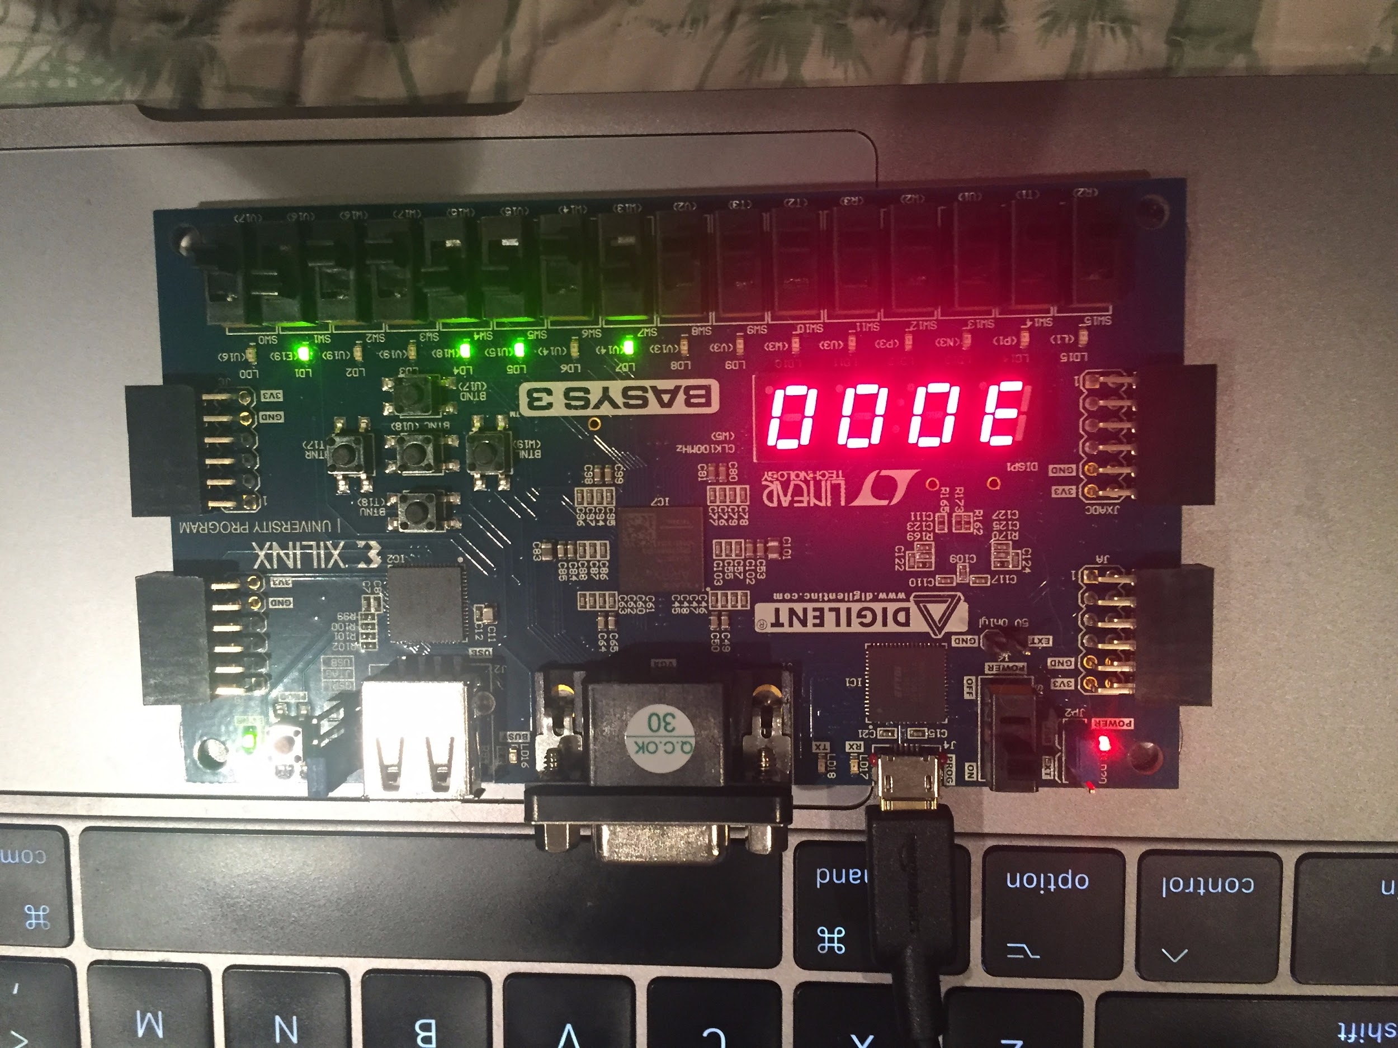

*Figure 5: State 3 during performing 1011 x 0010 calculation*

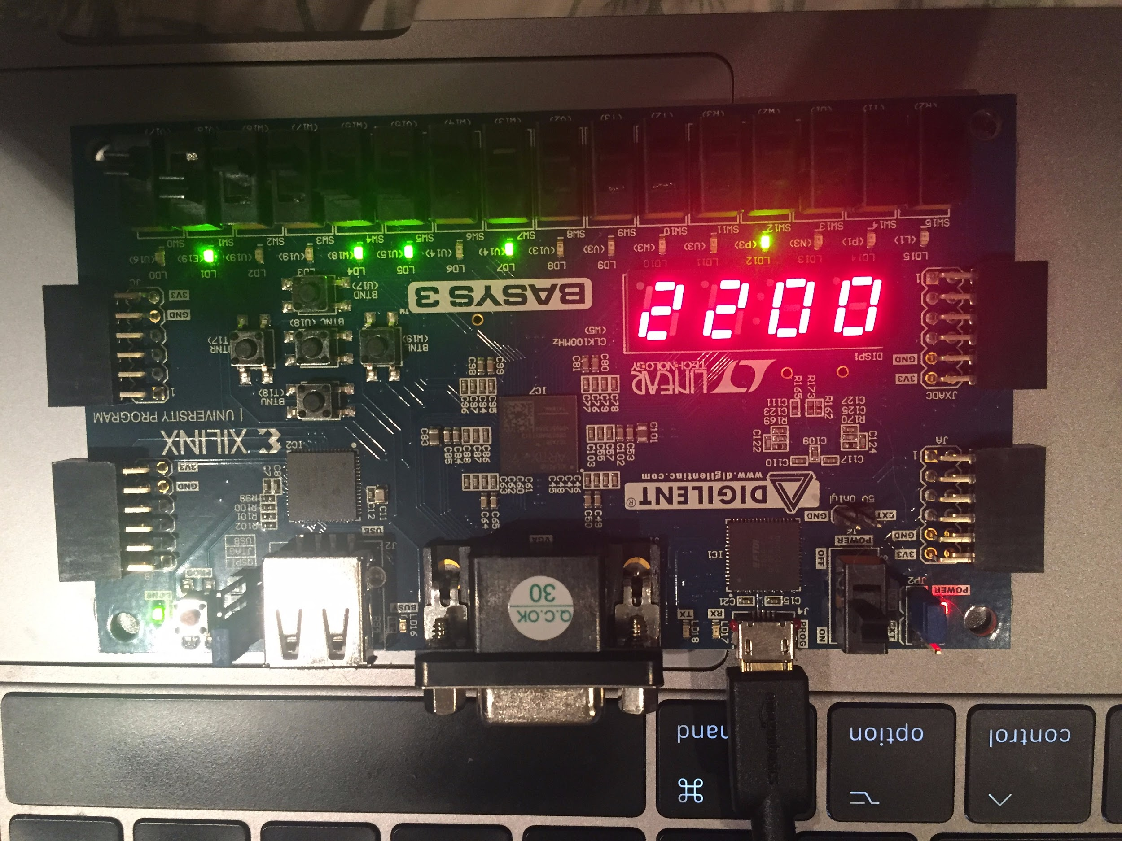

*Figure 5: State 0 after performing 1011 x 0010 calculation. Product is 22 from the calculation of 11 x 2*