|  |
| --- |
| *Cheyenne River Sioux Tribe* |
|  |
| *Game, Fish & Parks – Wildlife Division* |
|  |
| *2024 Fishing Season, Fees & Limits* |

**\*A FEE OF $1.00 WILL BE CHARGED FOR ALL REISSUED LICENSES\***

**\*A $10.00 PROCESSING FEE WILL BE CHARGED FOR NONMEMBERS\***

**\*ALL SEASONS, FEES AND LIMITS ARE SUBJECT TO CHANGE\***

# Fishing Season

Start Date: End Date:

Monday, January 1st, 2024

Tuesday, December 31st, 2024

Season Length: Annual

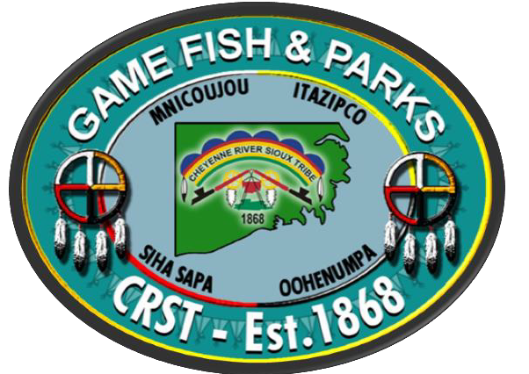

# Season Fees

|  |  |
| --- | --- |
| **Status** | **Cost** |
| Elderly / Income Eligible / Handicap | Free |
| Member / Affiliated Tribal Member Spouse | Free |
| Nonmember - Resident | $35.00 |
| Nonmember - Nonresident | $35.00 |

**Season Limits**

|  |  |  |
| --- | --- | --- |
| **2024 Daily Fish Possession Limits** | | |
| **Fish Species** | **CRST Impoundments** | **Oahe Reservoir, Moreau and Cheyenne Rivers** |
| Large Mouth Bass | 5 | 10 |
| Small Mouth Bass | 5 | Unlimited |
| Walleye, Sauger, Saugeye | 5 | 15 |
| Rainbow Trout | 5 | 10 |
| Chinook Salmon | NA | 10 |
| All Pike Species | Unlimited | 10 |
| Yellow Perch | 25 | Unlimited |
| Blue Gill | 25 | Unlimited |
| Black Crappie | 25 | Unlimited |
| All Other Sunfish | 25 | Unlimited |
| Channel Catfish | 5 | Unlimited |
| All Bullhead Species | Unlimited | Unlimited |

**Cheyenne River Sioux Tribe**

**Hunting, Fishing, & Outdoor Recreation Code**

**Section 13-1-20: Fishing Regulations**

1. FISHING IS RESTRICTED TO AUTHORIZED METHODS – It shall be unlawful to catch, attempt to catch, take or kill fish by any method other than those expressly provided for in this code.
2. License Possession – It shall be unlawful for any person to take fish without a valid tribal fishing license.
3. Use of Explosives, Electrical Devices or Poisons to Take Fish – It shall be unlawful for any person to use explosives, electrical devices, or poisons, to take fish.
4. Refuse Left Behind – It shall be unlawful for any person to deposit any form of organic or inorganic waste on the ice, in the water or on the land anywhere on the Cheyenne River Sioux Reservation. Provided however, that this section shall not be construed to prevent the deposit of such refuse into containers set aside for that purpose or in certified dump sites within the reservation.
5. Maximum Number Of Lines – It shall be unlawful for any person to angle with more than two (2) lines at the same time and no more than two (2) hooks shall be attached to the same line, except when ice fishing. Artificial lures constitute one hook regardless of the number of gang hooks per lure.
6. Ice Fishing Restrictions – It shall be unlawful for any person to ice fish with more than six (6) lines through the ice.
7. Labeling Fishing Houses – Fishing houses, shanties and other such shelters built on the ice must display on the outside, the name and address of the owner, in letters at least two (2) inches high.
8. Restriction On The Possession And/Or Use of Fishing Devices:

**Gill Nets:** No person shall set gill nets within Tribal Waters

**Frame Nets/Hoop Nets:** No person shall use frame nets and/or hoop nets on Tribal waters without a special license issued by the Director. Such license will contain special restrictions regarding this activity. No person shall maintain more than five (5) hoop nets or frame nets.

**Seines:** Seines may not be more than ¼ inch mesh six and 15 foot in length and may only be used for bait fish, smelt and crayfish.

**Trot Lines:** Trot lines shall contain a minimum of 10 hooks and a maximum of 25 hooks, anchored on both ends, marked with a buoy on each end. In areas of boat activity, trot lines must be submerged a minimum of six (6) feet. They only may be used within the Missouri River (Lake Oahe) and the Moreau River embayment not to extend upstream past the Promise Bridge and the Cheyenne River embayment, not to extend upstream past the Highway 63 bridge. No person shall maintain more than two (2) trot lines.

**Set Lines:** Set lines shall contain a maximum of 10 hooks tied to the bank at one end and anchored at the other. They only may be used within the Missouri River (Lake Oahe) and the Moreau River embayment not to extend upstream past the Promise Bridge and the Cheyenne River embayment, not to extend upstream past the Highway 63 bridge. No person shall maintain more than five (5) set lines.

**Jug Lines:** A maximum of five (5) jugs with the maximum of two (2) hooks per jug may be used on all Tribal Waters except Buffalo Lake. No person shall maintain more than five jugs.

**Fish Traps:** Fish traps, including minnow traps, may only be used for baitfish and crayfish. The mouth of the trap may not exceed one and one half inches.

1. Blocking Channel – It shall be unlawful for any person to set his nets, traps or setlines in such a manner that would block more than one half (1/2) of the channel.
2. Distance Between Nets – It shall be unlawful for any person to set his nets, traps or setlines closer than within one hundred (100) yards of any other set-net, trap or setline.
3. Marking Traps – It shall be unlawful for any person to set nets, traps, lines or seines in the water without clearly and permanently affixing his name to each piece of equipment.
4. Restrictions on Disposal of Fish – It shall be unlawful for any person to sell fish obtained within the boundaries of the Cheyenne River Sioux Reservation without a commercial license issued by the Tribal Council.
5. RESTRICTIONS ON THE NUMBER OF FISH TO BE TAKEN – It shall be unlawful for any person to exceed the daily / possession limits on game fish, including catfish, regardless of the method of capture. Daily and Possession limits for fishing shall be fixed by the Tribal Council upon the recommendations of the Director of the Tribal Game, Fish & Parks Department and Natural Resources Department. Recommendations made pursuant to this section shall be submitted to the Tribal Council, annually in writing, on or before the first day of December each year.

POSSESSION LIMITS: Two (2) times the daily limit for each species, as set by the Tribal Council.

1. Grass Carp (White Amur) – May not be possessed without a special permit issued by the Director. No grass carp will be stocked into Tribal waters without written permission of the Director.
2. AREAS OPEN TO BOW FISHING – All streams, lakes, ponds and other waters in the Cheyenne River

Reservation are open to the taking of “ROUGH FISH” by means of bow and arrow, except that all waters within a distance of 100 yards of any boat dock, swimming area, picnic area or other place where people are congregated are closed to bow fishing.

1. RESTRICTIONS ON THE USE OF BOWS –
   1. No person shall take fish within Tribal waters with a bow and arrow without a Cheyenne River Sioux Tribal Fishing License.
   2. Bow and arrow fishing is restricted to daylight hours.
   3. Minimum draw weight is twenty-five (25) pounds.
   4. All arrows used for bow fishing must have a barbed head and a line must be attached to the bow.
   5. No person shall use a crossbow.
2. PROHIBITED BAIT – No person may use carp or goldfish for hook and line fishing. Bluegill less than three inches may be permitted. No live bait fish may be used at Buffalo Lake.