Boobs Not Bombs!

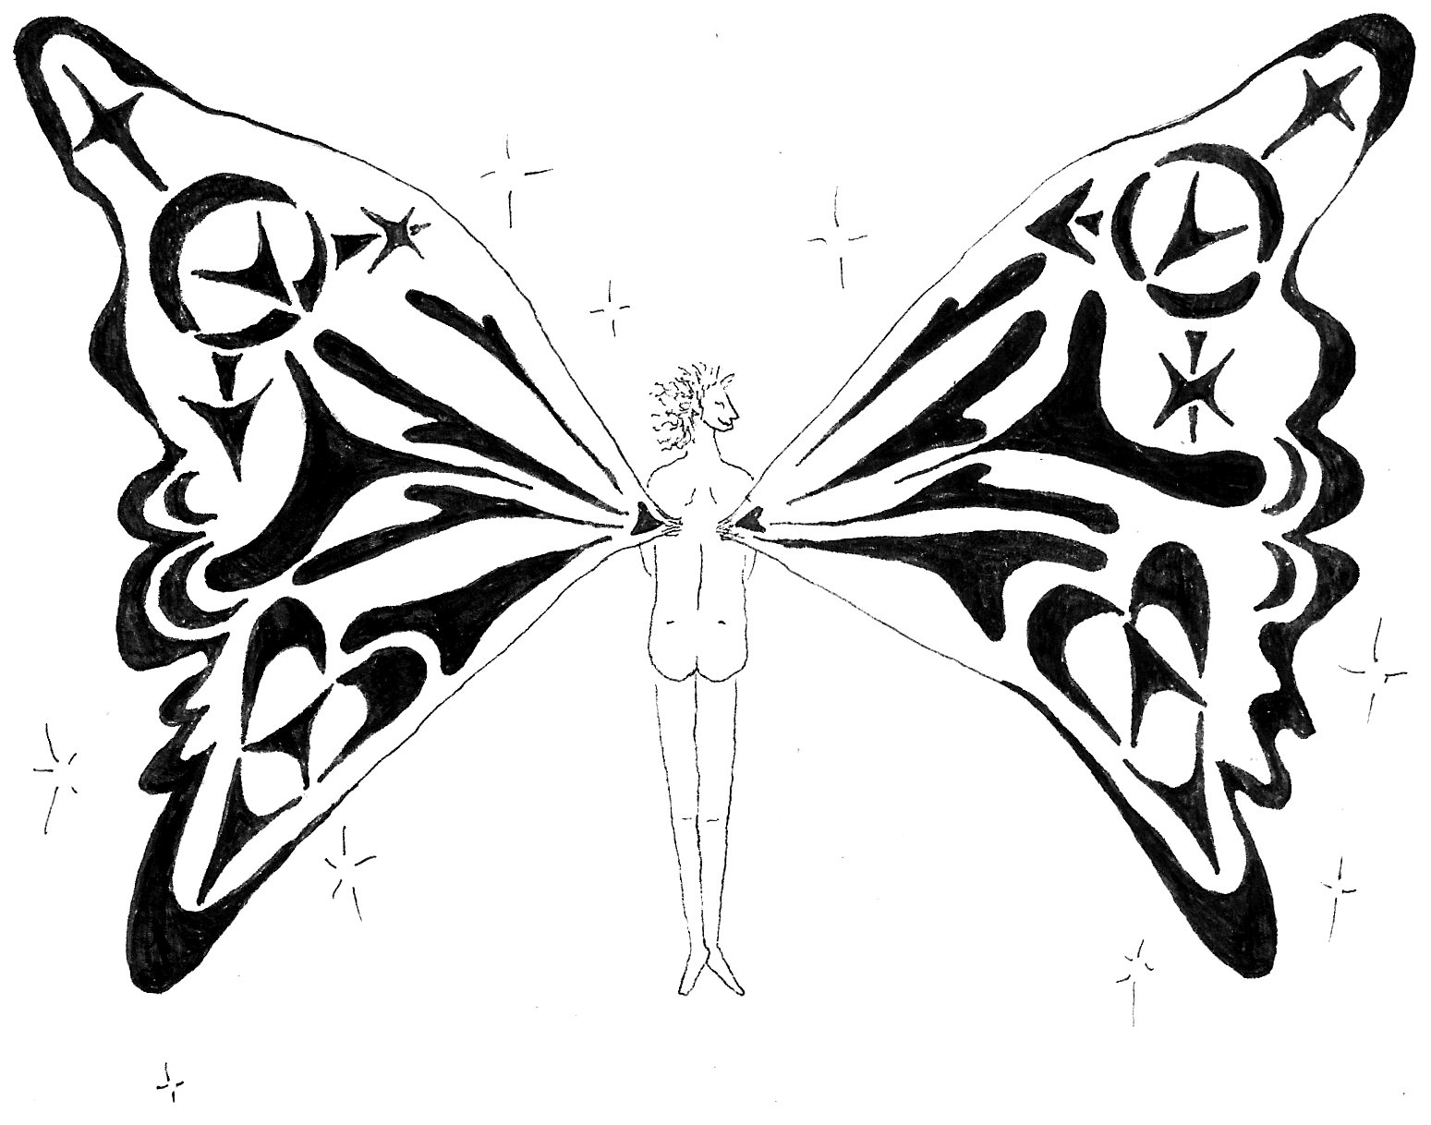

Fairy Wings V1.2
Summer 2022
Table of Contents

What is this?…………………………………………………………………………………1-2
Why do this? …………………………………………………………………………………3-4
How do you do this?…………………………………………………………………5-16
Other resources……………………………………………………………………………17

Disclaimer: Neither the fairy wings vial nor this zine are intended to diagnose, treat, prevent, or cure any medical illness. None of these statements have been evaluated by the FDA and are NOT medical advice.
What is this vial?
This section is assuming you are holding a vial of estrogen in your hands already. If you're not, send an email (preferably from another protonmail account) to fairywingsma@protonmail.com, or ask whoever you got the zine from.
So what you've got here is a vial of estradiol (also known as estrogen) formulated for transdermal use. This means you can apply it to your skin, rub it in, and it'll do the rest. Applying lotion afterwards will slightly increase absorption, sunscreen will decrease absorption, and make sure to not come make contact between your forearm and someone else that doesn't want estrogen in their body (especially AFAB people) for 1 hour. After that you should be good to resume skin-to-skin contact.
A standard dose is 0.57ml which is about 1/4th of a dropper applied to the scrotum or neolabia once per day. Based on the bloodwork we have done so far this should be enough to fully suppress testosterone into the female range and induce feminization. If you would like lower levels you can switch to a less efficient application site, or reduce the amount you take. Skin sites in order from least absorbent to most absorbent are as follows: sole of foot/palms, abdomen, forearm, armpit, scrotum/neolabia.. Alternatively if your levels aren’t high enough you could increase the dose that you take, or a take a dose twice per day. It's worth noting that once testosterone has been suppressed higher levels of estradiol have not been shown to produce any benefit and does carry additional risk. This is not to say higher levels shouldn't be used - the decision is of course up to you. Above all else, think of this product as a tool to further your bodily autonomy. There is no right or wrong way to use it as long as you understand the risks.
What is this zine?
This zine is meant to accompany the vial of estrogen that you are now holding. It offers information about how to use it, the risks, the possible rewards, a detailed step-step-step guide about how to create a chapter of your own, and additional resources. Boobs Not Bombs is a reference to Food Not Bombs, an anarchist food distribution project dating back decades. For more information see here. So, Boobs Not Bombs is the name of the idea of distributing estrogen for low/no cost and Fairy Wings Mutual Aid is the name of our specific chapter. This chapter was created as an explicitly anarchist project and we have tried to organize it around anarchist principles. If anarchy is an unfamiliar concept to you – don’t worry. This zine was written for a non-technical non-anarchist audience, and wherever possible we’ve tried to write in a way that’s straightforward and easy to understand. If anything in here is unclear or confusing don’t hesitate to send us an email at fairywingsma@protonmail.com. We’d love to hear from you!
Risks
So, let's go over the risks of taking estradiol. First and foremost you must know that the estradiol we bought as raw powder was tested and shown to be 97.2% estradiol. The test also showed that it contained no heavy metals. That being said, we weren’t able to figure out what the remaining 3% was, due to technical problems. Is there something dangerous in that 3%? We don’t know. That being said, this is true for grocery store supplements as well. Companies might get investigated if they’re accused of putting dangerous chemicals in their supplements but otherwise supplements are not regulated by the FDA. So, it’s our opinion that this estrogen is about as dangerous as a standard supplement. This is not to minimize this fact, though. If you get prescribed estradiol from a doctor it will undoubtedly be higher quality due to having to pass certain standards. If you are able to get estradiol prescribed and you can afford it we recommend you do this. Nevertheless this isn’t possible for many people, which is where we come in.
In addition there are certain inherent risks to taking estradiol. For clarity's sake this is written for AMAB people. For AFAB people the risks are greater and the rewards are very different.
For all people estradiol is associated with coagulation. Coagulation can lead to a number of adverse events such as heart attack, stroke, and blood clots, also known as thrombosis. Of particular concern are venous thromboembolisms, or VTE events. These are blood clots that form in veins moving blood towards the heart. For AMAB people that take estradiol the increased risk is dose and route of administration dependent. This means your risks are greater with higher levels and that some ways of taking estradiol (“route of administration”) are more associated with VTE events than others. Exacty how much your risk increases is not precisely known, as research on trans people is poorly funded. However, based on the available data it seems that transdermal estradiol levels within 100-200 pg/ml, and perhaps as high as 300 pg/ml produce little or no additional risk of clotting events. For a fuller overview of the research see here.
Another risk to consider is breast cancer. Like blood clots there seems to be a causal link between exposure to estrogens and breast cancer. This also seems to be dose dependent, so higher doses of estradiol will result in an increased risk of breast cancer. As with blood clots the exact amount of risk isn't precisely known and for AMAB people taking estradiol the risk level is likely to be somewhere between the risk levels for cis men and cis women.
Lastly, the primary effects of estradiol itself - feminization and suppression of your body's reproductive processes - could be considered risks depending on your perspective. For better or worse the vast majority of effects from estradiol are temporary. Things like smoother skin and fat redistribution will reverse. However some effects like breast development and possibly infertility are permanent. If you're okay with these risks - enjoy your estradiol and if you are able to please donate $10 to this project. The best way to do this is to go to where you got the vial and out money into the donation jar. The donation jar should be with the bottles and zines. If everything else fails send an email to our protonmail account, again preferably from another protonmail account, and we can figure it out from there.

Why do this?
There are risks associated with taking estradiol but as with anything there are risks associated with not taking it as well, and for some people those can be serious and life threatening. A common talking point that people who want to restrict access to hormones bring up has to do with the "irreversible changes" that are associated with taking hormones. This fails to take into account that our bodies are changing in irreversible ways all the time. Taking exogenous hormones is simply taking the reins of that change and moving it in the direction that feels more aligned with how you want to be.
While there are innumerable barriers in place to prevent people (especially trans people) from accessing hormones like estradiol there are comparatively few mechanisms in place to ensure that everyone that wants hormones has access to them. Furthermore, even when the medical establishment is able to meet our needs it's done so on the terms of insurance corporations, medical review boards, the state, the family, and other institutions that have historically served to oppress, exploit, and exclude people. These institutions restrict access to things like hormones in order to reinforce cisheteronormativity (the idea that being cis and straight is the only "correct" or "natural" way to be). They want to reinforce these ideas and gate-keeping structures in order to maintain power and control over people's bodily autonomy because that power and control helps them maintain control of all other aspects of our lives. Rather than trying to work within and validate the existence of these institutions we deliberately choose to work outside of them. We believe everyone should be free of the coercive power of the state and the medical establishment, and should have access to the tools needed to shape their bodies in the way that they want. We'd rather risk going to jail trying to help other people meet their needs than collaborate with a system responsible for our oppression to begin with. The term we usually use for this is mutual aid - which is just a fancy term for cooperating with other people to meet your needs. Mutual aid is one of the basic tenets of anarchism and as anarchists is something we hold dearly.
The state would tell us that this can't be done. Only huge institutions can meet people's needs and even then they have to adopt repressive practices to do so. We are told there is no realistic alternative to this. If you're reading this zine and holding a vial of estradiol in your hands we've proven them wrong. By making estradiol widely and easily available at low/no cost we help people access a greater degree of bodily autonomy than the existing medical establishment. If we can poke a hole in the supposed necessity of these institutions for hormone access, maybe others will start to question their necessity in other contexts too.
We can have freedom from coercion and hierarchy while still providing for each other's needs (whatever they may be) through building alternatives based on solidarity and mutual aid. If you're on board with this vision and want to learn more about anarchist politics, stop by whatever anarchist book store/infoshop/social center is nearest to you. If you like the people and projects you learn about there – stick around! Talk to other people and find out how you can plug into things.
Lastly, if this project excites you and you'd like to see it expand consider starting your own chapter. There are step by step instructions further down on how to do so. It takes a bit of money up front and a couple friends but apparently it is doable task. We need as many people as possible committed to acting in accordance with these principles in order to challenge the structures that dominate and oppress us.

How did we do this?
The process of producing a usable form of estradiol is pretty straightforward. Based on our experiences the hardest parts by far were researching how exactly to turn estradiol powder into something usable, and trying (and failing) to find a lab to analyze the estradiol we bought. Fortunately, now that we've done the research no one else has to - you can simply copy our steps and end up with about the same result. That being established we strongly encourage you to poke around and learn as much as you can on this topic. None of us are experts and we would all benefit from learning from each other. Furthermore, the way we chose to go about this is not the only way. We could have also bought a pill press and a binding agent and cranked out estradiol pills that could be taken orally. We also could have produced injectable estradiol. We could have looked into making blockers. Each approach has its strengths and weaknesses and in the end the correct approach is the one you and your friends are most excited about pursuing.
We’ve broken this section down into 5 parts: project infrastructure, first steps, ordering materials, making a batch, and distribution. Each section includes a general idea of what to do in bold followed by detailed instructions and notes.
For reference, all of the instructions below have been calculated for a batch that starts with 100 grams of estradiol. This number was chosen because it's relatively affordable and makes the math a little bit easier.
Furthermore, the formula that we used is based on a patent (technically two patents) we found for a transdermal birth control product. The patent describes a product that is 0.24% active ingredient, which is split between a progestin (0.18%) and estradiol (0.06%). We modified this patent to include only estradiol at 0.24%. Thus, it’s the same amount of active ingredient but is otherwise unchanged. We recommend that you look over these patents to get an idea of what we’re doing and why and to make sure we’re not missing anything. A copy of these patents, in addition to the spreadsheets we used to calculate the amounts of each ingredient, and other helpful information can be found here.

Things to consider before getting started
- Before embarking on your own Boobs Not Bombs adventure you should think carefully about the risks involved and whether or not you're willing to take them. Estradiol is not a controlled substance and so far as we can tell what we are doing is legal given that what we are offering is not intended to diagnose, treat, prevent, or cure any medical illness. Nevertheless, the fact that something is legal has never stopped the state from harassing people. This is especially true given that trans people have unfortunately become a hot button issue for many conservative politicians. The prospect of people handing out estrogen on the street is ripe to get blown out of proportion by the right wing media and politicians looking to score points by hating on trans people. If you aren't comfortable with these risks consider helping existing BnB efforts by donating and/or contacting us to see how you can help. If you decide you are willing to take these risks read watch this video on why you should NEVER speak to the police. You may also want to read this zine about security culture, though much of it is overly stringent for these purposes.
- As a rule, don't discuss your involvement in this project with people that you don't trust and only tell people what you think they need to know. If you need to discuss the project with others using electronic means, always use open source encrypted software like Signal, ProtonMail, Cryptpad, and others. Of course, every approach has limitations and there is nothing you can do to perfectly guarantee that you haven't left a trace. Nevertheless defenses should be thought of as being layered. The guidelines we have set out here should be regarded as a solid base line that can be added to rather than a security guarantee. For more information about digital security see here.

Project infrastructure
- The first step in this, or any, or project is to get together with your friends and comrades and see who would like to help make it a reality. If you don’t have a network of trusted friends that are interested in helping try going to the closest anarchist bookstore or community center and see what projects you can help out with. Hopefully you will develop friendships with people through working together on shared projects. If all goes well eventually Boobs Not Bombs can be one of the projects you all can add to your repertoire!
- Before/during/after starting a Boobs Not Bombs please send an email to us at fairywingsma@protonmail.com! We would love to help in any way we can, purchase materials together, and learn from each other’s experience. If nothing else it’ll be nice to be in touch with other people working on the same project. In addition, if you come across any helpful materials we can include them in the public cryptpad repository referred to in footnote 6 above.
- To work on this project on your computer we recommend that you get a Tails stick. This is a USB flash drive with the Tails operating system installed on it. Tails is a highly secure operating system that only connects to the internet via the Tor network and saves absolutely nothing to your hard disk. To download a copy of Tails have a friend that already has a Tails stick clone it. If you don’t know anyone with Tails you can download it and read a full set of instructions at tails.boum.org. If this process seems overwhelming find a computer savvy friend to help you. Once this is done start your computer running tails and create an email account with which to contact vendors. It is strongly recommend that you only sign in to this email or anything else that directly relates to your Boobs Not Bombs project from within Tails. Remember that Tails and Tor are not magic. If you sign into your personal email account at the same time as you sign in to your BnB email you will have associated the two. So, ONLY work on one project at a time when using Tails.
- To prepare for ordering and receiving shipments get together with your friends and find out how you will receive packages anonymously. The easiest way would be to get a friend that isn't directly involved in the project to receive the package for you. Ship it to them under their own name and then pick it up from them once it's arrived. Receiving packages on behalf of BnB is a great way for people to help the project while limiting their involvement. Other ideas include getting packages shipped to a friendly community center, or shipping to your own houses if the packages are spread out. For example maybe one person will order the propylene glycol and have it shipped to themselves and another person will order the diethylene glycol monoethyl ether, still a third person will order and receive the alcohol. Doing it in this way reduces the chances that any investigation will be able to determine the pattern of purchases. If someone is receiving a package it’s usually best that they pay for the package using their own payment methods and then you give them cash reimbursement. Some people can receive multiple packages if the things they’re receiving are especially not sketchy, such as scales and glass jars. With all of this in mind, you should always try to reduce online purchases as much as possible. Wherever possible try to buy things with cash in person. Do you need to buy glass overflow jars online or can you get them from a thrift store with cash?
- Like all projects you will need an amount of money and/or resources to get started. Fund raise discreetly among friends to get the necessary money. You should be able to do all of this for about $2000. If you’re able to we absolutely recommend trying to get more than this to allow for fuck ups and unexpected problems. This money should be kept as cash in a secure location and should be well accounted for. Keep track of how much money goes in and how much has been spent on each item. This is mostly so you can see how much money you have left for things as well as where you can try to reduce expenses in the future, in addition to transparency.
- Your operation will also need a physical location to operate out of. An empty bedroom is big enough, though we don’t recommend using a bedroom that anyone lives in. This is because this project requires a fairly large amount of stuff and it would be difficult to store everything in a room that’s already filled with someone’s personal possessions. You should also think about security here: wherever the project is based out of should be secure. We recommend finding a friendly community center that is willing to rent a room to a member of the project. Do not mention BnB officially, just rent it as a personal room. Draft a lease that stipulates that your room is not to be entered into without your permission and leave a lock on the door. This both protects you and the community center. The community center is protected because in the event you get busted they have a lease to provide legal cover: they as landlords are not responsible for what their tenants do.
- Create a cryptpad spreadsheet to keep track of your finances. This includes managing your money and keeping track of any and all prepaid cards. Make sure to keep track of any/all of these cards, including where they are, how much is on them, what they've been used for so far, and the billing information attached to them. For example if a website requires you to put in a billing address for the card make sure you write down which billing address has been used for which cards. This is to prevent the card from getting rejected due to using contradictory information.
- Finally, a note on formatting. For the rest of this section we’ve provided detailed step by step instructions on how to produce and distribute hundreds of years worth of estradiol. For each section there are numbered points that say in bold the simple version of what to do. If you want to learn how to do things on your own you can simply follow those points and try to figure it out from there. If you’d like more info we’ve included bulleted notes on how exactly to do this. We’ve also included how much to budget for each item. As always, do not assume that we’re especially smart or know the best way to do things. We don’t. In fact we greatly look forward to receiving emails from people saying things like, “why did you do X like this? You could have done Y thing instead and it’s so much easier/faster/cheaper!” So please experiment, learn more than us and then let us know how you did it!
First steps
- Purchase and test estradiol Cost: $800 ($300 for estradiol, $500 for the test)
  - Raw estradiol can be purchased directly from manufacturers listed on the Estradiol PubChem page. Generally, the prices they quote are prohobitively expensive. In addition many manufacturers will only ship to businesses or research institutions. This is not to say that's an insurmountable hurdle however - finding a friend with a .edu email address and an address for packages may be sufficient. Alternatively, you can message gray market vendors from China. As an example Hanzhong Han Traceability Biological Technology Co. Ltd. To find more vendors just try searching "estradiol suppliers china" on duckduckgo. They usually sell bulk amounts of estradiol however you can expect the quality might be lower as a result. To get in touch with any vendor email them from your secure email account. When it comes time to pay see if you can pay via money order. If so purchase a money order with cash and mail it to them. If they do not, you can use cash to purchase a pre-paid debit card from any Walmart, in addition to many other big box stores. You can probably also pay with bitcoin but you will need to make sure that the bitcoin itself was bought in a manner that can't be traced (e.g. with cash). However you do it, purchase 100 grams of pure estradiol, CAS number 50-28-2 and have it shipped to you using one of the secure shipping methods outlined. If you used a prepaid debit card make note of it in your spreadsheet.
  - Once your estradiol arrives you will need to test it assuming you bought it from a gray market supplier. This step is second because if the test doesn’t come back clean (e.g. they sold you a bunch of baking soda) you will need to repeat the previous step before proceeding further. Go to toxassociates.com. Order a comprehensive drug analysis, tell them you want a quantitative analysis of estradiol and a test for heavy metals. This is a step where multiple BnB branches can work together and save a lot of money. Assuming multiple chapters place an order of estradiol together only a single test will need to be performed for everyone. Thus, the costs for testing will be split between however many chapters go in on the order together. Pay for the test with a money order purchased with cash and await your results. You're looking for the results to ideally say >99% estradiol and no heavy metals or anything else detected. Ours was 97%. We would love to know what the other 3% is but after extensive research it seems we'd need thousands of dollars and corporate/academic credentials to do so. If you know of another way to identify impurities in a sample for cheap please contact us!
Purchase materials
- Purchase 6 gallons of 95% alcohol. Cost: $650.
  - You can buy bulk alcohol online from laballey.com and organicalcohol.com. Depending on the vendor alcohol may be referred to as ethanol. Ethanol is the name for the kind of alcohol that you can drink. You could also use isopropyl alcohol and it would be much cheaper. We went with ethanol because we wanted to stick as close to the patent as possible. The patent does mention that you can use isopropyl alcohol however they imply that ethanol is the form that they preferred. If you use laballey you should know they have pretty strong fraud protection measures and as a result they will automatically cancel any order that has a different shipping and billing address. To get around this you can have a friend buy alcohol from them legitimately, paying with their own card, shipping it to their legal name. You will need to have alcohol shipped to someone older than 21 and they must sign for the package when it arrives. You can also get around this step by buying everclear from liquor stores. This has the advantage of being much faster, and much more secure but is also much more expensive. Our rough calculations showed everclear to be about 3x as expensive.
  - Alcohol is extremely flammable and 6 gallons of it should be considered a major hazard. Do not open the container it came in until you’re ready to make a batch. In addition store the alcohol as far away as possible from any flames or anything that could produce a flame. When working with alcohol do not smoke or be anywhere near any flames.
- Purchase 2 gallons of propylene glycol USP. Cost: $150
  - Propylene glycol is a very common chemical and can be found from a number of websites like laballey. See above for tips when it comes to ordering from laballey. Wherever you get it make sure that it’s just propylene glycol and not propylene glycol mixed with some other thing.
  - USP stands for United States Pharmacopoeia and refers to a standard of purity for chemicals. All chemicals should be sold to you as USP. If you have the money you should also send all of your reagents off for testing in addition to the estradiol.
- Purchase 2 liters of diethylene glycol monoethyl ether USP. Cost: $200
  - Follow the steps for propylene glycol but with diethylene glycol monoethyl ether. We were unable to find other vendors for diethylene glycol monoethyl ether so we had to use laballey.com.
- Purchase a large wide mouth glass container for mixing. Cost: $30
  - Throughout the manufacturing process we use glass because it’s nonreactive. It’s possible other materials would be acceptable as well but we simply don’t know. If you find out – let us know!
  - Realistically, it's hard to find wide mouth glass containers larger than 2 or 2.5 gallons. You can find 5 gallon glass carboys (the kind of bottles used in water coolers,) however they are very difficult to mix owing to their narrow mouth. It's possible you could find a workaround for this involving a long, narrow stirring stick, a magnetic stirrer or something else. What we used was a wide mouth glass container of about 2 gallon capacity. Generally bigger is better provided that you can find a way to stir it.
  - You might be able to find a large enough glass container at a store somewhere. If you can absolutely try to buy it with cash. If not there are plenty of options on amazon.
- Purchase an even larger glass container for storing finished product. Cost: $60
  - The use of this will become more clear later on. The size of this container doesn’t matter very much so long as it’s bigger than the mixing container and it’s glass. It’s unlikely you’ll be able to find this at a store in person but you can check if you like. Otherwise you can get a 5 gallon glass carboy for $60 on Amazon.
- Purchase 7 wide mouth glass containers of medium size. Cost: $100
  - The size of these containers don’t matter as much. Perhaps half a gallon. These should absolutely be purchased with cash at a store. You can likely spend far less than $100 for all of these if you go to a thrift store.
- Purchase scales. Cost: $75
  - One will need to be a higher capacity kitchen scale accurate down to .1g (1g is also okay,) and the other will be accurate down to 0.01g. Make sure that the higher capacity scale can handle the weight of the mixing jar, and water/alcohol. For our batch the scale should have a capacity of at least 15 pounds, preferably 20.
- Purchase bottles and tincture droppers. Cost: $600
  - There are several websites where you can buy bottles and droppers in bulk. Thebottlestore.com and containerandpackaging.com are two such options. Buy at least 350 4oz amber boston round bottles and an equal number of 1ml tincture droppers. Make sure that the bottles and droppers have matching neck sizes. In this case 24-400 is the neck finish we used.
- Purchase misc. lab equipment. Cost: $100
  - For this step we’re mostly thinking about gloves, goggles, perhaps a table if needed, and any other small items.
- Buy water. Cost: $20
  - Buy 4 gallons of distilled water from any grocery store. It MUST be distilled water, not spring water or anything else.
Make a batch
Overview
The basics of making girl juice are as follows: measure out all of the raw materials by mass, add them to a mixing container, mix vigorously, pour into a larger container, and bottles from there. Bottling is just pouring out of the large carboy into a smaller wide mouth container and from there being scooped out and poured into bottles. The reason why the carboy is used is so that one team can continue to make 2 gallon batches while another team bottles. Based on our experience the bottleneck in this process is, ironically, bottling. Because we bottled by hand it took much longer than actually making the batch itself. So, using the carboy is a way to speed up the process. Otherwise the team making each batch will have to stop and wait until all of the girl juice has been bottled before they can start making the next batch. For context, about 5 two gallon batches will need to be made. The process is actually pretty straightforward, it just takes a while to bottle. You should clear your afternoon for this and plan on it taking about 4 hours. Keep in mind that this process will likely be messy and will involve alcohol spilling over your work environment. You should also pick a place where this won't be an issue and clean up as you go. You should also not work by open windows where a passerby will see what you're doing. It will look like you're making drugs and will attract unwanted attention.
- Label all of your containers.
  - Once you’re ready to get started clean your work surface, lay out all of the materials, and label your containers. You should have a weighing container and an overflow container for every ingredient except estradiol. You should also have a 2 gallon mixing container, a 5 gallon (or more) glass carboy, and a bottling jar. Protip: if you ordered more than one bottle of something just have a single one on the work surface, the other(s) can be put away and retrieved as needed. The will help keep the space less cluttered. You can also have the bottling station setup separately to keep things organized and decluttered.
- Put on PPE
  - This means long sleeves, gloves and goggles. If you have long hair put it up before beginning.
- Add 16.4 grams of estradiol in the 2 gallon mixing container.
  - Place your estradiol weighing container on the scale and tare it. Then add 16.4 grams of estradiol using a spoon. If you add too much scoop some back into the container that the estradiol came in. Then pour the estradiol into the 2 gallon glass jar. Some estradiol will likely remain in the cup. We will deal with that in a second.
- Measure out 2872.9 grams of alcohol to the mixing container and mix vigorously.
  - Place the alcohol weighing container on the larger scale and tare it. Then add 2872.9 grams of alcohol. If you add too much pour some out into the alcohol overflow jar until you've got the number right. When you are weighing out alcohol for the next batch add this overflow into the alcohol weighing container first. As you pour alcohol into the mixing container have someone hold the estradiol weighing container in the mixing jar and pour in the alcohol such that it washes it out. Once the alcohol has been poured in mix vigorously for 1 minute using a glass stirring rod. If you don't have one use a large metal serving spoon.
- Add 2585.7 grams of distilled water to the mixing container and stir.
  - Use the large scale to measure out 2585.7 grams of distilled water. Use the water overflow jar to pour out any overflow. When you've got the amount right, add it to the mixing container and mix vigorously for 1 minute.
- Add 1026.6 grams of propylene glycol and stir.
  - Follow these steps for propylene glycol. PG overflow goes into the PG overflow jar and gets added in to the next batch. If you want to be especially precise make sure to weigh the weighing container after you've poured the propylene glycol into the mixing container. Some will be left in the container and this will tell you how much exactly. Write this amount down and add slightly more than this amount to the PG weighing container. Add it to the mixing jar and then check the weight to see how much actually ended up in the mixing jar. Repeat until you're satisfied that you're close enough. Once you are done adding PG mix vigorously for 1 minute.
- Add 342.2 grams of diethylene glycol monoethyl ether and stir.
  - Follow this same procedure for diethylene glycol monoethyl ether and mix vigorously for 1 minute.
- Pour the mixing container into the carboy, begin bottling, start next batch.
  - When steps 1-7 are completed you have completed a 2 gallon batch. Using a large clean funnel pour all of the contents of the mixing container into the glass carboy. The bottling team can then pour the girl juice out of the carboy and into another wide mouth container. From there they can scoop out the girl juice using a half or ¾ cup measuring cup and use a funnel to pour it into bottles. When you fill the bottles you should leave a little room at the top. Otherwise when you add the dropper lid it’ll overflow. After filling a bottle dry it with a towel and then add a label. Store the bottle in whatever box/container you’re keeping the girl juice in before distributing it.
  - While one group of people is bottling another group should repeat steps 1-7. Continue to do so until you can no longer make another batch using the amounts required. At that point you can either stop and help with bottling or measure out the thing you don’t have enough of, and then using the ratios provided calculate new amounts for all of the other ingredients. For example, if you only have 1500 grams of alcohol you can’t make a full batch. But since you know alcohol is 42% of the batch by weight you can find out the weight of the new (smaller) batch and make one final batch before needing to reorder supplies.
- Clean up your workspace.
  - Once you are done making all of the girl juice you should clean up your work area. Tear off all of the labels of the packages you received and burn them. This is to prevent you from putting a bunch of incriminating evidence into the same dumpster. Once all of the labels have been disposed of you can dispose of the boxes as regular recycling. If you peel the labels off the chemicals you bought (propylene glycol and diethylene glycol monoethyl ether) you can also dispose of them as normal recycling. If not, dispose of each one in separate dumpsters.
  - Pour any remaining overflow containers back into their original bottles. Thoroughly wash all non-disposable lab equipment. Return all of your supplies to wherever you normally store them. You should have about 300 bottles filled. You very well might have less depending on whether or not you fully ran out of something or just stopped when you didn’t have enough for a full batch.
- Print zines
  - We designed our zine from scratch because we didn’t have anything to work from. However you can absolutely just take this zine, change out the contact info and any other relevant details, and print your own edition. Make sure to change the title of the zine to “Boobs Not Bombs – [Your chapter’s name] 1st edition” or something other than the title of this zine, so as to not confuse people. If you’d like an electronic copy of the zine for editing – send us an email.
  - Giving the length of this zine printing will be very expensive. We recommend you find someone with a free/cheap printing hook up. As a suggestion look up the closest zine distro and ask them. If you don’t know any zine distros or this won’t work for whatever reason send us an email and we’ll try to help you out.
Distribute
- Create a distribution network.
  - Seek out places (especially public/easily accessible places) where you could leave a BnB station. The station itself will consist of a number of bottles, an equal number of zines, and a donation jar. The specifics of what locations to pick are of course up to you. If you’d prefer a more clandestine arrangement you could also keep the bottles yourself and distribute them through word of mouth only. If you’re okay with a more public arrangement you could advertise online and mail the bottles out. If you’d like to go this route we recommend you contact hrt.cafe and see if your small operation can be listed on the website.
  - Other places that can serve as distribution points are Really Really Free Markets, Food Not Bombs servings, art spaces, an anywhere frequented by people that would like estrogen and ordinarily would not have access to it. Of particular interest currently are places (such as Republican controlled states) that are making it increasingly difficult or impossible for minors to access hormones. If this isn’t feasible for you that’s okay too. The main criteria is that you pick a plan that you and your friends are excited about and go from there!
  - If you opt for a physical distribution plan make sure to periodically check the places that you all have left bottles to see when they need more. As a suggestion when you drop off more bottles you can also pick up any donations from the donation jar. Make sure to record any income in your finance spreadsheet, as always.
  - Our initial goal at Fairy Wings was to spread out pretty far to try to get as many people interested as possible. In the long term our hope is that other projects will come online and we will be able to shrink out network because that’s just what makes the most logistical sense.
- Distribute bottles.
  - Once you know where to take the bottles/zines physically transport them to all of the various locations. You can mail them if you like however it will be quite expensive give that the package(s) will be rather heavy. If you ship any of the bottles make sure to add wrapping so they don’t shatter in transit.
  - If you’re distributing at physical locations you might need to setup a station with bottles, zines, and a donation jar. This might necessitate buying a folding table for each location or figuring out some other arrangement. For a donation jar we recommend making one by cutting an opening in an old coffee container lid and writing “$10 suggested donation” or “donations” in large visible letters on it.
  - Once you have run out of bottles and zines, collect a final round of donations, conduct any additional fundraising (if necessary) and then start all over.

Other Resources
Trans related info
- transfemscience.org
  - We highly recommned this website for any/all research needs. The site is run by transfemme people for transfemme people and interested medical practitioners. We recommend spending as much time as possible on here learning the ins and outs of feminizing hormone therapy
- transdiy.reddit.com
- estrogel.reddit.com
- hrt.cafe
  - This site is great for sourcing everything you’d need for feminizing hormone therapy. Including antiandrogens. The downside is that everything on the site must be purchased online, which can be a barrier for young and/or transient people.
Anarchism
- sub.media/a-is-for-anarchy
  - This is a great short video series on many of the basic anarchist concepts. SubMedia has other longer videos on a whole range of topics and we recommend all of them highly! If you’re not familiar with Anarchism A is for Anarchy is an excellent starting point.
- Sproutdistro.com
  - Sprout Distro has a great collection of zines on a whole range of topics. If you’re looking for short reads on a variety of anarchist topics you should poke around here.
- Itsgoingdown.org
  - IGD is primarily an anarchist news site. Check it out to see what anarchists around the world are up to!
- Crimethinc.com
  - CrimeThInc has all kinds of resources from books to videos to podcasts. Many of those are intended for a beginner audience and others aren’t. We recommend CrimeThInc highly for all kinds of material.

A guide for medium to large scale DIY production and distribution of estrogen for about $20 per person per year. Includes step by step instructions and additional resources. For more information see tinyurl.com/boobsnotbombs. Contact us at fairywingsma@protonmail.com.
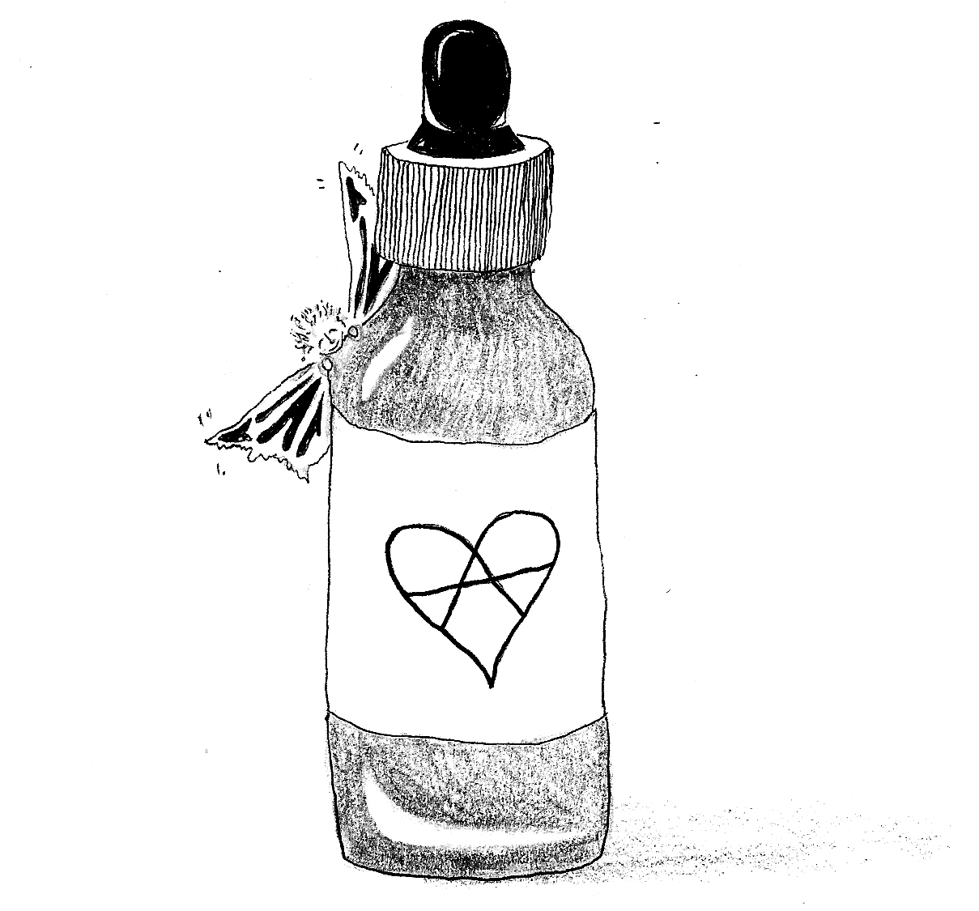

This work in its entirety is under anti-copyright and is dedicated to the public domain immediately. Feel free to reprint, alter, or do whatever you want with it.

https://transfemscience.org/articles/genital-e2-application/
https://en.wikipedia.org/wiki/Food_Not_Bombs note that a lot of information on the “official” Food Not Bombs website is inaccurate and out of date. If you want to see what FNB is actually like contact the closest chapter and get involved!
https://www.sproutdistro.com/catalog/zines/theory/anarchism-what-it-is and https://crimethinc.com/zines/to-change-everything are both zines (short magazines) that offer an introductory view of anarchism
https://transfemscience.org/articles/estrogens-blood-clots/
https://transfemscience.org/articles/breast-cancer/
https://tinyurl.com/boobsnotbombs or https://cryptpad.fr/drive/#/2/drive/view/isZDZxnR6gLfyvL94EdSYfypGFV1J3yD0oGOLk4cerU/
https://www.youtube.com/watch?v=d-7o9xYp7eE (title: don’t talk to police, 18m views) note that this professor is seemingly a liberal and thus although we disagree with much of his framing we nevertheless agree with his conclusion: never speak to the police under any circumstances.
https://crimethinc.com/2004/11/01/what-is-security-culture
https://ssd.eff.org/

