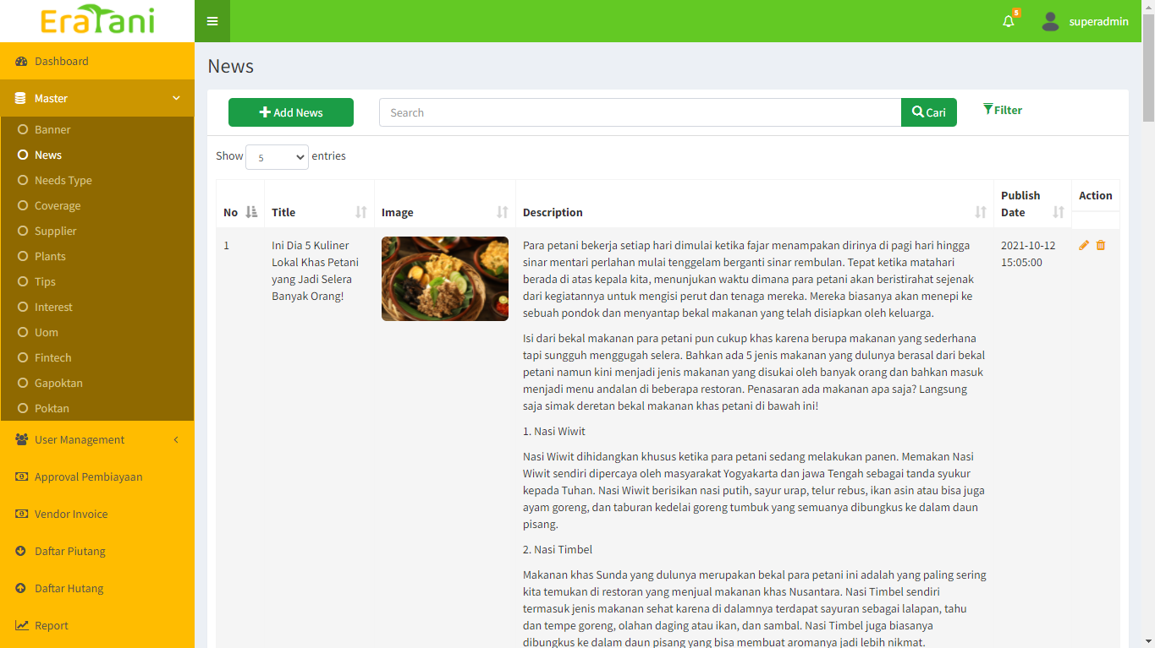8. Eratani

**Description :** Yotani Niaga is Agri-Tech Company.

**Tasks List :**

**Content Management System (CMS)**

* **Master**
* **Farmer Story**
* **API**

Technology : Laravel, JQuery, MySql, Lumen API

9. Arya Noble

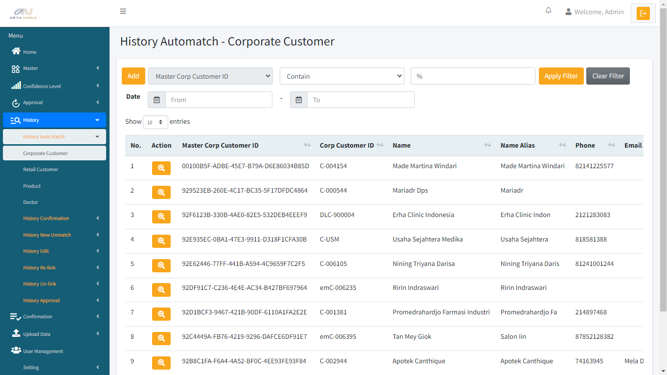

**Description :** Data Steward Console manage Arya Noble golden record

**Tasks List :**

**Content Management System (CMS)**

* **Confidence Level**
* **History**
* **Upload Data**

Technology : Laravel, JQuery, MS SQL Server