Class05

Ryan Park

January 24th, 2019

#class05 graphics intro

#my first boxplot  
x <- rnorm(1000,0)  
boxplot(x)

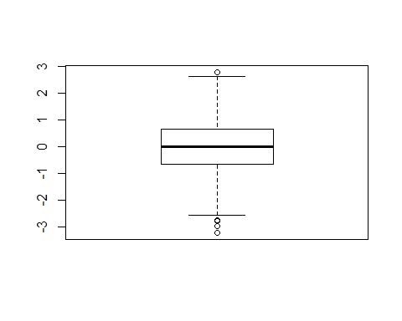

summary(x)

## Min. 1st Qu. Median Mean 3rd Qu. Max.   
## -3.217603 -0.671518 -0.003437 -0.005026 0.639805 2.771669

hist(x)

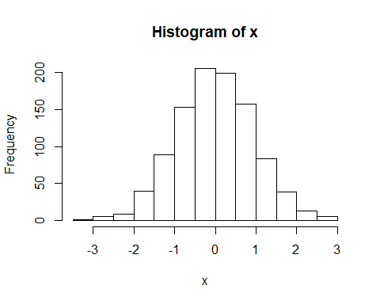

boxplot(x, horizontal = TRUE)

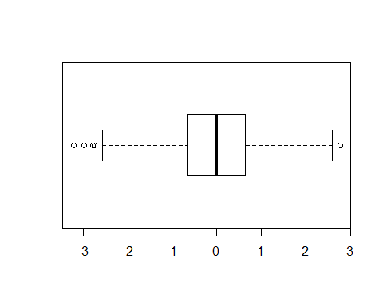

weight <- read.table("bimm143_05_rstats/bimm143_05_rstats/weight_chart.txt", header = TRUE,sep = "")  
plot(weight$Age,weight$Weight, type = "o", pch = 15,cex=1.5,lwd=2,ylim=c(2,10),xlab = "Age (months)",ylab = "weight(kg)",main = "Some title")

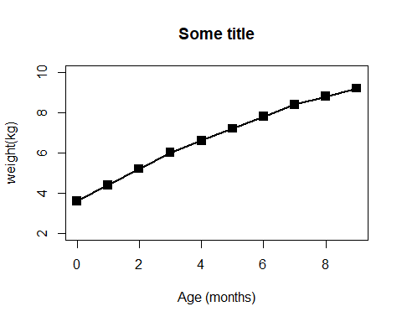

feature <- read.table("bimm143_05_rstats/bimm143_05_rstats/feature_counts.txt", header = TRUE,sep = "\t")  
par(mar = c(5.1,4.1,4.1,2.1))  
barplot(feature$Count,horiz = TRUE,ylab = "A title", names.arg = feature$Feature,las = 1)

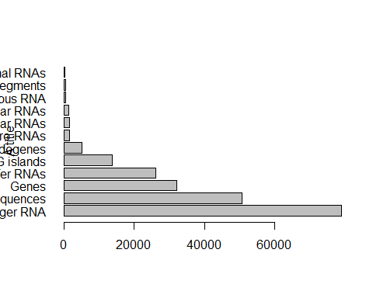

hist(c(rnorm(10000),rnorm(10000)+4), breaks = 100)

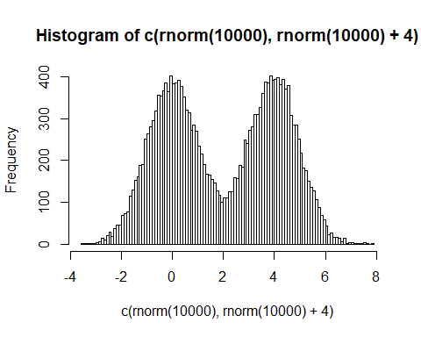

counts <- read.delim("bimm143_05_rstats/bimm143_05_rstats/male_female_counts.txt", row.names = NULL, sep = "")  
barplot(counts$Count, col = rainbow(nrow(counts)))

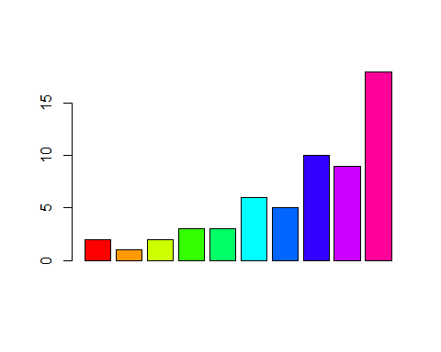

genes <- read.delim("bimm143_05_rstats/bimm143_05_rstats/up_down_expression.txt")  
table(genes$State)

##   
## down unchanging up   
## 72 4997 127

plot(genes$Condition1,genes$Condition2, col = genes$State)

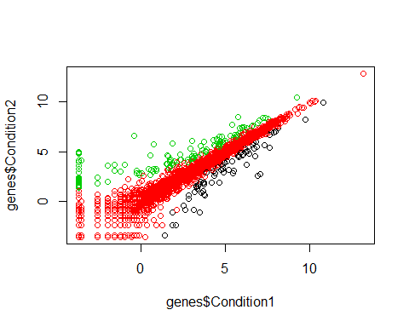

meth <- read.delim("bimm143_05_rstats/bimm143_05_rstats/expression_methylation.txt")  
colorss <- densCols(meth$expression, meth$gene.meth, colramp = colorRampPalette(rainbow(10)))  
plot(meth$expression, meth$gene.meth, pch = 20, col = colorss)

