Eye tracking inference experiment results:

- Behavioral data
  - Subjects were asked two different questions, each on separate trial. One question asked them whether the presented story was logical (i.e. made sense) second question asked them about the hidden content of the cup.
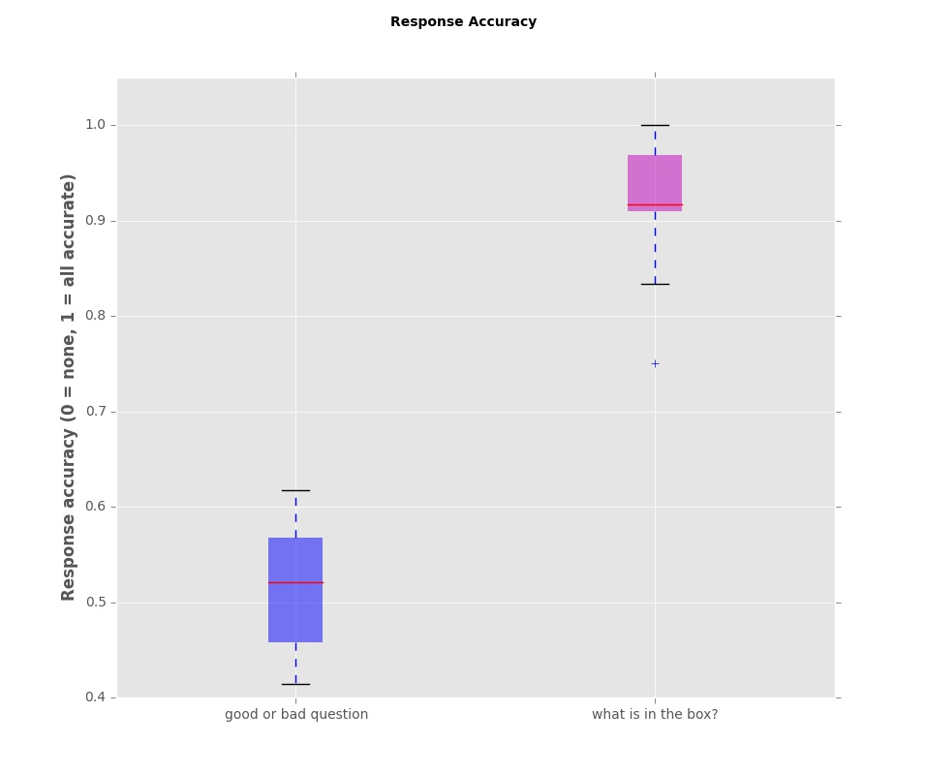Illustration 1: Response accuracy for two different questions. Subjects responded around chance level for the question whether the story was logical or not. Subjects repsponded very accurately to the question about the hidden content of the cup.

- Eye tracking data
  - Preprocessing: Gaze data was restricted to samples recorded inside the display coordinates (1920 by 1080 px display). Missing data inside the display (due to loss of tracking, for example during eye blink) was filled using linear interpolation.

  - The most important question in the experiment concerns the quantitative differences in gaze patterns occurring during trials when inference is possible vs trial when inference is impossible. 3 different measures were used to quantify such difference: Region of Interest (ROI) analysis, principal component analysis (PCA) together with logistic regression and heat map comparison.

  - ROI: Two ROI were selected, left representing object appearing from behind an occluder and right representing object inside the cup. To identify when subject switched the gaze from left to right ROI the x-component of gaze coordinates was isolated resulting in the following time series:
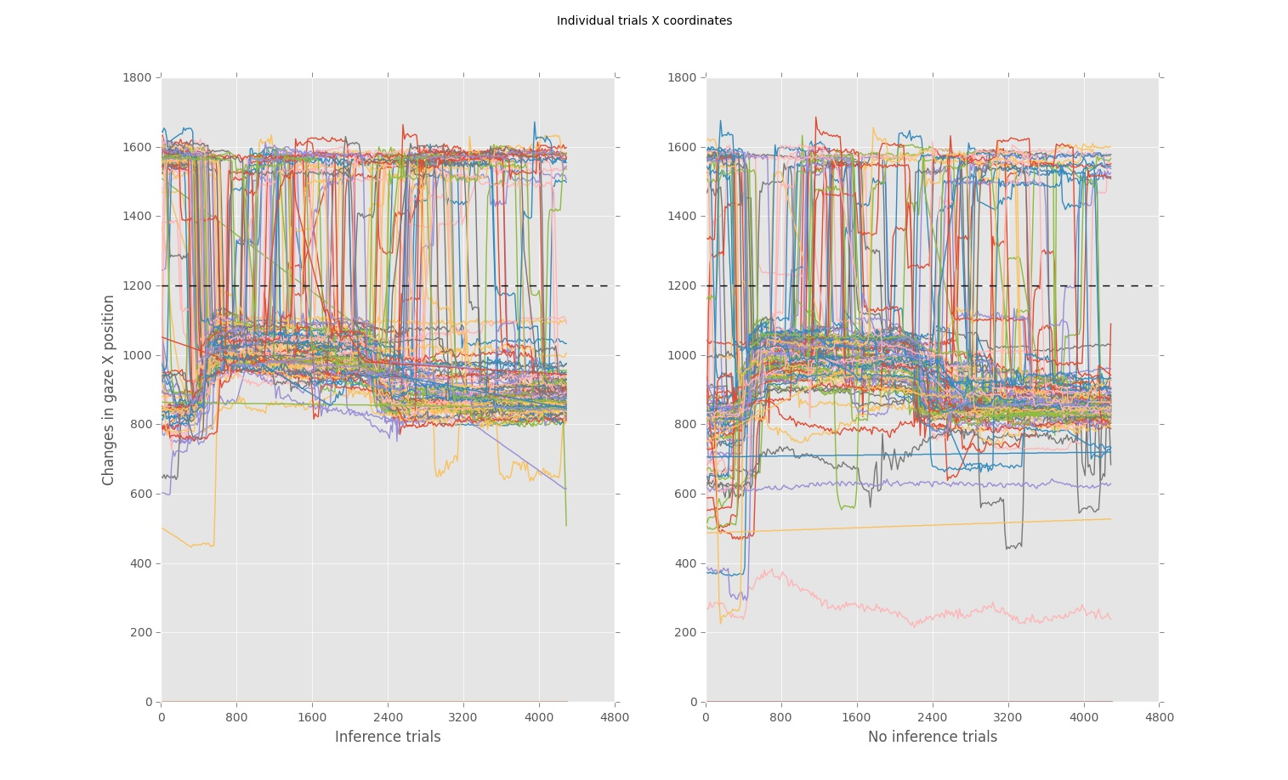Illustration 2: Changes in gaze X position during inference and no inference trials. Each colored line represent a single trial and trials are aggregated from all subjects. The black dotted line represents the border between left and right ROI.
For each subject we calculated the average amount of threshold crossing (threshold is marked by black dotted line) and compare the collection of averages between inference and no inference conditions. The following box plots show these results:

Using a paired sample t-test we determined the difference between conditions was significant (p < 0.05).
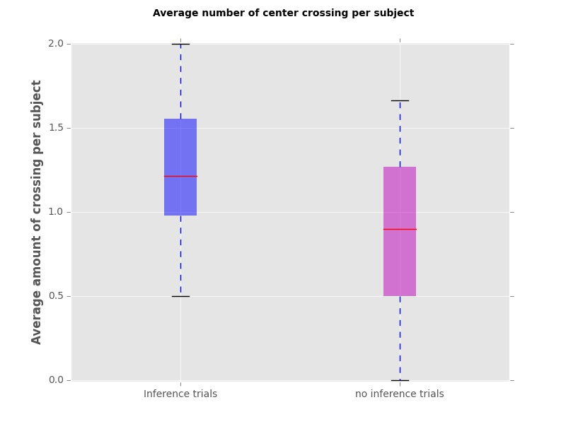Illustration 3: We counted each time subject crossed the ROI border in one direction (from left to right).

- PCA and Logistic regression
  - Following a similar approach to the ROI analysis we isolated the x-coordinate of the gaze to create a collection of signals in inference and no inference conditions. This approach enables identifying characteristics of the signal which can be used to classify it without knowing from which condition it originated. For each subject an average signal (representing changes in x coordinates ) was calculated resulting in the following figure:

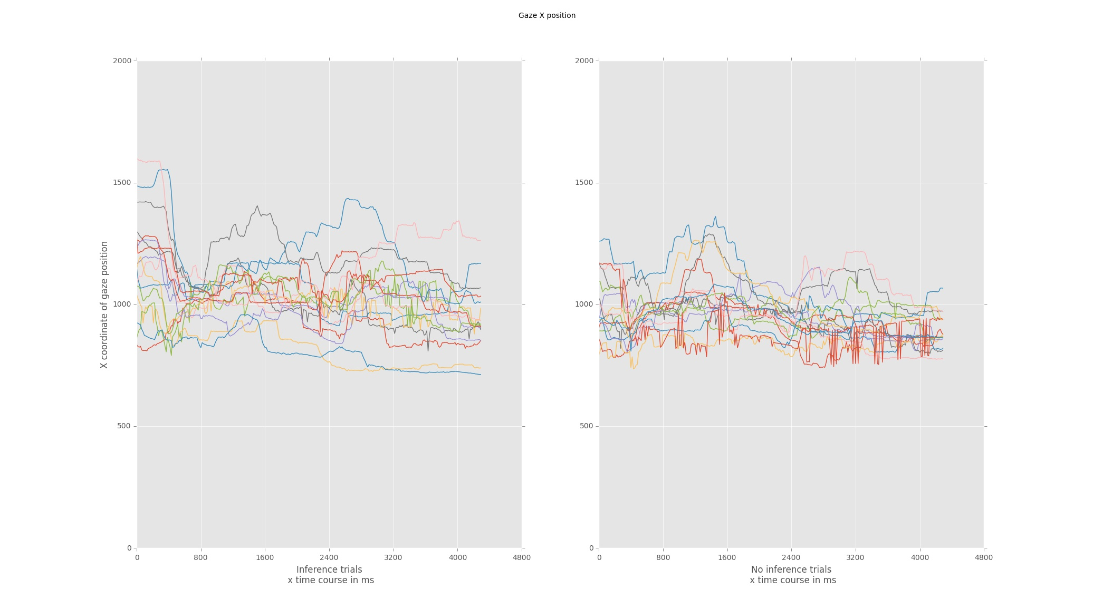Illustration 4: Averaged changes in x coordinate of the gaze during inverence vs no inference.

The figure above has more detailed information about individual averages but can be represented as a grand average with standard deviation:

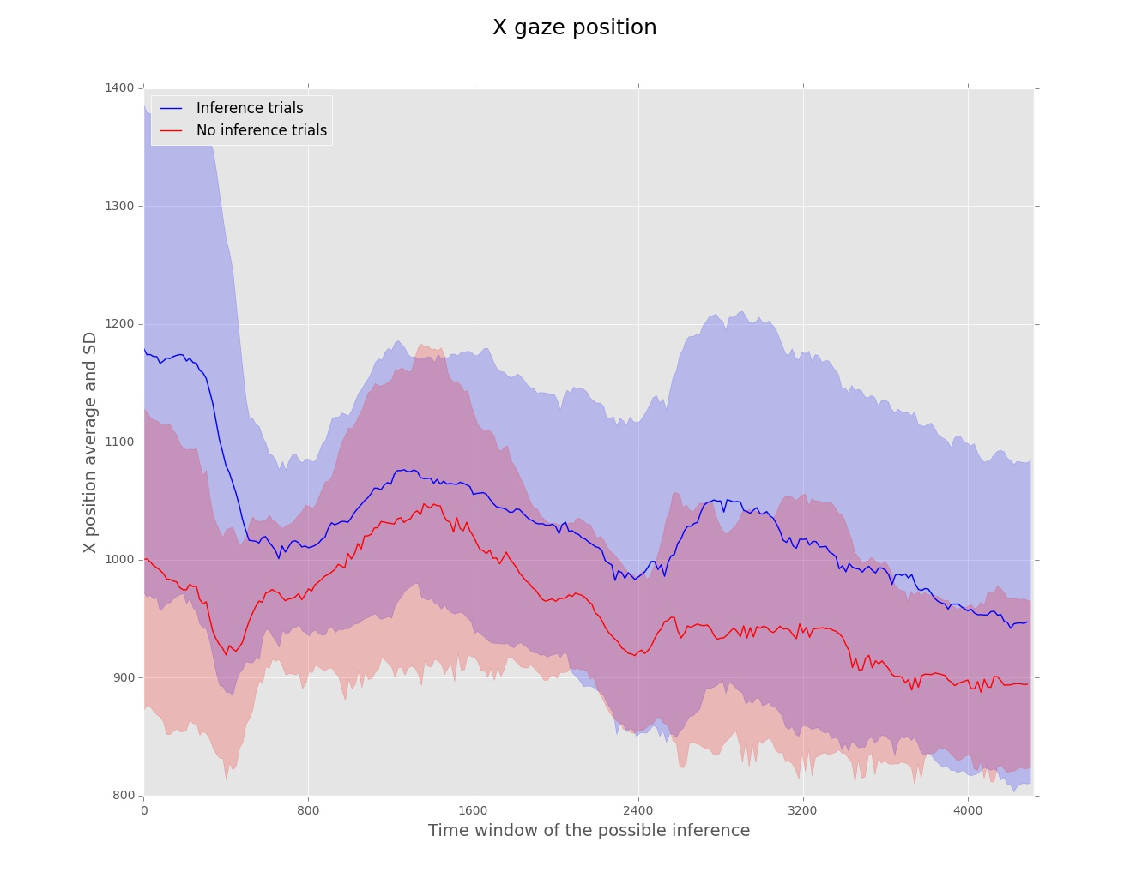Illustration 5: The grand average of changes in X coordinate during the inference vs no inference condition.
Average signals of each subject during two conditions were mixed and reconstructed using PCA and logistic regression. First the dimensions were reduced to the first principal component (since it explained most of variance). Then the score of each signal after the PCA decomposition was used as a predictor in the logistic regression discriminating between the inference vs no inference conditions.

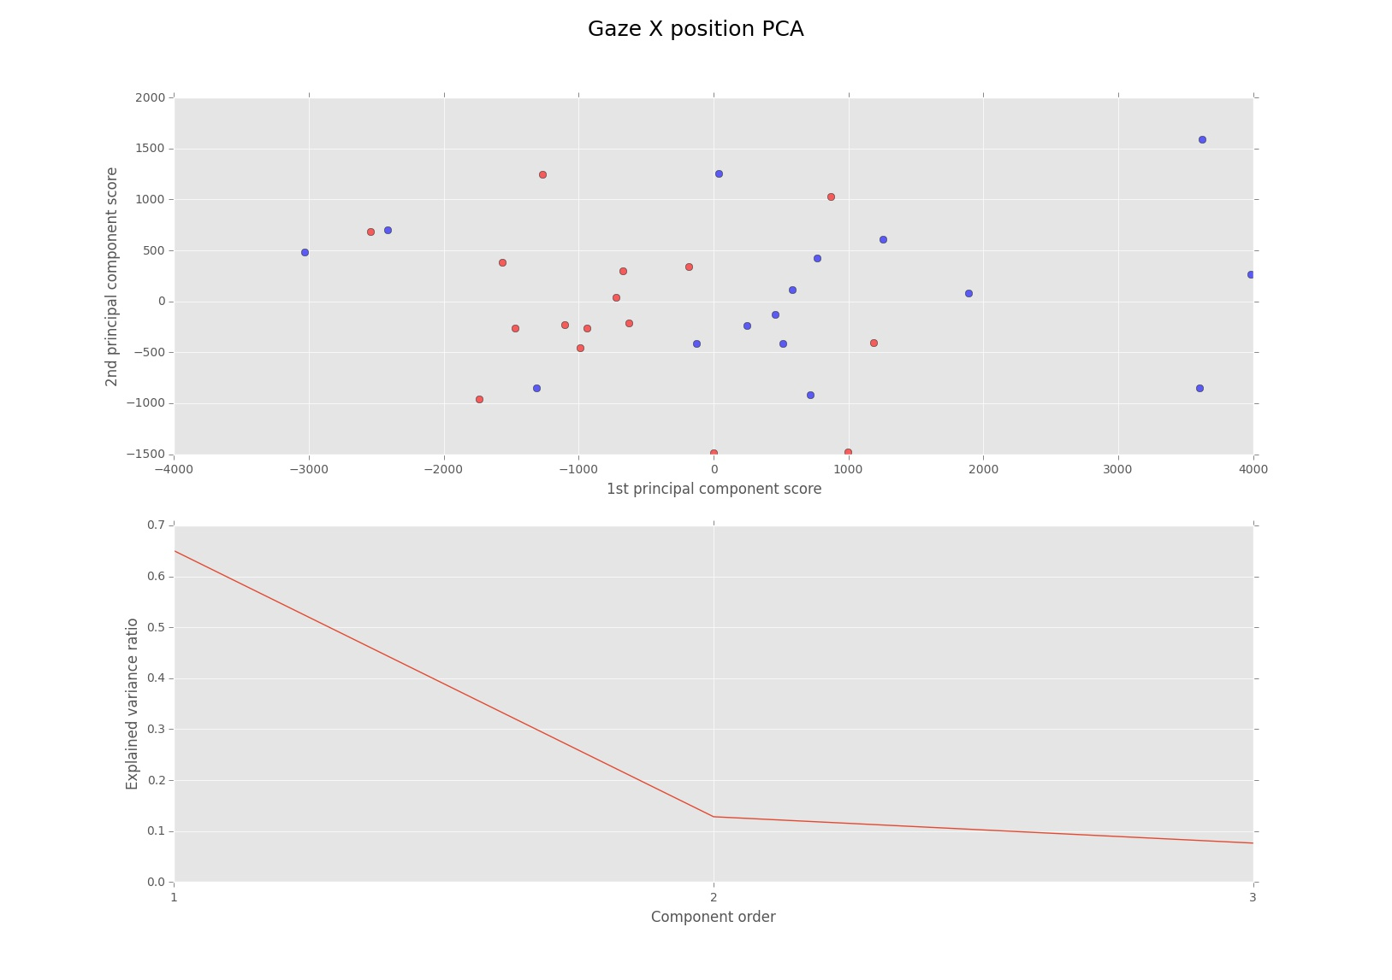Illustration 6: Results of the principal component analysis. Red points represent the average signals durin the no inference condition and the blue points represent the signals during inference condition. (The points were colored 'by hand' just to show that PCA can pick up a significant difference, since most of the red points have negative score while the blue points have mostly positive scores).
The first 3 principal components were used as a predictor in a linear regression model. Only the fiirst component significantly contributed to the explanatory power of the model (p = 0.071). The model was statistically significant χ2(3) = 7.594, p = 0.055 and could accurately classify 68.8 % of the cases (75% for the no inference trials and 62.5 for the inference trials).

- Heat maps: this method was used to analyze the 2 dimensional distribution of the gaze across the two conditions. A 2D histogram of the x and y gaze position was constructed to represent the heat map per condition:
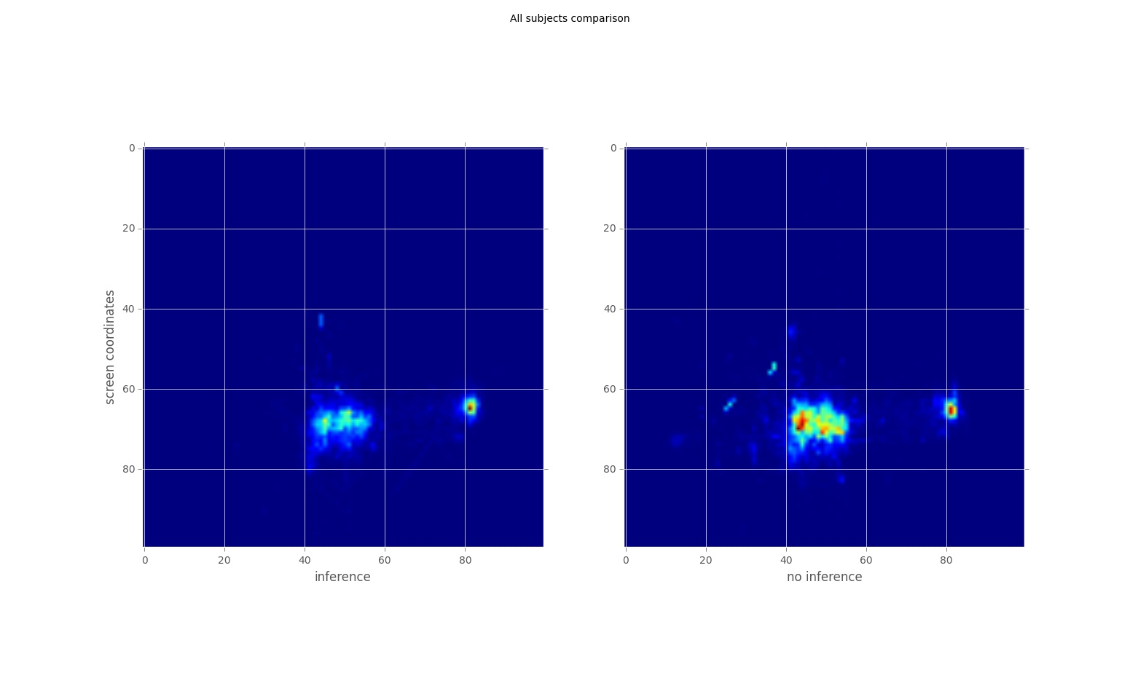
The method for quantifying the difference between these 2D histograms still needs to be devised (a simple difference would be such a measure but with no statistical comparison). What is visible at first is a bigger dispersion in the inference condition possibly due to higher frequency of saccades between left and right ROI (to be checked).

This heatmaps were constructed from these type of images and analysis which is less restrictive in filtering the the two previous methods. All the gaze info is taken, not only the samples inside the screen to preserve the same duration for both heat maps. A more suitable filtering method might be needed. The following pictures represent two example subjects, one during inference one during no inference condition (all material is included in attachments):

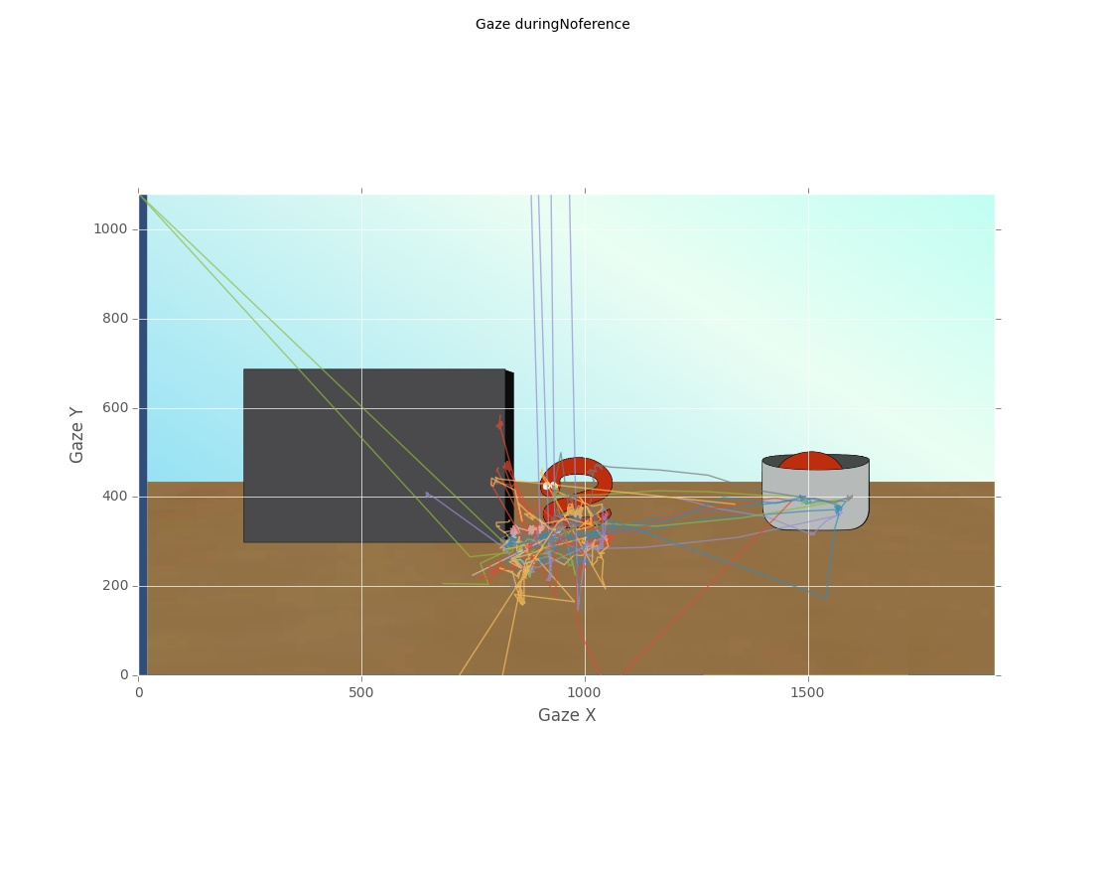Illustration 7: The unfiltered (aside for interpolation for missing data inside the screen) gaze distribution durin no inference trials. Each color represent different trial from a single subject. The y cooridinates of the gaze are not perfectly aligned with the background image, beacuse it was taken from a monitor with different aspect ratio then the one of the experiment.

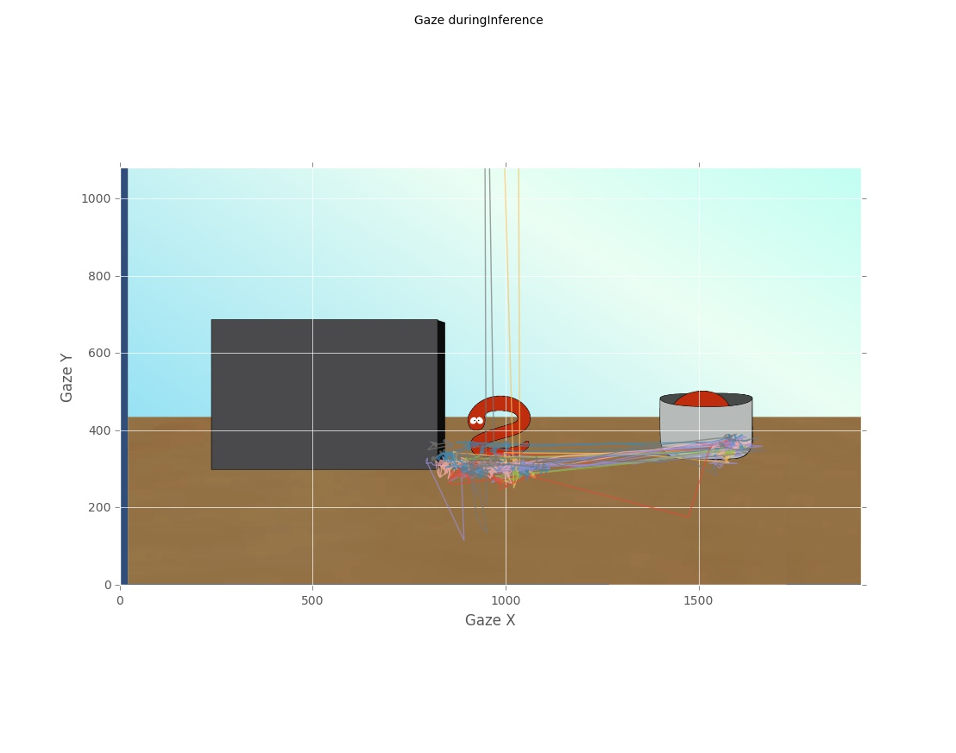Illustration 8: The same example as the one above, only taken in the inference condition.

Conclusions:
The first two types of analysis (ROI and PCA + logistic regression) yielded significant indications of differences in gaze patterns when observing logical stories with possibility of inference vs no possibility conditions. Further elaboration of the heat map measure will need to bne used to quantify the results from the last method. Also a machine learning method can be implemented on the data presented in the last two figures described here: http://dev.pymvpa.org/examples/eyemovements.html

