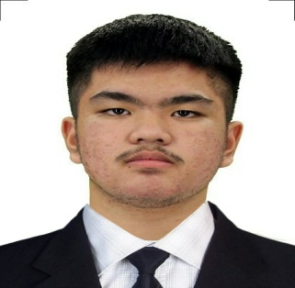
RYAN PAUL R. CALO
rysch20@gmail.com | [https://github.com/rysch20-pixel]
Age- 19
Civil Status- Single
Citizenship- Filipino
PROFESSIONAL SUMMARY
Dedicated BS Information Technology student with a strong interest in software development and Cyber Security. Beginner in Java and Python, with a focus on building functional GUI-based applications. Eager to contribute technical skills and a collaborative approach to a professional environment.
TECHNICAL SKILLS

Programming Languages: Java, Python, HTML/CSS
Software & Tools: Eclipse IDE, VS Code
Hardware: Computer Hardware Diagnostics and Troubleshooting
PROJECTS

Inventory Management System | Java, Eclipse
- Developed a GUI-based desktop application to streamline inventory tracking.
- Implemented search, add, and update functionalities for efficient data management.
EDUCATION

Laguna State Polytechnic University - Sta. Cruz, Laguna
Bachelor of Science in Information Technology | Expected Graduation: 2028

South Greenville School - Pila, Laguna
Secondary Education | Graduated 2024
Graduated Class Valedictorian
SKILLS & ABILITIES
- Adaptability: Proven ability to quickly learn new programming frameworks and tools.
- Time Management: Successfully balanced multiple academic coding projects and deadlines.
- Cooperation: Experienced in team-based environments and collaborative problem-solving.

