|  |  |  |
| --- | --- | --- |
| **Ryan Reedy** | Automated Mechanical Design Synthesis  Homework 3 | **03 Mar 2019** |

# *Please see the main MATLAB script, Homework3.m for further details about my code.*

# 1. Create a Voxel

The function generateEqns.mgenerates autoODE.m. The Voxel class produces either 2D pixels or 3D voxels; use pix = Voxel(‘dimensions’, 2) to create a pixel.

# 2. Create Video

See the Plots folder for all plots and animations.

# 3. 2D Voxel Analysis

A single pixel with unit length and four unit masses is simulated. The top-right point is displaced by [+0.5, +0.5] at the start of the 30 second simulation. Each of the six links have unit stiffness. The critical damping coefficient is shown in Equation 1.

$$\begin{aligned}c_{c}=2m\sqrt{\frac{k}{m}}=2\#\left(1\right)\end{aligned}$$

At zero damping, the point mass oscillates wildly, passing through the other diagonal spring. At critical damping, there is little to no oscillation about the resting position. The simulation is reasonably well damped (and reasonably interesting to watch for more than a few seconds) when the damping ratio is about 0.25 to 0.50 (c = 0.5 and c =1.0).



Figure 1: Initial conditions (see initialSquare.m)

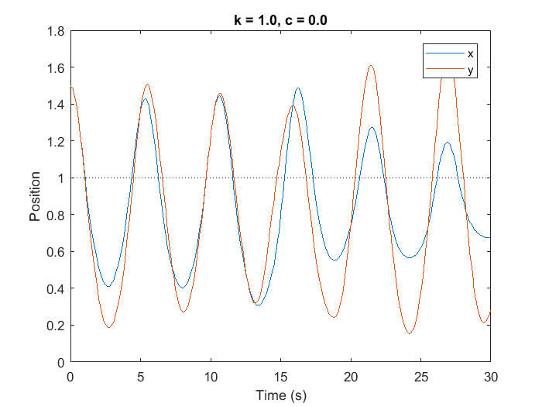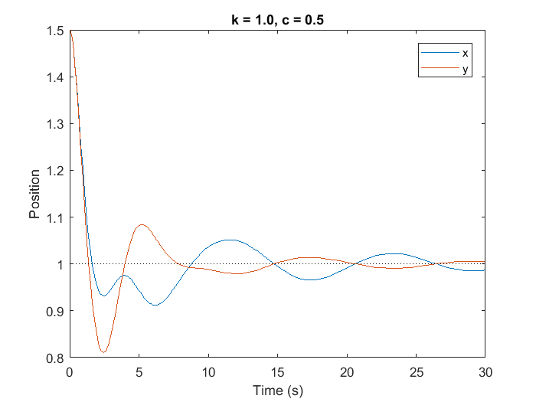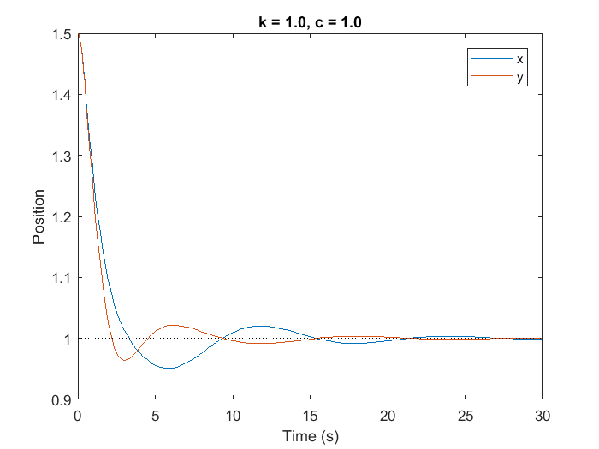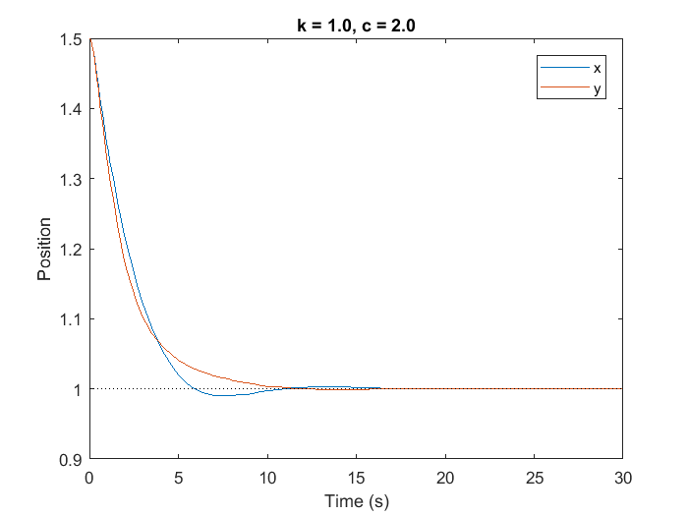Figure 2: Plots with various damping ratios (pardon the inconsistent y-axis scale)

# 4. Create a Row of Voxels

A row of three voxels is simulated, clamped on its left end. The gravity vector is [0, -1]. The red voxel’s damping coefficient is half that of the blue ones. Note that the shared links are purple, indicating that the stiffness and the damping (and the color) are taken as the average of its parents.

*See* initialPart4.m for how this is generated.

|  |  |  |  |
| --- | --- | --- | --- |
|  | Stiffness | Damping | Mass per Point |
| Blue | 100 | 50 | 1 |
| Red | 100 | 25 | 1 |



Figure : Results of initialPart4.m

# 5. 3D Array of Voxels Analysis

See Plots/Test1.avi and Plots/Test2.avi. The setup file is initial3DArray.m, and setting the flag orange = 0 or 1 changes to case 1 or 2.



Figure : State at end of Test2.avi



Figure : Side views of resting positions of Test1 and Test2