Kejimkujik National Park and interior Nova Scotia blanding’s turtle (Emydoidea blandingii) population monitoring optimization analysis (1996:2015)
MCGOWAN LAKE
Summary:
We took data provided from McGowan Lake and ran simulations and resampling calculations to estimate the average return on sampling effort. We used two indices of effort for this exercise: 1) Turtle CPUE – Elapsed monitoring time·# of observers⁻¹, and 2) the total number of hours spent monitoring (‘observational hours’) - # of observers * elapsed time sampling. We chose the index of observational hours as it provides an index of the cumulative effort required to observe individuals in a population.
In our analyses we made several assumptions. First we only used counts of late juvenile and adult turtles (19+ years) and we assume that all turtles within this age range were available during all sampling events. These assumptions can be modified, but for now they offered a pragmatic first step given the relatively small dataset available for McGowan’s lake.
We show that when observers are sampling for over two hours there is a large jump in the likelihood they will observe more turtles (Figure 1). Similarly, we show that sampling events of over 6 hours shows a higher likelihood that more turtles will be observed (Figure 2). Extending this analysis we calculated the number of unique turtles observed in each year respective to the sampling effort. Year after year it appeared that the number of turtles observed asymptoted at ~23 unique turtles. This observation was only made when sampling effort exceeded 500 people hours (Figures 2-5).
Next we combined the sampling effort among all years to see how the accumulated effort year to year resulted in the detection of unique turtle IDs. We ran a segmented regression to identify the breakpoint where the return on sampling effort begins to plateau. We show that after 900 observational hours (2006-2007) the observation of new turtles begins to plateau adding only a few turtles year to year, presumably new recruits. This suggests that it could take up to 4 years to observe the majority of adults in the population based on the average sampling effort of ~450 observational hours (Figure 6). We estimate that it would take ~4428 observational hours to observe all 52 unique turtles of the specified age range in the population. This could represent approximately a decade of sampling based on the average observational period from 1996-2014 (Figure 7). However, this result does not take into account the fact that new turtles are emigrating into the population and were therefore not available for sampling in years previous.
This analysis presents a first look at the how sampling effort is related to population assessment. With more data these analyses can be built upon. In particular the assumption that all unique turtles based on the specified age range and does not currently account for the fact that new turtles emigrate to the population. This can be incorporated using the unique Turtle ID tags. Using analyses developed and information gained from the McGowen Lake monitoring data simulations could now be constructed to forecast sampling regimes. These simulations could be used to test the sensitivity of population assessments based on varying levels of sampling effort.
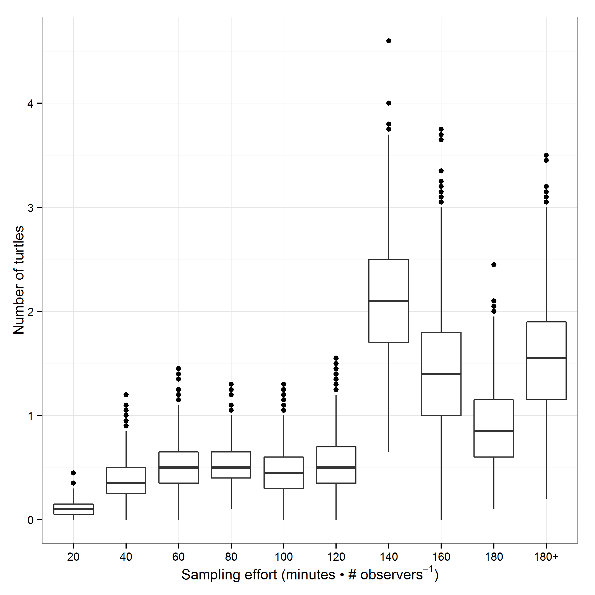

Figure 1: Number of Blanding’s turtles observed as a function of sampling effort (total time • number of observers⁻¹) as observed between 1996:2015.

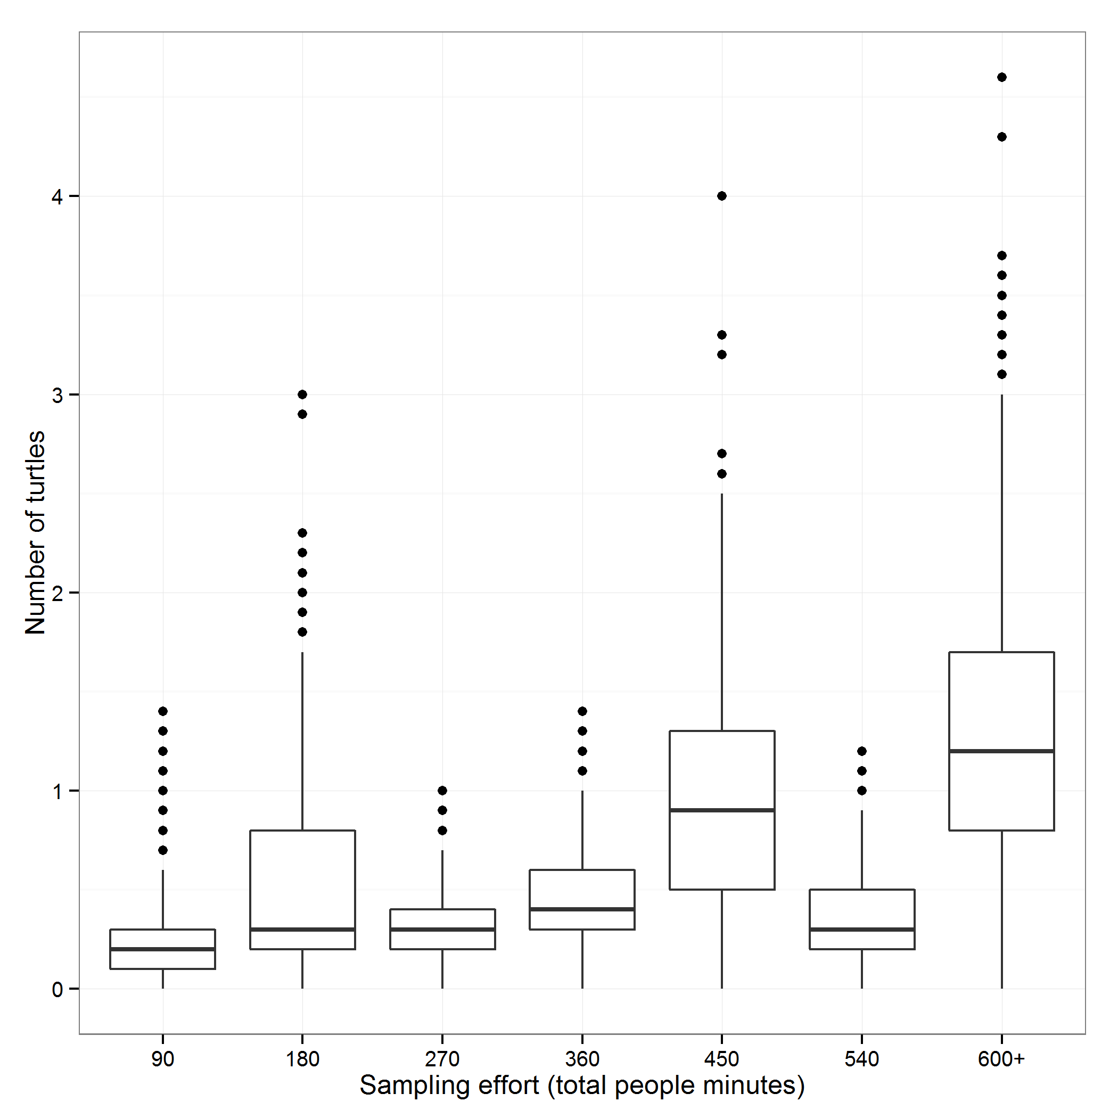

Figure 2. Number of Blanding’s turtles observed as a function of sampling effort (total # of people minutes) as observed (1996:2015).

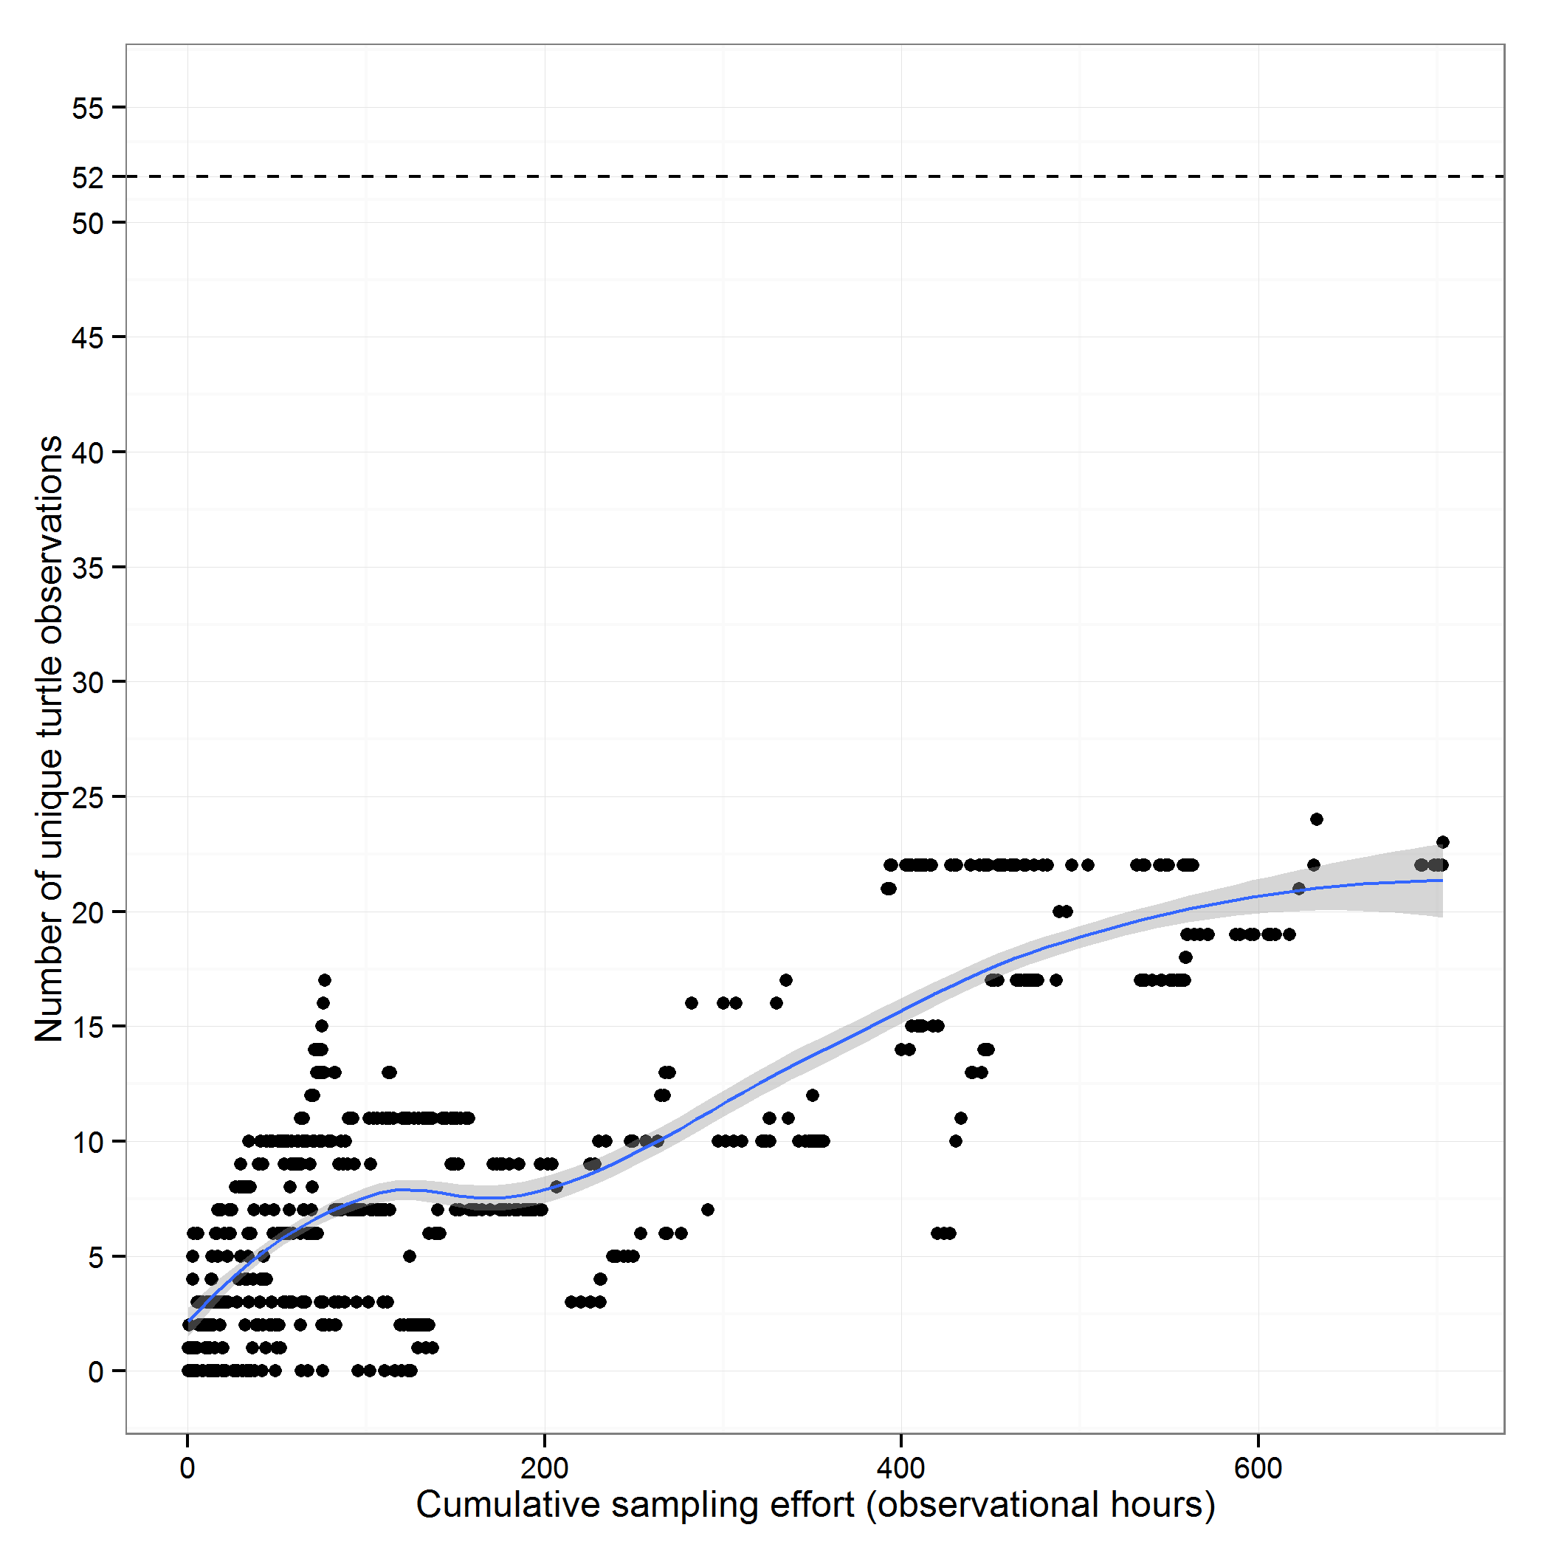

Figure 3. Number of unique turtles versus the total cumulative sample time within each sample year (1996:2014). Dashed line represents the total number of unique turtles observed throughout the sampling period (1996:2015). Note effort is cumulative in chronological order from the beginning of monitoring in 1996. 2015 excluded because of extended sampling season.

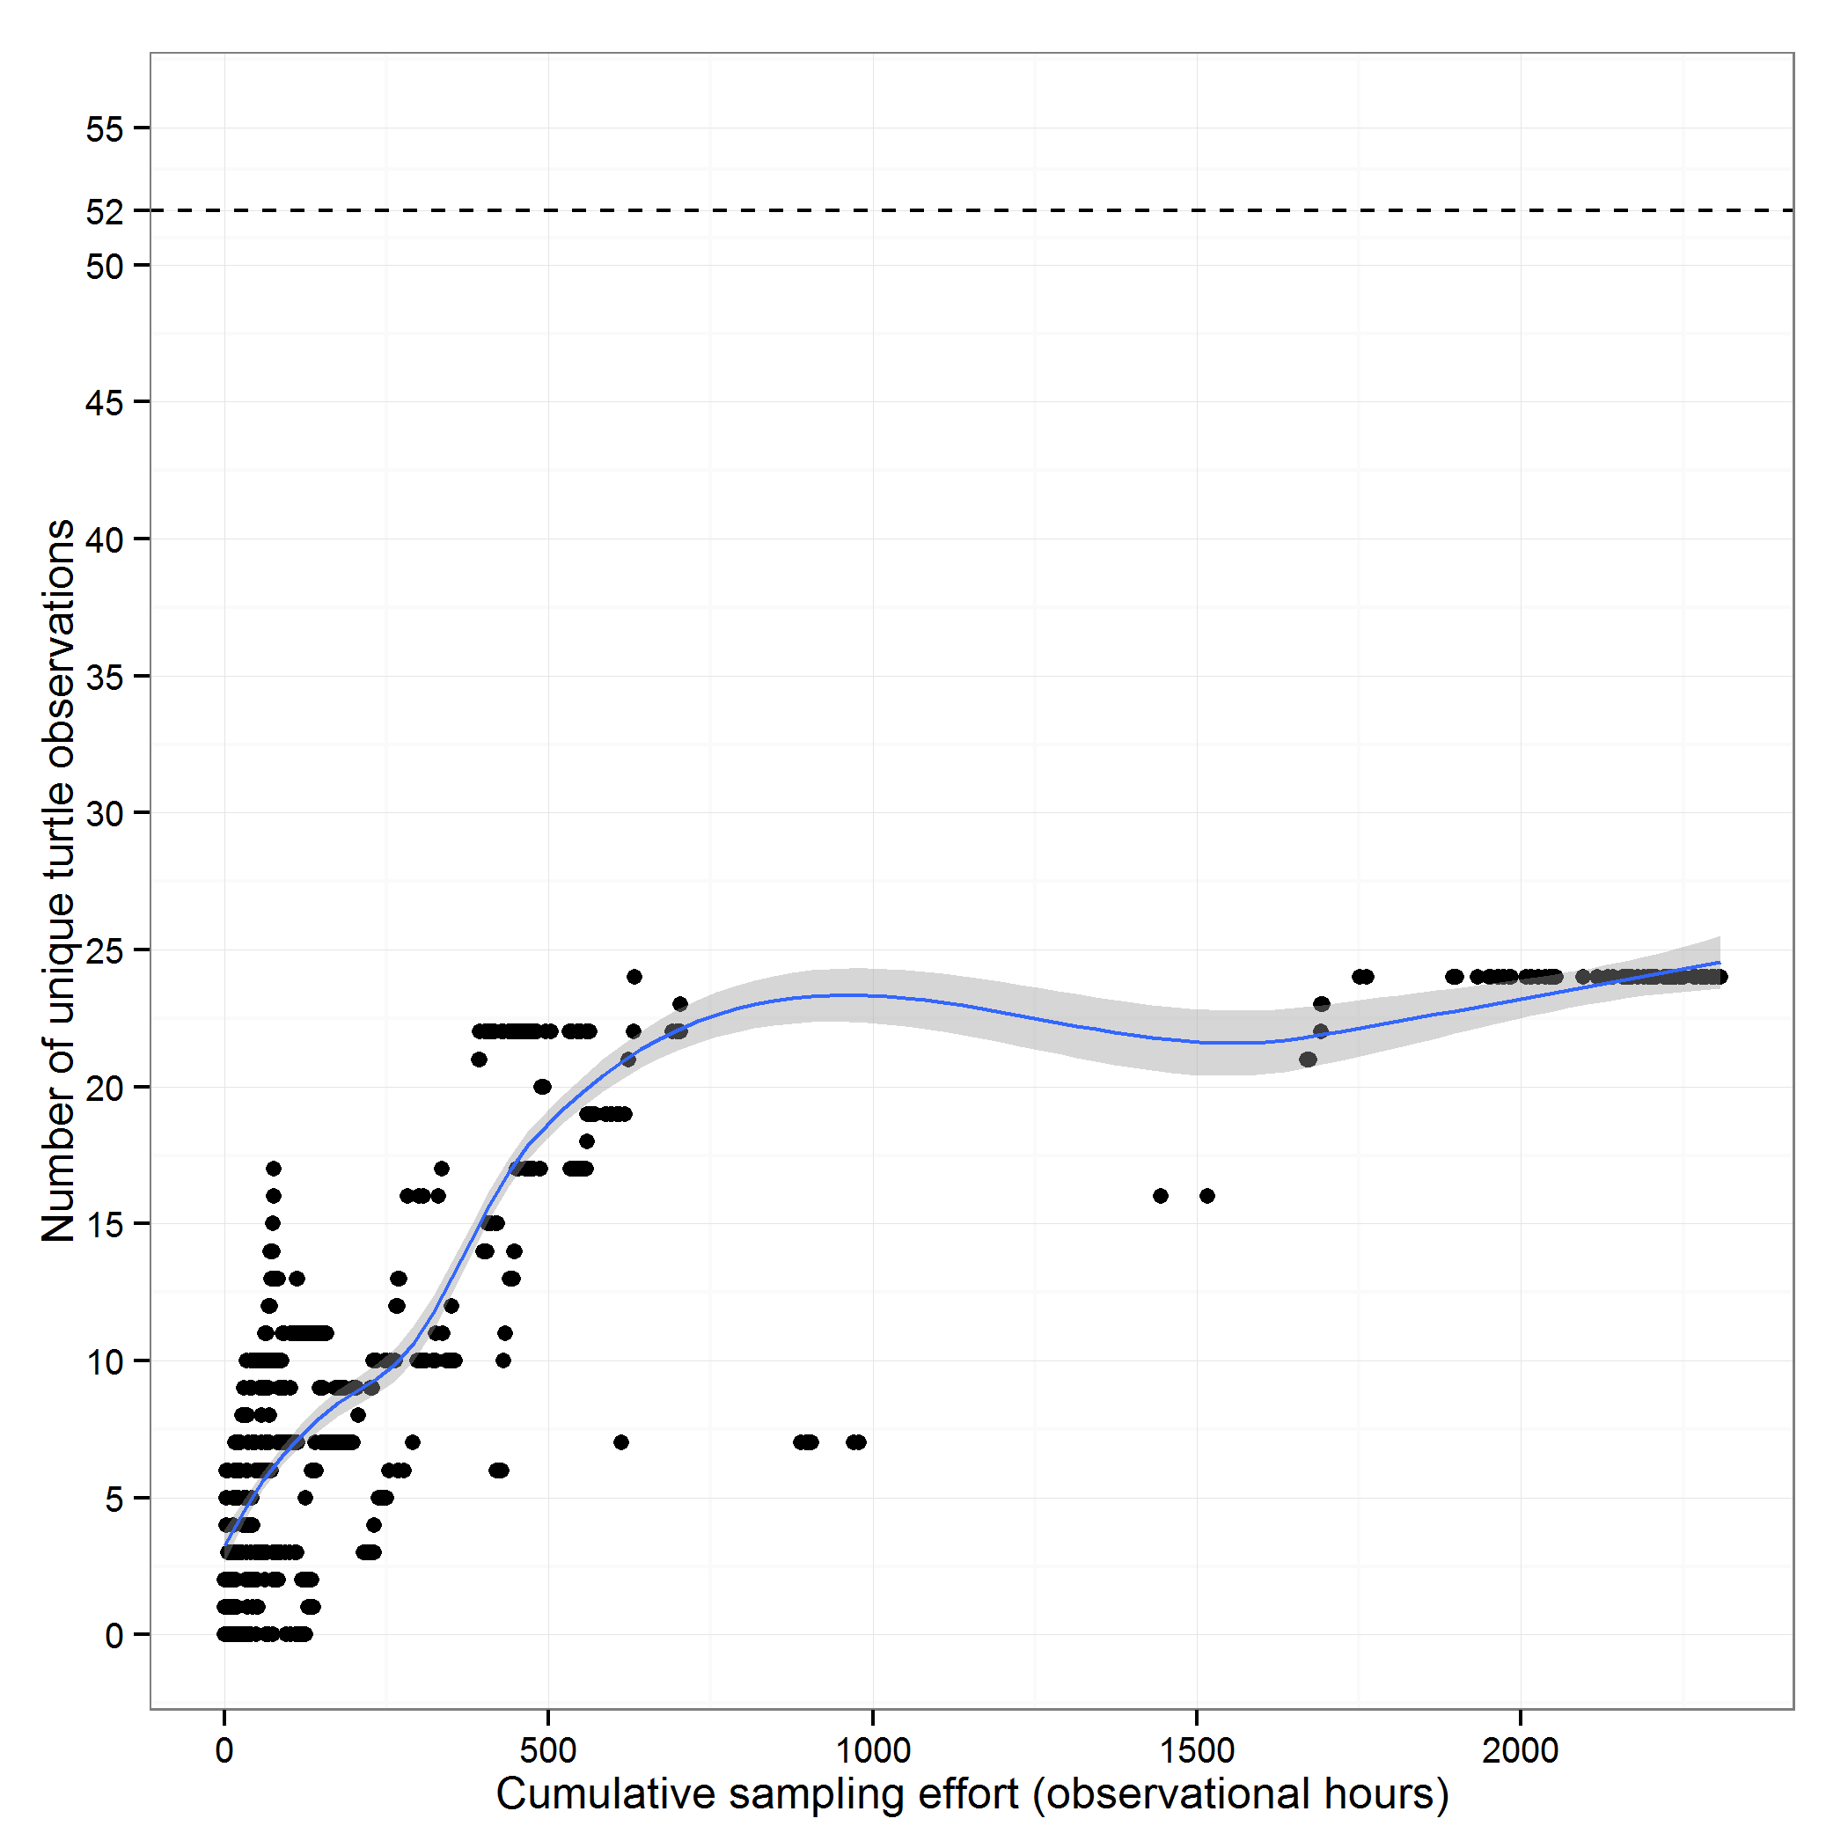

Figure 4. Number of unique turtles versus the total cumulative sample time within each sample year (1996:2015). Dashed line represents the total number of unique turtles observed throughout the sampling period. Note effort is cumulative in chronological order from the beginning of monitoring in 1996.
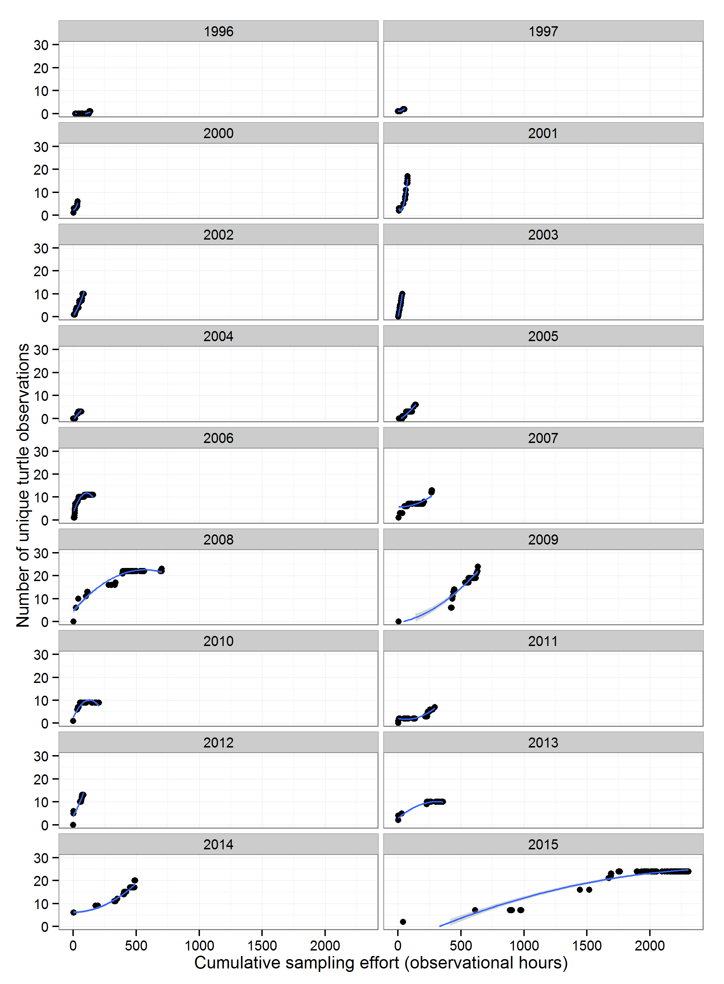

Figure 5. Number of unique turtles versus the total cumulative sample time within each sampling year (1996:2015).

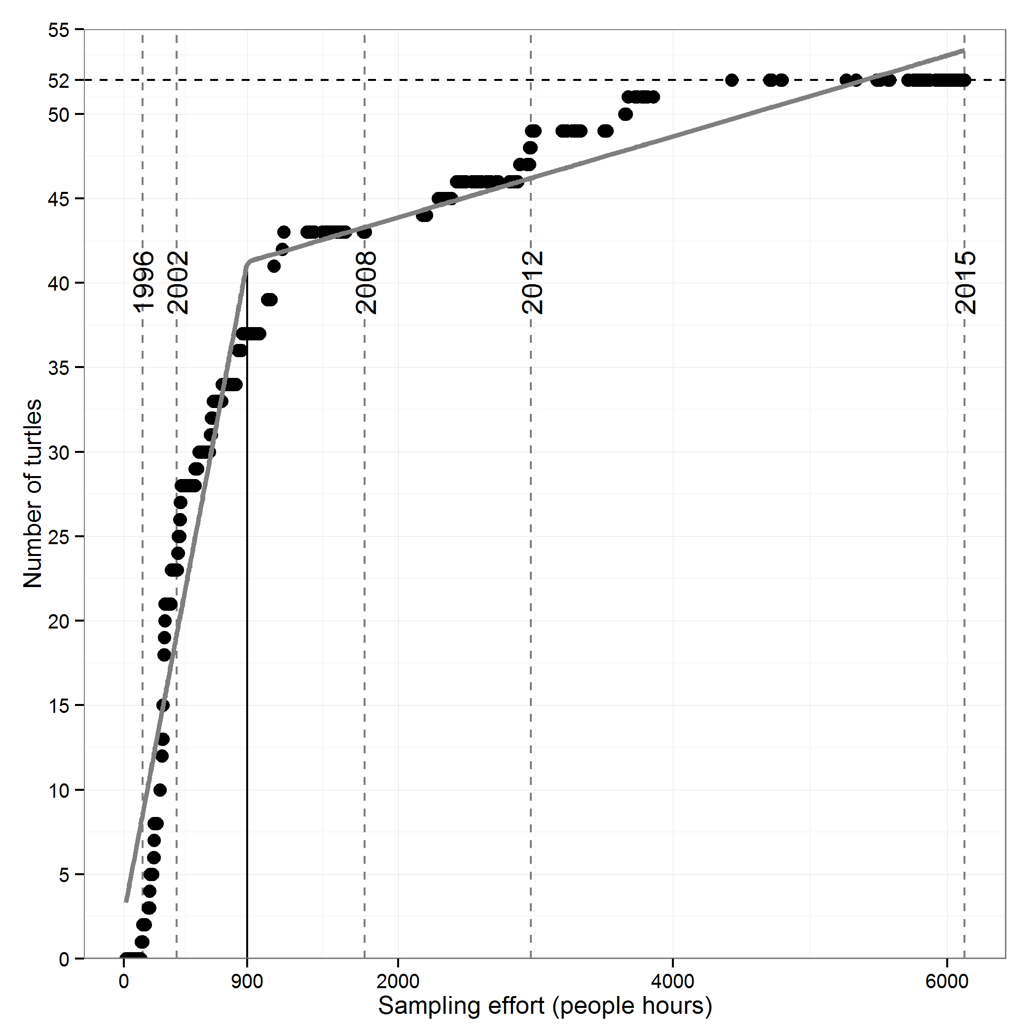
Figure 6: Number of unique turtle captures vs. sampling effort (total people hours) for each sample event. Horizontal dashed line represents the total number of unique turtles observed in McGowan’s lake. Vertical solid line represents the point of inflection as estimated by a segmented regression analysis (grey line). Dashed grey vertical lines represent the cumulative sampling effort on the respective year. Note effort is cumulative in chronological order from the beginning of monitoring in 1996.
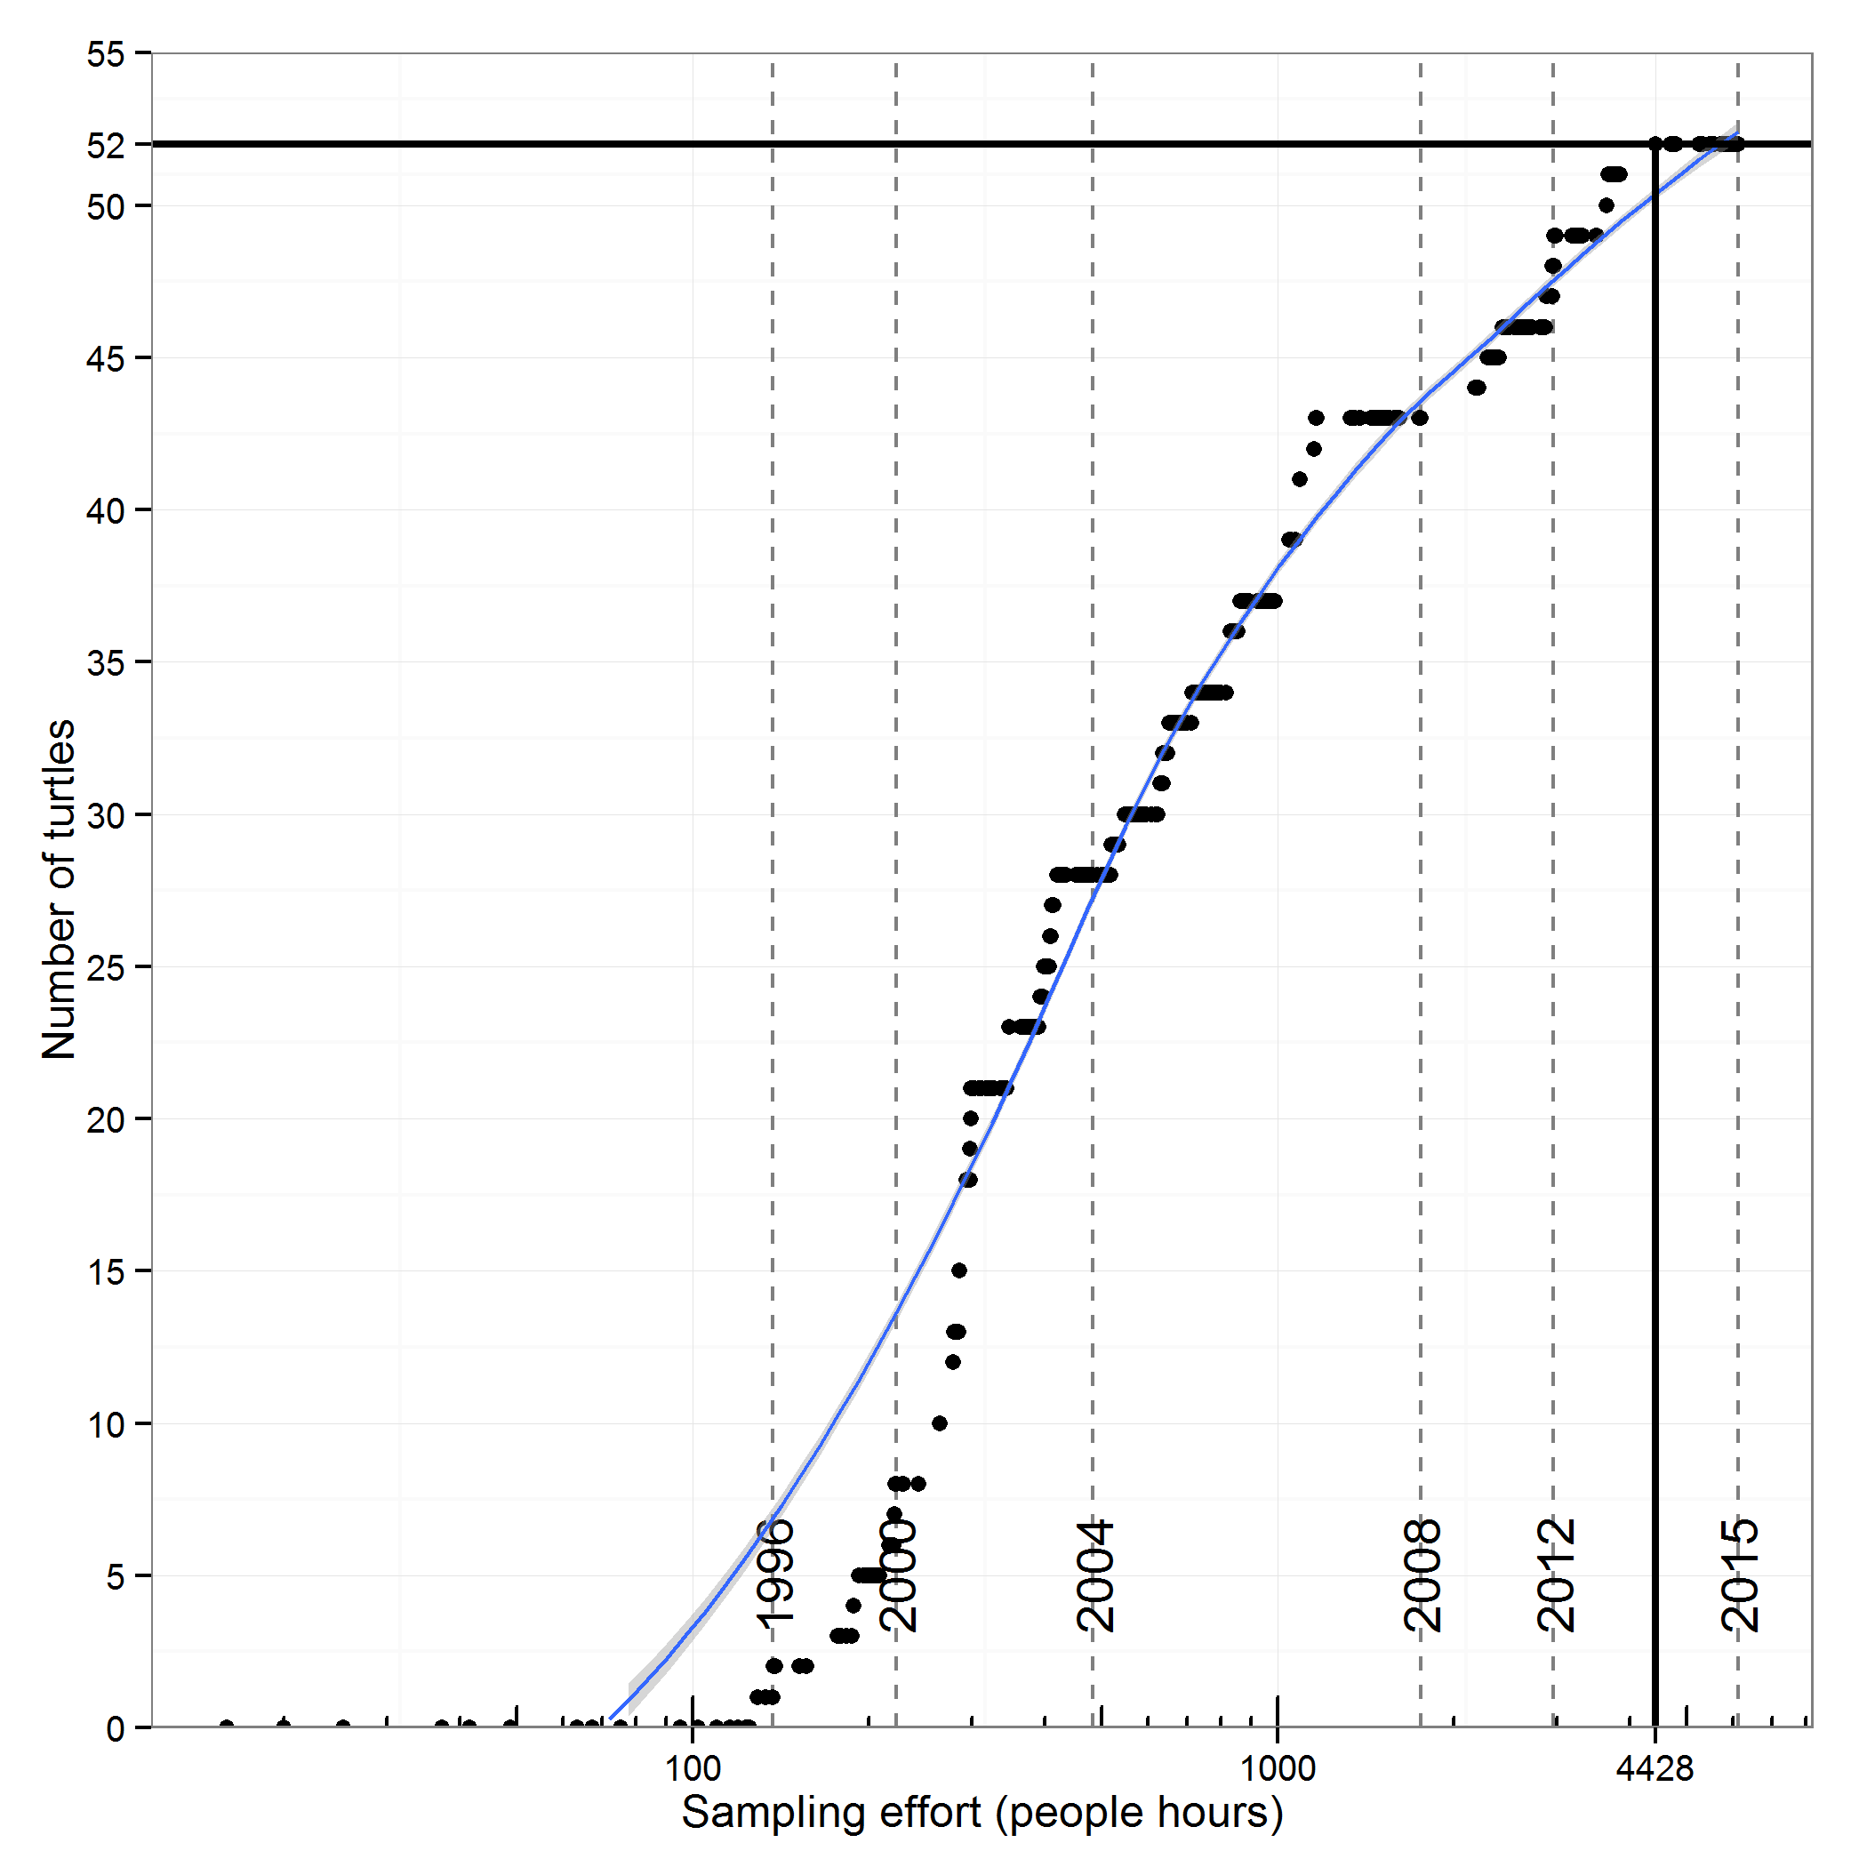
Figure 7. Number of unique turtle captures vs. sampling effort (total people hours) for each sample event. Vertical solid line represents the point where all turtles have been observed (n=52; horizontal solid line). Dashed grey vertical lines represent the cumulative sampling effort on the respective year. Note effort is cumulative in chronological order from the beginning of monitoring in 1996.

