**POSSIBLE DATABASE OPTIONS FOR FINDING REMAINING STIMULI**

Please note that some of these require writing to the authors/lab to gain download permission.

1. [The Chicago Face Database](https://chicagofaces.org/default/)- DOWNLOADABLE

The Chicago Face Database was developed at the University of Chicago by Debbie S. Ma, Joshua Correll, and Bernd Wittenbrink. The CFD is intended for use in scientific research. It provides high-resolution, standardized photographs of male and female faces of varying ethnicity between the ages of 17-65. Extensive norming data are available for each individual model. These data include both physical attributes (e.g., face size) as well as subjective ratings by independent judges (e.g., attractiveness).

1. [Asian Face Age Dataset (AFAD)](https://afad-dataset.github.io/)

Download AFAD-Lite: <https://github.com/afad-dataset/tarball-lite>

Download AFAD-Full: <https://github.com/afad-dataset/tarball>

The Asian Face Age Dataset (AFAD) is a new dataset proposed for evaluating the performance of age estimation, which contains more than 160K facial images and the corresponding age and gender labels. This dataset is oriented to age estimation on Asian faces, so all the facial images are for Asian faces. It is nted that the AFAD is the biggest dataset for age estimation to date. It is well suited to evaluate how deep learning methods can be adopted for age estimation.

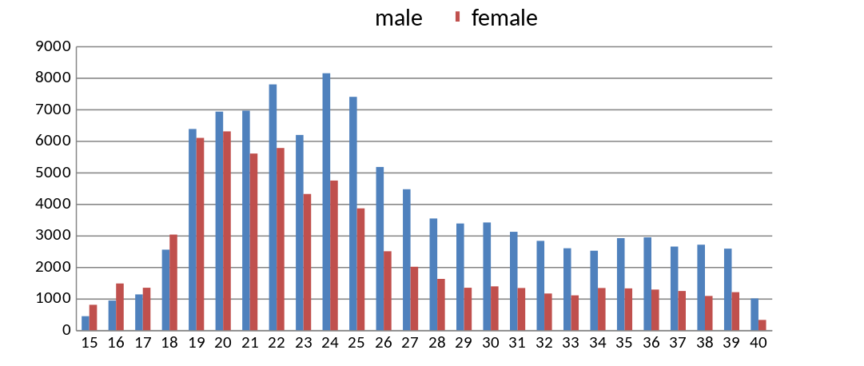

There are 164,432 well-labeled photos in the AFAD dataset. It consist of 63,680 photos for female as well as 100,752 photos for male, and the ages range from 15 to 40. The distribution of photo counts for distinct ages are illustrated in the figure above. Some samples are shown below. Its download link is provided in the "Download" section. In addition, we also provide a subset of the AFAD dataset, called AFAD-Lite, which only contains well-labeled photos. It consists of photos for female as well as photos for male, and the ages range from 15 to 40.

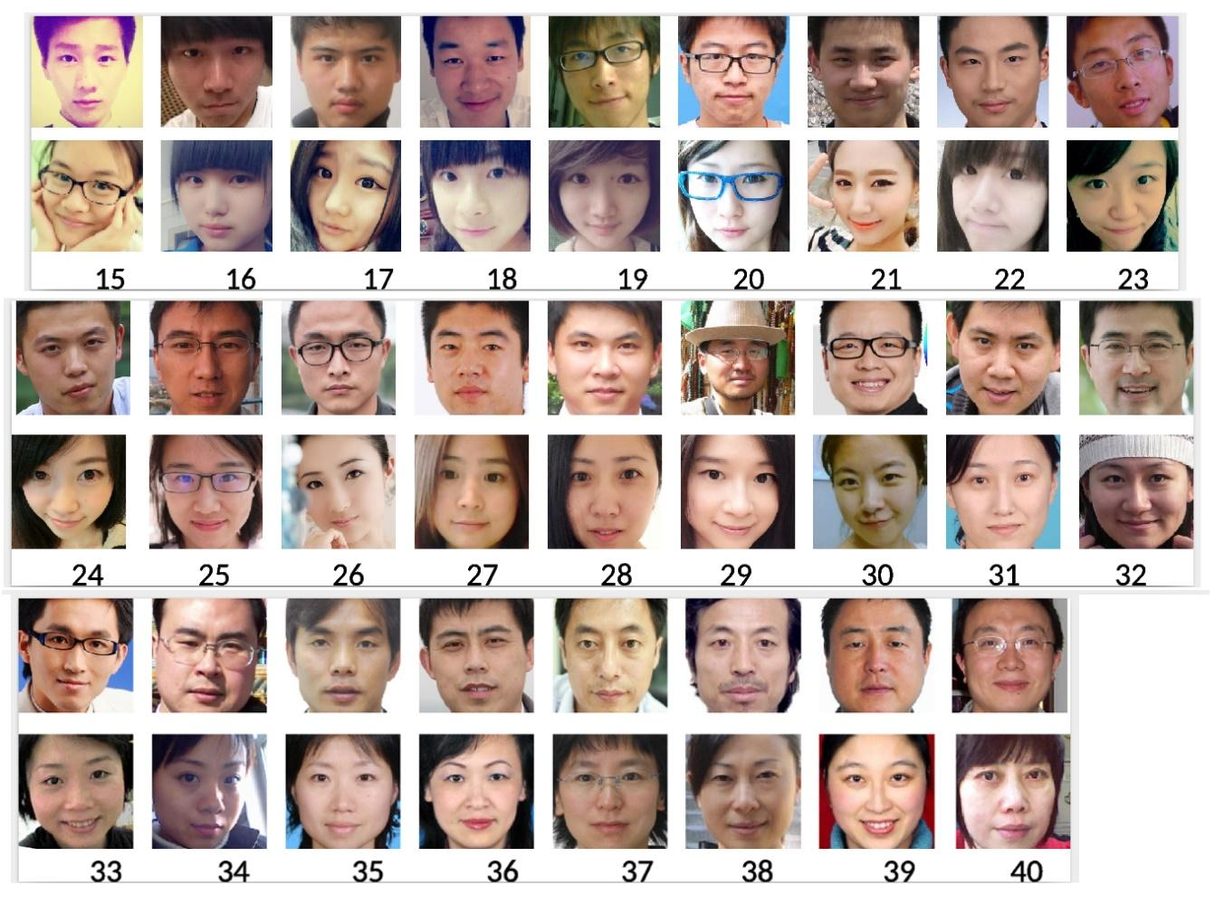

**I CAN’T SEEM TO FIGURE OUT HOW TO DOWNLOAD THIS NEXT ONE (PF01)…**

1. Asian Face Image Database PF01  
   <https://citeseerx.ist.psu.edu/viewdoc/download;jsessionid=AC6D7020A1F071376262AEDCC2223B87?doi=10.1.1.115.9985&rep=rep1&type=pdf>

PF01 contains the true-color face images of 103 people, 53 men and 50 women, representing 17 various images (1 normal face, 4 illumination variations, 8 pose variations, 4 expression variations) per person. All of the people in the database are Asians. There are three kinds of systematic variations, such as illumination, pose, and expression variations in the database. The database is expected to be used to evaluate the technology of face recognition for Asian people or for people with systematic variations.

1. [Tsinghua facial expression database – A database of facial expressions in Chinese young and older women and men: Development and validation](https://journals.plos.org/plosone/article?id=10.1371/journal.pone.0231304)  
     
   <https://cloud.tsinghua.edu.cn/d/f616b666754b4bdd8645/>

Perception of facial identity and emotional expressions is fundamental to social interactions. Recently, interest in age associated changes in the processing of faces has grown rapidly. Due to the lack of older faces stimuli, most previous age-comparative studies only used young faces stimuli, which might cause own-age advantage. None of the existing Eastern face stimuli databases contain face images of different age groups (e.g. older adult faces). In this study, a database that comprises images of 110 Chinese young and older adults displaying eight facial emotional expressions (Neutral, Happiness, Anger, Disgust, Surprise, Fear, Content, and Sadness) was constructed. To validate this database, each image was rated on the basis of perceived facial expressions, perceived emotional intensity, and perceived age by two different age groups. Results have shown an overall 79.08% correct identification rate in the validation. Access to the freely available database can be requested by emailing the corresponding authors.

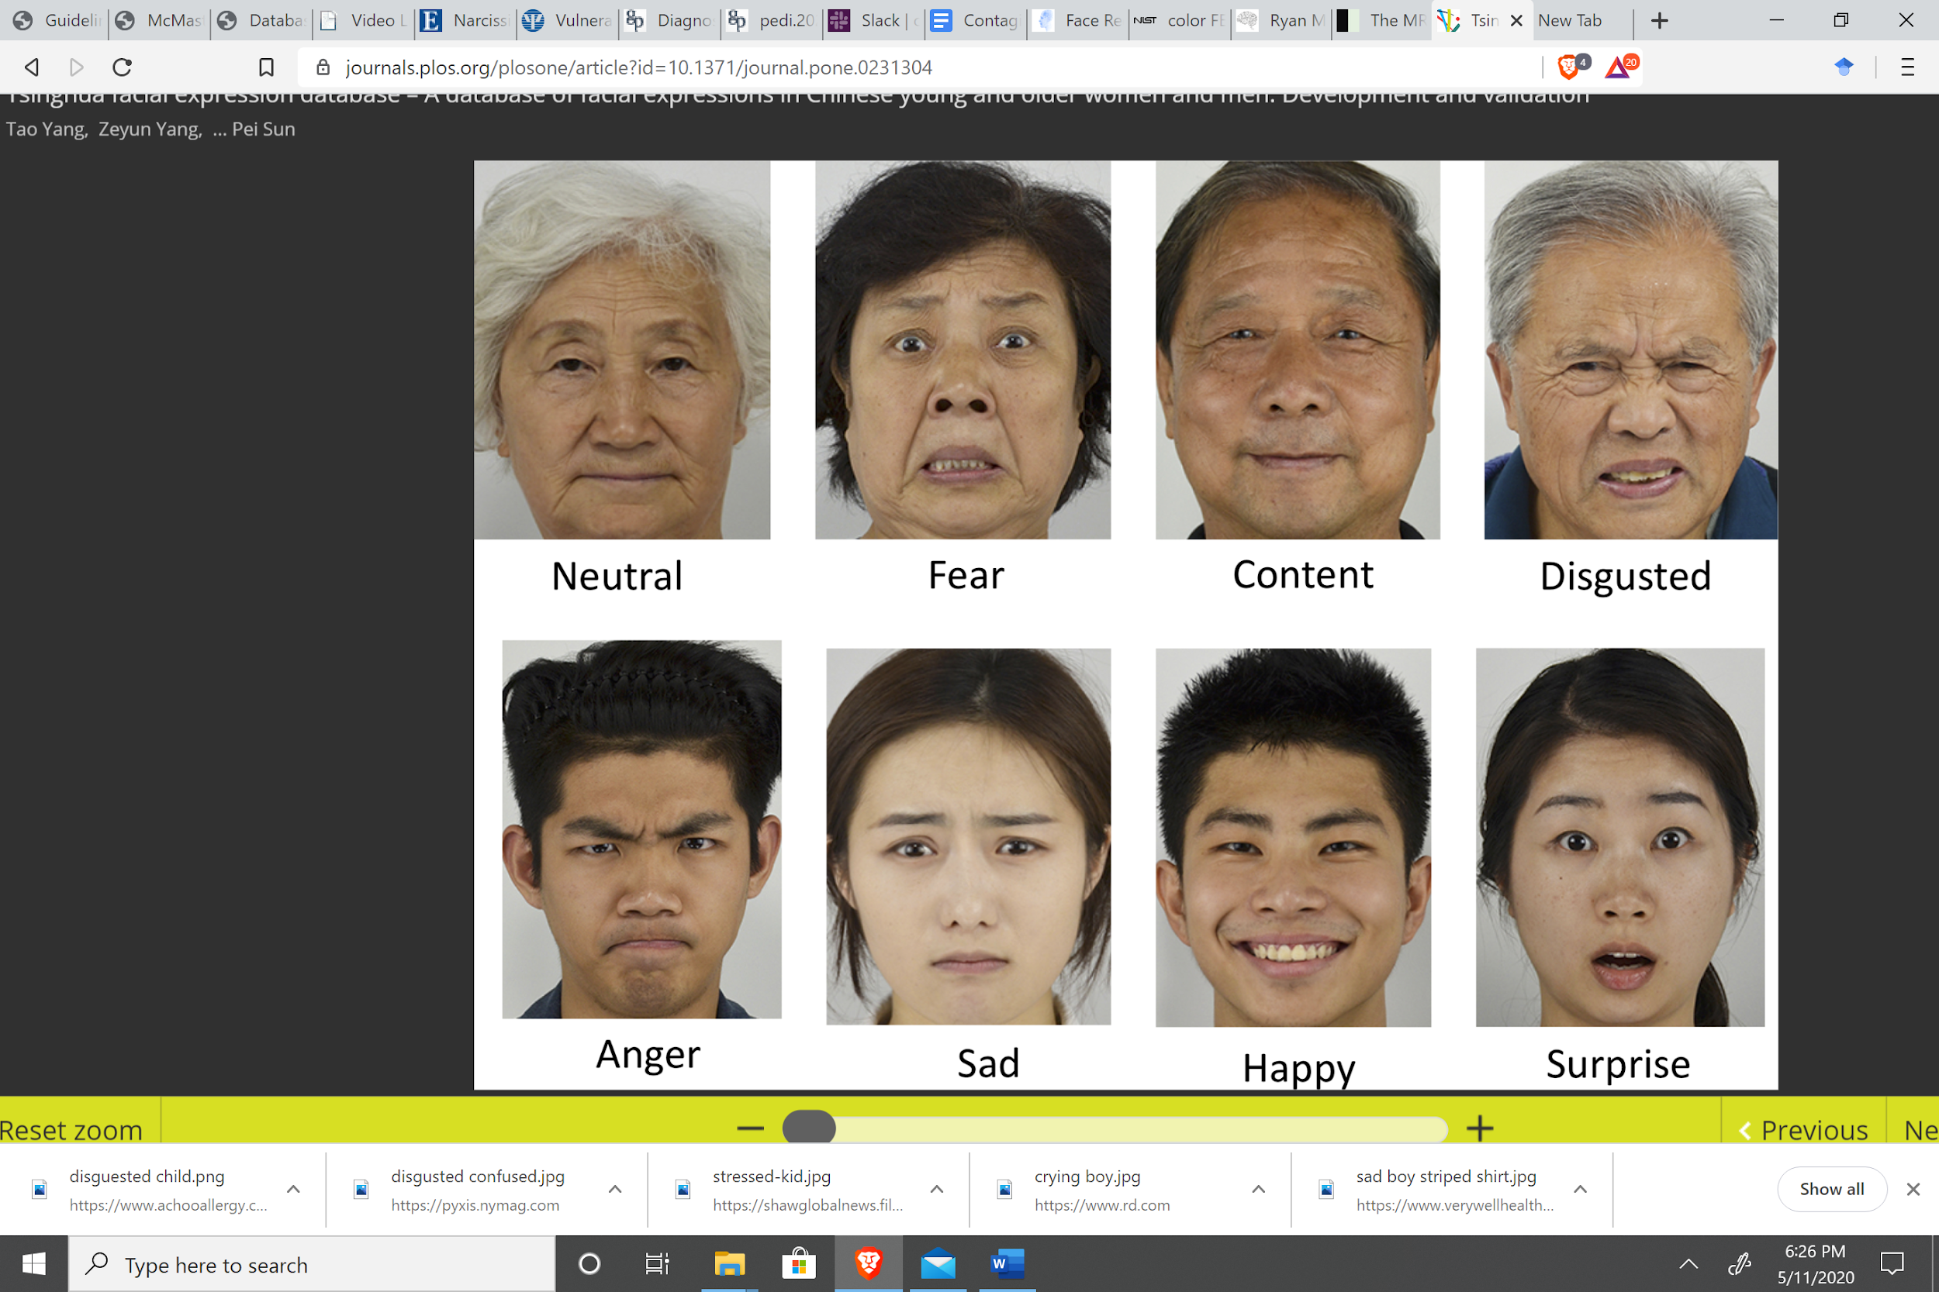

1. [BU-3DFE Database (Static Data)](http://www.cs.binghamton.edu/~lijun/Research/3DFE/3DFE_Analysis.html)

BU-3DFE (Binghamton University 3D Facial Expression) includes 100 subjects with 2,500 facial expression models. The BU-3DFE database is available to the research community (e.g., areas of interest come from as diverse as affective computing, computer vision, human computer interaction, security, biomedicine, law-enforcement, and psychology). The database contains 100 subjects (56% female, 44% male), ranging age from 18 years to 70 years old, with a variety of ethnic/racial ancestries, including White, Black, East-Asian, Middle-east Asian, Indian, and Hispanic Latino.

1. <http://www.milbo.org/muct/>

The MUCT database consists of 3755 faces with 76 manual landmarks. The database was created to provide more diversity of lighting, age, and ethnicity than currently available [landmarked 2D face databases](http://www.milbo.org/muct/other-databases.html). Some examples are shown on the right (in low-resolution). A full resolution image:



<http://www.milbo.org/muct/The-MUCT-Landmarked-Face-Database.pdf>

1. <http://biometrics.idealtest.org/dbDetailForUser.do?id=9>  
     
   CASIA Face Image Database Version 5.0 (or CASIA-FaceV5) contains 2,500 color facial images of 500 subjects. The face images of CASIA-FaceV5 are captured using Logitech USB camera in one session. The volunteers of CASIA-FaceV5 include graduate students, workers, waiters, etc. All face images are 16 bit color BMP files and the image resolution is 640*480. Typical intra-class variations include illumination, pose, expression, eye-glasses, imaging distance, etc.
2. [CUHK Face Sketch Database (CUFS)](http://mmlab.ie.cuhk.edu.hk/archive/facesketch.html)

CUHK Face Sketch database (CUFS) is for research on face sketch synthesis and face sketch recognition. It includes 188 faces from the Chinese University of Hong Kong (CUHK) student database, 123 faces from the AR database [1], and 295 faces from the XM2VTS database [2]. There are 606 faces in total. For each face, there is a sketch drawn by an artist based on a photo taken in a frontal pose, under normal lighting condition, and with a neutral expression.

1. [Taiwanese Facial Expression Image Database (TFEID)](http://bml.ym.edu.tw/tfeid/)

The TFEID consists of 7200 stimuli captured from 40 models (20 males), each with eight facial expressions: neutral, anger, contempt, disgust, fear, happiness, sadness and surprise. Models were asked to gaze at two different angles (0° and 45°). Each expression includes two kinds of intensities (high and slight) and was captured by two CCD-cameras simultaneously with different viewing angles (0° and 45°).

1. [NimStim](http://danlab7.wixsite.com/nimstim) ([article here](https://www.ncbi.nlm.nih.gov/pubmed/19564050)): "A set of face stimuli called the NimStim Set of Facial Expressions is described. The goal in creating this set was to provide facial expressions that untrained individuals, characteristic of research participants, would recognize. This set is large in number, multiracial, and available to the scientific community online. The results of psychometric evaluations of these stimuli are presented. The results lend empirical support for the validity and reliability of this set of facial expressions as determined by accurate identification of expressions and high intra-participant agreement across two testing sessions, respectively."
2. [Center for Vital Longevity (Park Aging Lab; PAL) Database:](http://agingmind.utdallas.edu/download-stimuli/face-database/) From their abstract, "...a database of 575 individual faces ranging from ages 18 to 93. Our database was developed to be more representative of age groups across the lifespan, with a special emphasis on recruiting older adults. The resulting database has faces of 218 adults age 18-29, 76 adults age 30-49, 123 adults age 50-69, and 158 adults age 70 and older."

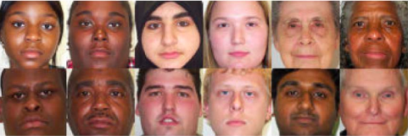

1. [The MR2 face database](http://ninastrohminger.com/the-mr2): "The MR2 is a multi-racial, mega-resolution database of facial stimuli. It contains 74 full-color images of men and women of European, African, and East Asian descent."  
   <http://ninastrohminger.com/the-mr2>

