Project Idea 1: Animated Game Banner

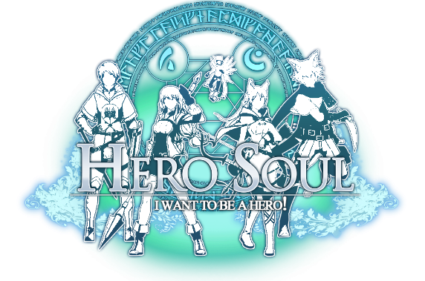

Starts as the logo for my game.

Over time, the logo itself will “glow”. At the same time, there will be particles that will be emitted from the logo as well. These effects are not interactable



After some time, “light snakes” will begin to appear that randomly move around the logo along with the glow and the particles. The snakes are also not interactable

Finally, after some time, user will be able to click causing a scene wipe. Still de deciding whether I want a white out effect or something with leaves. This will then ideally lead to my portfolio page for the game.

I was mainly inspired by my classmate’s previous works for this idea.

The particle system comes from Simi’s star particle system

<https://www.openprocessing.org/sketch/474313>

I really want to recreate the surreal feel I see and get from her sketch. Specifically, the particle coming from the origin as well as the textured field in the background.

Another example of a particle system

<https://p5js.org/examples/simulate-multiple-particle-systems.html>

The light snakes come from one of Peyton’s sketches

<https://www.openprocessing.org/sketch/480044>

What really drew my eyes where the little snake like things that gravitate towards the mouse. I think having something similar will make the sketch real cool.

Another inspiration comes from a game called final fantasy where they really do what I am going for.

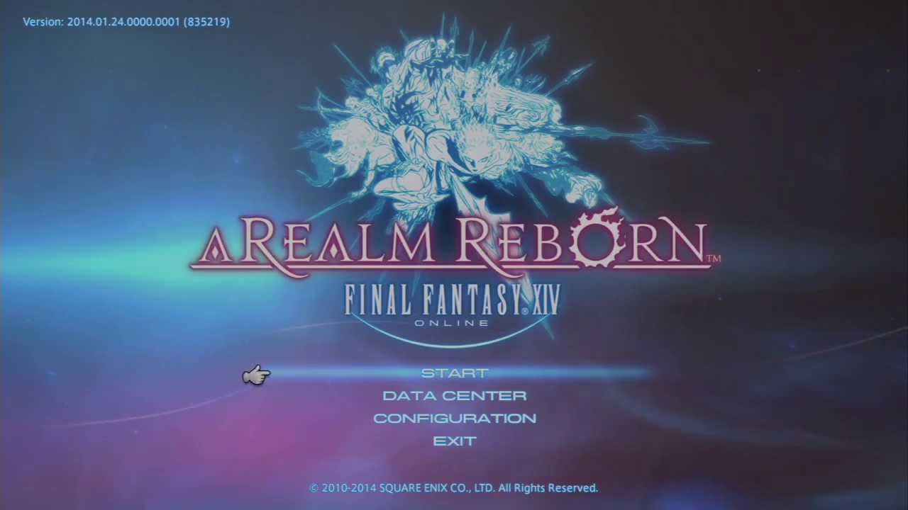

Project Idea 2: Classic Game Remake Snake

As this is a game, it will be mostly be run by user input. The game will start with a minimum sized snake.

User will need to control the snake using the mouse consuming food to extend the length of the snake and gain score. There can only be 1 food at any time randomly generating.

For challenge over time, as the snake gets larger the speed at which the snake moves increases. Users must avoid hitting themselves as the they get larger and the wall.

When a collision happens, player will get a game over and will lose control of the snake.

Food

Snake

Score: xxx

Score: xxx

Score: xxx

Score: xxx

Game Over!

A while ago there was a very popular game called snake.io which reimagined the concept of snake. Like that game, I would like to do something similar.

<http://supersnake.io/>

For me snake is a perfect game to recreate because it is easy to pick up because of the simple mechanics and rules. I think this kind of thing is perfect for people that aren’t very familiar with games, so that it will be easier for them to pick it up.

I think that coding this project will be a true challenge. Specifically, code the snake is going to be hard since I plan to make it sort of modular so keeping track of where each part of the snake is going to be challenging.

Here are a few more versions of snake, one of which is done in JS which should be extremely helpful when codding this.

<https://p5js.org/examples/interaction-snake-game.html>

<http://patorjk.com/games/snake/>

<https://www.coolmath-games.com/0-snake>

The overall goal is to recreate a classic game from the past with my own skill and style.

Project Idea 3: Reimagined Flappy Bird

Game Over!

Score: xxx

This game is of the runner/platformer genre. Users will control an avatar and will need to control it to traverse the game.

Player will constantly be going forward, and their only input will be to jump using the mouse. The longer the mouse is held, the higher the player jumps.

While player is controlling their avatar, the level will randomly generate obstacles that the player will need to jump though. Player accrues score as they player, getting more for surviving longer.

If the player’s avatar hits one of the obstacles, they will lose and lose control of their avatar. They will then need to restart the game to try again.

Player

Score: xxx

Score: xxx

Score: xxx

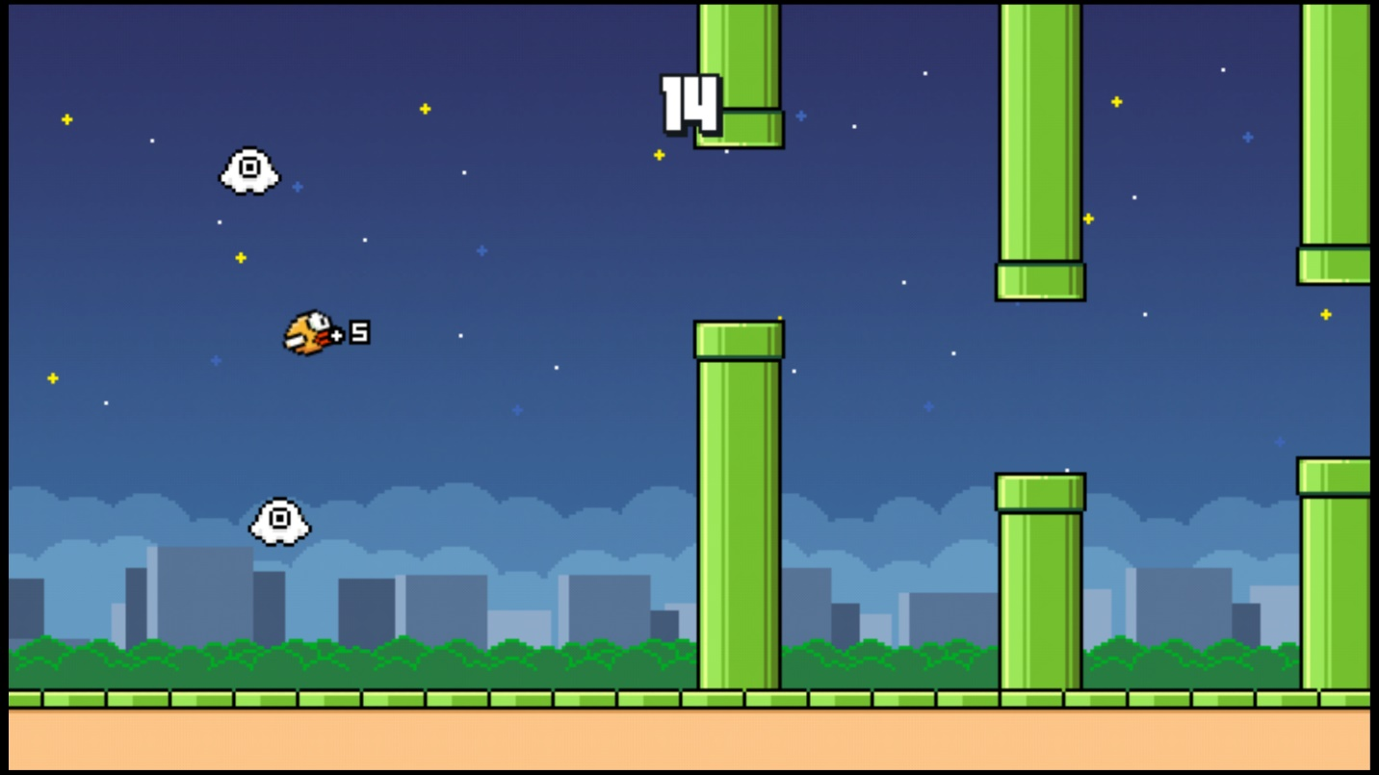

This game is heavily inspired by the very popular game flappy bird, where a player would have only 1 input in the game, to make the bird go up slightly. As it turns out this simple game became super popular, so considering that I too would like to try my hand at making this simple and fun little game.

Despite how simple the game seems, the coding challenge involved translating the concept to JS seems like an interesting and fun prospect.

For this project specifically, I think it would be fun and challenging to learn more about the photo importing as well as sound.

Some helpful p5 examples of images processing:

<https://p5js.org/examples/image-load-and-display-image.html>

<https://p5js.org/examples/image-background-image.html>

Great example of sound

<https://p5js.org/examples/hello-p5-song.html>

Project Idea 4: Reimagined Pong

Score: xxx

This will be a multiplayer experience. Where each player will control a paddle on a virtual game of tennis.

Like the classic pong, players will use their controlled paddles to hit the ball around with the goal of scoring on the other player.

However, unlike normal pong, players will have a chance to interact with each other. They will be able to “shoot” at the other player or erect walls to block the ball. All of which will interact with the other player of the ball

The game ends when one player score enough points to win

Score: xxx

Score: xxx

Score: xxx

Player 1 Wins!

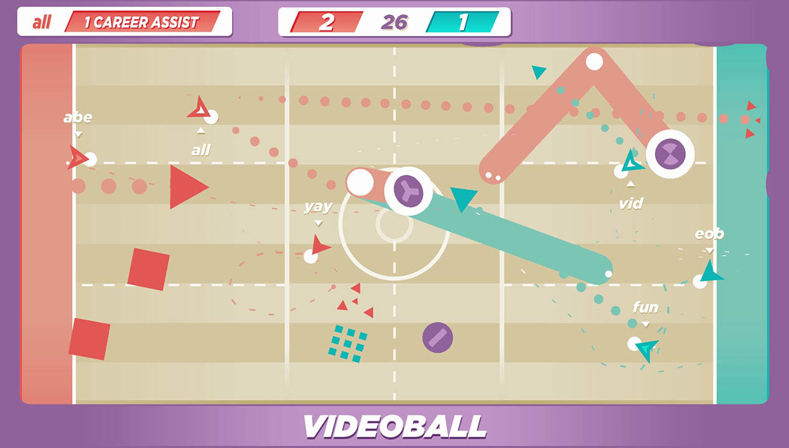

This was heavily inspired from a game called Video Ball which recreates the idea of pong in a very interesting way.

<http://videoball.net/>

The interesting thing about this game/idea is that it will be heavily focused on simulating physics which poses and interesting programming challenge.

Another reason I wanted to pursue this project is that a multiplayer experience offers different possibilities for interactions compared to a singular experience. I would like to explore that aspect trying to create a fun and interactive experience between 2 players.

Some useful physics examples:

<https://p5js.org/examples/mobile-acceleration-ball-bounce.html>

<https://p5js.org/examples/simulate-soft-body.html>

https://p5js.org/examples/simulate-forces.html