Project 4 Final Report:
Investigation of Variable Selection Methods in Linear Regression

Ryan Summers
5/4/26

Table of Contents
1. Introduction 2
2. Methods 2
3. Analysis 4
4. Results 4
5. Discussion 8
References 10
Reproducibility Statement 10
Supplementary Materials 11

1. Introduction
Simulation studies allow statistical methods to be evaluated under controlled conditions. This project investigates the performance of several variable selection methods in linear regression under varying sample sizes and predictor correlation structures. Methods include backward selection using p-values, Akaike Information Criterion (AIC), and Bayesian Information Criterion (BIC), along with penalized regression approaches including LASSO and Elastic Net (ElNet). Performance is evaluated using variable selection accuracy, bias, confidence interval (CI) coverage, and type I and II error rates. This project follows the ADEMP framework proposed by Morris et al. (2018).

2. Methods

2.1 Data-generating Mechanism
Data will be generated using the hdrm package (Breheny, 2025) under the linear regression model framework Y = Xβ + ε, where X is an Nx20 matrix and ε ~ N(0, σ²). Five predictors are truly associated, with coefficients β = (0.5/3, 1/3, 1.5/3, 2/3, 2.5/3), while the remaining 15 are null. An exchangeable correlation structure will be imposed at ρ ∈ {0, 0.35, 0.70}, crossed with sample sizes N ∈ {250, 500}, yielding six scenarios each replicated 10,000 times. Using 10,000 replications, the Monte Carlo standard error for binary or proportion-based metrics is approximately 0.005 in the worst case (p=0.50) and approximately 0.002 for measures near 0.95 or 0.05, such as coverage and type I error. Therefore, only differences exceeding these magnitudes should be interpreted as meaningful method differences.

2.2 Variable Selection Methods
All 20 predictors were initially included in a full model, from which variables were iteratively removed by largest p-value (α = 0.10), or by minimizing AIC or BIC. The alpha level of 0.10 was chosen based on literature suggesting that 0.157 is equivalent to AIC (Lindsey & Jones 1998). Penalized regression methods were also evaluated, including LASSO, which shrinks coefficients exactly to zero using an $L_{1}$ penalty and elastic net, which combines $L_{1}$ and $L_{2}$ penalties and is more useful when predictors are strongly correlated (Zou & Hastie, 2005).
For both LASSO and elastic net, the tuning parameter lambda will be selected by using 10-fold cross-validation, and two lambdas will be investigated, one that minimizes CV prediction error ($λ_{min}$) and a more conservative choice within 1 SE of that minimum ($λ_{1se}$).

2.3 Performance Measures
Methods were evaluated on true positive rates (TPR) and false positive rates (FPR), specificity, and confusion matrices. For retained true predictors, bias, 95% CI coverage, and type I/II error rates are reported. Coverage of 95% CIs will be evaluated across all variables (p=20). For selected variables, coverage is determined by whether the CI contains the true parameter. For non-selected variables, coefficients are treated as zero and failure to select a true predictor is counted as non-coverage. Correctly excluding null predictors is considered coverage. This unconditional approach was chosen so that CI coverage and bias reflected the full variable selection process, since predictors not retained in the final model were effectively treated as having coefficient estimates of zero.

3. Analysis

Each of the six scenarios generated a dataset, applied a selection method, and recorded the selected variables, estimates, and inferential statistics. All analyses were conducted using scripted workflows, and simulation outputs, summary tables, and figures were generated directly from R scripts (version 4.5.3; Reassured Reassurer).

4. Results
Aggregated metrics, including TPR, FPR, model size, and type I and type II error rates, are averaged over the 10,000 simulation iterations within each scenario, while variable-level patterns are explored graphically. Here, “liberal” methods refer to approaches that tend to retain more predictors and produce larger models, whereas “conservative” methods refer to approaches that select fewer predictors and produce sparser models.

4.1 Variable Selection Performance
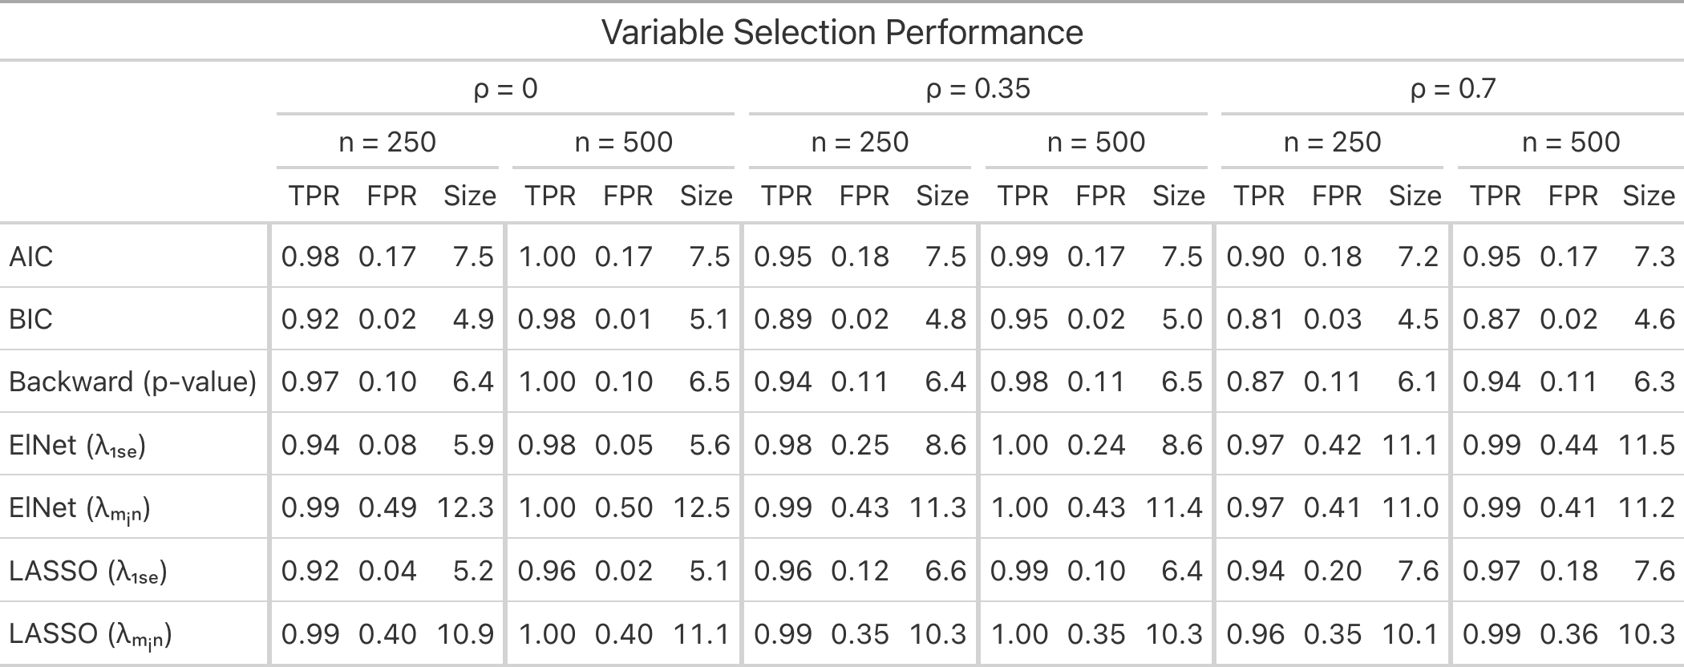Table 1. Variable selection performance across methods, sample sizes, and correlation structures. Results summarize variable selection performance across 10,000 simulation iterations for each scenario. True positive rate (TPR) represents the proportion of true predictors correctly selected, false positive rate (FPR) represents the proportion of null predictors incorrectly selected, and mean model size reflects the average number of predictors retained in the final model. Results are stratified by predictor correlation and sample size.
Liberal methods, including AIC and $λ_{min}$-based penalization, achieved higher TPR values but also larger FPRs and model sizes, with $λ_{min}$ methods in particular exhibiting substantial FPRs and model sizes. Conservative approaches, particularly BIC and $λ_{1se}$-based methods, reduced false positive selection at the cost of lower TPR. Increasing predictor correlation reduced selection accuracy, while larger sample sizes improved TPR but had little effect on FPR across most methods.

4.2 Estimation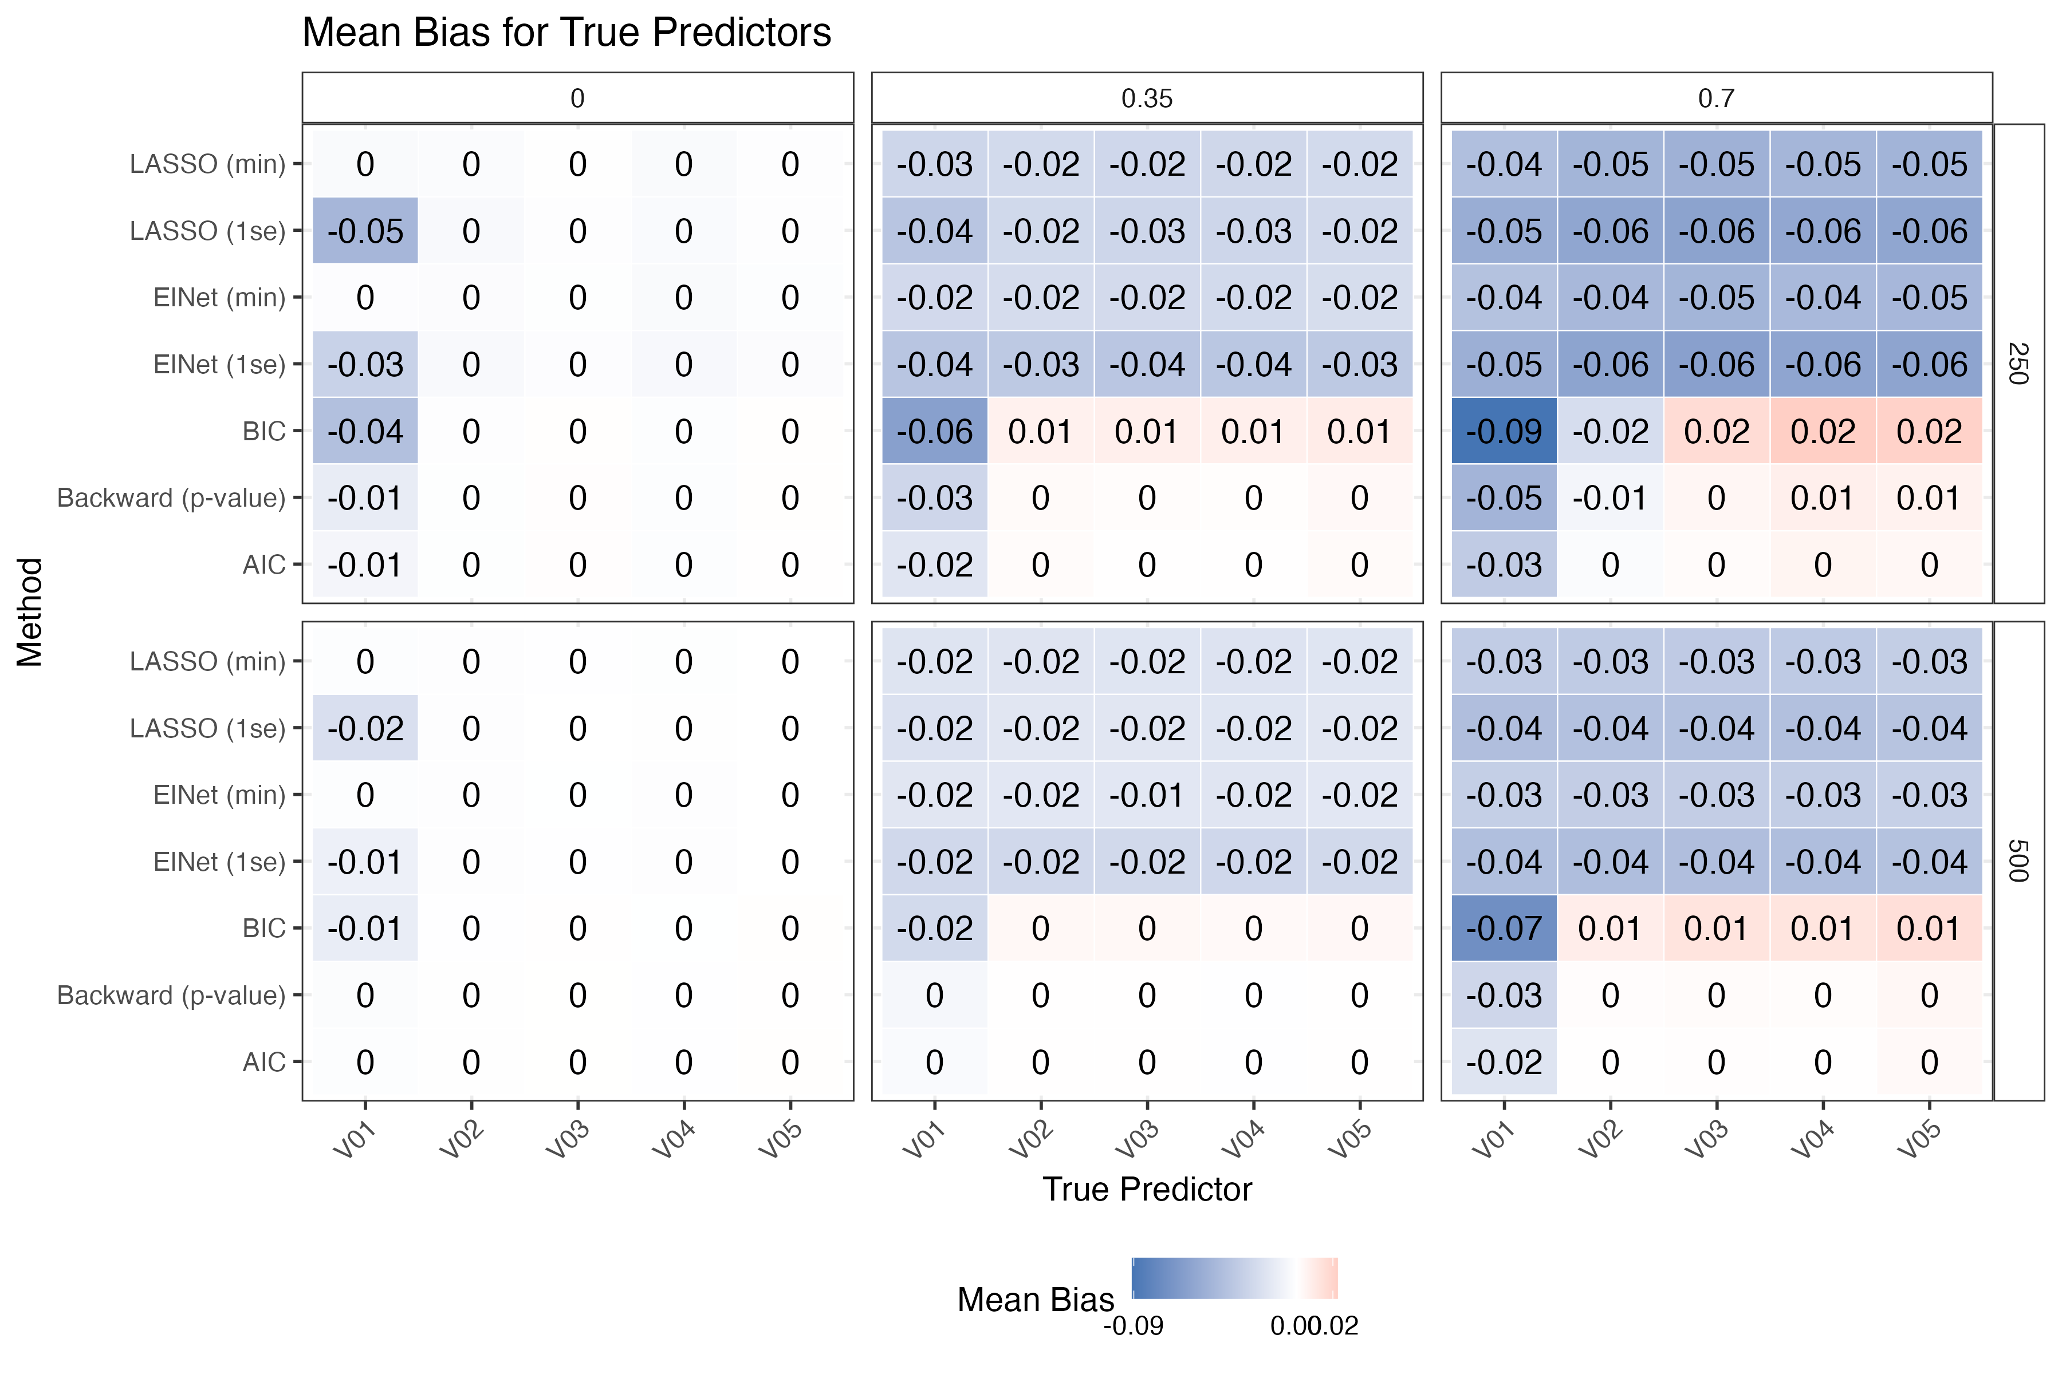Figure 1. Mean bias for true predictors across variable selection methods, sample sizes, and correlation structures. Cells display the average bias for the five true predictors (V01–V05) across 10,000 simulation iterations. Rows correspond to variable selection methods, while panels are stratified by sample size and predictor correlation. Negative values (blue) indicate underestimation of the true coefficient.
Bias became increasingly negative under stronger correlation structures, particularly for predictors with smaller true effects (e.g., V01). Conservative methods exhibited larger negative bias due to more frequent omission of true predictors, which were assigned coefficient estimates of zero when not selected.

4.3 Type I & II errors
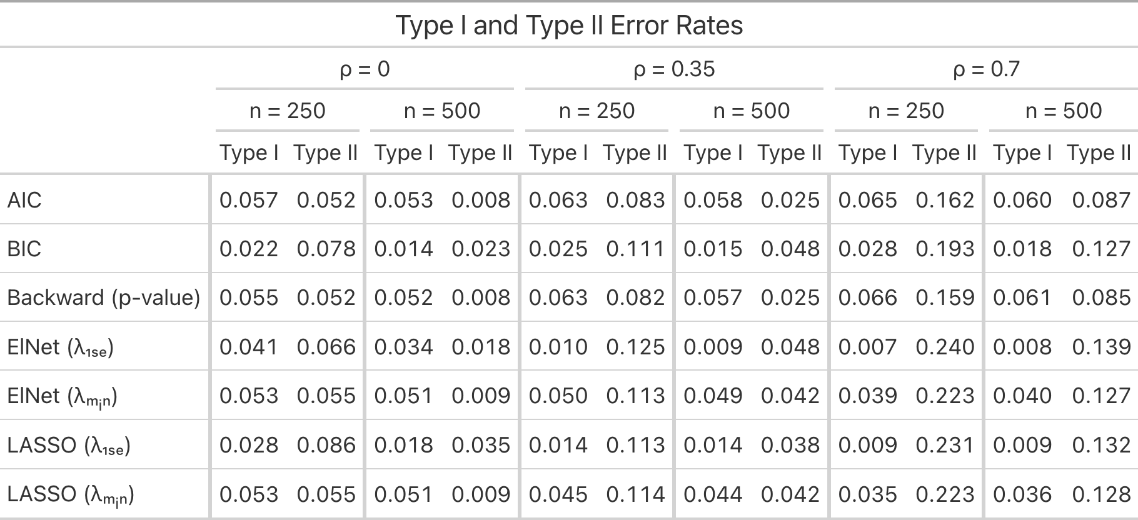Table 2. Type I and Type II error rates across variable selection methods, sample sizes, and correlation. Results summarize empirical type I and type II error rates across 10,000 simulation iterations for each scenario. Type I error rates represent the probability of incorrectly rejecting a null predictor, while type II error rates represent the probability of failing to detect a true predictor. Results are stratified by predictor correlation and sample size.
Lower type I error rates were generally associated with higher type II error rates, reflecting the inherent trade-off between false positive and false negative control. Conservative methods produced the smallest type I error rates but substantially larger type II error rates under stronger predictor correlation. Larger sample sizes reduced type II error and modestly improved type I error across most methods.

4.4 Coverage
Coverage for null predictors was consistently close to the nominal 95% level across methods. Since non-selected variables were treated as having coefficient estimates equal to zero, null predictors often achieved high coverage by construction. Therefore, coverage analyses primarily focused on true predictors, where post-selection coverage differences were more meaningful. Coverage values modestly below 0.95 were interpreted cautiously due to Monte Carlo variability (±0.002), while larger deviations were considered evidence of non-coverage.
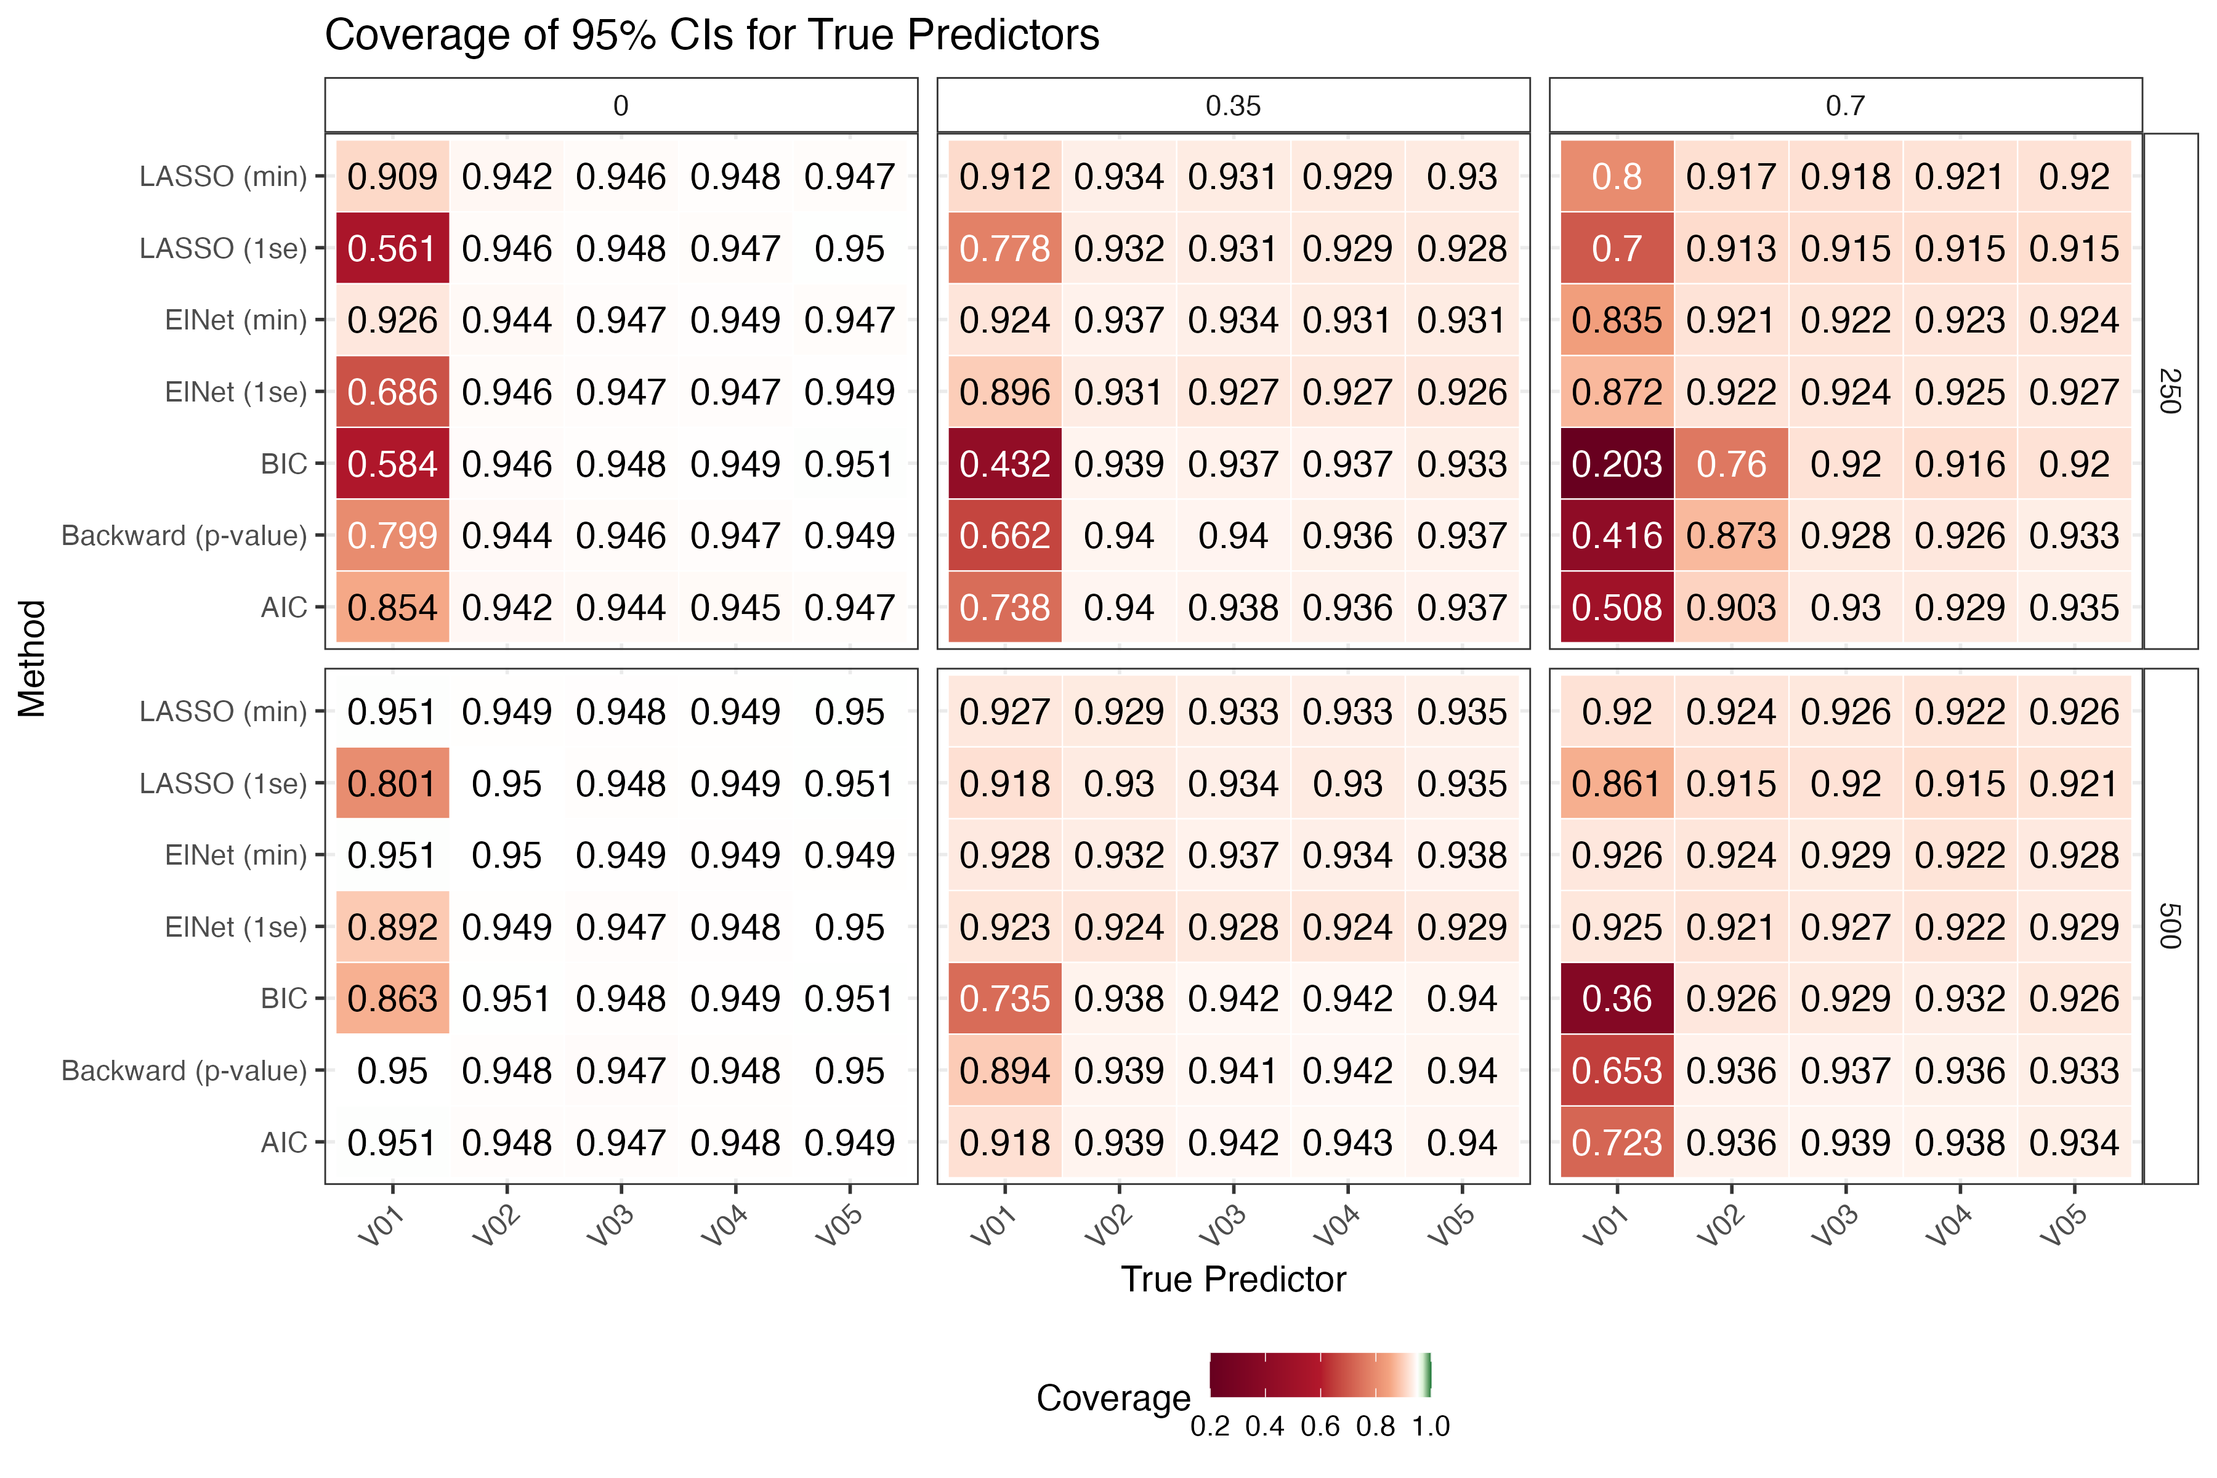Figure 2. Coverage of 95% confidence intervals for true predictors across selection methods and scenarios. Cells display coverage probabilities for the five true predictors (V01–V05) across 10,000 simulation iterations. Rows correspond to variable selection methods, while panels are stratified by sample size and predictor correlation. Coverage values closer to the nominal 95% level appear lighter (white), while darker red cells indicate substantial non-coverage.
Coverage generally declined as predictor correlation increased, particularly for smaller-effect predictors (V01). Conservative methods exhibited the greatest non-coverage due to more frequent omissions of true predictors, while liberal methods had coverage closer to the nominal levels across most scenarios. Increasing the sample size improved coverage performance overall, although substantial non-coverage for predictors with smaller true effect sizes remained under strong correlation.

5. Discussion
The simulation results demonstrated clear trade-offs between selection accuracy, model parsimony, and inferential performance. Liberal methods achieved higher sensitivity (TPR) and better coverage but also selected more null predictors and produced larger models. Conservative methods reduced false positive selection but exhibited worse performance for selecting predictors with smaller true effects (V01), although stronger correlation reduced selection probability for these small effects across all methods (Supplementary Figure 1). Increasing predictor correlation consistently worsened performance across all methods, while larger sample sizes improved most metrics. The results also highlight the importance of evaluating post-selection inference jointly with variable selection performance.

5.1 Limitations
Several limitations should be noted. First, the simulation considered only linear regression models with normally distributed errors and continuous predictors under an exchangeable correlation structure. Results may differ under alternative model assumptions, non-normal errors, or more complex correlation structures. Second, only one configuration setting (p = 20, with 5 true predictors) and a limited set of coefficient magnitudes were evaluated. Third, CI coverage was assessed after variable selection by setting non-selected predictors coefficient estimates of zero, which counts as non-coverage. Therefore, alternative definitions of coverage may produce different conclusions.
Monte Carlo standard error calculations were based on formulas presented by Morris et al. (2018), but their correct application within this project cannot be verified and therefore these results are presented as supplementary materials (Supplementary Figure 2). Finally, other important performance metrics, such as model convergence, was not evaluated but may provide additional insight into performance.

5.2 Conclusions
Variable selection methods differed substantially in both selection accuracy and inferential performance. AIC and $λ_{min}$-based penalization achieved higher sensitivity and coverage, while BIC and $λ_{1se}$-based methods produced smaller models with lower false positive rates. No single method uniformly outperformed the others, highlighting the trade-offs between prediction accuracy, sparsity, and post-selection inference.

References
ChatGPT was used to check R code errors for some of the packages used and to grammar check (OpenAI, 2025).
Morris, T. P., White, I. R., & Crowther, M. J. (2018). Using simulation studies to evaluate statistical methods. Statistics in Medicine, 38(11), 2074–2102. https://doi.org/10.1002/sim.8086
Breheny, P. (2025). hdrm: High-dimensional regression modeling (Version 0.17.1) [R package]. GitHub. https://github.com/pbreheny/hdrm
Lindsey, J. K., & Jones, B. (1998). Choosing among generalized linear models applied to medical data. Statistics in Medicine, 17(1), 59–68. https://doi.org/10.1002/(SICI)1097-0258(19980115)17:1<59::AID-SIM727>3.0.CO;2-5
Shtatland, E. S., Kleinman, K., & Cain, E. M. (2003). Stepwise methods in using SAS PROC LOGISTIC and SAS Enterprise Miner for prediction. Proceedings of the Twenty-Eighth Annual SAS Users Group International Conference (SUGI 28). SAS Institute Inc.
Zou, H., & Hastie, T. (2005). Regularization and variable selection via the elastic net. Journal of the Royal Statistical Society: Series B (Statistical Methodology), 67(2), 301–320. https://doi.org/10.1111/j.1467-9868.2005.00503.x

Reproducibility Statement
The statistical code used to generate, analyze, and summarize all simulation results is available on GitHub under the Code directory at: https://github.com/rysummers/BIOS6624-Class/tree/main/Project4
Because this project used simulated data, no external raw dataset was used. All simulation scenarios, parameter settings, and analysis procedures can be reproduced directly from the provided code. Random seeds were set within the simulation scripts to facilitate reproducibility.

Supplementary Materials
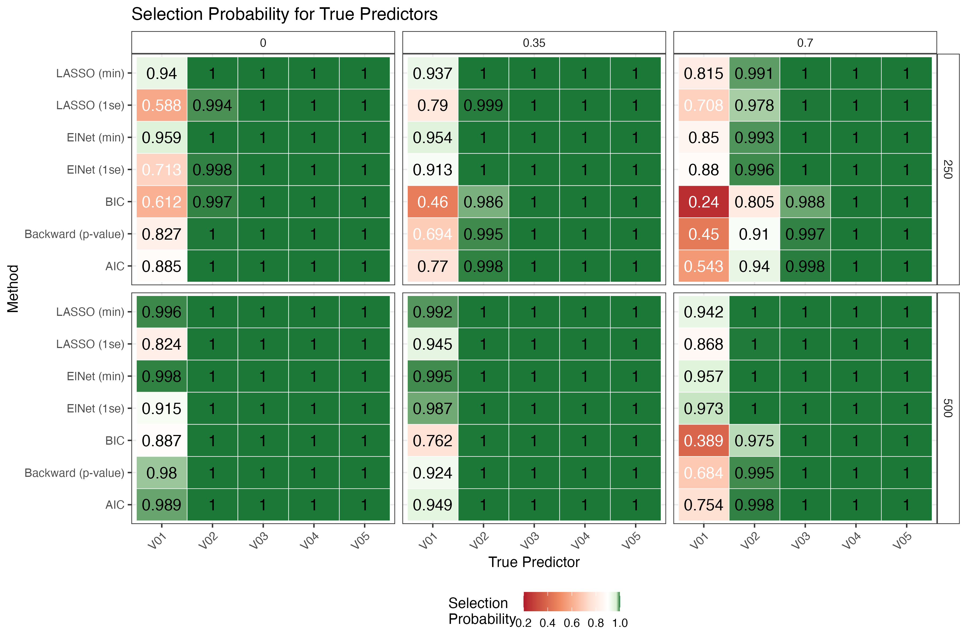
Supplementary Figure 1. Selection probability for true predictors across variable selection methods and simulation scenarios. Cells display the proportion of simulation iterations in which each true predictor (V01–V05) was retained in the final selected model across 10,000 simulations per scenario. Results are stratified by sample size and predictor correlation.
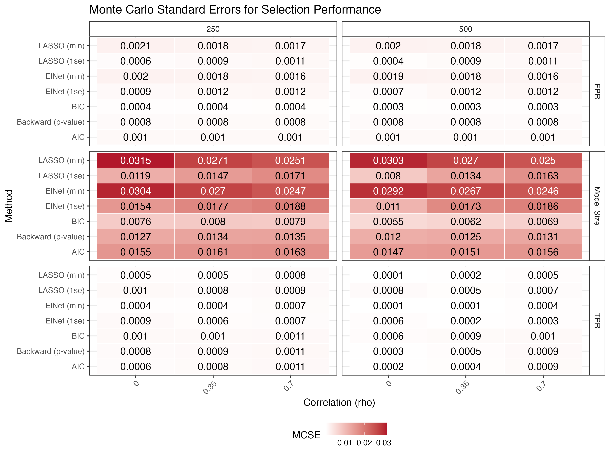Supplementary Figure 2. Monte Carlo standard errors (MCSE) for selection performance. Cells display MCSEs for true positive rate (TPR), false positive rate (FPR), and average model size across simulation scenarios. Results are stratified by sample size and predictor correlation.
Overall, MCSE values were small relative to observed differences between methods. The largest MCSE values were observed for model size, particularly among more liberal methods such as $λ_{min}$-based penalization, reflecting greater variability in the number of selected predictors across simulation replications.
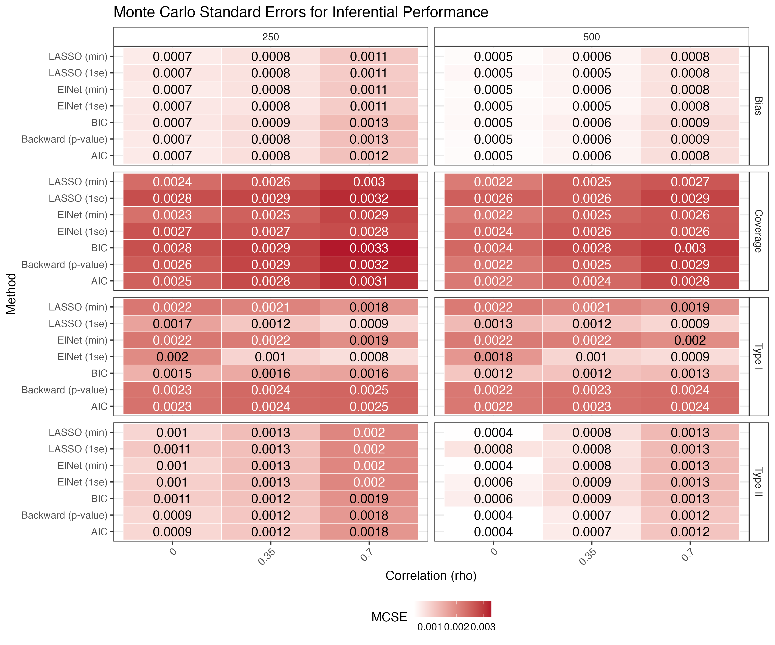Supplementary Figure 3. Monte Carlo standard errors (MCSE) for inferential performance. Cells display MCSEs for bias, confidence interval coverage, and type I and II error rates across simulation scenarios. Results are stratified by sample size and predictor correlation.
MCSE values were uniformly small, generally ranging from approximately 0.0005 to 0.003, suggesting low simulation variability. MCSEs tended to increase slightly under stronger predictor correlation, particularly for coverage and type II error estimates.

