Project1:

Data Analysis Plan

Ryan Summers
3/2/26

Table of Contents
1. Introduction 2
2. Methods 2
3. Preliminary Results 4

1. Introduction
This project is a secondary analysis of data from the Multicenter AIDS Cohort Study (MACS), an ongoing prospective cohort study of HIV-1 infection in homosexual and bisexual men in four major U.S. cities. The dataset contains up to 8 years of annual follow-up on 715 HIV-infected men after initiating HAART (highly active antiretroviral therapy), including longitudinal laboratory measures, quality-of-life outcomes, and demographic and health information.
The primary objective of this analysis is to determine whether treatment response two years after initiating HAART differs between men who reported using hard drugs at baseline and those who did not report such use. This question was biologically motivated by previous studies in vitro and in animal models that suggest hard drug use may suppress immune function and increase HIV replication. However, evidence from human studies has been inconsistent.
Treatment response in this study will be evaluated using four outcome measures assessed two years after HAART initiation. The first outcome is viral load defined as the number of HIV RNA copies per milliliter of blood. The second outcome is CD4+ T-cell count, a measure of immune function.
In addition to laboratory outcomes, two quality-of-life (QOL) measures derived from the SF-36 instrument will be examined. The aggregate physical health score and the aggregate mental health score, each ranging from 0 to 100, with higher scores indicating better perceived health.
The purpose of this preliminary report is to develop an analysis plan to answer the specific hypothesis guiding this analysis, that men who reported hard drug use at baseline will demonstrate a poorer treatment response at two years compared to non-users. Poorer response would be reflected by higher viral load, lower CD4+ T-cell count, and potentially lower physical and mental QOL scores.

2. Methods

2.1 Data Cleaning
The primary exposure variable, baseline hard drug use, was coded as a binary indicator (Yes versus No). Comorbidity variables including diabetes, hypertension (HBP), kidney disease, and liver disease (stage 3/4) contained additional categories reflecting “trajectory-based” classifications and “insufficient data.” For the purposes of exploratory analyses, trajectory-based “Yes” and “No” categories were collapsed into single “Yes” and “No” levels, and observations coded as “insufficient data” were treated as missing or NA values.
The race/ethnicity covariate will combine White-Hispanic, Black-Hispanic, and Other-Hispanic as one category for Hispanic. We acknowledge that race is a social construct and that observed differences likely reflect structural inequities rather than biological differences. Additionally, we are not estimating race effects but purely adjusting for confounding. The education covariate was also collapsed into High School or less, College, and Post-grad for simplicity.
Viral load values were highly right-skewed and were transformed using logarithm with base-10 for modeling. CD4+ T-cell counts on the original scale will be retained after examining distributional properties and residual diagnostics from preliminary regression models. Although the raw CD4 distribution was moderately right-skewed, preliminary residual diagnostics indicated acceptable normality and consistent variance.

2.2 Data Analysis
The primary objective of this analysis is to evaluate whether baseline hard drug use is associated with treatment response two years after initiation of HAART. Treatment response will be assessed separately for viral load, CD4+ T-cell count, physical quality-of-life score, and mental quality-of-life score. A secondary objective is to assess whether treatment adherence mediates this relationship. Adherence was measured during follow-up after HAART initiation and is hypothesized to lie on the causal pathway between baseline hard drug use and treatment response.
For each outcome, analyses will be conducted using general linear regression to assess the association between baseline hard drug use and treatment response, while adjusting for relevant covariates and potential confounders. All models are adjusted for age, BMI, smoking status, education, race/ethnicity, and baseline disease severity.
For CD4+ T-cell count, physical quality-of-life score, and mental quality-of-life score, outcomes will be modeled on their original scales. Each model will include the corresponding baseline value of the outcome as well as the same set of prespecified covariates described above.
In addition to frequentist linear regression models, Bayesian regression models will also be fit for each outcome to allow comparison of inference under a Bayesian framework. The same model structure will be used in both frameworks. For Bayesian prior specifications, vague normal priors will be used on regression coefficients, and a half-Cauchy prior will be used on the residual standard deviation for initial modelling.
Mediation will be evaluated by using a two-model approach. First, adherence will be modeled as a function of baseline hard drug use and baseline covariates. Second, the Year 2 outcome will be modeled as a function of baseline hard drug use, adherence, baseline outcome level, and covariates. Bayesian mediation models will also be used for comparisons. Highest density intervals (HDIs) will be used to assess evidence of mediation.
Model assumptions for the frequentist analyses will be evaluated using residual diagnostic plots, including assessment of linearity, constant variance, and normality of residuals. Statistical significance under the frequentist framework will be determined using two-sided hypothesis tests with an alpha level of 0.05. P-values less than 0.05 will be considered statistically significant.
Under the Bayesian framework, posterior distributions obtained from Markov Chain Monte Carlo (MCMC) sampling will be used to assess significance. Posterior means and 95% HDIs will be reported for each parameter estimate. Convergence of each Bayesian model will be assessed using trace plots and the Gelman–Rubin statistic (R̂).
To assess the potential impact of loss to follow-up, baseline characteristics will be compared between participants with complete baseline and Year 2 measurements and those without Year 2 data. Differences in continuous variables will be evaluated using Welch’s t-test or Wilcoxon rank sum test, and differences in categorical variables will be assessed using Pearson’s chi-square tests or Fisher’s exact tests. Findings will be interpreted under the assumption that missingness is at least missing at random (MAR), where dropout depends on observed variables.
All regression analyses will be conducted using complete-case observations for the variables included in each specific model. The number of observations removed due to missingness will be reported alongside model results.

3. Preliminary Results
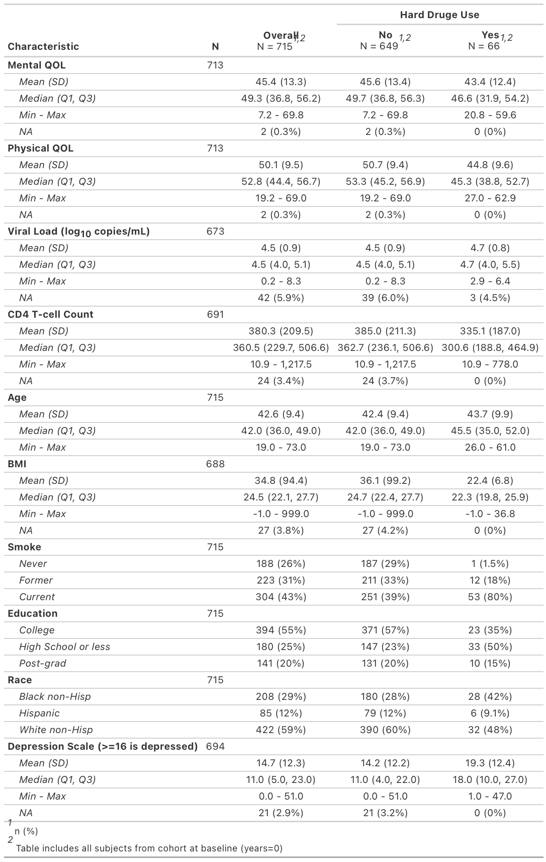
Table 1. Baseline characteristics of HIV-infected men initiating HAART, overall and stratified by baseline hard drug use.
Baseline characteristics of the study cohort at HARRT initiation are presented in Table 1, which shows that 9.2% of participants reported hard drug use at initiation. Drug users were typically more depressed, had lower baseline CD4 counts, and had comparable baseline viral load levels and QOL metrics relative to non-users.

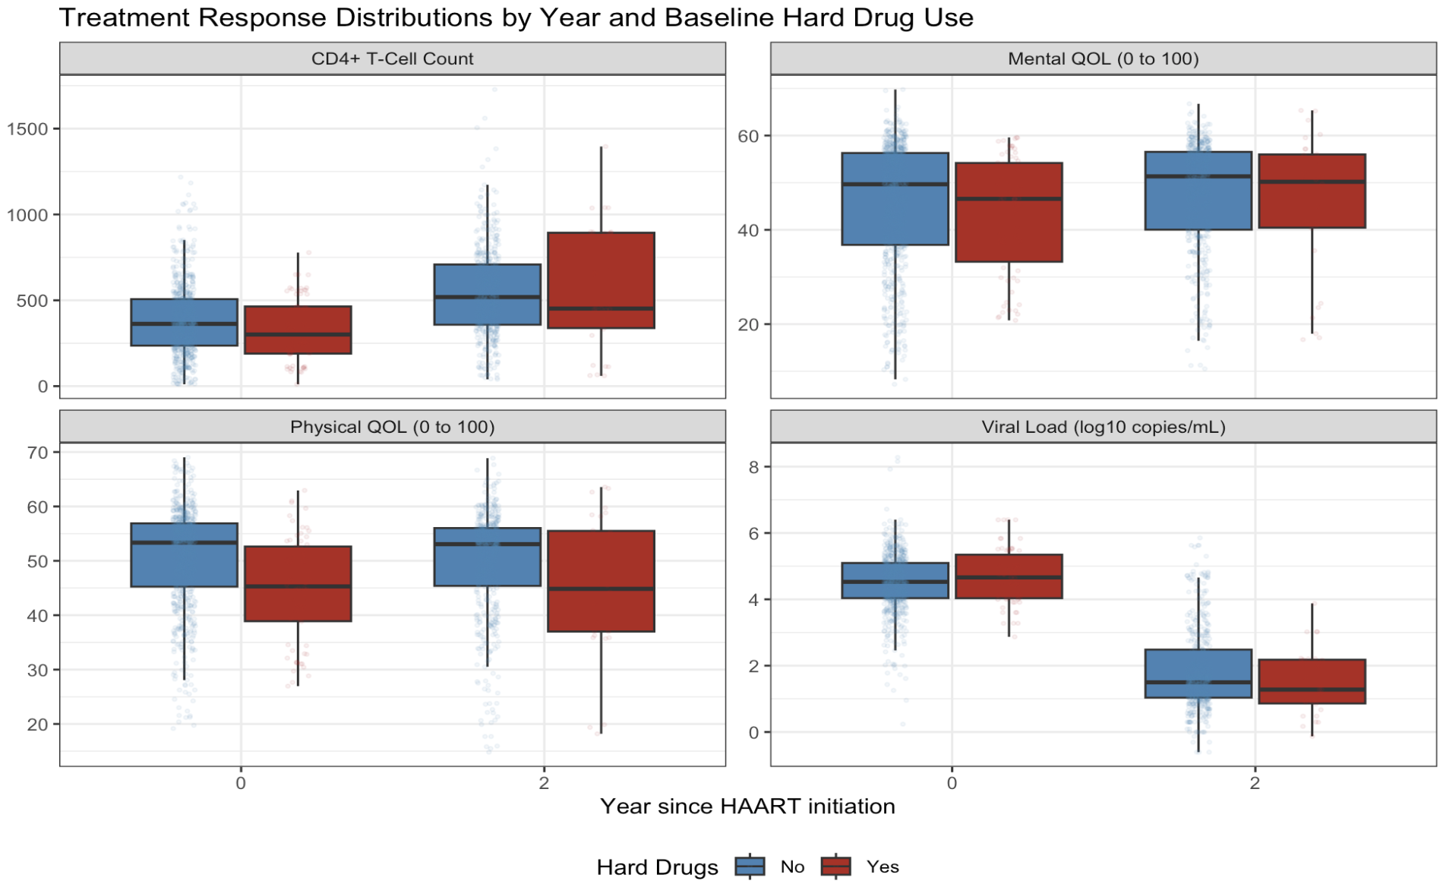
Figure 1. Distribution of treatment response measures at baseline (Year 0) and Year 2 following HAART initiation, stratified by baseline hard drug use. Boxplots display the median (black line) and interquartile range, with points representing individual observations.
CD4+ T-cell counts increased from baseline to Year 2 in both groups. Participants reporting hard drug use at baseline generally exhibited slightly lower CD4 counts at both time points but with more variability at year 2. Viral load (log10 copies/mL) declined substantially following treatment initiation in both groups. No apparent differences in viral load are visible at both time points. Physical and mental quality-of-life scores remained relatively stable over time with drug users typically reporting lower QOL scores across both time points.

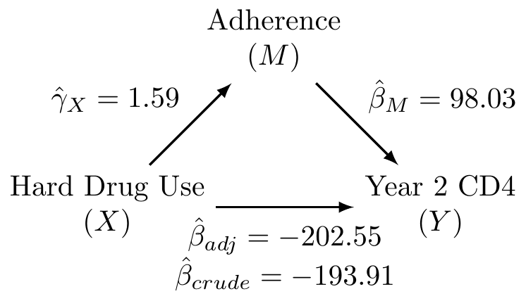
Figure 2. Conceptual hypothesized mediation structure linking baseline hard drug use (X), adherence (M), and Year-2 CD4 count (Y) outcome. Hard drug use may affect immune recovery directly and indirectly through its association with adherence. Covariates are not shown for simplicity.
Baseline hard drug use (X) is hypothesized to influence Year-2 CD4 count (Y) both directly and indirectly through adherence to HAART (M). The arrow from X to M represents the association between hard drug use and adherence, while the arrow from M to Y represents the association between adherence and CD4+ T cell counts. The direct path from X to Y reflects both the crude association between hard drug use and year-2 CD4 and the adjusted association after accounting for adherence. Covariates are omitted from this preliminary diagram for clarity but are included in adjusted analyses. Initial results, show that the percent being mediated by adherence is minimal at approximately 4.4% [$\frac{\hat{β_{crude}}- \hat{β_{adj}}}{\hat{β_{crude}}}$].

