BIOS 6624 : Project 1
Ryan Summers
2026-02-04

Read in the csv
HIV_raw <- read_csv("/Users/ryan_summers/GitHub/BIOS6624-Class/Project1/DataRaw/hiv_6624_final.csv",
col_select = -1) # col_select = -1 removes first column
## Rows: 3935 Columns: 33
## ── Column specification ────────────────────────────────────────────────────────
## Delimiter: ","
## dbl (33): newid, AGG_MENT, AGG_PHYS, HASHV, HASHF, income, BMI, HBP, DIAB, L...
##
## ℹ Use `spec()` to retrieve the full column specification for this data.
## ℹ Specify the column types or set `show_col_types = FALSE` to quiet this message.

Data Management & Cleanup
Convert specific variables to factors
var_fct <- c("newid", "SMOKE", "RACE", "EDUCBAS", "hard_drugs")
HIV_raw <- HIV_raw %>%
mutate(
newid = factor(newid),
SMOKE = factor(SMOKE, levels = c(1,2,3),
labels = c("Never", "Former", "Current")),
RACE = factor(RACE,
labels = c("White non-Hisp", "White Hisp", "Black non-Hisp",
"Black Hisp", "Other", "Other Hisp")),
EDUCBAS = factor(EDUCBAS,
labels = c("<=8th grade", "9,10,11th grade", "12th grade",
">=1yr college", "4yr college degree", "Some grad",
"Post-grad degree")),
hard_drugs = factor(hard_drugs, levels = c(0,1),
labels = c("No", "Yes")),
ADH = factor(ADH,
levels = c(1,2,3,4),
labels = c("100%", "95-99%", "75-94%", "<75%")))
Collapse specific factors * education and race - we are not making inferences or estimating the effects of either
HIV_raw <- HIV_raw %>%
mutate(
)

Exploratory Data Analysis (EDA)
Missing value analysis:
# number of NAs
lapply(HIV_raw, function(x) sum(is.na(x)))
## $newid
## [1] 0
##
## $AGG_MENT
## [1] 19
##
## $AGG_PHYS
## [1] 19
##
## $HASHV
## [1] 143
##
## $HASHF
## [1] 63
##
## $income
## [1] 9
##
## $BMI
## [1] 389
##
## $HBP
## [1] 0
##
## $DIAB
## [1] 0
##
## $LIV34
## [1] 0
##
## $KID
## [1] 0
##
## $FRP
## [1] 0
##
## $FP
## [1] 0
##
## $TCHOL
## [1] 907
##
## $TRIG
## [1] 1716
##
## $LDL
## [1] 1901
##
## $DYSLIP
## [1] 0
##
## $CESD
## [1] 0
##
## $SMOKE
## [1] 6
##
## $DKGRP
## [1] 50
##
## $HEROPIATE
## [1] 22
##
## $IDU
## [1] 30
##
## $LEU3N
## [1] 209
##
## $VLOAD
## [1] 222
##
## $ADH
## [1] 714
##
## $RACE
## [1] 0
##
## $EDUCBAS
## [1] 0
##
## $hivpos
## [1] 0
##
## $age
## [1] 0
##
## $ART
## [1] 0
##
## $everART
## [1] 0
##
## $years
## [1] 0
##
## $hard_drugs
## [1] 33
# missing value percentages
HIV_raw %>%
ungroup() %>%
miss_var_summary()
## # A tibble: 33 × 3
## variable n_miss pct_miss
## <chr> <int> <num>
## 1 LDL 1901 48.3
## 2 TRIG 1716 43.6
## 3 TCHOL 907 23.0
## 4 ADH 714 18.1
## 5 BMI 389 9.89
## 6 VLOAD 222 5.64
## 7 LEU3N 209 5.31
## 8 HASHV 143 3.63
## 9 HASHF 63 1.60
## 10 DKGRP 50 1.27
## # ℹ 23 more rows
# number of subjects
length(unique(HIV_raw$newid))
## [1] 715
Look at distribution of measurements (cumulatively)
# measurement stats
HIV_raw %>%
group_by(newid) %>%
summarise(n_measurements = n()) -> mnts_per_id
# summary stats for number of measurements per subject
mnts_per_id %>%
summarise(avg = mean(n_measurements),
min = min(n_measurements),
med = median(n_measurements),
max = max(n_measurements))
## # A tibble: 1 × 4
## avg min med max
## <dbl> <int> <int> <int>
## 1 5.50 1 6 9
# distribution of measurements
hist(mnts_per_id$n_measurements, breaks=11, freq = FALSE)
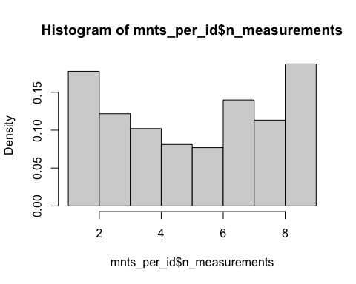
# percentage distribution of measurements
mnts_per_id %>%
dplyr::count(n_measurements) %>%
mutate(percent = round(100 * n / sum(n) , 1))
## # A tibble: 9 × 3
## n_measurements n percent
## <int> <int> <dbl>
## 1 1 46 6.4
## 2 2 81 11.3
## 3 3 87 12.2
## 4 4 73 10.2
## 5 5 58 8.1
## 6 6 55 7.7
## 7 7 100 14
## 8 8 81 11.3
## 9 9 134 18.7
# cumulative percentages (e.g. % more than 3 measurements)
mnts_per_id %>%
reframe(
threshold = 1:9,
percent_gt = sapply(threshold, function(k) {
mean(n_measurements > k) * 100
}))
## # A tibble: 9 × 2
## threshold percent_gt
## <int> <dbl>
## 1 1 93.6
## 2 2 82.2
## 3 3 70.1
## 4 4 59.9
## 5 5 51.7
## 6 6 44.1
## 7 7 30.1
## 8 8 18.7
## 9 9 0
How many observations per race category?
HIV_raw %>%
group_by(RACE) %>%
summarize(n = n())
## # A tibble: 6 × 2
## RACE n
## <fct> <int>
## 1 White non-Hisp 2527
## 2 White Hisp 156
## 3 Black non-Hisp 1006
## 4 Black Hisp 37
## 5 Other 33
## 6 Other Hisp 176
Problems arise when race is: * Interpreted biologically * Used as a proxy for genetic ancestry * Over-interpreted or over-stratified without power
We are not interpreting or estimating race effects, so we should be good to collapse
Potential explanation in final report: Self-reported race/ethnicity was included as a covariate to account for potential confounding by social determinants of health and healthcare access disparities. Race/ethnicity categories were collected as [describe original categories]. For analyses with limited statistical power due to sample size, we combined categories as follows: [describe any collapsing]. We acknowledge that race is a social construct and that observed differences likely reflect structural inequities rather than biological differences.
Look at distributions of outcomes
hist(HIV_raw$VLOAD)
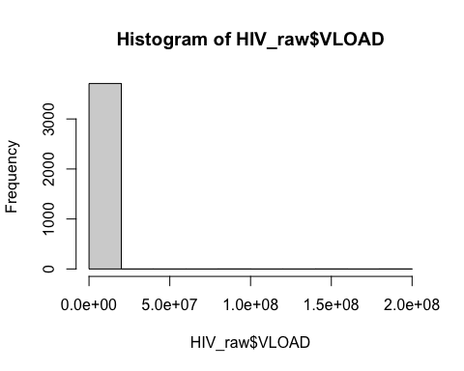
Spaghetti plots
HIV_raw %>%
filter(years %in% c(0,1,2) & !is.na(hard_drugs)) %>%
ggplot(aes(x = years, y = log10(VLOAD), group = newid, color = hard_drugs)) +
geom_line(alpha = 0.25, linewidth = 0.6) +
geom_point(alpha = 0.25, size = 1.0) +
stat_summary(aes(group = hard_drugs), fun = mean, geom = "line",
linewidth = 0.75, color = "firebrick") +
facet_wrap(~ hard_drugs, ncol = 3) +
scale_color_manual(values = c("steelblue", "rosybrown2")) +
#geom_smooth(aes(group=hard_drugs), se=F) +
labs(
title = "Viral Load Trajectories From Baseline to Year 2, Stratified by Drug Users",
subtitle = "Faint lines = subjects; bold red lines = group means",
x = "Year", y = "Viral Load log10 copies/ml", color = "Group") +
theme_minimal() +
theme(legend.position = "none",
axis.text.x = element_text(angle = 45, hjust = 1))
## Warning: Removed 89 rows containing non-finite outside the scale range
## (`stat_summary()`).
## Warning: Removed 77 rows containing missing values or values outside the scale range
## (`geom_line()`).
## Warning: Removed 89 rows containing missing values or values outside the scale range
## (`geom_point()`).
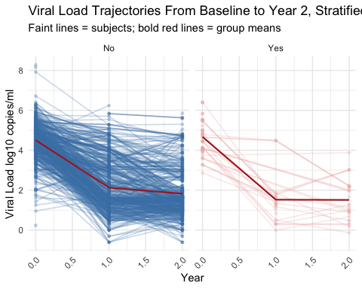
# number missing for hard drug group
HIV_raw %>%
group_by(hard_drugs) %>%
summarize(n = n())
## # A tibble: 3 × 2
## hard_drugs n
## <fct> <int>
## 1 No 3611
## 2 Yes 291
## 3 <NA> 33
long_outcomes <- HIV_raw %>%
filter(years %in% c(0,1,2) & !is.na(hard_drugs)) %>%
mutate(log_vload = log(VLOAD)) %>%
pivot_longer(cols = c(log_vload, LEU3N, AGG_PHYS, AGG_MENT),
names_to = "outcome",
values_to = "value") %>%
mutate(
outcome = recode(outcome,
log_vload = "Viral Load (log copies/mL)",
LEU3N = "CD4+ T-Cell Count",
AGG_PHYS = "Physical QOL (0 to 100)",
AGG_MENT = "Mental QOL (0 to 100)"))
ggplot(long_outcomes, aes(years, value, group = newid, color = hard_drugs)) +
geom_line(alpha = 0.05) +
stat_summary(aes(group = hard_drugs), fun = mean,
geom = "line", linewidth = 0.6) +
facet_wrap(~ outcome, scales = "free_y") +
scale_color_manual(values = c("steelblue", "firebrick")) +
labs(title = "Observed Trajectories of Treatment Response",
x = "Years",
y="",
color = "Hard Drugs") +
theme_bw() +
theme(legend.position = "bottom")
## Warning: Removed 177 rows containing non-finite outside the scale range
## (`stat_summary()`).
## Warning: Removed 152 rows containing missing values or values outside the scale range
## (`geom_line()`).
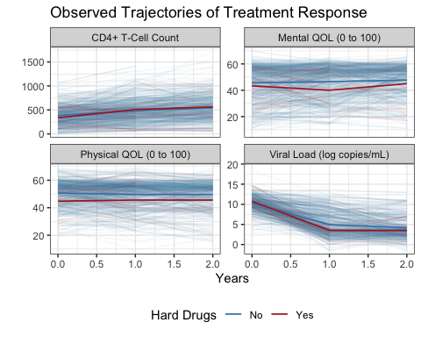

Model Building
base <- HIV_raw %>%
filter(years == 0) %>%
transmute(
newid,
hard0 = hard_drugs,
age0 = age,
bmi0 = BMI,
smoke0 = SMOKE,
educ0 = EDUCBAS,
race0 = RACE,
vload0 = VLOAD,
cd40 = LEU3N,
physical0 = AGG_PHYS,
mental0 = AGG_MENT,
cesd0 = CESD,
hbp0 = HBP,
diab0 = DIAB,
liv34_0 = LIV34,
kid0 = KID)
y2 <- HIV_raw %>%
filter(years == 2) %>%
transmute(
newid,
vload2 = VLOAD,
cd42 = LEU3N,
physical2 = AGG_PHYS,
mental2 = AGG_MENT,
adh2 = ADH,
cesd2 = CESD,
hbp2 = HBP,
diab2 = DIAB,
liv34_2 = LIV34,
kid2 = KID)
ana <- base %>%
left_join(y2, by="newid") %>%
mutate(
log_vload0 = log10(vload0), # **based on literature log10 is typically used**
log_vload2 = log10(vload2),
log_cd40 = log10(cd40),
log_cd42 = log10(cd42),
d_log_vload = log_vload2 - log_vload0,
d_vload = vload2 - vload0,
d_cd4 = cd42 - cd40,
d_phys = physical2 - physical0,
d_ment = mental2 - mental0)
Calculate the number of insufficient data labels for the comorbidities
HIV_raw %>%
filter(years == 0) %>%
summarise(
across(
c(DIAB, HBP, KID, LIV34, FRP, FP),
~ sum(. == 9, na.rm = TRUE),
.names = "n9_{.col}"))
## # A tibble: 1 × 6
## n9_DIAB n9_HBP n9_KID n9_LIV34 n9_FRP n9_FP
## <int> <int> <int> <int> <int> <int>
## 1 405 68 508 245 1 156
Collapse levels of comorbidities into a simple yes or no category with 9s being converted to NAs. Additionally, for the depression scale (CESD), convert -1 to NAs
# using baseline values
ana2 <- ana %>%
mutate(
diab0 = case_when(
diab0 %in% c(1, 3) ~ "No",
diab0 %in% c(2, 4) ~ "Yes",
diab0 == 9 ~ NA_character_,
TRUE ~ NA_character_) %>%
factor(levels = c("No", "Yes")),
hbp0 = case_when(
hbp0 %in% c(1, 3) ~ "No",
hbp0 %in% c(2, 4) ~ "Yes",
hbp0 == 9 ~ NA_character_,
TRUE ~ NA_character_) %>%
factor(levels = c("No", "Yes")),
liv34_0 = case_when(
liv34_0 %in% c(1, 3) ~ "No",
liv34_0 %in% c(2, 4) ~ "Yes",
liv34_0 == 9 ~ NA_character_,
TRUE ~ NA_character_) %>%
factor(levels = c("No", "Yes")),
kid0 = case_when(
kid0 %in% c(1, 3) ~ "No",
kid0 %in% c(2, 4) ~ "Yes",
kid0 == 9 ~ NA_character_,
TRUE ~ NA_character_) %>%
factor(levels = c("No", "Yes")),
educ0 = case_when(
educ0 %in% c("<=8th grade", "9,10,11th grade", "12th grade") ~ "High School or less",
educ0 %in% c(">=1yr college", "4yr college degree") ~ "College",
educ0 %in% c("Some grad", "Post-grad degree") ~ "Post-grad",
TRUE ~ educ0) %>%
factor(),
race0 = case_when(
race0 %in% c("White Hisp", "Black Hisp", "Other Hisp", "Other") ~ "Hispanic",
TRUE ~ race0) %>%
factor(),
cesd0 = ifelse(cesd0==-1, NA_character_, cesd0),
cesd0 = as.numeric(cesd0))

Create table1
tbl1 <- ana2 %>%
tbl_summary(
by = hard0,
include = c(mental0, physical0, log_vload0, cd40, age0, bmi0, smoke0,
educ0, race0, cesd0), # add ADH or no?
type = all_continuous() ~ "continuous2",
statistic = list(
all_continuous() ~ c(
"{mean} ({sd})",
"{median} ({p25}, {p75})",
"{min} - {max}"),
all_categorical() ~ "{n} ({p}%)"),
digits = all_continuous() ~ 1,
missing = "ifany",
missing_text = "NA",
missing_stat = "{N_miss} ({p_miss}%)",
# change variable names
label = list(
mental0 ~ "Mental QOL",
physical0 ~ "Physical QOL",
log_vload0 ~ "Viral Load (log<sub>10</sub> copies/mL)",
cd40 ~ "CD4 T-cell Count",
age0 ~ "Age",
bmi0 ~ "BMI",
smoke0 ~ "Smoke",
educ0 ~ "Education",
race0 ~ "Race",
cesd0 ~ "Depression Scale (>=16 is depressed)")) %>%
add_overall() %>%
bold_labels() %>%
italicize_levels() %>%
#add_p(pvalue_fun = label_style_pvalue(digits = 2)) %>%
add_n() %>%
modify_spanning_header(
c("stat_1", "stat_2") ~ "**Hard Druge Use**") %>%
modify_footnote_header(
footnote = "Table includes all subjects from cohort at baseline (years=0)",
columns = all_stat_cols(),
replace = FALSE) %>%
as_gt() %>%
gt::fmt_markdown(columns = everything()) %>%
gt::fmt_number(
columns = dplyr::starts_with("p.value"),
decimals = 2) %>%
tab_options(
table.font.size = "small",
heading.align = "left",
data_row.padding = px(3),
table.border.top.width = px(2),
table.border.bottom.width = px(2))
tbl1
 |  |  | Hard Druge Use
Characteristic | N | Overall N = 715^{1,2} | No N = 649^{1,2} | Yes N = 66^{1,2}
Mental QOL | 713
<md_container><w:p><w:pPr></w:pPr><w:r><w:rPr></w:rPr><w:t xml:space="preserve">Mean (SD)</w:t></w:r></w:p></md_container> |  | 45.4 (13.3) | 45.6 (13.4) | 43.4 (12.4)
<md_container><w:p><w:pPr></w:pPr><w:r><w:rPr></w:rPr><w:t xml:space="preserve">Median (Q1, Q3)</w:t></w:r></w:p></md_container> |  | 49.3 (36.8, 56.2) | 49.7 (36.8, 56.3) | 46.6 (31.9, 54.2)
<md_container><w:p><w:pPr></w:pPr><w:r><w:rPr></w:rPr><w:t xml:space="preserve">Min - Max</w:t></w:r></w:p></md_container> |  | 7.2 - 69.8 | 7.2 - 69.8 | 20.8 - 59.6
<md_container><w:p><w:pPr></w:pPr><w:r><w:rPr></w:rPr><w:t xml:space="preserve">NA</w:t></w:r></w:p></md_container> |  | 2 (0.3%) | 2 (0.3%) | 0 (0%)
Physical QOL | 713
<md_container><w:p><w:pPr></w:pPr><w:r><w:rPr></w:rPr><w:t xml:space="preserve">Mean (SD)</w:t></w:r></w:p></md_container> |  | 50.1 (9.5) | 50.7 (9.4) | 44.8 (9.6)
<md_container><w:p><w:pPr></w:pPr><w:r><w:rPr></w:rPr><w:t xml:space="preserve">Median (Q1, Q3)</w:t></w:r></w:p></md_container> |  | 52.8 (44.4, 56.7) | 53.3 (45.2, 56.9) | 45.3 (38.8, 52.7)
<md_container><w:p><w:pPr></w:pPr><w:r><w:rPr></w:rPr><w:t xml:space="preserve">Min - Max</w:t></w:r></w:p></md_container> |  | 19.2 - 69.0 | 19.2 - 69.0 | 27.0 - 62.9
<md_container><w:p><w:pPr></w:pPr><w:r><w:rPr></w:rPr><w:t xml:space="preserve">NA</w:t></w:r></w:p></md_container> |  | 2 (0.3%) | 2 (0.3%) | 0 (0%)
Viral Load (log10 copies/mL) | 673
<md_container><w:p><w:pPr></w:pPr><w:r><w:rPr></w:rPr><w:t xml:space="preserve">Mean (SD)</w:t></w:r></w:p></md_container> |  | 4.5 (0.9) | 4.5 (0.9) | 4.7 (0.8)
<md_container><w:p><w:pPr></w:pPr><w:r><w:rPr></w:rPr><w:t xml:space="preserve">Median (Q1, Q3)</w:t></w:r></w:p></md_container> |  | 4.5 (4.0, 5.1) | 4.5 (4.0, 5.1) | 4.7 (4.0, 5.5)
<md_container><w:p><w:pPr></w:pPr><w:r><w:rPr></w:rPr><w:t xml:space="preserve">Min - Max</w:t></w:r></w:p></md_container> |  | 0.2 - 8.3 | 0.2 - 8.3 | 2.9 - 6.4
<md_container><w:p><w:pPr></w:pPr><w:r><w:rPr></w:rPr><w:t xml:space="preserve">NA</w:t></w:r></w:p></md_container> |  | 42 (5.9%) | 39 (6.0%) | 3 (4.5%)
CD4 T-cell Count | 691
<md_container><w:p><w:pPr></w:pPr><w:r><w:rPr></w:rPr><w:t xml:space="preserve">Mean (SD)</w:t></w:r></w:p></md_container> |  | 380.3 (209.5) | 385.0 (211.3) | 335.1 (187.0)
<md_container><w:p><w:pPr></w:pPr><w:r><w:rPr></w:rPr><w:t xml:space="preserve">Median (Q1, Q3)</w:t></w:r></w:p></md_container> |  | 360.5 (229.7, 506.6) | 362.7 (236.1, 506.6) | 300.6 (188.8, 464.9)
<md_container><w:p><w:pPr></w:pPr><w:r><w:rPr></w:rPr><w:t xml:space="preserve">Min - Max</w:t></w:r></w:p></md_container> |  | 10.9 - 1,217.5 | 10.9 - 1,217.5 | 10.9 - 778.0
<md_container><w:p><w:pPr></w:pPr><w:r><w:rPr></w:rPr><w:t xml:space="preserve">NA</w:t></w:r></w:p></md_container> |  | 24 (3.4%) | 24 (3.7%) | 0 (0%)
Age | 715
<md_container><w:p><w:pPr></w:pPr><w:r><w:rPr></w:rPr><w:t xml:space="preserve">Mean (SD)</w:t></w:r></w:p></md_container> |  | 42.6 (9.4) | 42.4 (9.4) | 43.7 (9.9)
<md_container><w:p><w:pPr></w:pPr><w:r><w:rPr></w:rPr><w:t xml:space="preserve">Median (Q1, Q3)</w:t></w:r></w:p></md_container> |  | 42.0 (36.0, 49.0) | 42.0 (36.0, 49.0) | 45.5 (35.0, 52.0)
<md_container><w:p><w:pPr></w:pPr><w:r><w:rPr></w:rPr><w:t xml:space="preserve">Min - Max</w:t></w:r></w:p></md_container> |  | 19.0 - 73.0 | 19.0 - 73.0 | 26.0 - 61.0
BMI | 688
<md_container><w:p><w:pPr></w:pPr><w:r><w:rPr></w:rPr><w:t xml:space="preserve">Mean (SD)</w:t></w:r></w:p></md_container> |  | 34.8 (94.4) | 36.1 (99.2) | 22.4 (6.8)
<md_container><w:p><w:pPr></w:pPr><w:r><w:rPr></w:rPr><w:t xml:space="preserve">Median (Q1, Q3)</w:t></w:r></w:p></md_container> |  | 24.5 (22.1, 27.7) | 24.7 (22.4, 27.7) | 22.3 (19.8, 25.9)
<md_container><w:p><w:pPr></w:pPr><w:r><w:rPr></w:rPr><w:t xml:space="preserve">Min - Max</w:t></w:r></w:p></md_container> |  | -1.0 - 999.0 | -1.0 - 999.0 | -1.0 - 36.8
<md_container><w:p><w:pPr></w:pPr><w:r><w:rPr></w:rPr><w:t xml:space="preserve">NA</w:t></w:r></w:p></md_container> |  | 27 (3.8%) | 27 (4.2%) | 0 (0%)
Smoke | 715
<md_container><w:p><w:pPr></w:pPr><w:r><w:rPr></w:rPr><w:t xml:space="preserve">Never</w:t></w:r></w:p></md_container> |  | 188 (26%) | 187 (29%) | 1 (1.5%)
<md_container><w:p><w:pPr></w:pPr><w:r><w:rPr></w:rPr><w:t xml:space="preserve">Former</w:t></w:r></w:p></md_container> |  | 223 (31%) | 211 (33%) | 12 (18%)
<md_container><w:p><w:pPr></w:pPr><w:r><w:rPr></w:rPr><w:t xml:space="preserve">Current</w:t></w:r></w:p></md_container> |  | 304 (43%) | 251 (39%) | 53 (80%)
Education | 715
<md_container><w:p><w:pPr></w:pPr><w:r><w:rPr></w:rPr><w:t xml:space="preserve">College</w:t></w:r></w:p></md_container> |  | 394 (55%) | 371 (57%) | 23 (35%)
<md_container><w:p><w:pPr></w:pPr><w:r><w:rPr></w:rPr><w:t xml:space="preserve">High School or less</w:t></w:r></w:p></md_container> |  | 180 (25%) | 147 (23%) | 33 (50%)
<md_container><w:p><w:pPr></w:pPr><w:r><w:rPr></w:rPr><w:t xml:space="preserve">Post-grad</w:t></w:r></w:p></md_container> |  | 141 (20%) | 131 (20%) | 10 (15%)
Race | 715
<md_container><w:p><w:pPr></w:pPr><w:r><w:rPr></w:rPr><w:t xml:space="preserve">Black non-Hisp</w:t></w:r></w:p></md_container> |  | 208 (29%) | 180 (28%) | 28 (42%)
<md_container><w:p><w:pPr></w:pPr><w:r><w:rPr></w:rPr><w:t xml:space="preserve">Hispanic</w:t></w:r></w:p></md_container> |  | 85 (12%) | 79 (12%) | 6 (9.1%)
<md_container><w:p><w:pPr></w:pPr><w:r><w:rPr></w:rPr><w:t xml:space="preserve">White non-Hisp</w:t></w:r></w:p></md_container> |  | 422 (59%) | 390 (60%) | 32 (48%)
Depression Scale (>=16 is depressed) | 694
<md_container><w:p><w:pPr></w:pPr><w:r><w:rPr></w:rPr><w:t xml:space="preserve">Mean (SD)</w:t></w:r></w:p></md_container> |  | 14.7 (12.3) | 14.2 (12.2) | 19.3 (12.4)
<md_container><w:p><w:pPr></w:pPr><w:r><w:rPr></w:rPr><w:t xml:space="preserve">Median (Q1, Q3)</w:t></w:r></w:p></md_container> |  | 11.0 (5.0, 23.0) | 11.0 (4.0, 22.0) | 18.0 (10.0, 27.0)
<md_container><w:p><w:pPr></w:pPr><w:r><w:rPr></w:rPr><w:t xml:space="preserve">Min - Max</w:t></w:r></w:p></md_container> |  | 0.0 - 51.0 | 0.0 - 51.0 | 1.0 - 47.0
<md_container><w:p><w:pPr></w:pPr><w:r><w:rPr></w:rPr><w:t xml:space="preserve">NA</w:t></w:r></w:p></md_container> |  | 21 (2.9%) | 21 (3.2%) | 0 (0%)
¹n (%)
²Table includes all subjects from cohort at baseline (years=0)
log10 interpretations * 10^n = where n is number of places after 1 * 10^8 ≈ in hundreds of millions * 10^5 ≈ hundreds of thousands * 10^4 ≈ tens of thousands * 10^0.2 ≈ 1.6 - in single digits - remember exponent of 0 is 1Create a table 2 to look at univariate relationships between hard drug use and comorbidities
tbl2 <- ana2 %>%
tbl_summary(
by = hard0,
include = c(hbp0, diab0, liv34_0, kid0),
type = all_continuous() ~ "continuous2",
statistic = list(
all_continuous() ~ c(
"{mean} ({sd})",
"{median} ({p25}, {p75})",
"{min} - {max}"),
all_categorical() ~ "{p}%"),
digits = all_continuous() ~ 1,
missing = "ifany",
missing_text = "NA",
missing_stat = "{p_miss}%",
# change variable names
label = list(
hbp0 ~ "High Bloood Pressure",
diab0 ~ "Diabetes",
liv34_0 ~ "Liver Disease (Stage 3/4)",
kid0 ~ "Kidney Disease")) %>%
add_overall() %>%
bold_labels() %>%
italicize_levels() %>%
add_p(pvalue_fun = label_style_pvalue(digits = 2)) %>%
modify_spanning_header(
c("stat_1", "stat_2") ~ "**Hard Druge Use**") %>%
modify_footnote_header(
footnote = "Table includes all subjects from cohort at baseline (years=0)",
columns = all_stat_cols(),
replace = FALSE) %>%
as_gt() %>%
gt::fmt_markdown(columns = everything()) %>%
gt::fmt_number(
columns = dplyr::starts_with("p.value"),
decimals = 2) %>%
tab_options(
table.font.size = "small",
heading.align = "left",
data_row.padding = px(3),
table.border.top.width = px(2),
table.border.bottom.width = px(2))
tbl2
 |  | Hard Druge Use
Characteristic | Overall N = 715^{1,2} | No N = 649^{1,2} | Yes N = 66^{1,2} | p-value³
High Bloood Pressure | 26% | 27% | 15% | 0.04
<md_container><w:p><w:pPr></w:pPr><w:r><w:rPr></w:rPr><w:t xml:space="preserve">NA</w:t></w:r></w:p></md_container> | 9.5% | 9.6% | 9.1%
Diabetes | 7.7% | 7.8% | 7.5% | 1.00
<md_container><w:p><w:pPr></w:pPr><w:r><w:rPr></w:rPr><w:t xml:space="preserve">NA</w:t></w:r></w:p></md_container> | 57% | 58% | 39%
Liver Disease (Stage 3/4) | 4.0% | 3.2% | 9.7% | 0.03
<md_container><w:p><w:pPr></w:pPr><w:r><w:rPr></w:rPr><w:t xml:space="preserve">NA</w:t></w:r></w:p></md_container> | 34% | 37% | 6.1%
Kidney Disease | 19% | 16% | 34% | 0.01
<md_container><w:p><w:pPr></w:pPr><w:r><w:rPr></w:rPr><w:t xml:space="preserve">NA</w:t></w:r></w:p></md_container> | 71% | 73% | 52%
¹%
²Table includes all subjects from cohort at baseline (years=0)
³Pearson's Chi-squared test; Fisher's exact test
- Collider bias? - do these comorbidities occur after exposure and outcome?
- The exposure and outcome can both independently create a collider variable. In contrast to the case of confounding, where the confounder is associated with both the exposure and outcome, the collider is created by both the exposure and outcome.
- Comorbidities can be downstream effects of higher viral load/cd4 and hard drug use, independently. Therefore, these comorbidities could very well be colliders
- Rates of liver and kidney disease are higher in drug users (3.2% vs 9.7% and 16% vs 34%, respectively). No difference in diabetes and higher blood pressure is more prevalent in the non-drug use group (27% vs 15%). Also, there is pretty substantial missing values for the kidney (71%), diabetes (57%), and liver (34%) groups.
options(scipen = 999)
vload.model2 <- lm(log_vload2 ~ factor(hard0) + log_vload0 + age0 + bmi0 + factor(smoke0) +
factor(educ0) + factor(race0),
data=ana)
summary(vload.model2)
##
## Call:
## lm(formula = log_vload2 ~ factor(hard0) + log_vload0 + age0 +
## bmi0 + factor(smoke0) + factor(educ0) + factor(race0), data = ana)
##
## Residuals:
## Min 1Q Median 3Q Max
## -2.4818 -0.6898 -0.2172 0.5067 3.9997
##
## Coefficients:
## Estimate Std. Error t value
## (Intercept) 1.1185988 0.7485198 1.494
## factor(hard0)Yes -0.2432820 0.2031613 -1.197
## log_vload0 0.4800401 0.0571163 8.405
## age0 -0.0044998 0.0060556 -0.743
## bmi0 0.0006976 0.0005167 1.350
## factor(smoke0)Former -0.2146634 0.1330086 -1.614
## factor(smoke0)Current -0.0368004 0.1360236 -0.271
## factor(educ0)9,10,11th grade -0.6843132 0.6260944 -1.093
## factor(educ0)12th grade -1.4411083 0.6091187 -2.366
## factor(educ0)>=1yr college -1.2565132 0.5996467 -2.095
## factor(educ0)4yr college degree -1.5409632 0.6068035 -2.539
## factor(educ0)Some grad -1.2366956 0.6253835 -1.977
## factor(educ0)Post-grad degree -1.1429927 0.6105970 -1.872
## factor(race0)White Hisp 0.1439039 0.2683251 0.536
## factor(race0)Black non-Hisp 0.2920885 0.1296359 2.253
## factor(race0)Black Hisp -0.0822988 0.6491991 -0.127
## factor(race0)Other -0.5188385 0.5033183 -1.031
## factor(race0)Other Hisp -0.2785484 0.2771306 -1.005
## Pr(>|t|)
## (Intercept) 0.1357
## factor(hard0)Yes 0.2317
## log_vload0 0.000000000000000517 ***
## age0 0.4578
## bmi0 0.1777
## factor(smoke0)Former 0.1072
## factor(smoke0)Current 0.7869
## factor(educ0)9,10,11th grade 0.2750
## factor(educ0)12th grade 0.0184 *
## factor(educ0)>=1yr college 0.0367 *
## factor(educ0)4yr college degree 0.0114 *
## factor(educ0)Some grad 0.0486 *
## factor(educ0)Post-grad degree 0.0618 .
## factor(race0)White Hisp 0.5920
## factor(race0)Black non-Hisp 0.0247 *
## factor(race0)Black Hisp 0.8992
## factor(race0)Other 0.3031
## factor(race0)Other Hisp 0.3154
## ---
## Signif. codes: 0 '***' 0.001 '**' 0.01 '*' 0.05 '.' 0.1 ' ' 1
##
## Residual standard error: 1.111 on 469 degrees of freedom
## (228 observations deleted due to missingness)
## Multiple R-squared: 0.1986, Adjusted R-squared: 0.1695
## F-statistic: 6.835 on 17 and 469 DF, p-value: 0.000000000000008649
tidy(vload.model2, conf.int = TRUE, exponentiate = FALSE) %>%
mutate(
estimate = round(estimate, 3),
std.error = round(std.error, 3),
statistic = round(statistic, 3),
p.value = round(p.value, 3),
conf.low = round(conf.low, 3),
conf.high = round(conf.high, 3),
vload_copies_ml = round(10^estimate, 3),
vload_ml_LL = round(10^conf.low, 3),
vload_ml_UL = round(10^conf.high, 3))
## # A tibble: 18 × 10
## term estimate std.error statistic p.value conf.low conf.high vload_copies_ml
## <chr> <dbl> <dbl> <dbl> <dbl> <dbl> <dbl> <dbl>
## 1 (Int… 1.12 0.749 1.49 0.136 -0.352 2.59 13.2
## 2 fact… -0.243 0.203 -1.20 0.232 -0.643 0.156 0.571
## 3 log_… 0.48 0.057 8.40 0 0.368 0.592 3.02
## 4 age0 -0.004 0.006 -0.743 0.458 -0.016 0.007 0.991
## 5 bmi0 0.001 0.001 1.35 0.178 0 0.002 1.00
## 6 fact… -0.215 0.133 -1.61 0.107 -0.476 0.047 0.61
## 7 fact… -0.037 0.136 -0.271 0.787 -0.304 0.23 0.918
## 8 fact… -0.684 0.626 -1.09 0.275 -1.92 0.546 0.207
## 9 fact… -1.44 0.609 -2.37 0.018 -2.64 -0.244 0.036
## 10 fact… -1.26 0.6 -2.10 0.037 -2.44 -0.078 0.055
## 11 fact… -1.54 0.607 -2.54 0.011 -2.73 -0.349 0.029
## 12 fact… -1.24 0.625 -1.98 0.049 -2.47 -0.008 0.058
## 13 fact… -1.14 0.611 -1.87 0.062 -2.34 0.057 0.072
## 14 fact… 0.144 0.268 0.536 0.592 -0.383 0.671 1.39
## 15 fact… 0.292 0.13 2.25 0.025 0.037 0.547 1.96
## 16 fact… -0.082 0.649 -0.127 0.899 -1.36 1.19 0.828
## 17 fact… -0.519 0.503 -1.03 0.303 -1.51 0.47 0.303
## 18 fact… -0.279 0.277 -1.00 0.315 -0.823 0.266 0.526
## # ℹ 2 more variables: vload_ml_LL <dbl>, vload_ml_UL <dbl>
After adjusting for baseline viral load, age, BMI, smoking, education, and race, baseline hard-drug users had an estimated 42.9% lower viral load at Year 2 compared with non-users (1-0.571), but this difference did not reach significance (p = 0.232).
- We are comparing hard-drug users and non-users while holding the baseline viral load, age, BMI, smoking status, education, and race values constant. In other words, after other affects have been accounted for.
- The model estimates differences in Year-2 viral load between groups after removing variation attributable to baseline viral load and covariates, effectively comparing individuals at the same starting level.
Test to see if comorbidities can be used as precision variables or may be on the casual pathway from drug use to viral load
options(scipen = 999)
vload.model3 <- lm(log_vload2 ~
# comorbidites
factor(hbp0) + factor(diab0) + factor(liv34_0) + factor(kid0) +
# Primary
factor(hard0) + log_vload0 + age0 + bmi0 +
factor(smoke0) + factor(educ0) + factor(race0),
data=ana2)
summary(vload.model3)
##
## Call:
## lm(formula = log_vload2 ~ factor(hbp0) + factor(diab0) + factor(liv34_0) +
## factor(kid0) + factor(hard0) + log_vload0 + age0 + bmi0 +
## factor(smoke0) + factor(educ0) + factor(race0), data = ana2)
##
## Residuals:
## Min 1Q Median 3Q Max
## -1.48962 -0.44481 -0.04362 0.30816 2.58866
##
## Coefficients:
## Estimate Std. Error t value Pr(>|t|)
## (Intercept) -0.2075945 0.6302799 -0.329 0.742678
## factor(hbp0)Yes -0.0487811 0.2198512 -0.222 0.824932
## factor(diab0)Yes 0.1633207 0.3310531 0.493 0.623032
## factor(liv34_0)Yes -0.4860772 0.3326070 -1.461 0.147546
## factor(kid0)Yes 0.0411815 0.1984335 0.208 0.836084
## factor(hard0)Yes 0.3153521 0.2741907 1.150 0.253283
## log_vload0 0.3570997 0.0989144 3.610 0.000514 ***
## age0 0.0068353 0.0085226 0.802 0.424753
## bmi0 0.0015997 0.0005235 3.056 0.002988 **
## factor(smoke0)Former -0.8845664 0.2408233 -3.673 0.000416 ***
## factor(smoke0)Current -0.1318882 0.2228467 -0.592 0.555515
## factor(educ0)High School or less 0.2629580 0.1854313 1.418 0.159778
## factor(educ0)Post-grad -0.1877618 0.2763203 -0.680 0.498641
## factor(race0)Hispanic 0.2771467 0.2663396 1.041 0.300989
## factor(race0)White non-Hisp -0.5920416 0.1990717 -2.974 0.003814 **
## ---
## Signif. codes: 0 '***' 0.001 '**' 0.01 '*' 0.05 '.' 0.1 ' ' 1
##
## Residual standard error: 0.7554 on 86 degrees of freedom
## (614 observations deleted due to missingness)
## Multiple R-squared: 0.4679, Adjusted R-squared: 0.3812
## F-statistic: 5.401 on 14 and 86 DF, p-value: 0.0000002859
tidy(vload.model3, conf.int = TRUE, exponentiate = FALSE) %>%
mutate(
estimate = round(estimate, 3),
std.error = round(std.error, 3),
statistic = round(statistic, 3),
p.value = round(p.value, 3),
conf.low = round(conf.low, 3),
conf.high = round(conf.high, 3),
vload_copies_ml = round(10^estimate, 3),
vload_ml_LL = round(10^conf.low, 3),
vload_ml_UL = round(10^conf.high, 3))
## # A tibble: 15 × 10
## term estimate std.error statistic p.value conf.low conf.high vload_copies_ml
## <chr> <dbl> <dbl> <dbl> <dbl> <dbl> <dbl> <dbl>
## 1 (Int… -0.208 0.63 -0.329 0.743 -1.46 1.04 0.619
## 2 fact… -0.049 0.22 -0.222 0.825 -0.486 0.388 0.893
## 3 fact… 0.163 0.331 0.493 0.623 -0.495 0.821 1.46
## 4 fact… -0.486 0.333 -1.46 0.148 -1.15 0.175 0.327
## 5 fact… 0.041 0.198 0.208 0.836 -0.353 0.436 1.10
## 6 fact… 0.315 0.274 1.15 0.253 -0.23 0.86 2.06
## 7 log_… 0.357 0.099 3.61 0.001 0.16 0.554 2.28
## 8 age0 0.007 0.009 0.802 0.425 -0.01 0.024 1.02
## 9 bmi0 0.002 0.001 3.06 0.003 0.001 0.003 1.00
## 10 fact… -0.885 0.241 -3.67 0 -1.36 -0.406 0.13
## 11 fact… -0.132 0.223 -0.592 0.556 -0.575 0.311 0.738
## 12 fact… 0.263 0.185 1.42 0.16 -0.106 0.632 1.83
## 13 fact… -0.188 0.276 -0.68 0.499 -0.737 0.362 0.649
## 14 fact… 0.277 0.266 1.04 0.301 -0.252 0.807 1.89
## 15 fact… -0.592 0.199 -2.97 0.004 -0.988 -0.196 0.256
## # ℹ 2 more variables: vload_ml_LL <dbl>, vload_ml_UL <dbl>
Look at multicollinearity issues if present
car::vif(vload.model3)
## GVIF Df GVIF^(1/(2*Df))
## factor(hbp0) 1.635341 1 1.278805
## factor(diab0) 1.574496 1 1.254789
## factor(liv34_0) 1.263004 1 1.123834
## factor(kid0) 1.225655 1 1.107093
## factor(hard0) 1.393134 1 1.180311
## log_vload0 1.173757 1 1.083401
## age0 1.478997 1 1.216140
## bmi0 1.750908 1 1.323219
## factor(smoke0) 1.663859 2 1.135741
## factor(educ0) 1.849518 2 1.166177
## factor(race0) 1.885299 2 1.171777
- hard drug use completely changes direction when including comorbidites. It now has an estimated 12.2% higher viral load as compared to non-drug users
Compare natural log and log10 transformations. log10 is standard use in prior literature in HIV studies
hist(log10(ana$vload0))
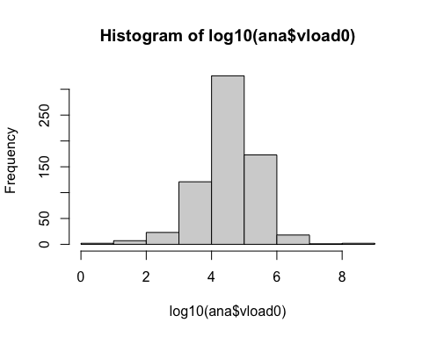
hist(log(ana$vload0))
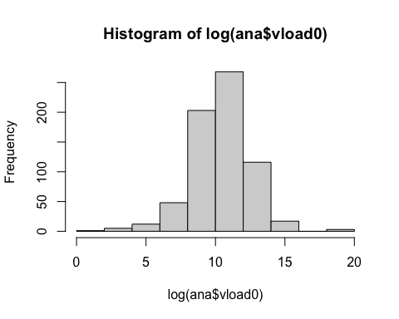
Build CD4 outcome model (frequentist). Did not transform as residuals looked good with raw values.
options(scipen = 999)
cd4.model <- lm(cd42 ~ factor(hard0) + cd40 + age0 + bmi0 + factor(smoke0) +
factor(educ0) + factor(race0),
data=ana2)
summary(cd4.model)
##
## Call:
## lm(formula = cd42 ~ factor(hard0) + cd40 + age0 + bmi0 + factor(smoke0) +
## factor(educ0) + factor(race0), data = ana2)
##
## Residuals:
## Min 1Q Median 3Q Max
## -691.25 -120.39 0.14 105.29 1052.75
##
## Coefficients:
## Estimate Std. Error t value
## (Intercept) 224.28035 48.10611 4.662
## factor(hard0)Yes -166.71173 30.94006 -5.388
## cd40 0.96094 0.04089 23.501
## age0 -1.05965 0.95362 -1.111
## bmi0 0.14935 0.08183 1.825
## factor(smoke0)Former 10.03690 21.12404 0.475
## factor(smoke0)Current -1.99504 21.48789 -0.093
## factor(educ0)High School or less 8.25671 22.17690 0.372
## factor(educ0)Post-grad 38.25840 20.92961 1.828
## factor(race0)Hispanic -14.15269 30.82248 -0.459
## factor(race0)White non-Hisp 3.57869 20.35517 0.176
## Pr(>|t|)
## (Intercept) 0.000004069 ***
## factor(hard0)Yes 0.000000112 ***
## cd40 < 0.0000000000000002 ***
## age0 0.2671
## bmi0 0.0686 .
## factor(smoke0)Former 0.6349
## factor(smoke0)Current 0.9261
## factor(educ0)High School or less 0.7098
## factor(educ0)Post-grad 0.0682 .
## factor(race0)Hispanic 0.6463
## factor(race0)White non-Hisp 0.8605
## ---
## Signif. codes: 0 '***' 0.001 '**' 0.01 '*' 0.05 '.' 0.1 ' ' 1
##
## Residual standard error: 178 on 476 degrees of freedom
## (228 observations deleted due to missingness)
## Multiple R-squared: 0.5683, Adjusted R-squared: 0.5592
## F-statistic: 62.67 on 10 and 476 DF, p-value: < 0.00000000000000022
tidy(cd4.model, conf.int = TRUE, exponentiate = FALSE) %>%
mutate(
estimate = round(estimate, 3),
std.error = round(std.error, 3),
statistic = round(statistic, 3),
p.value = round(p.value, 3),
conf.low = round(conf.low, 3),
conf.high = round(conf.high, 3))
## # A tibble: 11 × 7
## term estimate std.error statistic p.value conf.low conf.high
## <chr> <dbl> <dbl> <dbl> <dbl> <dbl> <dbl>
## 1 (Intercept) 224. 48.1 4.66 0 130. 319.
## 2 factor(hard0)Yes -167. 30.9 -5.39 0 -228. -106.
## 3 cd40 0.961 0.041 23.5 0 0.881 1.04
## 4 age0 -1.06 0.954 -1.11 0.267 -2.93 0.814
## 5 bmi0 0.149 0.082 1.82 0.069 -0.011 0.31
## 6 factor(smoke0)Former 10.0 21.1 0.475 0.635 -31.5 51.5
## 7 factor(smoke0)Current -2.00 21.5 -0.093 0.926 -44.2 40.2
## 8 factor(educ0)High Sc… 8.26 22.2 0.372 0.71 -35.3 51.8
## 9 factor(educ0)Post-gr… 38.3 20.9 1.83 0.068 -2.87 79.4
## 10 factor(race0)Hispanic -14.2 30.8 -0.459 0.646 -74.7 46.4
## 11 factor(race0)White n… 3.58 20.4 0.176 0.861 -36.4 43.6
Indentify why I’m getting contrast error
table(ana2$hard0, useNA = "ifany")
##
## No Yes
## 649 66
table(ana2$smoke0, useNA = "ifany")
##
## Never Former Current
## 188 223 304
table(ana2$educ0, useNA = "ifany")
##
## College High School or less Post-grad
## 394 180 141
table(ana2$race0, useNA = "ifany")
##
## Black non-Hisp Hispanic White non-Hisp
## 208 85 422
After adjusting for baseline CD4+ T cell counts age, BMI, smoking, education, and race, baseline hard-drug users had an estimated 42.9% lower viral load at Year 2 compared with non-users (1-0.571), but this difference did not reach significance (p = 0.232).
Look at distribution of CD4 T cell count, log counts, and boxplots between drug user group
hist(ana2$cd40)
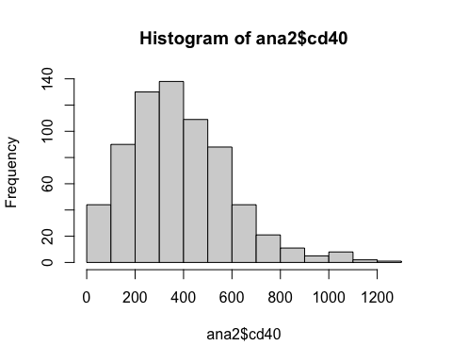
hist(ana2$log_cd40)
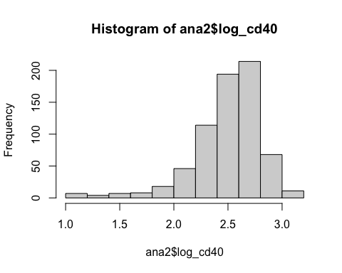
boxplot(ana2$log_cd40~ana2$hard0)
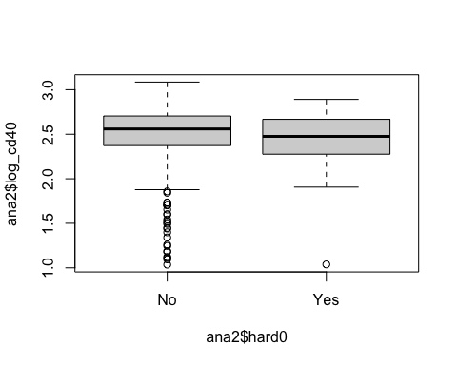
boxplot(ana2$cd40~ana2$hard0)
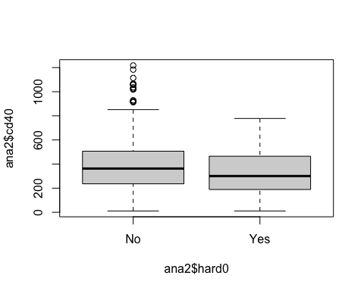
Check that residuals look good using raw CD4 counts
# check residuals to determine if skewness is too extreme for this model approach
plot(cd4.model) # residuals vs fitted
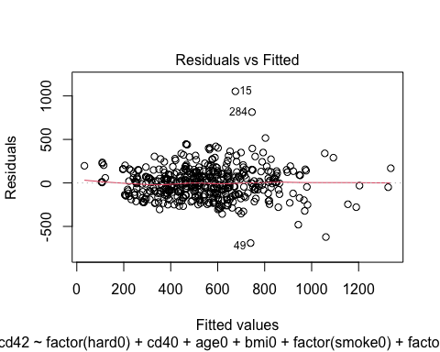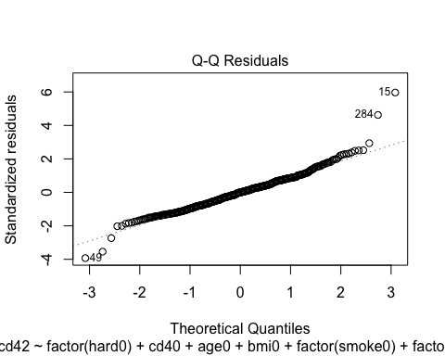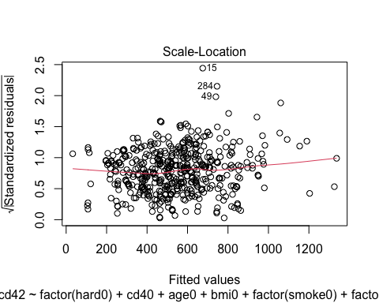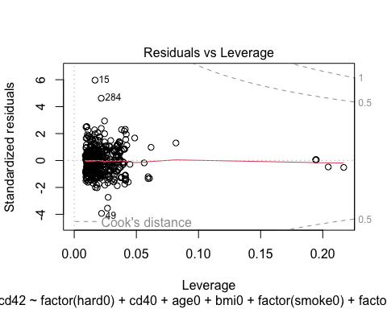
- some outliers but overall residuals look good with raw CD4 values
Check distribution of QOL measures to identify odd values
hist(ana2$physical0)
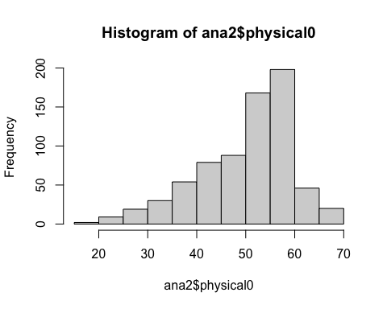
summary(ana2$physical0)
## Min. 1st Qu. Median Mean 3rd Qu. Max. NA's
## 19.16 44.36 52.79 50.11 56.65 69.03 2
hist(ana2$mental0)
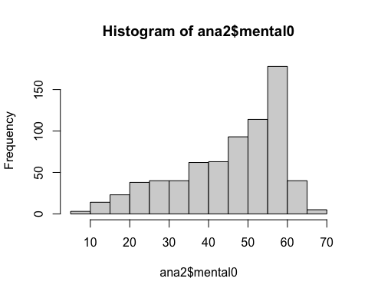
summary(ana2$mental0)
## Min. 1st Qu. Median Mean 3rd Qu. Max. NA's
## 7.229 36.760 49.322 45.402 56.183 69.774 2
Build Mental QOL outcome model (frequentist)
options(scipen = 999)
mental.model <- lm(mental2 ~ factor(hard0) + mental0 + age0 + bmi0 + factor(smoke0) +
factor(educ0) + factor(race0),
data=ana2)
summary(mental.model)
##
## Call:
## lm(formula = mental2 ~ factor(hard0) + mental0 + age0 + bmi0 +
## factor(smoke0) + factor(educ0) + factor(race0), data = ana2)
##
## Residuals:
## Min 1Q Median 3Q Max
## -33.257 -4.678 1.537 5.898 23.088
##
## Coefficients:
## Estimate Std. Error t value
## (Intercept) 22.75891 2.79148 8.153
## factor(hard0)Yes -0.77503 1.71448 -0.452
## mental0 0.48556 0.03374 14.389
## age0 0.02884 0.05291 0.545
## bmi0 -0.01059 0.00452 -2.342
## factor(smoke0)Former 1.65165 1.16495 1.418
## factor(smoke0)Current 1.88996 1.18594 1.594
## factor(educ0)High School or less -0.72537 1.21828 -0.595
## factor(educ0)Post-grad 2.70854 1.15879 2.337
## factor(race0)Hispanic -0.01312 1.68227 -0.008
## factor(race0)White non-Hisp 0.29711 1.11573 0.266
## Pr(>|t|)
## (Intercept) 0.00000000000000308 ***
## factor(hard0)Yes 0.6514
## mental0 < 0.0000000000000002 ***
## age0 0.5859
## bmi0 0.0196 *
## factor(smoke0)Former 0.1569
## factor(smoke0)Current 0.1117
## factor(educ0)High School or less 0.5519
## factor(educ0)Post-grad 0.0198 *
## factor(race0)Hispanic 0.9938
## factor(race0)White non-Hisp 0.7901
## ---
## Signif. codes: 0 '***' 0.001 '**' 0.01 '*' 0.05 '.' 0.1 ' ' 1
##
## Residual standard error: 9.847 on 483 degrees of freedom
## (221 observations deleted due to missingness)
## Multiple R-squared: 0.3378, Adjusted R-squared: 0.3241
## F-statistic: 24.64 on 10 and 483 DF, p-value: < 0.00000000000000022
tidy(mental.model, conf.int = TRUE, exponentiate = FALSE) %>%
mutate(
estimate = round(estimate, 3),
std.error = round(std.error, 3),
statistic = round(statistic, 3),
p.value = round(p.value, 3),
conf.low = round(conf.low, 3),
conf.high = round(conf.high, 3))
## # A tibble: 11 × 7
## term estimate std.error statistic p.value conf.low conf.high
## <chr> <dbl> <dbl> <dbl> <dbl> <dbl> <dbl>
## 1 (Intercept) 22.8 2.79 8.15 0 17.3 28.2
## 2 factor(hard0)Yes -0.775 1.71 -0.452 0.651 -4.14 2.59
## 3 mental0 0.486 0.034 14.4 0 0.419 0.552
## 4 age0 0.029 0.053 0.545 0.586 -0.075 0.133
## 5 bmi0 -0.011 0.005 -2.34 0.02 -0.019 -0.002
## 6 factor(smoke0)Former 1.65 1.16 1.42 0.157 -0.637 3.94
## 7 factor(smoke0)Current 1.89 1.19 1.59 0.112 -0.44 4.22
## 8 factor(educ0)High Sc… -0.725 1.22 -0.595 0.552 -3.12 1.67
## 9 factor(educ0)Post-gr… 2.71 1.16 2.34 0.02 0.432 4.99
## 10 factor(race0)Hispanic -0.013 1.68 -0.008 0.994 -3.32 3.29
## 11 factor(race0)White n… 0.297 1.12 0.266 0.79 -1.90 2.49
Build Physical QOL outcome model (frequentist)
options(scipen = 999)
physical.model <- lm(physical2 ~ factor(hard0) + physical0 + age0 + bmi0 + factor(smoke0) +
factor(educ0) + factor(race0),
data=ana2)
summary(physical.model)
##
## Call:
## lm(formula = physical2 ~ factor(hard0) + physical0 + age0 + bmi0 +
## factor(smoke0) + factor(educ0) + factor(race0), data = ana2)
##
## Residuals:
## Min 1Q Median 3Q Max
## -36.265 -3.409 1.279 4.225 21.803
##
## Coefficients:
## Estimate Std. Error t value
## (Intercept) 20.215120 3.263633 6.194
## factor(hard0)Yes -2.676533 1.378757 -1.941
## physical0 0.668464 0.041924 15.945
## age0 -0.080932 0.043847 -1.846
## bmi0 -0.004608 0.003650 -1.262
## factor(smoke0)Former -0.256356 0.932456 -0.275
## factor(smoke0)Current -1.540952 0.955749 -1.612
## factor(educ0)High School or less -1.385518 0.982571 -1.410
## factor(educ0)Post-grad -0.075783 0.932987 -0.081
## factor(race0)Hispanic 1.541082 1.353018 1.139
## factor(race0)White non-Hisp -0.321888 0.901158 -0.357
## Pr(>|t|)
## (Intercept) 0.00000000126 ***
## factor(hard0)Yes 0.0528 .
## physical0 < 0.0000000000000002 ***
## age0 0.0655 .
## bmi0 0.2074
## factor(smoke0)Former 0.7835
## factor(smoke0)Current 0.1076
## factor(educ0)High School or less 0.1592
## factor(educ0)Post-grad 0.9353
## factor(race0)Hispanic 0.2553
## factor(race0)White non-Hisp 0.7211
## ---
## Signif. codes: 0 '***' 0.001 '**' 0.01 '*' 0.05 '.' 0.1 ' ' 1
##
## Residual standard error: 7.929 on 483 degrees of freedom
## (221 observations deleted due to missingness)
## Multiple R-squared: 0.4171, Adjusted R-squared: 0.4051
## F-statistic: 34.56 on 10 and 483 DF, p-value: < 0.00000000000000022
tidy(physical.model, conf.int = TRUE, exponentiate = FALSE) %>%
mutate(
estimate = round(estimate, 3),
std.error = round(std.error, 3),
statistic = round(statistic, 3),
p.value = round(p.value, 3),
conf.low = round(conf.low, 3),
conf.high = round(conf.high, 3))
## # A tibble: 11 × 7
## term estimate std.error statistic p.value conf.low conf.high
## <chr> <dbl> <dbl> <dbl> <dbl> <dbl> <dbl>
## 1 (Intercept) 20.2 3.26 6.19 0 13.8 26.6
## 2 factor(hard0)Yes -2.68 1.38 -1.94 0.053 -5.39 0.033
## 3 physical0 0.668 0.042 15.9 0 0.586 0.751
## 4 age0 -0.081 0.044 -1.85 0.066 -0.167 0.005
## 5 bmi0 -0.005 0.004 -1.26 0.207 -0.012 0.003
## 6 factor(smoke0)Former -0.256 0.932 -0.275 0.783 -2.09 1.58
## 7 factor(smoke0)Current -1.54 0.956 -1.61 0.108 -3.42 0.337
## 8 factor(educ0)High Sc… -1.39 0.983 -1.41 0.159 -3.32 0.545
## 9 factor(educ0)Post-gr… -0.076 0.933 -0.081 0.935 -1.91 1.76
## 10 factor(race0)Hispanic 1.54 1.35 1.14 0.255 -1.12 4.2
## 11 factor(race0)White n… -0.322 0.901 -0.357 0.721 -2.09 1.45

Mediation Analysis
Adherence variable is ordinal in nature and values are not evenly spaced. Therefore, we can’t use a linear approach. Let’s try converting to a binary and see results
ana2 <- ana2 %>%
mutate(
adh_bin = case_when(
adh2 %in% c("100%","95-99%") ~ 1, # ≥95%
adh2 %in% c("75-94%", "<75%") ~ 0, # <95%
TRUE ~ NA_real_),
adh_bin = factor(adh_bin, levels = c(0,1),
labels = c("<95%", "≥95%")))
We also need a complete case analysis or we will keep getting “number of observations do not match between mediator and outcome models” error
# complete case analysis
ana2_cc <- ana2 %>%
select(cd42, hard0, adh_bin, cd40,
age0, bmi0, smoke0, educ0, race0) %>%
na.omit() %>%
droplevels()
Custom function for calculating mediation coefficients
# boot_fun <- function(data, idx) {
# d <- data[idx, ]
# m <- glm(adh_bin ~ hard0 + age0 + bmi0 + smoke0 + educ0 + race0,
# family = binomial,
# data = d)
# y <- lm(cd42 ~ hard0 + adh_bin + cd40 +
# age0 + bmi0 + smoke0 + educ0 + race0, data = d)
#
# a <- coef(m)["hard0"]
# b <- coef(y)["adh2"]
# cprime <- coef(y)["hard0"]
#
# c(indirect = a*b, direct = cprime, total = cprime + a*b)
# }
#
# set.seed(1)
# bt <- boot(ana2_cc, statistic = boot_fun, R = 2000)
#
# boot.ci(bt, type = "perc", index = 1) # indirect
# boot.ci(bt, type = "perc", index = 2) # direct
# boot.ci(bt, type = "perc", index = 3) # total
Using mediation package
# Mediator model: adherence as outcome
m_mod <- glm(adh_bin ~ hard0 + age0 + bmi0 + smoke0 + educ0 + race0,
family = binomial,
data = ana2_cc)
# Outcome model: Year-2 viral load, adjusting for baseline viral load + adherence
y_mod <- lm(cd42 ~ hard0 + adh_bin + cd40 +
age0 + bmi0 + smoke0 + educ0 + race0,
data = ana2_cc)
# Mediation estimation (bootstrap for inference)
med_vl <- mediate(m_mod, y_mod, treat = "hard0", mediator = "adh_bin",
boot = F, sims = 2000)
## Warning in mediate(m_mod, y_mod, treat = "hard0", mediator = "adh_bin", :
## treatment and control values do not match factor levels; using No and Yes as
## control and treatment, respectively
summary(med_vl)
##
## Causal Mediation Analysis
##
## Quasi-Bayesian Confidence Intervals
##
## Estimate 95% CI Lower 95% CI Upper p-value
## ACME 5.5068753 -1.1675679 12.7813011 0.094 .
## ADE -174.1100611 -232.2682768 -113.6807544 <0.0000000000000002 ***
## Total Effect -168.6031857 -227.8464506 -108.9698211 <0.0000000000000002 ***
## Prop. Mediated -0.0328123 -0.0866324 0.0068153 0.096 .
## ---
## Signif. codes: 0 '***' 0.001 '**' 0.01 '*' 0.05 '.' 0.1 ' ' 1
##
## Sample Size Used: 487
##
##
## Simulations: 2000
table(ana2_cc$race0)
##
## Black non-Hisp Hispanic White non-Hisp
## 133 48 306
table(ana2_cc$adh_bin)
##
## <95% ≥95%
## 52 435
library(brms)
## Loading required package: Rcpp
## Loading 'brms' package (version 2.23.0). Useful instructions
## can be found by typing help('brms'). A more detailed introduction
## to the package is available through vignette('brms_overview').
##
## Attaching package: 'brms'
## The following object is masked from 'package:bayesplot':
##
## rhat
## The following objects are masked from 'package:tidybayes':
##
## dstudent_t, pstudent_t, qstudent_t, rstudent_t
## The following object is masked from 'package:lme4':
##
## ngrps
## The following object is masked from 'package:locfit':
##
## lf
## The following objects are masked from 'package:gtools':
##
## ddirichlet, rdirichlet
## The following object is masked from 'package:stats':
##
## ar
# Mediator model
med_model <- bf(adh_bin ~ hard0 + cd40 + age0 + bmi0 + smoke0 + educ0 + race0,
family = bernoulli(link = "logit"))
# Outcome model
out_model <- bf(cd42 ~ hard0 + adh_bin + cd40 +
age0 + bmi0 + smoke0 + educ0 + race0,
family = gaussian())
med.brm.fit <- brm(med_model + out_model + set_rescor(FALSE),
chains = 4, cores = 6, iter = 2000,
data = ana2_cc)
## Compiling Stan program...
## Trying to compile a simple C file
## Running /Library/Frameworks/R.framework/Resources/bin/R CMD SHLIB foo.c
## using C compiler: ‘Apple clang version 17.0.0 (clang-1700.6.3.2)’
## using SDK: ‘MacOSX26.2.sdk’
## clang -arch arm64 -std=gnu2x -I"/Library/Frameworks/R.framework/Resources/include" -DNDEBUG -I"/Library/Frameworks/R.framework/Versions/4.5-arm64/Resources/library/Rcpp/include/" -I"/Library/Frameworks/R.framework/Versions/4.5-arm64/Resources/library/RcppEigen/include/" -I"/Library/Frameworks/R.framework/Versions/4.5-arm64/Resources/library/RcppEigen/include/unsupported" -I"/Library/Frameworks/R.framework/Versions/4.5-arm64/Resources/library/BH/include" -I"/Library/Frameworks/R.framework/Versions/4.5-arm64/Resources/library/StanHeaders/include/src/" -I"/Library/Frameworks/R.framework/Versions/4.5-arm64/Resources/library/StanHeaders/include/" -I"/Library/Frameworks/R.framework/Versions/4.5-arm64/Resources/library/RcppParallel/include/" -I"/Library/Frameworks/R.framework/Versions/4.5-arm64/Resources/library/rstan/include" -DEIGEN_NO_DEBUG -DBOOST_DISABLE_ASSERTS -DBOOST_PENDING_INTEGER_LOG2_HPP -DSTAN_THREADS -DUSE_STANC3 -DSTRICT_R_HEADERS -DBOOST_PHOENIX_NO_VARIADIC_EXPRESSION -D_HAS_AUTO_PTR_ETC=0 -include '/Library/Frameworks/R.framework/Versions/4.5-arm64/Resources/library/StanHeaders/include/stan/math/prim/fun/Eigen.hpp' -D_REENTRANT -DRCPP_PARALLEL_USE_TBB=1 -I/opt/R/arm64/include -fPIC -falign-functions=64 -Wall -g -O2 -c foo.c -o foo.o
## In file included from <built-in>:1:
## In file included from /Library/Frameworks/R.framework/Versions/4.5-arm64/Resources/library/StanHeaders/include/stan/math/prim/fun/Eigen.hpp:22:
## In file included from /Library/Frameworks/R.framework/Versions/4.5-arm64/Resources/library/RcppEigen/include/Eigen/Dense:1:
## In file included from /Library/Frameworks/R.framework/Versions/4.5-arm64/Resources/library/RcppEigen/include/Eigen/Core:19:
## /Library/Frameworks/R.framework/Versions/4.5-arm64/Resources/library/RcppEigen/include/Eigen/src/Core/util/Macros.h:679:10: fatal error: 'cmath' file not found
## 679 | #include <cmath>
## | ^~~~~~~
## 1 error generated.
## make: *** [foo.o] Error 1
## Start sampling
table(ana2_cc$adh_bin, useNA="ifany")
##
## <95% ≥95%
## 52 435
summary(med.brm.fit)
## Family: MV(bernoulli, gaussian)
## Links: mu = logit
## mu = identity
## Formula: adh_bin ~ hard0 + cd40 + age0 + bmi0 + smoke0 + educ0 + race0
## cd42 ~ hard0 + adh_bin + cd40 + age0 + bmi0 + smoke0 + educ0 + race0
## Data: ana2_cc (Number of observations: 487)
## Draws: 4 chains, each with iter = 2000; warmup = 1000; thin = 1;
## total post-warmup draws = 4000
##
## Regression Coefficients:
## Estimate Est.Error l-95% CI u-95% CI Rhat Bulk_ESS
## adhbin_Intercept 1.39 0.89 -0.37 3.16 1.00 5387
## cd42_Intercept 173.73 53.66 68.60 279.55 1.00 5487
## adhbin_hard0Yes 2.45 1.28 0.53 5.44 1.00 3290
## adhbin_cd40 0.00 0.00 -0.00 0.00 1.00 3940
## adhbin_age0 0.00 0.02 -0.03 0.04 1.00 6025
## adhbin_bmi0 -0.00 0.00 -0.00 -0.00 1.00 4220
## adhbin_smoke0Former 0.24 0.43 -0.60 1.05 1.00 3927
## adhbin_smoke0Current -0.21 0.38 -0.96 0.56 1.00 3466
## adhbin_educ0HighSchoolorless -0.46 0.39 -1.21 0.32 1.00 4421
## adhbin_educ0PostMgrad -0.02 0.44 -0.86 0.86 1.00 5846
## adhbin_race0Hispanic -0.00 0.52 -0.99 1.06 1.00 4797
## adhbin_race0WhitenonMHisp 0.55 0.37 -0.18 1.29 1.00 4455
## cd42_hard0Yes -173.88 30.43 -233.85 -113.17 1.00 5018
## cd42_adh_bin≥95% 62.53 26.77 11.59 115.05 1.00 5104
## cd42_cd40 0.95 0.04 0.87 1.03 1.00 4953
## cd42_age0 -1.11 0.96 -2.97 0.78 1.00 4969
## cd42_bmi0 0.18 0.08 0.02 0.34 1.00 5487
## cd42_smoke0Former 8.78 21.18 -33.61 50.64 1.00 3702
## cd42_smoke0Current -0.51 21.18 -41.79 41.28 1.00 3445
## cd42_educ0HighSchoolorless 11.01 21.86 -32.06 53.85 1.00 4336
## cd42_educ0PostMgrad 38.95 20.09 0.24 78.46 1.00 4879
## cd42_race0Hispanic -13.83 30.47 -73.80 45.65 1.00 3815
## cd42_race0WhitenonMHisp 0.61 20.03 -38.98 40.13 1.00 3325
## Tail_ESS
## adhbin_Intercept 3336
## cd42_Intercept 2719
## adhbin_hard0Yes 2208
## adhbin_cd40 2875
## adhbin_age0 3135
## adhbin_bmi0 3132
## adhbin_smoke0Former 3056
## adhbin_smoke0Current 2701
## adhbin_educ0HighSchoolorless 3318
## adhbin_educ0PostMgrad 3254
## adhbin_race0Hispanic 3037
## adhbin_race0WhitenonMHisp 3236
## cd42_hard0Yes 2905
## cd42_adh_bin≥95% 3113
## cd42_cd40 3246
## cd42_age0 2647
## cd42_bmi0 3325
## cd42_smoke0Former 3046
## cd42_smoke0Current 2393
## cd42_educ0HighSchoolorless 2822
## cd42_educ0PostMgrad 2938
## cd42_race0Hispanic 3062
## cd42_race0WhitenonMHisp 3049
##
## Further Distributional Parameters:
## Estimate Est.Error l-95% CI u-95% CI Rhat Bulk_ESS Tail_ESS
## sigma_cd42 177.57 5.66 167.01 189.13 1.00 5309 3388
##
## Draws were sampled using sampling(NUTS). For each parameter, Bulk_ESS
## and Tail_ESS are effective sample size measures, and Rhat is the potential
## scale reduction factor on split chains (at convergence, Rhat = 1).
Extract the draws
# extract posterior draws
med_draws <- as_draws_df(med.brm.fit)
# get parameter names
names(med_draws)[grepl("^b_", names(med_draws))]
## [1] "b_adhbin_Intercept" "b_cd42_Intercept"
## [3] "b_adhbin_hard0Yes" "b_adhbin_cd40"
## [5] "b_adhbin_age0" "b_adhbin_bmi0"
## [7] "b_adhbin_smoke0Former" "b_adhbin_smoke0Current"
## [9] "b_adhbin_educ0HighSchoolorless" "b_adhbin_educ0PostMgrad"
## [11] "b_adhbin_race0Hispanic" "b_adhbin_race0WhitenonMHisp"
## [13] "b_cd42_hard0Yes" "b_cd42_adh_bin≥95%"
## [15] "b_cd42_cd40" "b_cd42_age0"
## [17] "b_cd42_bmi0" "b_cd42_smoke0Former"
## [19] "b_cd42_smoke0Current" "b_cd42_educ0HighSchoolorless"
## [21] "b_cd42_educ0PostMgrad" "b_cd42_race0Hispanic"
## [23] "b_cd42_race0WhitenonMHisp"

Diagnsotics for Bayesian Mediation Model
# diagnostics
mcmc_areas(med_draws,prob = 0.95,
pars = c("b_adhbin_hard0Yes"))
# Trace plots for each parameter
mcmc_trace(post_samples,
pars = c("b_adhbin_hard0Yes", "b_cd42_hard0Yes"))
levels(ana2_cc$hard0)
## [1] "No" "Yes"
names(med_draws)[grepl("^b_", names(med_draws))]
## [1] "b_adhbin_Intercept" "b_cd42_Intercept"
## [3] "b_adhbin_hard0Yes" "b_adhbin_cd40"
## [5] "b_adhbin_age0" "b_adhbin_bmi0"
## [7] "b_adhbin_smoke0Former" "b_adhbin_smoke0Current"
## [9] "b_adhbin_educ0HighSchoolorless" "b_adhbin_educ0PostMgrad"
## [11] "b_adhbin_race0Hispanic" "b_adhbin_race0WhitenonMHisp"
## [13] "b_cd42_hard0Yes" "b_cd42_adh_bin≥95%"
## [15] "b_cd42_cd40" "b_cd42_age0"
## [17] "b_cd42_bmi0" "b_cd42_smoke0Former"
## [19] "b_cd42_smoke0Current" "b_cd42_educ0HighSchoolorless"
## [21] "b_cd42_educ0PostMgrad" "b_cd42_race0Hispanic"
## [23] "b_cd42_race0WhitenonMHisp"
## X = drug use & M = adherence
## We are using complete-case analysis so use ana2_cc dataset
# make sure hard0 has the right reference
ana2_cc$hard0 <- relevel(factor(ana2_cc$hard0), ref = "No")
# mediator levels - current reference is <95%
levM <- levels(ana2_cc$adh_bin)
m0 <- levels(ana2_cc$adh_bin)[1] # reference
m1 <- levels(ana2_cc$adh_bin)[2]
# create new dataset with X set to No and Yes
hd_NO <- ana2_cc
hd_NO$hard0 <- factor("No", levels = levels(ana2_cc$hard0))
hd_YES <- ana2_cc
hd_YES$hard0 <- factor("Yes", levels = levels(ana2_cc$hard0))
# Posterior expected adherence probabilities P(M=1|X,C)
# For bern, posterior_epred gives probability of success (i.e., P(M == m1))
pM0 <- posterior_epred(med.brm.fit, resp = "adhbin", newdata = hd_NO)
pM1 <- posterior_epred(med.brm.fit, resp = "adhbin", newdata = hd_YES)
# Posterior expected CD4 means for each X and each fixed mediator level
# Build newdata that sets adh_bin to m0 or m1
hd_NO_lt95 <- hd_NO; hd_NO_lt95$adh_bin <- factor(m0, levels = levM)
hd_NO_gt95 <- hd_NO; hd_NO_gt95$adh_bin <- factor(m1, levels = levM)
hd_YES_lt95 <- hd_YES; hd_YES_lt95$adh_bin <- factor(m0, levels = levM)
hd_YES_gt95 <- hd_YES; hd_YES_gt95$adh_bin <- factor(m1, levels = levM)
# expected CD4 if No hard drugs w/ <95% ADH + Covs
mu0_m0 <- posterior_epred(med.brm.fit, resp = "cd42", newdata = hd_NO_lt95)
# expected CD4 if No hard drugs w/ ≥95% ADH + Covs
mu0_m1 <- posterior_epred(med.brm.fit, resp = "cd42", newdata = hd_NO_gt95)
# expected CD4 if Yes hard drugs w/ <95% ADH + Covs
mu1_m0 <- posterior_epred(med.brm.fit, resp = "cd42", newdata = hd_YES_lt95)
# expected CD4 if Yes hard drugs w/ ≥95% ADH + Covs
mu1_m1 <- posterior_epred(med.brm.fit, resp = "cd42", newdata = hd_YES_gt95)
## Standardize over the mediator distribution:
# 1 - pM0 = prob of low ADH ; pM0 = prob of high ADH | No hard drug use
# 1 - pM1 = prob of low ADH ; pM1 = prob of high ADH | Yes hard drug use
EY_0M0 <- rowMeans(mu0_m0 * (1 - pM0) + mu0_m1 * pM0) # pop-level E[CD4|X=0]
EY_1M1 <- rowMeans(mu1_m0 * (1 - pM1) + mu1_m1 * pM1) # pop-level E[CD4|X=1]
# expectation of CD4 if a hard drug user but ADH behaved as if they were NOT
# a drug user
EY_1M0 <- rowMeans(mu1_m0 * (1 - pM0) + mu1_m1 * pM0)
## CD4 depends on adherence.
## ADH depends on drug use.
## So to understand mediation, we must avg CD4 preds over how often people are ADH
# calculate the effects
TE <- EY_1M1 - EY_0M0
NIE <- EY_1M1 - EY_1M0
NDE <- EY_1M0 - EY_0M0
# summarize
summ <- function(x) {
c(
mean = mean(x),
hdi_low = hdi(x, prob = 0.95)[1],
hdi_high = hdi(x, prob = 0.95)[2],
Pr_gt_0 = mean(x > 0))
}
rbind(TE = summ(TE), NIE = summ(NIE), NDE = summ(NDE))
## mean hdi_low hdi_high Pr_gt_0
## TE -167.871852 -227.8157835 -108.00492 0.00000
## NIE 6.011599 0.5286263 12.02298 0.99025
## NDE -173.883452 -233.9579262 -113.37813 0.00000
Total Effect (TE) Interpretation: Moving from No hard drug use to Yes hard drug use is associated with an average decrease of about 168 CD4 cells at Year 2.
Indirect Effect (NIE-mediation through adherence) Interpretation: There is strong posterior evidence that adherence mediates part of the association.
Direct Effect (NDE) Interpretation: Even if adherence were held constant, hard drug use would still be associated with a ~174 cell lower CD4 count.
This suggests that most of the effect is not explained by adherence
Proportion Mediated mean(NIE / TE) = 6/168 ≈ 3.6%

