Introduction
The data for this project were provided by the study investigator, consisting of 31 healthy control subjects. The study evaluated agreement between a novel saliva collection device (Saliva Procurement and Integrated Testing [SPIT] booklet) and electronically recorded cap times (MEM), adherence to protocol-defined collection windows after waking, and diurnal patterns of cortisol and DHEA throughout the day
Participants provided multiple saliva samples per day across repeated collection days, scheduled relative to waking time. Data included booklet- and cap-recorded collection times, sleep diary-reported wake times, and cortisol and DHEA concentrations.
The purpose of this report is to answer the following hypothesis/questions of interest:
- Booklet-reported minutes since waking are linearly associated with electronic recorded Cap minutes since waking
- Estimate the percentage of samples collected within ±7.5 and ±15 minutes of the scheduled time (descriptive).
- Cortisol and DHEA concentrations increase significantly from waking to 30 minutes after waking.
- After 30 minutes post waking, cortisol and DHEA concentrations decline for the remainder of the day.

Methods

2.1 Data Cleaning
Booklet and cap clock times were standardized and converted to minutes since waking using sleep diary-reported wake times. Timing differences were defined as Booklet minus Cap minutes since waking.
One subject (SubjectID=3037) was excluded due to repeated DHEA values at the upper detection limit (5.205 nmol/L). One observation with an implausibly high cortisol value (89.6 nmol/L) was removed, likely reflecting laboratory error.

2.2 Data Analysis
Cortisol and DHEA were summarized overall and by collection sample using means, medians (IQR), and ranges. Timing adherence was summarized as the proportion of samples within the protocol windows.
Booklet and cap minutes since waking were compared using scatterplots (by collection sample) and Pearson correlations.
A linear mixed-effects model regressed booklet minutes since waking on cap minutes since waking, with subject-specific random intercepts to account for repeated measures; the intercept reflects average bias (booklet-cap) and the slope reflects agreement.
Adherence at +30 minutes (sample 2) and +600 minutes (sample 4) was summarized descriptively and compared using chi-square or Fisher’s exact tests, as appropriate.
To characterize diurnal patterns, cortisol and DHEA were log-transformed and modeled using piece-wise linear mixed-effects models with a knot at 30 minutes post-waking and subject-specific random intercepts.
All analyses were conducted using R (version 4.5.1). Significance was evaluated using a two-sided significance level of 0.05, indicating p-values less than 0.05 were considered significant.

Results
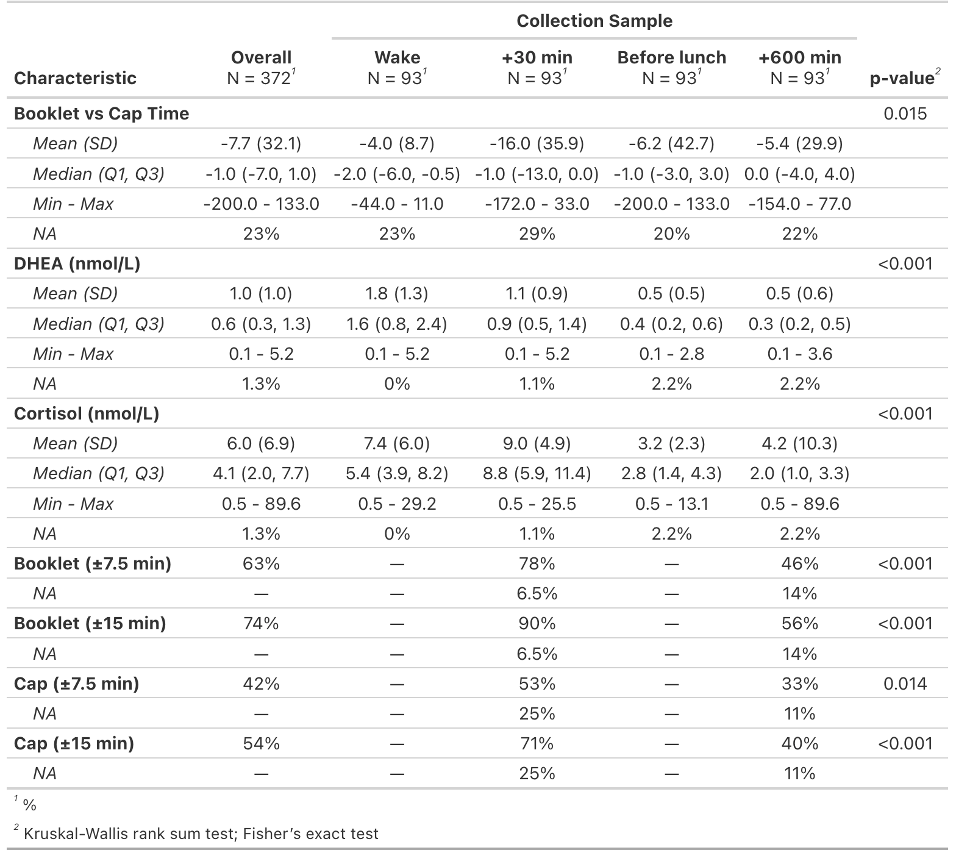
Table 1. Descriptive statistics for cortisol and DHEA concentrations, timing differences between Booklet and Cap recorded times, and timing adherence by collection sample.
Timing differences between booklet and cap recordings varied across collection samples. Missing cortisol and DHEA values occurred despite recorded collection times, suggesting laboratory or sample-quality issues. Cap times were missing more frequently than booklet times, consistent with device malfunction or user error (Table 1).

3.2 Agreement Between Booklet and Cap Timing

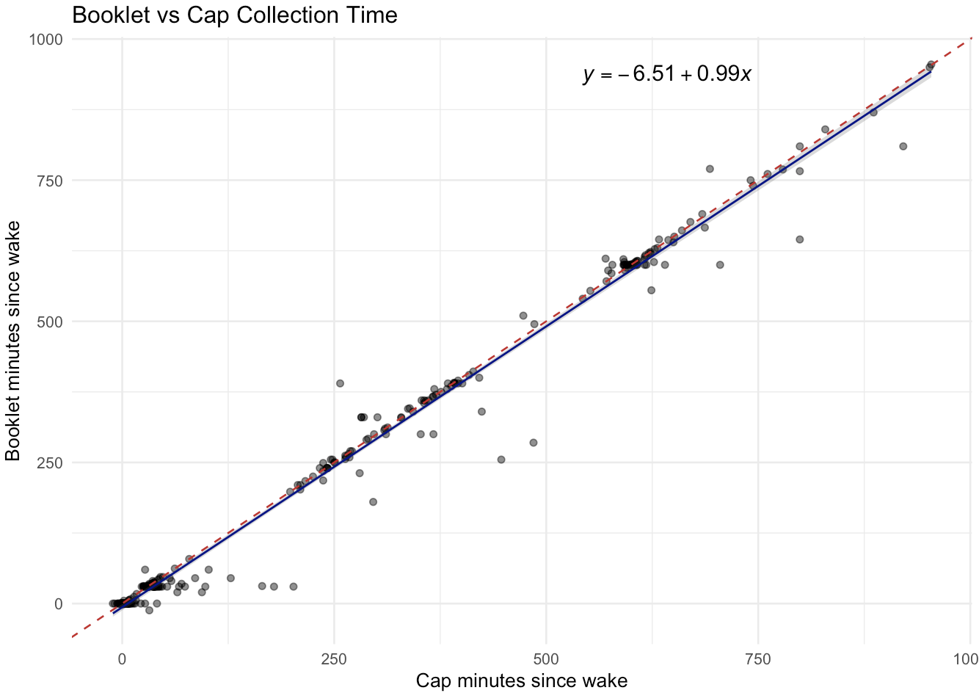
Figure 1. Scatterplots of Booklet versus CAP minutes since waking by collection sample. The solid line shows the fitted linear mixed-effects model with a subject-specific random intercept, while the dashed line represents perfect agreement (y = x).

Βοοklet versus cap minutes since waking showed a strong linear association or agreement between the two timing methods. Booklet times closely tracked cap times throughout the day with a near one-to-one correspondence. (Figure 1).

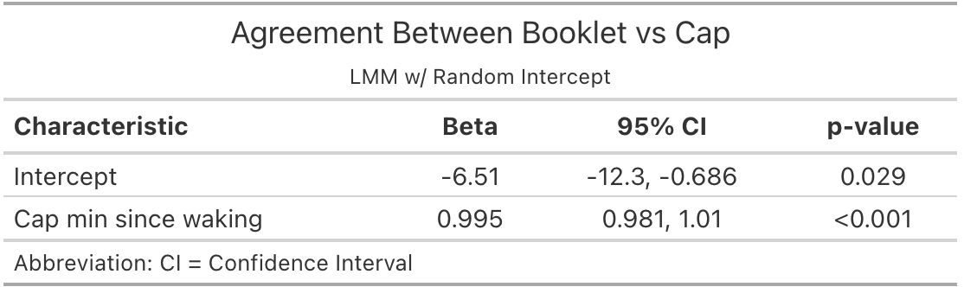
Table 2. Linear Mixed-effects model of timing differences between Booklet and Cap measurements. The slope reflects the degree of agreement in elapsed time between the two measures, while the intercept represents the average bias between Booklet and Cap times.

Linear mixed-effects regression model indicated near perfect linear agreement between booklet and cap minutes (slope ≈ 1.0), suggesting that booklet times closely follow cap-recorded times throughout the day, on average. The intercept suggested some bias, with booklet times being recorded by about 6-7 minutes earlier on average (Table 2).

3.3 Adherence to Protocol Timing
Adherence differed by collection sample and adherence window definition. Sample 2 (+30min) showed higher adherence under both ±7-minute and ±15-minute windows, with significant differences being noted for both booklet and cap-based measures between these adherence windows (Table 1). Between the two measures, the booklet-recorded time had higher rates of adherence overall of meeting either threshold (63% vs 42% [±7min]; 74% vs 54% [±15min]).

3.4 Diurnal Patterns of Cortisol and DHEA

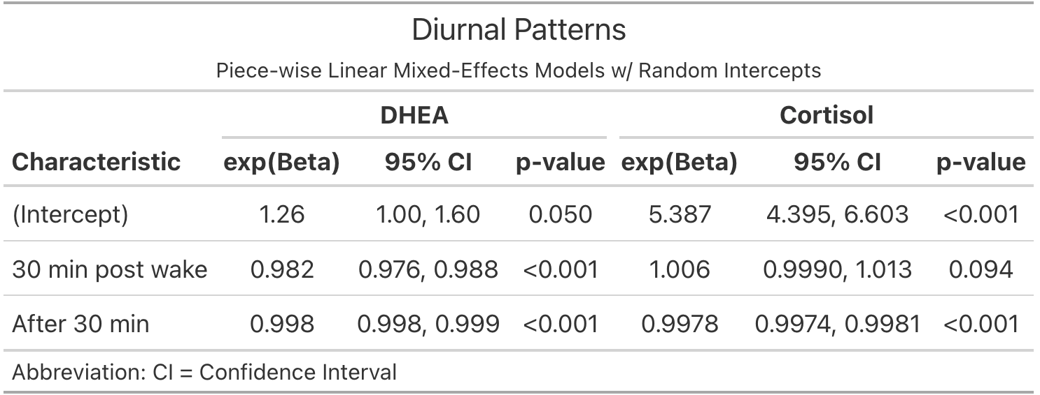
Table 3. Piece-wise linear mixed-effects models describing diurnal patterns of DHEA and cortisol levels. Models included a knot at 30 minutes post waking to estimate the initial post-waking change and the subsequent rate of change over the remainder of the day, with subject-specific random intercepts accounting for repeated measures. Exponentiated coefficients represent multiplicative changes in concentration levels per minute within each time segment.

During the first 30 minutes after waking, cortisol increased by about 0.6% per minute (≈ 20% cumulatively over 30min), while DHEA decreased by about 1.8% per minute (≈ 58% cumulatively over 30min). After 30 minutes, both declined more gradually, with cortisol decreasing at approximately 0.23% per minute (≈ 12.5% per hour), and DHEA at 0.2% per minute (≈ 9% per hour) (Table 3).

Discussion
This study evaluated the agreement and adherence of a novel saliva collection method (the SPIT booklet) for assessing diurnal patterns of cortisol and DHEA. Overall, booklet-recorded times closely tracked electronically recorded cap times, with an average bias of 6-7 minutes being recorded earlier by the booklet method.
Adherence to protocol-defined collection windows varied by sample and window, with lower adherence at the +600-minute collection and under the stricter ±7.5-minute window. Booklet recordings generally showed higher adherence than cap recordings.
Observed cortisol and DHEA patterns were consistent with expectations: cortisol rose after waking and then declined across the day, while DHEA declined early and continued to decrease. Prior literature has described an inverse relationship between cortisol and DHEA (Ahmed et al., 2023).
Limitations include missing data from both methods, which could bias results if missingness was not random. Linear mixed effect models are robust if missingness doesn’t depend on any unobserved data or any data at all.
Timing differences between booklet and cap-recorded times exhibited substantial variability and some extreme values within specific collection sample windows. The simple linear mixed model fitted for this analysis cannot capture these specific collection sample discrepancies.
In summary, the SPIT booklet appears to be a valid method for collecting salivary cortisol and DHEA. Despite some timing biases and variable adherence, agreement with electronic monitoring and the ability to capture expected diurnal patterns support its application in a research setting when timing and adherence is emphasized.

References
ChatGPT was used to check R code errors for some of the packages used and to grammar check (OpenAI, 2025).
Ahmed, T., Qassem, M., & Kyriacou, P. A. (2023). Measuring stress: a review of the current cortisol and dehydroepiandrosterone (DHEA) measurement techniques and considerations for the future of mental health monitoring. Stress, 26(1), 29–42. https://doi.org/10.1080/10253890.2022.2164187

Reproducibility Statement
The statistical code used in this analysis is available at: https://github.com/rysummers/BIOS6624-Class/tree/main/Project0
Raw data are not tracked in this repository and is available upon request.

