BIOS 6624 : Project 0
Ryan Summers
2026-01-22

Read in the csv
spit_raw <- read_csv("/Users/ryan_summers/GitHub/BIOS6624-Class/Project0/DataRaw/Project0_Clean_v2.csv")
## Rows: 372 Columns: 15
## ── Column specification ────────────────────────────────────────────────────────
## Delimiter: ","
## chr (1): Collection Date
## dbl (9): SubjectID, Collection Sample, Booklet: Sample interval Decimal Tim...
## time (5): Booket: Clock Time, MEMs: Clock Time, Sleep Diary reported wake ti...
##
## ℹ Use `spec()` to retrieve the full column specification for this data.
## ℹ Specify the column types or set `show_col_types = FALSE` to quiet this message.
# number of subjects
length(unique(spit_raw$SubjectID))
## [1] 31
# number of missing measurements per collection sample
spit_raw %>%
#filter(`Collection Sample` != 1) %>%
group_by(`Collection Sample`) %>%
summarise(
bk_miss = sum(is.na(`Booket: Clock Time`)),
mem_miss = sum(is.na(`MEMs: Clock Time`)),
n_obs = n(),
`bk_%` = bk_miss/n_obs,
`mem_%` = mem_miss/n_obs)
## # A tibble: 4 × 6
## `Collection Sample` bk_miss mem_miss n_obs `bk_%` `mem_%`
## <dbl> <int> <int> <int> <dbl> <dbl>
## 1 1 5 16 93 0.0538 0.172
## 2 2 6 23 93 0.0645 0.247
## 3 3 11 12 93 0.118 0.129
## 4 4 13 10 93 0.140 0.108

Data Management & Cleanup
# clean up the column names
spit_df <- spit_raw %>%
# lowercase columns & rows
setNames(tolower(names(.))) %>%
mutate_if(is.character, tolower) %>%
# remove white-space in columns
setNames(gsub("\\s+", "_", names(.)))
spit_df <- spit_df %>%
mutate(
# get weekday for collection dates
collection_date = as.Date(collection_date, format = "%m/%d/%Y"),
weekday = weekdays(collection_date),
# determine if weekday is the weekend
weekend = factor(if_else(weekday %in% c("Saturday","Sunday"),
"Weekend", "Weekday")),
# add zeroes for MEMS collection on 1st sample
`mems:_sample_interval_decimal_time_(mins)` =
ifelse(collection_sample == 1, 0,
`mems:_sample_interval_decimal_time_(mins)`),
# log transform response
log_cortisol = log(`cortisol_(nmol/l)`),
# calculate time differences between book and MEM
time_diff_min = as.numeric(difftime(`booket:_clock_time`,
`mems:_clock_time`, units = "mins")),
interval_diff_min = `booklet:_sample_interval_decimal_time_(mins)` -
`mems:_sample_interval_decimal_time_(mins)`)
summary(spit_df$time_diff_min)
## Min. 1st Qu. Median Mean 3rd Qu. Max. NA's
## -200.000 -7.000 -1.000 -7.712 1.000 133.000 87
hist(spit_df$time_diff_min)
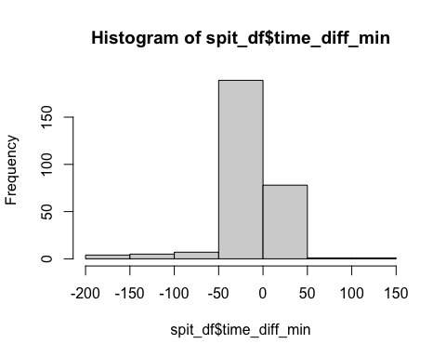
# distribution of cortisol and dhea values
summary(spit_df$`cortisol_(nmol/l)`)
## Min. 1st Qu. Median Mean 3rd Qu. Max. NA's
## 0.5242 2.0555 4.1385 5.9509 7.6562 89.5571 5
hist(spit_df$`cortisol_(nmol/l)`)
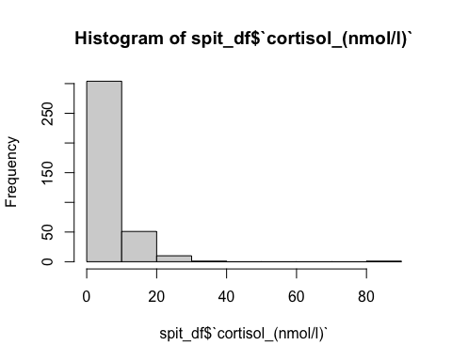
summary(spit_df$`dhea_(nmol/l)`)
## Min. 1st Qu. Median Mean 3rd Qu. Max. NA's
## 0.1076 0.3093 0.6121 0.9811 1.2834 5.2050 5
hist(spit_df$`dhea_(nmol/l)`)
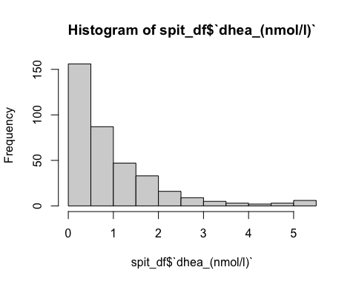
# log-transformed
hist(log(spit_df$`cortisol_(nmol/l)`))
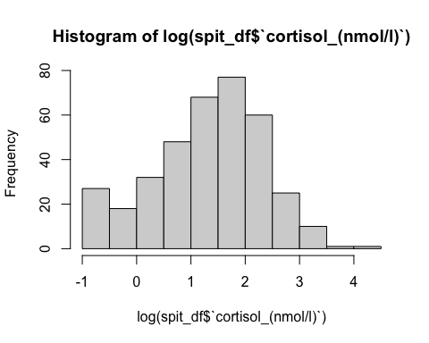
hist(log(spit_df$`dhea_(nmol/l)`))
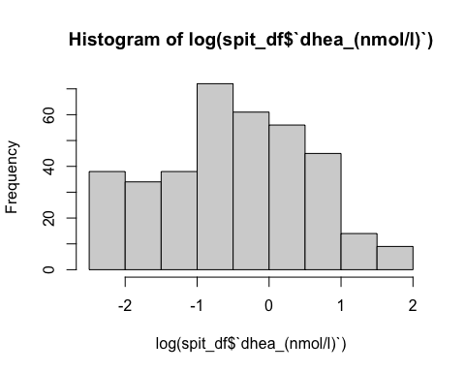
Create a datetime variable that merges the collection date and booklet clock time. * Use this variable as an anchor to determine minutest since wake-up * Additionally, create a column that stores either booklet or MEM clock time based on whether booklet contains a missing value.
spit_df <- spit_df %>%
mutate(
# create a variable that includes the date and clock time for booklet and MEMs
bk_dt = as.POSIXct(paste(collection_date, `booket:_clock_time`),
format = "%Y-%m-%d %H:%M", tz = "UTC"),
mems_dt = as.POSIXct(paste(collection_date, `mems:_clock_time`),
format = "%Y-%m-%d %H:%M", tz = "UTC")) %>%
group_by(subjectid, collection_date) %>%
mutate(
# use wake time determined by sleep diary as PI noted
diary_wake_time = as.POSIXct(
paste(collection_date, sleep_diary_reported_wake_time),
format = "%Y-%m-%d %H:%M", tz = "UTC"),
# fill down datetime values for each subject on each day
diary_wake_time = fill(data.frame(diary_wake_time),
diary_wake_time,
.direction = "down")$diary_wake_time,
# extract collection times from booklet, if NA grab MEMs
sample_dt = coalesce(`booket:_clock_time`, `mems:_clock_time`),
dt_source = if_else(!is.na(`booket:_clock_time`), "Booklet", "MEMS"),
# calculate time since waking for both booklet and MEMs from diary start
bk_min_since_wk = as.numeric(difftime(bk_dt, diary_wake_time,
units = "mins")),
mem_min_since_wk = as.numeric(difftime(mems_dt, diary_wake_time,
units = "mins")),
# create knot for piecewise regression - PI wants to kknow if theres
# an increase in cortisol and/or DHEA from waking to 30min. Also, rate of
# decline after 30min of waking.
t30 = pmin(`mems:_sample_interval_decimal_time_(mins)`, 30),
t_after30 = pmax(0, `mems:_sample_interval_decimal_time_(mins)`-30),) %>%
ungroup()
Indicate whether Samples 2 and 4 are within 7.5min and 15min acceptance windows for adherence
targets <- c(`2` = 30, `4` = 600)
spit_df2 <- spit_df %>%
#filter(collection_sample %in% c(2, 4)) %>%
mutate(
target_min = targets[as.character(collection_sample)],
good_bk = abs(bk_min_since_wk - target_min) <= 7.5,
adeq_bkt = abs(bk_min_since_wk - target_min) <= 15,
good_mem = abs(mem_min_since_wk - target_min) <= 7.5,
adeq_mem = abs(mem_min_since_wk - target_min) <= 15)
spit_df2 <- spit_df %>%
mutate(
target_min = case_when(
collection_sample == 2 ~ 30,
collection_sample == 4 ~ 600,
TRUE ~ NA_real_),
# booklet times
good_bk = if_else(
!is.na(target_min),
abs(bk_min_since_wk - target_min) <= 7.5,
NA),
adeq_bkt = if_else(
!is.na(target_min),
abs(bk_min_since_wk - target_min) <= 15,
NA),
# MEM times
good_mem = if_else(
!is.na(target_min),
abs(mem_min_since_wk - target_min) <= 7.5,
NA),
adeq_mem = if_else(
!is.na(target_min),
abs(mem_min_since_wk - target_min) <= 15,
NA))

Missing Data Analysis
# number of NAs
lapply(spit_df, function(x) sum(is.na(x)))
## $subjectid
## [1] 0
##
## $collection_date
## [1] 0
##
## $collection_sample
## [1] 0
##
## $`booket:_clock_time`
## [1] 35
##
## $`mems:_clock_time`
## [1] 61
##
## $sleep_diary_reported_wake_time
## [1] 279
##
## $`booklet:_sample_interval`
## [1] 130
##
## $`booklet:_sample_interval_decimal_time_(mins)`
## [1] 55
##
## $`mems:_sample_interval`
## [1] 177
##
## $`mems:_sample_interval_decimal_time_(mins)`
## [1] 84
##
## $`cortisol_(ug/dl)`
## [1] 0
##
## $`dhea_(pg/dl)`
## [1] 5
##
## $`cortisol_(nmol/l)`
## [1] 5
##
## $`dhea_(nmol/l)`
## [1] 5
##
## $daynumb
## [1] 0
##
## $weekday
## [1] 0
##
## $weekend
## [1] 0
##
## $log_cortisol
## [1] 5
##
## $time_diff_min
## [1] 87
##
## $interval_diff_min
## [1] 122
##
## $bk_dt
## [1] 35
##
## $mems_dt
## [1] 61
##
## $diary_wake_time
## [1] 0
##
## $sample_dt
## [1] 9
##
## $dt_source
## [1] 0
##
## $bk_min_since_wk
## [1] 35
##
## $mem_min_since_wk
## [1] 61
##
## $t30
## [1] 84
##
## $t_after30
## [1] 84
spit_df %>%
ungroup() %>%
#group_by(collection_sample) %>%
select(`booket:_clock_time`, `mems:_clock_time`, `cortisol_(ug/dl)`, `dhea_(pg/dl)`,
`cortisol_(nmol/l)`, `dhea_(nmol/l)`) %>%
miss_var_summary()
## # A tibble: 6 × 3
## variable n_miss pct_miss
## <chr> <int> <num>
## 1 mems:_clock_time 61 16.4
## 2 booket:_clock_time 35 9.41
## 3 dhea_(pg/dl) 5 1.34
## 4 cortisol_(nmol/l) 5 1.34
## 5 dhea_(nmol/l) 5 1.34
## 6 cortisol_(ug/dl) 0 0

Address PI’s question about agreement between the subject’s recordings of sampling times compared to the times recorded by an electronic monitoring cap (1)
Scatter-plot of agreement (stratify by collection sample) for PI
cor_by_sample <- spit_df %>%
filter(!is.na(mem_min_since_wk), !is.na(bk_min_since_wk)) %>%
group_by(collection_sample) %>%
summarise(
r = cor(mem_min_since_wk, bk_min_since_wk),
p = cor.test(mem_min_since_wk, bk_min_since_wk)$p.value)
cor_by_sample
## # A tibble: 4 × 3
## collection_sample r p
## <dbl> <dbl> <dbl>
## 1 1 0.0734 5.40e- 1
## 2 2 0.125 3.18e- 1
## 3 3 0.853 5.13e-22
## 4 4 0.945 3.07e-36
library(ggpubr)
ggplot(spit_df, aes(x = `mems:_clock_time`, y = `booket:_clock_time`)) +
geom_point(alpha = 0.5) +
geom_abline(slope = 1, intercept = 0, linetype = 2, color = "firebrick3") +
facet_wrap(~ collection_sample) +
stat_cor(
method = "pearson",
label.x.npc = "left",
label.y.npc = "top",
size = 3
) +
labs(
title = "Booklet vs MEMS Collection Time by Sample",
x = "MEMS minutes since wake",
y = "Booklet minutes since wake"
) +
theme_minimal(base_size = 10)
## Warning: Removed 87 rows containing non-finite outside the scale range
## (`stat_cor()`).
## Warning: Removed 87 rows containing missing values or values outside the scale range
## (`geom_point()`).
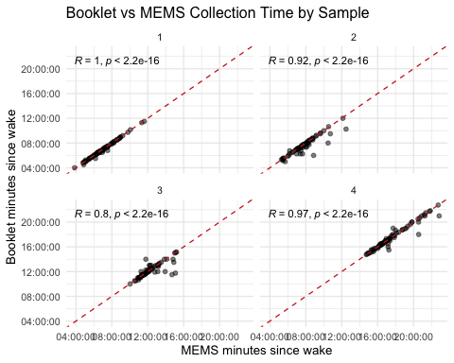
ggplot(spit_df, aes(x = `mems:_clock_time`, y = `booket:_clock_time`)) +
geom_point(alpha = 0.5) +
geom_abline(slope = 1, intercept = 0, linetype = 2, color="firebrick3") +
facet_wrap(~ collection_sample) +
labs(
title = "Booklet vs MEMS Clock Time by Collection Sample",
x = "MEMS time (minutes)",
y = "Booklet time (minutes)"
) +
theme_minimal(base_size = 10)
## Warning: Removed 87 rows containing missing values or values outside the scale range
## (`geom_point()`).
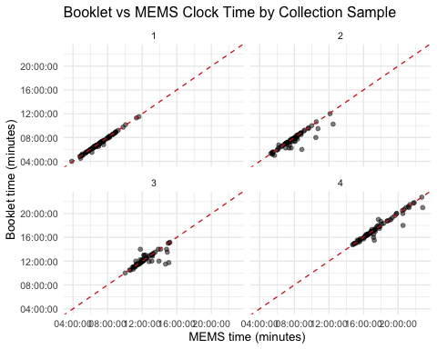
Mixed Model: Is there bias in self-reported times, and does it differ by sample, accounting for repeated measurements within subjects?
# booklet minus mem
agrmnt.model <- lmer(
time_diff_min ~ factor(collection_sample) + (1 | subjectid),
data = spit_df)
summary(agrmnt.model)
## Linear mixed model fit by REML. t-tests use Satterthwaite's method [
## lmerModLmerTest]
## Formula: time_diff_min ~ factor(collection_sample) + (1 | subjectid)
## Data: spit_df
##
## REML criterion at convergence: 2759
##
## Scaled residuals:
## Min 1Q Median 3Q Max
## -6.0659 0.0084 0.1101 0.3667 4.3412
##
## Random effects:
## Groups Name Variance Std.Dev.
## subjectid (Intercept) 47.96 6.925
## Residual 973.36 31.199
## Number of obs: 285, groups: subjectid, 31
##
## Fixed effects:
## Estimate Std. Error df t value Pr(>|t|)
## (Intercept) -4.118 3.912 158.733 -1.053 0.2941
## factor(collection_sample)2 -12.163 5.341 260.787 -2.277 0.0236 *
## factor(collection_sample)3 -2.122 5.175 255.232 -0.410 0.6821
## factor(collection_sample)4 -1.471 5.200 259.170 -0.283 0.7775
## ---
## Signif. codes: 0 '***' 0.001 '**' 0.01 '*' 0.05 '.' 0.1 ' ' 1
##
## Correlation of Fixed Effects:
## (Intr) fc(_)2 fc(_)3
## fctr(cll_)2 -0.652
## fctr(cll_)3 -0.673 0.492
## fctr(cll_)4 -0.672 0.488 0.505
agrmnt.model2 <- lmer(
bk_min_since_wk ~ mem_min_since_wk + (1 | subjectid),
data = spit_df)
summary(agrmnt.model2)
## Linear mixed model fit by REML. t-tests use Satterthwaite's method [
## lmerModLmerTest]
## Formula: bk_min_since_wk ~ mem_min_since_wk + (1 | subjectid)
## Data: spit_df
##
## REML criterion at convergence: 2787.7
##
## Scaled residuals:
## Min 1Q Median 3Q Max
## -5.9420 0.0024 0.1588 0.2635 4.3866
##
## Random effects:
## Groups Name Variance Std.Dev.
## subjectid (Intercept) 44.11 6.642
## Residual 989.60 31.458
## Number of obs: 285, groups: subjectid, 31
##
## Fixed effects:
## Estimate Std. Error df t value Pr(>|t|)
## (Intercept) -6.50779 2.91608 66.29918 -2.232 0.029 *
## mem_min_since_wk 0.99494 0.00706 262.91666 140.931 <2e-16 ***
## ---
## Signif. codes: 0 '***' 0.001 '**' 0.01 '*' 0.05 '.' 0.1 ' ' 1
##
## Correlation of Fixed Effects:
## (Intr)
## mm_mn_snc_w -0.641
Intercept should be zero and slope should be 1.
Interpretation: In lme model of time differences (Booklet − MEMS), agreement at waking did not show significant bias ($ _0:t=-1.1; p=0.29$);however,the+30−minutesampleshowedthatparticipantsrecordedtimesapproximately16.3minutesearlier(−4.1+−12.2)thantheMEMStimestamp,onaverage.Thereisnoevidenceofdisagreementforsamplesbeforelunch($p=0.7$)and600minafterwaking($p=0.8$).
- Between-subject differences in reporting bias are modest (~7 min)
- Within-subject variability is much larger (~31 min)
Most disagreement arises from occasion-to-occasion variability, not consistent subject-specific bias.
Correlation is invariant to shifts: * If Booklet times are always 10 minutes later than MEMS, correlation can still be ~1.0. * High correlation does not preclude bias; the mixed model identifies a consistent offset at Sample 2 after accounting for subject-level variability.

Address PI’s question about adhering to +30min and 600min sampling times (2)
and create a table 1 (Descriptive Table)
# variables used to remove NA calculation for samples 1 and 3
adherence_vars <- c("good_bk", "adeq_bkt", "good_mem", "adeq_mem")
tbl1 <- spit_df2 %>%
mutate(
collection_sample = factor(
collection_sample,
levels = c(1, 2, 3, 4),
labels = c(
"Wake",
"+30 min",
"Before lunch",
"+600 min"))) %>%
ungroup() %>%
select(
time_diff_min,
collection_sample,
`dhea_(nmol/l)`,
`cortisol_(nmol/l)`,
good_bk,
adeq_bkt,
good_mem,
adeq_mem ) %>%
tbl_summary(
by = collection_sample,
type = all_continuous() ~ "continuous2",
statistic = list(
all_continuous() ~ c(
"{mean} ({sd})",
"{median} ({p25}, {p75})",
"{min} - {max}"),
all_categorical() ~ "{p}%"),
digits = all_continuous() ~ 1,
missing = "ifany",
missing_text = "NA",
missing_stat = "{p_miss}%",
# change variable names
label = list(
time_diff_min ~ "Booklet vs MEM Time",
`dhea_(nmol/l)` ~ "DHEA (nmol/L)" ,
`cortisol_(nmol/l)` ~ "Cortisol (nmol/L)",
good_bk ~ "Booklet adherence (±7.5 min)",
adeq_bkt ~ "Booklet adherence (±15 min)",
good_mem ~ "MEMS adherence (±7.5 min)",
adeq_mem ~ "MEMS adherence (±15 min)"
)) %>%
add_overall() %>%
# modify_table_body(
# ~ .x %>%
# mutate(
# across(
# starts_with("stat_"),
# ~ if_else(is.na(.) | str_detect(., "^NA"), "—", .)))) %>%
modify_table_body(
~ .x %>%
mutate(
across(
starts_with("stat_"),
~ if_else(
# only replace NA-looking output for categorical rows / missing rows,
# and NOT for continuous variables (continuous2 multi-line rows)
var_type != "continuous" &
row_type %in% c("level", "missing") &
(is.na(.) | str_detect(., "^NA")), "—", .)))) %>%
modify_table_body(
~ .x %>%
mutate(
# remove Overall NA calculation for adherence variables (misleading to have)
stat_0 = if_else(row_type == "missing" & variable %in% adherence_vars,
"—", stat_0),
# remove NA calculation for collection 1 and 3
stat_1 = if_else(row_type == "missing" & variable %in% adherence_vars,
"—", stat_1),
stat_3 = if_else(row_type == "missing" & variable %in% adherence_vars,
"—", stat_3))) %>%
modify_table_body(
~ .x %>%
mutate(
across(
starts_with("stat_"),
~ if_else(
# Only touch adherence variables, any row type,
# and replace anything that is NA / starts with NA (e.g., NA%, NA (NA%))
variable %in% adherence_vars & (is.na(.) | str_detect(., "^NA")),
"—", .)))) %>%
bold_labels() %>%
italicize_levels() %>%
add_p(pvalue_fun = label_style_pvalue(digits = 2)) %>%
modify_spanning_header(
c("stat_1", "stat_2", "stat_3", "stat_4") ~ "**Collection Sample**") %>%
as_gt() %>%
tab_options(
table.font.size = "small",
heading.align = "left",
data_row.padding = px(3),
table.border.top.width = px(2),
table.border.bottom.width = px(2))
tbl1
 |  | Collection Sample
Characteristic | Overall N = 372¹ | Wake N = 93¹ | +30 min N = 93¹ | Before lunch N = 93¹ | +600 min N = 93¹ | p-value²
Booklet vs MEM Time |  |  |  |  |  | 0.015
Mean (SD) | -7.7 (32.1) | -4.0 (8.7) | -16.0 (35.9) | -6.2 (42.7) | -5.4 (29.9)
Median (Q1, Q3) | -1.0 (-7.0, 1.0) | -2.0 (-6.0, -0.5) | -1.0 (-13.0, 0.0) | -1.0 (-3.0, 3.0) | 0.0 (-4.0, 4.0)
Min - Max | -200.0 - 133.0 | -44.0 - 11.0 | -172.0 - 33.0 | -200.0 - 133.0 | -154.0 - 77.0
NA | 23% | 23% | 29% | 20% | 22%
DHEA (nmol/L) |  |  |  |  |  | <0.001
Mean (SD) | 1.0 (1.0) | 1.8 (1.3) | 1.1 (0.9) | 0.5 (0.5) | 0.5 (0.6)
Median (Q1, Q3) | 0.6 (0.3, 1.3) | 1.6 (0.8, 2.4) | 0.9 (0.5, 1.4) | 0.4 (0.2, 0.6) | 0.3 (0.2, 0.5)
Min - Max | 0.1 - 5.2 | 0.1 - 5.2 | 0.1 - 5.2 | 0.1 - 2.8 | 0.1 - 3.6
NA | 1.3% | 0% | 1.1% | 2.2% | 2.2%
Cortisol (nmol/L) |  |  |  |  |  | <0.001
Mean (SD) | 6.0 (6.9) | 7.4 (6.0) | 9.0 (4.9) | 3.2 (2.3) | 4.2 (10.3)
Median (Q1, Q3) | 4.1 (2.0, 7.7) | 5.4 (3.9, 8.2) | 8.8 (5.9, 11.4) | 2.8 (1.4, 4.3) | 2.0 (1.0, 3.3)
Min - Max | 0.5 - 89.6 | 0.5 - 29.2 | 0.5 - 25.5 | 0.5 - 13.1 | 0.5 - 89.6
NA | 1.3% | 0% | 1.1% | 2.2% | 2.2%
Booklet adherence (±7.5 min) | 63% | — | 78% | — | 46% | <0.001
NA | — | — | 6.5% | — | 14%
Booklet adherence (±15 min) | 74% | — | 90% | — | 56% | <0.001
NA | — | — | 6.5% | — | 14%
MEMS adherence (±7.5 min) | 42% | — | 53% | — | 33% | 0.014
NA | — | — | 25% | — | 11%
MEMS adherence (±15 min) | 54% | — | 71% | — | 40% | <0.001
NA | — | — | 25% | — | 11%
¹%
²Kruskal-Wallis rank sum test; Fisher's exact test
# instances where there is no booklet or mem time recorded but cortisol/dhea
# levels are recorded
spit_df2 %>%
filter(is.na(`booket:_clock_time`) & is.na(`mems:_clock_time`))
## # A tibble: 9 × 34
## subjectid collection_date collection_sample `booket:_clock_time`
## <dbl> <date> <dbl> <time>
## 1 3019 2018-10-03 3 NA
## 2 3021 2018-10-21 4 NA
## 3 3028 2018-10-22 3 NA
## 4 3029 2018-10-07 4 NA
## 5 3030 2018-11-06 3 NA
## 6 3038 2018-10-29 2 NA
## 7 3038 2018-10-29 3 NA
## 8 3038 2018-10-29 4 NA
## 9 3049 2018-12-04 2 NA
## # ℹ 30 more variables: `mems:_clock_time` <time>,
## # sleep_diary_reported_wake_time <time>, `booklet:_sample_interval` <time>,
## # `booklet:_sample_interval_decimal_time_(mins)` <dbl>,
## # `mems:_sample_interval` <time>,
## # `mems:_sample_interval_decimal_time_(mins)` <dbl>,
## # `cortisol_(ug/dl)` <dbl>, `dhea_(pg/dl)` <dbl>, `cortisol_(nmol/l)` <dbl>,
## # `dhea_(nmol/l)` <dbl>, daynumb <dbl>, weekday <chr>, weekend <fct>, …
Confirm the rates of adherence are accurate in tbl_summary
# booklet = good adherence
spit_df2 %>%
ungroup() %>%
filter(collection_sample %in% c(2, 4)) %>%
group_by(collection_sample) %>%
summarise(
n_total_rows = n(),
n_nonmissing = sum(!is.na(good_bk)),
n_good = sum(good_bk == T, na.rm = T),
pct_good = 100 * n_good / n_nonmissing) %>%
ungroup()
## # A tibble: 2 × 5
## collection_sample n_total_rows n_nonmissing n_good pct_good
## <dbl> <int> <int> <int> <dbl>
## 1 2 93 87 68 78.2
## 2 4 93 80 37 46.2
# mem = good adherence
spit_df2 %>%
ungroup() %>%
filter(collection_sample %in% c(2, 4)) %>%
group_by(collection_sample) %>%
summarise(
n_total_rows = n(),
n_nonmissing = sum(!is.na(good_mem)),
n_good = sum(good_mem == T, na.rm = T),
pct_good = 100 * n_good / n_nonmissing) %>%
ungroup()
## # A tibble: 2 × 5
## collection_sample n_total_rows n_nonmissing n_good pct_good
## <dbl> <int> <int> <int> <dbl>
## 1 2 93 70 37 52.9
## 2 4 93 83 27 32.5
Confirm proportions test is accurate in tbl_summary
# booklet good test
tab <- spit_df2 %>%
filter(collection_sample %in% c(2, 4)) %>%
filter(!is.na(good_bk)) %>%
with(table(collection_sample, good_bk))
addmargins(tab)
## good_bk
## collection_sample FALSE TRUE Sum
## 2 19 68 87
## 4 43 37 80
## Sum 62 105 167
chisq.test(tab)
##
## Pearson's Chi-squared test with Yates' continuity correction
##
## data: tab
## X-squared = 16.84, df = 1, p-value = 4.067e-05
fisher.test(tab)
##
## Fisher's Exact Test for Count Data
##
## data: tab
## p-value = 2.638e-05
## alternative hypothesis: true odds ratio is not equal to 1
## 95 percent confidence interval:
## 0.1155585 0.4945701
## sample estimates:
## odds ratio
## 0.2426543

Address PI’s question about changes of cortisol and DHEA over time (3)
Identify subjects with cortisol levels over 80 nmol/L and DHEA upper limit of 5.205 nmol/L. These subjects could have underlying health problems and should be excluded from analysis
# identify subjects with biologically implausible values and DHEA levels at 5.205
spit_df %>%
filter(`cortisol_(nmol/l)` > 80 | `dhea_(nmol/l)`==5.205)
## # A tibble: 7 × 29
## subjectid collection_date collection_sample `booket:_clock_time`
## <dbl> <date> <dbl> <time>
## 1 3021 2018-10-21 1 05:45
## 2 3024 2018-10-21 1 07:15
## 3 3025 2018-10-20 4 16:15
## 4 3037 2018-11-04 1 08:06
## 5 3037 2018-11-04 2 08:47
## 6 3037 2018-11-05 2 09:06
## 7 3037 2018-11-06 1 08:30
## # ℹ 25 more variables: `mems:_clock_time` <time>,
## # sleep_diary_reported_wake_time <time>, `booklet:_sample_interval` <time>,
## # `booklet:_sample_interval_decimal_time_(mins)` <dbl>,
## # `mems:_sample_interval` <time>,
## # `mems:_sample_interval_decimal_time_(mins)` <dbl>,
## # `cortisol_(ug/dl)` <dbl>, `dhea_(pg/dl)` <dbl>, `cortisol_(nmol/l)` <dbl>,
## # `dhea_(nmol/l)` <dbl>, daynumb <dbl>, weekday <chr>, weekend <fct>, …
# exclude any observations for patiens from analysis
spit_df_filt <- spit_df %>%
filter(`cortisol_(nmol/l)` <= 80 | `dhea_(nmol/l)`!=5.205) %>%
mutate(
# split time from wake to 30min and after 30min after waking (PI interest)
# use booklet time as PI requested
t30 = pmin(bk_min_since_wk, 30),
t_after30 = pmax(0, bk_min_since_wk - 30))
pw.model <- lmer(log_cortisol ~ t30 + t_after30 +
(1|subjectid),
data=spit_df_filt)
summary(pw.model)
## Linear mixed model fit by REML. t-tests use Satterthwaite's method [
## lmerModLmerTest]
## Formula: log_cortisol ~ t30 + t_after30 + (1 | subjectid)
## Data: spit_df_filt
##
## REML criterion at convergence: 851.5
##
## Scaled residuals:
## Min 1Q Median 3Q Max
## -3.1803 -0.5049 0.0459 0.5482 4.6607
##
## Random effects:
## Groups Name Variance Std.Dev.
## subjectid (Intercept) 0.1052 0.3244
## Residual 0.6227 0.7891
## Number of obs: 336, groups: subjectid, 31
##
## Fixed effects:
## Estimate Std. Error df t value Pr(>|t|)
## (Intercept) 1.698e+00 1.044e-01 1.067e+02 16.271 <2e-16 ***
## t30 4.054e-03 3.866e-03 3.031e+02 1.049 0.295
## t_after30 -2.020e-03 1.951e-04 3.064e+02 -10.353 <2e-16 ***
## ---
## Signif. codes: 0 '***' 0.001 '**' 0.01 '*' 0.05 '.' 0.1 ' ' 1
##
## Correlation of Fixed Effects:
## (Intr) t30
## t30 -0.620
## t_after30 0.005 -0.503
exp(fixef(pw.model))
## (Intercept) t30 t_after30
## 5.4632034 1.0040619 0.9979822
t30: * During first 30min of waking, cortisol increases 0.71% per minute * 1.0070562^30 ≈ 1.2348 means cortisol increases to about 23.5% total between waking and 30min
t_after30: * after 30min, cortisol decreases by about 0.21% per minute * 0.9978616^60 ≈ 0.8795 or after 30min, cortisol decreases by about 12.1% per hour
tr1 <- emtrends(pw.model, specs = ~ 1, var = "t30")
tr2 <- emtrends(pw.model, specs = ~ 1, var = "t_after30")
# Combine into one object and contrast
tr_both <- rbind(tr1, tr2)
contrast(tr_both, method = list("t30 - t_after30" = c(1, -1)))
## contrast estimate SE df t.ratio p.value
## t30 - t_after30 0.00607 0.00397 305 1.531 0.1269
##
## Degrees-of-freedom method: kenward-roger
knot <- 30
newdat <- expand.grid(
time_min = seq(0, max(spit_df_filt$bk_min_since_wk, na.rm = T), by = 1)) %>%
mutate(
t30 = pmin(time_min, knot),
t_after30 = pmax(time_min - knot, 0))
newdat$fit <- predict(pw.model, newdata = newdat, re.form = NA)
# convert back to original units
newdat$exp_fit <- exp(newdat$fit)
ggplot(newdat, aes(x = time_min, y = fit)) +
geom_line(linewidth = 0.7) +
geom_vline(xintercept = knot, linetype = 2, color="firebrick3") +
annotate("text", x = knot, y = max(newdat$fit, na.rm = TRUE),
label = paste0(knot, " min"), vjust = 3.5, hjust = -0.1,
size = 4, color = "black") +
labs(
title = "Mean log(Cortisol) by minutes since waking",
subtitle = paste0("Piecewise linear slopes with knot at ", knot, " minutes"),
x = "Minutes since waking",
y = "Predicted mean log(Cortisol)") +
theme_minimal(base_size = 13)
