Project 3:

Data Analysis Plan

Ryan Summers
4/8/26

Table of Contents
1. Introduction 2
2. Methods 2
3. Preliminary Results 4

1. Introduction
The data for this project comes from the Framingham Heart Study (FHS), a long-term prospective study of the pathogenesis of cardiovascular disease among a population of free-living subjects in the community of Framingham, Massachusetts. The dataset contains up to 24 years of biennial follow-up on 4,434 participants, who were followed for the occurrence of the following events: Angina Pectoris, Myocardial Infarction, Atherothrombotic Infarction, Cerebral Hemorrhage (Stroke), or death. Specifically, this subset includes laboratory, clinic, questionnaire, and adjudicated event data. Participant clinic data was collected during three examination periods, approximately 6 years apart, from roughly 1956 to 1968.
The primary objective of this analysis is to determine what the important risk factors of stoke are and compute the 10-year probability of stroke based on different risk profiles. To evaluate risk factors measured closest in time to the outcome, only the first 10 years of follow-up will be used, with baseline risk factors serving as the primary predictors. All analyses will be stratified by sex (male/female) to assess whether risk factor profiles and stroke probabilities differ between groups.
As a secondary aim, this report will describe the degree of change in key risk factors across the three examination periods. This descriptive information will inform whether a more complex time-varying covariate analysis may be warranted in future work.
The purpose of this preliminary report is to develop an analysis plan to answer the research question guiding this analysis: What baseline risk factors are significantly associated with stroke incidence within 10 years of follow-up, and how does the 10-year probability of stroke vary by risk profile and sex among participants in the FHS.

2. Methods

2.1 Data Cleaning
The original FHS dataset contains 4,434 participants with up to 24 years of follow-up structured in long format with repeated biennial visits per participant. For this analysis, follow-up was restricted to the first 10 years and data was filtered to examination period 1 in order to use baseline risk factors as the primary predictors. Additionally, participants who had experienced a stroke prior to study entry were excluded, as they would not be at risk for a first stroke event. These exclusions resulted in a final dataset of 4,402 participants.
The primary outcome is time to first stroke, measured in days. Participants who did not experience a stroke within the 10-year follow-up window were censored at either 10 years or their last observed follow-up time, whichever came first. A binary indicator variable was also created to denote whether a participant experienced a stroke within 10 years (yes/no), which will be used for computing 10-year stroke probabilities by risk profile.

2.2 Data Analysis
To address the primary research question, a multivariable Cox proportional hazards model will be fit separately for men and women to identify baseline risk factors significantly associated with time to first stroke within 10 years of follow-up. The proportional hazards assumption will be assessed for each sex-specific model.
Candidate baseline risk factors selected a priori, based discussions with the primary investigator (PI), includes age, systolic blood pressure (BP), and diabetes status. Other potential risk factors to be assessed include total cholesterol, BMI, current smoking status, blood pressure medication use, and prevalent coronary heart disease (CHD).

Potential correlations and confounding among predictors will be assessed using sensitivity analyses to evaluate the impact of high correlation and confounding among predictors (e.g., systolic BP and BP medication use) on model estimates and interpretation, including the impact of including or excluding these predictors.
To address the secondary research question, 10-year stroke probabilities will be computed from the fitted Cox models for different risk profiles of interest, stratified by sex. Risk profiles will be defined by stratifying ages 40, 50, and 60 along with clinically meaningful combinations of significant risk factors identified in the multivariable model.
“To illustrate the clinical impact of the fitted models, 10-year stroke probabilities will be estimated for five prespecified risk profiles at three selected ages. Predicted risks will be computed separately for men and women. The selected scenarios will represent clinically meaningful combinations of major baseline risk factors, ranging from low-risk to high-risk profiles”
As an additional descriptive aim, the degree of change in key risk factors across the three examination periods will be summarized using means and standard deviations for continuous variables and proportions for categorical variables. This will inform whether a time-varying covariate analysis may be warranted in future work.
All analyses will be conducted using complete-case observations for the variables included in each model. The number of observations removed due to missingness will be reported alongside model results. Findings will be interpreted under the assumption that missingness is at least missing at random (MAR), where dropout depends on observed variables.

3. Results
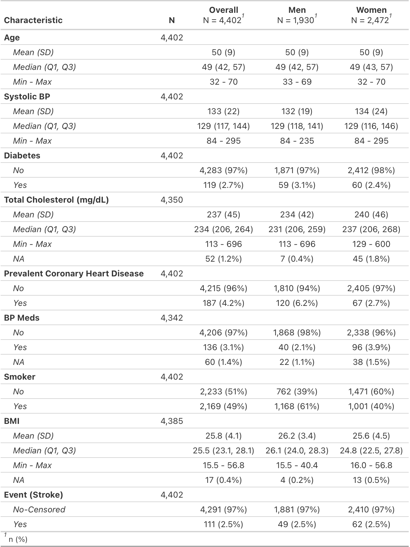
Table 1. Baseline characteristics of Framingham Heart Study participants, overall and stratified by sex.
Baseline characteristics of the FHS cohort are presented in Table 1, which shows that 2.5% of participants experienced a stroke, while 97.5% did not experience the event by the 10yr cutoff. Smoking status and pre-existing CHD were higher among men as compared to women. Age, systolic BP, diabetes status, cholesterol levels, BP medication use, and BMI showed no practically meaningful differences between men and women.

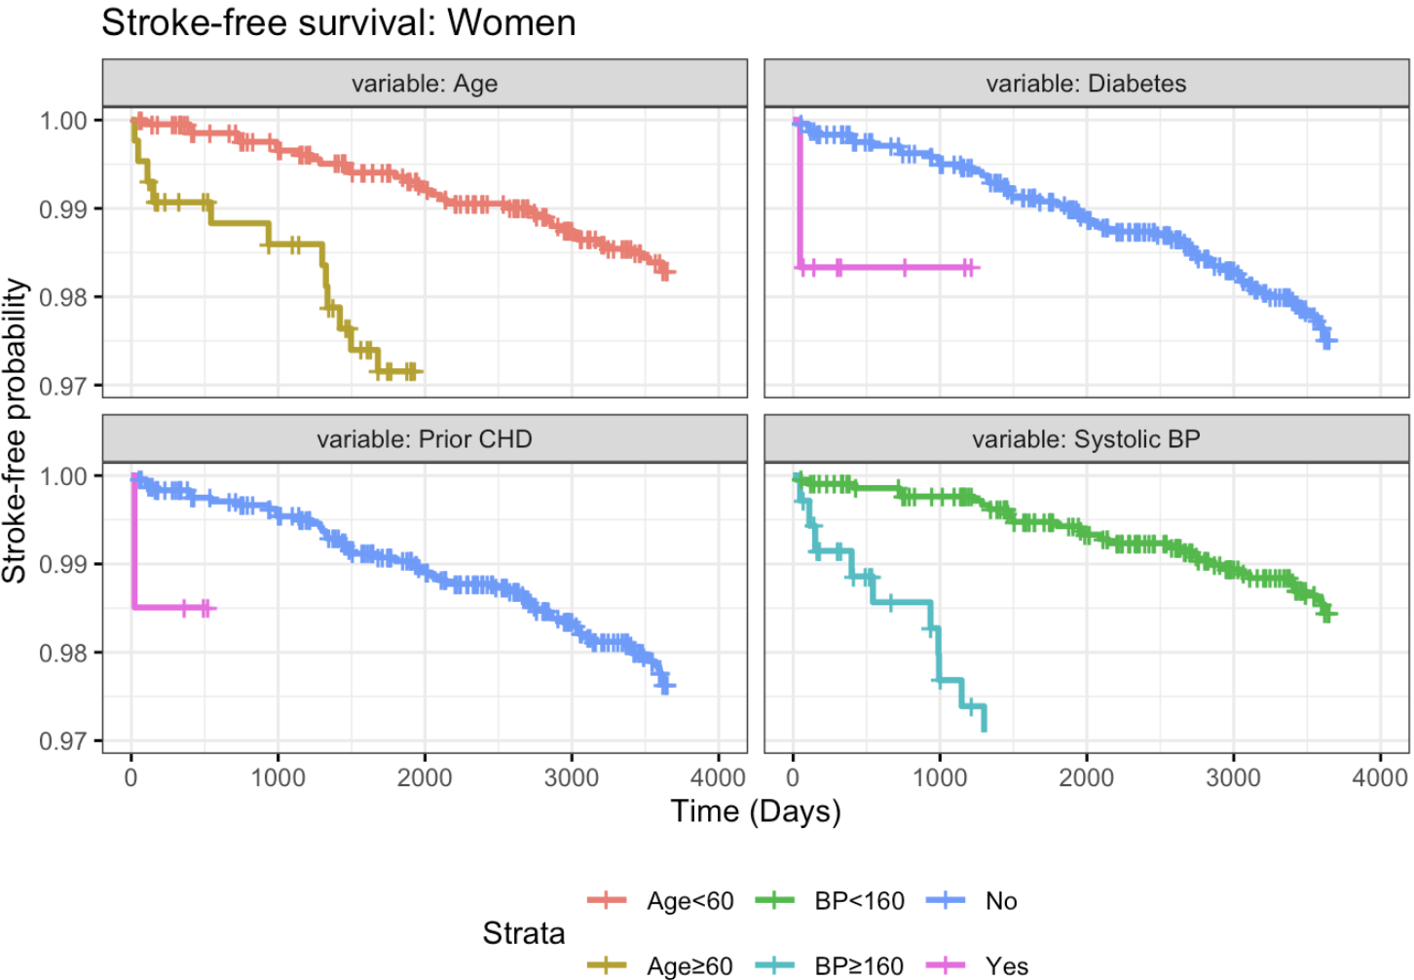
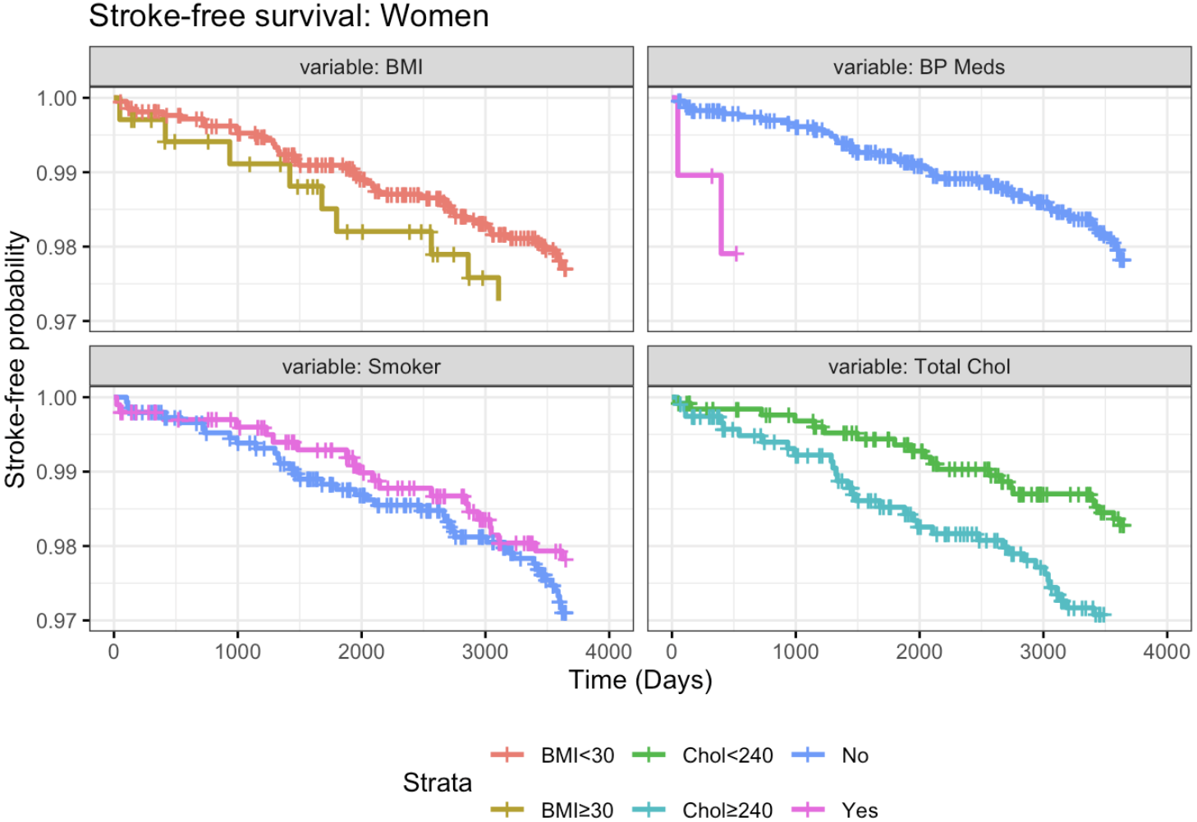
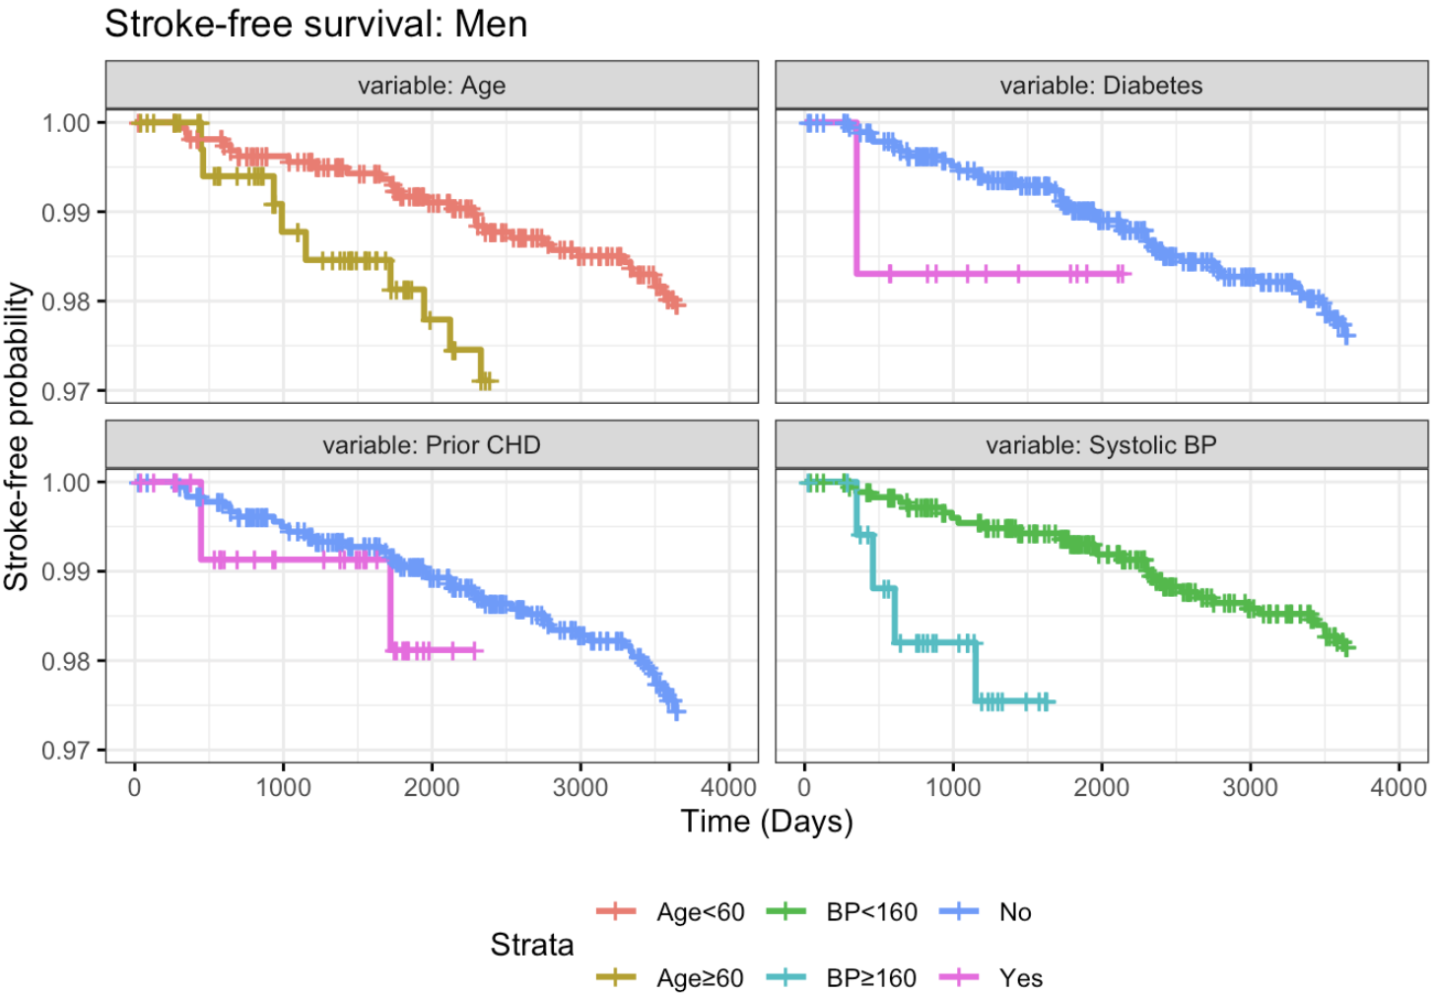
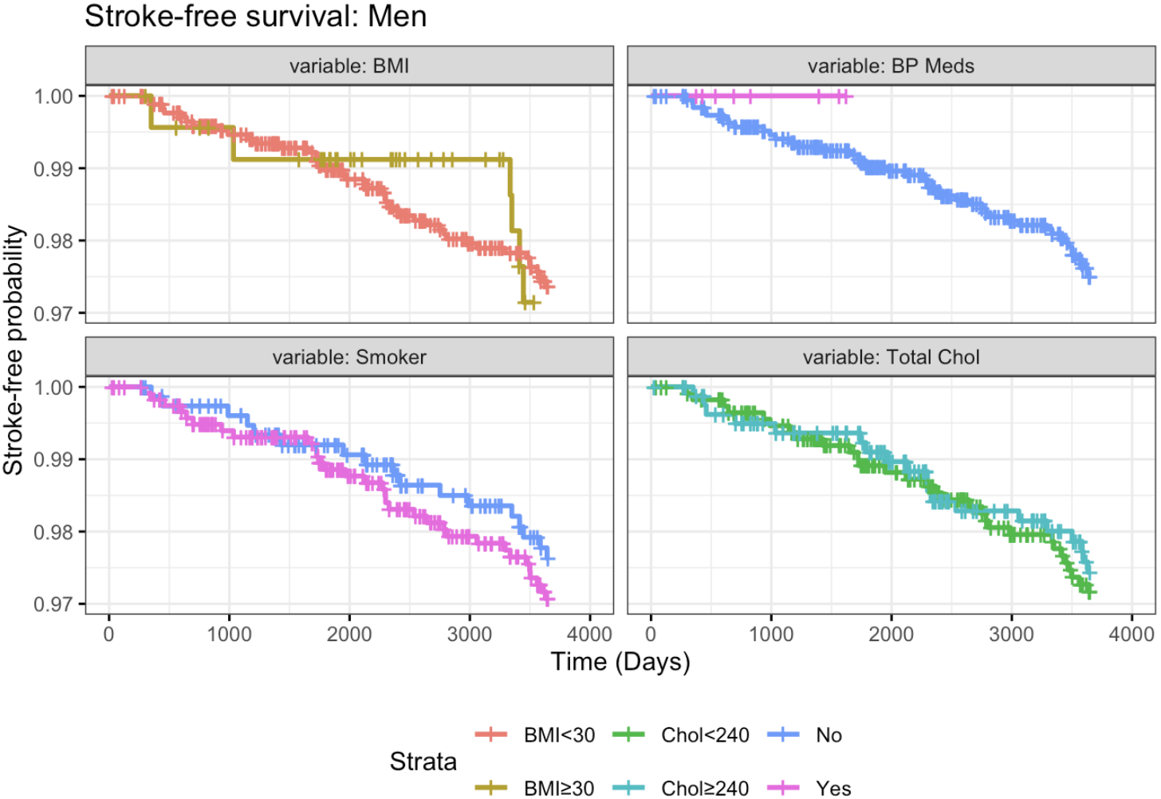
Figure 2. Kaplan–Meier curves of stroke-free survival over 10 years, stratified by sex and baseline risk factors. Each panel displays survival probabilities for levels of the corresponding risk factor for women and men, with tick marks denoting censored observations.
Kaplan–Meier curves stratified by selected baseline risk factors showed modest differences in stroke-free survival over 10 years. Lower survival probabilities were observed among participants with elevated systolic BP, not on BP medication, diabetes, prevalent CHD, and older age. Although these differences appear small in magnitude, due to the low incidence of stroke, it supports the inclusion of these variables in subsequent multivariable Cox proportional hazards models.

4. Discussion

4.1 Limitations

4.2 Conclusions

References
ChatGPT was used to check R code errors for some of the packages used and to grammar check (OpenAI, 2025).

Reproducibility Statement
The statistical code used in this analysis is available on my GitHub under the Code directory at: https://github.com/rysummers/BIOS6624-Class/tree/main/Project3
Raw data are not tracked in this repository and is available upon request.
Link to data on local drive: /Users/ryan_summers/GitHub/BIOS6624-Class/Project3/DataRaw/frmgham2.csv

