EEG Project Notes

Plan

Minimal initial scope

Questions

Next steps

Progress report

Formats, Data

Sleep stages

Software

R resources

Tableau

Background papers

Time series analysis

Other interesting links

Hardware: Flexible electronics

# 

# Plan

## Minimal initial scope

1. create simulated “EEG signal” by simply combining small number of sinusoids with
2. read EEG signal from available sleep recordings - ideally annotated i.e.
3. segment the signal into 30 seconds intervals and for each interval generate features. This can be done number of ways: [FFT](https://en.wikipedia.org/wiki/Fast_Fourier_transform), [CWT](https://en.wikipedia.org/wiki/Continuous_wavelet_transform) [potentially with custom wavelets] or maybe rather [DWT](https://en.wikipedia.org/wiki/Discrete_wavelet_transform), some others e.g. autocorrelation?
4. If number of features is large it might be useful to do dimensionality reduction. Number of approaches is available for this - one of the most promising seems to be [Stochastic Neighbor Embedding](https://en.wikipedia.org/wiki/T-distributed_stochastic_neighbor_embedding)
5. Cluster segments: what method? k-means? k-medoids? [DBSCAN](https://en.wikipedia.org/wiki/DBSCAN)? [mean-shift](https://en.wikipedia.org/wiki/Mean_shift)? other?
6. Visualize clusters and generate [hypnogram](https://en.wikipedia.org/wiki/Hypnogram)

## Questions

1. What is the optimal segment size? It seems that typically 30 seconds is used, but is it optimal?
2. In dimensionality reduction step what is the optimal number of target dimensions? 2-3 are great for visualization, but may not be the best to represent “real” manifold structure...
3. What are the potential artefacts of the signal? How to deal with them?
4. How to visualize the results?
5. How to go from clusters to “sleep stages”?

## Next steps

1. Use Konrad’s signal recordings from Muse [http://www.choosemuse.com/]

# Progress report

1. 2015-09-09: EDF reader for R identified
2. 2015-09-12: Sample sleep recording in EDF format from Physionet read successfully
3. 2015-09-30: Installed open source [edfbrowser](http://www.teuniz.net/edfbrowser/) to be able to read/browse through EEG recordings - here is the first screenshot:

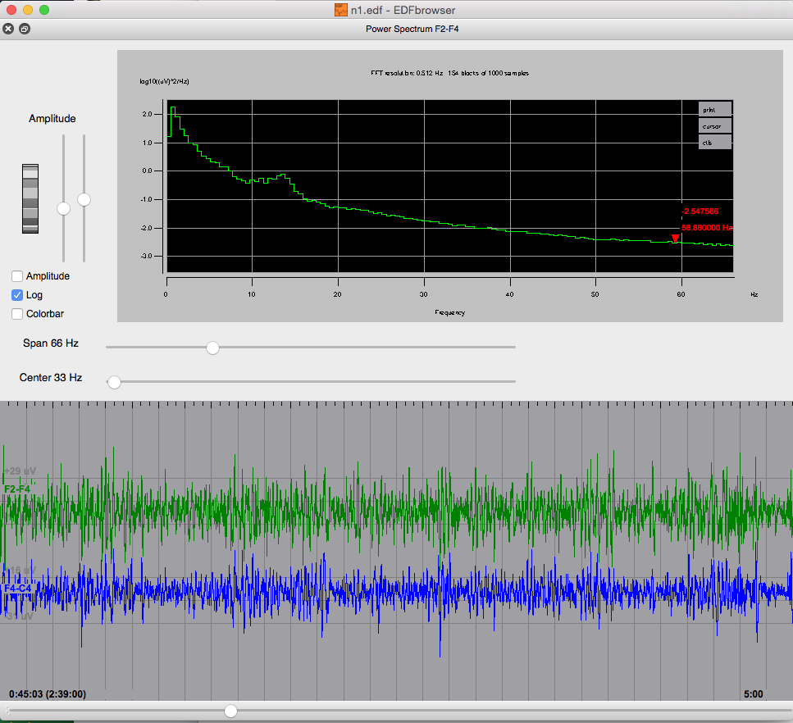

1. 2015-11-13: First minimal version of sim-eeg.R implemented. The idea is to use it for generating simple signal with well known characteristics which can be used to test EEG analysis, signal segmentation into windows and clustering. Here is the example output in which signal has six components (six different frequencies) with six different amplitudes which are switched randomly for each one of 4 windows. Of course, for testing I will generate longer signals - this is just for illustration. 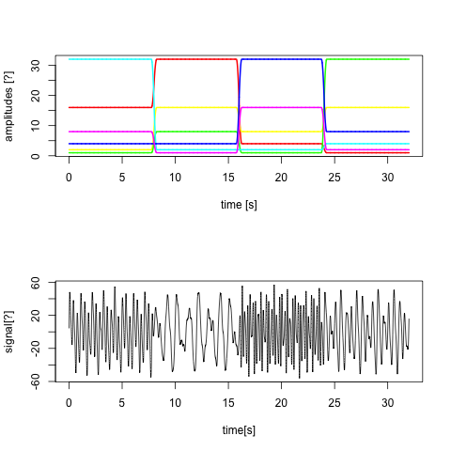

# Formats, Data

1. <https://en.wikipedia.org/wiki/European_Data_Format> - EDF is a standard [file format](https://en.wikipedia.org/wiki/File_format) designed for exchange and storage of medical [time series](https://en.wikipedia.org/wiki/Time_series) [...]
2. <http://www.edfplus.info>
3. <http://sccn.ucsd.edu/~arno/fam2data/publicly_available_EEG_data.html>
4. <http://www.physionet.org/physiobank/database/sleep-edf/>
5. <http://www.physionet.org/physiobank/database/sleep-edfx>
6. <http://sleep.partners.org/edf>
7. <https://sleepdata.org> - [meeting Oct 9, 2015 in Boston](https://sleepdata.org/forum/43-nsrr-early-adopters-meeting-oct-9-2015)

# Sleep stages

1. <https://en.wikipedia.org/wiki/Sleep_spindle> - A **sleep spindle** is a burst of [oscillatory brain activity](https://en.wikipedia.org/wiki/Neural_oscillation) visible on an [EEG](https://en.wikipedia.org/wiki/Electroencephalography) that occurs during [stage 2 sleep](https://en.wikipedia.org/wiki/Sleep#Physiology). It consists of 12–14 Hz waves that occur for at least 0.5 seconds [...] Along with [K-complexes](https://en.wikipedia.org/wiki/K-complex) they are defining characteristics of, and indicate the onset of, [stage 2 sleep](https://en.wikipedia.org/wiki/Sleep#Physiology)
2. <https://en.wikipedia.org/wiki/Non-rapid_eye_movement_sleep> -

# Software

1. [eegAnalysis](http://lib.stat.cmu.edu/R/CRAN/web/packages/eegAnalysis/index.html), [eegkit](http://lib.stat.cmu.edu/R/CRAN/web/packages/eegkit/index.html) - R packages for EEG analysis
2. <https://github.com/bwrc/edf> - R code to read EDF files
3. <http://www.teuniz.net/edfbrowser/> - EDF browser
4. <https://en.wikipedia.org/wiki/EEGLAB>, [EEGLAB](http://sccn.ucsd.edu/eeglab/) - open source Matlab Toolbox
5. [https://en.wikipedia.org/wiki/Window_function](https://en.wikipedia.org/wiki/Window_function#Parzen_window) - for segmented FFT analysis; it might be important to select proper window function to minimize leakage
6. [“Compiled EEGLAB”](http://sccn.ucsd.edu/wiki/A13:_Compiled_EEGLAB) - Open source EEGLAB compiled with MATLAB.
7. <http://jupyter.com>
8. <http://scikit-learn.org> - Python machine learning methods

## R resources

1. <https://www.r-project.org> - main R site
2. [CRAN Task View: Time Series Analysis](https://cran.r-project.org/view=TimeSeries) - overview of TS tools in R
3. “[A Method for Visualizing Multivariate Time Series Data](http://www.jstatsoft.org/v25/c01/paper)” Roger D. Peng, Journal of Statistical Software March 2008, Volume 25, Code Snippet 1.
4. <http://shiny.rstudio.com/> - web app application framework for R
5. <http://tryr.codeschool.com/> - code school for R
6. <https://www.datacamp.com/> - Learn R and data analysis
7. <http://www.statmethods.net/> - R in Action book.

## Tableau

<http://www.tableau.com/solutions/time-series-analysis>

# Background papers and materials

1. “[EEG Analysis Applied to Sleep](http://www.epi.ch/_files/Artikel_Epileptologie/Achermann_1-09.pdf)” (in Epileptologie 2009) Peter Achermann
2. “Automatic Sleep Stages Classification Using EEG Entropy Features and Unsupervised Pattern Analysis Techniques”, Entropy 2014, 16, 6573-6589; [doi:10.3390/e16126573](http://www.mdpi.com/1996-1073/5/11/4697), [Jose Luis Rodríguez-Sotelo](http://www.mdpi.com/search?authors=Jose%20Luis%20Rodr%C3%ADguez-Sotelo) et al.
3. “[EEG analysis with nonlinear deterministic and stochastic methods: a combined strategy](http://www.ane.pl/pdf/6010.pdf)” Jurgen Fell et al. Acta Neurobiol. Exp. 2000, 60: 87-108
4. <https://en.wikipedia.org/wiki/Electroencephalography>
5. <https://en.wikipedia.org/wiki/Polysomnography> - sleep study [PSG]
6. <http://www.brainmaster.com/generalinfo/eegbands/eegbands.html> - EEG frq bands
7. <https://en.wikipedia.org/wiki/Hypnogram>

# Time series analysis

1. “[A Bayesian Nonparametric Approach for Time Series Clustering](https://projecteuclid.org/download/pdfview_1/euclid.ba/1393251774)” [Luis E. Nieto-Barajas](https://projecteuclid.org/euclid.ba/1393251774#author-euclidba1393251774Nieto-BarajasLuisE) and [Alberto Contreras-Cristán,](https://projecteuclid.org/euclid.ba/1393251774#author-euclidba1393251774Contreras-CristnAlberto) [Bayesian Anal.](https://projecteuclid.org/euclid.ba) 9 [(1](https://projecteuclid.org/euclid.ba/1393251762)) (2014), 147-170. [R package]
2. [Multivariate time-series analysis and diffusion maps](http://ece.duke.edu/~lcarin/WenzhaoDiffusion.pdf). W Lian, R Talmon, H Zaveri, L Carin, R Coifman. Signal Processing 116, 13-28, 2015
3. <https://en.wikipedia.org/wiki/Box%E2%80%93Jenkins> -
4. <https://en.wikipedia.org/wiki/Time_series> -
5. <https://en.wikipedia.org/wiki/Chirplet_transform> - [...] used in EEG processing [...]
6. <https://en.wikipedia.org/wiki/Short-time_Fourier_transform> -
7. <http://www.di.fc.ul.pt/~jpn/r/fourier/fourier.html> - nice intro to FFT

# Other interesting links

1. <http://people.ece.cornell.edu/land/courses/ece4760/FinalProjects/s2012/cwm55/cwm55_mj294/> - EEG based brain-computer interface (BCI) design
2. <https://www.quora.com/How-do-I-read-an-EEG> - interesting general reading about EEG analysis
3. <https://en.wikipedia.org/wiki/Electroceuticals> -
4. <https://www.bostonglobe.com/metro/2015/09/27/devices-spark-movement-treat-disease-with-electricity/pdVGw650XIS8aM6ZxrVquN/story.html>
5. <http://www.nature.com/news/electroceuticals-spark-interest-1.15494>
6. <http://www.natureworldreport.com/2015/09/brain-to-brain-link-possible/>
7. <http://www.economist.com/news/science-and-technology/21664943-computers-can-recognise-complication-diabetes-can-lead-blindness-now> - from Kaggle competition
8. <http://www.sleepresearchsociety.org/>
9. <http://www.advancedbrainmonitoring.com/sleep-profiler/> -
10. <https://ryancquan.com/blog/2015/01/28/sleep-cycle-analysis/> - R analysis of SleepCycle app data
11. <http://www.sleepcycle.com/> - iPhone app
12. <http://24-7.motionx.com/> -
13. <http://news.mit.edu/2015/brain-controls-sleep-1013> - How the brain controls sleep Brain structure generates pockets of sleep within the brain.

# Hardware: Flexible electronics

1. <https://www.parc.com/services/focus-area/flexible-and-LAE/>
2. <https://www.parc.com/services/focus-area/prototyping/>
3. <http://onlinelibrary.wiley.com/doi/10.1002/app.39461/epdf>