Project Requirement and Specification

on

INTELLIGENT VOICE BASED HOME AUTOMATION

(BTECH V Semester Mini project )

2020-2021



Submitted to:

MR ASHWINI KUMAR Submitted by:

Rythem Sharma

Roll. No.: 2014819

Guided by: B.Tech -V-Sem

Dr Gaurav Verma Session: 2020-2021

(Resource Person)

DEPARTMENT OF COMPUTER SCIENCE AND ENGINEERING

GRAPHIC ERA UNVERSITY, DEHRADUN

--------------------------CONTENTS-----------------------

1.1 ABOUT PROJECT--------------------------------------

1.2 SYSTEM REQUIREMENT--------------------------- 1.3 MODULE--------------------------------------------------

1.4 DATA FLOW DIAGRAM---------------------------- 1.5 REFERENCE----------------------------------------------

----------------------------------------------------------------------------------------

* + About Project

**Home automation** or **domotics**is [building automation](https://en.wikipedia.org/wiki/Building_automation) for a home, called a **smart home** or **smart house**. A home automation system will monitor and/or control home attributes such as lighting, climate, entertainment systems, and appliances. It may also include home security such as access control and alarm systems. When connected with the Internet, home devices are an important constituent of the [Internet of Things](https://en.wikipedia.org/wiki/Internet_of_Things) ("IoT").

A home automation system typically connects controlled devices to a central [smart home hub](https://en.wikipedia.org/wiki/Smart_home_hub) (sometimes called a "[gateway](https://en.wikipedia.org/wiki/Residential_gateway)"). The [user interface](https://en.wikipedia.org/wiki/User_interface) for control of the system uses either wall-mounted terminals, tablet or desktop computers, a mobile phone application, or a Web interface that may also be accessible off-site through the Internet.

While there are many competing vendors, there are increasing efforts towards open source systems. However, there are issues with the current state of home automation including a lack of standardized security measures and deprecation of older devices without backwards compatibility.

Voice Controlled Wireless Home Automation Based on internet/ Bluetooth/ wi-fi is a project that is integrated system with mobile phone (application) to give the facility to the elderly and the disable people, so that they can easily control home utilities fully Based on their phone through voice command. The device is built in such a way that it will be easy to carry, install, configure, run and maintain for the non-technical person. Home automation involves introducing to connect the certain electrical devices that are used in a home.

1. Introduction

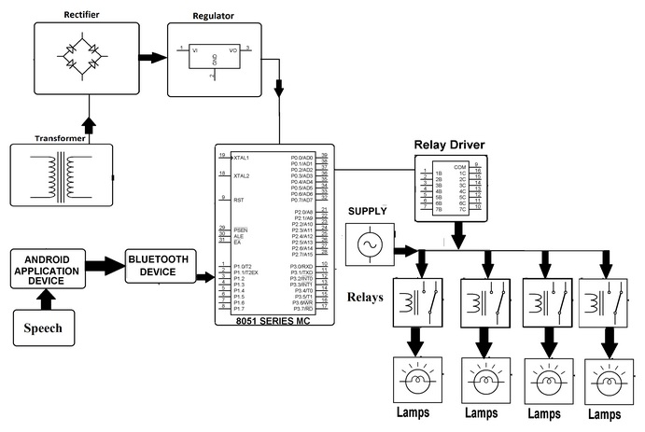

What is IOT?

IoT is one of the emerging technology which has an astonishing impact on the daily life

routine, whenever we come across dealing with the objects that are around us. The Internet

is one of the major media that is responsible for the World to be connected to a global village,

probably more than that. Well if Internet can be responsible for connecting the people

together, then what if we carefully use the same technology in a much logical format to

connect it to the objects that are around us? Is that logical and possible? [1]

The answer to this question is totally positive, it is possible. And even if we analyse this

concept, there are a certain number of examples and experiments and even the

implementations that lead to the very successful results. Indeed, it’s a great leap forward for

the human welfare in terms of their interaction to the objects that are around.

1.2 Requirement of Project

1.2.1 Hardware Requirement:

* Relay Module
* Esp8266 or Node MCU
* STORAGE: 5 MB(MAXIMUM)
* OS: WINDOWS 8
* FTDI TTL MODULE
* DS3231 OR TIME CLOCK MODULE

1.2.2 Software Requirement:

* Embedded C
* Arduino IDE

Hardwares used in Project :

* ESP8266

The ESP8266 is a low-cost Wi-Fi microchip, with built-in TCP/IP networking software, and microcontroller capability, produced by Espressif Systems in Shanghai, China. This small module allows microcontrollers to connect to a Wi-Fi network and make simple TCP/IP connections using [Hayes](https://en.wikipedia.org/wiki/Hayes_command_set)-style commands. However, at first, there was almost no English-language documentation on the chip and the commands it accepted.The very low price and the fact that there were very few external components on the module, which suggested that it could eventually be very inexpensive in volume, attracted many hackers to explore the module, the chip, and the software on it, as well as to translate the Chinese documentation.

Esp8266

* Relay Module

A **relay** is an [electrically](https://en.wikipedia.org/wiki/Electric) operated [switch](https://en.wikipedia.org/wiki/Switch). It consists of a set of input terminals for a single or multiple control signals, and a set of operating contact terminals. The switch may have any number of contacts in multiple [contact forms](https://en.wikipedia.org/wiki/Electrical_contact#Contact_form), such as make contacts, break contacts, or combinations thereof.Relays are used where it is necessary to control a circuit by an independent low-power signal, or where several circuits must be controlled by one signal. Relays were first used in long-distance [telegraph](https://en.wikipedia.org/wiki/Electrical_telegraph) circuits as signal repeaters: they refresh the signal coming in from one circuit by transmitting it on another circuit. Relays were used extensively in telephone exchanges and early computers to perform logical operations.

Relay Module

* Real Time Clock Module

A real-time clock (RTC) is a computer clock, usually in the form of an integrated circuit that is solely built for keeping time. Naturally, it counts hours, minutes, seconds, months, days and even years. RTCs can be found running in personal computers, embedded systems and servers, and are present in any electronic device that may require accurate time keeping. Being able to still function even when the computer is powered down through a battery or independently from the system’s main power is fundamental.

Real Time Clock Module

* FTDI TTL MODULE

The FTDI USB to TTL serial converter module is a UART (universal asynchronous receiver-transmitter) board used for TTL serial communication.It is popularly used for communication to and from microcontroller development boards such as ESP-01s and Arduino micros, which do not have USB interfaces.

# 

# 

# 1.5 REFERENCE

1. Stack Overlow
2. Arduino.com