ENTRA ID SECURITY LAB

Environment | Microsoft Entra ID (Free Tier)
SIEM/Logging | Splunk Free
Report Date | Sep 5, 2026

Summary:
This report is self-directed study to learn practically. This lab is built entirely on free tier tooling such as: Microsoft Entra ID for identity and access management, and Splunk Free for log aggregation and detection.
The objective was to simulate real life attack patterns consisting of brute force, legacy auth and anomalous location sign ins. Then use the tools to detect, analyze and professionally report using the same workflow as SOC analyst would follow in a production.
Three simulated scenarios were investigated in depth: 20 attempt brute force lockout, a legacy authentication (ROPC), and a sign-in anomaly showing impossible travel patterns between Calgary and Singapore. Each is mapped to a corresponding MITRE ATT&CK technique below.

The lab environment consisted of 8-10 test users across mixed roles (administrative, standard staff, and contractor) to simulate a real-life organization. I made 4 users manually to understand how a user is made then after for efficiently I use AI to make 20 users. After users were created, I moved on to learn more about roles and least privilege role assignments such as Global Reader and User Administration, only 3 users were granted roles due to efficiency.

Roles and Justifications:
Note: each user may qualify for more than 1 or several roles, but for efficiency I limit to 1-3 roles max.
User | Role | Why
Alex Rivera  (IT Manager, IT) | Global Reader | Being an IT Manager, you should have access to most of stuff. But instead of Global Admin, where the user can change anything is not safe, keeping in mind the least privileged rule. Therefore, the highest 2nd most important role would be sufficient.
Jordan Lee  (IT Support Analyst, IT) | Attribute Log Administrator  Security Administrator  Service Support Administrator | Can analyze logs, information and reports and manage. Can also manage tickets. Mostly analyzing roles makes sense.
Taylor Morgan  (Helpdesk Admin, IT) | User Administrator  Helpdesk Administrator | Can manage users and reset passwords for limited admins. Can reset passwords and manage basic user issues. Matches support/helpdesk job function.

Note: Only the 3 users above (IT-Admins group) were assigned Entra ID roles. All other users remain standard members with no elevated access

Detection Capabilities Built
MA = Microsoft Authenticator
User | MFA | Login Attempt Description | Result
Alex Rivera | MA | Legacy Auth Attempt: It can't support MFA at all, there's no step for "now approve on your phone," so if someone steals the password, they're in. | Tried EWS and IMAP, did not work, but ROPC flow worked, interestingly there is a filter to find ROPC on Entra but not the others, I think and researched that only ROPC remained intact, while others have retired, which did not give a flag.
Jordan Lee | MA | Brute force wrong password | Account locked
Morgan Patel | MA | Use VPN: before using a VPN on a user I need to log through my home account then use VPN to show change of network | Logs flag account was opened from a different location than the usual one

Incident 1: Legacy Authentication (ROPC) Sign-In

Summary:
Entra ID sign-in logs recorded an authentication event for user Alex Rivera using the ROPC protocol via Microsoft Azure PowerShell. ROPC is a legacy authentication flow in which the client application collects the user's raw username and password directly, without redirecting to a secure sign-in page — this is what makes it dangerous, since it provides no interactive surface for an MFA challenge. By comparison, other legacy protocols like EWS and IMAP are blocked at the tenant level before credentials are even evaluated. ROPC remains an active grant type and has been abused at scale in the wild, including an 81-million-attempt credential-stuffing campaign documented by Huntress. This maps to MITRE ATT&CK technique T1110.004 (Brute Force: Credential Stuffing) as the access method, with T1078.004 (Valid Accounts: Cloud Accounts) covering post-compromise use of the account once ROPC returns a valid token.
EWS:
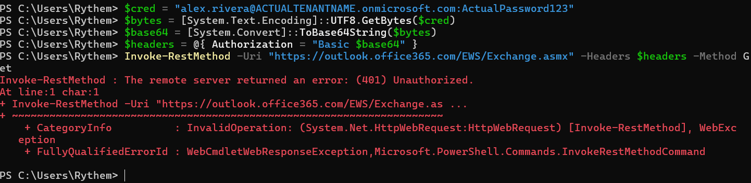
IMAP: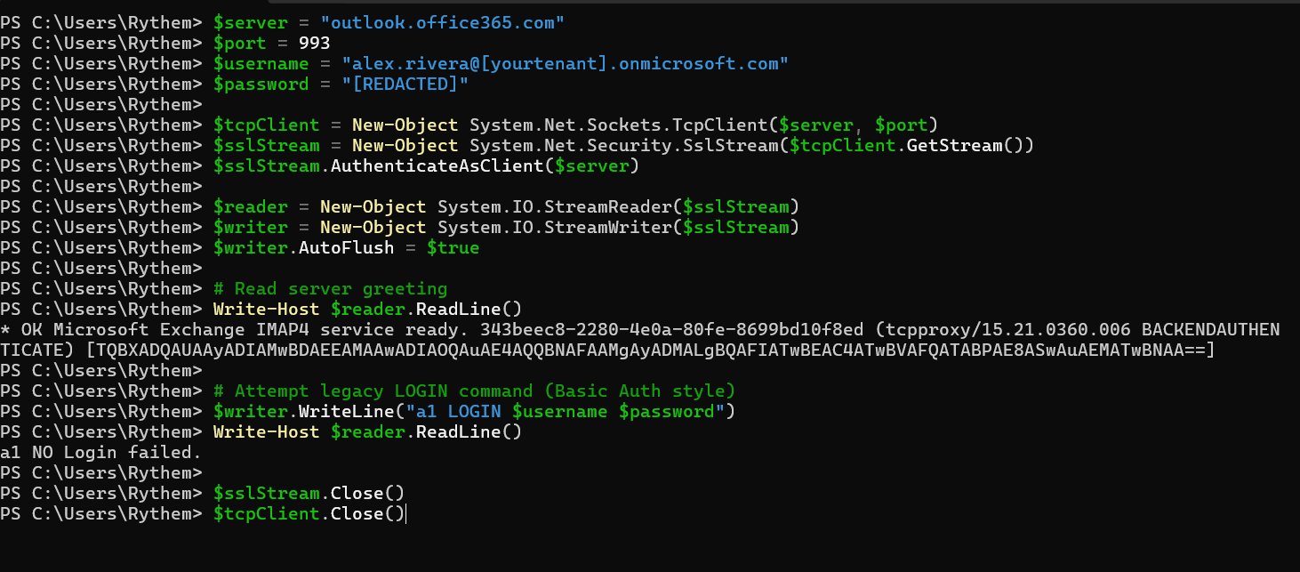ROPC flow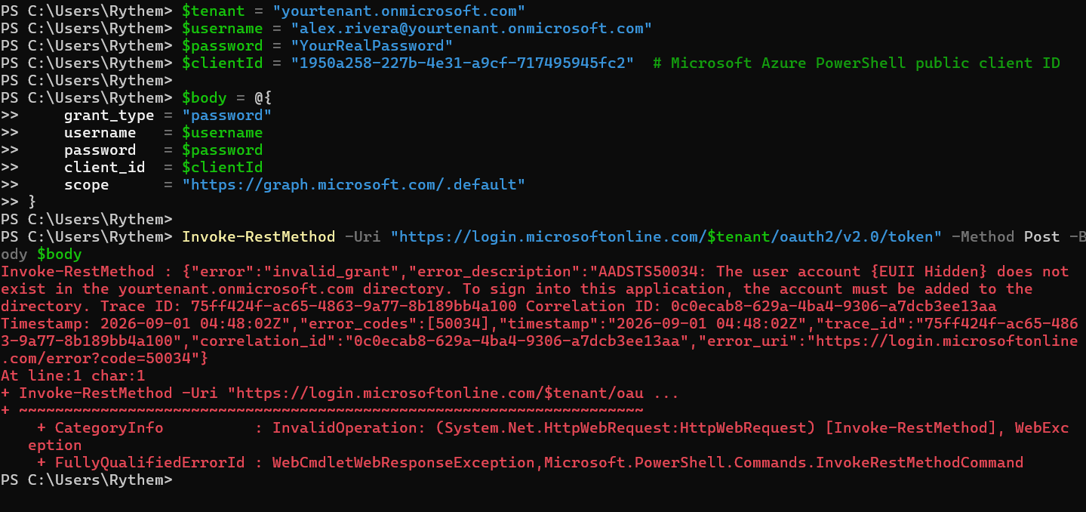

Incident 2: Location Change Anomaly

Summary:

Morgan Patel's sign-ins consistently originated from Calgary, CA. To simulate a different-network scenario, I connected via VPN and signed in again. Splunk logs show 2 sign-in attempts from an IP geolocated to Singapore at 22:17, although both attempts were blocked.

Error code 399218 does not correspond to a documented Microsoft Entra/Azure AD error code. Since this test data was synthetically generated for the lab, this is likely a placeholder value rather than a real Microsoft status code. The sign-in attempt itself is still meaningful as evidence of the location anomaly (Calgary → Singapore), even without an official code definition.
This map to T1078.004 (Valid Accounts: Cloud Accounts), referenced here as an Impossible Travel / Anomalous Sign-in detection analytic.

Log
Time | IP Address | City | Country | Client App
2026-08-31 21:33:06 | 2604:3d09:8d7a:400:e0e8:7ac1:8cf4:a094 | Calgary | CA | Mobile Apps and Desktop clients
2026-08-31 21:57:13 | 2604:3d09:8d7a:400:a58f:f54b:302c:5d97 | Calgary | CA | Browser
2026-08-31 21:59:57 | 2604:3d09:8d7a:400:e0e8:7ac1:8cf4:a094 | Calgary | CA | Browser
2026-08-31 22:00:20 | 2604:3d09:8d7a:400:e0e8:7ac1:8cf4:a094 | Calgary | CA | Browser
2026-08-31 22:00:23 | 2604:3d09:8d7a:400:e0e8:7ac1:8cf4:a094 | Calgary | CA | Browser
2026-08-31 22:17:25 | 162.128.70.83 | Singapore | SG | Browser
2026-08-31 22:17:28 | 162.128.70.83 | Singapore | SG | Browser

Incident 3: Brute Force Sign-In

Summary:
Entra ID detected a brute force sign-in attempt against Jordan Lee where 20 consecutive attempts were recorded from the same IP address, each returning Azure AD error code 50126. This pattern is consistent with manual password guessing attack than routine user error given the speed and volume of the attempts. Azure’s built in protection responded automatically after the failed attempt threshold was reached by locking the account and generating error code 50053. This incident maps to MITRE ATT&CK technique T1110.001 (Brute Force: Password Guessing). The root cause is assessed as an external or simulated credential-guessing attempt against a single known username, and the impact was fully mitigated by Azure AD's native lockout mechanism, requiring no manual intervention beyond password reset and user verification.
After 20 attempts the account was locked:

Limitations
This lab was built entirely without paid tooling. The original plan was to use Wazuh for SIEM log analysis, but configuring the host and forwarding logs consumed more time than the analysis itself was worth, so I switched to Splunk Free as a faster path to actual detection work. Working entirely on free tires also meant several production-grade capabilities weren't available: Entra ID Free doesn't include the Identity Protection risk engine, so sign-in risk (like the impossible-travel anomaly in Incident 2) had to be identified manually through log correlation rather than an automated risk score. Conditional Access, which would normally enforce blocking or MFA step-up automatically also requires a paid Entra ID P1/P2 license, so recommendations in this report describe what a policy would do rather than a live control that was tested. Similarly, without a licensed SIEM, alerting and case management were done manually rather than through automated detection rules.

Key Takeaways
This lab taught me a wide range of practical skills I didn't have going in: standing up and administering Entra ID, hosting and configuring a VM, ingesting and querying logs in Splunk, and understanding how an organization actually manages users, roles, and day-to-day security monitoring rather than just the theory behind it. Mapping each incident to MITRE ATT&CK sharpened how I think about technique and impact rather than simply flagging something as suspicious. EWS and IMAP are already deprecated and blocked at the service level, while ROPC remains a fully active grant type that continues to be abused in real-world attacks. This distinction changed how I would prioritize hardening a production tenant. I also picked up basic SPL (Splunk's query language), which I now recognize as foundational to this kind of work in the same way SQL is foundational to data analysis.

