USAID Bangladesh Country Scorecard FY23

FTF-PAE/ADL

Date generated: 2024-04-03

**2/3 On track**

# Performance on priority targets

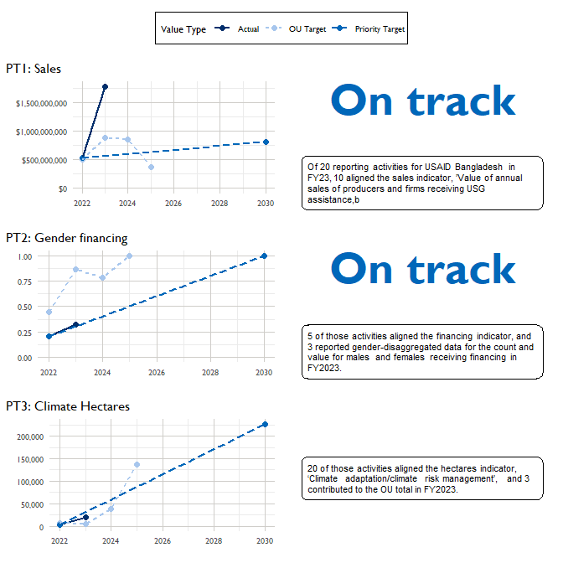

# Appendix 1: Key Issue Narratives Section 4 Excerpts

## Priority Target 1: Sales

A total of six projects reported FY 2023 results against this indicator, which.is around 112 percent higher than the target, indicating all the reporting projects had positive performance during the reporting period. The Aquaculture and the Nutrition project received a time extension of nine months, which allowed it to reach more beneficiaries than its original target. In addition, there was an increase in the prices of milk and meat this period, which also contributed to this higher result. The activities worked with the smallholder producers and private sector firms in different agricultural value chains. Targeted grants for specific sectors played a significant role in achieving the results. The outyear targets declined for a couple reasons. One key reason is that the Aquaculture project is ending in 2023 and did not set outyear targets. The remaining projects and the new FTF Climate Smart Agriculture (CSA) project have set the outyear targets in line with their objectives and annual work plans. USAID will revisit the FY 2025 targets during the FY 2024 PPR and adjust as needed based on FY 2024 results, implementation experience, and start-up time of the new activities.

## Priority Target 2: Gender Financing

The FTF Aquaculture and Nutrition, CSISA Mechanization and Extension (CSISA MEA), and FTF Livestock and Nutrition projects reported FY 2023 results against this indicator. Two of the projects exceeded their targets, but the Livestock project fell short and so the overall aggregate result was 39 percent lower than the target. Due to a delay in negotiations, the Livestock project was only able to partner with two financial service providers, out of its target of three, to extend livestock loans to dairy, beef, and goat farmers and other market actors. Therefore, it could not facilitate the targeted amounts of loan access. The outyear targets declined due to the Aquaculture project ending in FY 2023. For FY 2024, the CSISA MEA and the Livestock projects set targets of $1,100,000 and $7,058,878 respectively, based on their plans to facilitate access to credit for target beneficiaries. USAID will revisit the FY 2025 targets during the FY 2024 PPR and adjust as needed based on FY 2024 results, implementation experience, and start-up time of the new activities.

## Priority Target 3: Hectares

A total of seven projects reported FY 2023 results for this indicator, with the overall result being 47 percent higher than the target. This is primarily because of the overachievement by the Aquaculture project, the Horticulture project, and the Livestock project. The Aquaculture project, which was scheduled to end this year in February, received a time extension through November. As a result, the project was able to reach more aquaculture beneficiaries than targeted. The Horticulture project formed additional partnerships with input firms, which contributed to covering more crop lands. In addition, the Livestock project was able to cover more lands for fodder cultivation thanks to additional outreach and training for the farmers, leading to a higher area coverage. Future outyear targets will decline due to the Aquaculture project ending in 2023. The rest of the projects as well as the new CSA project have set FY 2024 and FY 2025 targets based on their annual work plans and FY 2023 implementation experience. USAID will revisit the FY 2025 targets during the FY 2024 PPR and adjust as needed based on FY 2024 results, implementation experience, and start-up time of the new activities.

## Priority Target 4

A total of six projects reported results for this indicator. This indicator overachieved its target by approximately 24 percent. This is primarily because four out of the six projects reporting on this indicator were able to exceed their targets significantly with additional private partnerships. In addition, the FTF Aquaculture and Nutrition project, which was supposed to end in February, received a time extension through November 2023. The additional nine months allowed the project to leverage more private sector partner investments. The Aquaculture and Nutrition project reported $712,898, CSISA MEA reported $3,528,351, Horticulture reported $9,086,835, IRRI reported $6,064,597, Livestock reported $979,564, and Nutrition reported $323,222 in private sector leveraging. The Aquaculture project ends in 2023, so the outyear targets are lower than the FY 2023 results. The other five projects have set out-year targets according to their work plans and