FTF Briefer: Leveling off smallholder farmer participation in FY2022

RFS/PAE/ADL/Data and Analytics Team

# 1 Trends in Smallholder Farmer Participation (2018-2022) for all Feed the Future Reporting Organizations

Smallholder farmers make up the majority of on-farm agricultural employment in countries where Feed the Future (FtF or “the initiative”) works. A key component of the Global Food Security Strategy is to reduce smallholder farmer employment and transition workers and value-added activities off the farm. To achieve this goal, Feed the Future needs to engage smallholder farmers in programming to enable them to increase productivity or transition to other forms of livelihood. The initiative began tracking total participation and smallholder farmer participation in FY2018, using the EG.3-2 indicator (see Table ?? below). While the initiative has had year-on-year increases in the total number of participants in every year except FY2021, the share of smallholder farmers (henceforth “smallholder”) has fluctuated. In FY2022, the share of smallholders fell from 25% to 20% for all reporting organizations, making FY2022 the third year in which it has dropped since reporting started. This brief report describes the trends in smallholder participation in FtF between FY2018 and FY2022 and explores a leading explanation for variation in participation of smallholders and overall participation–the program cycle.

The brief concludes that smallholder participation is mostly flat, but slightly increasing in absolute terms and as a share of the total participants between FY2020 and FY2022. A slight bump in both absolute and relative figures in FY2021 was lost in FY2022. These decreases in the share of participants are negated when removing the USAID/Nigeria operating unit (OU) that has reported incredible increases in both total participants and smallholder farmers between FY2021 and FY2022. Excluding the USAID/Nigeria OU, the share of smallholder participants remained constant, and participation overall appears to be flat.

| ROs | Disaggregate | FY2018 | FY2019 | FY2020 | FY2021 | FY2022 |
| --- | --- | --- | --- | --- | --- | --- |
| All ROs | Total | 4487592 | 23795660 | 29444448 | 29415082 | 35332326 |
| All ROs | Producer: Smallholder Farmer | 1317238 | 5827728 | 5354922 | 7279899 | 6930988 |
| All ROs | Percent of Smallholder Farmers | 29% | 24% | 18% | 25% | 20% |
| USAID Only | Total | 1962829 | 15278116 | 22818766 | 22712076 | 27585629 |
| USAID Only | Producer: Smallholder Farmer | 941838 | 5714018 | 5354202 | 7217299 | 6864216 |
| USAID Only | Percent of Smallholder Farmers | 48% | 37% | 23% | 32% | 25% |

As to the effect of the program cycle, it appears to explain A few activities that ended recently (or are in their final year) account for a loss of 2.4 million smallholder farmers (see Figure 3.1). The losses from these activities is greater than the total reduction in smallholder participation between FY2021 and FY2022, suggesting that other new activities added to the number of smallholders. This highlights the sensitivity of EG.3-2, like all FtF indicators, to the program cycle. EG.3-2 captures a “snapshot in time” and reflects the number of participants for each activity in each reporting year, rather than an annualized number. This means that the reported values are sensitive to the program cycle of USAID and other reporting organizations. Activities tend to report lower values during years that they start and end for two reasons. First, during start up and end years (or “closeout years”), staff and implementing partners are engaged in administrative tasks and have less time to implement the activity. Second, start and end dates are not necessarily aligned to the reporting calendar (October-September), so the activity may report only what occurs in part of the year as the annual value.

# 2 Multiple ways to measure participation in FtF

Feed the Future reporting is designed to measure participation at the **Activity/IM level** to aid in adaptive management, though this focus on the activity poses challenges to aggregating participation numbers to the level of operating unit or the initiative overall. Participants can work with multiple USAID activities and each activity should count that individual, resulting in a (purposeful) over counting. To correct for over counting in the activity level values, initiative level reporting uses a twin indicator, EG.3-2_OULevel, which is manually de-duplicated by USAID Mission/OU staff. The manual de-duplication has seen growing, but still inconsistent compliance, leading the ADL/Data & Analytics Team to use a hybrid approach to calculate participation. The hybrid approach uses the OU level value where it is available and substitutes the sum of activity level values for missing OU level data. Figure ?? shows the results of using four different approaches to calculating OU participation:

1. IM_Level_Sum is the sum of the Activity/IM values.
2. OU_level is the de-duplicated value reported by OUs/Missions, which is sometimes missing.
3. Hybrid_OULevel uses the EG.3-2_OULevel indicator when it is present and, if it is missing, substitutes the sum of the EG.3-2 indicator at the Activity/IM-level.

Figure ?? shows the difference between the three measurements in a line chart. The OU level *should* be lower than the sum of the IM-level values in every case, leading to a lower overall headcount across IMs that report both figures. We can see from Figure ?? that the OU Level count of smallholder farmers and total participants converged with the EG.3-2 sum of IM-level figures in FY2022. In FY2022, three USAID operating units did not report OU-level figures–Bangladesh, Rwanda, and Ethiopia.

## Warning: Removed 4 rows containing non-finite values (`stat_summary()`).

## No summary function supplied, defaulting to `mean_se()`  
## No summary function supplied, defaulting to `mean_se()`

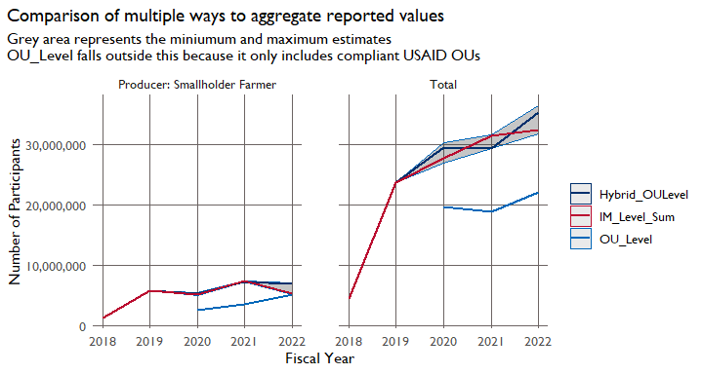

The remainder of the briefer reports on the trends in smallholder participation using the best available data–the hybrid OU values or the Activity/IM-level sum depending on the appropriate level of disaggregation.

# 3 Trends in smallholder farmer participation

The largest increase in the total number of participants in FtF occurred after FY2018, presumably due to increased reporting compliance. Smallholder farmer participation has increased at a slower rate than the increase in overall participation, and dropped in absolute terms in the latest fiscal year.USAID/Nigeria’s reporting carries a heavy weight for the participation in FY2022. Figure ?? below shows the change over time in participation including a breakdown with USAID/Nigeria, other large reporters, and other OUs. USAID/Nigeria alone reported nearly 8 million participants in FY2022, inflating the total number of participants from 27.7 million to 35.3 million, and increasing the number of smallholders from 4.4 million to 6.9 million. The table and figure below show the same information. The figure provides an overview at a glance, while the Table ?? provides the detailed figures.

| Group | Disaggregate | FY2018 | FY2019 | FY2020 | FY2021 | FY2022 |
| --- | --- | --- | --- | --- | --- | --- |
| All OUs | Total | 4,487,592 | 23,795,660 | 29,444,448 | 29,415,082 | 35,332,326 |
| All OUs | Producer: Smallholder Farmer | 1,317,238 | 5,827,728 | 5,354,922 | 7,279,899 | 6,930,988 |
| Excluding Nigeria | Total | 3,971,622 | 23,133,226 | 28,310,051 | 27,906,548 | 27,751,573 |
| Excluding Nigeria | Producer: Smallholder Farmer | 1,051,056 | 5,501,946 | 5,195,382 | 7,150,527 | 4,390,179 |

Conversely, the majority of the reduction in participation comes from four key operating units—-RFS, Tanzania, Ethiopia, and Ghana. These four OUs accounted for about 50% of the total smallholder farmers in FY2021, but only about 25% in FY2022, as shouwn in Figure ??.

## Scale for fill is already present.  
## Adding another scale for fill, which will replace the existing scale.

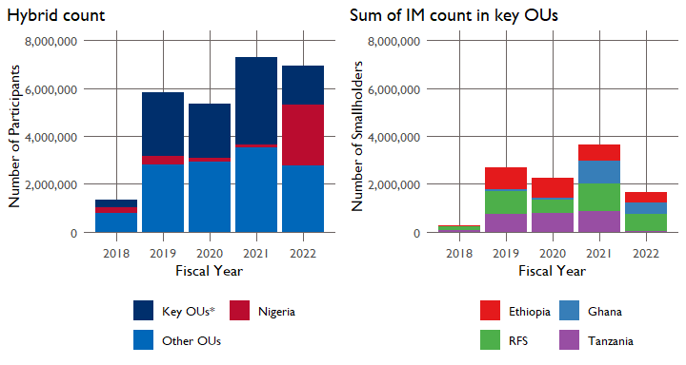

The changes in smallholder participation are not evenly spread throughout the initiative, but are concentrated in a few operating units and activities. The next section discusses the activities that have contributed most to the changes in smallholder participation.

## 3.1 Activity/IM level Differences between FY2021 and FY2022

The Activity/IM level reporting provides additional detail on the extent to which ending activities contribute to the drop in participation levels. Twenty-four activities had an absolute value change of 50,000 smallholder participants between FY2021 and FY2022 (shown in Figure 3.1). The four largest losses, shown at the top of the figure, account for a loss of 2.4 million, while those with losses above 50,000 account for 1.4 million. These losses are counteracted by nine activities that gained more than 50,000 smallholder farmer participants, for a total of 1.6 million.

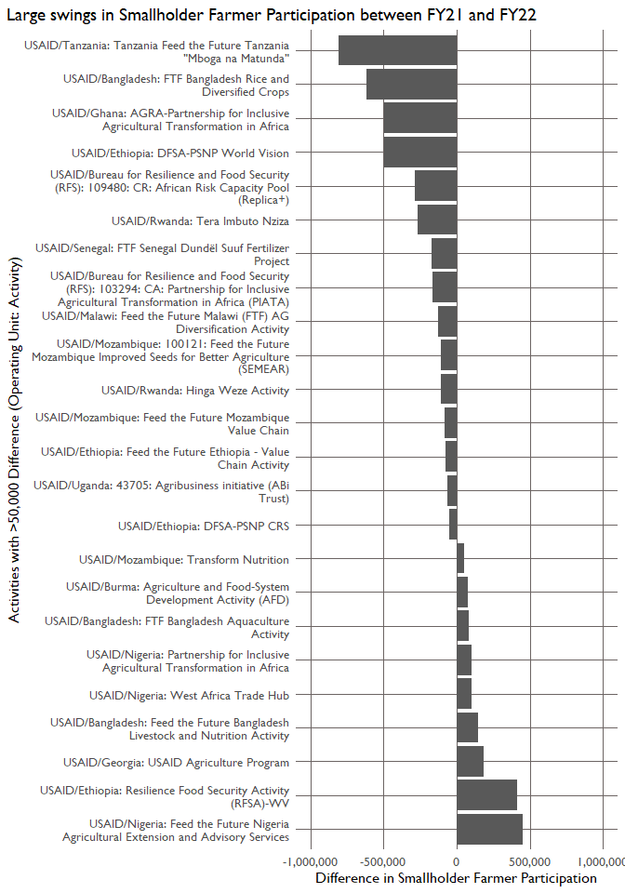

Figure 3.1: Changes in smallholder participation can be explained in part by activities ending.

Several of these activities ended recently:

* The Tanzania activity, “Mboga na Matunda”, ended 6/30/2022.
* The Bangladesh activity, “FTF Bangladesh Rice and Diversified Crops” ended 12/12/2021.
* The Rwanda activity “Tera Imuto Nziza” ended 10/1/2022; the “Hinga Weze” activity ended 6/22/2022.
* The Senegal activity, “FTF Senegal Dundël Suuf Fertilizer Project”, ended 2/19/2023.
* The Malawi activity”AG Diversity Activity” ended 9/28/2023.
* The Mozambique activity “SEMEAR” ended 9/30/202; the Mozambique Value Chain activity ended 6/30/2022.
* The Ethiopia “Value Chain activity” ended 6/30/2022. The Uganda activity “Agribusiness initiative” ended 11/1/2021.

Others would require additional research to explain why they lost participation from so many smallholders:

* The Ghana activity, “AGRA-Partnership…” is ongoing and we do not have an explanation for why it lost so many smallholders year over year.
* The RFS activity “CR: African Risk Capacity Pool (Replica+)” ends in October 2025, so we do not have an explanation for why it lost so many smallholder participants year over year. The “PIATA” activity ends in September 2027.
* The Ethiopia activity, “DFSA-PSNP World Vision” does not have an end date, but it is labeled “closed”; it started 9/28/2016, so may have closed after the 5th year in 2021. Same for the “DFSA-PSNP CRS” activity in Ethiopia.

Where is the greatest level of over- and under-counting, measured by the absolute difference between the OU-Level indicator and the IM-level sum?